DIAG-7 Distributed monitoring of microwave power density
TG priority: Critical | Start date: 2015 | Status: On-going | Personnel exchange: No
IO priority: | End date: | Motivation:

Device /  Association | Contact  Person | 2016 TG  Request | Activity (from JEX/JA spreadsheet)
 |  |  | 2015 | 2016 | 2017 | 2018
ITER / TU/e | H. Oosterbeek | Desirable
DIIID | R. Boivin | Desirable | Committed
AUG | A. Stoeber | Desirable | Committed
W7-X | H. Laqua | Desirable
Purpose
1. Physics requirement
Non-absorbed microwave power will occur in the ITER vessel due to non-complete absorption of ECH and due to the CTS gyrotron which has no resonance in the plasma. In addition Electron Synchrotron losses becoming significant at high electron temperatures. The microwave loads, in order of increasing power density, are expected to be: i) isotropic stray radiation, ii) electron synchrotron radiation, iii) cross polarized beam and iv) directed beam.
The microwave power densities can lead to heating of in-vessel components and damage to diagnostics. Therefore distributed monitoring of the power density is required while individual diagnostic systems must rely on fast and dedicated protection systems.
The microwave bolometer described in this proposal is designed for motoring purposes. It is of very modest size and inherently simple. They are designed to be placed in junction boxes in vessel and thus allow for distributed monitoring of microwave power. Up to 100 such units are foreseen. Objectives:
- Understanding of microwave loads as a function of microwave actuators and plasma.
- Possibility to raise an alarm signal in case of excessive microwave power density.
- Physics data on plasma absorption and electron synchrotron losses.
- Acquire insight on how to make next step fusion devices robust to microwave loads.
2. Brief description of the microwave bolometer
The design of the unit, and the current status, is shown in figures 1 and 2.

ΔV = α*P_{RF}
But V_{BA} <> V_{AB} as:
T₁: V_{BA} = α∗P_{RF} + β∗P_{neutrons}
T₂: V_{AB} = β∗P_{neutrons}
ΔV = V_{CB} + V_{BA} – V_{AB} - V_{BC}
V_{CB} = V_{BC}

Fig. 1: Operating principle of the microwave bolometer. T1 and T2 represent the bolometer bodies connected together with thermo-couple wires (e.g. B = Alumel, A = Chromel). T1 is coated with microwave absorber. T3 is an isothermal block that is used to connected the thermo-couple wires to the twin electrical cable (plain conductors, no thermo-couple) connecting the bolometer signal to the vessel feed-through.
Results for 2015
1. Design optimization.

The design 2014 / 2015 is based on an elaborate analytical thermal model. During 2015 the model was validated using Finite Element (FE) software. This resulted in overall verification in general but also showed some discrepancies. These were understood and the model updated and the design further tuned. Using the same FE-software - but now the electro-magnetic module - the antenna pattern of the unit was analyzed and optimized. The new arrangement increases sensitivity to incident power, reduces sensitivity to polarization and limits microwave power entering inside the unit itself. The increased sensitivity leads to overheating in case of the maximum specified power of 1.25 MW/m² and a simple filter is proposed that allows to change the sensitivity be approximately a factor of 10. The design optimization is reported in:
Electromagnetic and thermodynamic design of the ITER microwave bolometer, K. Arts, Eindhoven University of Technology, Department of Applied Physics, July 2015.

2. Production and installation for test in DIIID.

The design optimization was completed by the summer of 2015. This was incompatible with the AUG vessel opening and we focused on producing two proto types for DIIID. The ITER CAD model was released and it emerged that some loose ends needed to be fixed. In addition specific alterations were required for use in DIIID. As a result an updated model was made at the Equipment Prototyping Centre (EPC) at Einhoven University together with production drawings. Production of two prototypes started at EPC while the microwave absorbing coating (Al₂O₃/Ti₂) was provided by DutchAreo. The initial prototypes were, however, rejected by us as between box and baseplate a risk of a trapped cavity arose. In addition some ceramic washers had cracked by baking at 330 °C. Two new versions (Mark II) were produced and shipped to DIIID at the beginning of October. Unfortunately one units suffers again from broken ceramic washers and spares are presently made and send to DIIID. Some safety tack-welding of components are carried out by DIIID and it is aimed at to install both units in DIIID in November for the experimental campaign. Below an expanded figure of a single unit, together with a unit as built.

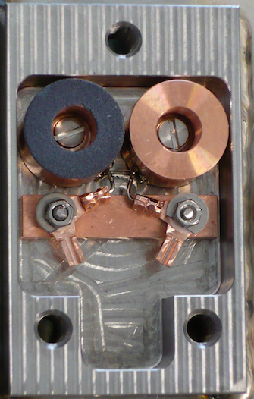
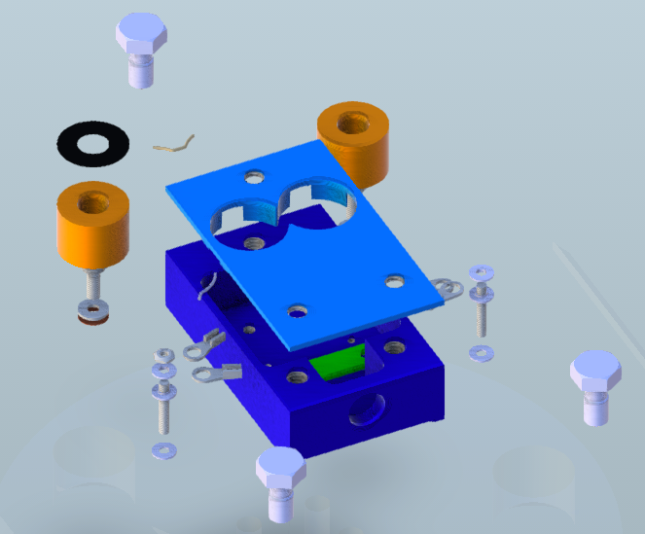
27 mm
45 mm
Exploded view of Mark II prototype for DIIID Photo as produced (with cover removed)

Plans for 2016
Test of the sensor in DIIID (expected early 2016):
- Installation, connections, vacuum compatibility.
- RF response: maximum power (test rig with directed beam?).
- RF response in-vessel: signal magnitude, S/N, temporal resolution, rejection of nuisance signals.
- Signal analysis and evaluation.
- Robustness of unit and coating in-vessel.

Test of sensor in W7-X Mistral (expected autumn 2016):
- Small signal response (signal magnitude, S/N, temporal resolution).
- Cross calibration against other RF sensors in MISTRAL.
- Evaluation of filter (sensitivity adjustment).
- Large signal response (directed beam): both signal magnitude as survival (or not).
- CW response at 1.25 MW/m².

Test of the sensor in AUG, if opening. Items: see under DIIID.

Development of Mark III sensor (several items > 2016):
- Simplification of electrical insulation of bolometer bodies.
- Simplification of fixtures.
- Investigate braising (and hence temperature cycling) overall assembly in one production process.
- Filter to change sensitivity.
- Electrical connection ITER (LEMO connector).
- Develop and test procedure for calibration.
- Investigate procedure for installation in ITER junction boxes in situ.
- All issues that come to light in the tests DIIID, AUG, W7-X.

