DIAG-8 Benchmark of wall reflections
TG priority: High | Start date: 2015 | Status: On-going | Personnel exchange: No
IO priority: | End date: Not fixed | Motivation: Plasma Control

Device /  Association | Contact  Person | 2016 TG  Request | Activity (from JEX/JA spreadsheet)
 |  |  | 2015 | 2016 | 2017 | 2018
ITER | M. De Bock  E. Veschev  S. Kajita (U. Nagoya)  A. Alekseev  (RF-DA, Triniti) | Desirable | Modelling
JET | N. Hawkes  M. Carr | Essential | Modelling
AUG | A. Herrmann | Essential | Committed
WEST | M. H. Aumeunier | Essential | Modelling
C-Mod | TBD | Not doing | Not doing
University of Basel | L. Marot | Essential | Committed
Motivation
Because of the metallic wall, scattered/reflected light (e.g. from the strong emission in the divertor) is very likely to interfere with the measurements of optical diagnostics in ITER. Modelling exists for ITER, but is in need of benchmarking against experimental data from existing machines.
Primary Tasks in brief (see below for a more detailed description)
- Acquiring of experimental data. Collection of experimental data for most relevant diagnostics: 2-D cameras (Visible & IR) and H-alpha in Devices with metallic walls (rather than carbon walls). The experimental data could be obtained in piggy back experiments. It is, however, vital that the plasma scenarios of these experiments are such that enough experimental data is available to assess the sources of emission (H-alpha emission in the divertor, continuum emission in divertor and bulk, heat flux to the wall …).
- Measurements of the BRDF function for first wall materials. This includes measurements of the BRDF function of the virgin FW materials and of FW materials that have been exposed to plasma conditions. The latter should give an indication of the plasma polishing or roughening of the FW materials.
- Modelling of the emission sources and numeric simulation of the reflection based on the experimental input data. The former needs experimental data from item 1. as input and its output is used as input in the numerical reflection simulation. The latter needs the input for item 2. and its output is compared to the experimental data of item 1.
- Tests of proposed data analysis in presence of reflections. For H-alpha spectral measurements and dedicated analysis are proposed for ITER to separate the reflected and direct contributions. This technique should, however, be tested on existing devices where reflections are present. Although this task focuses specifically on H-alpha measurements, knowledge gained during this task might be useful for other diagnostics suffering from stray light as well.

Results for 2015
- Acquiring of experimental data: No dedicated experiments were yet performed in 2015. Focus was put on points 2 and 3 in preparation for experiments.
- Measurements of the BRDF function for first wall materials: The method of the test and materials to measure were identified. The study will be performed at the University of Basel (Switzerland) as part of a PhD position on wall reflection modeling. The University of Basel has, therefore, been added to the list of contributing associations of the JEX proposal.
The aim is to measure the BRDF over the full visible range and into to IR range for IR thermography. For the visible range the equipment is now present, however for the IR range there is still a need for the correct measurement equipment (fibres, spectrograph). The wall samples are available. Measurements in the visible range will start early 2016.
- Modelling of the emission sources and reflection: Several reflection modeling tools have been prepared:
  - Model of the JET wall derived (reduced) from CATIA model for inclusion in the Light Tools reflection modeling software (aimed at visible reflection modeling).
  - Model of the ASDEX-U and WEST walls derived for inclusion in the CATIA SPEOS reflection modeling software (aimed at IR emission and reflection modeling).
  - Raysect/CHERAB software developed of visible (plasma) emission and reflection modeling and JET, MAST and ASDEX-U wall models included.
- Tests of proposed data analysis in presence of reflections: Analysis (and modeling) based on expected different spectral shape of H-alpha emission coming from the divertor and inner (HFS) and outer (LFS) scrape of layer further developed (presentation 29th ITPA-D meeting [1])
Plans for 2016
After the preparatory phase in 2015, in 2016 experiments are expected to be conducted or prepared in detail.
At a meeting with all concerned parties at the 29th Diagnostics ITPA (2 – 6 November 2015, Cadarache, France) the strategy shown in Figure 1 was proposed.
Hereby the BRDF measurements (Task 2) will start early 2016 at the University of Basel. The aim it to determine the BRDF over the full visible and IR range. Equipment for measurements in the visible is already available. For the infrared range specifically IR-rated fibres and spectrograph are not yet available. Material samples are available.
After the BRDF measurements 2 separate tokamak experiments are considered:
- For benchmarking wall reflection in the visible light an experiment at JET is proposed, focussing on the H-alpha diagnostic.
- For benchmarking wall reflection in the IR range an experiments at ASDEX Upgrade and (later) WEST are proposed.
For the latter a collaboration has already been set up between CEA, IPP, the university of Basel and the A*Midex (see presentation by M.H. Aumeunier at the 29th Diagnostics ITPA).
For the former informal discussions have been held between the team at JET and the RF-DA (specifically the Triniti and Kurchatov institutes). For the reflection modeling also S. Kajita of the University of Nagoya is involved.
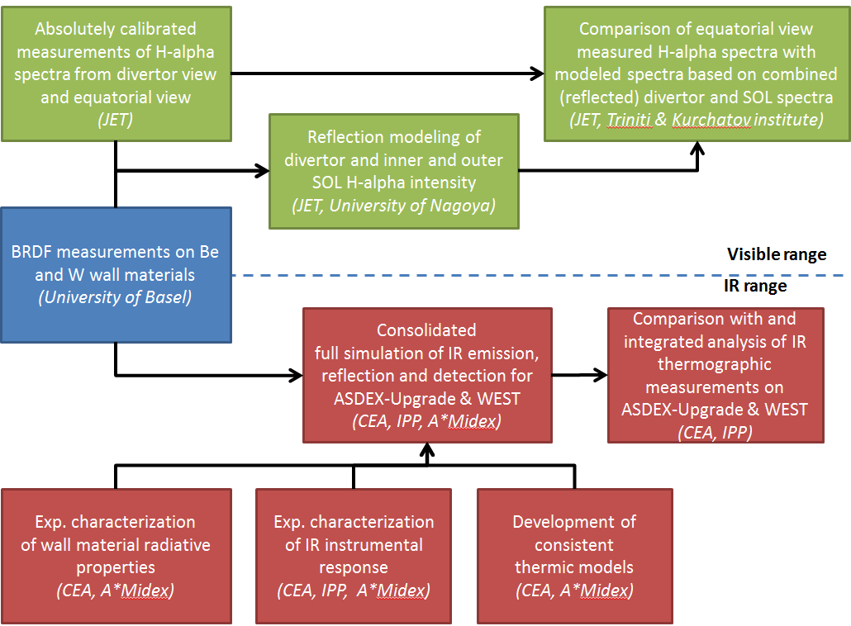
Visible wall reflection experimental proposal
As mentioned above for the visible wall reflection experiments the H-alpha emission has the 1st priority.
This is on the one hand because it is expected to be the most affected diagnostic in the visible range. On the other hand, the reflected part of the H-alpha light has a different spectral shape compared to the directly collected light. This feature helps with the benchmark as it potentially allows distinguishing the reflected fraction in the measurement (Task 1). At the same time this spectral signature is one of the ways of handling data analysis in the presence of reflections (Task 4).
As the main source of reflected light will likely come from the divertor region and reflect into views that look at the equatorial Scrape Off Layer (SOL). The divertor and SOL emission source is, however, very difficult to model accurately (Task 3). Therefore, the proposal is not to model the emission sources, but to extract them experimentally using 2 sets of views: 1 directly looking into the divertor, 1 looking in the equatorial plane.
- Firstly the direct divertor views can be assumed to be less affected by reflection and the measured data can be used directly as the divertor emission source (intensity).
- Using the measure divertor emission source as input to reflection modeling (using the BRDF provided by the measurements at the University of Basel), the reflected (intensity) contribution to the equatorial views can be calculated. Either LightTools or the RaySect/CHERAB ray tracing software will be used for this. (Task 3)
- The difference between the measured intensity (integrated over the spectrum) on the equatorial views and the calculated reflected intensity then gives the directly collected intensity from the SOL.
- The now predicted intensities of the (reflected) divertor and (direct) SOL contributions can, together with the different spectral shape (governed by measured magnetic field and temperature) for the divertor and SOL, be used to reconstruct the predicted total spectra for the equatorial views, which can be compared to the actual measured spectra.
The above sketches, of course, a very much simplified version of the actual experimental/simulation/analysis work. Also, as an “upgrade” of point 1. reflections in the divertor could in principle also be taken into account rather than being neglected.
For this experimental proposal, the following is required:
- BRDF of the wall materials in the visible range
- CAD model of JET wall
- Lines of sight directly to the divertor and equatorial lines of sight
- Spectrometers with high enough spectral resolution to identify small changes in the spectral shape
- Absolute intensity calibration of the full systems (i.e. from the line of sight aperture/window up to the spectrometers/detectors
- Potentially: specific plasma/divertor scenarios that allows for:
  - Significantly difference in spectral shape of the divertor and SOL H-alpha emission
  - Different H-alpha intensity ratios between divertor and SOL
IR wall reflection experimental proposal
The IR experimental proposal focusses on IR thermography.
- The BRDF of the wall materials (Task 2) will be measured in the IR range.
- Because the emission source is the wall itself, to model it (Task 3) …
  - … the radiative properties of the wall materials will be experimentally determined.
  - … a consistent thermic model will be developed
- A full experimental characterization of the IR instrumental response will be performed as part of Task 1.
- Using the CATIA SPEOS ray tracing software and the input of the ASDEX Upgrade & WEST wall models, the measured BRDF of the wall elements, the thermic model including the radiative properties of the wall materials, and the IR instrumental response the expected IR images for a number of plasma discharges will be simulated (Task 3). This will be compared to the actual IR camera measurements (Task 1).
- Using the full simulation of IR emission, reflection and detection, retrieve the actual wall temperatures and compare (where possible) with independent measurements (e.g. thermocouples) (Task 4).

For this experimental proposal, the following is required:
- BRDF of the wall materials in the visible range
- CAD model of ASDEX Upgrade & WEST wall
- Radiative emission properties of the wall materials
- IR cameras with fully determined instrumental response and wide view on the tokamak wall & divertor.
- Thermo couples or other temperature sensors (e.g. Bragg grating fibres) in the wall at locations observed by the IR cameras
- Potentially: specific plasma/divertor scenarios that allow for different wall temperatures and hot spots

