Facility and Diagnostic Accomplishments in FY2015 - 2016
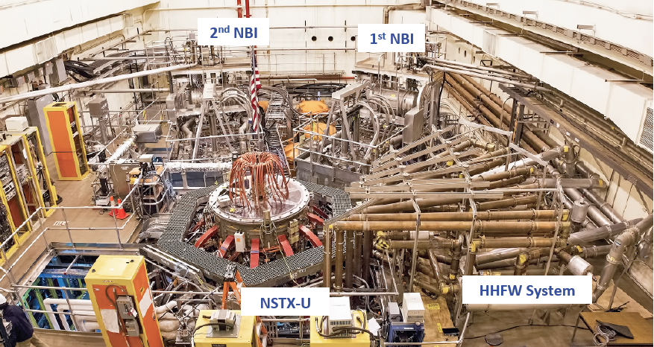
In FY 2015, the NSTX Upgrade Project was successfully completed on budget and on schedule. After the completion of an integrated systems test procedure (ISTP), on August 10, 2015 in shot 201085, NSTX-U achieved a 100 kA test plasma satisfying the CD-4 key performance parameter (KPP) threshold of 50kA necessary for completion of the NSTX Upgrade Project. The preliminary EFIT equilibrium reconstructions confirmed the plasma current and plasma shape consistent with the camera images. This achieved an important first step toward resuming research operations and using the new capabilities of NSTX-U. It took over 250 people and 574,000 hours over the last 5+ years to bring this construction project to this culminating achievement. In September 2015, the NSTX Upgrade Project was successfully concluded with DOE approval. The digital coil protection system (DCPS), which provides an intelligent coil protection system, and the plasma control system (PCS), which is upgraded with new hardware and software, are important new capabilities of the upgraded facility. Those systems were commissioned successfully and they are now supporting plasma operation. After an extensive high temperature bake-out of vacuum vessel, plasma operation started on Dec. 18, 2015. CD-4-like discharges were achieved on the first day, and the current was quickly ramped up to 700 kA on Dec. 22, 2015. After the new year, boronizations were performed and with NBI injection into the plasma, the H-mode was accessed in plasmas on Jan. 13, 2016. H-mode access is now routine, and experimental machine proposals (XMPs) have been performed and a number of experimental proposals (XPs) have begun. A NSTX-U Test Cell aerial view taken in Feb. 2016 is shown in Fig. 1. The installation and commissioning for the modifications to the Multi-Pulse Thomson Scattering (MPTS) diagnostic required for the NSTX-U were completed in FY 2015 and the MPTS is now supporting research operations. To provide capabilities needed to carry out NSTX-U scientific research, the NSTX Team identified high priority facility and diagnostic enhancements for post upgrade operations as the part of the successful DOE NSTX-U Five Year Plan Review. These included diagnostics and physics capabilities provided by NSTX Research Team members from U.S. laboratories other than PPPL as shown in Fig. 2. Those capabilities being currently implemented are indicated by the green dots. The red circles are the longer-term significant enhancements, i.e., divertor cryo-pump, outer lower divertor high-Z PFCs, non-symmetric control coil (NCC), and electron cyclotron heating (ECH), and conceptual engineering designs are being developed for all of them FY 2016.
Fig. 1. Aerial view of the NSTX-U Test Cell. The newly commissioned 2nd NBI beam box can be seen in the background.

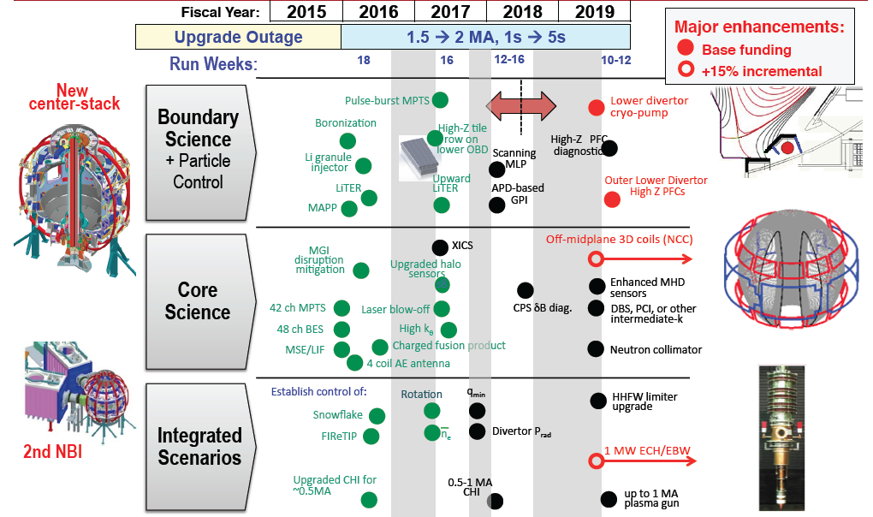
Fig. 2. NSTX-U Facility and Diagnostic Enhancement Timeline

Facility and Diagnostic Milestones for FY2015
Facility Milestone F(15-1): Complete high-Z tile design and begin procurement. (July 2015)
Description: For future facilities such as FNSF, it is important to investigate the viability of a high-Z metallic divertor in NSTX-U. After making an assessment of all graphite plasma facing component (PFC) plasma operations, a row of high-Z tiles will be installed on lower outboard divertor region.

Milestone F(15-1) Report: The purpose of the NSTX-U Divertor Upgrade-1 (DU1) is to provide operational experience and design evaluation prior to a larger, more comprehensive machine upgrade in future years. Following a similar logic as used for the NSTX Liquid Lithium Divertor system, the DU1 will be installed in the outboard divertor target in an effort to minimize operational risks during high-triangularity, high-performance discharges. In order to make a design assessment relevant to future upgrades of the high power divertor surfaces within NSTX-U, however, specific plasma discharges will be developed in the FY2016 run campaign to challenge the DU1 PFCs with heat and particle flux approaching levels expected during full, high-power operation of the NSTX-U. A study has been carried out to develop discharge shapes that will provide heat and particle flux to different areas of the outboard divertor in order to accomplish these tests. A compromise is made in plasma shaping because it is not possible to produce plasma discharges with arbitrary amounts of input power for a given discharge shape and divertor strike-point location due to plasma stability. As a result, a 0D analysis was conducted to estimate the maximum power for a given discharge shape and then a peak heat flux “Figure-Of-Merit” (FOM) was developed as a basis of comparison. As with other engineering FOMs, the peak heat flux calculated from this FOM is not informed by a multitude of effects present during actual experiments and only provides guidance for design and experimental planning.
Fig. 3: Conceptual design of the outboard high-Z tiles. The surface castellations are clearly shown and the overall geometry mimics that of the existing tiles providing a 1:1 replacement.
The present design scheme aims to provide a 1:1 replacement of the existing graphite tiles. These will also rely on inertial cooling to minimize the required installation time. In order to achieve as broad a temperature range as possible, the design features a castellated surface that relieves thermo-mechanical stresses. The temperature limits that remain are derived from material limitations only. The molybdenum alloy “TZM” (Titanium-Zirconium-Molybdenum) is planned for usage owing to its greater ease of manufacturing than tungsten. The project scope includes several experimental tiles that will be used to further evaluate design variations including the use of tile shaping to eliminate leading edge effects and the possible use of bulk tungsten. Initial analyses of the first design iteration have been completed. Material procurements have begun after a successful Conceptual Design Review. The initial design is shown in Fig. 3. A preliminary design review of the overall project was successfully completed in early December, 2015 and a final design review is scheduled for February 2016. The NSTX-U DU1 is on schedule for installation following the FY16 run campaign.

Facility Milestone F(15-2): Develop cryo-pump system engineering design. (September 2015)

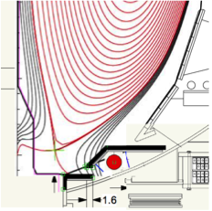
Description: For steady-state NSTX-U operations, an effective particle control tool is required. The divertor cryo-pump (DCP) has been used widely in conventional tokamak operations including DIII-D. On NSTX-U, a physics design study was performed on a closed divertor cryo-pump system in collaboration with ORNL as shown in Fig. 4. The initial indications are promising for providing divertor pumping for a relatively broad divertor parameter space including the snow-flake configuration. The cryo-pump system is a high priority major enhancement for the NSTX-U Five Year Plan. It is critical to develop an engineering design to start the long-lead procurement. The DCP is planned to be installed in mid-FY 2018 where a long outage is planned to start.
Milestone F(15-2) Report: The divertor cryo-pump (DCP) engineering design has two major components; in-vessel and ex-vessel. Layout of in-vessel routing of the cryo-pump has started as shown in Fig. 5. A conceptual layout of the cryo-system including the cryo-lines through the test cell has been performed as shown in Fig. 6. The specification of cryo-system details for the components that need to be fabricated have been formulated.
Fig. 4. A layout of divertor cryo-pump in NSTX-U.

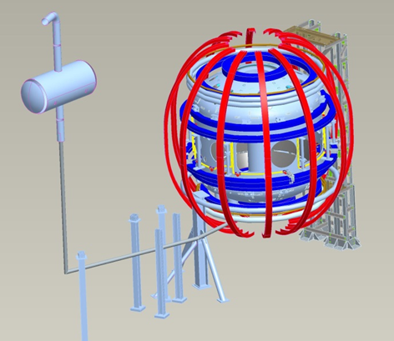
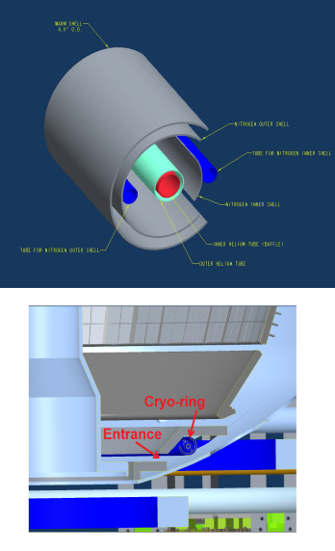
Fig. 6. A layout in the test cell that shows the transfer line routed from the compressor room to the north-east quadrant (bay B/C area).
Cryo-ring

Fig. 5. A layout of the divertor cryo-pump with cryo-ring in the inset.

Facility Milestone F(15-3): Develop electron cyclotron heating (ECH) system engineering design. (September 2015)
Description: ECH/EBW is a promising tool to initiate STs and tokamaks without a central solenoid. It could also provide a means to control the plasma current profile. For NSTX-U, initially the ECH/EBW system will provide electron heating during non-inductive plasma start-up; later it will be used for off-axis EBW heating and current drive. The ECH system is a high priority major enhancement for the NSTX-U Five Year Plan. A 28 GHz high-power electron cyclotron/electron Bernstein wave (EC/EBW) heating system is planned in collaboration with the Tsukuba University, Japan. The engineering design includes a site-specific plan for the gyrotron location and power supply/control. The initiation of procurement of the 28 GHz tube is high priority because of the long manufacturing and qualification testing. The ECH system is planned to be operational in FY 2018.

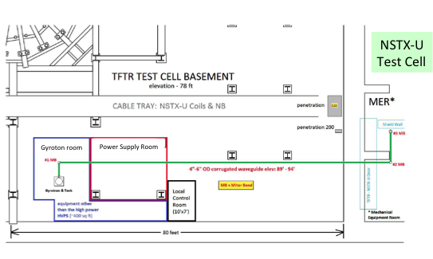
Milestone F(15-3) Report: The current ECH/EBW engineering design project began in November 2014. The project for the NSTX-U ECH / EBW High Power 28 GHz RF Source is gyrotron-based and after a site selection process, it was decided that the optimum location is the TFTR Test Cell (TF) Basement as shown in Fig. 7. The more-than one megawatt RF power will be routed to an antenna in the NSTX-U torus on the Bay E mid-plane through a low-loss waveguide system. Siting the gyrotron and its high voltage power supply in the TFTR TC Basement looks promising, as the availability of floor space and ample AC power and water cooling are already available. After various routing studies, a routing with minimal interferences for running the waveguide to the NSTX-U Test Cell was also identified. Low-loss, corrugated circular waveguide will be used along with high performance waveguide components. Even though the waveguide path is more than 200-feet long, it is expected that 90% or more of the gyrotron’s output will be delivered to the antenna’s input. Considerable progress has been made to date on the engineering design:
Fig. 7. Gyroton site location schematic.
  - The conceptual design of the overall system was presented and accepted by the NSTX-U management in February 2015.
  - The gyrotron design development being conducted by the Tsukuba University in Japan has advanced from 1.2 MW for 0.1 second to >1.5 MW for 2 seconds
  - The waveguide system’s preliminary design and all waveguide components’ design descriptions have been completed
  - The ambient and dynamic magnetic fields have been measured during full coil field tests. The ambient magnetic field is about 2 Gauss (G) with < 0.2 G variation during coil pulses at ten to fifteen feet away from the NSTX field coil cable tray. The gyrotron will be installed about 15-20 feet from the tray and therefore will not be affected by the magnetic field. The actual stray magnetic field measurement indeed showed negligible field at the gyrotron location.
The Tsukuba University is presently constructing a second generation gyrotron and plans to test it during FY 2016.
Facility Milestone F(15-4): Develop non-axi-symmetric control coil (NCC) system engineering design. (September 2015)

Description: NCC is a promising tool for NSTX-U MHD studies including for improved control of RWMs, ELMs, and disruptions. This effort is in collaboration with Columbia University and General Atomics. The NCC system is a high priority major enhancement for the NSTX-U Five Year Plan. The engineering design includes the specification of the NCC coil configuration, back-plate (if any), and possible PFC modifications.
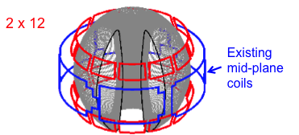
Milestone F(15-4) Report: NCC design and physics analysis have been continued and extended, in particular by combining the existing mid-plane coils as shown in Fig. 8 These are effectively three rows of coils that can produce highly coherent perturbations at the outboard section without a gap between the coils, and thus better align and control the perturbation relative to the field lines. IPECOPT with stellarator optimizing tools and also the IPEC code were successfully utilized to find the n=1-6 optimized configuration for neo-classical toroidal viscosity (NTV) with minimizing residual resonant fields. For RWM control capability by NCC, the sensors were successfully optimized, and VALEN3D predicts that the active RWM control can stabilize plasma even near the ideal wall limit if the optimized sensors and gains are combined with NCC. The investigation of RMP characteristics by NCC has also been continued based on vacuum island overlap width (VIOW) criterion. TRIP3D analysis showed 2x6 partial NCC can achieve thick enough VIOW for ELM suppression and interesting combinations of high n islands when more coils are added. The scope of the NCC engineering design project is defined at a Conceptual Design Review (CDR) level. The project is divided into the following subsections: NCC Coils, Passive Plates Modifications, PFC Modifications, Vessel Penetrations, Cooling Systems, Power Supply, Metrology and Project Management. A detailed engineering design has been developed and analysis have been conducted. Mineral Insulated Cable (MIC) as shown in Fig. 9 has been a strong candidate for in-vessel coils applications. The cross-section of the coil conductors was determined using iterative engineering design and analyzed. Sample MICs were purchased and currently being tested to qualify. Since the coils will be located inside the NSTX-U Vacuum Vessel, it is very important that vacuum compatible and thermal resistant end termination and joint techniques are developed. Another critical part of this project is being able to create feedthrough ports for all coil leads. Engineering design supported by field measurements is currently in progress. The project will also require the installation of new electrical junction box where the coil leads get connected to the power supply. In addition, the project will require modification of the passive plates, design of new tiles and development of reinforcement and support structures. A cost and schedule estimate will be prepared as part of the conceptual design review which is targeted for May 2016.
Fig. 8. 2 x 12 NCC configuration in red and existing 6 RWM mid-plane coils in blue.
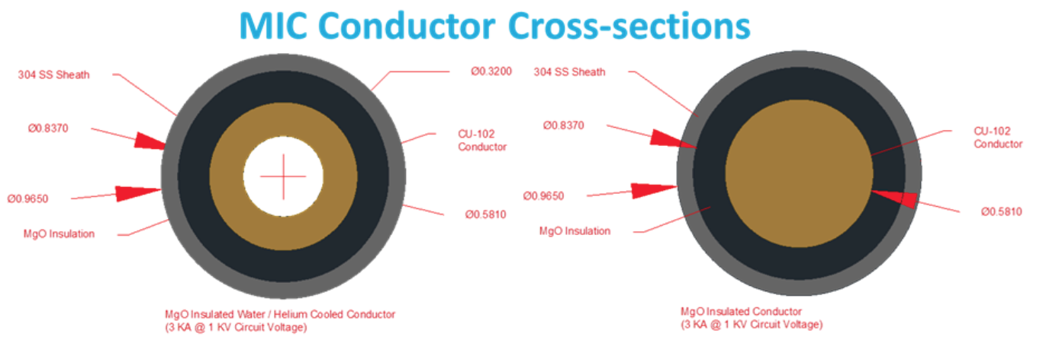

Fig. 9. Candidate MIC conductor cross-sections for NCC.
Diagnostic Milestone D(15-1): Install and commission Material Analysis Particle Probe (MAPP) (September 15)
Description: To support boundary physics operation, the MAPP diagnostic system will be installed and commissioned. MAPP is an in-vacuo inter-shot diagnostic capable of correlating surface chemistry evolution with plasma response to PMI conditioning. A unique MAPP capability is an in-situ, between-shots sample analysis following plasma exposure where samples are retracted in-vacuo into an adjoining chamber, and a variety of analysis techniques are performed during the in-between shots window.

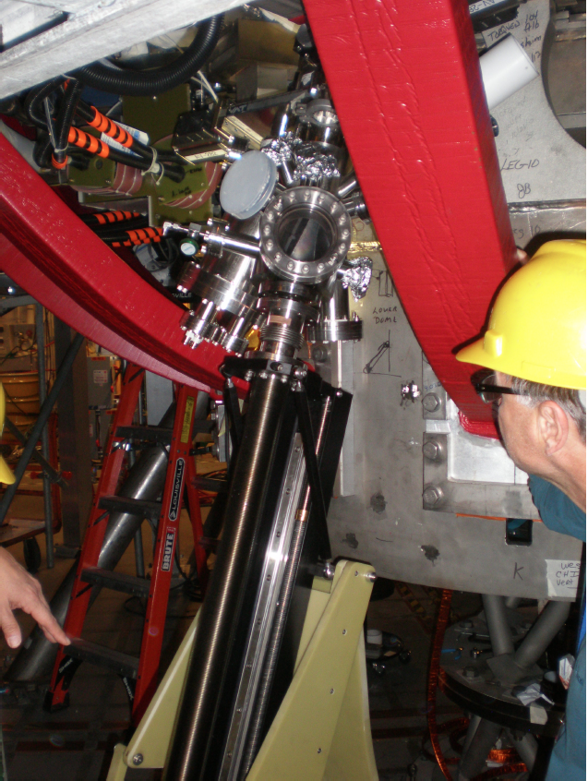
Milestone D(15-1) Report: A major NSTX-U PMI diagnostic addition is the Material Analysis Particle Probe (MAPP). The MAPP system was developed by personnel from Purdue University and the University of Illinois at Urbana-Champaign (UIUC). It is an in-vacuo inter-shot diagnostic capable of correlating surface chemistry evolution with plasma response to PMI conditioning. MAPP utilizes multiple surface-science measurement techniques to characterize a sample material exposed to NSTX-U conditions and assess plasma-surface interactions near the divertor strike point. A unique sample head has been designed for MAPP to allow simultaneous exposure of up to four samples to plasma discharges. The surface of each sample is positioned (via shims or custom machining) colinear to the top surface of the retaining stems in order to avoid self sputtering. Independently controlled heaters are contained beneath each sample and radiative and conductive cross-talk heating is reduced using vertical heat baffle shields. Following plasma exposure, samples are retracted in-vacuo into an adjoining chamber, where a variety of analysis techniques are performed during the in-between shot window. Analysis techniques include X-ray photoelectron spectrscopy (XPS) – used to assess the chemical interactions of the top ~10 nm, ion scattering spectroscopy (ISS) – interrogates the top 1-2 monolayers to determine surface chemical composition, and direct recoil spectroscopy (DRS) – uniquely capable of measuring the surface hydrogen content in samples. In addition, thermal desorption spectroscopy (TDS) can be performed at the end of each day in order to measure and quantify bulk deuterium retention. The MAPP installation on NSTX-U has been completed as shown in Fig. 10. The analysis chamber and probe drive have been mounted on the NSTX-U lower dome port and connected to a vacuum pumping system. Connections to AC power have been made to the electronics rack, and cables have been installed between it and the analysis chamber, probe drive, and vacuum pumping system. A communications link has been established and tested for remote control between the NSTX-U Control Room and the electronics rack in the NSTX-U Test Cell. The initial set of MAPP diagnostics needed for NSTX-U experiments are XPS and TDS. Commissioning of these instruments is complete and the first experimental proposal requiring analysis of MAPP samples has been performed.
Fig. 10. MAPP system installed on NSTX-U.

NSTX Upgrade Project Accomplishments - The NSTX Upgrade (NSTX-U) Project, which has two major components, a new center stack and a 2nd NBI, has made excellent progress in FY 2015. The 2nd NBI CD-1 Key Performance Parameters (KPP) was achieved in May 2015 and the new center-stack CD-1 KPP was achieved in August 2015. With the successful completion of the DOE reviews in September 2015, the NSTX Upgrade Project is now successfully closed, having met the CD-2 base cost and schedule.
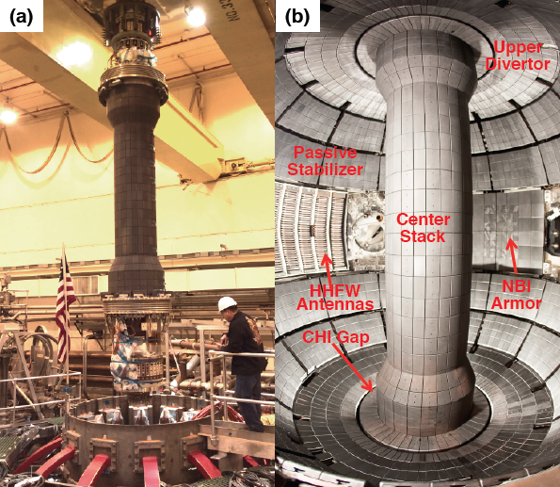
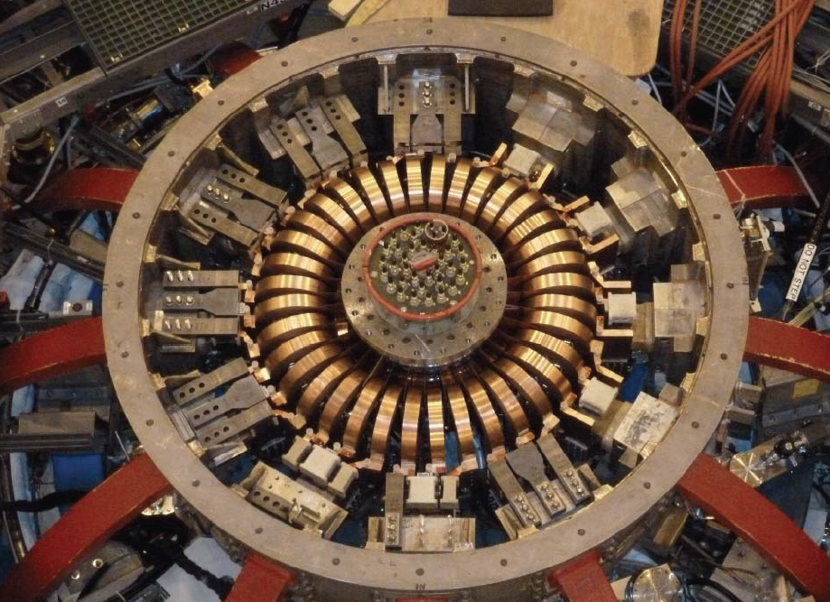
New Center Stack (CS) Upgrade – The CS components were fabricated by the end of FY 2014. The completed OH/TF/PF1 bundle and CS casing were then transported to the NSTX-U Test Cell South Bay. After wrapping the TF/OH/PF1 bundle with Micro-therm thermal insulation, the CS casing was lowered onto the bundle to complete the CS assembly. The assembled CS was then lowered into the NSTX-U vacuum chamber in November 2014 as shown in Fig. 11. To complete the TF coil, the inner TF bundle was connected to the outer TF legs using high strength Cu–Zr copper alloy flex joints. The completed upper TF joint configuration is shown in Fig 12.

Figure 11. (a) NSTX-U center-stack lowering into vacuum vessel. (b) NSTX-U Center-stack installed.
Figure 12. Upper TF flex bus installed on NSTX-U.

Digital Coil Protection System - To protect NSTX-U from unintended operational conditions due to the power supplies delivering current combinations and consequential forces or stresses beyond the design-basis, a digital coil protection system (DCPS) was implemented. The DCPS is designed to prevent accidental (either due to human or equipment failure) overload beyond the design conditions of the structure which the power supply system could generate, even while each individual power supply is operating within its allowable current range. In the initial instance of DCPS, the algorithms will test approximately 125 force and stress calculations against limit values, using both two models for the plasma shape and two models for potential post-disruption currents; this results in 500 total force/stress calculations in addition to 14 thermal limit calculations. The update rate of each type will be 200 μs for both the force-based and the thermal-based signals. Redundant current measurements for each coil and plasma current will be provided as inputs. This type of sophisticated coil protection system if fully demonstrated could be utilized for safe operation of future fusion devices including ITER. It should be noted that ITER has expressed interest in the DCPS and a collaboration is being discussed. The DCPS has been successfully tested and utilized during the power supply commissioning and integrated testing leading to the achievement of the first plasma and KPP target. It is now routinely supporting plasma operations.
Power system upgrades - The NSTX-U power systems include 68 identical rectifiers (Transrex AC/DC Convertors) providing a total pulsed power capability of 1650 MVA for 6 seconds every 300 seconds. New firing generators (FG) were installed for the precise control of thyrister firing angles needed for NSTX-U operations, and is particularly critical for the 8-parallel, 130kA TF system configuration. The new FG delivers firing pulses with far greater resolution, precision, and repeatability than the previous ones in NSTX. In addition, the NSTX-U 650 MVA / pulse motor generator with weld cracks was also repaired. The motor generator repair brought the motor generator to its original specifications, and the repair will enable the full operation of NSTX-U.
Neutral Beam Injection (NBI) Systems – This fiscal year, all of the NSTX Upgrade NBI final construction work was completed for beamline, services, power, controls, and armor. Additionally a concrete shield wall was installed in the North gallery to replace the shield blocks removed from the NTC for the 2nd NBI system. Rework was required on the water lines and the beam line control cabling but the jobs were completed in time to support the effort to perform the KPP beam shots into armor. The Liquid Helium refrigerator was reactivated and resumed operation in support the achievement of the NSTX-U NBI KPP. Full Beamline 2 operations began with check out of water flow, vacuum, pneumatics, and cryogenics. Power supplies were reactivated and fully tested prior to source installation. Beamline 2 ion sources were then conditioned using standard operating procedures. Several sources experienced electrical faults and were removed and replaced with spares.
2nd NBI CD-4 KPP achievement – On May 11, 2015, the NB2 neutral beam system successfully fired 45kV beams at 100 msec pulse lengths for multiple shots, successfully completing the NSTX Upgrade Project CD-4 KPP for Neutral Beam injection into the in-vessel armor at > 40keV beam for > 50 milliseconds. The first cryo-panel regeneration of NB2 (and for NSTX-U) was successfully completed. After completing the NSTXU NBI KPP on Beamline 2, the Beamline 1 reactivation effort began. The beamline systems were restored to full service and source conditioning began. Several sources experienced failures after years of storage. The Source Shop returned to full operation to support repair and refurbishment tasks to replenish our supply of sources and spares. Efforts to repair and replace source grid modules has started in earnest with repairs to existing modules underway and fabrication of new parts under evaluation. To support ongoing NBI operations, the SF6 skid was refurbished to allow full control of our SF6 inventory with 6 NBI systems back in use. Additional resources have been added to handle the electronics repairs, mechanical repairs, and source shop and decontamination efforts to fully support NBI operations in the future. The six sources on NBI Beamlines 1 and 2 are operational and now supporting the research plasma operations.
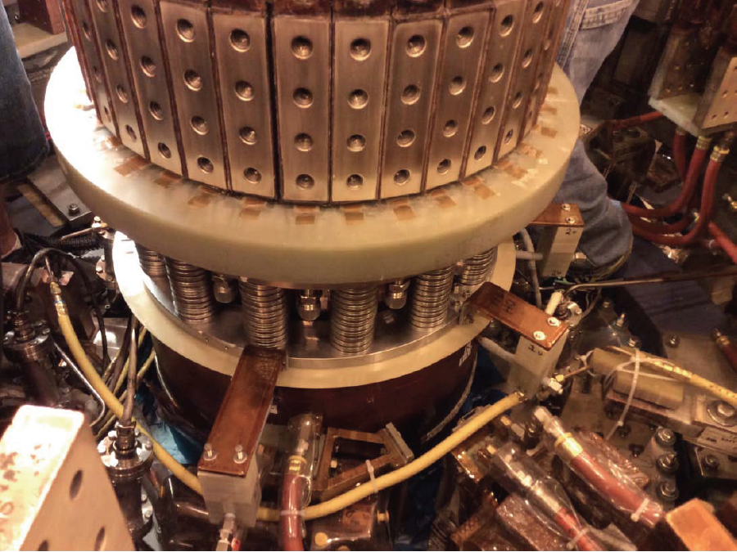
OH Ground Fault - On April 24th, 2015 during the execution of the coil power tests the NSTX-U OH circuit suffered arc damage from a short created by the movement of a grounding conductor on the OH Ground Plane across energized OH water connections. The arc damaged the conductor water connections, caused a water leak and tripped off the power supplies. The cause was quickly identified as a grounding conductor on the OH ground plane that was installed without the required electrical break. The resulting circulating currents in the conductor interacted with the OH field, propelling it into the water connections. The lack of a proper ground on the OH compression ring to which the water connections were mounted was identified as a contributing cause. Subsequent inspection and investigation confirmed the cause as well as identifying other areas of the design that could be improved to avoid a recurrence of the fault. These items include redesign of the grounding clamp on the OH ground plane, grounding of the OH compression ring, and redesign of the water connections on the OH coil. Disassembly and inspection of all of the TF and OH components in the upper and lower umbrella identified other areas that could be improved including TF finger supports, OH coaxial connector, and buss-bar support grounding. In parallel, internal and external reviews were conducted to identify the cause of the fault and review the recovery plan. In addition, a review committee to look into the “extent of condition” and a review committee to perform root cause analysis of the fault were conducted. The necessary repairs and improvements were completed in July 2015, and the first plasma and subsequent plasmas satisfying the CD-4 KPP target were successfully achieved on August 10, 2015. The repaired and improved upper umbrella section is shown in Fig. 13.
FIG.13. The restored and improved upper umbrella section.
Plasma Control System development in preparation for research plasma operations - A key capability required for the achievement of the CD-4 KPP targets and research plasma operation is the plasma control system. FY-2015 saw a large number of upgrades to the plasma control system hardware and software. These upgrades have been oriented to improve both the maintainability and reliability of the system, and to prepare for both the CS-Upgrade KPP and subsequent research operations. A number of key elements of the plasma control system is provided below.

New control computers - In FY-15, new real-time Linux computers featuring the Concurrent RedHawk OS replaced the Sunfire v40z hardware from FY-06. These come complete with vendor support for the real-time performance of the hardware and software, including the interface card drivers. These new systems use a modern serial FPDP (Front Panel Data Port) interface instead of the previously employed parallel FPDP interface, providing enhanced data acquisition capabilities and room for future expansion. The two new systems mirror the previous two systems in terms of having a dedicated “active” computer for normal operations, and a standby “development” computer to facilitate building and deploying new control software in-situ. Each new system has 64 available processing cores, upgraded from the 8 available in the v40z. Note that these computers must run not only the plasma control system, but also one (of two) instances of the DCPS.
Deployment of new real-time hardware - In FY-15, additional real-time hardware has been deployed. A second generation of the Stand Alone Digitizer, called the SAD II, has been deployed to measure both magnetics signals and coil currents. These digitizers were designed by PPPL, and incorporate both a 32 channel digitizer and hardware to multiplex a series of digitizers. Three of these SAD II digitizers have been deployed.
Improvements to the power supply control code - In NSTX, the Transrex power supplies, which power the TF, OH, and PF coils, were controlled via a stand-alone program called PSRTC (Power Supply Real Time Control). This code was first written in FORTRAN, then converted to C, and as a consequence was hard to maintain and improve. During the later stages of the construction outage, this code was rewritten as a module within the plasma control system. This upgrade allows the code to be more easily maintained and upgraded, and couples it more closely with the physics algorithms that generate the current or voltage requests. As an example of an upgrade facilitated by this code rewrite, a new feature was added where the code checks the measured values of dI_{coil}/dt against that predicted by a simple model, and turns off the power supply in the event of a significant discrepancy as occurred during the OH fault.
Additional magnetic sensors available in real-time - As part of the CS upgrade project, approximately 20 additional magnetic field sensors and 15 additional poloidal flux loops were added to the CS. These signals have been brought into the real-time system. Additionally, eight more magnetic field sensors in the outboard divertor have been brought into the real-time system. Collectively, it is anticipated that these additional sensors will better constrain the divertor magnetic structure in rtEFIT, thus benefiting the research program in control of advanced divertors (snowflake, X-divertor, etc)
Preparing rtEFIT for research operations - The rtEFIT code, which resides within PCS, computes the full 2D magnetic equilibrium in real-time, constrained by various real-time measurements. This code is thus critical for all efforts in profile control and shape/position control. In order to bring this code up to the requirements for NSTX-U, a senior PPPL physicist and a PPPL post-doc visited GA in January, 2015 for training on the code and to learn about future updates. Following this visit, an updated version of rtEFIT was placed in the NSTX-U PCS. This version has been tested using input data created by NSTX-U TRANSP simulations; the magnetic field at the location of sensors was computed based on the TRANSP simulations, and then provided as constraints to rtEFIT. The updated PCS code was then used to reconstruct the equilibrium based on the synthetic measurements; this is described in more detail in the Advanced Scenarios and Control section of the report. This is a significant step toward commissioning the code for research operations.
Shape Control Development - The convention on NSTX was to use an algorithm called “day0” to provide simple pre-programmed current control of the PF coils during the plasma breakdown phase. Around 20ms, when the plasma current was about 200 kA, the PF current control would transition to the plasma current and control (PCC) algorithm that provided active feedback of the outer gap, Z position and vertical stability, as well as the option to scale the PF request with plasma current. Finally, control of at least the PF3 and PF5 coils would transition to the ISOFLUX algorithm, with a separate vertical stability algorithm applied as a final step. This capability was restored for NSTX-U within the PCS code; however an alternative scheme was also implemented that provides more flexibility and simplicity.
In the new scheme, the PCC algorithm provides pre-programmed current control, active feedback of the outer gap, and the option to make the PF request proportional to I_{p} (for plasma equilibrium) and ohmic current (to account for the larger ohmic fringe field variation on NSTX-U). Active control of the Z-position and vertical stability is handled in the separate Vertical Position category (VPC) that can operate in conjunction with either PCC or ISOFLUX control; this capability is described below. This architecture removes a number of algorithm transitions that often limited flexibility in scenario development and simplifies the flow of control. The PCC algorithm was also improved by removing a number of hard-coded parameters, such as the choice of magnetic sensors, in order to increase the code flexibility.
Updates to the ISOFLUX algorithm, which provides shape control based on the results of rtEFIT reconstructions are also underway. The modifications are being tested using rtEFIT reconstructions of synthetic data from TRANSP simulations as described in the previous section. An additional “add-on” to ISOFLUX will allow for control of advanced divertors; see description below.
Improved vertical control capability - The NSTX vertical control system was based on a single pair of poloidal flux loops, whose voltage was used to infer a quantity roughly proportional to the plasma vertical velocity; as noted above, those calculations were essentially an add-on following the ISOFLUX calculations. For NSTX-U, this code has been broken out into its own category (called VPC), with dedicated algorithms. This new code has been improved to include 18 flux loop voltages. Capability has been included to correct the observed voltage signals for variations in the coil current, allowing a more accurate estimate of the plasma velocity. Furthermore, an observer for the plasma position has been included, based on poloidal flux measurements. Finally, code has been added to disable vertical control algorithm if control is observed to be lost. This will help limit the forces on NSTX-U.
Neutral beam injection control from PCS - A category for PCS control of the six neutral beam sources has been developed. The algorithm allows the PCS operator to pre-program sources to be on or off at selected intervals during the discharge, or to let the algorithm determine a modulation pattern for the source to achieve an operator requested time-averaged power. To avoid source faults and limit the fatigue on neutral beam components, minimum on and off times, as well as a maximum number of modulations per discharge are enforced for each beam in determining. The power requests can be made on an individual per source basis, or the sources can be grouped together. For example, all of the sources could be combined into one group, enabling the operator to provide a single request for total beam power. The order in which sources are modulated within a group by the real-time code is determined by an operator specified `batting order’. Finally, the power for request for each group of sources can be communicated to the NBI category in real-time from other PCS categories, for example, those responsible for β_{N} or rotation profile control, allowing the neutral beams to be used for feedback control.
Progress towards β and l_{i}/q_{o} control - A software specification has been written for a PCS category to post-process the results of rtEFIT, enabling the use of smoothing filters and dynamic observers to make the estimates of parameters like β_{N}, l_{i}, and the q-profile more suitable for use in feedback control algorithms. A software specification has also been written for a flexible control category that will be used for simultaneous feedback control of the scalar quantities like β_{N}, l_{i}, q₀ in the near-term, and will later be used to control spatial profiles, like q and rotation. Two algorithms have been specified within the category: one for PID control, and another for implementing more general state-space control algorithms. The algorithms will generate actuator requests (like beam power, plasma current, and shape descriptors) that will be distributed to the dedicated PCS categories for each physical actuator (e.g., the beam power request will be sent to the NBI category).
Advanced Divertor Control - Additional capabilities are currently being added to the ISOFLUX algorithm which will enable real-time feedback control of snowflake divertor (SFD) magnetic configurations in NSTX-U. The SFD is an alternative magnetic divertor concept that is characterized by a second-order null formed by two x-points in close proximity. The SFD, which has increased flux expansion and a larger plasma-wetted area, is an attractive option for heat flux mitigation in NSTX-U in which unmitigated peak heat fluxes in a standard divertor configuration may reach 20 MW/m² and compromise plasma-facing components. The real-time SFD control system at NSTX-U will be capable of simultaneous control of multiple SFD parameters, such as the separation between the two x-points in the divertor region and their orientation. The system is currently designed to use the upper and lower PF-1a, PF-1c, and PF-2 coils for control and is intended to work in conjunction with the other shape control functionality within ISOFLUX. The capabilities for SFD control that will be implemented include a non-iterative algorithm that is capable of approximating the locations of two x-points in real-time using input data from rtEFIT. The specified algorithm then calculates the PF coil currents required to minimize the errors between the two calculated and desired x-point locations, operates on these errors with a PID controller, and then outputs the appropriate voltage requests to the PF coils. The new snowflake algorithm in ISOFLUX will enable control of upper, lower, or combined upper-lower SFD configurations. Future work will focus on integration of SFD control with control of additional plasma shape parameters such as strike point and flux expansion.
Preparation toward full operational capability - We are formulating a plan for progressing toward full operational capability on NSTX-U. A draft version is based on an assessment of physics needs for first year of operations. The 1st year goal is to operate NSTX-U with the electromagnetic forces (I_{p}B_{T}) at halfway between NSTX and NSTX-U limits and 50% of the NSTX-U design-point of heating of any coil. This still allows NSTX to operate at B_{T} ~ 0.8 T, I_{p} ~ 1.6 MA, and a maximum flat-top duration of 3.5 s in the first year which is far beyond the achieved NSTX parameters. The device will be inspected and refurbished as needed at the end of the each operating year. For the second year, the toroidal magnetic field will be increased to its full field value of 1 T but keeping the heating of the coil to 75% of the design-point of any coil. This will allow 3 sec discharges at full field and current. The same limits should allow the full 5 sec discharges at B_{T} ~ 0.8 T, I_{p} ~ 1.6 MA. The device will be brought to full operational capability at B_{T} ~ 1.0 T, I_{p} ~ 2.0 MA the maximum flat-top duration of 5.0 s in the third year of NSTX-U operation.

HHFW Heating and Current Drive Systems - The NSTX RF heating and current drive (CD) systems will consists of the existing 6 MW high harmonic fast wave (HHFW) system and the new ECH/EBW system, which is an important element of the NSTX five year facility upgrade plan. The HHFW system is expected to perform better with the higher toroidal field of NSTX-U, as significant heating efficiency improvement with toroidal magnetic field has been observed in NSTX. After initial HHFW operation with NSTX-U plasmas, an upgrade of the HHFW antennas is envisioned to increase the heating power and heating / CD efficiency. As a part of the NSTX-U five year plan, a MW-class ECH/EBW system is planned. The ECH/EBW system is particularly crucial for non-inductive start-up research, since it can effectively bridge the temperature gap between the CHI based start-up plasmas which tend to be below 50 eV, and the HHFW heating and CD regime which tends to be above ~ 200 eV. It is estimated that about 0.5 to 1 MW to ECH/EBW power would be sufficient to heat the CHI plasmas to ~ 200 eV range. The ECH/EBW system could also provide the efficient off-axis CD needed for advanced ST operations.

HHFW Antenna Upgrade - In the HHFW area, while the system is basically unchanged, the HHWF feed-thru conductor had to be modified to be able to handle the higher disruption loads (~ x 4) in NSTX-U. To handle those disruption loads, compliant connectors were designed, tested and installed between the feed-throughs and antenna straps for the NSTX-U operations. In order to increase the power from the existing 12-strap HHFW antenna, RF voltage stand-off was tested on an RF test stand with the new compliant feeds. The test demonstrated the RF voltage stand-off of 46 kV, which is about twice the value required. The HHFW antennas with the compliant feeds and improved back plate grounding were installed in NSTX is shown in Fig. 14. The tests also showed RF-induced arc-prone areas behind the back-plate, and improved back-plate grounding was implemented. The HHFW system installation was completed and steady progress has been made in commissioning. For the HHFW system, all sources are ready for operation.
Fig. 14. Enhanced HHFW antenna installed in NSTX-U with compliant feeds and improved back-plate grounding.
Significant HHFW-related diagnostic upgrades have been performed in FY 2015. Two arrays of divertor Langmuir probes were installed in the NSTX-U vessel specifically for HHFW studies. Circuitry is being built to directly measure the RF (30 MHz) component of the collected current to determine the process underlying the SOL loss of HHFW power. Recent analysis suggests that RF rectification is driving the heat flux to the surface. Measuring the RF voltage at the divertor, along with a new wide-angle IR-camera view provided by ORNL, will test this hypothesis in great detail. A SOL reflectometer, upgraded by ORNL to be compatible with the higher magnetic fields in NSTX-U, is being reinstalled. A mid-plane probe shaft, situated in the middle of the HHFW antenna, is being fitted with two Langmuir probes and a double-Langmuir probe designed by ORNL.

Coaxial Helicity Injection (CHI) System - Recent NIMROD simulations in the NSTX-U geometry have shown very high levels of closed flux for CHI initiation in the NSTX-U geometry. Three new individuals are now certified in the CHI capacitor bank operating procedures. The resistive voltage divider network was installed, and work is in progress to finish installation of two Ross Electronics based fast voltage monitors. These systems monitor the NSTX-U vessel voltage during CHI operations. Work related to the final connections of the gas lines to the CHI gas injection valves are in progress. Initial testing of the CHI system into a plasma load will begin after these activities are completed.

Resistive Wall Mode (RWM) control system - While NSTX-U is a modification of NSTX, changes to the device conducting structure (e.g., new 2nd NBI port structure), mid-plane RWM control coils, and equilibria require re-computation of n = 1 active RWM control performance using proportional gain, and RWM state space control. The upgrade also adds new capability, such as independent control of the 6 RWM coils. This new capability, combined with the upgrade of the RWM state space controller will also allow simultaneous n = 1 and n = 2 active control, along with n = 3 dynamic error field correction. Finally, the active control performance of the proposed off-mid-plane non-axisymmetric control coils (NCC) also needs to be evaluated, and a significant increase in controllable β_{N} is expected with the RWM state space control in NSTX-U, as was found for NSTX.
Disruption Mitigation Systems - Predicting and controlling disruptions is an important and urgent issue for ITER. Methods to rapidly quench the discharge after an impending disruption is detected are also essential to protect the vessel and internal components of an ST-FNSF. In support of this activity, NSTX-U will employ three Massive Gas Injection (MGI) valves that are very similar to the double flyer plate design being considered for ITER. NSTX-U will be the first device to operate this valve design in plasma discharges. These valves have been tested off-line and deliver the required amount of gas (~ 200 – 400 Torr-Liters) to support NSTX-U experiments. They will offer new insight into the MGI data base by studying gas assimilation efficiencies for MGI gas injection from different poloidal locations, with emphasis on injection into the private flux region. The valve has also been successfully operated in external magnetic fields of 1 T. The upper MGI valve has been installed on NSTX-U. All of the necessary piping connections for the lower valve have been installed. Details of the piping connections for the mid-plane valve are in progress. Compact power supplies required for operation the MGI valves on NSTX-U were built and tested at the University of Washington and the hardware shipped to PPPL. The control system software for operating the compact power supply was developed at PPPL. Work is now underway at PPPL to install the power supply hardware and to complete the hardware electrical wiring to enable MGI operations on NSTX-U.
Electromagnetic Particle Injector (EPI) - The shattered pellet injector now being considered for ITER uses the MGI valve to propel the frozen pellet. This will limit its velocity to about 300-400m/s, and because it will be located many meters away from the plasma limit its response time. The penetration depth of the shattered fragments into ITER grade plasmas is unknown. To address this important issue, a novel system based on the rail-gun concept has been designed, and an off-line experimental assembly of the hardware is now in progress at the University of Washington. The device referred to as the electromagnetic particle injector (EPI) is fully electromagnetic, with no mechanical moving parts, which ensures high reliability after a period of long standby. In addition to responding on the required fast time scale, its performance substantially improves when operated in the presence of high magnetic fields. The system is also suitable for installation in close proximity to the reactor vessel.

Fueling Tools - NSTX-U plasma operations will require the capability for gas injection from numerous locations. The gas injection systems on NSTX were not adequate to meet the physics program needs of NSTX-U as improvements are needed in the area of divertor heat flux mitigation, and increased levels of gas injection from high-field side to meet the up to 10s discharge pulses planned for in NSTX-U. These are briefly summarized.
For normal inductive plasma operation, NSTX-U will rely on three outboard gas injectors as on NSTX. However, Injectors 2 and 3 are being relocated to bays I and G as their original locations on the vessel were eliminated by the modifications providing the 2nd neutral beam port. NSTX relied on two high-field side gas injectors, one injecting near the midplane and one injecting at the “shoulder” of the center stack near the PF-1aU coil. These were used for H-mode triggering, and the high-field mid-plane injector was routinely used on most of the H-mode discharges. In NSTX-U, the system will have the capability for injection from two mid-plane locations and two “shoulder” locations at the top of the center stack. At each location, these injectors are toroidally displaced by 180 degrees. Furthermore, for both the midplane and shoulder locations, one installation has a larger diameter tube, while the other installation has a small diameter tube; this variation in tube size provides a measure of control over the flow rates. The higher gas delivery capability from these injectors may be required during Li conditioned operation on NSTX-U as the injectors on NSTX were at some times (such as during the diffusive Li coating experiments) were found to be inadequate to maintain the required electron densities in NSTX.
For CHI start-up, in addition to the existing gas injector on bay K bottom, a Tee will be added at Bay G bottom port, which is the location of lower divertor Penning gauge, and this will also be used to provide more control and improved toroidal gas injection symmetry.
The glow discharge conditioning (GDC) system uses one of the mid-plane injectors as on NSTX. The NSTX-U boronization system, based on deuterated Tri-Methyl-Boron (dTMB) in a He carrier gas has a new gas delivery system with improved safety features. In addition to mid-plane injection, provisions are provided for gas injection from both the upper and lower divertor regions. This is based on results from DIII-D that suggest that spatially distributed injectors will provide more uniform coverage of the boron coatings.
For divertor heat flux mitigation studies, NSTX relied on a single low-conductance gas injection location beneath the lower divertor plate on Bay-E. Initial NSTX-U capabilities replace this injector with two high-conductance injectors in the lower divertor, separated by 180 degrees toroidally. This capability can be extended to additional toroidal angles, and to the upper divertor, in subsequent years once experience is gained with the new system.
Commissioning of the gas injection system for NSTX-U - The legacy gas injection code from NSTX, while functional, had reached a state where maintenance and upgrades were difficult. Therefore, the control algorithms were redesigned and rewritten to improve its clarity, consistency and the ability to introduce new capabilities (such as density or radiation feedback) that employ the NSTX-U gas injectors. A number of the gas lines and vessel pressure measurements were changed or upgraded during the outage, and these systems were brought on-line and calibrated in support of CD-4 operations and the subsequent research operations. Note that unlike NSTX, all gas injectors are now programmed from the PCS.

Boronization - Boronization is a conditioning technique for reducing oxygen that will be applied to NSTX-U plasma-facing components after bakeout and helium glow discharge cleaning (GDC). The boronization process involves GDC with a mixture of 95% helium and 5% deuterated trimethylborane (dTMB) which is followed by another period of helium GDC. During the past year, a new dTMB system was installed on NSTX-U. A PLC is used to control the flow of dTMB through coaxial lines from a specially-designed gas cabinet inside the NSTX-U Test Cell to the vacuum vessel. The boronization system became available for plasma operations in FY16 and several boronizations have been already performed.

Preparations for NSTX-U Lithium Operations - The safe handling of lithium is essential for supporting the technologies required for lithium conditioning of plasma-facing components (PFCs) and ELM control. As part of the process of evaluating practices and procedures for lithium use at PPPL facilities including NSTX-U, a Lithium Safety Peer Review was held at PPPL on June 16 – 18, 2015. The review was part of a US Department of Energy “notable outcome” for the Laboratory for fiscal year 2015. The reviewers included representatives from Environmental Health and Safety group at Princeton University, Applied Research Laboratory at the Pennsylvania State University, Corrosion Science and Technology Group at Oak Ridge National Laboratory, and Sandia National Laboratories in New Mexico. The reviewers visited PPPL facilities that included the NSTX-U Test Cell and areas for lithium technology development and storage. They also examined lithium handling procedures, and interviewed members of the staff who work with lithium. The reviewers observed that PPPL personnel and their safety practices were appropriate and adequate for present lithium-related activities.

Granule Injector for Investigation of Multi-species Particle Injection and ELM Control – The mechanical assembly and testing was completed for the NSTX-U granule injector (GI). A new remote control system for remote GI operation has been designed and implemented. The initial motivation for the GI was to inject lithium granules for ELM control (“ELM pacing”). This was successfully demonstrated on EAST and DIII-D, and ELM pacing experiments with lithium injection are planned for NSTX-U. An outstanding question is the effect of other granule materials on plasmas, and this will be investigated in the upcoming NSTX-U run. Laboratory tests of the GI have been performed with boron and boron carbide granules. Boronization will precede PFC conditioning with lithium, and the ability to inject boron and boron carbide will permit granule injection studies without introducing lithium into NSTX-U.

Lithium Evaporator – The NSTX lithium evaporator (LITER) system will be reused on NSTX-U. Each LITER is a temperature controlled stainless steel container filled with liquid lithium (LL), with a nozzle to direct the lithium vapor for coating PFCs at desired locations. As on NSTX, the nozzle will be aimed on NSTX-U toward the middle of the inner divertor to maximize the lithium deposition on the divertor plates. The LITER passes through a PFC gap in the upper divertor region. Changes to the upper umbrella structure required by NSTX-U necessitated modifications to the LITER mounting brackets. The LITERs have been remounted and checked for interferences with the upper divertor gap. The mechanical operation of liquid lithium filler for LITER (LIFTER) was also successfully tested. The station where the LIFTER is used load the LITERs has been reinstalled in the NSTX-U South High Bay. Two layers of stainless steel protect the concrete floor from accidental exposure to liquid lithium. To further insure the safe LITER operation, an argon purge system has been installed on NSTX-U.

Liquid lithium technology development – The implementation of a flowing liquid lithium divertor is a long-term goal for NSTX-U. However, the challenge of developing a system that requires lithium flow through the vacuum boundary from an external reservoir to an in-vessel divertor is daunting. Recent experiments with lithium coatings on high-Z plasma-facing components (PFCs) under high-flux plasma bombardment in the Magnum PSI linear plasma device indicated that the erosion rate of deuterium-saturated lithium was much lower than lithium alone. This suggests that the properties of liquid lithium PFCs could be investigated with significantly reduced lithium inventories. For example, tiles could be “preloaded” with internal reservoirs of lithium that could flow to the surface during plasma operations. Several concepts were developed in collaboration with the Eindhoven University of Technology in the Netherlands. They are the basis for a test tile under consideration for installation as part of the high-Z divertor tile upgrade planned in FY16.

NSTX-U Diagnostic System Status and Plans - Diagnostic installation was an active area of NSTX-U operational preparation in FY2015 - 2016. A status of the diagnostic systems expected to be available during the early phase of the NSTX-U operation is shown in Table 1. Over half of those diagnostic systems are provided by collaborators, with installation support provided by PPPL. The diagnostic work in FY2015 focused on completion of vacuum interfaces that did not require vessel entry for installation and on installation of diagnostic hardware outside the vessel. Installation, calibration, and commissioning of the core diagnostic capabilities needed to support the FY2016 campaign have been completed. The status of these key systems at this time is briefly summarized on Table 1 and also commented on below.
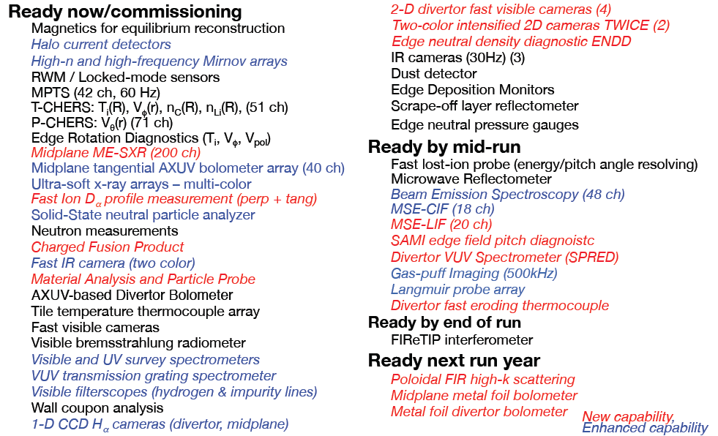
Table 1 – Status of Initial NSTX-U Diagnostic Systems

Multi-Pulse Thomson Scattering (MPTS) – Modification of the MPTS system was required to reorient the laser beams to accommodate the larger diameter of the new center stack while maintaining the necessary spatial resolution. A new laser beam input flight tube, new exit flight tube, new beam dump, and modifications of the light collection optics were required. These new components were fabricated, installed, and aligned. The system was commissioned and a calibration based on Rayleigh and Raman scattering from nitrogen and argon gases in the vessel was completed. Ten of the MPTS polychromators were rebuilt to improve their optical performance. The MPTS system has begun to support the FY2016 campaign.
CHERS – Reinstallation and calibration of the following charge-exchange recombination spectroscopy (CHERS) diagnostics was completed: CHERS (toroidal and poloidal), Edge Rotation Diagnostic (ERD, toroidal and poloidal) and Real-Time Velocity (RTV). An upgrade of the operating system for the control and data acquisition PCs was completed. Modification of the control and data acquisition software to be compatible with the new PC operating systems was completed and the CHERS diagnostics were commissioned to be ready to support the FY2016 experimental campaign.

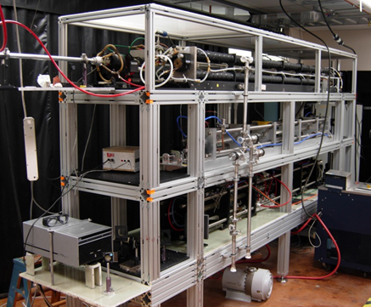
Far Infrared Tangential Interferometer/Polarimeter – UC-Davis is in the process of reconfiguring and upgrading the Far Infrared Tangential Interferometer/Polarimeter (FIReTIP) on NSTX-U. The seven-channel FIReTIP system employed previously on NSTX is being reconfigured into a three-chord system. Chord #1 will be employed for core plasma density monitoring as well as density feedback control and density calibration of the Thomson scattering system, while subsequent channels (as additional vacuum windows and retro-reflectors are installed) will monitor core and edge fluctuations. The FIReTIP lasers will be placed just outside the NSTX-U test cell, necessitating the fabrication of long lengths of over-moded waveguide to transport the FIReTIP beams to Bay G. A 3-level laser table has been fabricated which will house not only the FIReTIP lasers, but also the CO₂ and CO₂-pumped FIR lasers for the poloidal high-k scattering system.
Constraints imposed by the new location of FIReTIP chord #1 has necessitated the design and fabrication of internal retro-reflectors (decision pending on subsequent chords). As internally-mounted retro-reflectors are subject to high levels of mechanical vibrations (attached, as they are, to the vacuum vessel rather than placed on a vibration isolation mount), this has required the addition of a vibration monitoring system consisting of a HeNe interferometer coupled to a field programmable gate array (FPGA) to provide real-time vibration compensated density information.
Fig. 15. Photograph of the 3-level laser table for FIReTIP and the poloidal high-k scattering system.

UC Davis has successfully overhauled the CO₂ and CO₂-pumped FIR lasers that generate the FIReTIP beams. Dielectric-coated waveguides and support flanges have been developed to couple the beams to/from the NSTX-U vacuum vessel. The in-vessel retroflector was installed in FY2014 and the beam input/output window structure was installed in FY2015. In FY2015, the UC-Davis group prepared the new FIR laser and detector systems and they will be installed on NSTX-U in FY2016. The 3-level laser tower has been completed as shown in Fig. 15, and is due to be installed on NSTX-U in FY 2016 along with the optics, phase comparator electronics, digitizers etc. that make up the full system. Chord #1 is expected to be commissioned in 2016, with additional chords to follow in succeeding years.
Soft X-Ray Diagnostics – The primary focus of the Johns Hopkins University group this year was diagnostic preparation for NSTX-U, comprised of the core and edge tangential Multi-energy Soft X-ray system (ME-SXR), the mid-plane tangential Transmission Grating Imaging Spectrometer (TGIS), and the poloidal Ultrasoft X-ray arrays (USXR). The new core/edge ME-SXR system was built and installed at Bay-G, currently sharing a port with the PPPL AXUV diode-based bolometer system. The core system provides a total of 100 channels of soft X-ray detection covering the entire plasma outboard mid-plane with a spatial resolution of ~3cm. In addition, the edge ME-SXR adds another 100 channels at high resolution, ~ 1cm, covering the plasma pedestal and outer edge, r/a ~ 0.6-1.1. These channels are grouped into 5 sets of 20 channels each viewing the plasma tangentially through a separate filtered pinhole, while a remotely activated shutter will protect the filters and diodes from lithium deposition during LITER operation. The data from the ME-SXR system is used as input to a JHU-developed Neural Network analysis code that will provide electron temperature profiles with high time resolution, of ~10kHz, on a routine between-shot basis. The NSTX-U ME-SXR array design and the Neural Network analysis method were implemented and tested also at the EAST tokamak, using a JHU built edge ME-SXR system. The EAST diagnostic tests demonstrated good agreement between the ME-SXR and the TS electron temperature profile, as well as stable in-vessel operation. The ME-SXR system will also be a main diagnostic for the assessment of impurity transport, and will be used in conjunction with gas impurity injection and with the laser blow-off diagnostic to be built within the PPPL-LLNL collaboration. For analysis of the impurity transport, the STRAHL transport code was modularized and inserted into a Python user interface, to streamline data handling and calculation of the transport coefficients. Finally, the ME-SXR system will be also used for fast boundary position measurements to assess the viability of non-magnetic sensors for equilibrium boundary detection and feedback position control.
The new Transmission Grating Imaging Spectrometer (TGIS) diagnostic with a direct-detection VUV/XUV sensor for increased sensitivity was also evaluated on LTX, where it was used to study the comparison between recycling of solid and liquid lithium surfaces. For NSTX-U, the TGIS with a direct-detection CCD will significantly reduce the complexity of the diagnostic as well as provide measurements with a significantly higher SNR. The JHU group is now also evaluating the direct-detection TGIS for analysis of the upper divertor on NSTX-U using a new, state-of-the-art atomic physics modeling code. The measurements from the divertor TGIS will provide spatially and spectrally resolved estimates of radiated power as well as the concentration and transport of impurities. These data will be used in conjunction with the OEDGE and DIVIMP codes for validation of divertor models. The JHU advanced atomic physics code was also used in support of a collaboration with PPPL and RFX-mod, by modeling the He-I line ratio emission for use as a plasma SOL/edge temperature and density diagnostic.
Motional Stark Effect – Collisionally Induced Fluorescence (MSE-CIF) – The MSE-CIF system was commissioned and is ready to support the FY2016 experimental campaign. The beam-into-gas calibration of the system will be performed early in CY2016. Testing and optimizing of the algorithms for real-time capability (rt-MSE) was completed and rt-MSE will be available for the FY2016 campaign. A study was performed to optimize the width of the light collection aperture to provide larger signals with the higher toroidal field of NSTX-U.
Motional Stark Effect – Laser Induced Fluorescence (MSE-LIF) – The MSE-LIF will provide measurements of the field line pitch angle profile without requiring injection of the heating neutral beam needed for the present MSE-CIF system on NSTX-U. This system was installed and commissioned prior to the NSTX upgrade outage and utilizes a small diagnostic neutral beam and a laser to excite the fluorescence. The light collection optics were reinstalled and optical and optical fibers for 32 spatial channels were installed. The detectors and filters needed to support these channels were installed and tested. The laser and diagnostic neutral beam are in the process of being re-commissioned. Initial experimental results will be obtained during the FY2016 campaign. It is expected that that combined measurements from the MSE-LIF and MSE-CIF diagnostics will allow radial profiles of the radial component of the electric field and the pressure to be measured.

Turbulence Diagnostics - For turbulence diagnostics systems, the high-k scattering system detector array presently located at Bay K had to be relocated to Bay L after the 2nd NBI installation at Bay K. By re-aiming the microwave beam, it is possible to measure both the radial and poloidal components of the high-k turbulence. The existing 280 GHz microwave-based system is being replaced by a 693GHz laser-based system (see below). The higher frequency system is designed to improve high-k resolution and SNR. For low-k turbulence, the beam emission spectroscopy (BES) system with a new generation of BES detectors has been developed by the University of Wisconsin group. The group is planning to expand the BES system from 28 spatial channels to 48 channels for NSTX-U (see below). For magnetic fluctuations, a promising diagnostic appears to be the cross polarization system presently being tested on DIII-D. A preliminary feasibility study is planned on NSTX-U. For the edge region, the existing gas puff imaging (GPI) diagnostic for edge turbulence studies on NSTX-U has been upgraded for FY16. This camera-based GPI system will now have a new optical zoom capability with ~1 mm spatial resolution to image turbulence below the ion gyroradius for the first time (near the ETG range).

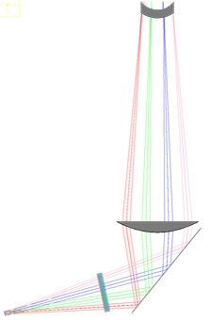
High-k Scattering System - The 290 GHz high-k tangential scattering system of NSTX is being replaced by a 693 GHz poloidal scattering system for NSTX-U, thereby considerably enhancing planned turbulence physics studies by providing a measurement of the k_{θ}-spectrum of both ETG and ITG modes. The probe beam in this case enters the plasma from Bay G while a tall exit window located on Bay L is employed to collect the radially- and poloidally-scattered beams and image them onto an array of waveguide mixers. The reduced wavelength will result in less refraction and extend the poloidal wavenumber coverage from the previous 7 cm⁻¹ up to >40 cm⁻¹. Measuring the k_{θ} as well as the k_{r} spectrum is crucial for identifying the source of turbulence, since the 2D k-spectra driven by different instabilities have different anisotropies.

Supplemental funds from DoE have been used for the purchase of a high power CO₂ laser from Edinburgh Instruments, which will pump a 693 GHz FIR laser recently overhauled by UC Davis. The lasers and supporting equipment will be housed in the “mezzanine” area just outside the NSTX test cell. A three level, 12-foot-long table supports both high-k scattering lasers, as well as four FIReTIP lasers, and is enclosed in Lexan panels for a dry air environment. The laser table will be installed in 2016 together as part of the FIReTIP system. Low loss corrugated waveguides, re-machined by UC Davis from the previous 290 GHz waveguide, bring the FIR beam to launch optics on Bay G. A system of mirrors and HDPE lenses have been designed to direct and focus the probe beam to the scattering region, while a steerable mirror aims the probe beam ±2.5° to target various scattering volumes. The receiver system is placed outside a large exit window on Bay L, with the scattered beams tilted up and then focused on to a 4-pixel mixer array as shown in Fig. 16. The tip/tilt angle of the large mirror is remotely controlled, as is the distance between the mirror and the focusing optics, thereby allowing placement of the scattering volume along the line-of-sight of the launch beam from the plasma core out to the pedestal region. While a single 4×1 mixer array is being fabricated by VDI for initial plasma operation, the system can be easily upgraded to an 8×2 configuration. The High-k Scattering system is scheduled to be completed in 2016, after which it will undergo laboratory testing and characterization. After testing is complete, it will be shipped to PPPL, installed, and commissioned in FY 2017.
Fig. 16. Optics simulation of the high-k scattering system, showing how the scattered beams pass through the Bay L window to be focused onto a multi-element mixer array.

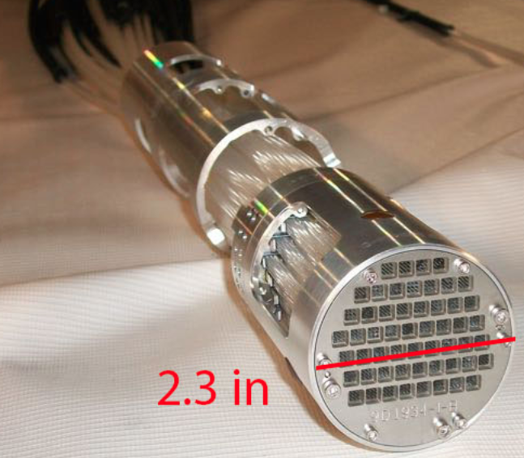
Beam Emission Spectroscopy - The Beam Emission Spectroscopy (BES) diagnostic on NSTX-U is based upon observing the D_{α} emission of collisionally-excited neutral beam atoms and provides spatially-resolved measurements of longer wavelength density fluctuations in the plasma core. These measurements play a key role in elucidating the physics of ion transport and MHD instabilities. In FY15, BES sightlines were reconfigured for 2D measurements spanning the outer plasma and pedestal region. The 2D fiber assembly was designed and fabricated by U. Wisconsin with support from PPPL, as shown in Fig. 17, and the new configuration contains 54 sightlines in an approximate 9x7 grid. The new 2D configuration opens scientific opportunities for multi-field turbulence measurements with flow fields from velocimetry techniques. Flow field observations can shed light on E×B flow and shear flow, zero-mean-frequency zonal flows, and geodesic acoustic mode (GAM) zonal flows. Also, turbulence-induced particle transport can be directly inferred from 2D BES measurements of density and flow field. Finally, the U. Wisconsin collaboration completed a 16-channel expansion of the BES detection system for a total of 48 detection channels available for the FY2016 campaign.
Fig. 17 BES-2D-Fiber Assembly.
Magnetics For Equilibrium Reconstruction, Boundary Control, and RWM Suppression - There are many more magnetic sensors in NSTX-U than NSTX, largely due to the increase in the number of sensors on the newly fabricated center column. Substantial progress was made in commissioning the NSTX-U magnetic diagnostics, as described below.
The poloidal field and flux measurements are used to constrain both off-line and realtime equilibrium reconstructions. The analog integrators for these systems were all checked, and repairs made. All sensors were then cabled to their integrators, and then to the transient and real-time digitizers. The sensors were then calibrated using single coil discharges. Updated sensor gains were determined, and errant pickup of the TF and OH fringing fields was corrected in the data. These sensors were used to support the CS KPP activity, allowing EFIT reconstructions of all discharges.
Progress was also made on other magnetic diagnostic systems. A Rogowski sensor was installed on one the TF outer legs, allowing a measurement of the time-derivative of the TF current. This measurement, combined with a toroidal flux loop, will used to measure the diamagnetic flux in the plasma. The resistive wall mode (RWM) sensor signals were examined during these magnetic field coil shots, and a number of cabling errors resolved. Finally, the plasma current measurement system was refurbished, with some major hardware upgrades. These were successfully commissioned, and the data that was collected will be used to improve the vessel-current compensation in the plasma current measurement.

Boundary Physics Diagnostics - The NSTX facility has been investing strongly in boundary physics related diagnostics in the past several years, and a major activity has been to insure that port space is available on NSTX-U to accommodate them. There are over 20 boundary physics diagnostic systems on NSTX-U and additional ones are being readied. They include Gas-Puff Imaging (500kHz), a new poloidal Langmuir probe array, Edge Rotation Diagnostics (T_{i}, V_{φ}, V_{pol}), 1-D CCD H_{α} cameras (divertor and midplane), 2-D fast visible cameras for divertor and overall plasma imaging, divertor bolometer, IR cameras (30Hz), fast IR camera (two color), tile temperature thermocouple array, divertor fast eroding thermocouples, dust detector, Quartz Microbalance Deposition Monitors, scrape-off layer reflectometer, edge neutral pressure gauges, Material Analysis and Particle Probe (MAPP) [see Milestone D(15-1) Report], Divertor Imaging Spectrometer, Lyman Alpha (Ly_{a}) Diode Array, visible bremsstrahlung radiometer, visible and UV survey spectrometers, VUV transmission grating spectrometer, visible filterscopes (hydrogen & impurity lines), and wall coupon for post-run analysis. Major upgraded boundary physics diagnostics are described in more detail below.
SOL and divertor diagnostic development for NSTX-U - Two new diagnostics are being developed by LLNL to support radiative divertor feedback control. In conceptual form, both spectroscopic diagnostics would provide a semi-localized electron temperature estimate in the divertor in real time, which can be used in the plasma control system to control the gas seeding rate. These diagnostics are the divertor SPRED vacuum ultraviolet spectrometer and the divertor imaging Balmer line spectrometer (DIBS). The divertor SPRED spectrometer will use real-time carbon or nitrogen spectral line intensities as proxies for radiated power, as well as boron-like, beryllium-like, and lithium-like line intensity ratios that are highly sensitive to electron temperature in the range 1-10 eV. The DIBS diagnostic will provide a multi-chordal coverage of the divertor legs. Temperature-sensitive high-n Balmer line intensity ratios (n=6-12) will be used in real-time for electron temperature evaluation. Both diagnostics are being installed on NSTX-U for initial testing in FY2016.

Design of Resistive and Infrared Imaging Bolometers for NSTX-U - Measurement of the power radiated from the plasma support a range of activates from informing day-to-day tokamak operations to in-depth physics studies. Excessive power radiated from the core can have a negative impact on performance, while emission in the boundary plasma can be used as an efficient means of spreading heat exhaust, thus making spatial coverage and resolution important. Power can be lost over a wide range of photon energies, and specialized sensor technologies must be used to make accurate measurements. Through collaboration with ORNL, key upgrades and improvements to NSTX-U radiated power measurements will work to enhance upcoming research in the areas of transport and boundary plasma physics through the use of resistive bolometers. Additional efforts through the ORNL and NIFS collaborations will explore using novel infrared imaging bolometers.

Resistive bolometers are a conventional proven technology for radiated power measurement used on nearly all large-scale magnetically confined plasma devices. Small thermally isolated metallic foils, 4 μm Au, absorb radiation emitted from the plasma resulting in a rise in temperature which can be detected via a resistance change and used to infer the radiated power. Prior implementation on NSTX has been challenging, and work in FY15 by ORNL and PPPL looked to understand and overcome the shortcomings of previous designs as well as adapt them for NSTX-U. Testing of existing sensor stock is underway and conceptual design activities are nearing completion in an effort to develop resistive bolometer tools to be installed following the FY16 campaign. Both core and lower divertor regions are being considered as priorities for initial diagnostic deployments, and a strategy for more comprehensive coverage beyond FY17 is being developed.
Infrared imaging bolometers offer a novel means of measuring radiated power by observing a foil’s temperature via infrared emission rather than its resistance. This technique leverages technological advancements in high-resolution IR imaging cameras to improve spatial coverage and has been demonstrated on large-scale fusion devices such as LHD and JT-60U. Collaborators from NIFS in Japan, along with colleagues from ORNL, joined PPPL personnel to perform laboratory testing and develop a conceptual design of an infrared imaging bolometer to view the lower divertor of NSTX-U. Expected for testing during FY16 operations, this will be the first imaging bolometer designed specifically for divertor and boundary physics research. Results will impact future developments of radiated power measurements, both at NSTX-U and within the tokamak community, helping to complement existing resistive bolometer tools.
Upper and lower divertor cameras - Full poloidal/toroidal coverage of impurity emission from the PFCs is achieved via a combination of bandpass-filtered fast cameras viewing upper and lower PFCs and line-scan cameras. Two wide-angle fast visible cameras (Bay E and Bay J top) were used in NSTX for the full toroidal imaging of the lower divertor. These cameras will be re-installed in NSTX-U and will be complemented with a symmetric view of the upper divertor from Bay H bottom. Two image-intensified radiation-hardened CIDTEC cameras expand these capabilities with the ability to image weaker visible lines and a custom-built two-color system (see below) for the simultaneous imaging of different wavelengths. Intensified camera views include the lower divertor (from Bay I top) and a close-up of the surface analysis sample system MAPP (from Bay J top).
TWICE diagnostic for NSTX-U - A two-color imaging system being developed by ORNL based on a charge injection device (CID) radiation-hardened intensified camera was built for studies of plasma-surface interactions on PFCs in NSTX-U. The two-color imaging system (TWICE, Two-Wavelength Imaging Camera Equipment) was developed to image the lower divertor PFCs and expand the capabilities available from fast visible cameras with the ability to image weaker visible lines (via an image intensifier) and the simultaneous imaging of the same field of view at different wavelengths. By means of commercially-available mechanically-referenced optical components, the two-color setup images the light from the plasma, relayed by a fiber optic bundle, at two different wavelengths side-by-side on the same detector. Remotely-controlled filter wheels are used for narrow bandpass and neutral density filters on each optical path allowing for simultaneous imaging of emission at wavelengths differing in brightness up to 3 orders of magnitude.

Divertor camera for churning mode, turbulence, and radiative divertor real-time feedback control - A new divertor imaging diagnostics was implemented to:
- Improve understanding of turbulent transport and its relation to the divertor heat flux width
- Improve understanding of snowflake divertor transport and the presence of the theorized ‘churning mode’ in the null-point region
- Implement divertor plasma temperature feedback for radiative divertor real-time control
The new LLNL Vision Research Phantom v1211 camera will be dedicated to the imaging of the lower divertor via a lower dome radial re-entrant divertor port on Bay B. The choice in the optics was driven by the needed field of view and magnification, the conservation of etendue and the minimization of filter bandpass shift while a Schott coherent bundle with 8/10 micron (core/clad) 1000x800 fibers will be used as optical guide. The resulting resolution of 360x288 pixels leads to a maximum frame rate of 76.6 kHz (200 kHz with cropping in the toroidal direction) and a 2 s recording time. Imaging via D-alpha and Li I is envisioned for turbulence studies. Imaging via C III is envisioned for the development of a radiative divertor feedback signal derived from the change in location of the C III radiation shell along the divertor leg as a result of changes in the divertor temperature in the transition to detachment.

Edge neutral density diagnostic - The Edge Neutral Density Diagnostic (ENDD) was used in recent years coupled to the Monte-Carlo neutral code DEGAS2 to infer neutral densities in the low field side SOL in discharges from the last year of NSTX operations. The ENDD diagnostics was upgraded for NSTX-U. ENDD was relocated to a re-entrant viewport on the Bay G midplane port cover with the shutter acting as a mirror. ENDD lines of sight are now tangential to the outer mid-plane in front of the NBI armor graphite tiles. Direct imaging on the camera sensor was substituted with imaging via a coherent fiber bundle allowing for the positioning of the DALSA camera farther away from NSTX-U. ENDD will monitor hydrogenic emission via a D-α narrow-bandpass interference filter. The choice of D-α instead of D-β was driven by the higher confidence in the knowledge of molecular contribution to D-α emissivity.

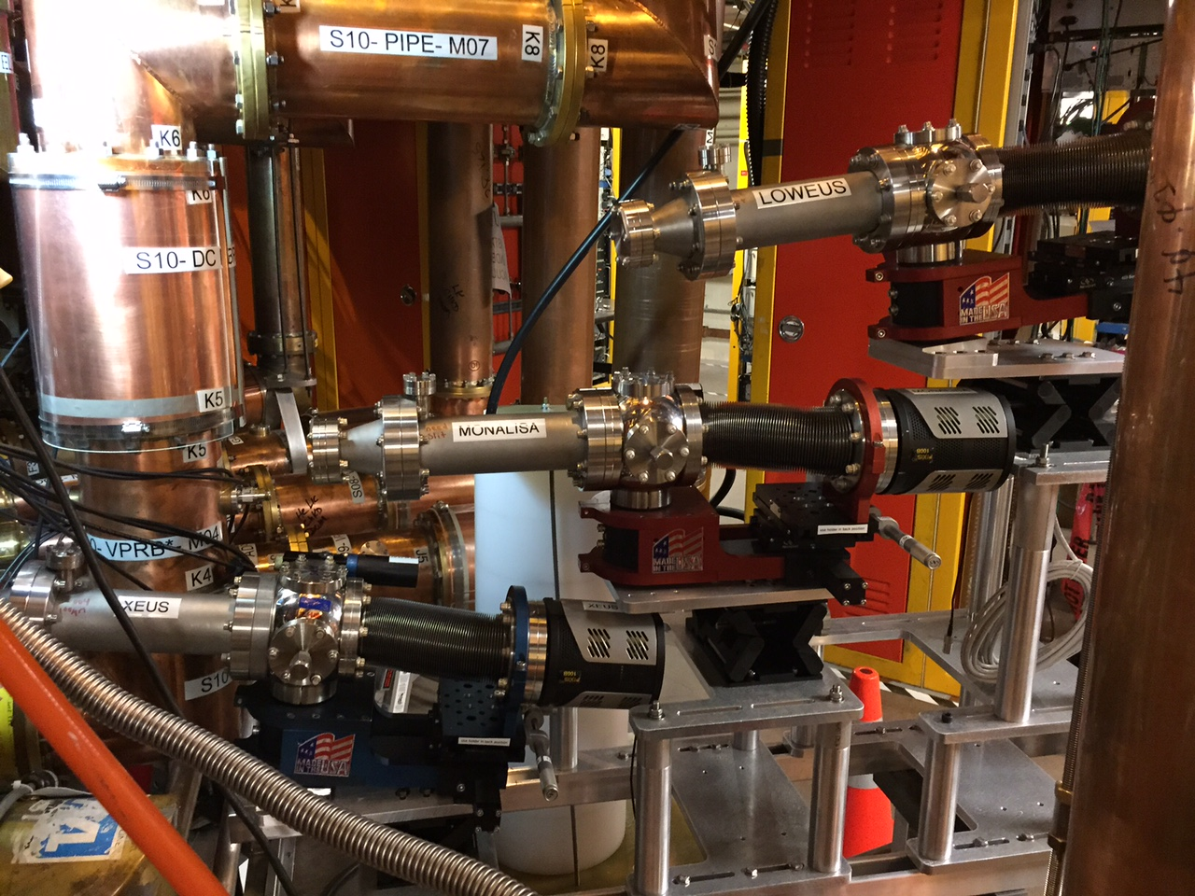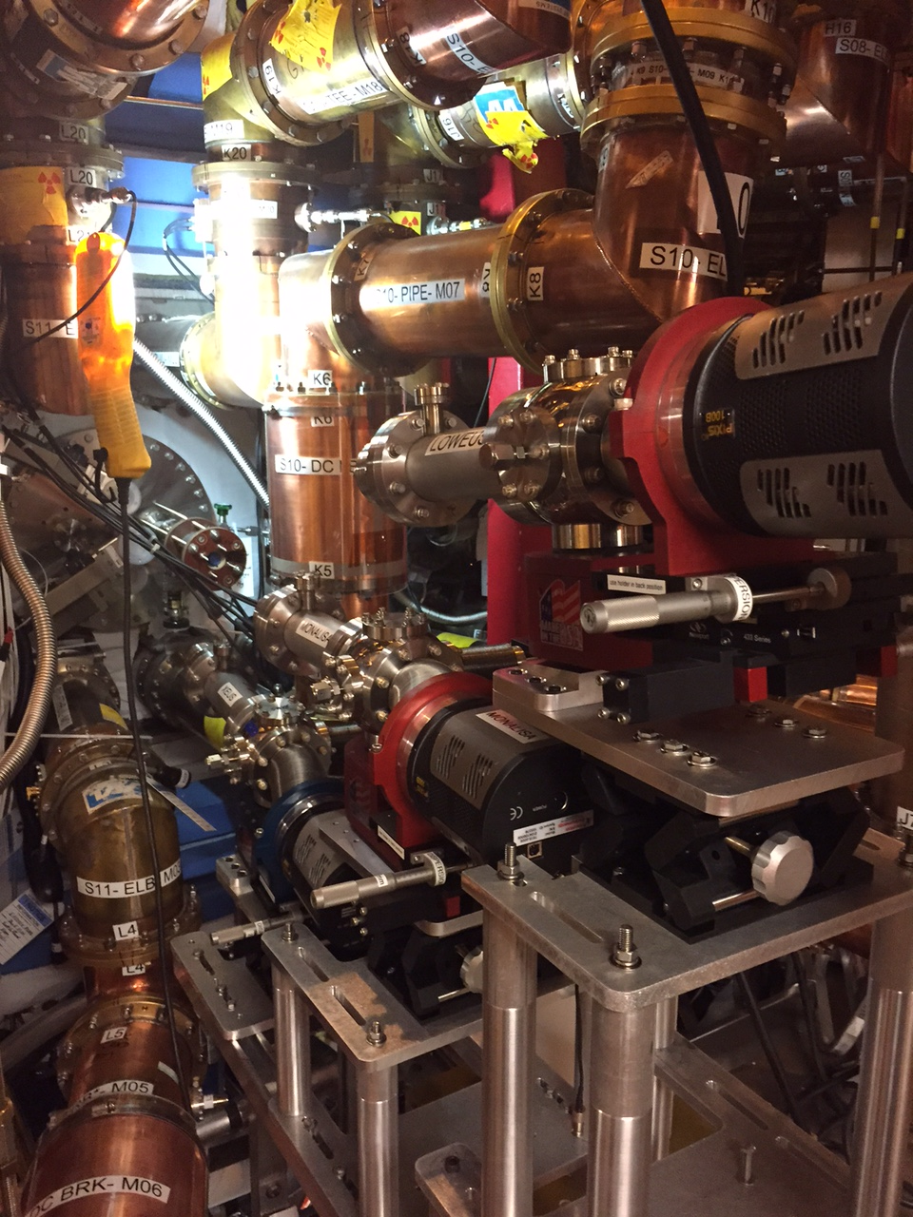
Fig. 18. New mounting system for the three EUV spectrometers XEUS, MonaLisa, and LoWEUS.

Divertor Spectrometers - Progress has been made with three LLNL high spectral resolution extreme ultraviolet (EUV) grating spectrometers that will be used to infer impurity densities in the plasma core and pedestal. The two previously existing spectrometers, the X-ray and Extreme Ultraviolet Spectrometer (XEUS) and the Long-Wavelength and Extreme Ultraviolet Spectrometer (LoWEUS) and the new spectrometer, the Metal Monitor and Lithium Spectrometer Assembly (MonaLisa), have been calibrated on the Livermore EBIT facility to cover the wavelength range between 5 – 440 Å. The design is such that the spectrometers will cover overlapping wavelength ranges to ensure no gaps in impurity monitoring (XEUS, 5 – 65 Å; MonaLisa, 50 – 220 Å; LoWEUS, 190 – 440 Å). All three spectrometers have been successfully mounted on NSTX-U (Fig. 18). The port is located at Bay E midplane with the spectrometers stacked on top of one another, providing near-midplane radial views.
Improved spectroscopic diagnostic coverage of the upper divertor and central stack of NSTX-U - In order to diagnose the in-situ behavior of lithium coatings and the impact of lithium on poloidal and toroidal asymmetries in lithium coatings, and correspondingly, on plasma conditions and stability, new high-resolution UV-VIS-NIR spectroscopic diagnostics are being installed in NSTX-U by University of Tennessee at Knoxville (UT-K) and ORNL teams to monitor the previously uncovered upper divertor and central stack region. The diagnostics consist of a high-speed ProEM-HS 512 camera, an IsoPlane SCT320 spectrometer and 32 sightlines: 16 sightlines on the upper divertor and 16 sightlines on the central stack. These spectroscopic views of the center-stack are obtained from one port at the Bay J equatorial plane for spectroscopy. A port at the Bay G bottom has been allocated to this project to provide views of the upper divertor. During the past year, a spectrometer, the Princeton instrument IsoPlane SCT320, was procured. This spectrometer can work with up to 3 different gratings: one low resolution grating (1200 G/mm) to monitor wide regions of the spectrum, one high resolution grating (3600 G/mm optimized for UV) to measure fine spectral features of selected spectral lines (i.e., to measure temperature), and one intermediate resolution (2400 G/mm optimized for visible light) to monitor the intensity of multiple impurity lines at once. A ProEM:512B camera will be coupled to this spectrometer. The diagnostic support and optical design for the Bay J mid-plane and Bay G are complete, and the PPPL machine shop is manufacturing the fiber holder and other mechanical components. The second fiber optic bundle has been delivered. These new diagnostic capabilities of the central stack and upper divertor will enable us to address outstanding questions regarding the dependence of the effectiveness of lithium evaporation on the poloidal and toroidal asymmetries in the coating.
Laser blow-off impurity injection system - Significant progress has been made in the laser blow-off (LBO) impurity injector development in FY2015. The LLNL group worked with PPPL on developing and installing a laser blow-off impurity injection system on NSTX-U. The LLNL LBO team presented a Conceptual Design Review of the system. The laser blow-off impurity injection system will be used for low- and high-Z impurity transport studies in the core, pedestal, and edge of NSTX-U plasmas. The system is comprised of a 10-Hz, 1 J laser, beam delivery optics, and a target chamber that will be mounted on the NSTX-U vacuum vessel. The laser to be utilized is an infrared 1064 µm Q-switched Nd:YAG laser with a 16 ns pulse duration which has previously been used as a laser ablation system on EBIT-I and SuperEBIT. A preliminary beam path has been laid out by LLNL and is awaiting approval and implementation. A new laser room location has been chosen and will be built on the mezzanine above the South Bay entrance. The laser room specifications for operation have been worked out. A contract is being placed with a vendor that will fabricate the laser room off site and deliver it to PPPL. The target chamber has been designed and will be located on Bay J. The system was designed and components are being fabricated. Installation on NSTX-U is planned for FY2017.
Pulse Burst Laser System – During FY2015, good progress was made on fabrication of the Pulse Burst Laser System (PBLS) being provided as an upgrade to the MPTS diagnostic under a DOE Early Career Research Project. Delivery of the laser to PPPL is expected in CY2016. The high time resolution measurements enabled by this capability will play a key role in exploration of H-mode pedestal and ELM physics. The fast data acquisition system required for the MPTS detectors to be able to follow the rapid laser pulses from the PBLS was acquired, installed, and commissioned.
Energetic Particle Diagnostics – In preparation for the FY 2016 NSTX-U run, both vertical and tangential Fast Ion D-Alpha (FIDA) diagnostics by UCI have been reinstalled, aligned and calibrated. Improvements have been made in the control modules and stray-light blocking to help make the measurements more accurate and reliable. Both FIDA systems are ready for plasma experiments on NSTX-U. A new and innovative ssNPA system by UCI, which uses stacks arrays of silicon diodes with different foil thickness to get spatial profile measurements and some energy information, has been installed. Arrays mounted at different ports around the NSTX-U vessel provide both radial and tangential views to enable measurements of the fast ion distribution at different values of radius, energy and pitch. The electronics have been successfully bench tested. They are able to measure fluctuations up to 150 kHz, which is suitable to study fast ion driven instabilities and transport. The final integration test of the ssNPA detectors and electronics is currently underway. Other fast ion diagnostics that were previously available on NSTX have also been reinstalled and tested. This includes neutron counters and a scintillator-based lost-ion probe (sFLIP), which measures lost fast ions reaching the vessel wall, and a new charged fusion product (CFP) profile diagnostic.
Neutron Diagnostics – Three fission chamber neutron detectors and two scintillator detectors were installed on NSTX in FY2015. The absolute calibration of the fission chambers was determined through use of a Cf-252 neutron source in the vessel. This source is one that PPPL obtained from ANL to replace an old TFTR-era source that had become too weak to provide in-vessel calibrations within an operationally acceptable amount of time. These fission chamber detectors were operational for the NSTX-U first plasma KPP. A transfer of the fission chamber calibrations to a much higher range of neutron rates has been performed early in the FY2016 campaign.
A scintillator-based Fast Lost Ion probe (sFLIP) contributes to the NB characterization by providing energy and pitch resolved spectra of lost fast ions, e.g., from prompt losses, as the NB tangency radius is varied. sFLIP is being upgraded with a faster CCD detector capable of frame rates up to 100 kHz. A set of photo-multiplier tubes is also being installed on sFLIP for energy and pitch integrated measurements at rates up to 250 kHz from 6-10 sub-regions of the sFLIP scintillator plate. Major modifications to the vacuum vessel and two large diagnostic ports to accommodate the new neutral beam lines for NSTX-U has resulted in displacement of sFLIP from the port it had used during NSTX operations. A suitable alternate port for this diagnostic was identified, and that port was enlarged and substantially reinforced to accommodate the diagnostic. The in-vessel part of this diagnostic was then installed at the new location, while at the same time extending its range of pitch angle acceptance. This latter change should allow for additional physically valuable information to be obtained about beam ion losses in the forthcoming campaigns.
Charged Fusion Product (CFP) Diagnostic - The fusion rate profile diagnostic (also known as the ‘proton detector’ or ‘PD’) has been designed by collaborators at Florida International University. It provides direct measurements of the fusion reactivity profile. Because both the 3 MeV protons and 1 MeV tritons produced by DD fusion reactions are largely unconfined for NSTX-U parameters, they quickly escape the plasma. When these ions are measured by the PD detector array, their orbits can be tracked backward into the plasma. Such orbits are equivalent to curved sightlines for each detector, so that multiple signals can be inverted to infer a radial profile of the high-energy fast ions. A 4-channel CFP prototype has been tested in FY2013 on the MAST device (see the Energetic Particle Research Section). The 3 MeV protons and 1 MeV tritons produced by DD fusion reactions in MAST have been clearly observed. Given the successful observations on MAST, a similar system with 6 channels) has passed its final design review. Construction and installation on a probe drive on NSTX-U is anticipated in early CY2016. The data obtained on NSTX-U will be used in a proposal for a future 16-channel system for NSTX-U.

Energetic-Particle-Induced Mode Diagnostics - A recently-developed UCLA 16-channel comb quadrature reflectometry system has been utilized on NSTX to study the eigenmode structure of fast-ion driven Alfven as well as other MHD modes. This unique system has also provided a wealth of additional information including investigation of three-wave coupling processes and identification of the potential role of Compressional Alfven Eigenmodes (CAEs) in contributing to core anomalous transport. In order to prepare for higher density operation in NSTX-U it is proposed to expand operation to 100GHz through the installation of 8 additional channels. This upgrade to 24 channels will allow detailed eigenmode structure measurements in high performance NSTX-U plasmas. Similarly to NSTX, several arrays of high-frequency Mirnov coils will provide routine measurements of the fluctuations spectrum on NSTX-U. Two sets of coils are toroidally displaced to enable the computation of the toroidal mode number of the modes from the phase of the complex spectrum. A reduced set of coils is displaced poloidally to provide information on the poloidal mode structure. The bandwidth of the magnetic fluctuation measurements will be extended on NSTX-U from the present 2-2.5 MHz up to 4 MHz, to account for the expected frequency up-shift of the modes as the toroidal field is increased. Another quantity of great relevance for EP studies is the radial structure of *AE (i.e., all types of Alfven eigen-modes). Several complementary systems will be available to this end on NSTX-U, including beam emission spectroscopy (BES) arrays, reflectometers, interferometers, polarimeters, and X-ray detectors. A proposal for installing a Doppler back-scattering (DBS) system will be also considered based on the available funds (see below). The BES system will provide low-k density fluctuation measurements near the mid-plane for normalized radii 0.1 < r/a < 1. The number of channels will be increased from 32 up to 64 to simultaneously sample a wide region of the plasma. The measurement region will extend poloidally to cover a ~10 cm broad strip along the mid-plane. Further improvements may include a toroidally-displaced set of viewing channels, possibly limited to the edge region, to measure background emission (in the absence of the 2nd NB source) or the toroidal mode number of the instabilities. Density fluctuations are also derived from a multi-channel reflectometer system. The 16 channels available on NSTX will be complemented by 8 new channels at higher frequency, which will enable fluctuation measurements up to densities ~10²⁰ m⁻³. Line-integrated measurements of density fluctuations will also be available from 3-4 far-infrared interferometer with sampling frequency ~4 MHz. Beside density fluctuations, other quantities such as magnetic field and velocity fluctuations are important for a thorough identification and characterization of the different instabilities. A new radial polarimeter system will provide direct measurement of magnetic fluctuations along the mid-plane. Pending incremental funding for diagnostics development, flow fluctuations will be measured through a millimeter-wave Doppler back-scattering (DBS) system operating in the 80-100 GHz frequency range. This new measurement capability represents an alternative, substantially independent tool for identifying fast-ion modes that would significantly strengthen comparison with theory, expanding previous internal measurements of fast-ion modes previously restricted to perturbed density on NSTX. Additional information on fluctuations with frequency < 100 kHz will be provided by a multi-energy SXR array with two toroidally displaced sets of views. Spatial resolution varies from ~1 cm at the outboard mid-plane (R>150 cm) to ~3 cm in the core and inboard mid-plane region (40<R<140 cm). Faster measurements with up to ~500 MHz bandwidth will be available from a system of two poloidal SXR arrays. Each array contains 16 channels viewing poloidally through two variable selected filters, with 2-3 cm resolution.
Doppler backscattering system (DBS) - UCLA collaborators will be installing a 96 GHz DBS in FY 2016. It recently underwent and passed a design review. Fabrication of the antenna mounting structure is proceeding. The electronics are already finished. It will probe density fluctuations with k_{θ}~10–15 cm⁻¹. It can penetrate to equilibrium densities as high as ~1.1x10²⁰ m⁻³. Note that there is a tradeoff between penetration and achievable k_{θ}. Penetrating to high equilibrium density reduces k_{θ}. The system can also function as a reflectometer, in which chase it will reflect at 1.1x10²⁰ m⁻³. A four channel 81-87 GHz system is currently being fabricated and is expected to replace the 96 GHz system early next year. As a reflectometer, it will extend the existing capability for measuring MHD or fast-ion mode amplitude in the core to higher density compared to the current reflectometer array which penetrates to 7x10¹⁹ m⁻³. As a DBS system, it will measure the Doppler shift of the turbulent fluctuations, which can be used to determine plasma equilibrium and fluctuation ExB velocity. That may allow direct determination of the E fluctuation associated with fast-ion driven modes. Currently, only the density perturbation associated fast-ion modes can be directly measured.

Alfven Eigenmode Antenna for AE Stability Measurements - Simple antennae have been used in several machines (JET, C-Mod) to study TAE stability. The linear damping rate can be measured by sweeping the antenna frequency through the mode frequency. It will be useful to extend these studies to low aspect ratio tokamaks (MAST and NSTX). This would also help to validate ITER projections by challenging our fundamental understanding of the physics in the drive and stability of these modes. For low aspect ratio the antenna can also be used to study higher frequency Alfvén modes such as GAE and CAE. The “MHD active spectroscopy” plan begins with relatively simple antenna design. As operational experience builds up, more ambitious designs will be tried. Several proto-type antenna designs will be evaluated to optimize the coupling to TAE and CAE. The NSTX-U prototype AE antenna system consists of up to 4 compact modules, each of which is a single, 5-turn ‘window-frame’ coil, similar in principle to those used on JET, C-Mod and MAST. In parallel, the external power supplies for driving the antenna, the coupling networks and control hardware and software will be developed. While the highest priority will be to develop the capability to study TAE, some time will be devoted to evaluating the antenna and coupling network at frequencies up to 2MHz, as will eventually be needed for Global and Compressional Alfvén eigen-mode studies. A four-element *AE antenna was designed and installed on NSTX-U to test selectivity of the toroidal / poloidal mode number, as well as improving the coupling of the antenna to the modes. The low power (≈ 1 kW) experiments will provide important information on antenna coupling and natural damping rates for each of the eigen-modes. This information will be used to determine the potential benefits of higher power experiments. If the natural eigen-mode damping rates are small, there is the possibility of driving them to amplitudes where stochastic heating of thermal ions occurs.

