MP001-170523-00-02

TO: J. Menard, S. Kaye, S. Gerhardt
FROM: M.A. Jaworski, Materials and PFCs
Subject: impact of potential polar region modifications on research and scenarios for Materials and Plasma-Facing Components Topical Science group

Introduction:

The NSTX-U Recovery project has initiated a wide-ranging review of systems in order to bring the NSTX-U back to operations. A number of design changes have been proposed and are being evaluated related to the tile shaping of the inboard divertor horizontal and vertical targets. Changes may also occur to certain PFCs in the outboard. In particular, the highest performance benefits seem to be gained from unidirectional operation with the use of fish-scaled plasma-facing components. This MEMO documents the potential impacts of these changes on the Materials and Plasma-Facing Components Topical Science Group.
In order to gather input, a TSG meeting was held on May 11th, 2017 to discuss the material presented at the Team meeting, review the 5/7 year plan and the FY16/17 run plans. The meeting was well attended by researchers active in the M&P TSG (participation from PPPL, ORNL, LLNL, and UTK) in addition to representatives from the engineering division working on internal components and the PFC design. Slides from the meeting are available in the drag’n’drop under the “Science Group” meetings area specific to the M&P TSG. In addition, U-Illinois collaborator JP Allain was contacted after the meeting to also obtain input.
The input is summarized here:
- The FY16/17 experimental plans mostly utilized piggy-back or reference shapes already developed and assumed included experiments on boronized and lithium-conditioned surfaces. Experiments utilizing MAPP were largely conducted in piggy-back (Bedoya, Skinner, Scotti)
- Only the FY16 XP on High-Z reference shape development requested specific shape development to enable planning for Row 2 upgrade. This shape is described below and is now referred to as a “PFC testing reference shape”. Requalifying the PFC in the current row 2 location (0.73m < R < 0.84m) would maintain a future ability to test novel plasma-facing components after the NSTX-U recovery project is completed. An additional request is a reference shape that would place the strike point very close to/on top of the MAPP diagnostic (R=1.04m). (Jaworski)
- Of the thrusts in the 5/7 year plan, only MP-3 requires significant revision. Thrusts on Li surface-science for long-pulse and material migration are not significantly impacted provided new diagnostic complications can be addressed. The thrust on continuous vapor-shielding can, in fact, benefit from a more general examination of the physics associated with self-limiting, ablating materials. The main target for consideration is Li-compound decomposition as a result of the higher temperatures that can be accessed with the NSTX-U.
A longer discussion is included in the sections below.

Shape Requests
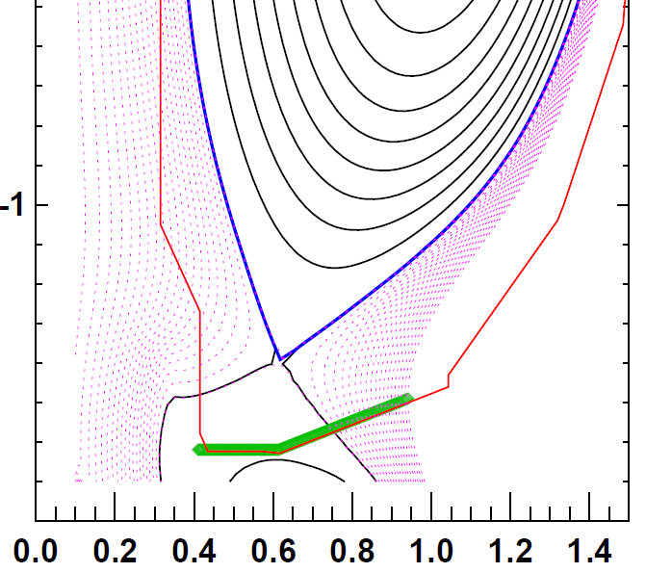
The ability to test novel plasma-facing component materials with the flexible magnetic geometry in the NSTX-U is still an advantage for the machine. The long-range goals of the program are expected to still include high-Z conversion and examination of liquid metal PFCs in a confinement device. While this goal is deferred until after the recovery project is completed, maintaining the flexibility to operate on an outboard divertor row is advantageous.
Figure 1: PFC testing reference discharge shape.
This ability is also advantageous to improve the amount of particle flux impinging the MAPP diagnostic. The MAPP is located well outboard at about 1m major radius. A number of papers in 2016 and 2017 have already made use of the MAPP data obtained in the FY2016 run campaign and the diagnostic was not designed to have the divertor strike-point directly impinging. The science purpose of the diagnostic can continue and is enhanced with the ability to divert on the outboard targets.
The shape study conducted with the NSTX-U High-Z divertor upgrade project is shown in figure 1 and will be referred to as the PFC test reference shape. This shape features an outboard strike-point on the outboard target at the location of row 2 (0.73m < R < 0.84m). The inboard divertor strike point is located on the vertical target. This means the helicity of the inboard strike point is not altered in the high-power regions of the divertor (helicity does reverse in the private-flux region, but this is not expected to receive significant power). The PFC reference shape was already expected to be power-limited by the design limitations of the high-Z tile design. This limit was 10 MW/m² for 1s at 5 degrees angle of incidence. This shape has the added advantage (beyond the high-performance discharges) of locating the strike point closer to the location of the MAPP diagnostic.
In addition, it is advantageous to conduct direct particle exposures onto the MAPP diagnostic. This would entail placing the strike point very close to/on top of the MAPP itself. The discharge 203879 has already achieved a strike point at R=1.04m. This will enable comparative studies of direct impingement vs. indirect impingement of particles onto samples loaded on the MAPP probe head.
Conduct of the M&P TSG research thrusts can be accomplished and the ability to look toward future PFC upgrades can be retained with the use of this shape in addition to the high-performance discharges already identified in the PFC Requirements document.
Cognizant of the fact that the PFC design will limit performance, a request is made that performance similar to the high-Z tile be available to the TSG (i.e. 10 MW/m² for 1s) in the case of the PFC test reference shape (nominal row 2). In the case of the MAPP shape request, the gap tiles of rows 4 and 5 will need to likely need to be requalified to determine the available power for a 1s discharge. In addition, high-fluence experiments benefit from longer discharge times. The M&P TSG research thrusts on surface science and material migration both benefit from 5s discharges, even at lower power levels. Therefore, scenarios that reach to the tile design limits in 5s in the PFC test reference shape are of interest to the TSG. Scenarios in the MAPP reference shape that reach design limits in 5s are also advantageous to the program.

Impact on Research Thrusts and Diagnostics
The M&P TSG group discussion resulted in consideration of the diagnostics and actuators necessary for the research plan. Several diagnostics are already explicitly mentioned in the PFC Requirements document including magnetic diagnostics, thermocouples, and Langmuir probes). Other diagnostics were discussed as having some impact due to the proposed “Mardenblock” design. The diagnostics needed for the M&P TSG research elements are listed here:
- MAPP – This diagnostic will not be affected by the proposed changes to the machine. In addition, there is sufficient stroke in the bellows drive to accommodate changes in divertor floor height of about an inch. (Kaita)
- Visible spectroscopy – There is a need to evaluate the impact on interpretation of signals obtained by spectroscopic tools if tile feature sizes are comparable to the spatial resolution of the diagnostic. For instance, emission from a tile gap may be significantly different than on the front-surfaces of the PFC and could cloud interpretation. (Soukhanovskii and Scotti)
- IR thermography – The interpretation of diagnostic signals needs to be assessed similar to visible spectroscopy above. Also discussed was the impact of lithium conditioning on surface emissivity which continues to be a research topic (Gray and Reinke)
- Langmuir probes – Redesigned PFCs will require redesign of the Langmuir probes and this is already reflected in the Requirements document draft. It is further expected that the Mardenblock design will require edge-mounted Langmuir probes unlike the existing Gunn-style (Jaworski)
- Quartz crystal monitors and witness plates – are not affected by the proposed changes to the polar regions of the machine (Skinner)
- Core high-Z spectroscopy MONA LISA, XEUS, LoWEUS – are not impacted by the proposed changes to the polar regions of the machine (Soukhanovskii)
- Though not needed, the following was also discussed: Fast eroding thermocouples – if included would have to be implemented to interface with any new PFC design. ORNL reports, however, that these diagnostics were removed from the ORNL field work proposal (Gray and Reinke)
A concept was proposed at the meeting that a special set of PFCs be implemented that are optimized for diagnostic interpretation (e.g. a toroidally localized strip of flat tiles with minimal gaps). This was considered not impossible by the engineers present at the meeting (Mardenfeld and Sibilia) but is not included in the current requirements document.
Assuming the ability to re-implement the affected diagnostics, then the following impacts on the 5/7 year plan research thrusts is expected:
- MP-1: Understand lithium surface-science for long-pulse
This research thrust is not affected by the proposed changes to the polar regions. This is largely expected as a result of the success of the FY16 run which utilized piggy-back discharges for MAPP exposure.
- MP-2: Unravel the physics of tokamak-induced material migration and evolution
This research thrust is not affected by the proposed changes to the polar regions. This is based on the fact that the NSTX-U divertor diagnostics (e.g. spectroscopy, probes) have already been designed around broad coverage of the divertor and the group expects localized diagnostics such as MAPP and witness plates are not impacted by the proposed changes to the machine.
- MP-3: Establish the science of continuous vapor-shielding
This research thrust was originally conceived to determine the viability of high-performance discharges with lithium coatings on high-Z substrates at high-temperatures. With the high-Z conversion of the machine deferred to post-recovery, this research thrust requires revision. In fact, consideration of generic materials that can ablative and shield the PFC can retain this research thrust and make it applicable to a wider range of materials of interest throughout the fusion community. This is discussed further below.

Modification of research thrust MP-3: the science of continuous vapor-shielding
As stated above, this research thrust was motivated by experiments conducted in NSTX and Magnum-PSI which observed power reductions in the divertor of the former and Li vapor-trapping at the material surface in the latter. In addition, it was expected that the NSTX-U power density and pulse-length would lead to very high component surface temperatures such that some consideration of Li ablation would be necessary and might result in performance limitation if vapor-trapping did not occur in the tokamak as in the linear device experiments. Ablation of material at high temperature is not unique to lithium but is also a well-known phenomenon in high-power carbon machines when carbon-bloom occurs. While carbon-bloom has been studied as has the effects of boronization on carbon erosion, high-temperature, lithiated-graphite is less well known in the fusion community.
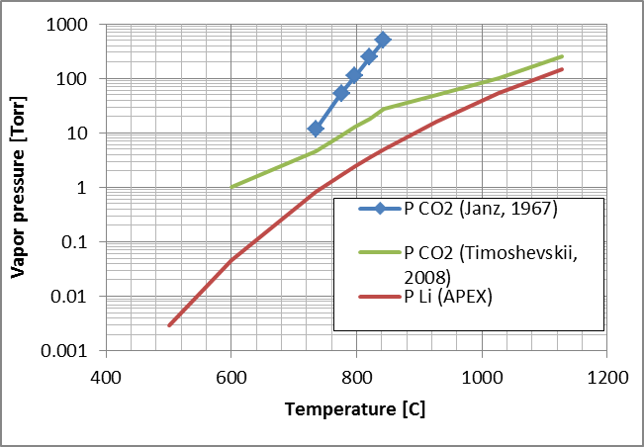
It is known from NSTX experience that compounds of lithium form rapidly in the machine[1]. In addition, it is known that the plasma redistributes material throughout the machine and could collect in the gaps between PFCs creating a reservoir effect. If such a reservoir of Li₂CO₃ forms, say, then decomposition into Li₂O+CO₂ can result in ablative shielding of the PFC from the CO₂ outgassing. Unfortunately, this impurity production may also threaten plasma performance if the divertor does not sufficiently shield the core plasma. This situation is essentially the same as lithium vapor-shielding. The difference here is that the evolved impurities are higher Z (carbon and oxygen vs. pure Li).
Figure 2: Vapor pressure of CO₂ or Li above Li₂CO₃ or pure Li respectively as a function of temperature.
Decomposition pressures of Li₂CO₃ are shown in figure 2 and compared to the equilibrium vapor pressure of pure lithium for the same temperatures. As can be seen, the decomposition pressure significantly exceeds pure Li vapor pressures. While Li carbonate is shown as an example, a range of lithium compounds are expected to form in the rich, mixed-material environment of the NSTX-U during plasma operations. Generalizing the research thrust to look at ablative surfaces could make the research more applicable to a broader range of materials and machines.

Summary
Discussion with the M&P TSG has identified a number of impacts as a result of the proposed changes to the polar regions of the NSTX-U. For the most part, the proposed PFC change creating unidirectional operation is not seen as strongly modifying the current set of research thrusts provided diagnostics can be sufficiently redesigned and understood in conjunction with the new PFCs. These diagnostics are listed above. The ability to test novel PFCs as described in the NSTX-U 5/7 year plan and PAC talks is a unique capability that reduces programmatic risk if a high-Z or liquid-metal conversion of the machine is conducted. A PFC-test reference shape based on the high-Z reference shape is therefore requested by the TSG. This shape has the added benefit of increasing the particle flux onto the MAPP diagnostic by placing the outboard strike-point closer to the MAPP location. In addition, the requested shape does not put significant power in the reverse helicity direction if such a design feature is implemented in the inboard divertor horizontal target. To further make comparative studies of PFC material response, a MAPP reference shape is requested placing the strike point nearly on the MAPP diagnostic head.
The M&P TSG research thrusts MP-1 and MP-2 are not significantly impacted by the polar-region redesign proposal. Research thrust MP-3 should be modified due to the deferment of the high-Z upgrade to the NSTX-U. The proposed modification broadens the research to general ablating materials and should, in fact, make the research more widely applicable to other materials and other machines in the fusion community.

[1] Jaworski, et al., “Liquid lithium divertor characteristics and plasma-material interactions in NSTX high-performance plasmas” Nuclear Fusion 53 (2013) 083032

