|  |  |  |  |
| --- | --- | --- | --- |
| **Princeton Plasma Physics Laboratory**  **NSTX-U Experimental Proposal** | | | |
| Title: **Characterizing the SOL Losses of HHFW Power in H-Mode Plasmas** | | | |
| **OP-XP-1510** | Revision: | Effective Date:  *(Approval date unless otherwise stipulated)*  Expiration Date:  *(2 yrs. unless otherwise stipulated)* | |
| **PROPOSAL APPROVALS** | | | |
| **Responsible Author:** | | | Date |
| **SG, TSG or TF Leader (assigned by RC):** | | | Date |
| **Run Coordinator (RC):** | | | Date |
| **Responsible Division: Experimental Research Operations** | | | |
| **RESTRICTIONS or MINOR MODIFICATIONS**  (Approved by Experimental Research Operations) | | | |
|  | | | |

NSTX-U EXPERIMENTAL PROPOSAL

|  |  |
| --- | --- |
| TITLE: **Characterizing the SOL Losses of HHFW Power in H-Mode Plasmas** | No. **OP-XP-1510** |
| AUTHORS: **Rory Perkins, Joel Hosea, Gary Taylor, Nicola Bertelli, Randy Wilson, Cornwall Lau, John Caughman, David Smith** | DATE: |

# 1. Overview of planned experiment

The main goal of this experiment is to understand the conditions that yield optimal coupling of HHFW power into H-mode plasmas by minimizing the amount of power lost to the SOL. Three diagnostic upgrades, a wide-angle IR-camera view of the lower divertor, RF-frequency divertor, Langmuir probes, and a SOL reflectometer, will allow the following measurements:

1. the total fraction of HHFW power lost to the RF spirals to the lower divertor,
2. the spiral intensity as a function of length along the spiral,
3. the RF voltage at the most intense portion of the spiral,
4. SOL density profiles in front of the HHFW antenna.

These quantities will be systematically measured under a variety of conditions: (a) toroidal magnetic field strength, keeping q95 fixed, (b) antenna phasing, (c) q95, keeping the magnetic field modulus at the antenna fixed, (d) radiative divertor conditions, (e) RF power level, and (f) recycling levels. This will allow a far more quantitative assessment of the assertion that the SOL losses are intimately tied to the position of the righthand cutoff in the SOL and should point to the conditions of optimal coupling for NSTX-U.

This experiment also supports two other goals: obtaining SOL density profiles using an upgraded reflectometer for RF-model validation, and investigating the influence/control of impurity transport by means of HHFW heating.

# 2. Theoretical/ empirical justification

The NSTX(-U) research team has expressed a desire to couple more HHFW power into H-mode plasmas. Being able to couple HHFW power into NB-heated H-modes is a priority for making the HHFW system a (more) widely available tool for NSTX-U research. However, RF-only H-modes are of interest as they can provide low-torque beam-less targets. Also RF-only shots in helium are particularly suitable to RF experimentation and have worked well in the past without lithium conditioning. As of such, both scenarios will be studied in this XP.

A motivating factor for running these experiments are three key diagnostic upgrades that will allow critical questions to be addressed that could previously be treated only superficially.

* **Wide-angle IR camera**: will capture much of the lower divertor and measure most of the RF spiral. This will allow us to determine:
  + *the total power deposited to the divertor underneath the lower RF spiral, which could previously only be roughly estimated [1],*
  + *whether the RF spirals account for the majority of the HHFW power not reaching the core, and thus whether other loss mechanism (e.g. PDI [2]) are important,*
  + *the variation of spiral heat flux along the length of the spiral [3].*
* **Radial arrays of RF Langmuir probes**: six-probe arrays on both the upper and lower divertor, situated at Bay I close to the most intense portion of the RF spiral. The electronics will directly measure the RF-component of the collected current. This will allow for:
  + *direct measurements of the RF component will determine definitively whether RF rectification is occurring within the spiral,*
  + *estimates of the peak heat flux in the spiral due to RF rectification [4] that can be directly compared to IR camera measurement from the same location.*
* **Upgraded SOL Reflectometer:** now compatible with the higher fields in NSTX-U. This will allow for:
  + *a detailed assessment of the statement that RF losses are enhanced as the region of FW propagation approaches the antenna,*
  + *SOL density profiles to be used in RF models [5].*

A number of scans have been selected to influence the predicted level of SOL losses. Each is justified below. For reference, the righthand cutoff density is given by

$n_{c}\sim \frac{Bk_{||}^{2}}{ω}$, (1)

and previous experimental work suggests that when the cutoff layer is too close to the antenna (typically for NSTX, when the cutoff density is too low), SOL losses are worse.

1. **Toroidal magnetic field strength, keeping q95 fixed**: HHFW heating efficiency has been observed to improve in raising the toroidal field strength from 0.45 T to 0.55 T, in keeping with the hypothesis that the increased field strength moves the righthand cutoff away from the antenna (Eq. 1). This could be very promising for NSTX-U, which will access higher fields up to 1 T.
2. **Antenna phasing**: HHFW heating efficiency is largest for highest phasing and gets progressively worse as phasing is lowered, again in keeping with Eq. 1 and our working hypothesis. The longer pulse lengths of NSTX-U will allow multiple phases to be tested in a single shot. However, the HHFW matching system is fixed at the beginning of the shot, meaning that only one phase can be perfectly matched, and for any other phases tested in the same shot we would have to deal with larger amounts of reflected power.
3. **q95, keeping the magnetic field modulus at the antenna fixed**: C-Mod has installed and operated a field-aligned antenna, which has produced some very positive results in terms of impurity production, and some puzzling results in terms of RF potentials [6]. In light of these findings, the point of varying q95 is to test the dependence of the SOL losses on the pitch angle in front of the antenna. The modulus of the magnetic field can be held fixed, meaning that only k|| is changing in Eq. ??.
4. **Radiative divertor**: There are two possibilities for what is going on in the RF spirals: (a) surface waves are propagating RF power to the divertor, where it is dissipated via RF rectification [Perkins15], or (b) parasitic coupling to the SOL is heating plasma just in front of the antenna, and the hot plasma then streams along field lines to the divertor. One possible way to resolve the two hypothesis is to setup a radiative divertor. If (b) is occurring, then most of the power should be radiated away. If (a) is occurring, then while the wave propagation would be altered by the density gradient, we wouldn’t expect the radiation to increase. Talking with Vlad, a radiative divertor can perhaps be established simply by puffing additional gas at the divertor and without having to modify the magnetic field structure at the X-point.
5. **RF power level**: There are different ideas about what is causing the spiral. Some ideas, such as RF rectification [Perkins15], will have a particular scaling of the heat flux with the input RF power. Others, such as PDI or two-stream instability of the RF currents, have a threshold value. The idea here is apply a ramped RF-power waveform and measure the losses at each power level to obtain the scaling. The plasma needs to be held stationary throughout the scan, meaning that this probably cannot be run in RF-only discharges.
6. **Recycling levels**: ICRF coupling is known to be very sensitive to both the density and the density gradient in front of the antenna. However, modifying the SOL density profile in NSTX is not straight forward. We have proposed a couple ways in which to modify the profile by modifying the recycling rates. The first is to observe the transition between helium and deuterium as a working gas for RF-only discharges; this takes several shots as the recycling “equilibrates.” The second is to gradually increase the inter-shot lithium evaporation rates. Both setups will benefit greatly from the SOL reflectometer, which can measure the resulting profiles.

[1] R. J. Perkins *et al.*, AIP Conf. Proc. **1580**, 81 (2014)

[2] T. M. Biewer *et al*., Phys. Plasmas **12**, 056108 (2005)

[3] R. J. Perkins *et al.,* Nucl. Fusion **53** 083025 (2013)

[4] R. J. Perkins *et al*., Phys. Plasmas **22**, 042506 (2015)

[5] N. Bertelli *et al*., Nucl. Fusion **54** 083004 (2014)

[6] S. J. Wukitch *et al.,* Phys. Plasmas **20**, 056117 (2013)

# 3. Experimental run plan

This experiment will be run in two configurations: (1) RF-only H-modes, and (2) NBI + RF H-modes. Independent shots plans have been spelled out for each scenario below. The decision over which scenario to run will be made after HHFW commissioning (XMP 026). However, given that weeks 5-8 will be in boronized (pre-lithium) wall conditions, we may lean towards RF-only helium H-modes for this first experiment, and postpone the NBI + RF experiment to weeks 9-16.

Each shot list is prioritized into three levels. Top priority shots are colored in red, second priority are colored blue, and third priority in green. Top priority shots will occupy all the “Priority 1” runtime allocated to the XP if the shot failure rate is 50%. Second priority shots can be run if we receive the “Priority 2” runtime allocated to the XP again assuming a failure rate of 50%. Priority 3 will probably only get run if we have a failure rate better than 50%. A list of assumptions made in planning this shot list can be found at the end of this section.

*RF-only Pre-Lithium H-Modes*

Working gas: **helium** (deuterium prefill). Outer gap TBD from XMP 026. Beam 1 should be on stand-by, as we will request “beam blips” (20 ms pulses from Source A) for diagnostic purposes.

* **Magnetic field scan**: scan BT keeping q95 fixed. Apply 2.5 MW of HHFW starting 50 ms after start of flat-top. Match HFHW tuning system for 180o phasing. For each shot, vary antenna phase from 180o -> 90o -> 30o for 120 ms each [*NOTE: if flat-top time is less than 400 ms, we will drop the 30o phasing period*]. Apply diagnostic beam blips at times indicated in Fig. ??.
  + Shot 1: BT = 0.55 T, Ip = 0.73 MA.
  + Shot 2: BT = 0.65 T, Ip = 0.87 MA.
  + Shot 3: BT = 0.75 T, Ip = 1.00 MA.
    - *If max BT at runtime is < 0.75 T, instead use BT = 0.60 T and Ip = 0.8 MA.*
  + NOTE: if we lose the plasma (or H-mode) after the 180o phasing period, DO NOT repeat shot. Move on.

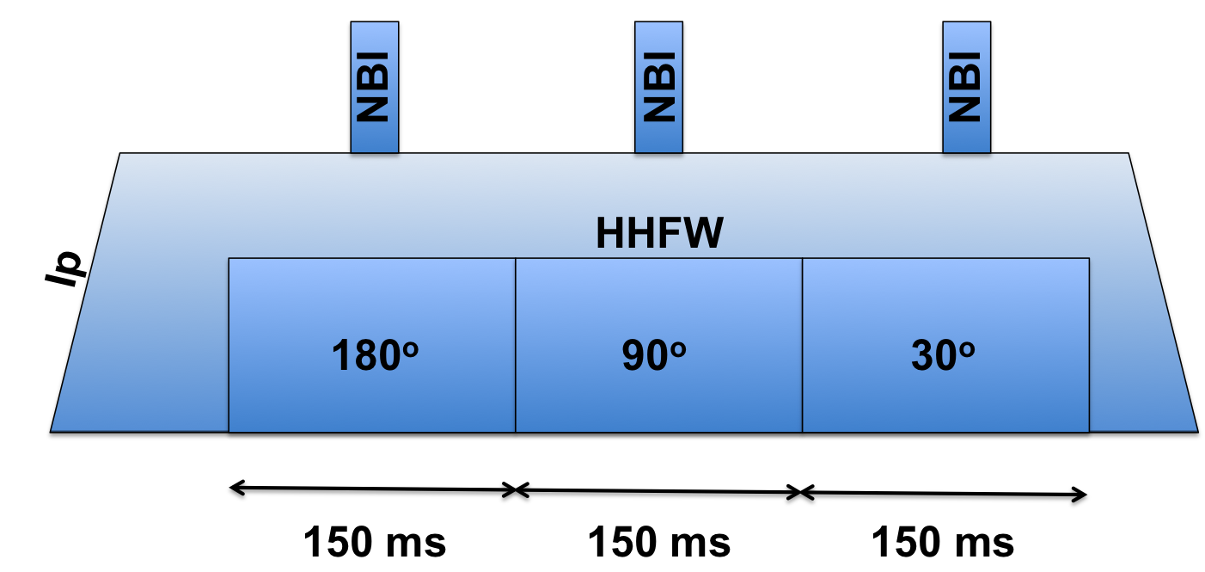

* **q95 scan**: Tune HHFW matching system to 90o and use 2.5 MW of RF power.
  + Shot 4: BT = 0.45 T and Ip = 1.0 MA.
  + Shot 5: BT = 0.65 T and I­p = 0.6 MA.
* **Radiative Divertor**: gradually increase divertor gas feed to “radiate away” the RF spiral. From earlier shots, select conditions that give strong SOL losses and that places the RF spiral in a good location for diagnostic observation; Shot 1 above is a likely candidate.
  + Shot 6: Starting 100 ms into HHFW pulse, begin to increase divertor He gas puffing by a substantial amount (probably a “staircase” waveform). We will discuss this beforehand
* **Priority Level 2 Shots**
  + Shot 7: Continue **Radiative Divertor** setup. Based on Shot 6, if core plasma (or overall plasma performance) is relatively unaffected, further increase the level of divertor He gas fueling. If overall performance suffered, reduce the level of additional divertor He gas puff.
  + Shot 8: Repeat **q95 scan** above with BT = 0.45 T, Ip = 0.60 MA.
  + Shot 9: Repeat **Magnetic field scan** above with BT = 0.45 T and Ip = 0.6 MA.
* **Priority Level 3 Shots:**
  + **Switch from He -> D:** Measure SOL density profile and HHFW performance as edge recycling changes once D is used instead of He. Set antenna phasing to 90o, BT = 0.55 T, Ip = 1.0 MA. Begin using deuterium. Record performance over the next several shots.
    - **NOTE:** If the shots from the last run before this XP were D, we can observe the reverse process during the D -> He transition.

*RF on NBI-driven H-Modes*

Working gas: **deuterium.** Outer gap TBD from XMP 026. Use 2 MW of beam power from source 1A (or whichever source allows for CHERS/ERD measurements). Li evaporation is requested; rate is TBD.

* **Magnetic field scan**: vary BT keeping q95 fixed. Apply 1.2 MW of HHFW. Match HFHW tuning system for 180o phasing. During each shot, vary antenna phase from 180o -> 90o -> 30o for 120 ms each [*NOTE: if flat-top time is less than 400 ms, we will drop the 30o phasing period*].
  + Shot 1: BT = 0.55 T, Ip = 1.1 MA.
  + Shot 2: BT = 0.65 T, Ip = 1.3 MA.
  + Shot 3: BT = 0.75 T, Ip = 1.5 MA.
    - *If max BT at runtime is < 0.75 T, instead use BT = 0.60 T and Ip = 1.2 MA.*
  + NOTE: if we lose the plasma (or H-mode) after the 180o phasing period, DO NOT repeat shot. Move on.
* **Antenna Phase & RF Power Scan**: Set BT = 0.45 T and Ip = 1.0 MA (or, select BT and Ip to locate spiral over RF Langmuir probes at Bay I). We will prepare a power-ramp waveform for the HHFW system that is to be used on each of these shots.
  + Shot 4: tune HHFW matching system to 180o. If necessary, adjust q95 and repeat.
  + Shot 5: tune HHFW matching system to 90o.
  + Shot 6: tune HHFW matching system to 30o.
* **Priority Level 2: Increased lithium evaporation**: Gradually increase lithium evaporation over the course of three shots and observe change in SOL density profile and HHFW performance. Select plasma conditions that give substantial SOL losses; Shot 7 above is a good candidate.
  + Shot 7: Increase Li evaporation
  + Shot 8: Increase Li evaporation
  + Shot 9: Increase Li evaporation
* **Priority Level 3 Shots**
  + Shot 10: Repeat **Magnetic field scan** setup with BT = 0.45 T and Ip = 0.9 MA

*Runtime & Shot Accounting*

For the purposes of the team review, the following is the list of assumptions I have made while planning the shot list.

* 24 shots/run day (20 min/shot)
* Runtime allocation of 0.5 “Priority 1” rundays and 0.25 “Priority 2” rundays
  + 12 “Priority 1” shots and 6 “Priority 2” shots
* A 50% shot failure rate [due to machine hiccups, RF trips, ect.]
  + *That means 6 “Priority 1” shots and 3 “Priority 2” shots*
  + Enough experimental material is proposed to “fill up” the runday if everything works miraculously well
* Maximum BT = 0.75 T
  + Instructions given for what to do if max BT = 0.65 T
* Maximum Ip = 1.5 MA
  + We probably don’t need to use the max Ip
* 500 ms flat-top
  + Allows for multiple antenna phase and power levels in a single shot
  + Limiting factors is slow-IR camera; want 3-4 frames @ 30 Hz for each phase/power setting, so ~ 100 – 150 ms is needed for each setting

# 4. Required machine, NBI, RF, CHI and diagnostic capabilities

* + XMP 026 is a pre-requisite for checking out the HHFW system end-to-end under plasma, for conditioning the antenna, and for compatibility of HHFW system with NBI systems.
  + To perform RF + NBI H-modes, we need at least one neutral beam with enough power to generate an H-mode (2 MW). We prefer Beam 1 Source A for diagnostic purposes.

# 5. Planned analysis

* EFIT and/or LRDFIT for equilibrium reconstruction; followed by SOL field-line mapping (SPIRAL).
* IR thermographic analysis to determine heat flux.
* AORSA and perhaps TORIC for wave propagation and absorption calculations. AORSA will probably use density profiles obtained from processing SOL reflectometer data.
* TRANSP to analyze HHFW heating of core
* Available impurity transport models to assess impact of HHFW

# 6. Planned publication of results

We want to generate a number of 2016 IAEA presentations: roughly, one focusing on the RF-spiral heat-flux properties, one on modeling based these results, one on SOL density measurements. Those that are accepted will also publish papers in Nuclear Fusion. Those that are not will still be submitted to peer-review journals.

# 7. Estimated Neutron Production

Based on the number of shots, plasma current levels, and expected durations, estimate the maximum neutron production of this experiment. See calculator in Appendix #2 for this calculation.

# of Shots used in Estimate:________ Estimated Total Neutron Production:________________

PHYSICS OPERATIONS REQUEST

|  |  |
| --- | --- |
| TITLE: **Characterizing the SOL Losses of HHFW Power in H-Mode Plasmas** | No. **OP-XP-1510** |
| AUTHORS: **R. Perkins et al.** | DATE: |

|  |
| --- |
| **Brief description of the most important operational plasma conditions required and any special hardware requirement:** Good control of the outer gap. |
| **Previous shot(s) which can be repeated: TBD from XMP 026**  **Previous shot(s) which can be modified: TBD from XMP 026** |
| **Machine conditions** *(specify* ***ranges*** *as appropriate, strike out inapplicable cases)*  BT Range (T): **0.45-0.75**  Flattop Duration (s): **>= 0.5**  IP Range (MA): **0.6-1.5 (1shot)** Flattop Duration (s): **>= 0.5**  Configuration: **DN or LSN**  Equilibrium Control: **Outer gap**  Outer gap (m): **TBD** Inner gap (m): **TBD** Z position (m): TBD  Elongation: **TBD** Triangularity (U/L): **TBD** OSP radius (m): **TBD**  Gas Species: **D / He** Injector(s): **MP CS, Divertor,**  **NBI** Species: **D** Heating Duration (s): **0.5 s**  Voltage (kV) 50 cm (1C): 60 cm (1B): 70 cm (1A): 2 MW  Voltage (kV) 110 cm (2C): 120 cm (2B): 130 cm (2A):  **ICRF** Power (MW): **Varies** Phase between straps (°): **Varies** Duration (s): **0.5**  **CHI**: **Off** Bank capacitance (mF):  **LITERs: Depends** Total deposition rate (mg/min) or dose per discharge (mg): **Varies**  **EFC coils: Off/On** |

DIAGNOSTIC CHECKLIST [1]

|  |  |
| --- | --- |
| TITLE: **Characterizing the SOL Losses of HHFW Power in H-Mode Plasmas** | No. **OP-XP-1510** |
| AUTHORS: **R. Perkins et al.** | DATE: |

*Note special diagnostic requirements in Sec. 4*

| **Diagnostic** | **Need** | **Want** |
| --- | --- | --- |
| Beam Emission Spectroscopy | **X** |  |
| Bolometer – midplane array |  | **X** |
| CHERS – poloidal |  | **X** |
| CHERS – toroidal |  | **X** |
| Divertor Bolometer (LADA) |  | **X** |
| Divertor visible cameras |  | **X** |
| Dust detector |  | **X** |
| Edge deposition monitors [2] |  |  |
| Edge neutral density diag. |  | **X** |
| Edge MIGs [2] |  |  |
| Penning Gauges [2] |  |  |
| Edge rotation diagnostic |  | **X** |
| Fast cameras – divertor [2] |  | **X** |
| Fast ion D_alpha - poloidal |  | **X** |
| Fast ion D_alpha - toroidal |  | **X** |
| Fast lost ion probes - IFLIP |  | **X** |
| Fast lost ion probes - SFLIP |  | **X** |
| Filterscopes [2] |  |  |
| FIReTIP |  |  |
| Gas puff imaging – divertor |  | **X** |
| Gas puff imaging – midplane |  | **X** |
| H cameras - 1D [2] |  |  |
| Infrared cameras [2] | **X** |  |
| Langmuir probes – divertor |  | **X** |
| Langmuir probes – RF | **X** |  |
| Langmuir probes – RF ant. |  | **X** |
| Magnetics – Diamagnetism |  |  |
| Magnetics – Halo currents |  | **X** |
| Magnetics – RWM sensors |  |  |

*Note special diagnostic requirements in Sec. 4*

|  |  |  |
| --- | --- | --- |
| **Diagnostic** | **Need** | **Want** |
| MAPP |  |  |
| Mirnov coils – high f. |  | **X** |
| Mirnov coils – toroidal array |  | **X** |
| MSE-CIF |  |  |
| MSE-LIF |  |  |
| Neutron detectors [2] |  | **X** |
| Plasma TV | **X** |  |
| Reflectometer – 65GHz |  | **X** |
| Reflectometer – correlation |  |  |
| Reflectometer – FM/CW |  |  |
| Reflectometer – fixed f |  |  |
| Reflectometer – SOL | **X** |  |
| SSNPA [2] |  | **X** |
| RF edge probes |  | **X** |
| Spectrometer – divertor |  | **X** |
| Spectrometer – MonaLisa |  |  |
| Spectrometer – VIPS |  |  |
| Spectrometer – LOWEUS |  | **X** |
| Spectrometer – XEUS |  | **X** |
| TAE Antenna |  |  |
| Thomson scattering | **X** |  |
| USXR – pol. Arrays |  |  |
| USXR – multi-energy |  |  |
| USXR – TG spectr. |  |  |
| Visible Brems. det. [2] |  |  |

Notes:

[1] Check marks in this table do not guarantee diagnostic availability. Check with diagnostic physicists or research operations management to ensure diagnostic coverage.

[2] In some cases, a given line represents multiple diagnostics. For instance, there are multiple SSNPAs, multiple IR cameras, multiple neutron detectors, and multiple Langmuir probe arrays.

**Appendix #1: Allowed Neutral Beam Power vs. Pulse Duration**

Heating of the primary energy ion dump limits the beam duration to that given in the following table[1]:

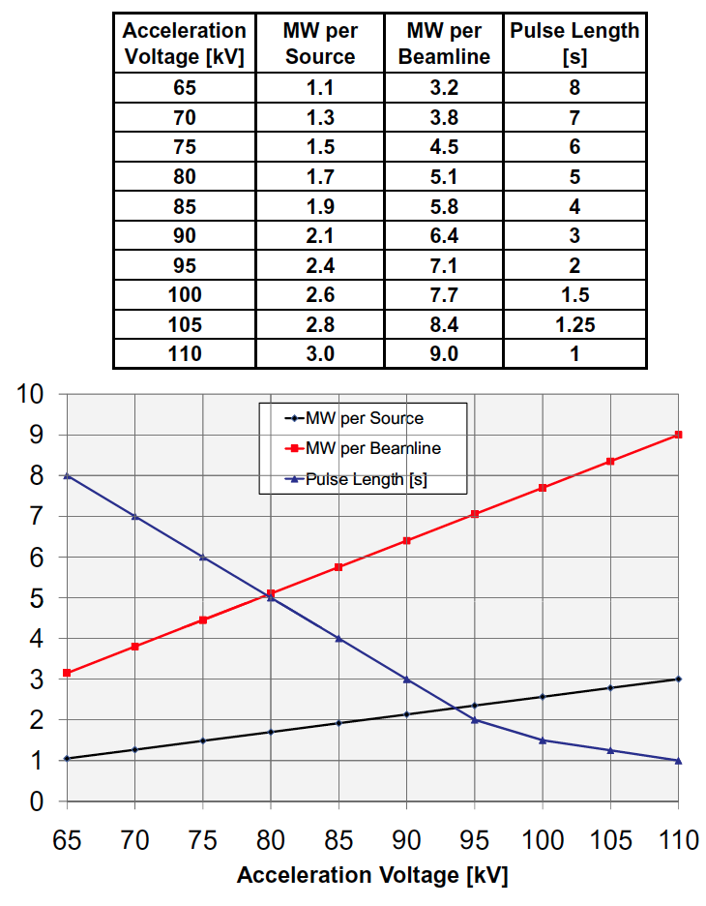

Table A1: Beam power and pulse length as a function of acceleration voltage

**Appendix #2: Table for neutron rate estimations:**



Table A2: Neutron Emission Rate Calculator. Double click to open in excel for automatic calculation. Change only the blue cells.

1. J.E. Menard, et al., Nuclear Fusion **52**, 2012 (83015)