Improvements in the fast vertical control systems in
KSTAR, EAST, NSTX and NSTX-U

D. Mueller¹, N.W. Eidietis², D. A. Gates¹, S. Gerhardt¹, S.H. Hahn³, E. Kolemen¹, J. Menard¹, S.W. Yoon³, and B.J. Xiao⁴
email: dmueller@pppl.gov
¹ Princeton Plasma Physics Laboratory, Princeton Univ., Princeton, N.J. 08543, U.S.A.
² General Atomics, San Diego, CA, 92186-5608, U.S.A.
³ National Fusion Research Institute, Daejon, Korea
⁴ Institute of Plasma Physics, Chinese Academy of Sciences, Hefei Anhui, China

The realization of a wide variety of plasma shapes with varying plasma current density profiles places challenging demands on the vertical control system. In particular the bootstrap current scales quadratically with elongation at fixed normalized β_{N} = β_{T}aB_{T}/Ip where I_{p} is the plasma current, B_{T} is the toroidal field, and β_{T} = P/(B_{T}²/2μ₀) and P is the volume averaged plasma pressure. The plasma elongation is controlled by the action of coils that generally act to produce a field shape with an index of curvature that is closer to vertical instability as the elongation is increased. In devices such as KSTAR, EAST and ITER, the superconducting coils are separated from the plasma by conducting structures that limit the plasma response time to changes in the coil currents. Fast control of the plasma vertical motion, essential for stable operation at high elongation and disruption avoidance, can be accomplished with coils internal to the vacuum vessel in these devices.
The shape control systems in these tokamaks are generally based upon equilibrium analysis that does not lend itself well to fast control and in particular cannot produce a reliable time derivative of the vertical position. The simple analysis of standard integrated magnetic signals to produce a vertical position (z) signal can be incapable of yielding a derivative term (dz/dt) that has sufficient signal-to-noise ratio to be adequate for control. Furthermore, for the two existing superconducting tokamaks, the slow response of the plasma to the distant superconducting coils necessitates the introduction of coils internal to the vacuum vessel in order to provide faster control of vertical instabilities. Each of the four devices, NSTX, EAST, KSTAR and NSTX-U, uses its own version of the GA plasma control system (PCS) to control the coil power supplies with feedback on plasma parameters.
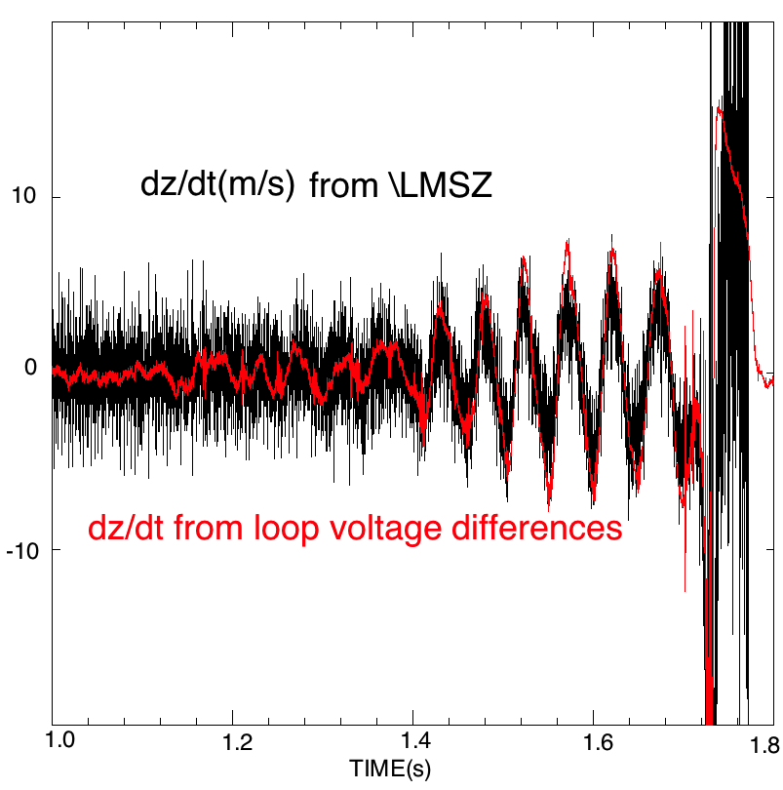Figure 1. The derivative of the fast z signal derived from integrated magnetics sensors shown in black is exhibits much more noise that the dz/dt term from the difference in a pair of up-down symmetric voltage loops shown in red.
The difference of the signal from up-down symmetric pairs of voltage loops can be used to provide a better signal for the dz/dt in the PD control loop of z. The NSTX control system used the analog difference of a pair of voltage loops, with a 2 kHz low-pass filters to remove signal due to n=1 plasma instabilities, to provide the dz/dt signal. This signal was used in the control of the difference in the rectifier power supplies for up/down difference in a pair of outer PF coils. Use of this improved signal-to-noise ratio signal realized an improvement in vertical control that allowed elongation (κ) to be increased by about 0.2.
The KSTAR control system uses coils internal to the vacuum vessel to provide control of vertical instabilities and has instrumented 2 pairs of voltage loops to provide a fast dz/dt that has better signal to noise than the derivative of signals derived from flux loops or Mirnov coils as can be seen in Fig. 1. Relay feedback was used to optimize the vertical PD control gains. The use of the voltage loop pairs in the control system has been successfully tested, but insufficient operational experience exists so far to quantify the improvement in controllability.
The EAST control system has been modified to include pairs of loop voltage difference signals and a relay feedback system to identify gains. Furthermore, the internal coil power supply has been modified to use voltage control rather than current control for faster response. These modifications will be commissioned, tested and the resulting performance will be documented in the next experimental campaign.
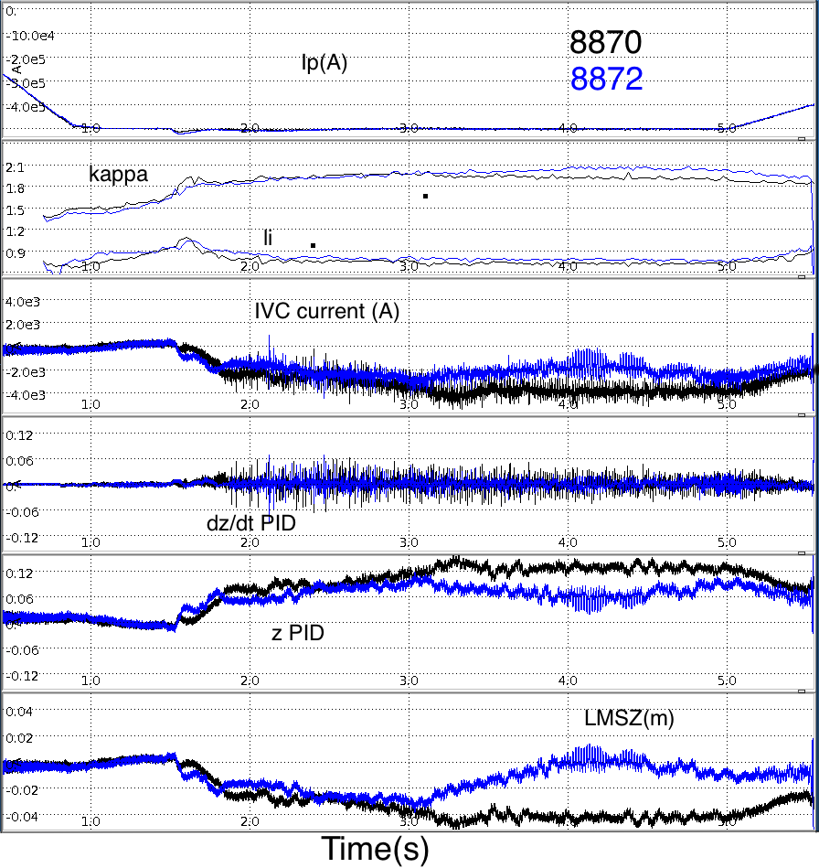
Figure 2. Comparison of plasma current, elongation, plasma internal inductance, IVC current, feedback terms and z position in KSTAR as a function of time for two discharges. For shot 8872, the z-position target was adjusted beginning at 3 s to achieve z ~ 0 after 4 s in plasmas with otherwise identical control. Note higher kappa in the shot with z~0.
NSTX-U will have 6 pairs of voltage loops instrumented to provide dz/dt for feedback control. Use of the RMP saddle coils with 7 kHz power supplies for vertical control will be tested for use in vertical control if the use of the slower rectifier supplies on the poloidal field coils proves inadequate at high elongation with high internal plasma inductance l_{i}.
In each device, the ability of the fast vertical control is affected by the slower shape control so the target values for the fast and slow control must be consistent in order to provide good control. Figure 2 illustrates an example of a DND plasma in which the z request in the fast control loop was adjusted to match the z provided by the slower shape control and results in more symmetrical plasma with higher kappa.
The results of using the voltage loop-based sensors in the KSTAR and EAST fast vertical control loops in their upcoming runs will be presented. In particular, the efficacy of employing these diagnostics in the fast control loop to achieve greater plasma elongation over a range of plasma internal inductance will be examined.

This research was supported by U.S. DOE contract DE-AC02-09CH11466

D.A. Gates et al., Nucl. Fusion 46 S22-S28 (2006) doi:10.1088/0029-5515/46/3/S04

