NSTX-U Plasma Facing Components
Requirements Document: NSTXU-RQMT-RD-002-00
*** Draft ***

_________________________________
Author: Stefan Gerhardt

___________________________________________________
NSTX-U PFC Requirements Working Group Leader: M.L. Reinke

_______________________________
NSTX-U Research Director: J. Menard

_____________________________________________
NSTX-U Recovery Project PFC Engineer: M. Mardenfeld

_________________________________________________
NSTX-U Vacuum Vessel and Internal Hardware RE: M. Sibilia

___________________________________
NSTX-U Engineering Director: C. Neumeyer

Record of Revisions
Revision | Date | Description of Changes
0 | 4/17/2017 | Initial Release (d/l from Google Doc on 3:40 pm on 4/17/17 and removed remaining unresolved comments)

Table of Contents
0.0 References 3
1.0 Introduction 4
2.0 General requirements 5
2.1: Materials and Structural Requirements 5
2.2: Disruptions and Halo Currents 5
2.3: General Thermal and Cycle Requirements 6
2.4: Bakeout Considerations 6
2.6: PFC Locations 7
2.7: Diagnostic Requirements 7
2.8: Installation and Maintenance Requirements 8
3.0 Requirements By Location 9
3.1: CS Narrow Section 9
3.1.1 CS Tile Alignment Tolerance: 9
3.1.2 CS Tile Diagnostics: 9
3.1.3 CS Tile Heat Flux: 9
3.2 Inner Horizontal Target 9
3.2.1: Stationary Heat Flux with Standard Target Helicity 10
3.2.2: Swept Heat Flux with Standard Target Helicity 11
3.2.3: Stationary Heat Flux with Reversed Target Helicity 12
3.2.4: PFC Dimensions 14
3.2.5: Diagnostic Requirements for the Horizontal Target 14
3.3: Vertical Target 15
3.4: Outboard Divertor 17
3.4.1 Stationary Heat Fluxes From Cases with the OSP on the IBDH 17
3.4.2 Stationary Heat Fluxes with the OSP on the OBD 17
3.4.3 Standard Divertor Heat Fluxes with the OSP near OBD Center 18
3.4.4 OBD Diagnostic Considerations 20
3.5: Passive Plates 20
3.6: Outboard Limiter 20
4.0 Interfaces Error! Bookmark not defined.
4.1: Vessel Heating/Cooling Systems 22
4.2: Diagnostics 22
Appendix: 23
A.1: Heat Flux Computation Methodology 23

0.0 References
[1] NSTX-U CS-Upgrade GRD, Rev. 6
[2] NSTX-SRD-11-031: System Requirements Document, Plasma Facing Components, Rev. 1, May 11, 1998
[3] NSTX-U-SRD-111-013: System Requirements Document, Plasma Facing Components, Rev. 0, June 20, 2011
[4] NSTX-CRIT-0001-02: NSTX Structural Design Criteria, January 2016
[5] Design Point Spreadsheet, file NSTX_CS_Upgrade_120409.xls or http://w3.pppl.gov/~neumeyer/NSTX_CSU/Design_Point.html
[6] Halo Current Memo_Rev3.docx
[7] Drawing E-ED1324: Centerstack and Inboard Divertor Sensor and Cabling Layout
[8] Drawing NSTX-345:
The requirements in Ref. [3] hold unless specifically contradicted by this document.
[9] NSTXU-CALC-11-05-00: Thermal Analysis of Neutral Beam Armor Array
[10] NSTXU-CALC-24-02-00 Armor Plate Backing Plate (Neutral Beam Armor E/M)

1.0 Introduction
The plasma facing components are designed with two complementary goals. First, they must protect the metallic structures of the vessel (the vessel wall, passive plates, etc.) from damaging heat fluxes from the vessel. Second, they must protect the plasma from influx of medium- and high-Z impurities that can contaminate it.

The NSTX-U Recovery Project requires that design of the divertor and potentially first wall PFCs be revisited, and likely that some tiles be redesigned, re-fabricated, and re-installed. This document provides requirements for design, analysis, fabrication, and installation of those tiles.

Working with the Vacuum Vessel and Internal Hardware RE, the PFC Engineering team should:

1: Work iteratively with the NSTX-U PFC Requirements Working Group (PFCR-WG) to develop requirements for the graphite tiles and outboard limiter. The initial draft of this requirements document is based on simple physics assumptions that will be revised in the future. Topics that are subject to revision are indicated in italics.

2: Assess existing CS, IBDV, IBDH, and OBD tiles, and outboard limiter, for consistency with requirements.

3: Develop new tile design for those regions that fail to meet requirements. Iterate requirements and design through FDR.

4: Lead efforts to procure, fabricate, and install said tiles.

2.0 General requirements

2.1: Materials and Structural Requirements
All PFCs in NSTX-Upgrade shall be made from either fine grain isotropic graphite, or from other carbon based materials, for instance carbon-carbon composites, here referred to as CFCs. The exception to this is the outboard limiter which can be made from boron nitride if integrated/combined with the RF antenna limiter.

For isotropic graphite, the brittle materials qualification shall be used, as per the structural design criterion [3]. The same criterion shall be applied to other carbon based materials for now; this requirement can be relaxed in a future revision based on test or additional data.

The PFCs themselves and any related materials should be compatible with a high vacuum environment. They should accommodate the following:
- Application of boron thin films as deposited by the dTMB system.
- Application of lithium thin films as deposited, for instance, by the LITER probes.
- Glow discharge cleaning with hydrogen, deuterium, helium, neon, and argon.

Non-ferritic materials should be used for all fasteners. SS316, A286 or Inconel are preferred. Magnetic permeability requirements shall be adhered to as per reference [1]

2.2: Disruptions and Halo Currents
Accommodation for halo currents as per memo by S. Gerhardt, located in the requirements folder. Tile designs should have a well defined means for halo currents entering the tile front surface to flow to backing structures. The design of the IBDH and OBD tiles (top and bottom) should accommodate halo currents bridging that gap during disruptions, with currents levels as ber the memo. A future version of this document will encapsulate the physics guidance into current density per unit area and nominal maximum field strengths which can be used to generate engineering load inventories.

Eddy current requirements as per the GRD [0].

The following disruption heat loads should be considered independently, coming after one of the heat loads from Section 3.1-3.6 have been applied from the ~5 second plasma.

- Disruption thermal quench loading based radiated power flux. Assume a radiative heat flux of 100 MW/m² is applied for 1 ms applied normal to the tile surface. This is based on an assumption of 1.5 MJ of energy in 1 ms, with 100% of the energy distributed into 15 square meters (~½ of the area). This specification may be updated with more complete requirements in a future revision.
or
- Disruption thermal quench loading based on plasma making contact with the PFCs during vertical disruption event. Assume a 1.5 GW/m² perpendicular heat flux, applied for 2 ms. This is based on the assumption of a 1.5 MJ stored energy, location and extent of contact area of 0.5 m² in 2 ms. This energy flux/duration and attack angle specification may be updated with more complete requirements in a future revision.

2.3: General Thermal and Cycle Requirements
The PFCs shall meet the following general thermal requirements
- The design scenarios described in sections below shall be qualified for repetition rate of <= 1200 seconds.
- The surface temperature of the wetted top face, away from local peaks at the edges, at the end of the pulse shall not exceed 1600 C; disruption heating need not be included in this consideration. These values will be updated or confirmed in a future revision.
- The edge temperature shall not exceed 2000 C; disruption heating need not be included in this consideration. These values will be updated or confirmed in a future revision.
- Unless otherwise stated, the duration of heat flux is to be taken as 5 seconds
- The disruption heat loads above need to be applied as well (fix text)

Cooling between shots may be performed by flowing gaseous helium through the existing in-vessel tubing. If this become necessary, a future version of this document shall enumerate the specific cooling heat fluxes provided by the helium, and the temperature at each interface as agreed with the Bake Out System engineer.

The tiles and fasteners should be qualified for the full lifetime of NSTX-U as per the GRD shot spectrum [0]. In particular, the full thermal and mechanical performance noted here shall be qualified for >5000 cycles.

Specific requirements on a per-location basis are provided in Section 3.1-3.6.

Tile designs favoring one target helicity may be used if necessary. Specifics of the helicity direction are identified in Section 3.1-3.6 per each individual PFC area. Vertical gaps, front-surface holes, etc. are allowed provided that designs can meet stress and temperature requirements.

2.4: Bakeout Considerations
All graphite shall be capable of being baked to 350 C. Provision shall be made to ensure that the mounting structure for PFCs provides appropriate levels of heat transfer to underlying heated structures. Interface heat fluxes shall be provided for each tile region specifying the thermal energy which can be provided by the Bake Out System.

CS Bakeout will continue to use a DC supply, and it is assumed here that the present insulators will be retained. Therefore, gaps between IBDH and OBD tiles should be sufficient to satisfy a 500 voltage differential w/o arcing at the following pressure levels: atmospheric pressure, NSTX-U operational vacuum, and NSTX-U bake out.

2.6: PFC Locations
In general, PFCs should conform to the envelope stated in Figure PFC-2.1-1 and Table PFC-2.1-1 of Ref. [1], and on the “CSC Dims” sheet of the Design Point Spreadsheet [5], unless otherwise stated.

PFCs design should ensure that there is no large line-of sight from the plasma to the centerstack casing, centerstack bellows, outer vacuum vessel in the “polar regions”, or PF-1c reentrant housing. Here, “large gaps” do not preclude nominally small tile-to-tile gaps. Regions on the casing and divertors not protected from direct lines of sight shall be minimized. For this revision, the intra-tile heat flux shall be taken as 1 MW/m², and may be updated on a per-region basis in a future revision to this document.

The tile design should accommodate the shrinkage of the CS under Lorentz load, and the expansion of the CS under thermal loads from the plasma or from bakeout. Tile design at the interface between the IBDHu and OBDu should also accommodate expected lateral lateral displacements from asymmetric halo currents w/o tile collision. A future version of this document will specify the range of dimensional change of the CS Casing.

In the future, a requirement on the IBDH/OBD gap may be defined based on transient Cat3/Cat4 voltages during normal operations and the expected divertor pressure.

2.7: Diagnostic Requirements

Requirements for diagnostics for specific locations are provided in the individual sections below. Detailed requirements will be provided in a later revision. Use of existing designs is encouraged but not required. General requirements include:

- Use of the existing Mirnov coil design is encouraged but not required. Any new designs for Mirnov coils should attempt to match the effective loop area * turns of the existing sensors at those locations as best possible. Mirnov may be mounted in tiles themselves as in the present design, or in structure immediately behind/beneath the tiles.
- If the present copper/omega-bond scheme is utilized for Mirnov coils, then the temperature of the Mirnov coils shall not exceed 550 C at any time during the plasma pulse or subsequent between-shot cooling period.
- Thermocouples should be placed in tiles as specified in Sections 3.1-3.6 such that the energy deposited in the tiles can be quantified.
- Langmuir probes should be integrated in the CS, IBDH, IBDV and OBD tiles or between tile submodules.
- Holes providing access to the organ pipes as per E-DC1324 shall be included.

Future versions of this document, or new documents, will specify detailed requirements for diagnostic designs.

Reference future PFC monitoring or protection document(s)

2.8: Installation and Maintenance Requirements

In order to ensure that the PFCs can be installed in a safe and efficient manner, the following requirements hold:
- No module or single component shall weigh more than 60 lbs, unless lifting and handling tooling and procedures are specially developed
- Any module and component must fit through the Bay A duct w/o the use of an overhead crane.
- Tiles of the base design should be able to bear the weight of technicians working in vessel. For design purposes, this can be assumed to be 300 lbf distributed over an area of 4 in². Langmuir probe tips or other specific fine features are an exception to this rule, and may require protection.

Furthermore, the design shall be such that removal replacement of any graphite tile shall not mandate the removal of the center-stack or outboard divertor copper/stainless structure.

An assembly sequence shall be provided with the design that takes account of machine assembly (including CS insertion to the machine), wire management, and any industrial hygiene concerns.

3.0 Requirements By Location
This section defines the requirements by location. The thermal loads so-derived should be added to those from halo currents and eddy currents. Future revisions to this section will also discuss diagnostic requirements by region.

The heat fluxes here are based on the v3 heat fluxes provide by Jon Menard. The values in the tables are typically based on exponential fits to the profiles. Profiles of field directions and heat flux magnitudes along the divertor surface are available upon request.

The numerical values in this Section 3 are subject to revision based on improvement to the underlying physics models and assumptions. Additionally, any non-axisymmetric effects due to, for instance, the application of external 3D fields or error fields, are not considered; these may be included in a future revision to this document.

3.1: CS First Wall Section (CSFW)

3.1.1 CS Tile Alignment Tolerance:
The CS tile height alignment tolerance will be specified in a future revision of this document based the leading edge heat flux peaking. Until that time, the a nominal target of .010” shall be used as a temporary goal..

3.1.2 CS Tile Diagnostics:
The CS tiles shall have as an initial goal diagnostics as indicated in drawing E-D1324. Provision shall be made for diagnostic wireways as appropriate.

3.1.3 CS Tile Heat Flux:
The CS tile heat flux is assumed to be dominated by radiation. For initial scoping studies, a uniform normal heat flux of 1 MW/m² should be used. This will be revised in the future, including expected heat flux from startup/limited phase.

3.2 Inner Horizontal Target

The horizontal target is the one plasma facing surface that may have heat from either the inner or outer strikepoint deposited on it. For the purpose of this document, “standard target helicity” refers to the field line direction when the Outer Strike Point is located on the IBDH tiles, for clockwise toroidal field and counter-clockwise plasma current (when viewing the tokamak from the above). Reversed target helicity refers to cases where the Inner Strike Point falls on the horizontal target tiles.

Formal tile alignment requirements are not provided for the inner horizontal target. Rather, leading edge temperature limits and field line impingement angle considerations should be used to determine the allowed tile gap and vertical alignment tolerances.

For this set of tiles, the range of field line angles in 0.9 to 5.4 degrees for standard target helicity and 1.3 to 4.0 for reversed target helicity.

3.2.1: Stationary Heat Flux with Standard Target Helicity
The horizontal target tiles shall accept the stationary heat fluxes from the scenarios noted in Table 3.2.1. Here, stationary refers to an unchanging magnetic equilibrium. The range of angles of incidence to these tiles are from 0.9 to 1.6 degrees for these cases.

Table 3.2.1: Heat flux characteristics for stationary cases on the inner horizontal divertor.
Case Name | Geqdsk file | Peak Heat Flux | E-folding width | q_{peak} Radius | Strike Point Radius | |Inclination Angle at Strike Point|
 | --- | MW/m² | cm | m | m | degrees
1.1 | NfHz0+_0 | 6.41 | 14.5 | 0.566 | 0.549 | 0.90
1.3 | NfHz0+_2 | 10.6 | 4.38 | 0.568 | 0.559 | 1.6
1.8 | NfHz0+_7 | 8.51 | 5.70 | 0.526 | 0.514 | 1.2

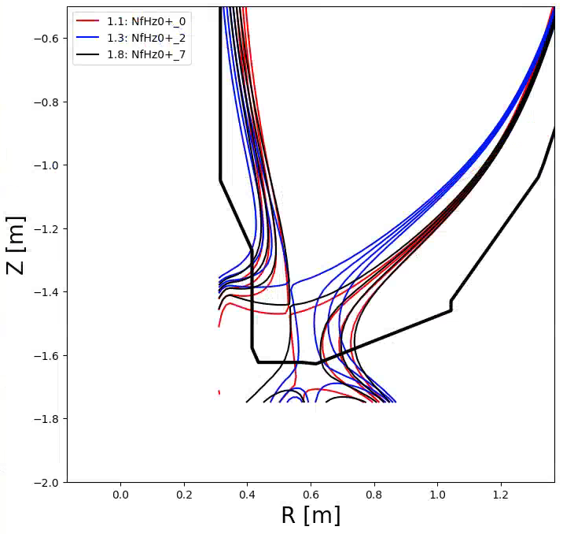
Fig. 3.2.1: Stationary high flux expansion divertor geometry placing heat on the inner target.

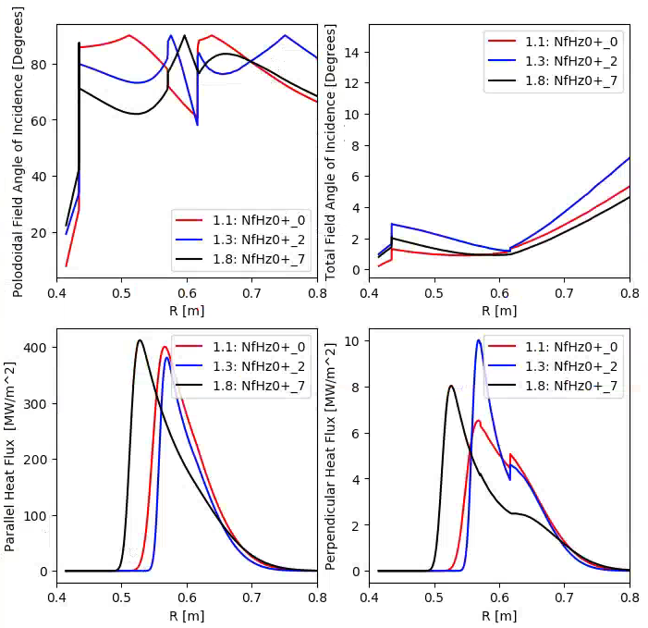
Fig. 3.2.2: Stationary divertor profiles for high flux expansion scenarios placing heat on the inner target.

3.2.2: Swept Heat Flux with Standard Target Helicity

The horizontal target tiles shall accept the swept heat fluxes from the scenarios noted in Table 3.2.2. The range of angles of incidence to these tiles are from 1.3 to 5.4 degrees from these cases.

Table 3.2.2: Heat flux characteristics for swept cases on the inner horizontal divertor.
Case Index | Geqdsk file | Peak Heat Flux | E-folding width | q_{peak} Radius | Strike Point Radius | |Inclination Angle at Strike Point|
--- | --- | MW/m² | cm | m | m | degrees
3.7 | NfHz0+0g | 41.3 | 1.55 | 0.527 | 0.524 | 5.3
3.6 | NfHz0+0f | 17.9 | 3.37 | 0.489 | 0.481 | 2.2
3.5 | NfHz0+0e | 34.0 | 1.96 | 0.499 | 0.494 | 4.3

In all cases given, the sweeping can be up to +10 cm outboard from the strikepoint location provided in the table. Full sweep rates up to 5 Hz can be used. These values will be updated or confirmed in a future revision.

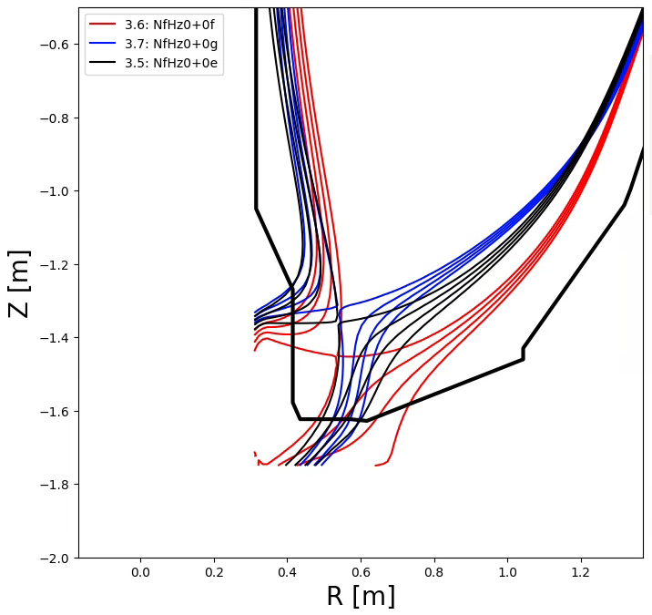
Fig. 3.2.3: Standard divertor geometry placing heat on the inner target. Sweeping is allowed for these cases.

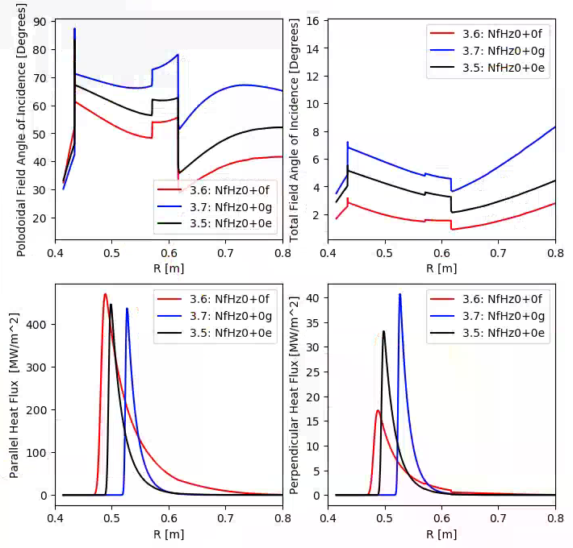
Fig. 3.2.4: Heat flux profiles for standard divertors placing heat on the inner target. Sweeping is allowed for these cases to qualify 5 second operations.

3.2.3: Stationary Heat Flux with Reversed Target Helicity

The horizontal target tiles shall accept the stationary heat fluxes from the scenarios noted in Table 3.2.2. Sweeping over the range R=[0.49, 0.57 ] at up to 5 Hz can be utilized to accommodate this heat flux. This case must be maintained for 1.0 seconds.

Table 3.2.3: Heat flux characteristics cases on the inner horizontal divertor.
Case Index | Geqdsk file | Peak Heat Flux | E-folding width | q_{peak} Radius | Strike Point Radius | |Inclination Angle at Strike Point|
--- | --- | MW/m² | cm | m | m | degrees
4.12* | NfHz0+QF | 6.78 | 2.27 | 0.601 | 0.601 | 3.7
* This case assumes a double null power split, for 0.7 MW on the lower inner target. This differs from the value in the excel sheet, which assumes a SN equilibria and peak heat flux of 23 MW/m².
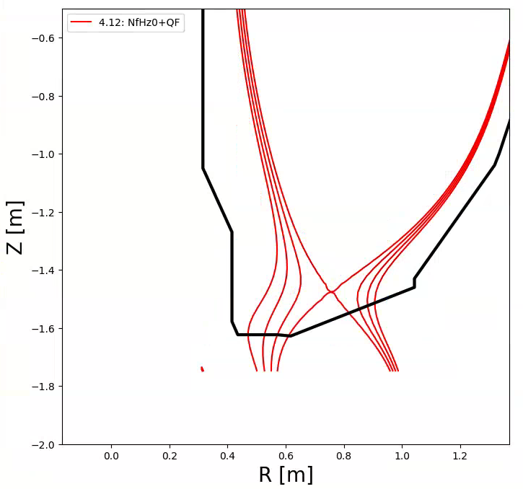
Fig. 3.2.5: Low triangularity equilibrium. This case has reversed target helicity on the inboard horizontal target.

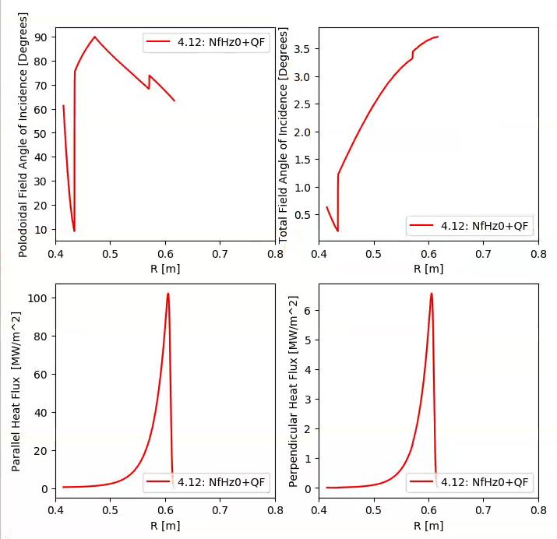
Fig. 3.2.6: Inboard horizontal target profiles for case with ISP on the horizontal target. This case has revered target helicity on the inner horizontal target. Note that a DN power split on the inner leg is assumed, unlike in the excel spreadsheet.

3.2.4: PFC Dimensions
As stated in Section 2.6, reasonably efforts should be made to stay within the envelope set by the NSTX-U Upgrade project GRD [1] and the Design Point Spreadsheet [5]. However, should this prove inconsistent with meeting other requirements, the tiles may grow vertically by up to 0.5 inches, and may be compressed in the vertical direction by an arbitrary amount (while meeting all other requirements, including diagnostic inclusion).

If the thickness of the IBDH tiles changes compared to the initial NSTX-U design, then the OBD tiles should be adjusted so that there are no vertical steps from tile to tile. The IBDV tiles will likely need adjustment as well, for at least the row of tiles nearest the horizontal flange.

3.2.5: Diagnostic Requirements for the Horizontal Target

Ideally, the diagnostic layout should remain as manifest in E-D1324. However, new designs may lead to revised constraints on diagnostics. Should that be the case, the following prioritization should apply:

- Thermocouples assessing the temperature of the bulk tile material should be integrated into the baseline design of any new tiles. Number and layout in the device in order to provide redundancy and assess potential non-axisymmetries to be defined in future revisions.
- Two axis magnetic field sensors (“2D Mirnovs”) should be installed at at least 2 toroidal angles in each of the upper and lower targets. As per E-D1324, Bays B and H are the ideal locations. Having multiple radial positions at each angle, as at Bay H in the initial NSTX-U design, is desirable but not required. Mirnov coils need not be embedded in graphite if other constraints render that inconvenient.
- Langmuir probes shall be developed consistent with high-level mechanical requirements. This may include locating sensors on the corners or edges of tiles. Number and layout to be defined in future revisions

3.3: Vertical Target

The vertical target shall be satisfy the ISP heat fluxes from the same cases in Table 3.3.1, Fig. 3.3.1, and Fig. 3.3.2. The range of angles of incidence to these tiles are from 1.6 to 4.2 degrees.

Table 3.3.1: Heat flux characteristics for stationary cases on the inner vertical divertor.
Case Index | Geqdsk file | Peak Heat Flux | E-folding width | q_{peak} Height | Strike Point Height | |Inclination Angle at Strike Point|
 | --- | MW/m² | cm | m | m | degrees
1.1 | NfHz0+_0 | 5.4281 | 4.7381 | -1.451 | -1.459 | 2.009
1.3 | NfHz0+_2 | 7.767 | 2.7059 | -1.3806 | -1.3861 | 3.3635
1.8 | NfHz0+_7 | 6.2266 | 3.8953 | -1.424 | -1.43086 | 2.49565
4.3 | NfHz0+Q3 | 10.2512 | 1.95033 | -1.58726 | -1.60657 | 4.20507

If the static heat loads cannot be met, then strikepoint sweeps with amplitude [0,+5 cm] at up to 5 Hz may be invoked to mitigate the heat flux. This range will be updated or confirmed in a future revision.
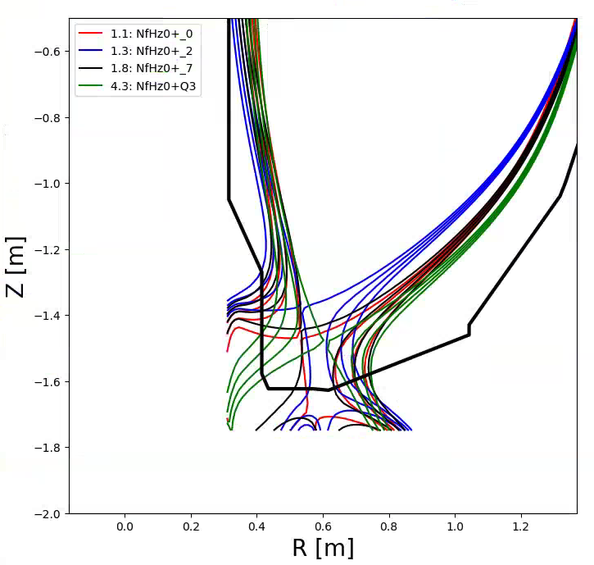
Fig. 3.3.1: Heat flux profiles on the vertical target.

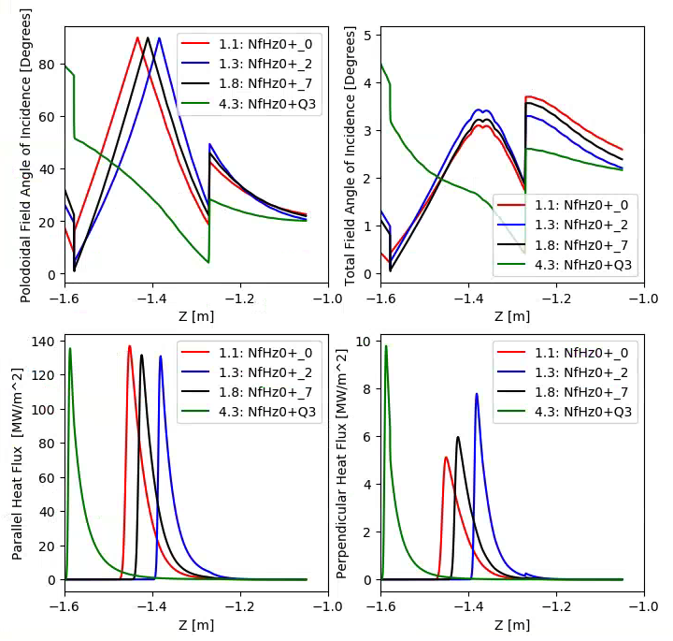
Fig. 3.3.2: Heat flux profiles on the vertical target.

3.4: Outboard Divertor
Only the outer strike-point can reach the outer target. Therefore reversed target helicities are not required. The range of angles of incidence to these tiles are from 0.86 to 6.9 degrees.

3.4.1 Stationary Heat Fluxes From Cases with the OSP on the IBDH

The cases described in 3.3.1 and 3.3.2 put the strikepoint on the IBDH. However, some heat will spill onto the OBD tiles in these cases. The OBD tiles shall be qualified for these level of heat fluxes for the full 5 second duration. The cases in 3.3.1 should be qualified for stationary configurations, while 3.3.2 is based on a swept strikepoint.

3.4.2 Stationary Heat Fluxes with the OSP on the OBD

In addition to the content in Section 3.4.1, outboard divertor tiles shall be qualified for the cases in table 3.4.1 for 5 second duration:

Table 3.4.1: Heat flux characteristics for stationary large flux expansion cases on the outboard horizontal divertor.
Case Index | Geqdsk file | Peak Heat Flux | E-folding width | q_{peak} Radius | Strike Point Radius | |Inclination Angle at Strike Point|
 | --- | MW/m² | cm | m | m | degrees
1.21 | NfHz0+_k | 9.19 | 10.4 | 0.603 | 0.593 | 1.5
1.6 | NfHz0+_5 | 6.811 | 26.0 | 0.599 | 0.585 | 1.2
1.24 | NfHz0+_n | 11.3 | 7.60 | 0.615 | 0.604 | 1.6

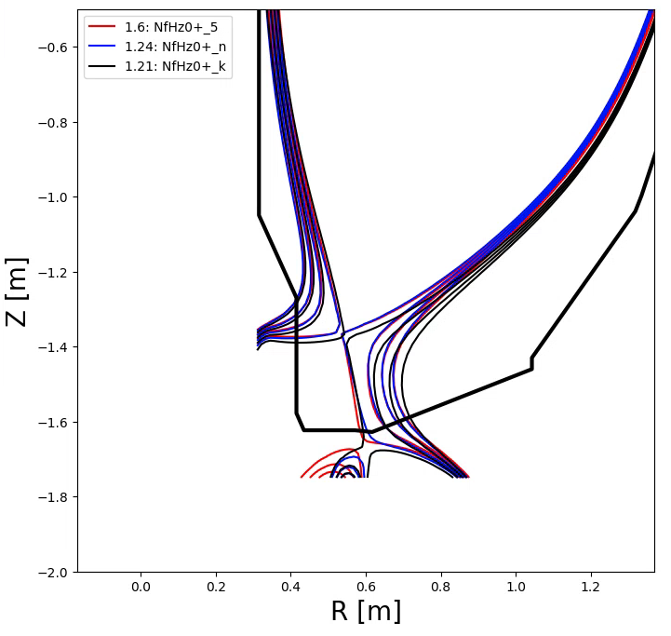
Fig. 3.4.1: Stationary high flux expansion divertor geometry placing heat on the outer target.

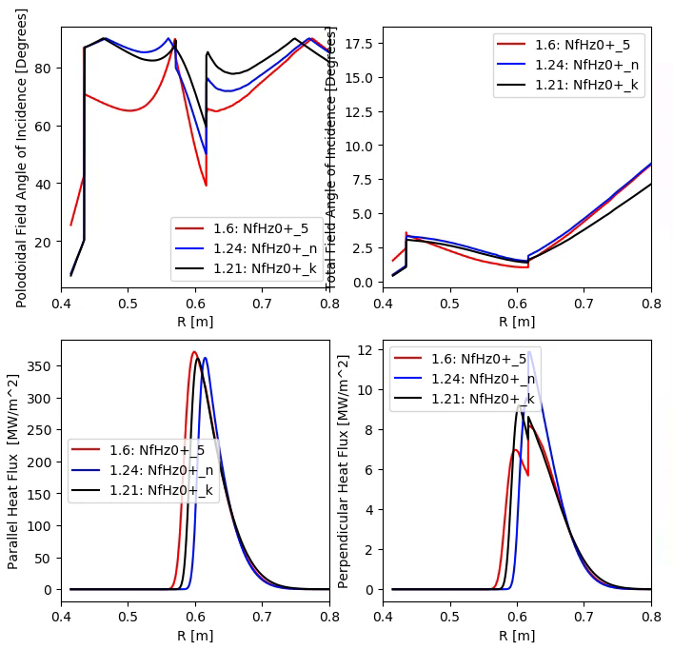
Fig. 3.4.2: Stationary high flux expansion divertor geometry placing heat on the outer target.

3.4.3 Standard Divertor Heat Fluxes with the OSP near OBD Center
It is required to run some low-triangularity cases for shorter duration, in order to assess various topics in MHD stability, transport, and divertor physics. As in Section 3.2.3, these cases shall be qualified for 2 seconds duration only. This value will be updated or confirmed in a future revision. See Fig. 3.4.3 for graphical representations of the magnetic equilibria, and Fig. 3.4.4 for profiles of the heat flux.

Table 3.4.2: Heat flux characteristics requirements for stationary low elongation cases on the outboard horizontal divertor.
Case Index | Geqdsk file | Peak Heat Flux | E-folding width | q_{peak} Radius | Strike Point Radius | |Inclination Angle at Strike Point|
 | --- | MW/m² | cm | m | m | degrees
4.3 | NfHz0+Q3 | 24.0 | 2.27 | 0.675 | 0.671 | 3.9

These cases may be qualified with static heat flux profile, or, if necessary, a [-2,+10] cm sweep with oscillation frequency up to 5 Hz. These values will be updated or confirmed in a future revision.

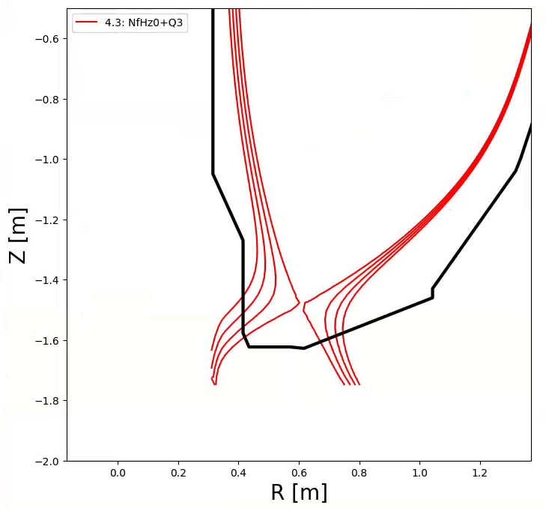
Fig. 3.4.3: Low-triangularity equilibrium placing heat on horizontal inner target (Section 3.2.3) and the middle of the outer target.

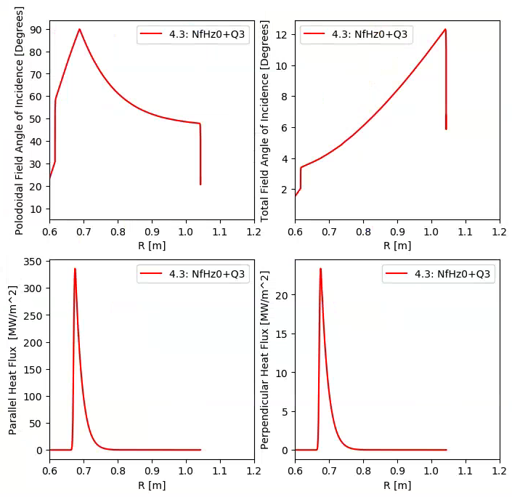
Fig. 3.4.4: Heat flux profiles for low-triangularity equilibrium placing heat on horizontal inner target (Section 3.2.3) and the middle of the outer target.

3.4.4 OBD Diagnostic Considerations
The outboard divertor diagnostics are described in drawing NSTX-345. The diagnostic layout should remain similar to the largest extent possible. Modifications from that layout shall be determined in future documentation, in consultation with physics.

3.5: Passive Plates
The requirements enumerated in Section 2.2 of Ref. [3] shall continue to hold for the passive plate PFCs. No changes are anticipated for these PFCs, but these values will be updated or confirmed and incorporated into a future revision of this document.

3.6: Outboard Limiter
This section will be updated in a future revision to this document.

3.7 Neutral Beam Armor

The neutral beam armor shall tolerate radiative heat fluxes from the plasma of ~1 MW/m2. The armor must also tolerate neutral beam fluxes, as described in Ref. [9][10]. These need not be applied simultaneously.

3.8 Regions not otherwise specified
This section will be updated in a future revision to this document to specify requirements for other regions, e.g., minimum heat fluxes for components not protected by PFCs.

Add something for disruption fluxes?
Large distance from strike point what is the heat flux (blobs, ELMs, Eich being wrong)

4.0 Interfaces
A future revision of this document will tabulate each interface with quantitative values and schematics with control volumes indicating exactly where each interface is located, along with any heat, load, displacement, current, etc. which occurs across it.

4.1: Vessel Heating/Cooling Systems

The tiles must interface to the vessel heating and cooling systems in order to
i) bake out the tiles
ii) cool the tiles between discharges.

With regard to item i), the Vacuum Vessel and Internal Hardware RE should work with the Bakeout Systems RE to develop the interface requirements, including conduction and radiative heat transfer from components directly heated by the hot He system. This document will be updated once these requirements are more explicitly defined.

With regard to item ii), the Vacuum Vessel and Internal Hardware RE should develop cooling requirements for the in-vessel systems in order to maintain a 1200 s cycle time. This document will be updated more explicit requirements are available.

4.2: Diagnostics

The PFC lead engineer should work with the Diagnostics RE and the individual cognizant physicists to ensure appropriate interface to diagnostics. Of particular concern are electrical connections to the vessel and ex-vessel cabling. Key diagnostic contacts include:

Langmuir Probes: Robert Lunsford and Mike Jaworski
Magnetic Diagnostics: Clayton Myers and Stefan Gerhardt
Thermocouples: Joe Petrella and Paul Sichta

4.3 Structural Interfaces
Acceptable reaction loads and any displacements shall be determined and tabulated at the interface between each PFCs support element and the area of the machine structure which it is connected to.

Appendix:

A.1: Heat Flux Computation Methodology
For the initial heat flux guidance provided here, 10 MW of input power is assumed, with a 30% radiation fraction. 80% of the remaining input power goes to the outboard leg side, and 20% to the inboard. The power is evenly divided between the upper and lower divertors. Outboard midplane scrape-off layer widths of approximately 2 mm are used for these 2 MA scenarios. Under this assumption, 2.8 MW of power go to each outer divertor.

The plasma physics assumptions on radiated power, heat flux widths, private flux region broadening, divertor power sharing and similar are under investigation and may be modified in future revisions to this document.

