Startup of the NSTXPC05 Computer for NSTX Vacuum System

==============================================================

Rev. 0 22JUN00 P. Sichta
Rev. 1 29JUN00 P. Sichta
Rev. 2 10Nov00 J. Dong

==============================================================

1.0 Introduction
This procedure provides a description of how to startup the Personal Computer named NSTXPC05. This computer is located in the NSTX Control Room and is used for remote control of the NSTX RGA System. The control program is Dycor2000, by Ameritek, running on the Windows98 operating system. Reference (a) describes system shutdown.

2.0 References
- Shutdown of the NSTXPC05 Computer

3.0 Procedure

- The following must be operating normally:
- CI&C RS-232 Communications to NSTX Test Cell
- NSTX Engineering Network
- NSTX Physics Network
- NSTX Engineering Network Firewall

- Turn the NSTXPC05 computer on using its front-panel power switch. Do not use the Ctrl-Alt-Del method.

- During the boot sequence a dialog box will appear entitled Network Password Prompt. Enter a carriage return at this prompt, no networking password is required.

- Note that the NetBackup program may automatically start.

- When NSTXPC05 is booted IDL will automatically launch on startup and will automatically begin running the READRGA software. When this happens you will see a maximized IDL window. This is normal. Simply minimize the window and continue working. If you want to stop the READRGA software, there are several equivalent methods of doing so. One method is to Press Ctrl-R from within the active IDL window. Another is to go to the RUN menu on the IDL menu bar and choose STOP, or you could press the button on the short-cut bar that looks like a piece of paper with a red X on it. The safest time to do this is when the last printed line in the status window says “waiting… “. Stopping the software at this point will prevent the possible corruption of MDSPlus data. Then you can simply exit IDL the way you would any Windows application, either by using File-exit on the IDL menu bar, or by clicking the X in the upper right hand corner of the IDL window. As part of normal operation you may occasionally see a window appear inside the IDL window entitled “IDL Blocking Spawn” with a cancel button. Do not press the cancel button. This is a normal part of operation and can be simply ignored.

- Start the Dycor2000 program by double-poking the Ametek desktop icon entitled monitor.
The icon looks similar to this :

- The following steps are done using the Dycor2000 program's window.

- Using the mouse, depress the Control pull-down, and then select the Scan option (this will also automatically turn on the Filament option).
- Using the mouse, depress the Control pull-down, and then select the Multiplier option.
- While holding down the keyboard's Shift key, use the left- mouse button to select each of the three displayed windows. When a window has been properly selected it will be surrounded by a yellow border.
The windows are entitled:
- Trend
- mass scan
- Tabular
- Using the mouse, depress the File pull-down, and then select the Save Data option.
- Observe the Save Trend As window, which should have appeared. In the lower right corner of the Save Trend As window, in a rectangular area called When File Full, poke the Start new file radio button.
- In the lower left corner of the Save Trend As, poke 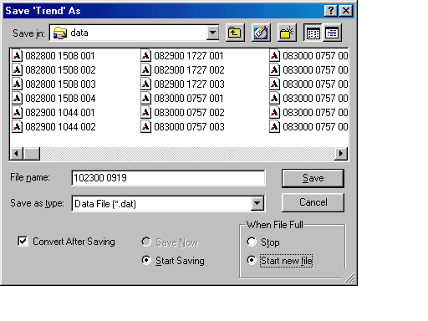the Convert After Saving square button.

- In the Filename entry area type in the new filename as shown below. The format is shown first, followed by several examples.

MMDDYY hhmm

(space)

Where:
MM should be substituted with the current month.
DD should be substituted with the current day.
YY should be the final two digits of the current year.
hh should be substituted with the current hour.
mm should be substituted with the current minute.
There must be one blank space between MMDDYY and hhmm.

For example, if the current date is March 19, 2001 and the time is 17:42 then the filename should be
031900 1742. The final digits (e.g. 001) are automatically appended by the Dycor2000 program.

- After the new filename has been typed in, depress the Save button on the Save Trend As window.

- After the Save Trend As menu disappears, each of the three windows of the Dycor2000 program should have a floppy disk icon shown in their upper right corner.
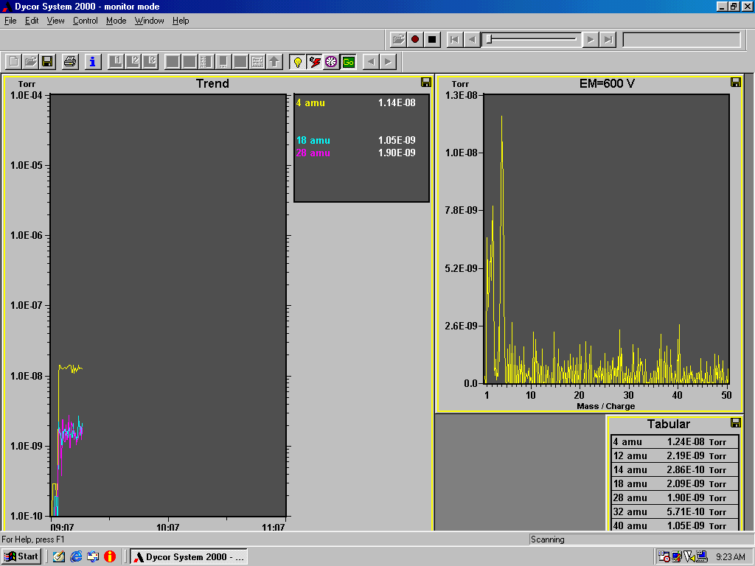

- Make a notation in the Vacuum Operations Logbook, located near the computer.

