Installing the Channel Archiver V2 on Linux

Rev 00 12OCT2004 P. Sichta
Rev 01 01NOV2005 PS

1.0 Introduction 1
2.0 References 2
3.0 Configure Workstation 2
4.0 Build the Channel Archiver Extension’s 3rd Party Software 3
5.0 Build the Channel Archiver Extension 4
6.0 Build the Archive Data Server 8
7.0 Java Client using Java Web Start 10
8.0 Hints 10

Appendix A – Configuration Files for Example Engine & Daemon Configuration 1
Appendix B – Web & Data Server Files 1
Appendix C – Building Java Client from Source 1
Appendix D – Java SDK and Ant Installation Support 1

Introduction
This procedure describes the steps used at NSTX to install The Channel Archiver V_2.1.4 and supporting applications on a Linux workstation. This document will show how to build and use all these tools with an example configuration that is suitable for the NSTX computer systems.

Configuring and operating the archiver, data management, data extraction, and user tools for NSTX Operations will be described in (to-be-written) separate documents.

This document was written using the following software:

For EPICS BASE:
- EPICS Base 3.14.6 baseR3.14.6.tar.gz (28 May 2004).
- Red Hat Enterprise Linux, WS-3 Update 3 (2.4.21… kernel).
- GNU gcc/g++ 3.2.3 (loaded with RHEL).
- GNU make 3.79.1 (loaded with RHEL).
- Perl 5.8.0 (loaded with RHEL).

For EPICS 3.14-style extensions:
- extensionsConfigure_20040406.tar.gz

For the Channel Archiver:

For Building the Channel Archiver
- archiver.tgz, a 09/30/2004 snapshot of the Channel Archiver.

For Building the Data Server
- Apache Web Server 2.0.46 (loaded with RHEL).

For the Java Client using Java Web Start technology
- Downloads current version from SNS website. As of this writing, version alpha 2004-09-30.
- Java SDK 1.4.2_05

For Building the Java Client from Source
- archiver-client.tgz, a 06/30/2004 snapshot of the Java Data Client.
- Apache Ant 1.5.2-23 (loaded with RHEL)
- Java SDK 1.4.2_05

References

1) Channel Archiver Manual, R3.14.4 version, Sept. 30, 2004 (see EPICS Home Page for link, or try here http://ics-web1.sns.ornl.gov/~kasemir/archiver/ ).
2) PPPL document NSTX-WBS6-DV-015, Building EPICS Base, Example Extension, Example Application, and a SoftIOC on Linux for Linux Target.
3) EPICS Channel Archiver Operations Guide, NSTX-WBS6-OP-26
4) Installation and User Guide for the EPICS ArchiveViewer, NSTX-WBS6-DV-018.

Configure Workstation
- This work was done on the epicsgate02 computer, as user epics.
- Define symbolic links for /eprun (the epics application area) and /epbld (the epics build area). See Appendix A.
- Define EPICS environment using the script cshrc.epics. See Appendix A.
- If not already done:
  - Install EPICS Base 3.14.6 .
  - Build an example 3.14 extension per reference 2.
  - The path environmental variable should contain EPICS base and extensions binaries ($EPICS_BASE/bin/linux-x86 and $EPICS_EXTENSIONS/bin/linux-x86).
  - The LD_LIBRARY_PATH environmental variable should contain EPICS base and extensions shared libraries ($EPICS_BASE/lib/linux-x86 and $EPICS_EXTENSIONS/lib/linux-x86).
- Download the archiver.tgz file into a directory of your choice.
- Unpack the archiver code:
gzip –dc archiver.tgz | tar xvf –

-OR-

tar vzoxf archiver.tgz

- Move the ChannelArchiver directory into the …/extensions/src folder in your Extensions area.

Build the Channel Archiver Extension’s 3rd Party Software
Reference Chapter 8 (Setup, Installation) of the Channel Archiver’s manual. The 3rd party tools are included with the archiver distribution in the ThirdParty directory. Newer versions of these tools may be available. Since this procedure is for a first-time build of the archiver it was decided to use tried-and-true software; Newer versions were not used in this procedure.

- Migrate to the directory ChannelArchiver/ThirdParty.
- Per section 8.1.1 of the Channel Archiver Manual, build w3c-libwww package. Note: this may be included with RHEL.
- Per section 8.1.1 of the Channel Archiver Manual, build and patch the xmlrpc-c package. Apply both patches as specified in section 8.1.1 of the manual.

- Per section 8.1.2 of the Channel Archiver Manual, build the xerces-c-current package.
  - Add /usr/local/lib to your environmental variable LD_LIBRARRY_PATH.
- Per section 8.1.4 of the Channel Archiver Manual, build the XML-Simple package.
- Per section 8.1.5 of the Channel Archiver Manual, build the Frontier-RPC package.

Build the Channel Archiver Extension
Now that the support tools are built, it is time to build the Channel Archiver.

- On the 9/30/2004 release of the archiver a perl script ChannelArchiver/ArchiveDaemon/ArchiveDaemon.pl needed an edit to eliminate a startup warning. See the e-mail in Appendix A.
- Edit the file ChannelArchiver/ArchiveDaemon/ArchiveDaemon.pl to change the time that the master_index file is updated. Change 60 minutes to 10 minutes for variable $index_update_minper.
- No edits on Tools/ToolsConfig.h
- (This step does not work, skip for now) Modify the lines in ChannelArchiver/Tools/ArchiverConfig.h to look like those below:
  - //#undef USE_PASSWD
  - #DEFAULT_USER = “cicopr”
  - //#DEFAULT_PASS = “engine”
  - (note: The default MULTI_ARCHIVE method is used, not BIN_ARCHIVE.)
- CD to extensions/src/ChannelArchiver.
- Type make
- Add EPICS_EXTENSIONS/lib/linux-x86 and EPICS_BASE/lib/linux-x86 to the environmental variable LD_LIBRARY_PATH.

5.1 Example Archiving Configuration
If the build was successful, then the Archiver can be operated. But first, the archiver will need to be configured. This section describes an example configuration using NSTX EPICS record names. The Archiver Daemon will be used to start two Archiver Engines. One engine will have two groups in it. Appendix A lists the source configuration files. Also, see reference #1, sections 3 & 4 for details on the configuration files. Chapter 7 of reference #1 also describes setting up an example.

The xml engine configuration files are created using a convertor program and a configuration file format used in the original Version 1 Channel Archiver.

- Create the directories:
  - /home/epics/exampleArchiver This is <top>.
  - <top>/conf1
  - <top>/conf2

- Copy some of the the Channel Archiver version one configuration files from epicsrv.pppl.gov:
  - ch_main.hst into <top>/conf1 and <top>/conf2.
  - vm_gfm.hst into <top>/conf2.
  - tc_temps.hst into <top>/conf1.
  - ch_sys.hst into <top>/conf1.

- Copy DTD files from the ChannelArchiver source directories into the ‘local’ directories.
  - ChannelArchiver/IndexTool/indexconfig.dtd into <top>.
  - ChannelArchiver/ArchiveDaemon/ArchiveDaemon.dtd into <top>.
  - ChannelArchiver/ArchiveDaemon/ArchiveDaemon.xml into <top>.
  - ChannelArchiver/Engine/engineconfig.dtd into <top>/conf1.
  - ChannelArchiver/Engine/engineconfig.dtd into <top>/conf2.

- Create engine xml configuration file, in directory <top>/conf1:
  - Rename ch_main.hst to config1.txt and edit so that it is as shown in Appendix A.
  - Edit files tc_temps.hst and ch_sys.hst so that they look like that shown in Appendix A.
  - Run the file format converter in directory <top>/conf1, to take the old-style ASCII configuration files and create XML files in the proper DTD format:
    - ConvertEngineConfig.pl –o config1.xml config1.txt

- Create engine xml configuration file, in directory <top>/conf2:
  - Rename ch_main.hst to config2.txt and edit so that it is as shown in Appendix A.
  - Edit file vm_gfm.hst so that it looks like that shown in Appendix A.
  - Run the file format converter in directory <top>/conf2:
    - ConvertEngineConfig.pl –o config2.xml config2.txt

- (Not sure if this step is required. ArchiveDaemon may do it). In the <top> directory, create the indexconfig.xml file :
  - make_indexconfig.pl conf1 conf2

- Move to the <top> directory and edit file ArchiveDaemon.xml so that it looks like that in Appendix A. It will start two Archive Engines, as configured by our two engine configuration xml files.

5.2 Operate the Archiver
See reference #1, sections 3 and 4 for details on operating the Engine and Daemon. Child directories and files will be created by the engines and the daemon. The master index will be periodically (once an hour) updated.

- Start the Daemon as shown below, or make a script (e.g. StartCAR) that contains the two commands.
  - cd /home/epics/exampleArchiver
  - ArchiveDaemon.pl –u 10 –f ArchiveDaemon.xml

- Several log files will be produced in the <top> and conf1 and conf2 directories.
- You can observe the status of the engines with the built-in web server:

  - http://localhost:4610 (daemon status)
  - http://localhost:4813 (engine 1 status)
  - http://localhost:4814 (engine 2 status)
  - http://localhost:4610/stop (stops daemon, but not
engines)
  - http://localhost:4813/stop (stops engine 1)
  - http://localhost:4814/stop (stops engine 2)

5.3 View Acquired Data
The ArchiveExport command-line tool can be used to view data. See reference #1 for details on how to operate.

- Go to the <top> directory.
To see the data for one channel:
/home/epics/exampleArchiver :ArchiveExport master_index tc_roomTemp_AI -format decimal -text
# Generated by ArchiveExport 2.1.4
# Method: Raw Data

# Time tc_roomTemp_AI [degC]
09/27/2004 11:34:58.746508515 20.3
09/27/2004 11:36:15.454330000 20.3 Repeat 1
09/27/2004 11:36:15.454330000 #N/A Disconnected
09/27/2004 11:36:15.454330000 #N/A Archive_Off
09/27/2004 11:47:52.913085000 #N/A Disconnected
09/27/2004 11:48:00.023526000 20.3
09/27/2004 11:49:58.712429583 20.3 Repeat 1
09/27/2004 11:49:58.712429583 20.5
09/27/2004 11:50:58.710217731 20.3
09/27/2004 11:52:58.705569843 20.3 Repeat 1
09/27/2004 11:52:58.705569843 20.5
09/27/2004 11:53:28.704404475 20.3
09/27/2004 11:58:58.692629295 20.3 Repeat 4
09/27/2004 11:58:58.692629295 20.5
09/27/2004 11:58:58.692629295 20.3 Repeat 4
09/27/2004 11:58:58.692629295 20.5
09/27/2004 11:59:58.689880047 20.5

- To average and ‘bin’ the data to get ’common’ timestamps:
/home/epics/exampleArchiver :ArchiveExport master_index tc_roomTemp_AI -format decimal -average 60
# Generated by ArchiveExport 2.1.4
# Method: Averaging every 60 seconds

# Time tc_roomTemp_AI [degC]
09/27/2004 11:34:30.000000000 20.3
09/27/2004 11:36:15.454330000 #N/A
09/27/2004 11:47:52.913085000 #N/A
09/27/2004 11:48:30.000000000 20.3
09/27/2004 11:49:30.000000000 20.4
09/27/2004 11:50:30.000000000 20.3
09/27/2004 11:52:30.000000000 20.4
09/27/2004 11:53:30.000000000 20.3
09/27/2004 11:58:30.000000000 20.4
09/27/2004 11:59:30.000000000 20.5
09/27/2004 12:00:30.000000000 20.3
09/27/2004 12:01:30.000000000 20.2
09/27/2004 12:02:30.000000000 20.3
09/27/2004 12:03:30.000000000 20.2
09/27/2004 12:06:36.076250000 #N/A
09/27/2004 12:07:03.059980000 #N/A

Build the Archive Data Server
The Archive Engine and the Archive Daemon have built-in web servers to view their status. To support data access a ‘real’ Apache web server must be installed. Then, XML-RPC can be used from a variety of programming languages to access the data. In addition, the Java Data Client tool (reference #4) can be used from MACs, PC,s and unix workstations to access the data.

I did not load a web server when I originally installed RHEL on my computer. Many of the steps below require you to be ‘root’.

- I used System_Settings->Add/Remove_Applications, then checked the ‘web server’ box to install that package. In the web server Details, I did not check any unchecked packages (that is, I used RHEL default selections).
- Start the web server: System_Settings->Server_Settings->Services and started the httpd service. Saved run-level on exit. Upon next reboot the httpd started automatically.
- Test the web server by going to a web browser on your computer and using the URL http://localhost/ . From another computer type http://epicsgate.pppl.gov/ . You should see the Apache Test Page as shown in Appendix B.
- Create directories:
  - /var/www/html/archive
  - /var/www/html/archive/cgi
  - chown, chmod, chgrp as desired.
- Edited the Apache configuration file /etc/httpd/conf/httpd.conf, as shown in Appendix B. What I did was a little different than what was in the Archiver’s manual section 5.3.1 What was in the manual seemed to be a mix of two path/installation methods.
- Restart the httpd service (to use the new httpd.conf file).

6.1 Configure the Archiver Data Server
Configure the xml file for our example installation:
- Copy serverconfig.xml and serverconfig.dtd from directory ChannelArchiver/XMLRPCServer into directory /var/www/html/archive.
- Edit the file /var/www/html/archive/serverconfig.xml to reference the engine configuration for our installation. Server files & mods are shown in Appendix B.
- Copy ChannelArchiver/XMLRPCServer/O.linux-x86/ArchiveDataServer to /var/www/html/archive/cgi/ArchiveDataServer.cgi . Note the filename extension ‘cgi’. Copy was done as ‘root’. Even though this was compiled in the ChannelArchiver’s make it was not installed in the EXTENSIONS binary directory.
- In O.linux-x86 there is a program ArchiverDataClientTest. Don’t know how to use this yet, not mentioned in Ref #1.

6.2 Test the Archiver Data Server
As described in the Archiver manual section 5.5, use the Perl Client to read the data served by the Archiver Data Server. See Appendix B for typical program output.
- $ setenv URL http://epicsgate.pppl.gov/EpicsArchive/ArchiveDataServer.cgi
- $ ArchiveDataClient.pl –u $URL –i
- This should list some info. If this works, continue with other examples as shown in the Archiver manual section 5.5.
- If there are errors, loog in the web server error log file /etc/httpd/logs/error_log .

There are two other clients already written that use xml-rpc to get archived data from the data server.
- A C++ client is at ChannelArchiver/XMLRPCServer/ArchiveDataClient.cpp .
- A java API is bundled in the Java Archive Client source code, archive_viewer/epics/archiver/client/ArchiveClient.java.

6.3 Create an index.html ‘help’ file
If the web server is dedicated to serving EPICS Archiver Data you may want to create a default webpage for the Web Server (e.g. with Microsoft Front Page). The page should be saved as index.html in the directory /var/www/html. Appendix B shows an example index.html page. This page could have instructions and/or details about how to use the data server, signal names, hyperlinks to the Engine/Daemon Status URLs, or have active-content displaying server status, date ranges (if you know how, I don’t) etc….

Java Client using Java Web Start
Note: Reference 4 describes how to install and use Java Web Start Client. Reference that document.

Appendix C contains instructions on how to build the program from source, on Windows and Linux platforms.

Hints
- When the ArchiveDaemon starts it begins storing data but the master_index is not updated until up to one hour later. So if you want to retrieve data (e.g ArchiveExport) using the master_index, the master_index can be updated manually as follows (for our example):

/home/epics/exampleArchiver :date
Tue Sep 28 08:52:18 EDT 2004
/home/epics/exampleArchiver :ArchiveIndexTool indexconfig.xml master_index

This will not destroy old data.

- A note on the Red Hat Enterprise Linux web server installation. I installed the RHEL from a set of CD-ROM with ISO images on them. The 4-CD set was for WS-3, Update 2. Over the past few months I did Red Hat Updates, which unbeknownst–to-me, installed a WS-3 Update 3 onto my machine. When installing the web server the installer asked me to insert disk #2. The media I had was for Update 2, but the installer wanted disk 2 from the Update 3 installation set (but the message didn’t say that, I found that out after the original disk #2 kept getting rejected). I had to download the RHEL WS-3 Update 3 ISO images, burn them onto four CD ROM, and then use the new Disk #2.
- You can use a tool like ‘xmllint’ on Linux to verify/check your xml configuration file against the DTD.
- Site-wide power outage note: In my example configuration the Archiver computer was behind a PV Gateway (V1.x) which connected to the IOCs. The archiver was started before the gateway, and of course did not make any connections with the IOC records. When the gateway was started, the archiver did not pick up the connections. Had to stop the daemon and engines and restart them to get connections through the gateway to the IOC.
- Starting the ArchiveDaemon with no engines running will start the daemon and engines. You can then Disable/Stop each engine from the Daemon’s :4610 web page. If you stop the daemon it will not stop the engines. If you restart the daemon with engines already running, there is no problem. I think the correct shutdown method is stop the engines using :engineport/STOP and then stop the daemon with :4610/STOP. Beware of archive active lock file and engine disable file in the engine directories as these will prevent the engine from running or starting.

Appendix A – Configuration Files for Example Engine & Daemon Configuration

Symbolic links at the root directory:

epbld -> /usr/local/EPICS/epicsR031406

eprun -> /usr/local/EPICS/nstxR031406

c-shell script for setting up the EPICS environment:

setenv EPICS_BASE /epbld/base

setenv EPICS_HOST_ARCH `$EPICS_BASE/startup/EpicsHostArch`

setenv EPICS_CA_ADDR_LIST "198.35.15.132"

setenv EPICS_CA_AUTO_ADDR_LIST NO

setenv PATH ".:/usr/bin:/usr/sbin:/usr/local/bin:/etc:/opt:${PATH}"

setenv PATH "$EPICS_EXTENSIONS/bin/${EPICS_HOST_ARCH}:${PATH}"

setenv PATH "$EPICS_BASE/tools:$EPICS_BASE/bin/${EPICS_HOST_ARCH}:${PATH}"

setenv X11_LIB /usr/lib

setenv X11_INC /usr/include

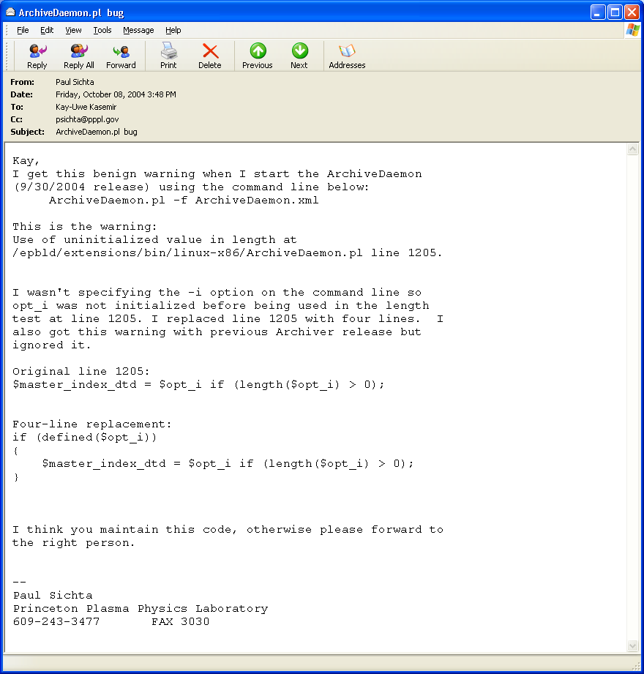
<top> directory:

/home/epics/exampleArchiver :date
Mon Sep 27 14:36:05 EDT 2004
/home/epics/exampleArchiver :pwd
/home/epics/exampleArchiver
/home/epics/exampleArchiver :ls -l
total 168
-rw-r--r-- 1 epics staff 650 Sep 27 10:45 ArchiveDaemon.dtd
-rw-r--r-- 1 epics staff 78406 Sep 27 14:35 ArchiveDaemon.log
-rw-r--r-- 1 epics staff 480 Sep 27 11:17 ArchiveDaemon.xml
-rw-r--r-- 1 epics staff 312 Sep 27 14:07 ArchiveIndexTool.log
drwxrwxr-x 3 epics staff 4096 Sep 27 12:07 conf1
drwxrwxr-x 3 epics staff 4096 Sep 27 12:07 conf2
drwxr-xr-x 2 epics staff 4096 Sep 27 10:42 fromEpicsrv
-rw-r--r-- 1 epics staff 300 Sep 27 11:59 indexconfig.dtd
-rw-r--r-- 1 epics staff 544 Sep 27 12:07 indexconfig.xml
-rw-r--r-- 1 epics staff 544 Sep 27 14:07 indexupdate.xml
-rw-r--r-- 1 epics staff 46204 Sep 27 14:07 master_index

/home/epics/exampleArchiver :more indexupdate.xml
<?xml version="1.0" encoding="UTF-8" standalone="no"?>
<!-- Written by the ArchiveDaemon -->
<!-- Do not edit while ArchiveDaemon is running -->
<!DOCTYPE indexconfig SYSTEM "indexconfig.dtd">
<indexconfig>
<archive>
<index>/home/epics/exampleArchiver/conf2/2004/09_27/index</index
>
</archive>
<archive>
<index>/home/epics/exampleArchiver/conf1/2004/09_27/index</index
>
</archive>
<archive>
<index>conf2/2004/09_27/index</index>
</archive>
<archive>
<index>conf1/2004/09_27/index</index>
</archive>
</indexconfig>

/home/epics/exampleArchiver :more indexconfig.dtd
<?xml version="1.0" encoding="UTF-8"?>
<!-- DTD for the ArchiveIndexTool Configuration -->
<!-- Lists all the indices of archives that -->
<!-- should be combined into the master index. -->
<!ELEMENT indexconfig (archive+)>
<!ELEMENT archive (index)>
<!ELEMENT index (#PCDATA)><!-- path -->

/home/epics/exampleArchiver :more indexconfig.xml
<?xml version="1.0" encoding="UTF-8" standalone="no"?>
<!-- Written by the ArchiveDaemon -->
<!-- Do not edit while ArchiveDaemon is running -->
<!DOCTYPE indexconfig SYSTEM "indexconfig.dtd">
<indexconfig>
<archive>
<index>/home/epics/exampleArchiver/conf2/2004/09_27/index</index
>
</archive>
<archive>
<index>/home/epics/exampleArchiver/conf1/2004/09_27/index</index
>
</archive>
<archive>
<index>conf2/2004/09_27/index</index>
</archive>
<archive>
<index>conf1/2004/09_27/index</index>
</archive>
</indexconfig>

conf1 directory:
/home/epics/exampleArchiver/conf1 :ls -l
total 116
drwxr-xr-x 3 epics staff 4096 Sep 27 11:01 2004
-rw-r--r-- 1 epics staff 29812 Sep 27 11:47 20040927
-rw-r--r-- 1 epics staff 1039 Sep 27 11:36 20040927113429.log
-rw-r--r-- 1 epics staff 6855 Sep 27 12:06 20040927114752.log
-rw-r--r-- 1 epics staff 30571 Sep 27 14:36 20040927120702.log
-rw-r--r-- 1 epics staff 133 Sep 27 12:07 archive_active.lck
-rw-r--r-- 1 epics staff 1738 Sep 27 11:47 config1.xml
-rw-r--r-- 1 epics staff 1087 Sep 27 10:24 engineconfig.dtd
-rw-r--r-- 1 epics staff 22894 Sep 27 11:47 index
/home/epics/exampleArchiver/conf1 :

/home/epics/exampleArchiver/fromEpicsrv :more config1.txt
# Rev 05 27SEP04 ps Changed name and shortened list for Linux V2 testing
# Changed / to ! for group
#
!write_period 300
!get_threshold 20
!group tc_temps.hst
!group ch_sys.hst

/home/epics/exampleArchiver/fromEpicsrv :more tc_temps.hst
# Rev 06 27SEP04 PS Shortned list for Linux testing Archiver V2.
# Added 60 to each line
#
tc_roomTemp_AI 60
tc_evv_u_4_AI 60
tc_evv_u_10_AI 60
tc_VVupperAvg_CALC 60
tc_VVmidAvg_CALC 60

/home/epics/exampleArchiver/fromEpicsrv :more ch_sys.hst
# Rev 03 27SEP2004 ps Added ioc2,3,9 & '60' to each record
#
ch_IOC1_VXfd_AI 60
ch_IOC1_VXcpu_AI 60
ch_IOC1_VXmem_AI 60
ch_IOC2_VXfd_AI 60
ch_IOC2_VXcpu_AI 60
ch_IOC2_VXmem_AI 60
ch_IOC3_VXfd_AI 60
ch_IOC3_VXcpu_AI 60
ch_IOC3_VXmem_AI 60
ch_IOC9_VXfd_AI 60
ch_IOC9_VXcpu_AI 60
ch_IOC9_VXmem_AI 60

/home/epics/exampleArchiver/conf1 :more config1.xml
<?xml version="1.0" encoding="UTF-8" standalone="no"?>
<!DOCTYPE engineconfig SYSTEM "engineconfig.dtd">
<engineconfig>
<buffer_reserve>3</buffer_reserve>
<file_size>30</file_size>
<get_threshold>20</get_threshold>
<ignored_future>1</ignored_future>
<max_repeat_count>120</max_repeat_count>
<write_period>300</write_period>
<group>
<name>ch_sys.hst</name>
<channel><name>ch_IOC1_VXcpu_AI</name><period>60</period><scan/></channel>
<channel><name>ch_IOC1_VXfd_AI</name><period>60</period><scan/></channel>
<channel><name>ch_IOC1_VXmem_AI</name><period>60</period><scan/></channel>
<channel><name>ch_IOC2_VXcpu_AI</name><period>60</period><scan/></channel>
<channel><name>ch_IOC2_VXfd_AI</name><period>60</period><scan/></channel>
<channel><name>ch_IOC2_VXmem_AI</name><period>60</period><scan/></channel>
<channel><name>ch_IOC3_VXcpu_AI</name><period>60</period><scan/></channel>
<channel><name>ch_IOC3_VXfd_AI</name><period>60</period><scan/></channel>
<channel><name>ch_IOC3_VXmem_AI</name><period>60</period><scan/></channel>
<channel><name>ch_IOC9_VXcpu_AI</name><period>60</period><scan/></channel>
<channel><name>ch_IOC9_VXfd_AI</name><period>60</period><scan/></channel>
<channel><name>ch_IOC9_VXmem_AI</name><period>60</period><scan/>
/channel>
</group>
<group>
<name>tc_temps.hst</name>
<channel><name>tc_VVmidAvg_CALC</name><period>60</period><scan/></channel>
<channel><name>tc_VVupperAvg_CALC</name><period>60</period><scan/></channel>
<channel><name>tc_evv_u_10_AI</name><period>60</period><scan/></channel>
<channel><name>tc_evv_u_4_AI</name><period>60</period><scan/></channel>
<channel><name>tc_roomTemp_AI</name><period>60</period><scan/></channel>
</group>
</engineconfig>

conf2 directory:
/home/epics/exampleArchiver/conf2 :ls -l
total 96
drwxr-xr-x 3 epics staff 4096 Sep 27 11:01 2004
-rw-r--r-- 1 epics staff 17730 Sep 27 11:47 20040927
-rw-r--r-- 1 epics staff 1039 Sep 27 11:36 20040927113429.log
-rw-r--r-- 1 epics staff 5995 Sep 27 12:06 20040927114752.log
-rw-r--r-- 1 epics staff 30398 Sep 27 14:36 20040927120702.log
-rw-r--r-- 1 epics staff 133 Sep 27 12:07 archive_active.lck
-rw-r--r-- 1 epics staff 1255 Sep 27 11:47 config2.xml
-rw-r--r-- 1 epics staff 1087 Sep 27 10:24 engineconfig.dtd
-rw-r--r-- 1 epics staff 16278 Sep 27 11:47 index

/home/epics/exampleArchiver/conf2 :more config2.xml
<?xml version="1.0" encoding="UTF-8" standalone="no"?>
<!DOCTYPE engineconfig SYSTEM "engineconfig.dtd">
<engineconfig>
<buffer_reserve>3</buffer_reserve>
<file_size>30</file_size>
<get_threshold>20</get_threshold>
<ignored_future>1</ignored_future>
<max_repeat_count>120</max_repeat_count>
<write_period>300</write_period>
<group>
<name>vm_gfm.hst</name>
<channel><name>vm_plc31gf_di1_AI</name><period>60</period><scan/></channel>
<channel><name>vm_plc31gf_di2_AI</name><period>60</period><scan/></channel>
<channel><name>vm_plc31gf_di3_AI</name><period>60</period><scan/></channel>
<channel><name>vm_plc31gf_di4_AI</name><period>60</period><scan/></channel>
<channel><name>vm_plc31gf_di5_AI</name><period>60</period><scan/></channel>
<channel><name>vm_plc31gf_di6_AI</name><period>60</period><scan/></channel>
<channel><name>vm_plc31gf_ivv_AI</name><period>60</period><scan/></channel>
<channel><name>vm_plc31gf_ovv_AI</name><period>60</period><scan/></channel>
<channel><name>vm_plc31gf_sumgf_BI</name><period>60</period><scan/></channel>
<channel><name>vm_plc31gf_sumlf_BI</name><period>60</period><scan/></channel>
<channel><name>vm_plc31gf_sumov_BI</name><period>60</period><scan/></channel>
</group>
</engineconfig>

/home/epics/exampleArchiver/fromEpicsrv :more config2.txt
# Rev 05 27SEP04 ps Changed name and shortened list for Linux V2 testing
# Changed / to ! for group
#
!write_period 300
!get_threshold 20
!group vm_gfm.hst

/home/epics/exampleArchiver/fromEpicsrv :more vm_gfm.hst
# Rev 01 27SEP04 PS Added period of 60 to each record.
#
vm_plc31gf_di1_AI 60
vm_plc31gf_di2_AI 60
vm_plc31gf_di3_AI 60
vm_plc31gf_di4_AI 60
vm_plc31gf_di5_AI 60
vm_plc31gf_di6_AI 60
vm_plc31gf_ovv_AI 60
vm_plc31gf_ivv_AI 60
vm_plc31gf_sumgf_BI 60
vm_plc31gf_sumlf_BI 60
vm_plc31gf_sumov_BI 60

/home/epics/exampleArchiver :more ArchiveDaemon.xml
<?xml version="1.0" encoding="UTF-8" standalone="no"?>
<!DOCTYPE engines SYSTEM "ArchiveDaemon.dtd">
<engines>
<engine>
<desc>Test Config #1</desc>
<port>4813</port>
<config>/home/epics/exampleArchiver/conf1/config1.xml</config>
<daily>00:00</daily>
</engine>
<engine>
<desc>Test Config #2</desc>
<port>4814</port>
<config>/home/epics/exampleArchiver/conf2/config2.xml</config>
<daily>00:00</daily>
</engine>
</engines>

Appendix B – Web & Data Server Files

Apache Webserver Test Page

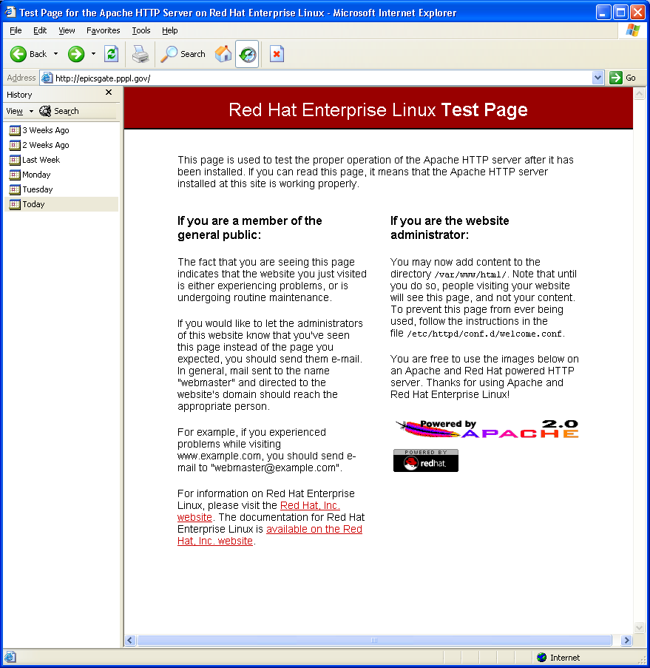

Portions of httpd.conf edits:
What I added is shown in red.

Specify ServerName

# If your host doesn't have a registered DNS name, enter its IP address here.
# You will have to access it by its address anyway, and this will make
# redirections work in a sensible way.
#

#ServerName new.host.name:80
# Line added below at PPPL by Sichta 29SEP2004 ////////////////////////
ServerName epicsgate.pppl.gov:80

User and group

# If you wish httpd to run as a different user or group, you must run
# httpd as root initially and it will switch.
#
# User/Group: The name (or #number) of the user/group to run httpd as.
# . On SCO (ODT 3) use "User nouser" and "Group nogroup".
# . On HPUX you may not be able to use shared memory as nobody, and the
# suggested workaround is to create a user www and use that user.
# NOTE that some kernels refuse to setgid(Group) or semctl(IPC_SET)
# when the value of (unsigned)Group is above 60000;
# don't use Group #-1 on these systems!
#
# change by Sichta from User apache ///////////////////////////////////////
# change by Sichta from Group apache //////////////////////////////////////
User epics
Group staff

file mods cont’d next page …

Specify paths, alias, and environmental variables
(note this is slightly different than in the Archiver manual)

ScriptAlias /cgi-bin/ "/var/www/cgi-bin/"

# "/var/www/cgi-bin" should be changed to whatever your ScriptAliased
# CGI directory exists, if you have that configured.
#
<Directory "/var/www/cgi-bin">
AllowOverride None
Options None
Order allow,deny
Allow from all
</Directory>

# ////////////// Section for EPICS Archiver ///////////////////////////
ScriptAlias /EpicsArchive/ "/var/www/html/archive/cgi/"

<Directory "/var/www/html/archive/cgi">
SetEnv EPICS_TS_MIN_WEST 300
SetEnv EPICS_BASE /epbld/base-3.14.6
SetEnv EPICS_EXTENSIONS /epbld/extensions
SetEnv LD_LIBRARY_PATH /usr/local/lib:$EPICS_BASE/lib/linux-x86:$EPICS_EXTENSIONS/lib/linux-x86
SetEnv SERVERCONFIG /var/www/html/archive/serverconfig.xml
PerlHandler Apache::Registry
PerlSendHeader On/
Options +ExecCGI
</Directory>

<Directory "/var/www/html/archive">
Order allow,Deny
Allow from all
</Directory>
# ////////////// Section for EPICS Archiver ///////////////////////////
serverconfig.xml modified for this example installation at our site.

[root@epicsgate archive]# date
Wed Sep 29 15:54:31 EDT 2004
[root@epicsgate archive]# more serverconfig.xml
<?xml version="1.0" encoding="UTF-8"?>
<!DOCTYPE serverconfig SYSTEM "serverconfig.dtd">
<serverconfig>
<archive>
<key>1</key>
<name>Engine1</name>
<path>/home/epics/exampleArchiver/conf1/index</path>
</archive>
<archive>
<key>2</key>
<name>GFM_Data</name>
<path>/home/epics/exampleArchiver/conf2/index</path>
</archive>
<archive>
<key>3</key>
<name>AllChannels</name>
<path>/home/epics/exampleArchiver/master_index</path>
</archive>
</serverconfig>

[root@epicsgate archive]# more serverconfig.dtd
<?xml version="1.0" encoding="UTF-8"?>
<!-- DTD for the XML-RPC Data Server Configuration -->
<!ELEMENT serverconfig (archive+)>
<!ELEMENT archive (key,name,path)>
<!ELEMENT key (#PCDATA)>
<!ELEMENT name (#PCDATA)>
<!ELEMENT path (#PCDATA)>
Testing the server with ArchiveDataClient Perl program.

[epics@epicsgate ~]$ setenv URL http://epicsgate.pppl.gov/EpicsArchive/ArchiveDataServer.cgi

[epics@epicsgate ~]$ ArchiveDataClient.pl -u $URL -i
Archive Data Server V 0
Description:
Channel Archiver Data Server V0,
built Sep 24 2004, 16:31:00
from sources for version 2.1.4
Config: '/var/www/html/archive/serverconfig.xml'
Supports requests with how = ...
0: 'raw'
1: 'spreadsheet'
2: 'average'
3: 'plot-binning'
4: 'linear'
Alarm Status Strings = ...
0: 'NO_ALARM'
1: 'READ'
2: 'WRITE'
…rest of text clipped …

[epics@epicsgate ~]$ ArchiveDataClient.pl -u $URL -a
Archives:
Key 1: 'Engine1' in '/home/epics/exampleArchiver/conf1/index'
Key 2: 'GFM_Data' in '/home/epics/exampleArchiver/conf2/index'
Key 3: 'AllChannels' in '/home/epics/exampleArchiver/master_index'

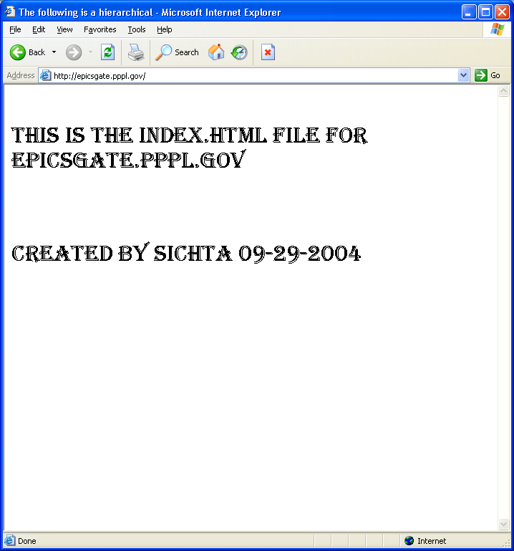

Appendix C – Building Java Client from Source

This section describes Building the Java Client from source code. The new method is to uses Java Web Start which is described in the main document (section 7).

This section will describe how to build the Java Client to view and access the data from the Archiver Data Server. A Linux and a WindowsXP build will be described. How about Macintosh? TBD!

C.1 Red Hat Enterprise Linux WS-3
- Download the archiver-client.tgz file into a directory of your choice.
- Unpack the archiver-client code:
gzip –dc archiver-client.tgz | tar xvf –

-OR-

tar vzoxf archiver-client.tgz

- Move the archive_viewer directory into the …/extensions/src folder in your Extensions area.
- Ant was already installed on my system with RHEL. Verify for your system by typing ‘which ant’ and verifying a reply to the binary ‘ant’.
- C.1.1 Java SDK Installation
- It seemed like I had Java SDK on my computer, as determined by typing the lines below and getting a valid reply (i.e. /usr/bin/java). But this was misleading, I did not have those tools installed.
  - which java
  - which javac
  - which jre
- To be sure, just type java. If you get a message about alternatives and a placeholder, you don’t have java SDK installed. See Appendix C for notes on this topic.
- Download Java SDK from Sun’s website. I used the self-installing RPM J2SE_1.4.2-05.
- Follow Sun’s installation instructions as shown in Appendix D. This will install the binaries into /usr/java/javasdk.../bin
- Per the ‘Java Notes’ in Appendix D, add the Java SDK binary directory to your $PATH variable. Be sure to prefix your existing PATH with the javasdk bin so that it is picked up (first) and not the /usr/bin/java ‘binary’, which is really only a link to a text file.
- Alternatively, if you know how to use the alternatives package, that would be the correct solution. I read on the web that updating libgcj reinstates the alternatives links.
3
- Add execute permission to who_needs_ant.sh
  - chmod +x who_needs_ant.sh
- Enter the bourne shell using the ‘sh’ command.
- Enter who_needs_ant.sh . My output is shown below:
sh-2.05b$ who_needs_ant.sh
Compiling...
Building jar file
Creating archiveviewer
Installing in /epbld/extensions/bin/linux-x86
Installing jcommon-0.9.0.jar
Installing xmlrpc-1.2-b1.jar
Installing junit.jar
Installing jfreechart-0.9.15.jar
Installing xercesImpl.jar
Installing xml-apis.jar
Done.
You should now be able to invoke 'archiveviewer'.

- The following should have been installed in the extensions/bin/linux-x86 directory:

-rw-r--r-- 1 epics staff 108476 Sep 30 10:20 xmlrpc-1.2-b1.jar
-rw-r--r-- 1 epics staff 123705 Sep 30 10:20 xml-apis.jar
-rw-r--r-- 1 epics staff 949628 Sep 30 10:20 xercesImpl.jar
-rw-r--r-- 1 epics staff 121070 Sep 30 10:20 junit.jar
-rw-r--r-- 1 epics staff 568692 Sep 30 10:20 jfreechart-0.9.15.jar
-rw-r--r-- 1 epics staff 258044 Sep 30 10:20 jcommon-0.9.0.jar
-rwxr-xr-x 1 epics staff 390 Sep 30 10:20 archiveviewer
-rwxr-xr-x 1 epics staff 211441 Sep 30 10:20 archiver.jar

- Run the Java Archive Viewer:
  - Start the archiveviewer by typing archiveviewer.
  - It will ask for a URL of the Data Server. For our example use http://epicsgate.pppl.gov/EpicsArchive/ArchiveDataServer.cgi
  - Then it will ask you to select the archive. Choices are Engine 1, GFM, or AllChannels. I picked AllChannels.
  - Then in the main window as shown in Appendix C, Select Start and End times/days.
  - Search for a channel and Add the channel.
  - Poke the Plot button to display the data.

C.2 WindowsXP
- Download the archiver-client.tgz file into a directory of your choice.
- File downloads with .tar extension. Change extension to .tgz.
- Decompress the file (e.g. WinZip) and Extract All to a directory of your choice.
- Move the decompressed folder archiver_client into your extensions/src directory.

C.2.1 Java SDK Installation
- Download Java SDK from Sun’s website to a directory of your choice. I used the Windows Installationfile j2sdk-1_4_2_05-windows-i586-p-iftw.exe .
- Per Sun’s installation notes (see Appendix D), uninstall any previous version of the Java SDK. My PC had a JRE installed, I removed that but am not sure if that was necessary.
- Follow Sun’s installation instructions as shown in Appendix D.
- During the install, I selected to install only the SDK and the Public JRE. I skipped Demos and Source.
- Create the JAVA_HOME environmental variable, C:\j2sdk1.4.2_05 .
- Add %JAVA_HOME%/bin to the PATH variable.

C.2.2 Apache ANT Installation
- Download ANT Windows binary from Apache-Ant website. I downloaded file apache-ant-1.6.2-bin.zip .
- Extract (e.g. WinZip) into C:\, the installation will create a folder C:\apache-ant-1.6.2 .
- Note: Installing Ant also installs Apache xerces2 (the XML parser).
- Complete the installation (per Appendix D directions):
  - Create the ANT_HOME environmental variable, C:\apache-ant-1.6.2 .
  - Add %ANT_HOME%/bin to the PATH variable.

C.2.3 Install support files
As of 9/30/2004 the java client source code was released in June 2004. This package was missing some files to make it easier to build the client in a Windows environment. Paul Sichta has made some files that will help to build under Windows. The source is listed in Appendix C. These should all be placed in the archiver_client directory.

The filenames are:
- archiveclient.bat
- archiveviewer.bat
- basename.pl
- who_needs_ant.bat
- Readme.txt (revised).

C.2.4 Build and Install
- Open a CMD window and navigate to the archiver_viewer directory in your extensions area.
- If there is a compile directory, delete it before running the next command.
- Enter who_needs_ant.bat
- This should build and install the necessary files to your …extensions/bin/win32-x86 directory.

C.2.5 Run ArchiveViewer java program
There are several ways to start the program.
1) Shortcut / Icon
    - Make a shortcut to …extensions/bin/win32-x86/archiveviewer.bat and place it on your Windows desktop.
    - Double click the icon to start the java program.
    - Optionally, add suffix for URL and other start up parameters in the shortcut’s ‘Target’ property.
2) From CMD window
- Open a CMD window (Start->Run, then type Cmd).
- Type archiveviewer.bat . This assumes the extensions/bin/win32-x86 is in your Path.
    - Optionally, add suffix for URL and other start up parameters after typing in the command.

Hint: When compiling the Java Client. The javac syntax is different according to the docs. For solaris/linux use colons to separate the filenames. In Windows use semicolons.

Hint: Windows properly uses backslash ‘\’ in the path, unix uses regular slash ‘/’. In some cases the regular slash work in Windows, but that behavior is not uniform throughtout all windows applications and utilities.

Hint: The filenames within a .jar file should never be absolute (i.e. never should a C:\ be there).
Java Archive Viewer – June 2004 version built on Linux/Windows.

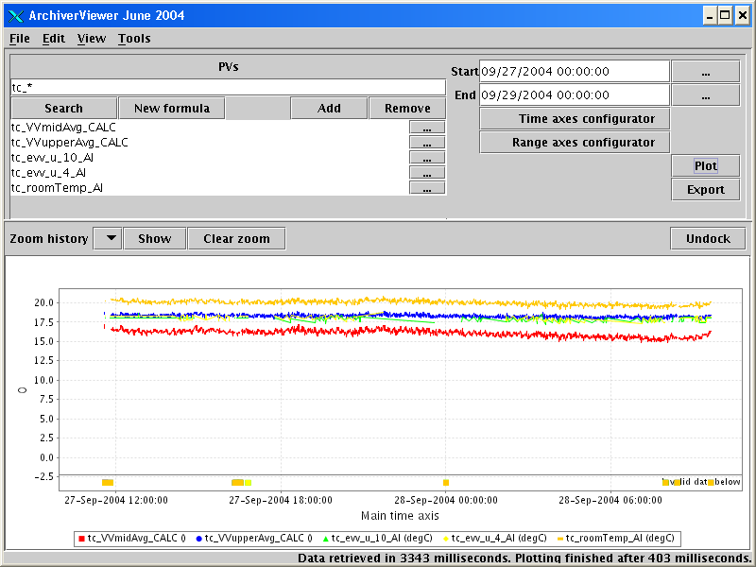

Archive Viewer 09-30-2004 using JAVA Web Start

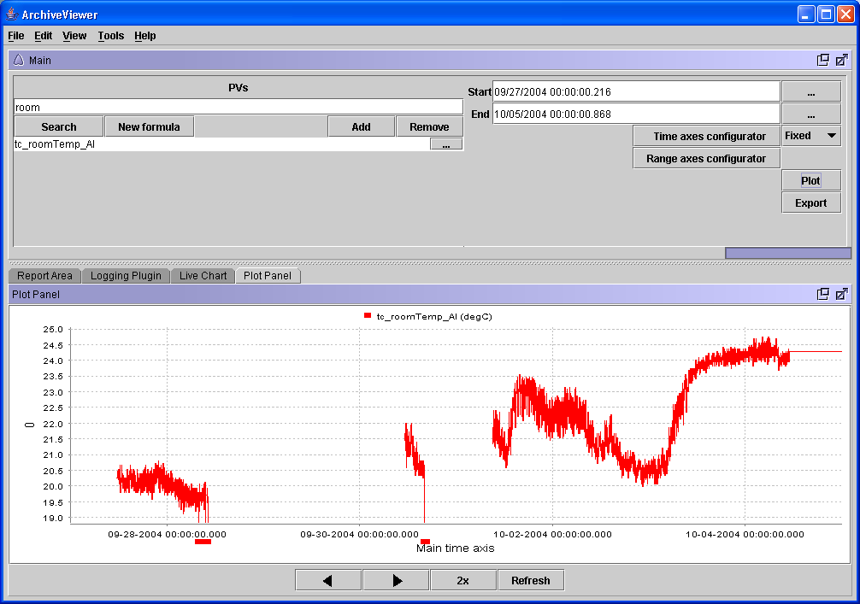
Addition to Readme.txt (existing file not listed)

Windows Users:2 Added by Sichta 07OCt2004
-- don't understand the relevance of the 'ant' comment above.
-- did not see the archiveclient.bat file from Kay in the distribution, so I made one.
-- Make sure you have Perl (Perl.exe) and it is in your path.
-- You need the perl file basename.pl in the archive_viewer directory.
-- I made who_needs_ant.bat from who_needs_Ant.sh. It to compile/build/install the ArchiveViewer on WindowsXP.

Source for archiveviewer.bat (this is created during the build and installed to extensions binary area.

REM Batch File to start the Archive Viewer

java -classpath C:\EPICS\EPBLD\extensions\bin\win32-x86\archiver.jar;C:\EPICS\EPBLD\extensions\bin\win32-x86\jcommon-0.9.0.jar;C:\EPICS\EPBLD\extensions\bin\win32-x86\xmlrpc-1.2-b1.jar;C:\EPICS\EPBLD\extensions\bin\win32-x86\junit.jar;C:\EPICS\EPBLD\extensions\bin\win32-x86\jfreechart-0.9.15.jar;C:\EPICS\EPBLD\extensions\bin\win32-x86\xercesImpl.jar;C:\EPICS\EPBLD\extensions\bin\win32-x86\xml-apis.jar ArchiveViewer %1 %2 %3 %4 %5

Source for archiveclient.bat (this starts the archiveviewer.bat file).

REM File to start the ArchiveClient

%EPICS_EXTENSIONS%/bin/%EPICS_HOST_ARCH%/archiveviewer.bat ^
http://epicsgate.pppl.gov/EpicsArchive/ArchiveDataServer.cgi ^
-a 3
Source for basename.pl

#!C:\Perl\bin
# Perl script to mimic unix's basename function
#That is, to strip the leading path returned by Windows Dir /B /S command.
#JAR files are always relative to the cwd, not an absolute path.
# Rev 00 07OCT2004 P. Sichta

# Usage:
# perl basename.pl filename %CD%
#
# where filename is a file with a list of filenames with full path.
# and %CD% is the CWD

open (IN, "$ARGV[0]") || die "can't open input file";
my @data = <IN>;
close (IN);
my $pathPrefix = $ARGV[1]; #This is cwd %CD%
$pathPrefix =~ s|\\|\/|g; #convert \ to / ... (can't get \ to evaluate)
$pathPrefix =~ s|$|\/|g; #append /

my $i;
foreach $i (@data) {
$i =~ s|\\|\/|g; #convert \ to /
$i =~ s|$pathPrefix||; #delete path to cwd
$i =~ s|\/|\\|g; #convert / back to \
}

open (OUT, ">$ARGV[0]") || die "can't open file for write";
foreach $i (@data) {
print OUT $i;
}
close (OUT);
print "Leading path stripped\n";
Source for file who_needs_ant.bat

@ECHO OFF
REM Windows Batch File who_needs_ant.bat
REM modeled after Kasemir's
REM who_need_ant.sh unix shell script.
REM This script uses a perl script basename.pl to emulate the unix basename function,
REM for which Windows has no equivalant.

REM This will work only in Windows for x86 architecture.
REM Must first set environmental variables
REM JAVA_HOME (your sdk top dir, e.g. C:\j2sdk1.4.2_05)
REM EPICS_EXTENSIONS (top)
REM EPICS_HOST_ARCH (see base/startup/EpicsHostArch.pl)

REM Rev 00 07OCT2004 P. Sichta

PUSHD .
IF NOT EXIST %JAVA_HOME%\bin\javac.exe GOTO NOJAVAHOME
set JAVAC=%JAVA_HOME%\bin\javac.exe

IF NOT EXIST %EPICS_EXTENSIONS%\nul GOTO NOEPICSEXT

IF %EPICS_HOST_ARCH% NEQ win32-x86 GOTO NOEPICSHA

set EXTN_JARS=jcommon-0.9.0.jar xmlrpc-1.2-b1.jar junit.jar jfreechart-0.9.15.jar xercesImpl.jar xml-apis.jar

set CP=compile;ext_jars
FOR %%j IN (%EXTN_JARS%) DO CALL :BUILD_CP %%j
GOTO BUILD_CP_DONE
:BUILD_CP
set CP=%CP%;ext_jars\%1
GOTO :EOF
:BUILD_CP_DONE

DIR /S /B *.java > null.tmp
IF NOT EXIST compile\nul GOTO COMPILE
echo "You already have a 'compile' subdir."
echo "If you want me to re-compile,"
echo "delete that 'compile' subdir"
DEL null.tmp
GOTO END
:COMPILE
echo "Compiling..."
mkdir compile
%JAVAC% -deprecation -classpath %CP% -d compile @null.tmp
DEL null.tmp

echo "Building jar file"
cd compile
DIR /S /B *.class > null.tmp
perl ../basename.pl null.tmp %CD%
jar cf archiver.jar @null.tmp
DEL null.tmp
cd ..

set INST=%EPICS_EXTENSIONS%\bin\%EPICS_HOST_ARCH%
set CP=%INST%\archiver.jar
FOR %%j IN (%EXTN_JARS%) DO CALL :BUILD_CP1 %%j
GOTO BUILD_CP1_DONE
:BUILD_CP1
set CP=%CP%;%INST%\%1
GOTO :EOF
:BUILD_CP1_DONE

echo "Creating archiveviewer.bat"
if exist archiveviewer.bat DEL archiveviewer.bat
echo REM Batch File to start the Archive Viewer > archiveviewer.bat
echo.>> archiveviewer.bat
echo.>> archiveviewer.bat
echo java -classpath %CP% ArchiveViewer %%1 %%2 %%3 %%4 %%5 >> archiveviewer.bat
echo.>> archiveviewer.bat

COPY /Y archiveviewer.bat %INST%\archiveviewer.bat > nul
COPY /Y compile\archiver.jar %INST%\archiver.jar > nul
FOR %%j IN (%EXTN_JARS%) DO CALL :COPYJAR %%j
GOTO COPYJAR_DONE
:COPYJAR
COPY /Y ext_jars\%1 %INST%\%1 > nul
GOTO :EOF
:COPYJAR_DONE

echo.
echo "Done."
echo "You should now be able to invoke 'archiveviewer.bat'."
GOTO END

=========================================================

:NOJAVAHOME
echo "No java compiler javac.exe found."
echo "Set JAVA_HOME first!"
GOTO END

:NOEPICSEXT
echo "EPICS_HOST_ARCH is not set"
GOTO END

:NOEPICSHA
echo "EPICS_EXTENSIONS is not set"
GOTO END

:END
echo "end of file"
POPD

Appendix D – Java SDK and Ant Installation Support

I) WindowsXP Java SDK Installation Support

See http://java.sun.com/j2se/1.4.2/install-windows.html for full text.

1.0 Installation Notes
Java 2 SDK, Standard Edition
Version 1.4.2
Microsoft Windows

Installation Instructions
In this procedure, you will run the self-installing executable to unpack and install the Java 2 SDK software bundle. As part of the Java 2 SDK, this installation includes the Java Plug-in and Java Web Start, as well as an option to include the public Java 2 Runtime Environment. (The Java 2 SDK also contains a private J2RE for use only by its tools.)

1. Check the download file size (Optional)

If you save the self-installing executable to disk without running it from the download page at the web site, notice that its byte size is provided on the download page. Once the download has completed, check that you have downloaded the full, uncorrupted software file.
2. If 1.4.2 Beta is installed, uninstall it.
Use the Microsoft Windows Add/Remove Programs utility, accessible from the Control Panel (Start -> Settings -> Control Panel).

3. Run the Java 2 SDK installer
Note - you must have administrative permissions in order to install the Java 2 SDK on Microsoft Windows 2000 and XP.
The file j2sdk-1_4_2_<version>-windows-i586-i.exe is the Java 2 SDK installer. If you downloaded it instead of running it directly from the web site, double-click on the installer's icon. Then follow the instructions the installer provides. The installer may ask you to reboot your computer. When done with the installation, you can delete the download file to recover disk space.
4. If you want to run Netscape 7.x/Mozilla 1.x with Java Plug-in, do this:

Exit the Netscape 7.x/Mozilla 1.x browser and all Netscape 7.x/Mozilla 1.x "objects" (Messenger, Composer ...);
If the Quick Launch feature is enabled, disable it;
Then restart Netscape 7.x/Mozilla 1.x.
5. Update the PATH variable (Optional)

You can run the Java 2 SDK without setting the PATH variable, or you can optionally set it as a convenience.
Should I set the PATH variable?
Set the PATH variable if you want to be able to conveniently run the Java 2 SDK executables (javac.exe, java.exe, javadoc.exe, etc.) from any directory without having to type the full path of the command. If you don't set the PATH variable, you need to specify the full path to the executable every time you run it, such as:

C:> \j2sdk1.4.2_<version>\bin\javac MyClass.java

It's useful to set the PATH permanently so it will persist after rebooting.
How do I set the PATH permanently?
To set the PATH permanently, add the full path of the j2sdk1.4.2_<version>\bin directory to the PATH variable. Typically this full path looks something like C:\j2sdk1.4.2_<version>\bin. Set the PATH as follows, according to whether you are on Microsoft Windows NT or 98/2000/ME.

Microsoft Windows NT, 2000, and XP - To set the PATH permanently:

Choose Start, Settings, Control Panel, and double-click System. On Microsoft Windows NT, select the Environment tab; on Microsoft Windows 2000 select the Advanced tab and then Environment Variables. Look for "Path" in the User Variables and System Variables. If you're not sure where to add the path, add it to the right end of the "Path" in the User Variables. A typical value for PATH is:
C:\j2sdk1.4.2_<version>\bin

Capitalization doesn't matter. Click "Set", "OK" or "Apply".
The PATH can be a series of directories separated by semi-colons (;). Microsoft Windows looks for programs in the PATH directories in order, from left to right. You should only have one bin directory for a Java SDK in the path at a time (those following the first are ignored), so if one is already present, you can update it to j2sdk1.4.2_<version>\bin.

The new path takes effect in each new Command Prompt window you open after setting the PATH variable.

II) Linux Java SDK Installation Support

SUN’s instructions to install SDK RPM:
Installation of RPM File
Use these instructions if you want to install Java 2 SDK in the form of RPM packages. If you want to use the self-extracting binary file instead, see Installation of Self-Extracting Binary.
1. Download and check the file size.
You can download to any directory you choose.
Before you download the file, notice its byte size provided on the download page on the web site. Once the download has completed, compare that file size to the size of the downloaded file to make sure they are equal.
2. Extract the contents of the downloaded file.
Change directory to where the downloaded file is located and run these commands to first set the executable permissions and then run the binary to extract the RPM file:
chmod a+x j2sdk-1_4_2_<version>-linux-i586-rpm.bin

./j2sdk-1_4_2_<version>-linux-i586-rpm.bin
Note that the initial "./" is required if you do not have "." in your PATH environment variable.
The script displays a binary license agreement, which you are asked to agree to before installation can proceed. Once you have agreed to the license, the install script creates the file j2sdk-1_4_2_<version>-linux-i586.rpm in the current directory.
3. Become root by running the su command and entering the super-user password.
4. Run the rpm command to install the packages that comprise the Java 2 SDK:
rpm -iv j2sdk-1_4_2_<version>-linux-i586.rpm
5. Delete the bin and rpm file if you want to save disk space.
6. Exit the root shell.

Notes on Java http://www.cs.brandeis.edu/~guru/java-notes.html
If you are having trouble with java, for example getting the following error message:
libgcj-java-placeholder.sh
This script is a placeholder for the /usr/bin/java and /usr/bin/javac
master links required by jpackage.org conventions. libgcj's
rmiregistry, rmic and jar tools are now slave symlinks to these
masters, and are managed by the alternatives(8) system.
This change was necessary because the rmiregistry, rmic and jar tools
installed by previous versions of libgcj conflicted with symlinks
installed by jpackage.org JVM packages.
Then read on:
Java *should* be installed at /usr/java/j2sdk1.4.2_05/ (if it isn't, please send an email to guru at cs dot brandeis dot edu telling us which machine you were working on)
In order to add java to your path, first determine your shell:
echo $SHELL
If it returns /bin/bash you need to edit your ~/.bashrc file:
echo 'export PATH="/usr/java/j2sdk1.4.2_05/bin/:${PATH}"' >> ~/.bashrc
If it returns /bin/tcsh you need to edit your ~/.cshrc file:
echo 'setenv PATH "/usr/java/j2sdk1.4.2_05/bin/:\${PATH}"' >> ~/.cshrc
(If it returns anything else, you ought to be able to deal with this on your own.)
At this point you can log out and log back in again and java should work as you expect. To make sure, you can run:
which java
and it should return /usr/java/j2sdk1.4.2_05/bin/java. If it doesn't, you might run into problems.

III) Installing Ant
The binary distribution of Ant consists of the following directory layout:

ant
+--- bin // contains launcher scripts
|
+--- lib // contains Ant jars plus necessary dependencies
|
+--- docs // contains documentation
| +--- ant2 // a brief description of ant2 requirements
| |
| +--- images // various logos for html documentation
| |
| +--- manual // Ant documentation (a must read ;-)
|
+--- etc // contains xsl goodies to:
// - create an enhanced report from xml output of various tasks.
// - migrate your build files and get rid of 'deprecated' warning
// - ... and more ;-)

Only the bin and lib directories are required to run Ant. To install Ant, choose a directory and copy the distribution file there. This directory will be known as ANT_HOME.

Windows 95, Windows 98 & Windows ME Note:
On these systems, the script used to launch Ant will have problems if ANT_HOME is a long filename (i.e. a filename which is not of the format known as "8.3"). This is due to limitations in the OS's handling of the "for" batch-file statement. It is recommended, therefore, that Ant be installed in a short, 8.3 path, such as C:\Ant.
On these systems you will also need to configure more environment space to cater for the environment variables used in the Ant lauch script. To do this, you will need to add or update the following line in the config.sys file

shell=c:\command.com c:\ /p /e:32768

Setup
Before you can run ant there is some additional set up you will need to do:

Add the bin directory to your path.
Set the ANT_HOME environment variable to the directory where you installed Ant. On some operating systems the ant wrapper scripts can guess ANT_HOME (Unix dialects and Windows NT/2000) - but it is better to not rely on this behavior.
Optionally, set the JAVA_HOME environment variable (see the Advanced section below). This should be set to the directory where your JDK is installed.
Note: Do not install Ant's ant.jar file into the lib/ext directory of the JDK/JRE. Ant is an application, whilst the extension directory is intended for JDK extensions. In particular there are security restrictions on the classes which may be loaded by an extension.

Optional Tasks
Ant supports a number of optional tasks. An optional task is a task which typically requires an external library to function. The optional tasks are packaged together with the core Ant tasks.

The external libraries required by each of the optional tasks is detailed in the Library Dependencies section. These external libraries may either be placed in Ant's lib directory, where they will be picked up automatically, or made available on the system CLASSPATH environment variable.

Windows and OS/2
Assume Ant is installed in c:\ant\. The following sets up the environment:

set ANT_HOME=c:\ant
set JAVA_HOME=c:\jdk1.2.2
set PATH=%PATH%;%ANT_HOME%\bin

Appendix E – Java Web Start Installation for Java Archive Viewer Client



