NSTX 2009-2013 Plan
DRAFT EXTENDED OUTLINE (Revision: 3 Date: 7/14/07)
Chapter 4: Waves and Energetic Particles

4.0 Introduction (Taylor)
Spherical torus discharges, such as those in NSTX, provide a unique opportunity for studying wave-particle interactions in plasma at high β and dielectric constant. Scenarios that use high harmonic fast wave (HHFW) and electron Bernstein wave (EBW) heating and current drive are being developed and explored in NSTX to assist non-inductive plasma startup, plasma current ramp up and sustained plasma operation at high β. Fast neutral beam ions in NSTX have velocities that exceed the Alfvén speed and can consequently resonate strongly with a wide variety of Alfvén waves. Controlling the distribution function of energetic ions through phase-space engineering is an important topic for spherical torus physics, as well as for ITER and tokamak research in general……
4.1 High Harmonic Fast Wave Physics (Hosea, Ryan, Phillips & Wilson)

4.1.1 HHFW Research Goals
Long-Term Goal:
- Assist startup and ramp-up to improve the ST concept for long pulse operation
and support heating and CD in H-mode plasmas
2009-13 Goals:
1. Optimize heating and current drive in L-mode and H-mode regimes (2008-13)
2. Enlarge plasma-antenna gap to provide for less interaction of NB ions with antenna:
- reduces edge density near the antenna to reduce edge power loss
- avoids arcing & edge MHD
3. Enhance coupled RF power by modifying antenna to two feedthroughs per
strap (2008-9)
4. Modify electronics to avoid feeding power during ELMs (2010-11)
5. Further optimize antenna structure (2011-13)

4.1.2 HHFW Physics (Phillips)
Summarize HHFW theoretical/modeling studies (RF SciDac etc.) and how they are addressing coupling, propagation and damping for NSTX & other Tokamaks
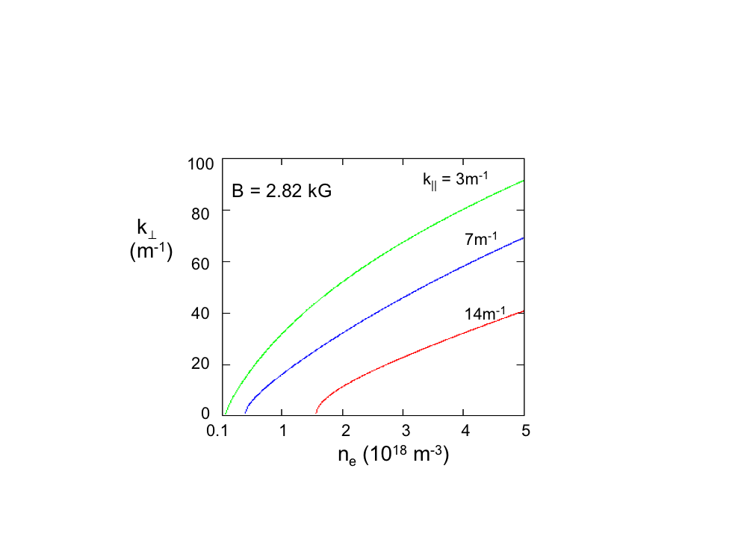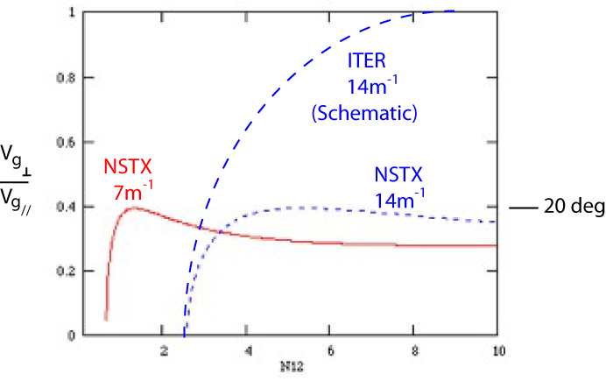
Fig. 4.1.1: Coupling of HHFW power to the core plasma requires avoiding surface wave interaction with edge plasma and antenna/walls to the extent possible, keeping edge density near antenna low relative to the onset density for perpendicular propagation (∝B×k||²/ω)

ITER NSTX

Fig. 4.1.2: 3-D AORSA modeling shows propagation to be near the wall on NSTX

NSTX

1. Optimize MHD stability to limit losses in the electron channel and to reduce
plasma/gas flow to the antenna that causes arcing
2. Understand fast wave damping mechanisms:
- Core: Landau/TTMP and short wavelength mode conversion effects
- Edge: Surface wave damping via collisions, sheaths, wall/antenna currents,
and parametric decay instability heating.
3. Predict conditions required to optimize plasma heating and CD:
- Co vs counter CD
- Can heating and CD be tailored for on and off axis applications?
- Can HHFW CD be used to help stabilize core MHD, e.g., by increasing reverse
shear in core with counter CD?

4.1.3 HHFW Heating System
- Present system has 12 antenna straps, six sources, decoupling loops, phase shifters, and
stubs. Also digital control of power and phase, and automated matching calculations
Fig. 4.1.3: NSTX HHFW antenna (circa 2007)
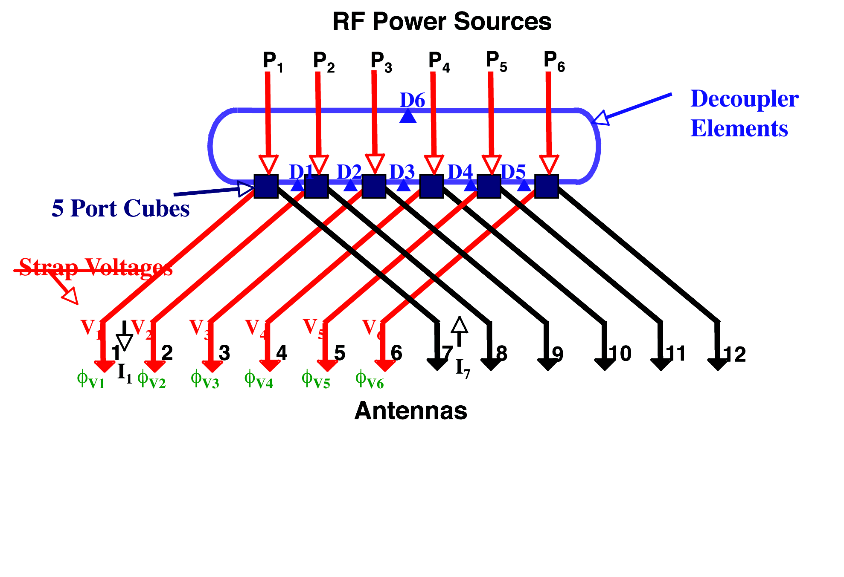
Fig. 4.1.4: HHFW Antenna feeds (circa 2007)

Planned upgrades:
2008-09:
- Major upgrade of antenna to have two feedthroughs per strap. Important for
higher power and to able to have a larger gap, to avoid edge power deposition at
high power

Fig. 4.1.5: Proposed HHFW antenna upgrade to two feedthroughs
per strap

2010-11:
- Upgrade for resilience to ELMs during H-mode:
Insert 3 db hybrids to improve operation in H-mode
Provide electronics for avoiding feeding ELMs
2011-13:
- Further improvements to V standoff (minimization of RF E field)
- Make antenna strap with 2 discreet poloidal segments (ITER-like) to permit reversal of
exciting RF current in the poloidal direction:
Provides poloidal spectrum with no m=0 component and peaked away from m=0
This upgrade should be made if modeling shows that it could be important for minimizing effects of surface waves and reactive fields on damping

4.1.4 Status of HHFW Research
Fig. 4.1.6: Role of perpendicular propagation onset close to the antenna/wall on edge power
loss revealed

1.Role of perpendicular propagation onset revealed [Fig. 4.1.6]
2.L-mode heating now demonstrated for CD phasing (90 deg phasing, k// ~ 7 m⁻¹) with
and without NBI [Fig. 4.1.7 & 4.1.8], in addition to heating phasing
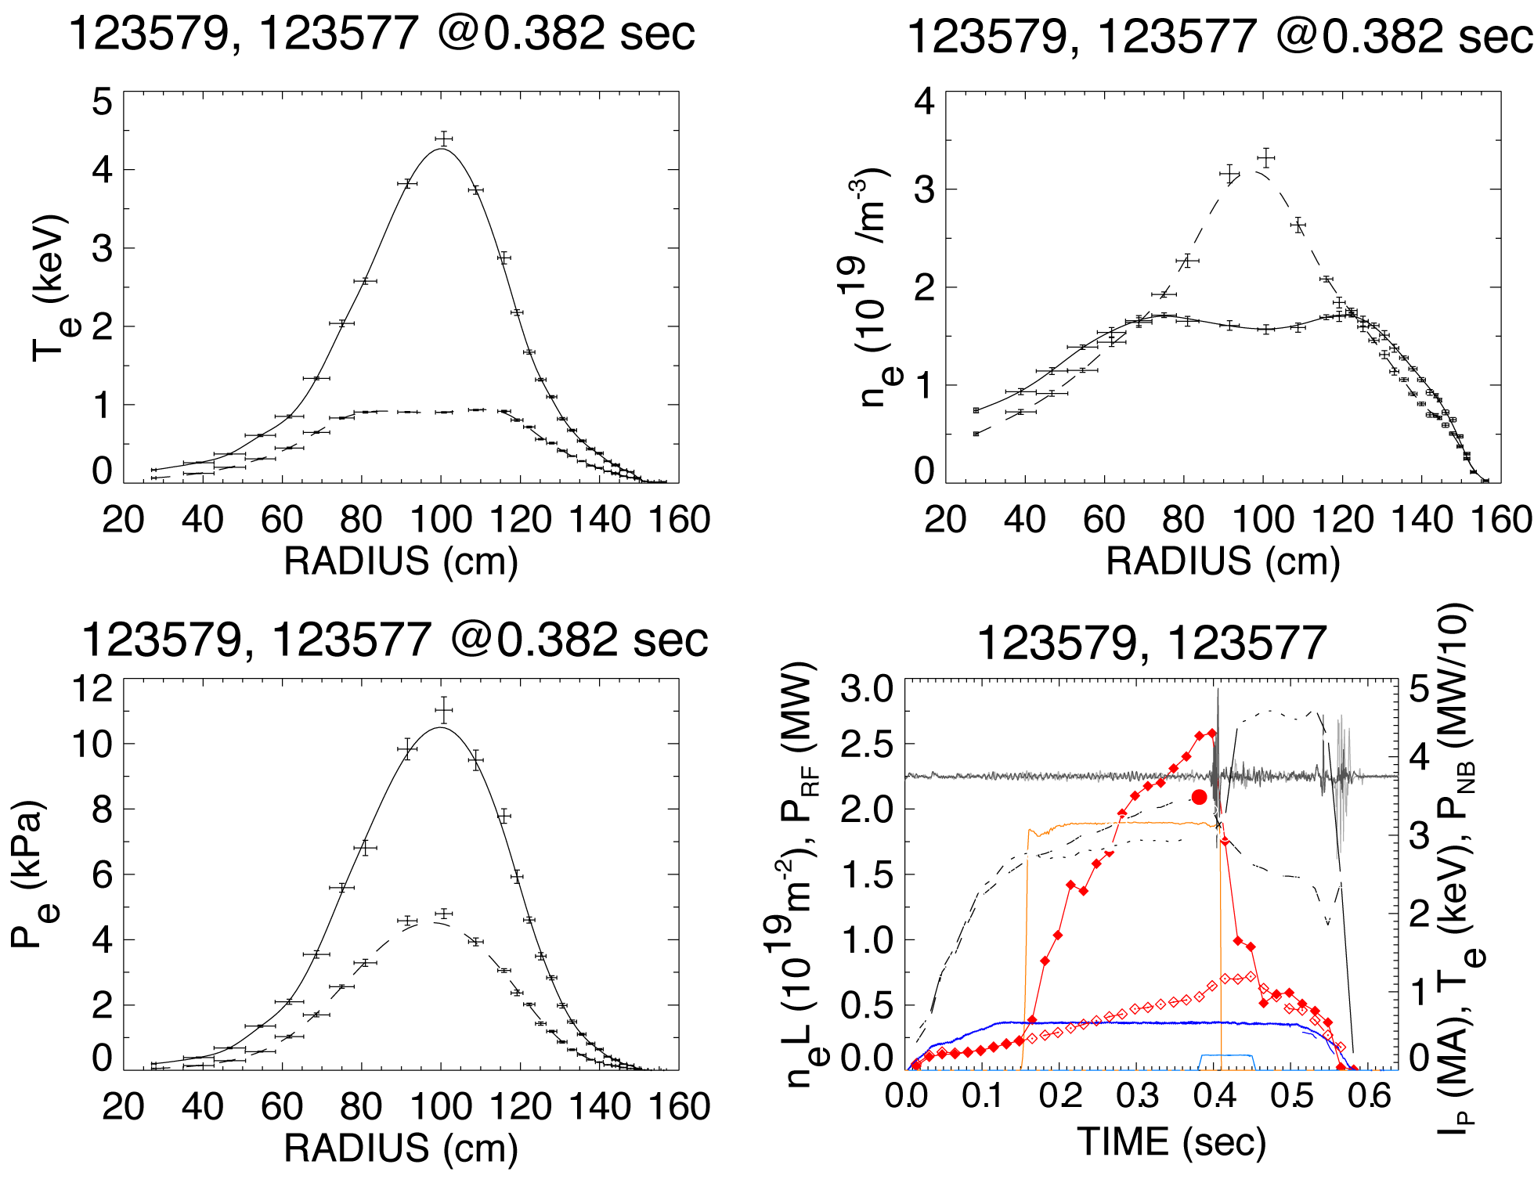
Fig. 4.1.7: High Te with HHFW and no NBI, compared to no HHFW case

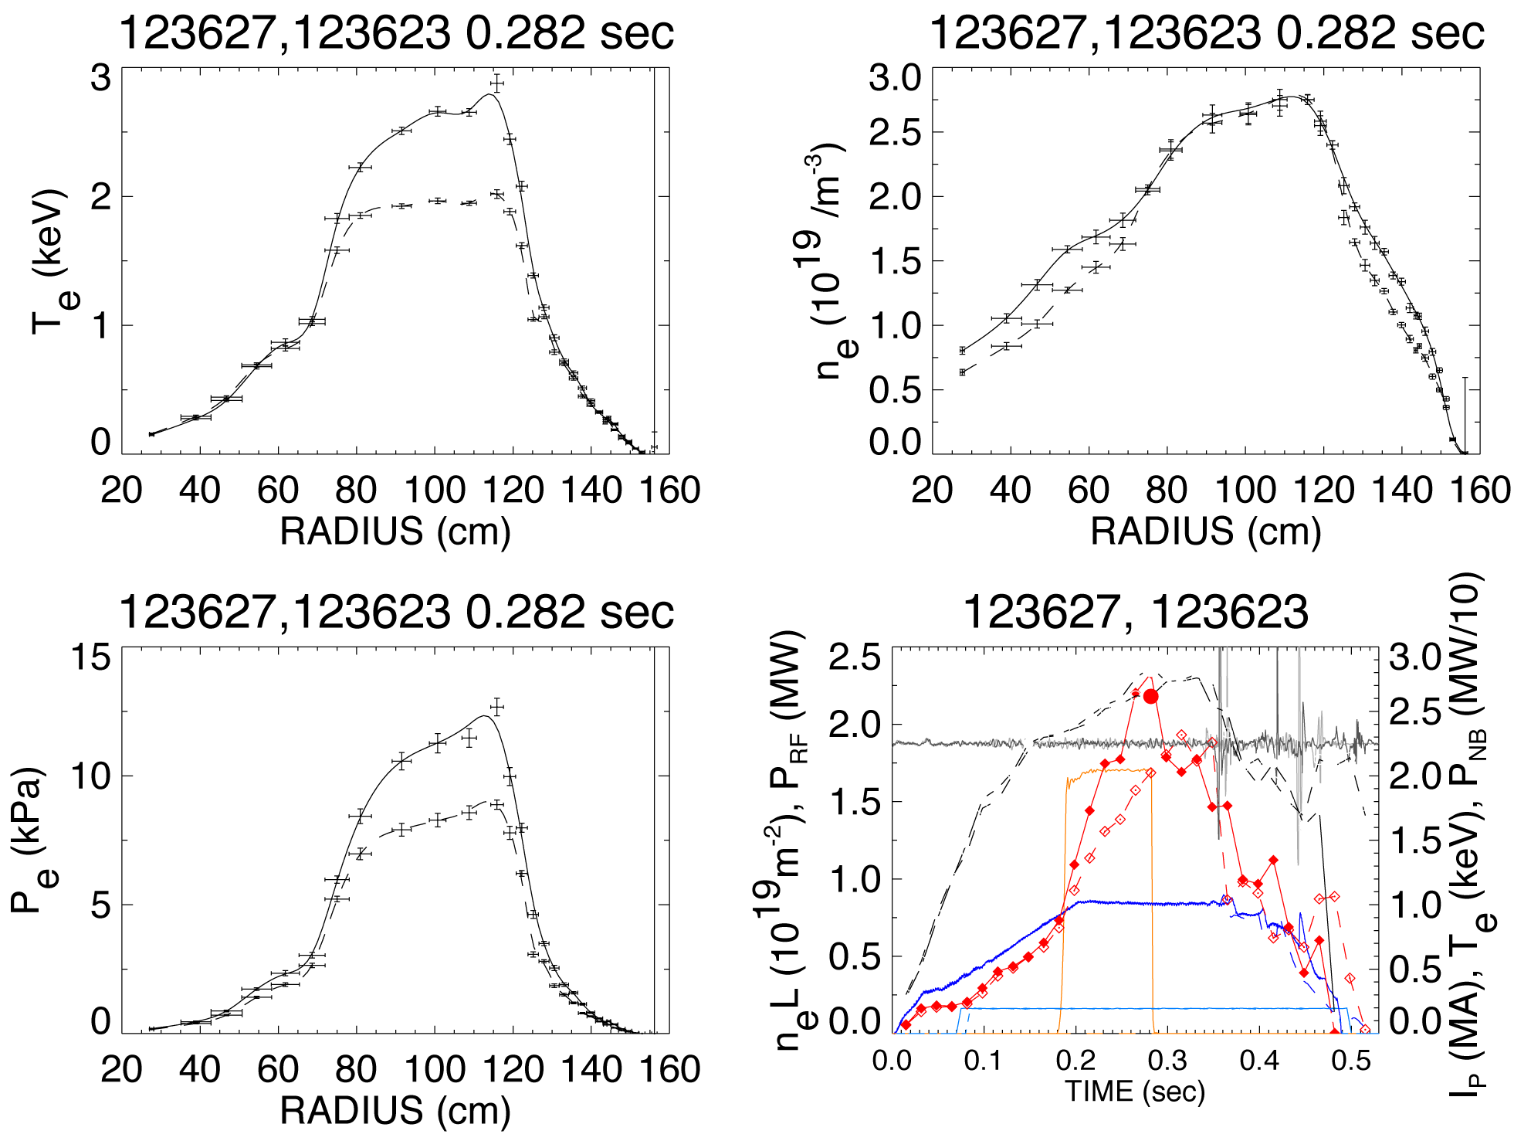

Fig. 4.1.8: Significant HHFW heating in core with NBI, compared to no HHFW case

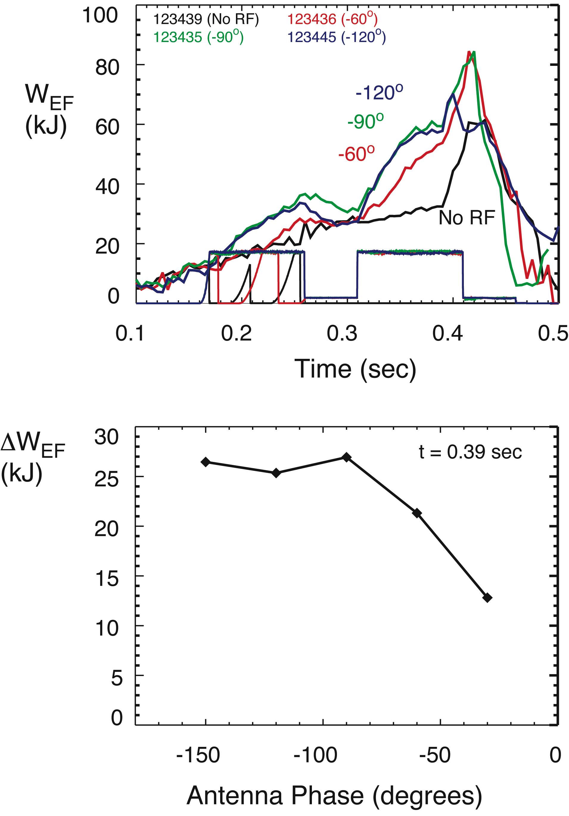

Fig. 4.1.9: Heating at longer wavelength is observed with longer RF pulses but with less efficiency than for - 90º (-7 m⁻¹) phasing

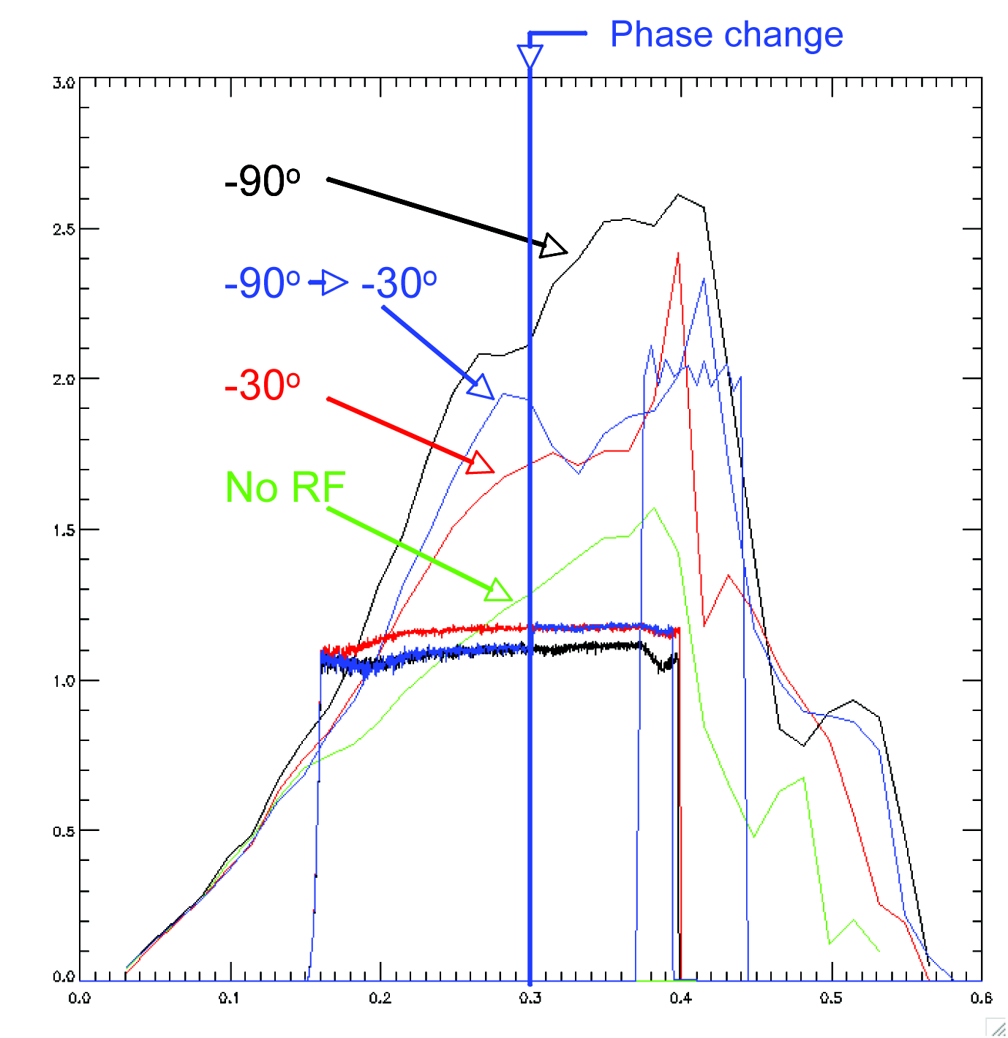
Fig. 4.1.10: HHFW Heating at - 30º is ~ 1/2 that at - 90º

3. HHFW heating efficiency at longer
wavelength (30 deg phasing,
k// ~ 3 m⁻¹) is about half that at shorter
wavelength (90 deg phasing,
k// ~ 7 m⁻¹) [Fig. 4.1.9 & 4.1.10]

4. CD effects small at powers used to date [Fig. 4.1.11]:
- Quantitative analysis underway
- MHD affects comparison between co and counter CD
- Counter case shows signs of ITB that could be caused by enhancement of negative
central shear
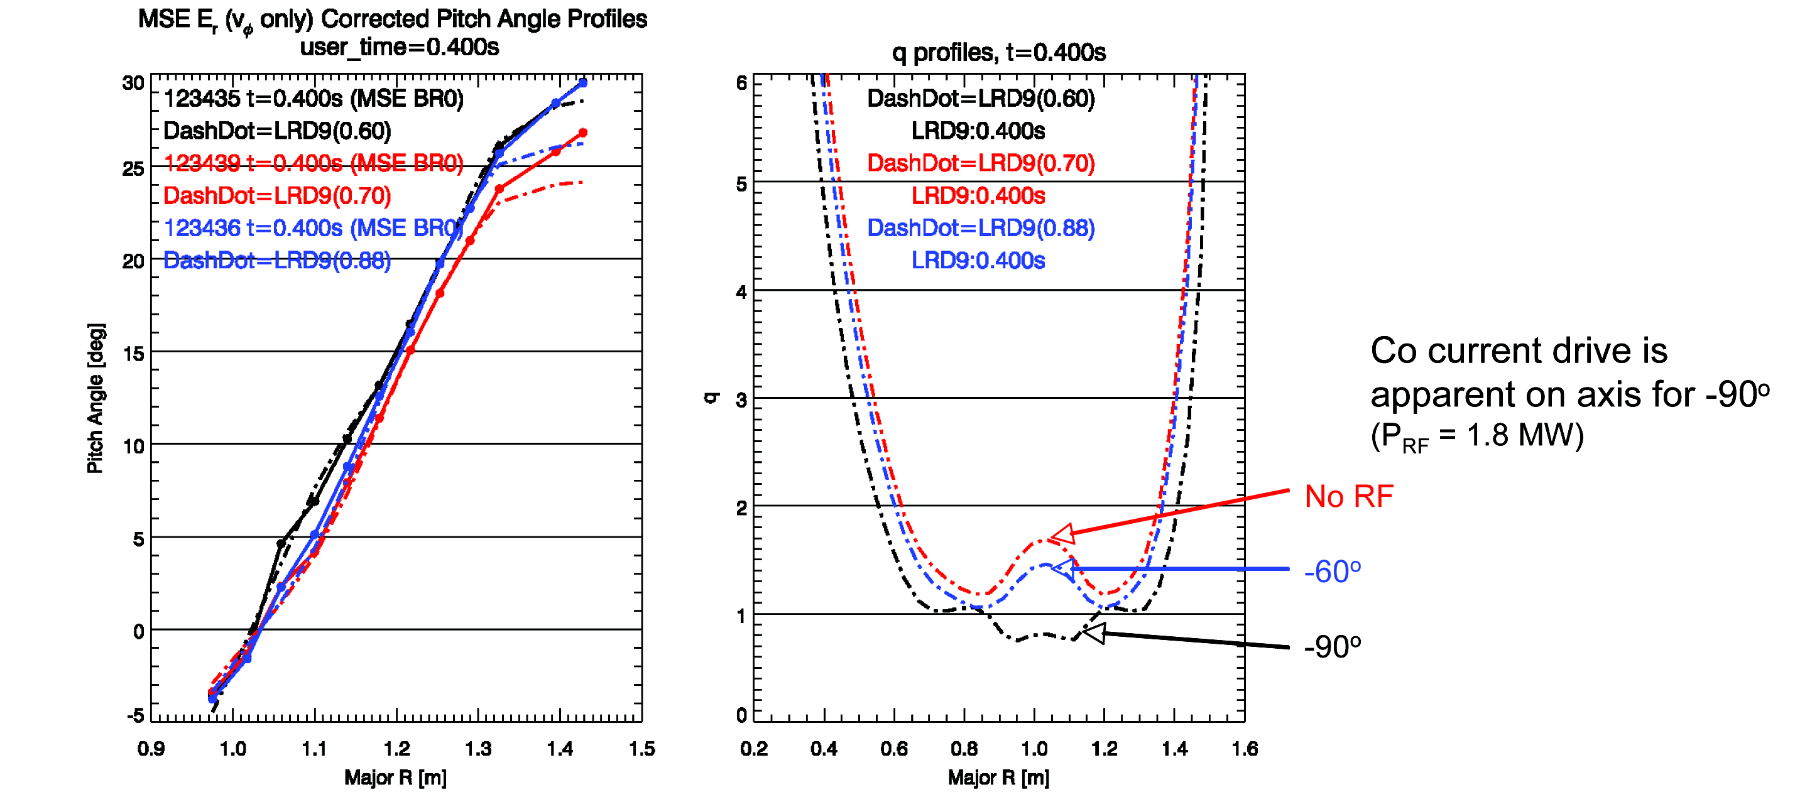

Fig. 4.1.11: MSE CD studies have begun - core CD effects seen

5. It is clear that NB ions are interacting with the boron nitride end plates of the antenna
A larger plasma-antenna gap improves stability during the NB injection pulse used for
the MSE measurement at the end of the RF pulse.

4.1.5 HHFW Research Plan for 2009-2013
2009-10:
- Optimize H&CD operation with NB for L-mode and H-mode with upgraded antenna
and using guidance of modeling
- Larger plasma-antenna gap permitted with more stability and power (more V standoff
and greater power for same V)
- Begin startup/ramp-up optimization
2011:
- Begin operations with ELM dump - further optimize H-mode H&CD operation
2012-13:
- Improve antenna based on previous results and continue startup/rampup and H-mode
optimization

4.2 Electron Bernstein Wave Physics (Taylor, Bigelow & Caughman)
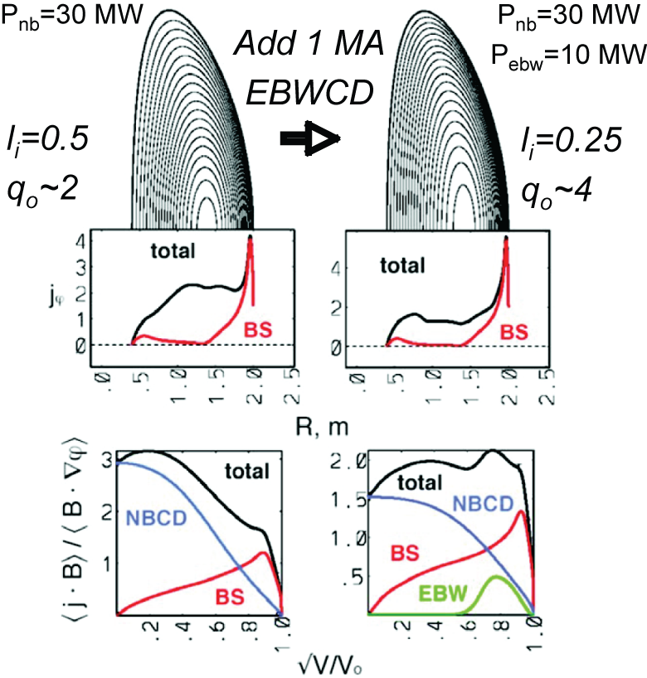
Fig. 4.2.1: Adding 1 MA of off-axis EBWCD to CTF plasma generating wall loading of 1 MW/m² can decrease l_{i} from 0.5 to 0.25 & increase q_{o} from ~ 2 to ~ 4

4.2.1 EBW Research Goals
Long-Term Goal:
- Assess EBWCD as a tool for sustaining β > 20% solenoid-free plasma
2009-13 Goals:
1. Develop ECH-assisted plasma startup to increase T_{e} sufficiently for
effective HHFW coupling
2. Evaluate EBWH-assisted overdense plasma I_{p} ramp-up
3. Demonstrate efficient EBW coupling at RF powers ~ 300 kW
4. Assess effect of ponderomotive force, heating & parametric decay @ UHR on EBW
coupling efficiency
5. Test EBW heating at RF powers ~ 600 kW & benchmark EBW code predictions for
heating efficiency & localization
6. Test off-axis EBWH & core EBWCD with RF powers ~ 1 MW & benchmark EBW code
predictions for core Fisch-Boozer CD

4.2.2 EBW Physics
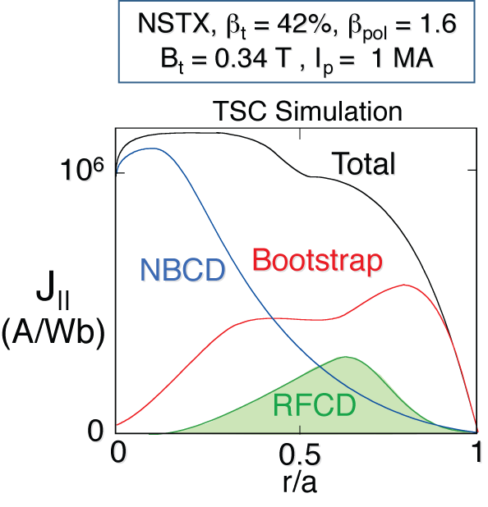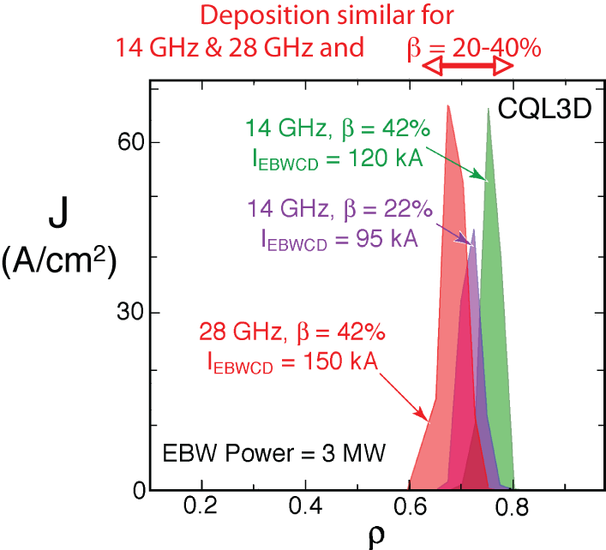

Fig. 4.2.2: Modeling predicts EBWCD can provide stabilizing current needed for β > 20% non-inductive NSTX scenarios

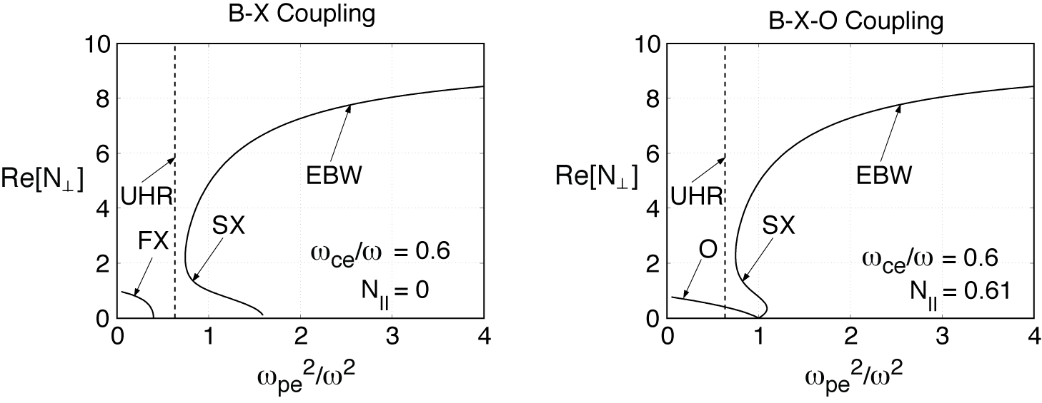
Fig. 4.2.3: Two EBW coupling schemes have been studied on NSTX and other machines. EBW and electron cyclotron wave roots of the real part of N⊥ as a function ω_{pe}²/ω² for (a) perpendicular (X-B: N// = 0) launch and (b) oblique (O-X-B; N// = N_{//,opt} = 0.61) launch. O-X-B coupling will be used for EBW heating experiments on NSTX.

- Discuss status of EBW theory & modeling (Ram)

4.2.3 EBW Heating System
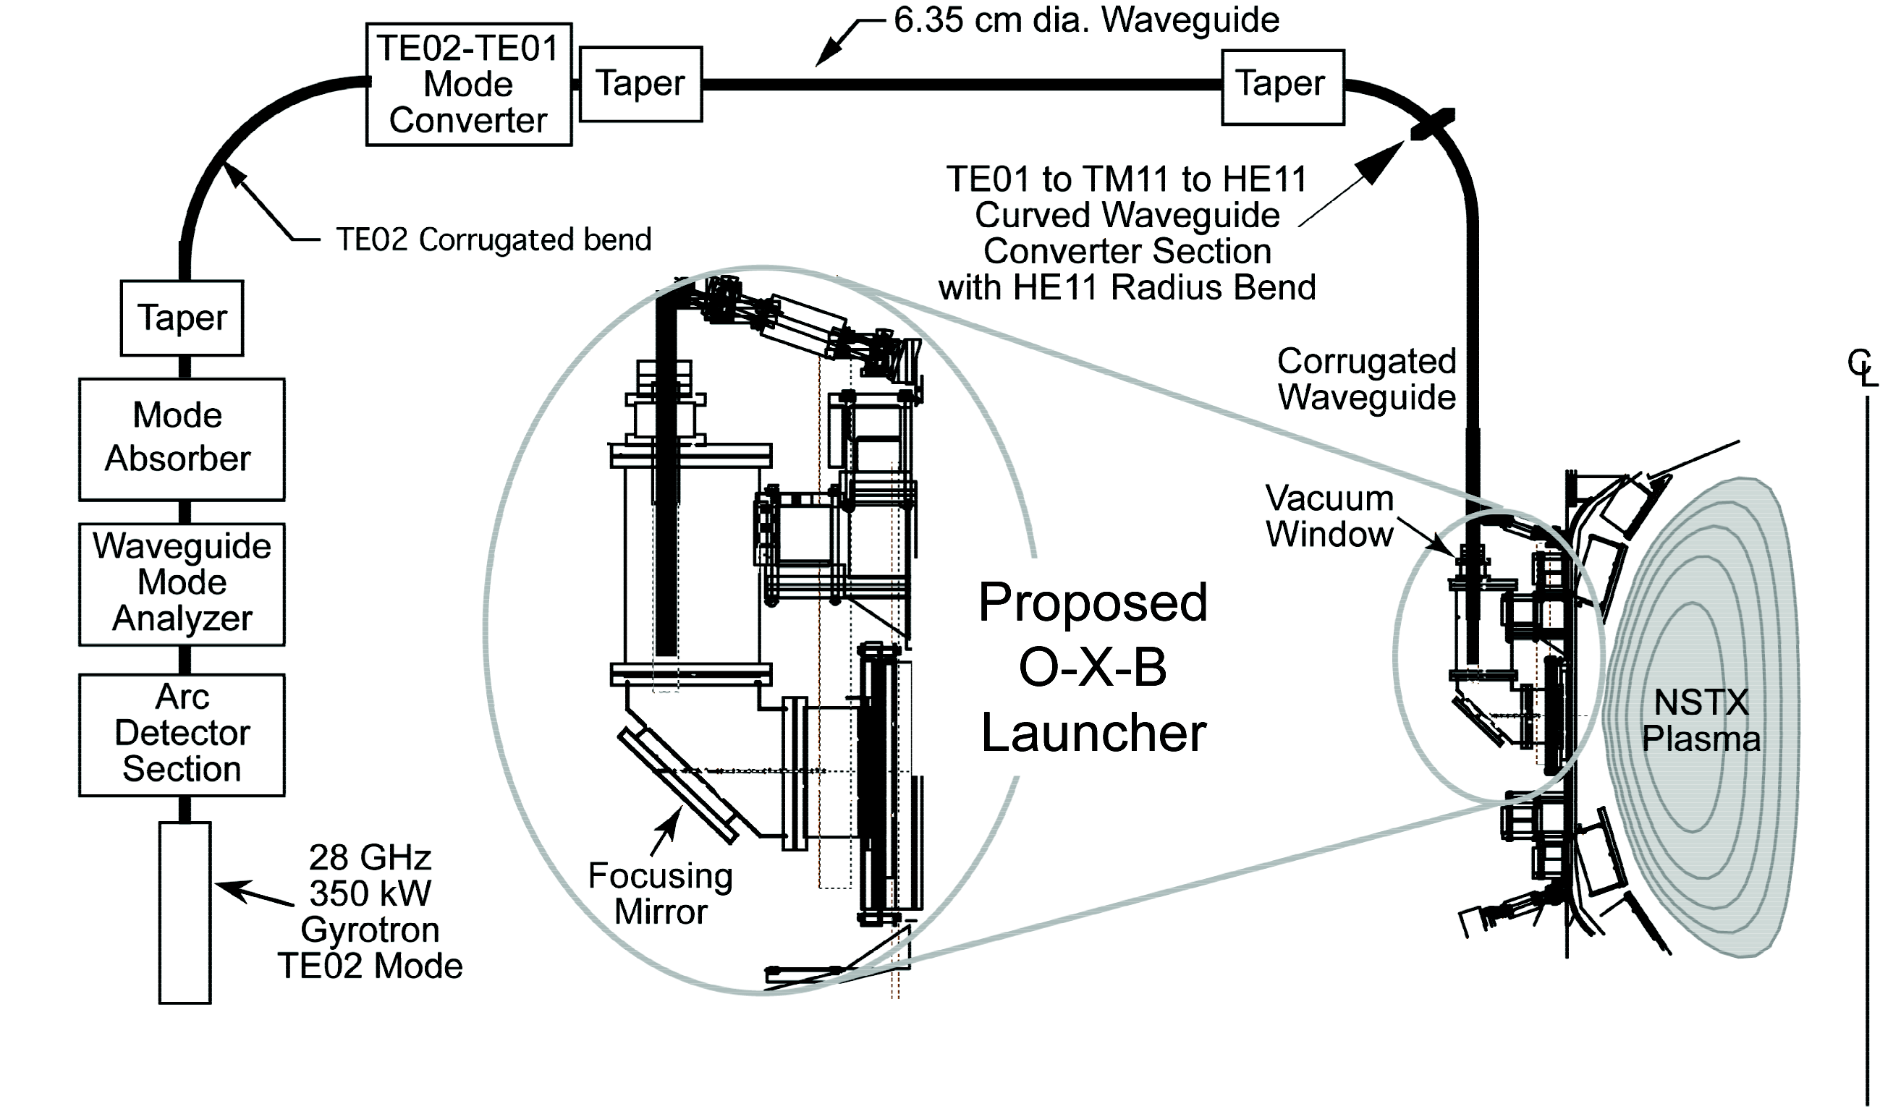
Fig. 4.2.4: 350 kW, 28 GHz, 500 ms, heating system being installed on NSTX for initial operation in FY09

- Additional gyrotrons proposed for FY10 & FY11 operation, providing ~ 1 MW
of 28 GHz power by FY12
- Possible operation at 15.3 GHz for f_{ce} EBWH on NSTX

4.2.4 Status of EBW Research
1. 80% B-X-O coupling measured for NSTX L-mode, agrees with modeling [Fig.4.2.5]
2. >30% B-X-O coupling recently measured at f_{ce} & 2f_{ce} in Li-conditioned,
high k, f_{BS}, H-mode NSTX plasmas.
3. Status of EBW theory & modeling (Ram, Harvey & Preinhaelter)

Fig. 4.2.5: Measured 80% f_{ce} B-X-O coupling in NSTX L-mode edge plasmas, consistent with modeling

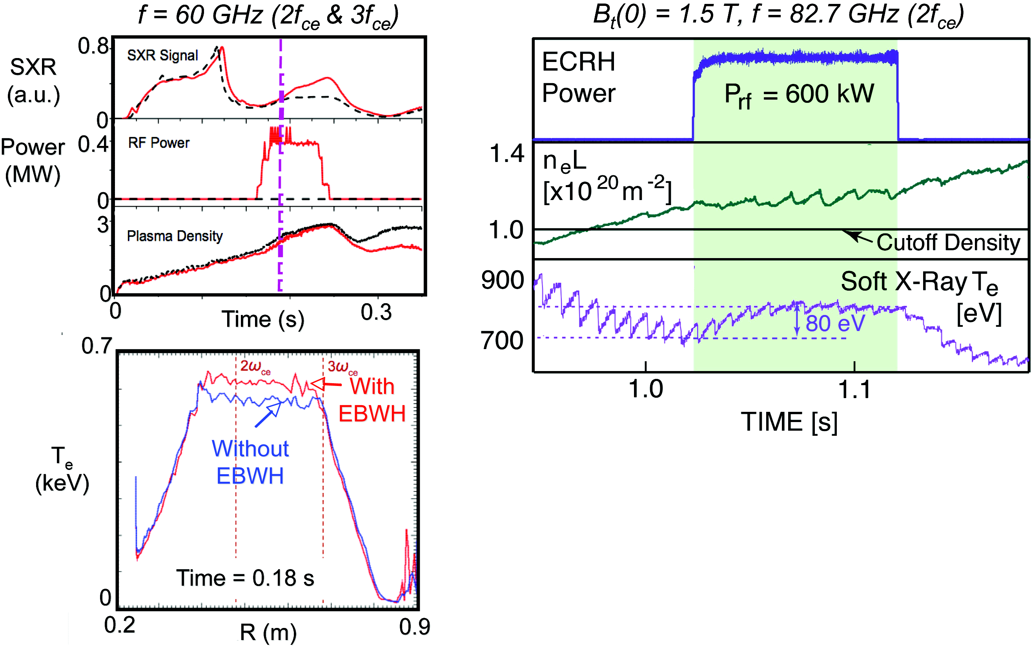
MAST TCV
Fig. 4.2.6: EBW heating via O-X-B coupling demonstrated on MAST & TCV

4. Recent results on MAST & TCV [Fig. 4.2.6] support viability O-X-B heating.
5. Non-inductive MAST startup plasma recently heated by 90kW, 28 GHz to T_{e} ~ 500 eV,
at n_{e} ~ 2x10¹⁸ m⁻³, generating I_{p} ~ 32 kA [May 2007]

4.2.5 EBW Research Plan for 2009-2013
2009:
- 350 kW, 500 ms, 28 GHz gyrotron system installed possible ~150 kW at 15.3 GHz:
- ECH-assisted startup using fixed horn launcher at Bay G midplane to heat CHI &
PF-only startup plasma to ~ 300 eV for HHFW coupling
2010:
- Install second 350 kW 28 GHz gyrotron
- Install fixed (or locally-steered) O-X-B launcher for I_{p} flat top at Bay G:
300 kW EBW coupling & core heating expts
High resolution edge T_{e} MPTS
Edge reflectometer at launcher for measuring local L_{n}
Antenn/probe for measuring lower hybrid parametric instability
- Install fixed EBW horn launcher for EBW-assisted startup & I_{p} ramp up expts.
2011:
- 600 kW EBW core & off-axis heating expts
- Continue EBW-assisted startup & I_{p} ramp up expts.
2012-13:
- Install third 350 kW 28 GHz gyrotron
- Install remotely-steered O-X-B launcher next to HHFW antenna [Fig. 4.2.7]
- 1 MW off-axis EBW heating & core EBWCD (Fisch-Boozer CD) expt.
4.3 Energetic Particle Physics (Fredrickson & Gorelenkov)
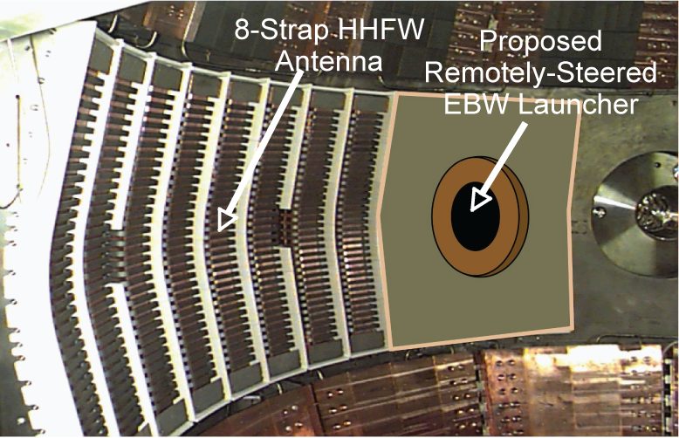

Fig. 4.2.7: NSTX double feed HHFW antenna showing proposed EBW launcher (circa 2012)

4.3.1 Energetic Particle Research Goals
Long-Term Goal:

2009-13 Goals:
1. Measure beam induced mode affect on fast ion transport, beam driven currents:
- Measure fast ion re-distribution with FIDA/NPA
- Measure losses with fast neutron detector, IFLIP and SFLIP
- Measure current profile evolutions with MSE
2. Develop Alfvén Spectroscopy tools
- Measure linear damping rate of stable modes
- Explore external drive of CAE
3. Benchmark simulation codes
- Measure internal mode amplitude, radial profile
- Model evolution with Nova-Orbit, M3D, TRANSP
4. Develop physics basis for CAE stochastic heating system
- Identify stochastic heating threshold
- Extend simulations with ORBIT to predict trans-threshold behavior
- Estimate power required to reach threshold, partitioning of power

4.3.2 Energetic Particle Physics
1. Multi-mode transport for ITER (ST-reactors)
- Transport during multiple modes
- Direct/indirect mode coupling
2. Benchmarking of simulation codes
- Needed to predict fast ion confinement on reactors
- NSTX uniquely suited:
Fast ion, fast mode, and good equilibrium diagnostics
New experimental tools (antenna, FIDA, BES)
Broad spectrum of instabilities
3. CAE stochastic heating
- Physics basis
- Relevance to future STs and ITER

4.3.3 CAE Heating System
1. Design of antenna
- Measure poloidal structure of beam-excited CAE
- Estimate coupling efficiency using TORIC
2. Measure coupling efficiency of proto-type antenna(s)
- Use Alfvén spectroscopy amplifier for initial studies
- Measure mode amplitude with reflectometers?
3. Initial heating experiments
- Use fixed frequency, high power oscillator
- Measure excited mode amplitude scaling with heating power
- Look directly for ion heating with CHERs

4.3.4 Status of Energetic Particle Research
1. Fishbones and EPMs [Fig. 4.3.1]
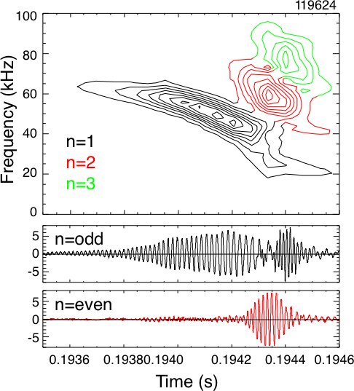
Fig. 4.3.1: Fishbone mode showing multimode
transport

- Bounce-resonance drive
- Present for q_{min} > 1, infernal modes?
- Strong chirps/multi-mode => losses

2. TAE and avalanches [Fig. 4.3.2]
- Multi-mode losses (Avalanches)
- Mode amplitude measured
- Fast ion losses measured (multi-mod
3. Beta-induced Alfvén Acoustic Eigenmodes [Fig, 4.3.3]
- Prediction
- Discovery
- Fast ion losses
4. Beta dependence of Alfvén Cascade modes [Fig. 4.3.4]
- Theoretical prediction (GAM coupling)
- Experiments at low beta

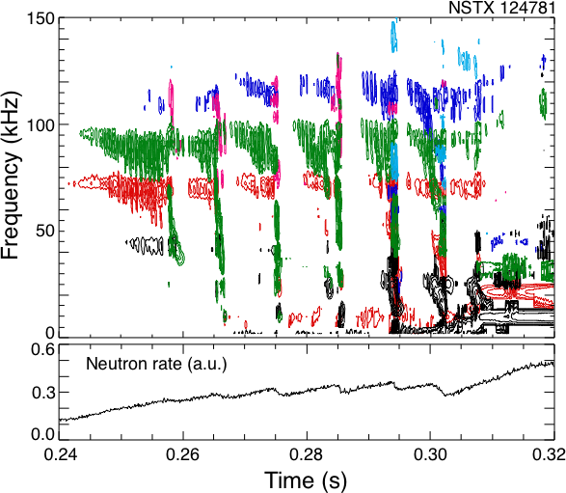
Fig. 4.3.2: TAE avalanches and neutron
drops indicating fast ion losses

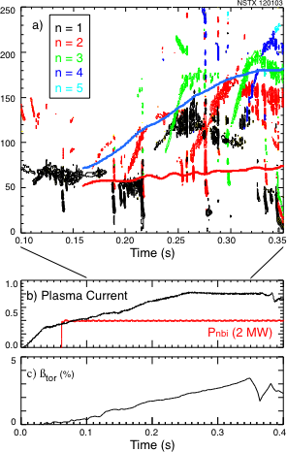

Fig. 4.3.4: Alfvén Cascades

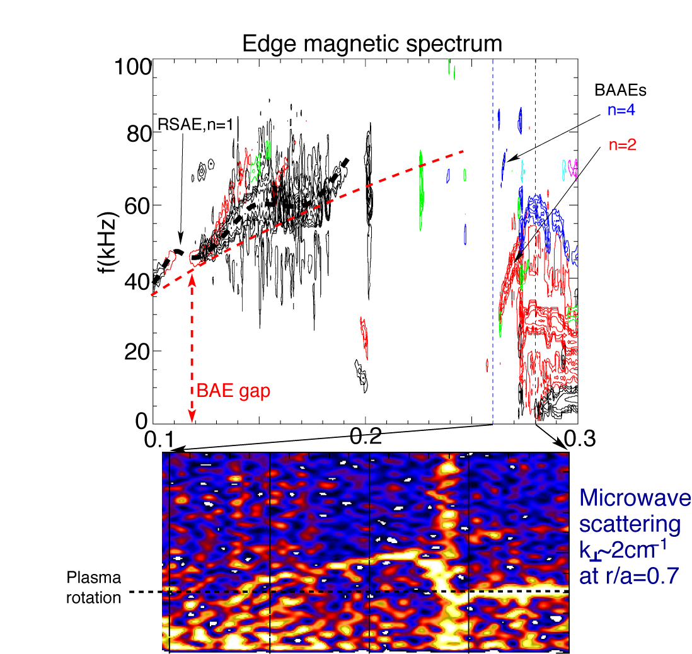

Fig. 4.3.3: Beta-induced Alfvén Eigenmodes

5. CAE (Hole-clumps) [Fig. 4.3.5]
- Match resonance condition
- Measured/calculated damping rate
- Measured mode amplitude

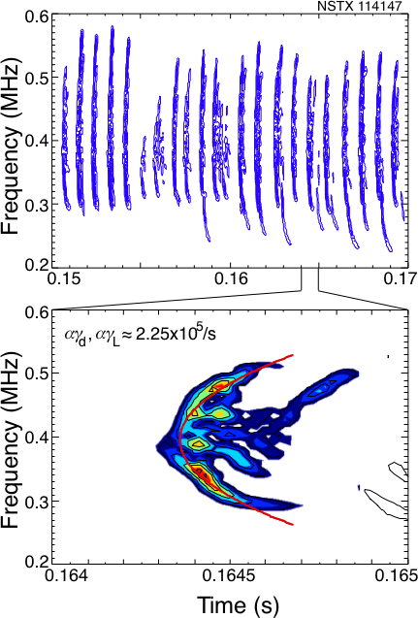
Fig. 4.3.5: CAE hole-clumps (Angelfish)

6. Global Alfvén Eigenmodes
- Predicted with HYM
- Discovered (polarization measurements)
7. Stochastic Ion Heating
- Estimated threshold amplitude
- Damping rates measured/calculated
(power to reach threshold)
- Outboard poloidal structure measured
8. Non-linear multi-mode coupling
- Direct coupling, bi-spectral analysis
- Indirect coupling through fast ion distribution
9. Energetic ion depletion?

4.3.5 Energetic Particle Research Plan for 2009-2013
2009:
TAE/BAAE/BAE:
- Multi-mode fast ion transport (Avalanches):
Measure fast ion redistribution (FIDA)
- Mode structure Documentation (BES/reflectometer)
- non-linear stability simulations M3D
- Fast ion transport simulations ORBIT/Nova
2010:
Fishbones, Alfvén Spectroscopy:
- Fast ion redistribution for q>1 EPMs
- Fast ion redistribution for q≈1 EPMs (fishbones)
- MHD spectroscopy in high-beta plasma, NBI current drive study
specific heat ratio study and its use for diagnostic
2011:
CAE/GAE:
- Internal structure of modes (BES/reflectometers)
- Poloidal structure of modes (partial to full fast poloidal array)
- High-k scattering to look for mode conversion
2012:
CAE/GAE Angelfish stabilization with HHFW

CAE Heating Plan for 2009-2013:
2009:
Design/purchase components for active spectroscopy “Exciter and detection
system”:
- 2 kW, 100 kHz – 10 MHz linear amplifier ≈ $35,000:
(JET system used 3 kW amplifier and 8 saddle coils)
- Initial operation to use internal RWM saddle coils
- Other electronics and control hardware ≈ $250,000(???).
2010:
Intall and begin MHD spectroscopy experiments:
- Determine coupling efficiency to CAE modes
- Design dedicated CAE antenna
2011:
Install CAE antenna:
- Begin experiments on CAE active spectroscopy
- Estimates of power required to reach stochastic heating threshold
- Decision point to continue stochastic heating program
- Design fixed-frequency (or narrow band), high power oscillator
2012:
Install fixed frequency, high power oscillator to begin stochastic ion heating experiments

References

