3.2 Transport and Turbulence
3.2.1 Understanding and Optimizing Transport and Turbulence in the Spherical Torus
The low toroidal field of NSTX, approximately a factor of ten lower than that in conventional aspect ratio devices, leads to plasma operations in parameter regimes that are different than those at higher aspect ratio, which in turn lead to new opportunities to extend and benchmark theory and to make new diagnostic measurements. The enhanced toroidicity and natural shaping at low aspect ratio is predicted to lead to reduced microturbulence levels, and thus reduced transport associated with the microturbulence. Enhanced toroidicity also results in higher trapped particle fractions, which can influence Trapped Electron Mode (TEM) turbulence. Furthermore, the low toroidal field and near Mach flow yields large values of the ExB shearing rates, believed to be important for the suppression of long wavelength microturbulence and its associated transport. NSTX operates in regimes whose plasma collisionality is similar to that at conventional aspect ratio (and to that of ITER), but in which both the plasma beta, β_{th}, and the electron and ion gyroradii, ρ_{e}, ρ_{i} respectively, can be up to a factor of 10 greater than those at higher toroidal field and aspect ratio. The high β (up to 40%) enables NSTX to explore electromagnetic and stochastic magnetic effects that may influence transport, and the large electron gyroradius (0.1 mm) allows for a direct measurement of spatially-resolved electron-scale turbulence.

Because of the extended parameter regime in which NSTX operates, the results will naturally extend and stress theory. Are models that are acceptable for conventional aspect ratio relevant to the low aspect ratio regime? What modifications or additions to these theories are necessary to make them relevant? Answers to these questions will necessarily deepen our understanding of basic toroidal confinement physics, which will naturally lead to more confidence when extrapolating this physics to future devices.

Not only will the physics theories themselves be tested, but complex numerical calculations that will push the limits of present computational resources will be necessary to gain this understanding. For instance, the non-linear simulation of short-wavelength, electron-scale instabilities will require use of state-of-the-art computational tools, especially under circumstances where scale separation between electrons and ions (i.e, high and low-k) modes, is not possible. NSTX operation does offer some regimes where such scale separation may be possible, regimes in which anomalous ion transport is low and thus the ions can be treated adiabatically, but the difficult issue of turbulence spreading may require fully kinetic calculations.

These requirements, and the validity of the results of the calculations, will be determined through extensive benchmarking. This benchmarking procedure, which has been ongoing through the life of the NSTX project, and has recently been called out as Verification and Validation by the wider fusion community, will be a true test of the validity of the transport physics models. As the codes for simulating the plasma transport become more sophisticated, so too will the diagnostics for measuring this turbulence and its associated transport. This will offer the opportunity to test theory at all levels, from the specific fluctuating quantities to an overall level of transport. Agreement between actual measurements and simulated measurements from diagnostics built into the codes at all these levels will give enhanced confidence in our understanding of the processes controlling the plasma transport.

The goal of this research is to develop a comprehensive picture of transport and turbulence in NSTX by combining and benchmarking results from measurement, analysis and theory, with an ultimate target of developing a fully predictive tool for energy, particle and momentum transport that can be used with confidence for predicting performance of future devices, both ST and non-ST. NSTX research is critical to justifying, and perhaps modifying, key assumptions for achieving the performance objectives of future devices. In particular, for an ST-based Component Test Facility, crucial assumptions include those of achievable confinement enhancement factors and operation in the Hot-Ion H-mode regime. Global confinement and ion transport and turbulence research at high P_{heat}/P_{LH}, including understanding the role of rotational shear in suppressing ion-scale microturbulence, addresses these assumptions. Of overriding importance for both future ST and non-ST burning plasma devices is the optimization of neutron production and/or fusion gain, both of which are tied directly to understanding and optimizing electron transport, a task for which NSTX is ideally suited.

Laying the foundation for this comprehensive understanding and predictive capability will necessarily involve coordinated research with other major devices both in the U.S. and internationally, and will allow for discharge scenario development in NSTX and in future devices such as q possible NSTX follow-on (ST-Performance Enhancement), and ST-based Component Test Facility, and longer-range targets such as an ARIES-ST prototype reactor. Such an understanding will allow for
  - confident extrapolations of transport and turbulence properties to ensure that confinement requirements can be satisfied at high input powers (greater than the L-H threshold power) and high power density divertors (e.g., P/R),
  - understanding and extrapolating momentum transport to assure adequate rotation and ExB shear for the suppression of microturbulence and MHD modes,
  - determining regimes in which plasma profiles for current drive and fusion production are optimized.
Further, the detailed physics understanding gained from this coordinated effort will aid in the prediction of performance of confidence for success of future devices at conventional aspect ratio, such as ITER.

3.2.2 Overview of Research Plans for FY2009-2013
The unique operating regime of NSTX will allow exploration of the transport and turbulence properties that govern toroidal confinement. Both as a complement to conventional aspect ratio tokamaks and as a confinement concept in its own right, NSTX will move in a direction to identify and control the fundamental physics mechanisms that are most important in determining energy, particle and momentum transport. Much progress has been made since the start of the FY2004-2008 Five Year Plan, and the key transport goals for the period from 2009 to 2013 are:

- To verify global scaling trends at very high P_{input}/P_{LH} and to establish the dependence of confinement on aspect ratio,
- To establish conditions for neoclassical ion transport through coupling low-k turbulence measurements to results of non-linear gyrokinetic simulations,
- To determine the role of both low-k and high-k turbulence, through measurement and non-linear theory, in setting the level of anomalous electron transport,
- To determine the source of the plasma rotation/radial electric field and its influence on both low- and high-k turbulence,
- To understand the relation of particle and impurity transport throughout the plasma to measurements and simulations of microturbulence, ultimately to
- Develop a validated, fully-predictive tool for developing confinement-optimized discharge scenarios for both NSTX and future ST and non-ST devices.

3.2.3 Transport and Turbulence Results and Plans by Topical Area
3.2.3.1 Energy Transport
Understanding and ultimately being able to control the sources of ion and electron transport is critical to the success of creating high performance plasmas in present day experiments. Furthermore, it is equally critical for being able to extrapolate to future device operation through high-confidence predictions. One of the goals of NSTX is to develop a comprehensive picture of energy transport for both electrons and ions. This can be done using a multi-faceted approach combining measurements from profile diagnostics and associated transport analysis, using international standard codes such as TRANSP, with details of turbulence measurements taken from both turbulence diagnostics across a wide range of wavelengths from ion to electron-scales, coupled to predictions of both turbulence levels and saturated heat flux from non-linear gyrokinetic simulations.
Of particular importance in this area of research is the study of electron transport, which, in NSTX, is anomalous in all operational regimes. NSTX is particularly suited to study the electron transport physics, since in many regimes the ion transport is at or near neoclassical levels, enabling the anomalous electron transport to be isolated. Because of the high neutral beam injection energy relative to the electron temperature in NSTX, the electrons are predominantly heated, by a 2:1 ratio, emulating the dominant electron heating in ITER as well as in possible future ST devices. Furthermore, the low toroidal field in NSTX leads to electron gyroradius scale-lengths that are approximately 0.1 mm, meaning that microturbulence on these scales is readily measurable with high spatial resolution using microwave scattering technology. These attributes, coupled with state-of-the-art computational tools, make NSTX an excellent laboratory in which to study electron transport.
A major part of the transport research will be the use of both linear and non-linear gyrokinetic calculations. These calculations will cover the range of neoclassical transport of ions, impurities and momentum using a kinetic (i.e., finite banana width and ultimately finite Larmor radius considerations) approach, to a determination of the unstable microinstabilities and their characteristics. An important part of these calculations will be detailed benchmarking of codes and physics models with respect to one another and with respect to measured quantities. This benchmarking, which is presently being called Verification and Validation, has been ongoing, but more sophisticated approaches will allow for more detailed benchmarking on a variety of levels. For instance, synthetic diagnostics will be built into the various simulation codes, and these will allow us to make direct comparisons with equivalent measured data such as the plasma fluctuations. Comparisons will be made between the measured and simulated primary characteristics of the fluctuation spectra, such as δT, δn, and cross-phase, as well as secondary characteristics, including Zonal Flows, and wavenumber and frequency spectra. At a higher level, local heat fluxes or thermal diffusivities calculated by the codes will be compared to those inferred from experiment. Ultimately, a physically valid and relevant model will yield agreement with measurements at those levels and at the highest level, which is a predication of global trends (i.e., the parametric dependence of confinement scaling). A successful Verification & Validation procedure will lead to a high confidence predictive tool for extrapolation to future devices.
Since transport and turbulence are inexorably related, they will be integrated into a single, coherent plan.
        - Global Confinement
Results
Dedicated global confinement studies that have been carried out over the last several years have focused on two issues, the first to establish the basic parametric dependences of the energy confinement at high heating power, and the second to address global confinement issues of particular importance to ITER and for which NSTX is particularly suited.
Dedicated confinement scans to elucidate the basic parametric dependences, such as the I_{p} and B_{T} scaling, were carried out in H-mode plasmas with elongation κ of 2.1 and triangularity δ of 0.6 at fixed beam power (P_{input}=4 MW) and at similar densities. These dedicated studies have revealed confinement trends that differ from those at conventional aspect ratio, as is illustrated in Fig. 1, where the results of the B_{T} and I_{p} scans at constant I_{p} and B_{T} respectively are shown. Unlike at conventional aspect ratio, where the dependence of τ_{E} on B_{T} is weak (τ_{E}~B_{T}^{0.15} in the ITER98(y,2) scaling [1]), the dependence on B_{T} in NSTX is stronger, with τ_{E}~B_{T}^{0.9} for both thermal and global confinement time. Alternatively, the dependence on plasma current is much weaker than what is observed at conventional aspect ratio, with τ_{E}~I_{p}^{0.4} as compared to I_{p}^{0.9} for ITER98(y,2). The results of these dedicated scans [2, 3] verify trends that were extracted from earlier data by statistical means [4]. To understand the sources of these global confinement trends, it is necessary to turn to local analysis.
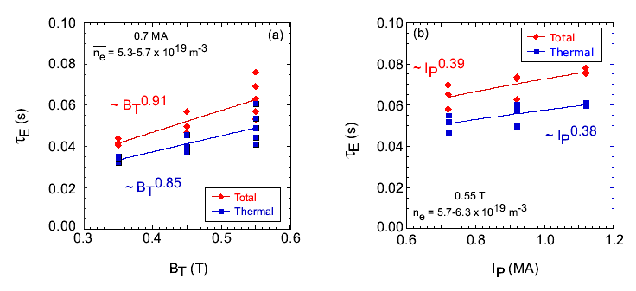
The confinement experiments have focused also on studying the dependence of confinement on plasma β, an issue that is critical to assessing the potential for success of the ITER Advanced Tokamak scenario, which will operate at higher β than the standard target. Key to this is whether there is the degree of degradation (if any) of confinement with plasma beta. The results from standard aspect ratio tokamaks are mixed; while JET and DIII-D experiments [5, 6] have shown no degradation of τ_{E} on β, experiments run by JT-60U and ASDEX-U [7, 8] have shown degradations that are similar to what is predicted by the ITER98(y,2) scaling, where Bτ_{E}~ β ^{-0.9}. One difference between the two sets of scans is that the results showing the strong degradation were from discharges that had lower κ and δ. NSTX is uniquely suited to address this problem, in that not only can a large range of β be covered in a scan, but shape comparisons can be performed within the NSTX device. The results of the scans are shown in Fig. 2, where the β scan was performed by varying power at fixed I_{p} and B_{T}. Across this range of power and beta, other dimensionless variables such as ν∗ and ρ∗ were held constant to within 20%. In the case with strong shaping, κ =2.1 and δ=0.6, the confinement time showed no degradation with β, while in the more weakly shaped plasmas, with κ=1.8-1.9 and δ =0.4, the confinement time was seen to degrade with β rather strongly, with τ_{E}~ β ^{-1.0}.
Fig. 1 Thermal and global confinement time scalings as a function of (a) B_{T} and (b) I_{p} from dedicated scans at constant injected beam power, 4 MW, and density.
Fig. 2 Scaling of H-mode confinement with β at fixed B_{T}, I_{p} for a plasma with (a) κ=2.1, δ=0.6 and (b) κ=1.85, δ=0.4
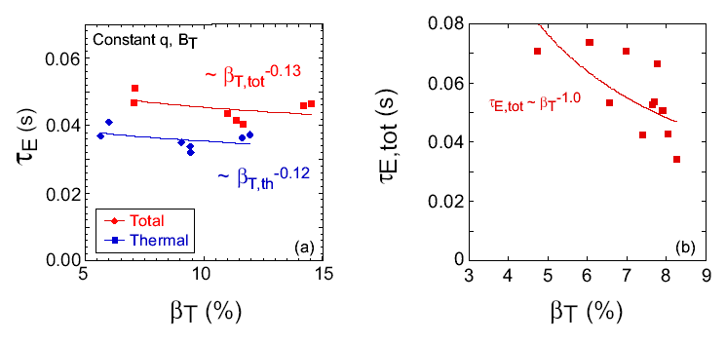
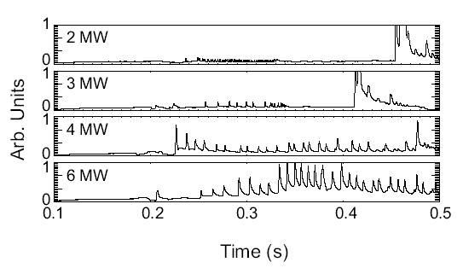
One of the key results of the scan showing the degradation is the variability of the ELM severity. In the high elongation/triangularity discharges, only small, Type V ELMs were observed for all powers, while in the lower elongation/triangularity scans, the ELM type varied from Type III at low power to Type I at high power (Fig. 3). Whether it is the ELM variability as a result of the shape change that causes the difference in degree of degradation will be the subject of future experiments and future collaborations among the various experiments around the world.
Fig. 3 ELM activity as a function of power (beta) for the k=1.85, d=0.4 plasma. The ELM type evolves from Type III at low power to Type I at higher power.
Plans
2009-2010:
The source of the variation of β degradation of confinement will be explored, focusing on the variation in ELM severity as a function of discharge shape. This study will be carried out with experiments to vary β in weakly shaped plasmas while keeping the level of ELM activity constant. Experiments will also be carried out to determine the dependence of confinement on R/a both within NSTX and in conjunction with conventional aspect ratio devices in order to optimize ST-PE design scenarios.
2010-2013:
The second neutral beam line will be operational during this time period, and experiments will be performed to verify confinement scaling trends at high P_{input}/P_{LH} in support of the NHTX and ST-CTF physics designs.
3.2.3.1.2 Ion Transport
Results
Ion transport in NSTX H-mode plasmas has been determined to be at or near neoclassical levels in the gradient region (e.g., r/a=0.3-0.7) of well-controlled and relatively MHD-queiscent H-mode plasmas. It was found further, that while the ion transport did not exhibit much variation with B_{T}, it was this channel, and, in fact, the variation of the neoclassical transport that was predominantly responsible for the scaling of global confinement with plasma current [2]. The variation of the ion thermal diffusivity profiles with I_{p} and B_{T} from these dedicated scans are
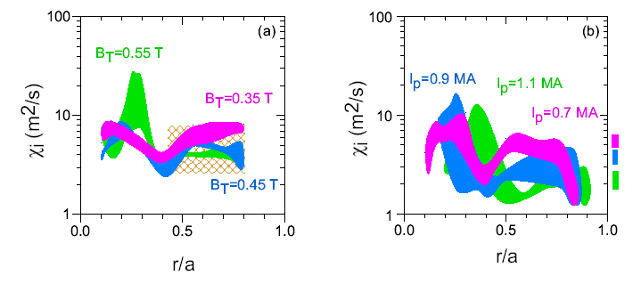
shown in Fig. 4. As can be seen, while the ion thermal diffusivity outside of r/a=0.5 did not vary much at different values of B_{T} for fixed I_{p}, there was a much stronger variation in the I_{p} scan, with χ_{i} decreasing with increasing plasma current. Also shown in the figure is the range of neoclassical transport, given by the cross-hatched rectangular region for the B_{T} scan, and by the solid, color-coded rectangles for the I_{p} scan. For this latter scan, the rectangles indicate the neoclassical levels in the region from r/a=0.4 to 0.7. For both scans, the neoclassical levels were determined by the GTC-NEO code [9], which uses a gyrokinetic approach, including finite banana-width and thus non-local effects, to determine neoclassical levels.
Fig. 4 Ion thermal diffusivity at fixed heating power and density as a function of (a) B_{T} at fixed I_{p} (b) I_{p} at fixed B_{T}. The cross hatched box in (a) and the color coded rectangular boxes in (b) indicate levels of neoclassical transport as determined by GTC-NEO.
A picture in which the ion transport is near the neoclassical level during the H-phase of the NSTX discharges, dropping from an anomalous level during the L-phase, is supported by both linear and non-linear gyrokinetic calculations. Shown in Fig. 5 are results from linear GS2 flux-tube calculations, showing much larger growth rates for low-k modes during the L-phase than during the H-phase of a selected discharge. Non-linear, global GTC calculations indeed show that the neoclassical ion heat flux is greater than the turbulence-driven flux during the H-phase of these discharges. Also adding to the suppression of these low-k modes during the H-phase is
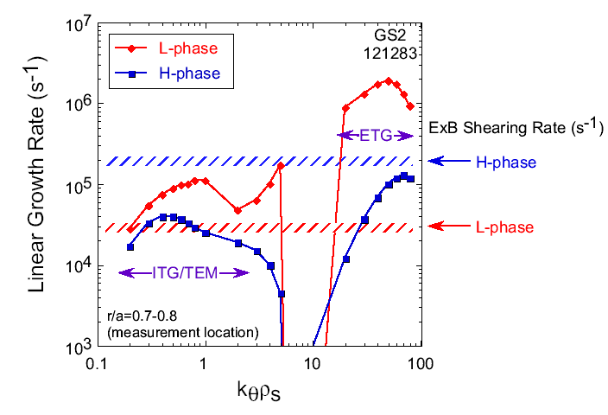
an increased level of ExB shearing rate, reaching values of up to five times the linear growth rate during the H-phase (see Fig. 5). Furthermore, the magnetic shear is seen to have a profound effect on the ion transport as well in L-mode plasmas, with the transport being anomalous in low magnetic shear or monotonically increasing q plasmas, while the transport drops to the neoclassical level in reversed magnetic shear plasmas, giving rise to ion Internal Transport Barriers in these RS plasmas [3].
Fig. 5 Linear growth rates as a function of k_{q}r_{s} for an L-mode phase and a subsequent H-mode phase. Also shown are the ExB shearing rates for both phases.
Ion transport barrier physics has been studied further in the Enhanced Pedestal H-mode plasmas, plasmas exhibiting much higher pedestal ion and electron temperatures than in standard H-modes, where very strong T_{i} gradients are observed in regions of zero toroidal and zero poloidal velocity (Fig. 6). The gradients are so strong that their scale lengths are of order the ion gyroradius (~1 cm). Standard neoclassical theory would suggest gradients to be limited to scales of order the banana width, and thus the smaller gradient scale lengths seen in NSTX may be indicative of neoclassical orbit shrinking and squeezing [10]. Analysis to test this theory is underway, as is determining the effect that these strong gradients would have on destabilization of low-k microturbulence (e.g., ITG modes).
Fig. 6 Ion temperature gradient and toroidal velocity near plasma edge during an Enhanced Pedestal H-mode plasma
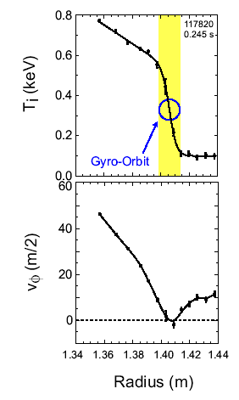
Plans
An important goal of ion transport research on NSTX is to develop a predictive understanding of the transition from neoclassical to turbulent-driven ion transport.
2009-2010:
The study of ion energy transport will continue to determine the conditions under which ions are governed by neoclassical transport vs either electrostatic or electromagnetic turbulent transport. This will be done by experimentally by actively changing the T_{i}/T_{e} driving/damping terms for ITG/TEM turbulence in L- and H-mode using RF injection into NBI discharges. The ExB shear damping term of ITG turbulence will be controlled by using the Non-Axisymmetric Magnetic Perturbations (NAMP) in fine steps to slow the plasma down, and determine the ExB level at which the ITG grows and ion transport becomes anomalous. Doppler reflectometry will be used to assess the role of Zonal Flows at the plasma edge. All these results will be coupled to results from non-linear gyrokinetic calculations, an input to which will be the full radial electric field determined from v_{φ}, v_{θ} and ∇p measurements. Ion Internal Transport Barrier studies will continue, focusing both on the potential for improved core fusion performance, and on regimes of strong T_{i} gradients and their relation to zonal flows, current profile and integer q-values. The strong T_{i} gradient regions and possible orbit shrinking/squeezing effects will allow validation of neoclassical theory at low aspect ratio. Initial low-k turbulence measurements will be made and compared to ion transport and predictions of microturbulence levels and transport from non-linear gyrokinetic codes, for both neoclassical and turbulent driven transport.
Fig. 6 Ion temperature gradient and toroidal velocity near plasma edge during an Enhanced Pedestal H-mode plasma
2011-2013:
The relation of inferred ion diffusivity to low-k fluctuations will be assessed in more detail using a low-k diagnostic (such as BES or a USXR telescope), and this, coupled with results from non-linear gyrokinetic calculations will allow for a very high-level validation of neoclassical and ITG theory in the NSTX plasmas. The comparisons will allow us to draw definitive conclusions regarding the source of ion transport under various operating conditions. They will also allow for an assessment of the non-local nature of turbulence due to the large ρ∗. The ion transport and turbulence levels at very high power will be assessed once the second beamline is operational, which will directly tie into establishing the physics basis of ST-PE and other possible future devices. Studies of ion transport barrier physics will continue, with new information over a range of heating powers measured by the low-k fluctuation diagnostic.
2013:
Low-to-medium k turbulence fluctuation levels will be measured with a newly commissioned Microwave Imaging Reflectometer. The ion transport in OH and RF-only heated plasmas with T_{i}/T_{e}<1 will be assessed using a non-beam based T_{i} measurement (Imaging X-ray Crystal Spectrometer). Internal NAMP coils will be used for finer control of magnetic braking to determine the role of ExB for suppressing low-k modes and affecting ion transport.
3.2.3.1.3 Electron Transport
Results
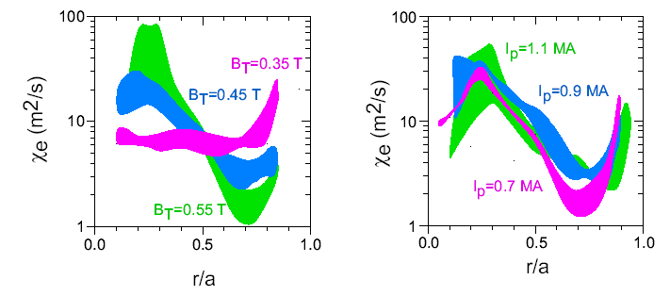
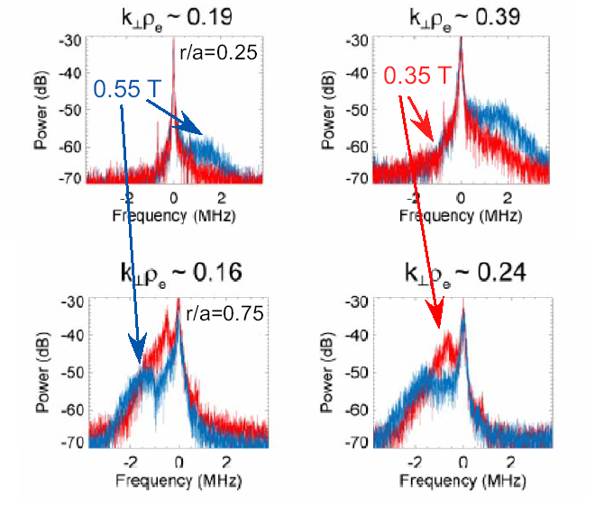
Unlike the ion transport, the electron transport was inferred to be anomalous in both L- and H-mode plasmas. It was the variation of electron transport that was found to govern the B_{T} scaling, as can be seen in Fig. 7. Seen in this figure is a strong decrease in χ_{e} outside of r/a=0.5 with increasing B_{T} that led to a broadening of the electron temperature profiles. Inside of this radius, the χ_{e} increases with increasing B_{T}, although the temperatures in this region are comparable for all values of the toroidal field. Thus, the increase in χ_{e} within r/a=0.5, where the total plasma volume is relatively small, does not significantly impact the overall improvement of electron and global confinement with increasing toroidal field. The change in electron thermal diffusivity in these two regions of the plasma is qualitatively consistent with the change in the measured high- k fluctuation levels with toroidal field at these two locations, as is seen in Fig. 8. Shown in this figure are results from the microwave scattering diagnostic, which reveals an increase in the high-k (k_{r}ρ_{s}~14) with increasing B_{T} in the very core of the plasma (r/a~0.25), while the fluctuation levels decrease with increasing field at r/a~0.75. Furthermore, linear and non-linear theory simulations indicate that ETG modes with the development of radial streamers are unstable in the outer part of the plasma (r/a>0.5) for the lowest toroidal field (Fig. 9), but not for higher toroidal fields. Non-linear saturated heat fluxes calculated from ETG/radial streamer theory are comparable to those inferred from the TRANSP transport analysis.
Fig. 7 Electron thermal diffusivity at fixed heating power and density as a function of (a) B_{T} at fixed I_{p} (b) I_{p} at fixed B_{T}.
Fig. 8 High-k scattering results for the B_{T} scan at fixed power, density and plasma current. The top panel shows the scattering results at r/a=0.25 for two different k_{r}r_{e}, while the bottom panel shows the same at r/a=0.75.
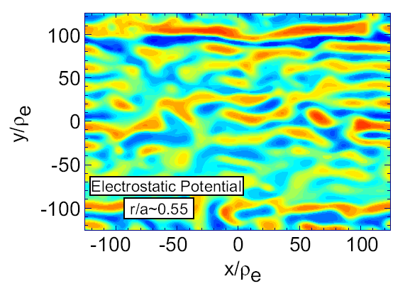
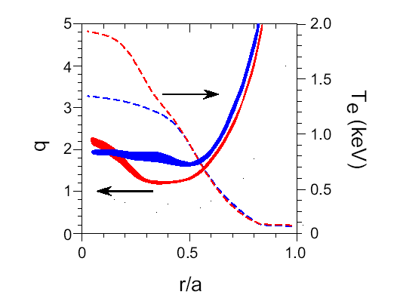
Just as the ion transport in L-mode plasmas improves with reversed magnetic shear, so to does electron transport, leading to electron Internal Transport Barriers (Fig. 10). While ETG modes are expected to be unstable outside the reversed shear region, and non-linear GYRO calculations predict electron heat fluxes that are consistent with those inferred from TRANSP analysis (Fig. 11), the reduction in the electron transport in the reversed-shear core region may in fact be due to a suppression of low-k microtearing modes. Microtearing modes, whose importance in NSTX was previously suggested [8] are low-k, electromagnetic modes extended along field lines that are important in the collisionality range within which NSTX operates. The instability of these modes is also dependent on magnetic shear profiles, and it is found that accompanying the reduction in transport with reversed magnetic shear is a narrowing of the wavenumber range over which microtearing modes are unstable. Calculations of the electron thermal diffusivity predicted by the magnetic stochastization due to microtearing modes in the core region of “hybrid” NSTX plasmas show agreement to within a factor of two to that inferred from transport analysis (Fig. 12). It is clear from these and the ETG results that there may be multiple instabilities across a range of wavenumbers that control electron transport.
Fig. 10 Electron temperature and q-profiles showing the development of an electron Internal Transport Barrier with reversed magnetic shear.
Fig. 9 Results of non-linear calculation showing the formation of radial streamers from ETG modes at B_{T}=0.35 T
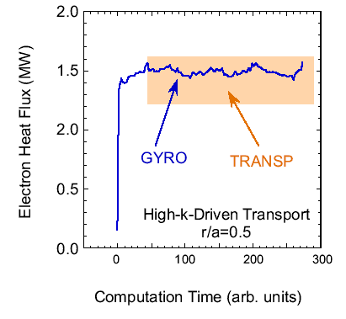
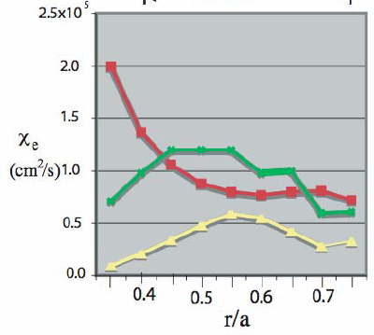
Experiments to determine the critical electron temperature to the transport-inducing modes have just begun. These experiments make use of High Harmonic Fast Wave heating to change the electron temperature gradient, and the change in high-k fluctuations accompanying the change in the mode driving term is measured by the microwave scattering diagnostic. An example of this is shown in Fig. 13. Seen in the figure is a strong peaking of the T_{e} profile as the RF heating is applied (Fig. 13a), along with an increase in the microturbulence driving term R/L_{Te} (Fig. 13b). Accompanying the T_{e} peaking is an increase and broadening of the high-k fluctuation spectrum (Fig. 13c). Linear gyrokinetic calculations confirm that ETG modes in the wavenumber range covered by the high-k scattering diagnostic are expected to be unstable for these R/L_{Te}.
Fig. 11 Electron heat flux outside the region of reversed magnetic shear calculated by non-linear GYRO simulations and inferred from TRANSP

Fig. 12 Experimental c_{e} inferred from TRANSP (red) compared to c_{e} predicted by microtearing theory using L⁻¹=L_{T}⁻¹ (yellow) and L⁻¹=L_{T}⁻¹+L_{n}⁻¹ (green)
Plans
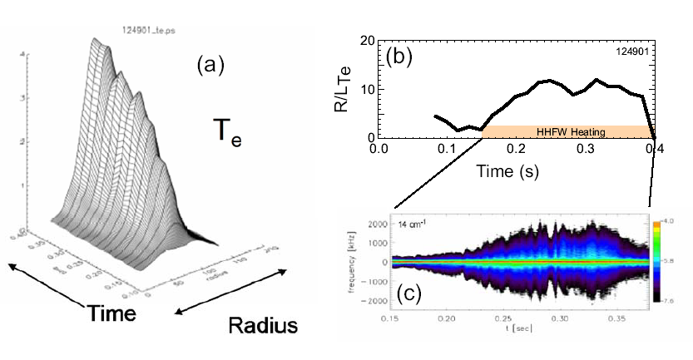
NSTX an ideal laboratory in which to study electron transport, and this study is one of the top priorities in the Transport and Turbulence Five Year Plan. Because of the relatively large ρ_{e} at the low fields at which NSTX operates, electron scale length turbulence can be measured. The microwave scattering diagnostic on NSTX, which is radially scannable and which provides a highly localized (±3 cm) k_{r} measurement, is particularly well-suited for measuring ETG and short wavelength TEM modes. Additionally, SXR arrays can be used to image electron temperature fluctuations. Since the anomalous electron turbulence can be isolated from the neoclassical ion transport in H-modes, non-linear gyrokinetic ETG simulations with adiabatic ions and scale separation are possible. The ultimate goal is to develop a comprehensive picture of electron transport for developing a predictive capability by the end of the Five Year Plan.

Fig. 13 (a) T_{e} profile as a function of time and radius with HHFW injection (b) R/L_{Te} as a function of time (c) high-k scattering signal at 14 cm⁻¹ as a function of time
2009-2010:
During this period, continued identification of TEM and ETG modes will be made using the present high-k scattering system. Collisionality scans will be made to differentiate modes, and the critical gradient necessary for destabilizing high-k turbulence will be assessed experimentally using HHFW to change the R/L_{Te} in fine steps. Once established experimentally, the critical gradient will be benchmarked against that predicted by gyrokinetic simulations. Experimental studies of the roles of reversed magnetic shear and low order rational q surfaces in the development of electron Internal Transport Barriers will be carried out by varying driving terms such as the magnetic shear, density gradient, ∇n_{e}, β, T_{e}/T_{i}, etc. Furthermore, the issue of whether the ST geometry, such as that which gives rise to precession reversal, reduces the TEM mode severity will be studied. Microtearing modes will also be studied experimentally in order to determine their importance in driving electron transport by changing the driving terms such as β and collisionality, and by making initial measurements of internal B-field fluctuations using MSE. Key to all these studies will be the direct connection and benchmarking against results from the gyrokinetic simulations at all levels. Synthetic diagnostics such as the high-k scattering and SXR and magnetic fluctuations will be built into the gyrokinetic codes for comparison with experiment. This could also help establish the importance of the high-k modes relative to the lower-k microtearing. Perturbed electron transport studies will investigate the cold pulse propagation from ELMs and pellets using high resolution measurements near the boundary with a multi-color soft X-ray array for fast T_{e}, n_{e} and n_{imp} profile measurements. Finally, Doppler reflectometry can be used to study the existence of Zonal Flows at the edge of the plasma in H-modes, and throughout the plasma in L-modes, and their effect on modes that are believed to drive electron transport.
2010-2011:
Electron transport and turbulence modification will be tested using local heating via local deposition of EBW at the 200 kW level. This will include early application of EBW to modify the q-profile and possibly induce ITB formation. Turbulent spreading outside the critical gradient region will be examined using the scannable high-k diagnostic, and this spreading will be related to the ExB shear layer and variation in magnetic shear. Experimental identification of microtearing modes will also be pursued experimentally by assessing the extent of these modes along the field line using the low-k diagnostic and from the internal B-field fluctuation measurements that can be obtained by MSE. Modulated EBW will be used to probe the local critical gradient physics and regions of good and bad transport along with the formation of Internal Transport Barriers, using a tangential optical soft X-ray system (TOSXR) with good signal-to-noise characteristics, and an upgraded MPTS. In order to use the MPTS for this, it will be necessary to combine several shots with different timing to get a complete evolution. The first high-k_{θ} measurements will be available from the modified microwave scattering diagnostic, and these, as well as low-k turbulence measurements from a low-k diagnostic such as BES or a USXR telescope, will be used in conjunction with results from gyrokinetic calculations for more detailed assessment of the microturbulent sources of electron transport.
2012-2013:
Studies of microturbulence and electron transport will become more detailed with more developed and full k_{r} and k_{θ} coverage, and at higher beam power. The new diagnostics that will aid in this include high-k_{θ} from the microwave scattering, Microwave Imaging Reflectometry, and low-k such as from BES or a USXR telescope. This will allow for much more comprehensive Verification and Validation of the gyrokinetic simulations across the full k-range. Included in this exercise will be the results of probing the structure of the higher-k fluctuations. For instance, both TEM and ETG are strongly ballooning to the outside, the modes are expected to be highly dispersive, indicating the importance of performing a frequency scan at various k⊥, and radial streamers may be expected from ETG. The existence or not of the radial streamers can be assessed with simultaneous measurements of k_{r} and k_{θ} from the microwave scattering. The high power EBW system (up to 2 MW) will be used for localized deposition and heating to probe critical gradient physics and turbulence spreading. These measurements, in turn, will be compared to output of similar synthetic diagnostics from gyrokinetic codes.
3.2.3.2 Momentum Transport
Results
The rotation in NSTX has been observed to be quite high, with toroidal velocities up to 300 km/s in the core, and this leads to strong ExB shearing rates that can be up to five times greater than the linear growth rates of low-k instabilities (Fig. 5). Thus, it is expected that the high rotation can effectively suppress these low-k instabilities, and indeed non-linear gyrokinetic calculations suggest that this is so. The rotation is important not only for suppressing the microturbulence, but also for suppression of both internal and external MHD modes and leading to achieving high performance goals both in NSTX and potentially in future devices. Consequently, it is important to understand the source of this rotation, how momentum diffusivity relates to electron and ion thermal and particle diffusivities, the effect of rotation and ExB shear on energy and particle confinement, and the source of intrinsic rotation on NSTX.
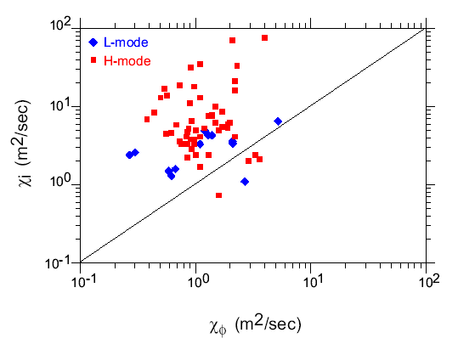
In conventional aspect ratio tokamaks, the momentum and ion thermal diffusivities are seen to scale with one another and are generally within a factor of a few of each other. This is attributed to the presence of ITG modes, which control both χ_{φ} and χ_{i}, at this aspect ratio. In NSTX, however, χ_{φ} is found to be significantly less than χ_{i}, and the two do not scale with each other, as can be seen in Fig. 14. For this analysis, the χ_{φ} was obtained from the TRANSP steady-state analysis. Steady-state analysis from the dedicated confinement scans actually reveal that the χ_{φ} appears to scale with χ_{e} as opposed to χ_{i}, but this anecdotal relation needs to be firmed up with future experiments. The lack of scaling of χ_{φ} and χ_{i} in NSTX can be attributed to the suppression of ITG modes due to the strong ExB shearing.
Fig. 14 χ_{i} as a function of χ_{φ} for L- and H-mode discharges
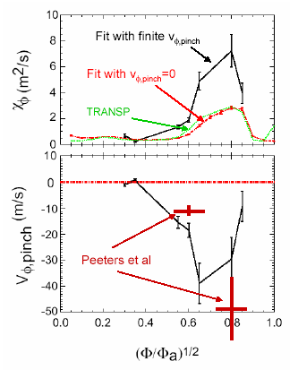
Dedicated momentum confinement scaling experiments have been carried out in NSTX, making use of Non-Axisymmetric Magnetic Perturbation (i.e., application of n=3 error fields) to slow the plasma. The NAMP were applied for 50 ms, and a momentum confinement analysis was performed at the time when the NAMP was turned off, when NBI was the only known source of torque. This perturbative technique allowed for determination of τ_{φ}, χ_{φ} and v_{pinch} through the plasma. Fig. 15 shows the results of this analysis for χ_{φ} and v_{pinch}. Consistent with the results from Fig. 15, both the global momentum balance and perturbative fit determination of the momentum confinement time indicates values of about 150 ms, and these values exceed the energy confinement time by a factor of approximately four. Additionally, the analysis indicates a significant inward pinch velocity, with values reaching 40 m/s, and momentum diffusvities of order several m²/s, which are closer to the values of χ_{i} than are the χ_{φ}’s deduced from the global momentum balance. Furthermore, the inward pinch velocity is consistent with values predicted by the theory of Peeters et al. [11], based on the Coriolis effect due to ITG/TEM modes. Previous work [12] has shown the change in angular momentum due to NAMP application is consistent with Neoclassical Toroidal Viscosity theory [13], and this will be used in the future as a basis for performing the momentum confinement/transport studies during the NAMP application.
Fig. 15 Results of perturbative analysis to determine the momentum diffusivity and inward pinch velocity. Shown for comparison are predictions from Ref. [11] for the pinch velocity
Plans
2009-2010:
Poloidal CHERS will be used to measure v_{θ} under a variety of discharge conditions, and these measurements will be compared directly to predictions from neoclassical theory in order to validate the present formulation of that theory. Non-Axisymmetric Magnetic Perturbation studies will continue in order to infer τ_{φ}, χ_{φ} and v_{pinch} at NAMP turn-off under a variety of discharge conditions. The inferred pinch velocities will be compared to predictions by theories [11, 14]. NTV theory will be used to estimate the torque due to the error field and thus the momentum transport properties during application of NAMP. These values will be compared to the post-NAMP values to check consistency and determine whether NTV theory provides a consistent picture that can be used for extrapolation to future devices and scenario development. The momentum transport will be compared in L- vs H- plasmas, with a focus on whether the χ_{φ}~χ_{i} relation is recovered when ITG is not suppressed and χ_{i}>χ_{neo}. Comparisons between momentum transport metrics and initial low-k measurements will be made.
2011-2013:
Rotation modulation studies will continue using NAMP. The low-k diagnostic will allow for a determination of the relation of low-k fluctuations to variations in momentum transport in both L- and H-modes. This low-k diagnostic will also allow for Zonal Flow/GAM studies, and these will entail coupling of these large-scale flows to other microinstabilities at all k, bicoherence analysis to determine the most robust coupling of these flows and modes, and the effect of these large-scale flows on transport.
2013:
Intrinsic rotation studies will be continued using imaging X-ray crystal spectrometry (a non-beam-based diagnostic). Application of NAMP from newly installed internal coils will permit finer control of the magnetic braking for momentum diffusivity, pinch velocity determinations.
3.2.3.3 Particle Transport
Particle transport, which is not well understood at present either at low or conventional aspect ratio, is a fertile area for analysis. Understanding particle transport is yet another level of validation of physics models describing microturbulent vs neoclassical transport, and it is complementary to energy transport studies. Another issue of importance is Helium transport, which relates to the Helium ash issue on ITER. Much of the necessary data for analysis already exists, and thus analysis can proceed immediately. Diagnostic and facility enhancments will, however, aid these studies. In addition, some of the unique features of NSTX add another dimension to the particle transport studies; these include the high mirror ratio in the Scrape-Off Layer (SOL) and thus a high trapped particle fraction, and the ability to extend the ranges in collisionality, q and β for these studies.
Results
To date, the particle transport studies in NSTX have focused on studies of impurity transport in beam-heated H-mode plasmas. These studies were carried out primarily using Neon injection into MHD quiescent plasmas. For these studies, the tangential array of Soft X-ray detectors with multi-foil capability for energy and thus radial discrimination was used to track the transport of the impurity. A synthetic SXR diagnostic with the multi-foil capability was built into the MIST code for comparison between simulated and measured impurity profile evolution. Fig. 16 shows this comparison, with very good agreement at this level of comparison between the measured and simulated profile evolution. In order to achieve this, a low core impurity particle diffusivity was assumed, with D~1 m²/s, which is at the neoclassical transport level for the Neon impurity, as is shown in Fig. 17. This result complements those of the ion energy transport, which as described in a previous section, also suggests neoclassical levels of transport in these plasmas.
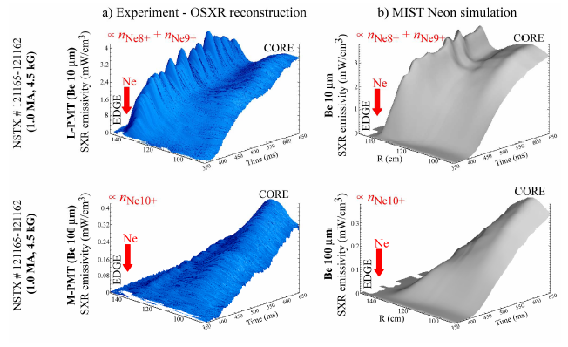
Plans
Fig. 16 Comparison of measured soft X-ray profile evolution for two different filters (left) with those from MIST simulations assuming neoclassical diffusivity for Neon. A small inward pinch is also required for agreement
2009-2011:
Particle transport levels in the core, within the dominant NBI-fueling regime (r/a<0.55) using the TRANSP code. Since NBI fueling is dominant in this regime, the particle source can be determined straightforwardly through the TRANSP beam Monte-Carlo calculation. The aim would be to understand the systematic variation of particle diffusivity with power, current, toroidal field, etc from the pre-existing database. The relation of the particle to thermal diffusivities will be assessed to determine whether they have the same parametric dependences and what the differences are between L- and H-mode; are the particles driven by turbulent transport in high density L-modes as the thermal ion heat flux seems to be?
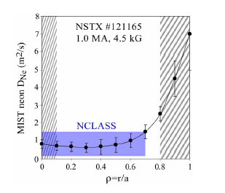
Modulated core fueling studies with beam blips will be carried out. The evolution of the density profile will have to be built up from numerous discharges in order to use amplitude and phase analysis to determine τ_{p}∗. The modulated studies will also allow a separation of D and v_{pinch}, to be compared both to the steady-state particle balance value of D (i.e., from TRANSP) and to theory.
Fig. 17 Particle diffusivity value assumed in MIST for the Neon transport compared to range of neoclassical value.
Density peaking studies and the effect of particle pinches, in conjunction with ITPA, will be carried out in order to determine the regimes in which fusion power production can be maximized for devices such as ITER and ST-CTF. There is a clear trade-off between maximizing core reactivity (i.e., peaked profiles) and plasma stability.
Outside of r/a=0.55, the fueling is dominated by wall fueling and recycling, and estimates of the source rate of the particles is more complicated. The ionization source needs to be determined using forward modeling with a combination of 2D codes, such as DEGAS2 and UEDGE. The process involves iterating between the two codes, with a plasma and SOL description from UEDGE input to DEGAS2 to determine the plasma-neutral source profiles, with these source profiles then being input back into UEDGE. Ideally, this iterative process is continued until convergence, when a global particle balance is achieved. Once this convergence is achieved, the neutral source profiles can be input to TRANSP for a determination of the particle diffusivities across the full plasma radius. Sensitivity analysis to both core fueling and to variations in the SOL flows and wall fueling will be an important part of this study, and it will help assign uncertainty ranges to the inferred particle diffusivities.
Impurity transport will be assessed using impurity puffing and TESPEL (Tracer Encapsulated Solid PELlet) injection at the edge. Tracking the impurities can be done with either the high-resolution edge/pedestal soft X-ray array or the CHERS diagnostic. Using the SXR array to deduce D and v_{pinch} requires extensive forward modeling using the MIST code, and it is, in fact, difficult to separate the two. Using CHERS is more straightforward, but would require a change in grating for measuring the different impurities.
The understanding of Helium transport is needed for assessing the likelihood of success for integrated scenarios in future devices. Helium transport studies in NSTX can be carried out with either He puffing into deuterium discharges, or with Helium discharges themselves. The Helium plasmas can give steady-state values of the diffusivity, while He puffing can yield D and v_{pinch} near the plasma edge. A change in the CHERS grating would be required to measure emission from He transitions for this study. Furthermore, the He edge source fueling rate would have to be determined using the iterative procedure described above between DEGAS2 and UEDGE.
In all these studies, determining the effect of the Liquid Lithium Divertor on the particle and impurity transport is critical.
2011-2013:
The role of low-k turbulence in controlling core particle transport will be assessed with the low-k turbulence diagnostic. The variation in density fluctuations will be studied as a function of D/D_{neo} in a variety of plasmas: L vs H, high vs low density (collisionality) and reversed magnetic shear vs low central shear (q-profile). Modulated core transport studies will continue, taking advantage of the upgraded MPTS diagnostic as well as higher beam power. Edge particle transport studies will continue with modulated fueling from the supersonic gas injector (SGI) and pellet fueling with a D pellet injector, again taking advantage of the upgraded MPTS. Helium transport studies will focus on assessing the core transport characteristics with the change in the NBI system (e.g., increase in power). In particular, the beams could be run in Helium for core fueling and transport studies. Finally, the effect of the LLD and Lithium wall conditioning on particle, impurity and Helium transport will be assessed; i.e., how do D and v_{pinch} change with the Li conditioning?
3.2.4 Theoretical Tools and Modeling
Present Tools
The international standard code, TRANSP, is and will continue to be used for steady-state energy, particle and momentum transport studies. An embryonic predictive tool based on TRANSP and TSC, pTRANSP, is being used for predictive transport analysis and discharge scenario development. At present, however, what is lacking is a validated transport model relevant to low aspect ratio.
Linear and non-linear gyrokinetic analysis is being done by a variety of codes. GTC-NEO takes into account finite banana width and thus non-local effects for determination of neoclassical transport. The GS2 flux tube code contains kinetic electron and ion, finite beta and generalized geometry descriptions, and it can be run in both linear and non-linear modes. However, for NSTX, global codes are necessary due to the large gyroradii of both electrons and ions. GYRO, a global code, contains all the relevant features. GTC is a generalized geometry global code that is still under development; kinetic electron and finite β effects need to be implemented in order to explore electron scale modes and ion modes with no scale separation. GEM is another global code that is presently being verified for low-k microtearing modes.
Plans
All available tools will be used, with a focus on Verification and Validation at all levels.
2009-2010:
A 2D/3D state-of-the-art neutrals package will be implemented in TRANSP to aid in particle transport studies. pTRANSP will be used to validate predictive models such as those given by TGLF [15]. GTC-NEO will be upgraded with multiple species and will be utilized to test neoclassical theory with v_{θ} measurements. Non-linear GYRO simulations with synthetic diagnostics over the full range of k will be carried out. Non-linear GTC simulations with kinetic electrons and synthetic diagnostics for high-k will begin. A multiple ion species capability will be implemented in GTC. Non-linear GEM simulations for low-k microtearing modes will be carried out. A version of GEM with kinetic electron physics implemented will be developed. GTC-NEO calculations will be coupled to non-linear calculations (GYRO, GTC) to evaluate the neoclassical and the non-diffusive turbulent flux (pinch and ∇p-driven residual stress) for toroidal angular momentum transport. Initial comparisons between low-k fluctuation measurements and results from synthetic diagnostics in non-linear gyrokinetic simulations will be made.
2011:
More detailed and comprehensive comparisons between low-k fluctuation measurements and results from synthetic diagnostics in non-linear gyrokinetic simulations will be made. The role of Zonal Flows and their relation and coupling to low-k turbulence will be assessed. pTRANSP simulations will become more sophisticated as the plasma transport properties become more fully understood and the models become more physics-based. Tests of turbulence spreading using results from local EBW deposition experiments will begin with comparisons to code predictions.
2012:
Predictions of ion and electron heat, particle and momentum transport profiles with respect to dimensionless variables will be made using gyrokinetic analysis with full features (i.e., collisions, turbulence spreading, etc). Transport codes such as TGLF will be used to predict full plasma profiles, and these will be compared to measured profiles as part of the Verification and Validation procedure.
2013:
Fully predictive transport simulation capabilities will be developed. These will be combined with other simulations (e.g., MHD) to form a fully integrated scenario package. This package will be used as a basis for developing actual experimental discharge scenarios in NSTX and in future devices.
3.2.5 Facility and Diagnostic Upgrades
2009:
Additional MPTS channels will provide more complete electron temperature and density profiles. The full complement of poloidal CHERS channels will be available for measuring the poloidal velocity. The full complement of FIDA channels and neutron collimators will be available for measuring beam deposition profiles for power balance. High-k backscattering will be available to complement the microwave scattering diagnostic. A high resolution, tangentially-viewing soft X-ray array for diagnosing the plasma edge/pedestal region will be implemented to support edge impurity and electron thermal transport studies. A low power ECH/EBW system (200 kW) will be available for localized heating experiments.
2010:
Additional filters for CCD cameras will aid in Helium transport and recycling studies. Extra channels will become available for the Edge Rotation Diagnostic for measuring the edge toroidal and poloidal rotation. A low-k fluctuation diagnostic will be implemented. MSE will provide internal B fluctuations. A second 6 MW neutral beam line will be operational.
2011:
The microwave scattering diagnostic will be modified to include k_{θ} measurement. MPTS will be upgraded to 45 channels and 100 Hz. The core multi-color soft X-ray array, upgraded for high signal-to-noise, will provide better discrimination and faster profile measurements of small localized heat pulses for probing internal transport and barrier formation.
2012:
The initial high power EBW system (2 MW) will be operational, and a divertor Thomson Scattering system will be implemented.
2013:
A Microwave Imaging Reflectometer will provide fluctuation information covering the range from ITG to the low end of ETG modes. An Imaging X-ray Crystal Spectrometer will be commissioned and will provide ion temperature and rotation profiles in all plasmas (i.e., beam-heated as well as OH and RF). Internal NAMP coils will be available for use.
3.2.6 Summary of Research Goals for FY2004-2008

The major NSTX Transport and Turbulence research goals by topical area from section 3.2.3-4 are re-stated below to summarize the proposed research plan for the upcoming five-year period. The proposed research program time line is shown following these goals.

- To verify global scaling trends at very high P_{input}/P_{LH} and to establish the dependence of confinement on aspect ratio,
- To establish conditions for neoclassical ion transport through coupling low-k turbulence measurements to results of non-linear gyrokinetic simulations,
- To determine the role of both low-k and high-k turbulence through measurement and non-linear theory in setting the level of anomalous electron transport,
- To determine the source of the plasma rotation/radial electric field and its influence on both low- and high-k turbulence,
- To understand the relation of particle and impurity transport throughout the plasma to measurements and simulations of microturbulence, ultimately to
- Develop a validated, fully-predictive tool for developing confinement-optimized discharge scenarios for both NSTX and future ST and non-ST devices.
The overall timeline for the research and tool development is shown on the next page.
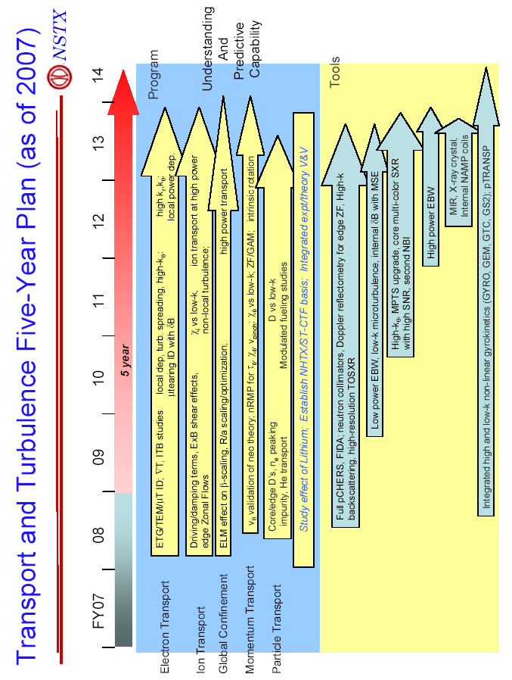
References

[1] ITER Physics Basis, Nuc. Fusion 39 (1999) 2137.
[2] Kaye, S.M. et al., Phys. Rev. Lett. 98 (2007) 175002.
[3] Kaye, S.M. et al., Nuc. Fusion 47 (2007) 499.
[4] Kaye, S.M. et al., Nuc. Fusion 46 (2006) 848.
[5] McDonald, D.C. et al., Plasma Phys. and Controlled Fusion 46 (2004) A215.
[6] Petty, C.C. et al., Phys. Plasmas 11 (2004) 2514.
[7] Takizuka, T. et al., Plasma Phys. and Controlled Fusion 48 (2006) 799.
[8] Vermare, L. et al., Nuc. Fusion 47 (2007) 490.
[9] Wang, W. et al., Comput. Phys. Commun. 164 (2004) 178.
[10] Shaing, K.C. and M. Peng, Phys. Plasmas 11 (2004) 3726.
[11] Peeters, A.G. et al., Phys. Rev. Lett. 98 (2007) 265003.
[12] Zhu, W. et al., Phys. Rev. Lett. 96 (2006) 225002.
[13] Shaing, K.C. et al., Phys. Fluids 29 (1986) 521.
[14] Hahm, T.S. et al., Phys. Plasmas 14 (2007) 072302.
[15] Staebler, G., personal communication (2006).

