Solenoid-Free Start-Up Research
The Spherical Torus (ST) is capable of simultaneous operation at high beta and high bootstrap current fraction [1]. These advantages of the ST configuration arise as a result of its small aspect ratio. At the low aspect ratios needed for an ST reactor, elimination of the central solenoid is necessary. Thus current generation methods that do not rely on the central solenoid are necessary for the viability of the ST concept. Elimination of the central solenoid could also lead to a more compact tokamak [2]. Thus ST-based fusion systems including the CTF (Component Test Facility) and power plant designs (e.g., ARIES-ST) assume complete elimination of the ohmic solenoid. Indeed designs for advanced tokamak reactors such as the ARIES series of devices also eliminate the central solenoid. The investigation of plasma start-up without the ohmic solenoid is a major component of the NSTX research program. NSTX is exploring the technique known as Coaxial Helicity Injection (CHI) [3] and Outer Poloidal Field Start-up [Ref] as methods to produce the initial plasma and sufficient toroidal plasma current to allow other methods of non-inductive current drive and sustainment to be applied. Other new methods such as Plasma Gun Injection will also be studied during the FY 2009 to 2013 period. Of the three US major magnetic fusion facilities (DIII-D, NSTX, C-Mod), at the present time NSTX is the only one actively conducting OH-solenoid-free start-up research.
We will describe the Coaxial Helicity Injection, Outer-Poloidal-Field Coil Start-up and Plasma Gun Injection concepts in detail in Sections A, B and C respectively. The rf-based start-up and ramp up concept is covered in the EBW section in the Chapter on Wave Particle Interactions. At the end of this section, the overall plans for non-inductive start-up development in NSTX and the associated tool development are summarized.

Coaxial Helicity Injection - The CHI concept is an outgrowth of the spheromak research [1]. It has also been tried on DIII-D [Ref]. A number of smaller helicity injection experiments were performed with some success prior to introducing it on NSTX [2-6]. More recently, the HIT-II device has unambiguously demonstrated plasma start-up using this method [Ref]. The method has now also successfully produced 160 kA of closed flux current in NSTX., which is a world record for non-inductively generated closed flux current [7,8]. The CHI research on NSTX has benefited greatly from a close collaboration with the HIT-II experiment at the University of Washington. The CHI near term research goal is to demonstrate coupling of the CHI produced current to induction from the central solenoid and beyond that to other non inductive current drive methods.
Outer-Poloidal-Field-Coil Start-up - Because of the criticality of the OH-solenoid-free start-up issue for ST research, the NSTX PAC has urged the NSTX team to pursue alternate methods of OH-solenoid-free start-up. This method uses the external poloidal field coils to induce a toroidal electric field. and has been successfully used on the START and MAST devices. In both these devices the poloidal field coils are located inside the vacuum vessel. NSTX will conduct these experiments in a configuration in which the PF coils are located outside the vacuum vessel. Initial results are promising and the potential for the generation of up to 500 kA of toroidal current exists in NSTX. This method could also work with an initial CHI or Plasma-Gun produced plasma to further boost the level of solenoid-free current generation.
Plasma-Gun Startup – In this method an electron beam is driven along magnetic filaments using a washer gun plasma source [Ref]. The method was first tried on the CDX-U machine [Ref] with some success. More recently the method has been further developed on the PEGASUS ST [Ref]. On Pegasus 30 kA of gun generated toroidal current was produced and ramped up to 80 kA after coupling to induction. The method has the advantage that it could be easily implemented in a reactor as the gun sources could be withdrawn after current generation. NSTX will test the viability of this concept in a large ST.
RF-Based Start-up - There is a possible rf based concept using ECH/EBW [Ref]. The ECH/EBW experiment can be tested when the ECH/EBW power system becomes available during FY 09-12 as described in the Chapter describing RF research. By using a trapped particle configuration, strong ECH/EBW electron heating can generate sufficient electron precessional toroidal current (~ tens of kA) to generate closed flux surfaces. Once the closed flux surfaces are formed, the bootstrap effect increases the plasma current. One can then inject multi-MW HHFW power to ramp the current up by further increasing the bootstrap and other pressure driven currents in addition to the active current drive.

A. Coaxial Helicity Injection
CHI is a promising candidate for non-inductive current initiation and has, in addition, the potential to drive edge current during the sustained phase of a discharge for the purpose of controlling the edge current profile to improve plasma stability limits and to optimize the bootstrap current fraction. Other possible benefits include inducing edge plasma rotation for transport barrier sustainment and controlling edge SOL flows. The development of these methods will improve the prospects of the ST as a fusion reactor.
An important advantage of CHI start-up is that it could be used for closed flux plasma generation without any time variations in the PF coil currents as demonstrated on HIT-II [Ref]. Therefore, it is compatible with future reactor system that would rely on superconducting PF coils, and PF coils located far away from the plasma.
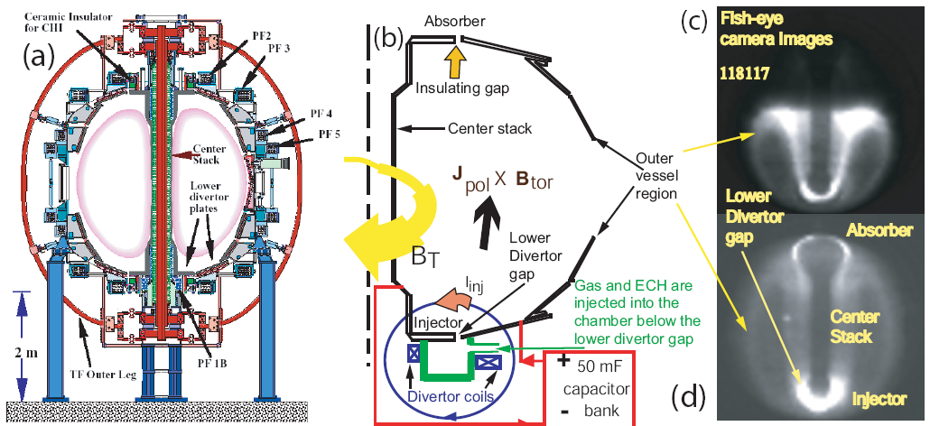
Figure 1: (a) The NSTX machine layout showing the location of the toroidal insulator and external poloidal field coils. Shown also are (b) the NSTX machine components used for CHI startup in NSTX and fast camera fish eye images showing (c) discharge evolution from near the injector region and (d) later during the discharge. Both gas and 18 GHz microwave power are injected in to a 100 Liter toroidal cavity beneath the lower divertor plates. The gas, which is ionized by the microwaves, emerges from the gap between the lower divertor plates, which eases the requirements for breakdown when the main capacitor bank discharge is initiated.

CHI implementation on NSTX - In order to accommodate CHI, the stainless steel vacuum vessel (nominal major radius 0.85 m, volume 30 m³) has separate inner and outer sections, electrically isolated from each other by toroidal ceramic rings at the top and bottom which also act as vacuum seals. An alternate way to implement it is to insulate one of the lower divertor plates from the rest of the vessel as was done in D-III-D. This would avoid the need for a vacuum insulator. The inner divertor plate, which is part of the center stack assembly, is then electrically separated from the outer divertor plate, which is attached to the outer vessel. This is illustrated in Figure 1. For CHI, the poloidal field coils located beneath the lower insulated gap are used to produce poloidal flux connecting the lower inner and outer divertor plates, as indicated qualitatively by the circle in Figure 1b. When a small amount of deuterium gas is introduced into the chamber below the lower divertor plates and a voltage (typically 1 – 2 kV) is applied between the plates, a discharge forms with current flowing in the plasma from the outer divertor plate to the inner lower divertor plate, as shown by the arrow in Figure 1b. In the presence of a toroidal field, the plasma current, which essentially flows along field lines, develops a toroidal component. The bright region at the top of Figure 1c is the top of the CHI plasma that has extended to approximately the middle of the vessel at a time during the discharge when the plasma current is below the peak value. As the plasma current increases to near the peak value, the discharge further elongates vertically to fill the vessel as shown in Figure 1d. The bright ring shaped region at the top of this image is referred to as an absorber arc, a condition when part of the injector current bridges the upper divertor gap. We refer to the lower gap connected by the poloidal field as the injector and the complementary upper gap as the absorber because when voltage is applied toroidal flux flows out of the injector and into the absorber.
The toroidal plasma current produced by CHI initially flows on open field lines joining the electrodes. In order to produce toroidal plasma current on closed flux surfaces magnetic reconnection must occur. In steady state, this reconnection depends on the development of some form of non-ax symmetric plasma perturbation. In transient CHI, the initial poloidal field magnitude is chosen such that the plasma carrying the injected current rapidly expands into the chamber. When the injected current is rapidly decreased, magnetic reconnection occurs near the injection electrodes, with the toroidal plasma current forming closed flux surfaces. The method of transient CHI has now been successfully used on NSTX producing an unambiguous demonstration of closed-flux current generation without the use of the central solenoid.

Transient CHI Startup- CHI can be applied in two ways. In both methods the toroidal plasma current produced by CHI initially flows on open field lines joining the electrodes. In order to produce toroidal plasma current on closed flux surfaces magnetic reconnection must occur. In the first approach referred to as steady state or driven CHI, closed flux generation relies on the development of some form of non-ax symmetric plasma perturbation. This mode of CHI operation, in which the injector circuit is continuously driven for a time longer than the timescale for resistive decay of the toroidal current (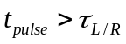) was initially studied in the early CHI experiments in NSTX [11]. However, for the purpose of initial plasma startup it was found in the HIT-II ST that a new mode of CHI operation in an ST, referred to as transient CHI [12], which involves only axisymmetric magnetic reconnection works very well and produces useful closed flux equilibrium. In transient CHI, the initial poloidal field configuration is chosen such that the plasma carrying the injected current rapidly expands into the chamber. When the injected current is rapidly decreased, magnetic reconnection occurs near the injection electrodes, with the toroidal plasma current forming closed flux surfaces. The method of transient CHI has now been successfully used on NSTX producing an unambiguous demonstration of closed-flux current generation without the use of the central solenoid [13]. The transient CHI method is therefore now being pursued as the preferred CHI method to start the NSTX discharge without the use of the solenoid.
There are two objectives for CHI research on NSTX. The primary objective is to start-up the NSTX plasma using CHI and to hand it off initially to inductive operation and then later to a non-inductive current drive system. The second objective is to provide edge current drive during sustained non-inductive operation, for the purpose of controlling the edge current profile and to modify the edge SOL flows.
For transient CHI, a 15-45mF capacitor bank was used at up to 1.75kV to provide the injector current. The present operating condition for CHI in NSTX uses the inner vessel and inner divertor plates as the cathode while the outer divertor plates and vessel are the anode. The operational sequence for CHI involves first energizing the toroidal field coils and the CHI injector coils to produce the desired flux conditions in the injector region. The CHI voltage is then applied to the inner and outer divertor plates and a pre-programmed amount of gas and 10 kW of electron cyclotron waves at 18 GHz are injected in an injector cavity below the lower divertor plates. This condition ensures that there is adequate energy in the capacitor bank for ionization and heating of the injected gas. The resulting current initially flows along helical magnetic field lines connecting the lower divertor plates. The large ratio of the applied toroidal field to the poloidal field causes the current in the plasma to develop a strong toroidal component, the beginning of the desired toroidal plasma current generation. If the injector current exceeds a threshold value, known as the bubble burst condition, the resulting ∆B_{tor}², (J_{pol} × B_{tor}), stress across the current layer exceeds the field-line tension of the injector flux causing the helicity and plasma in the lower divertor region to expand into the main torus chamber. The initial poloidal field configuration is chosen such that the plasma rapidly expands into the chamber. When the injected current is then rapidly decreased, magnetic reconnection occurs near the injection electrodes, with the toroidal plasma current forming closed flux surfaces.
In Figure 2, we show traces for the toroidal plasma current, the injector current and fast camera images at two different times during the discharge. Note that the generated toroidal plasma current is about sixty times the injector current. The CHI capacitor bank discharge is initiated at 5 ms. In these experiments the discharge rapidly grows to fill the vessel within about 2 ms, then starting at about 9 ms the discharge begins to detach from the injector electrodes. At 11 ms, the injector current is zero and about 60 kA of plasma current is still present. Note that at 13 ms, the ring shaped plasma is clearly disconnected from both the injector and the upper divertor plate regions. As time progresses, the large bore plasma that fills the vessel gradually shrinks in size and after about t = 14 ms, it evolves into a small diameter plasma ring, as seen in the 15 ms time frame image. The formation of closed flux regions is clearly seen in the camera frames corresponding to 11 ms and beyond as expected from a decaying closed magnetic flux configuration. For these discharges, circuit calculations show that only about 7 kJ of capacitor bank energy is expended to generate 60 kA of closed flux current. Electron pressure and temperature profiles from Thomson scattering [Ref] show that profiles at later times are less hollow than at earlier times. This is consistent with the CHI startup process, since initially CHI drives current in the edge. After reconnection in the injector region, one expects the current profile to flatten, which should result in the profiles becoming less hollow. The evolution of a hollow pressure profile into a peaked pressure profile is shown in Fig. 2(c). The measured electron temperatures of about 20 eV, combined with a plasma inductance of about 0.5 - 1μH, should result in an e-folding current decay time on the order of about 8 ms, which is consistent with the observed current persistence time after the injector current has been reduced to zero.

Equilibrium reconstructions from discharge 120874 are shown in Figure 3. The experimentally measured poloidal magnetic field, from 40 sensors, and poloidal flux, from 44 flux loops, are used in the computation of the Grad-Shafranov plasma equilibrium. While equilibrium reconstructions show the presence of closed flux for lower current discharges, such as for example, the data shown in Figure 2, equilibrium reconstructions for the higher current discharges such as for shot 120874, are much more robust and result in residuals similar to that in conventional inductive discharges. The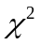, which is a measure of the residual error, for the fit shown in Figure 3 is 50. At the time I_{inj} is reduced to zero this discharge has 150 kA of current, After t = 9 ms, there is no I_{inj}, therefore there are no open field line currents. The only plausible explanation for the decaying current magnitude from 150 kA to 70 kA at 12 ms is that it must result from decaying closed flux equilibrium, which is consistent with the equilibrium reconstructions. The LRDFIT Grad-Shafranov equilibrium code, developed by J. Menard, which is now in routine use for NSTX discharges, is used for these reconstructions. The code uses a circuit equation model of the plasma, vessel, and passive plate currents to better constrain the equilibrium fits at low I_{p}.
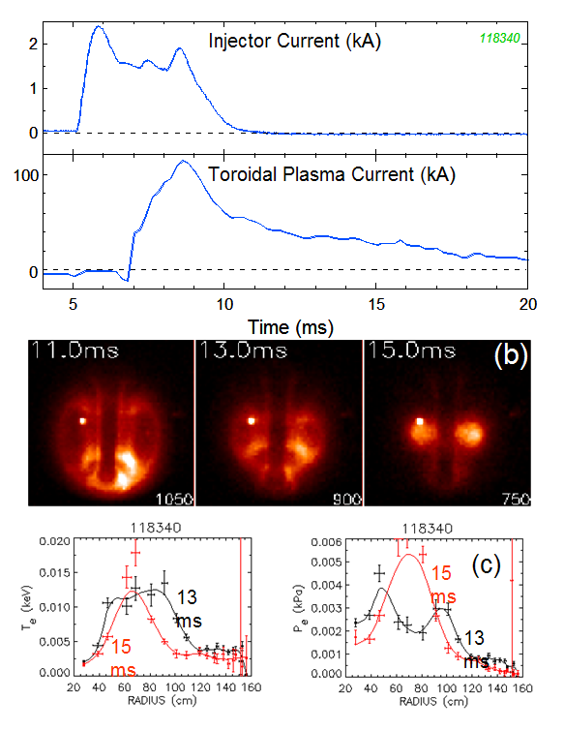

Figure 2: Shown are (a) Injector and plasma current traces (b) fast camera images and (c) the electron density and electron pressure profiles, at 13 and 15ms from a CHI discharge in NSTX. In this discharge about 2kA of injector current produces 120kA of toroidal current resulting in a current multiplication of 60. The best attained current multiplication (not shown here) was 70. During these discharges, the NSTX CS was disconnected from its power supply. The small bright glow is light from a tungsten filament. The images at 11 and 13ms show an elongated dark region, which is surrounded by a brighter region, like usual tokamak photos. It is useful to note that an absorber arc has not been produced in this discharge.

Figure 3: Equilibrium reconstructions show the shape evolution of the CHI produced plasma in response to decaying current, which is further evidence of decoupling from the injector leaving behind an inductively decaying plasma. In this discharge the increase in I_{inj} around 7.5ms is due to the presence of an absorber arc. Overdriving the injector by using a larger capacitor bank (45mF, charged to 1.8kV) caused a large amount of unused capacitor bank energy to be dissipated as an absorber arc, which probably contributed to an increase in the resistivity of these yet unoptimized discharges.
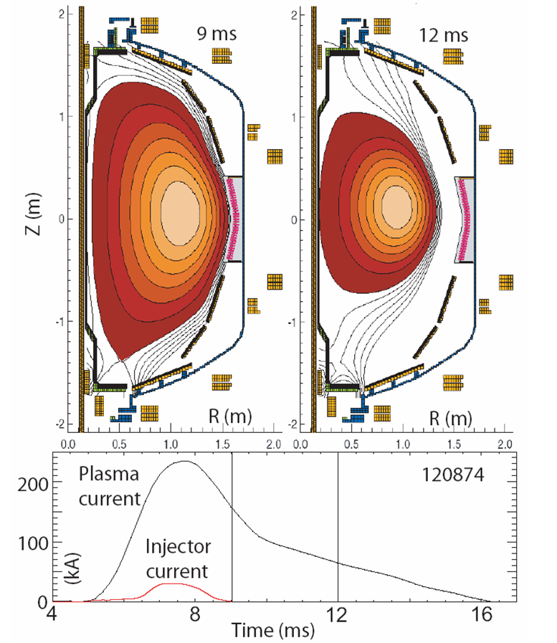

A result of particular importance for the extrapolation of this method to future machines is that the ratio of the generated plasma current to the injector current exceeds 60 for NSTX is an order of magnitude larger than the previous results on HIT-II. The next objective for CHI research on NSTX is to demonstrate coupling to OH. Experiments on the HIT-II device have shown that CHI discharges couple to and outperform inductive-only discharges, an example of which is shown in Figure 4.
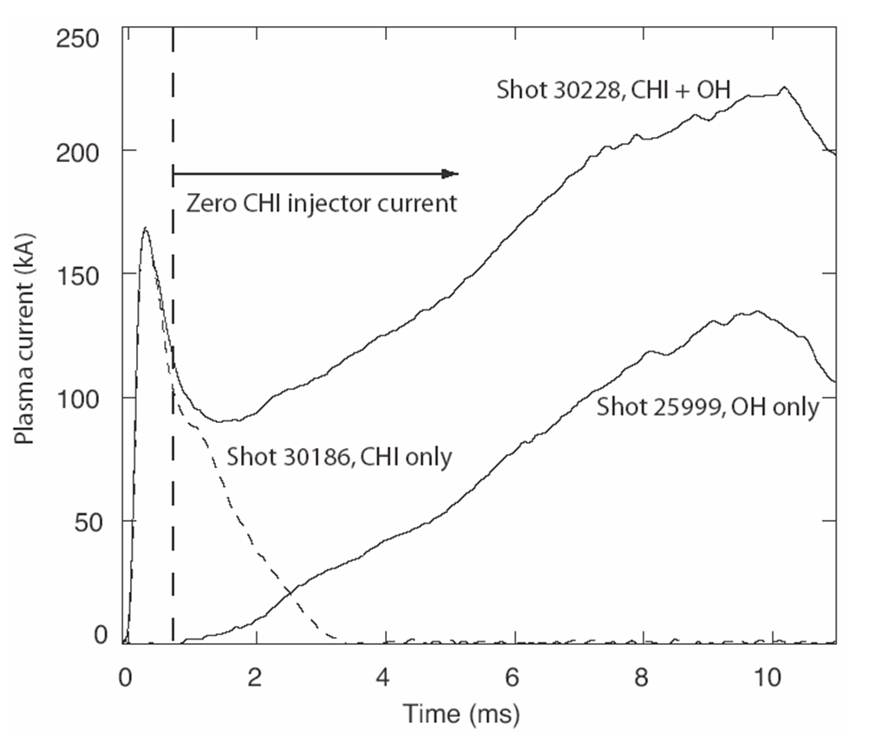

Figure 4: The dashed trace is a CHI only discharge. The vertical dashed line shows the time at which the CHI injector current is reduced to zero. CHI current persistence beyond this time is due to the existence of a closed flux equilibrium. It is this closed flux plasma that is inductively driven in shot 30228. For comparison, an inductive only discharge, using the central solenoid, under identical pre-programmed loop voltage time history (total 30 mV s consumed) is also shown (shot 25999).

New engineering tools and improvements for CHI research
1. ECH Heating of CHI Produced discharges:
Results from the HIT-II experiment show that CHI produced discharges couple to induction only if the power radiated by the decaying CHI discharge is less than the input power from ohmic heating. At an applied loop voltage of about 3 V, and at 100 kA of plasma current, the ohmic input power is about 300 kW. Present CHI discharges are observed to have an electron temperature in the range of 10 to 20 eV at the start of the current decay phase. The radiated power from the best discharges is probably below 200 to 300 kW. Because of the decreased sensitivity of the NSTX bolometers to emission below 20 eV, the radiated power cannot be accurately estimated. During 2009, a 200-400kW ECH system will be available on NSTX. The ECH system will be used to increase the temperature of the CHI target to improve coupling to induction and to other non-inductive current drive methods.
2. Higher CHI voltage capability:
Results from the HIT-II experiments show that by optimizing the injector voltage, injector flux and toroidal field, the extent of closed flux current can be increased. To increase the closed flux current more injector flux is needed. To reduce the injector current at higher levels of injector flux, the toroidal field needs to be increased. At higher toroidal field, the injector voltage needs to be increased. As a result of such an optimization, the magnitude of closed flux current in HIT-II was increased to 100 kA. Figure 5 shows the results of this optimization.
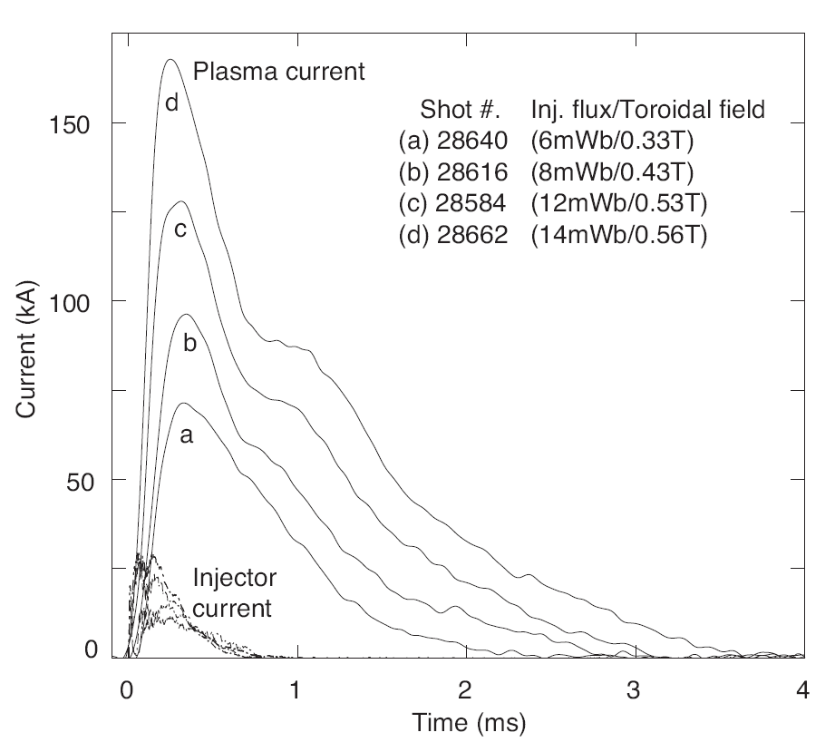
Figure 5: The amount of useful closed flux plasma current increases with the injector flux, which is a measure of the maximum poloidal flux the discharge can contain. The capacitor bank charge voltages for discharges (a) to (d) are 2.5, 2.7, 3.4 and 3.9 kV respectively. Note that the toroidal field is also increased as the injector flux is increased. On HIT-II, 800 kA turns of current in the toroidal field coil corresponds to 0.5 T at the machine geometric axis. The flattening of the current traces at about 1 ms, is probably due to relaxation activity, a phase during which open field line currents begin to flow on closed field lines. The flattening may be an indication of the generation of closed field line currents and resulting changes to the current profile.

At present in NSTX, such an optimization scan has not been conducted. At a capacitor bank charging voltage of 1.5 kV used during FY 2005, 60 kA of closed flux current was achieved. At 1.7 kV used during FY 2006, 160 kA was obtained. As indicated by Figure 6, at a capacitor bank charging voltage of 2 kV closed flux current magnitude of 300 kA should be possible. If the voltage could be increased to 2.5 kV even higher levels of current should be attainable. If the lower divertor plates could be insulated from the rest of the vessel (similar to the ring electrode that was used on DIII-D), then it should be possible to bias the inner and outer vessel components with respect to this plate, which would allow the injector voltage to be increased to 4 kV while maintaining the inner vessel voltage at 2 kV. This modification is not under consideration at this time. The present voltage snubbing system on the CHI system (the Metal Oxide Varistors) begins to significantly conduct at a voltage of 1.7 kV. In order to extend the voltage to the full 2 kV, new MOVs with a higher voltage rating are required. This upgrade is planned during the 2008 maintenance break. In preparation for this, during the 2007 maintenance break, the CHI voltage monitors are being improved to better asses the magnitude of the injector voltage transients.
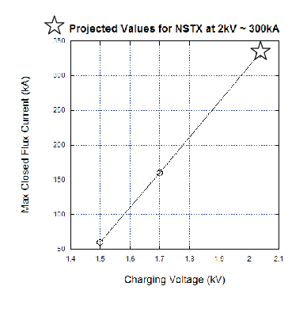
Figure 6: Projected closed flux current at a capacitor bank charging voltage of 2kV

3. Absorber field-null control
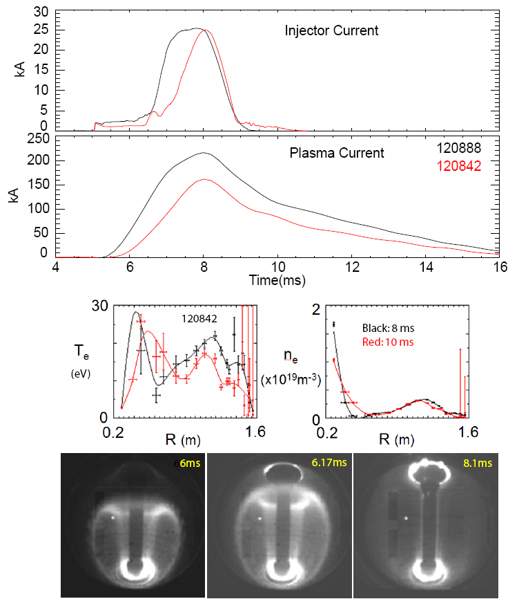
Figure 7. A discharge (120888) in which about 160 kA of persisting closed flux current is present after the injector current is reduced to zero. A lower current discharge (120842) is also shown along with electron temperature and electron density profiles at 8 and 10 ms. Shown are the injector current, the plasma current, Thomson scattering data (for 120842) and fast camera images for discharge 120888, which show the development of an absorber arc at 6.17 ms. The Absorber arc is seen by the bright visible ring that is seen in the absorber region. The arc can be seen intensifying at 8.1 ms. For comparison, note that the images from Figure 2 do not show evidence for such a visible light emission in the upper divertor gap.

During CHI discharge initiation, the injected current flows along field lines connected to the lower divertor electrodes. As the magnitude of the injected current increases and the plasma grows to fill the vessel, an ionized region begins to form in the upper divertor region. Because of the presence of some poloidal magnetic field in this region (due to fringing fields from the PF5 and PF3U coils), these stray fields provide a conducting path between the upper divertor plates. If the impedance of this path becomes sufficiently low, such as when an ionized plasma front reaches this region due to a elongated plasma, then an alternate current path can develop along the upper divertor region. This is known as an absorber arc. An example of such an arc is shown in Figure 7. In NSTX, discharges with no absorber arc typically draw about 2 – 4 kA of injector current. Once the absorber arc initiates, the injector current increases to above 15 kA, the maximum level dependent on the size of the capacitor bank. This additional arc current serves no useful purpose and could increase the impurity content in the CHI discharge. On HIT-II, the absorber arcs are minimized by providing a region of poloidal field null in the absorber region. Absorber field control is very effective in minimizing or eliminating absorber arcs in HIT-II. In preparation for this possibility two new absorber poloidal field coils were installed in NSTX. These coils can be driven using the same power supplies used to drive the Resistive Wall Mode coils in NSTX. Power feed cables from the CHI absorber coils to the RWM power supplies will be installed during the 2008 outage and the plasma control system revised to control these coils to provide a region of poloidal field null in the absorber region during the transient CHI discharge phase.

4. Staged capacitor bank operation
The present CHI power supply consists of up to ten capacitors, each 5 mF in size. Any number of these can be connected in parallel and discharged using a single ignitron. Adding two more ignitron switches that would allow two or three ganged up capacitors to discharge in sequence would provide an important control knob for discharge development. The immediate improvement would be that the size of the capacitor bank can be varied between shots without the need for a time consuming controlled access. The second benefit is that it would give greater control of absorber arcs as fewer capacitors could be used for injector flux conditions that require fewer capacitors. Under changing electrode conditions, such as when Lithium is deposited, having the capability to discharge three small banks separated in time by about 1ms, would allow the injector voltage to be maintained at a higher level for longer durations, as required for the transient CHI start-up process. This upgrade is planned for the 2007-2008 maintenance break.

Plans for 2009 - 2013
Our overall goals for this 5-yr research are: (1) Transfer a CHI produced plasma to the inductive system and (2) Study coupling of a CHI produced plasma to the available non-inductive current drive systems in NSTX and coupling to induction from the outer PF coils. Investigate the use of CHI for edge current drive and scrape-off-layer flow control in a pre-formed inductive discharge.
2008: Demonstrate coupling CHI produced plasma to induction
As previously demonstrated on the HIT-II experiment, a transient CHI discharge will be produced and during the current decay phase, induction from the central solenoid will be applied to ramp the current up to higher levels. Target PF coil currents will be determined that allow CHI start-up to be initiated with a fully pre-charged central solenoid.

2009: Using the 200kW ECH system, improve CHI coupling to induction. Test CHI edge current drive.
ECH heating of transient CHI discharges has the potential to increase the electron temperature from the present 10-20eV to about 200eV. At this electron temperature, coupling to induction should further improve. In a separate experiment, an inductively produced lower single null discharge will be produced and the CHI capacitor bank will used to drive current along the SOL, to study current penetration to the interior.

2010: Increase CHI produced closed flux current

Using the capability for electron heating and by operating the CHI cap-bank at the full 2 kV rating, the magnitude of closed flux current will be increased to as high as possible.

2011: Test coupling of CHI to other non-inductive current drive systems

Using the best CHI discharges produced to-date, HHFW and NBI will be applied to a high-current CHI target that has its current further boosted using induction from the outer PF coils.

2012: Physics of coupling to non-inductive current drive systems

Improving on the results from 2011, we will study the physics of coupling a CHI target to the non-inductive current drive systems available in NSTX.

2013: Use CHI produced discharges in combination with outer PF startup to produce a high-beta discharge

The CHI/PF synergism will be exploited to produce a solenoid-free start-up equilibrium to be used for producing a high-beta target.

Conclusions and Discussions – The CHI program plan on NSTX consists of two parts. For solenoid-free plasma startup, the transient CHI approach will be used. This method was demonstrated on HIT-II, and on HIT-II CHI started discharges are more robust than inductive only discharges, and they couple to and improve the performance of inductive only plasmas. Using this method, thus far 160kA of closed flux current has been produced in NSTX, which is a world record for non-inductive closed flux current generation. Much of the needed technical development and hardware improvements needed to correctly implement this method on NSTX has been completed. The remaining steps are to (1) couple a CHI produced discharge to induction and (2) couple it to a non-inductive current drive method. The physics of CHI applied edge current drive will be studied.

B. Plasma Start-up Using Outer Poloidal Field Coils
Introduction - In addition to CHI NSTX will investigate a concept for solenoid-free inductive plasma startup utilizing only the outer poloidal-field coils. We describe an experimental setup for generating up to 500 hundred kilo amperes of plasma current in NSTX by this method. Such plasma would provide a suitable starting point for the non-inductive current ramp-up experiments. If successful, this concept is applicable as a possible start-up method for the NHTX (Next Step ST) device [Ref], and will provide a crucial element for future ST-based nuclear facilities, such as the Component Test Facility (CTF).
The MAST experiment routinely uses poloidal field coils at a larger major radius than the plasma but still inside the vacuum chamber to initiate the plasma; however, to be able to extrapolate the technique to future experiments, and fusion energy systems, it would be advantageous to use only the poloidal field coils located outside the vacuum vessel wall for startup.
Basic Concept of the Plasma-Start-Up with Outer Poloidal Coil System - Using only the outer PF coils of NSTX, shown in Figure 8, we are able to satisfy the conditions for plasma start-up which have been established by many previous experiments using a conventional central solenoid. There are three important conditions which need to be satisfied for inductive startup:
- A region of low poloidal magnetic field must be created over a sufficiently large region of the vacuum vessel poloidal cross-section to allow the ionization avalanche to develop in the applied toroidal electric field. The condition for highly reliable breakdown can be expressed as E_{T}·B_{T} / B_{P} > ~1 kV/m, where E_{T} is the induced toroidal electric field, B_{T} is the toroidal magnetic field and B_{P} is the average poloidal (i.e. transverse) magnetic field. However, the application of suitable rf waves to break down the gas can relax this condition. For example, on DIII-D, operating at B_{T} = 2 T, with high-power ECH pre-ionization (~ 800 kW), start-up was achieved at E_{T} = 0.3 V/m with B_{P} > 5 mT over most of the vessel cross-section [19]. This represents a value of E_{T}·B_{T} / B_{P} ≈ 0.12 kV/m. The benefit of pre-ionization with even a very small ECH power (~ 20 kW) has been shown on NSTX (and also on other ST devices including CDX-U, START, MAST, and PEGASUS) [20]. The proposed configuration for NSTX startup achieves E_{T}·B_{T} / B_{P} ~ 0.12 kV/m, comparable to the value achieved on DIII-D.
- The field null, which is produced transiently by the combined effects of currents in the PF coils and the induced currents in the machine structure, must be maintained for a sufficient duration ~ 3 milliseconds to develop the avalanche. DIII-D experiment found that the time required increased as the loop voltage was reduced. However, high power ECH pre-ionization (~ 800 kW) was able to shorten this process on DIII-D to ~ 2 msec even at low loop voltage. The field null is maintained in the proposed NSTX startup configuration for 3 msec.
- After breakdown, the poloidal field coils must provide both fields to maintain plasma equilibrium and sufficient flux change for the current to ramp up to the desired level. The change in the vertical field required for equilibrium produces additional flux during the current ramp-up. These requirements are met in the proposed configuration.
Outer Poloidal Field Start-Up Configuration on NSTX – We propose to utilize the existing poloidal coil sets and available power supplies on NSTX for solenoid-free start-up. In Figure 8 (a) the poloidal coils installed on NSTX are shown. The required current levels in Figure 8 (a) are consistent with the current rating of the coils and power supplies for the short durations needed for this experiment. The mid-plane vertical field generated by the combination of PFs 2, 3, and 5 is compared with that generated by PF 4 in Figure 8 (b). The combined field is shown in Figure 8 (c); the field null is created around R = 1.4 m. In Figure 9 (a), the resulting two dimensional poloidal field contours are shown. As can be seen in Figure 9 (a), a high quality field null is created. From Figure 9 (b), one can see that about 0.16 Wb (at R = 1.0 m) is available for the current ramp up for this particular set of coil currents. In NSTX, under an optimized condition, about 0.3 Wb from the solenoid can produce a 1 MA discharge. Thus, the 0.16 Wb flux swing available from this scenario at R ≈ 1.0 m could, in principle, produce plasma currents of order 0.5 MA.
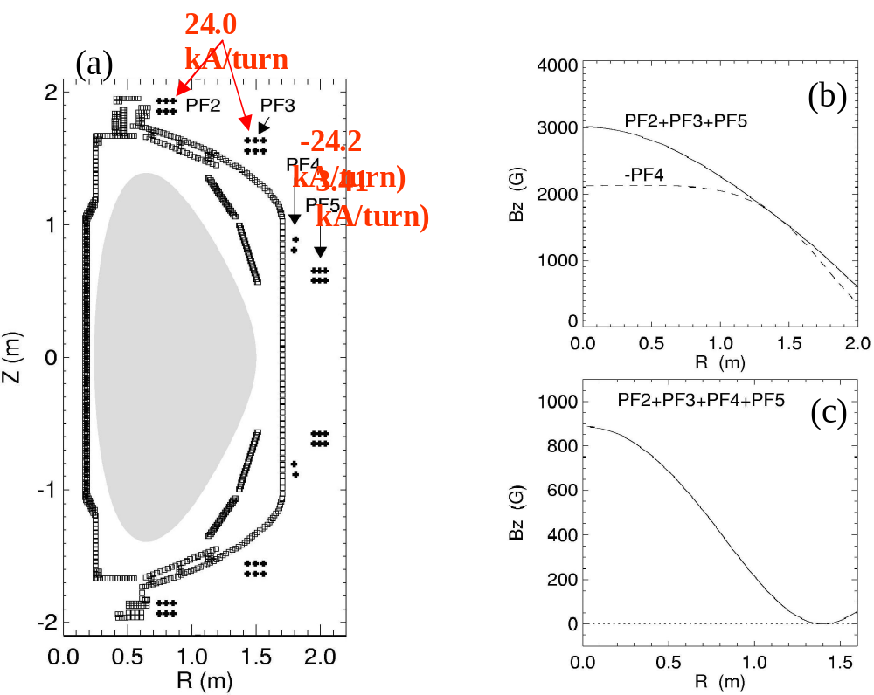
Figure 8. NSTX Configuration. (a) A schematic of the NSTX polodial field coil set up. The required coil currents are indicated. (b) The mid-plane vertical field for the combination of PFs #2,#3 and#5 and PF #4. (c) The mid-plane vertical field generated by PFs 2, 3, 4, and 5.

Pre-Ionization – On NSTX, start-up has been routinely achieved for a relatively low loop voltage of ~ 2 V with ECH pre-ionization. For the outer-PF-only start-up scenario, we expect to be able to generate a loop voltage up to 6 V transiently, corresponding to a toroidal electric field of 0.7 V/m at the radius of the field null, R = 1.4 m. The toroidal field there is up to 0.35 T. Within the broad region where the poloidal field is < 20 G, the value of E_{T}·B_{T} / B_{P} is above 0.12 kV/m. Since DIII-D was able to initiate the plasma for E_{T}·B_{T} / B_{P} as low as this value with strong ECH pre-ionization, start-up should be also feasible in NSTX if adequate pre-ionization is provided. For NSTX, with a combination of ECH (~ 20 kW) and HHFW (~ 1 MW), a favorable pre-ionization condition may be created. On CDX-U, this combined ECH-HHFW technique was indeed shown to be effective in creating relatively robust preionized plasmas [22]. This preionization can be further developed and its effectiveness tested in the near term on NSTX using the existing ECH and multi-MW HHFWsystems. An initial test using these pre-ionization methods and a field null volume significantly larger than described above allowed the production of up to 20 kA of plasma current, as shown in Figure 10. The primary findings are that the 20 kW of ECH and inductive heating together are too small to achieve impurity radiation burn-through, and that HHFW is not a good pre-ionizing system if the plasma-antenna distance grows too large or the neutral pressure is too low. The experiment will be attempted again in 2009 after the installation of the 200-400 kW ECH system. In addition to this a washer plasma gun source will be installed for the 2009. This may inject adequate amounts of ionized plasma into the field null region, which should facilitate easier breakdown of the remaining neutral gas. A Compact Toroid (CT) injector is also being considered for Advanced Fuelling experiments. This has the potential to inject all of the required plasma directly into the field null region, and is a possibility for experiments beyond 2009.
Maintenance of Field Null – During the initiation, it is important to maintain the field null for about 3 ms to create the avalanche. Since the poloidal field is changing rapidly during this period and inducing significant vacuum vessel eddy currents, a dynamic modeling code to include the vacuum vessel eddy currents has been implemented. This analysis shows that it is indeed possible to maintain the field null for about 3 ms, which should be long enough to initiate the avalanche process with the aid of sufficient pre-ionization as described above. The plasma stability with the presence of the eddy currents is an issue that needs to be further investigated. The presence of the nearby passive plates in NSTX should aid the vertical stability. The PF 4 vertical position can be adjusted if needed.
Hardware and Modeling Requirements –
. 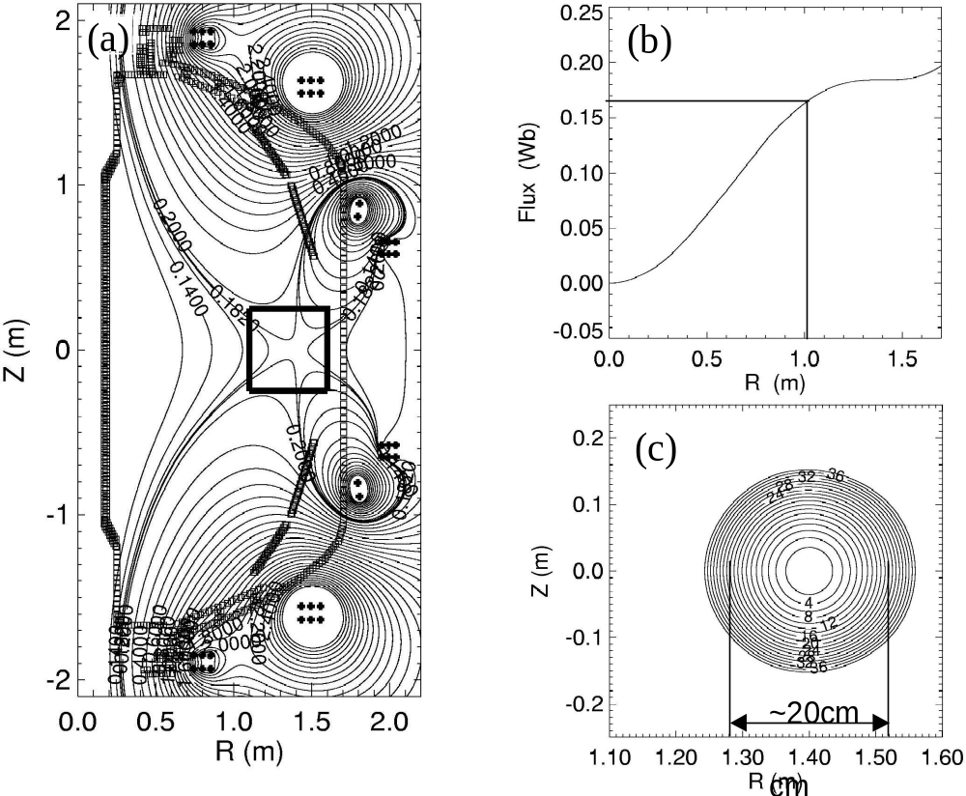 Figure 9. The NSTX null-field configurations. (a) Flux contours. (b) Flux radial profile. (c) Mod-B surfaces of the field null region
The current ramp up will require PF 5 to provide much of the equilibrium vertical field. However, for the initial test of the concept, the crucial initial breakdown and avalanche process was tested by reversing the PF 5 connection to its existing power supply. The bi-polar capability will be implemented after further tests. Once the plasma initiation is successful, feedback control must be introduced to maintain the plasma equilibrium and shape during the current ramp-up. The TSC code [23] will be utilized for the development of suitable current ramp-up scenarios to guide the development of control algorithms.
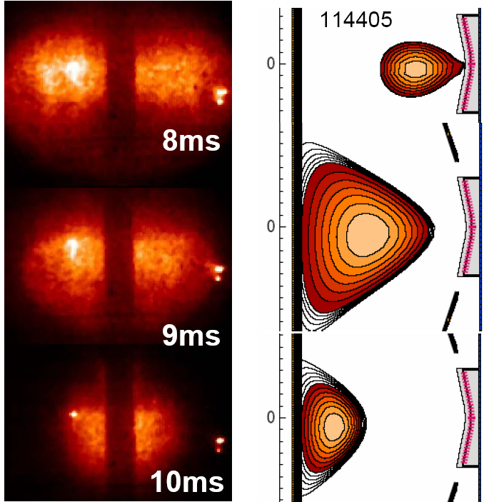

Figure 10: Shown on the left are fast camera fish eye visible images of a discharge produced using outer PF start-up. A small bore plasma is formed in the outer region as show by LRDFIT reconstruction as 8ms (top right), that subsequently moves to the inner wall and decays over several 10s of ms. Up to 20kA of plasma current was generate

Plans for 2009 – 2013
2008: Preparatory work scopes:
- Continue the basic start-up calculations including the wall eddy currents
- Assess basic power supply reconfigurations
- Analyze electro-magnetic forces and needs (if any) for further bracing of PF coils.

2009: Initial Plasma Initiation Experiments:
- Develop effective pre-ionization capability using the new ECH system and the washer gun plasma sources.
- Conduct initial breakdown and current initiation experiment up to ~ 100 kA with strong ECH pre-ionization using the existing uni-polar supply for PF 5.
- After confirming successful breakdown, implement needed hardware changes including the bi-polar capability of PF 5.
- Develop optimized current ramp-up scenarios using TSC.
- Develop required magnetic sensors and control algorithms based on the TSC simulation.
2010-12: Start-up Demonstration Experiments:
- Establish a few hundred (Ip ~ 300 - 500 kA) plasma discharges without use of the OH solenoid and higher power HHFW.
- Apply HHFW and/or NBI to achieve high beta poloidal discharges without the OH solenoid.
- Develop comprehensive understanding and predictive capabilities of the outer poloidal field coil plasma start-up concept for future devices including NSST.
2013: Assist the non-inductive research as a tool for ohmic-solenoid-free start-up.
- Using a combination of CHI start-up and outer PF start up or Plasma Gun start-up and outer PF start-up, ramp-up to a high beta target.

Conclusions and Discussions – A plasma start-up concept using only the outer PF coils has been introduced. This method appears capable of generating in NSTX a solenoid-free start-up current of a few hundred kilo amperes, comparable to that produced by CHI. Once a significant level of plasma current is established, it should be possible to use other means of non-inductive current drive such as the bootstrap over-drive, and/or NBI / RF current drive to further ramp up and maintain the current. The outer PF coil start-up concept can be implemented relatively quickly with minimal facility modifications and, if successful, can play an important role in the non-inductive research phase of NSTX as described in this Five-Year plan. The concept scales favorably toward larger and higher field devices, such as ST-CTF, since the higher field tends to ease the breakdown requirements and the amount of available flux scales with the square of the major radius and linearly with the field. If successful, it will give us a method for the ohmic-solenoid-free start-up of future ST devices to a significant level of plasma current.

C. Plasma Gun Startup
Introduction - In this method, an electron beam is created by biasing a washer gun plasma source negative with respect to the external vessel or a floating probe inserted into the vacuum chamber. An appropriate vacuum magnetic field pattern is setup so that the combination of poloidal and toroidal fields creates a spiraling field line configuration. The electrons released by the gun then follow these field lines. This method now adopted by PEGASUS is an improvement over the early experiments on CDX-U [Ref], in that CDX-U used a heated Lanthanum Hexaboride cathode, which likely introduces more high-Z impurities than the plasma gun sources. In the Plasma gun sources, by choosing the appropriate bias voltages, the ions released by the gun can be made to preferentially fall back into the gun cavity, thereby reducing impurity influx into the vessel. These plasma gun sources typically operate for about 10ms, which is about the time needed to couple it to induction from the outer PF coils.
Results from Pegasus
At present two different experiments have been performed on Pegasus. In the initial experiment, the gun source was located near the lower divertor region. It was then biased with respect to a floating component positioned below the upper divertor, so that an electron beam was driven up as shown in Figure 11(1). At sufficient low values of the toroidal field the spiraling electron beam channel relaxed and merged to a diffuse current channel that filled the entire vessel as shown in bottom portion of Figure 11(2). In these experiments up to 50kA of toroidal current was generated using 4kA of gun current. For representative cases, the toroidal field was about 0.01T and the vertical field was 0.005T.
In more recent experiments of perhaps more relevance to NSTX, the gun and a collector assembly was mounted in the outer midplane as shown in Figure 12. The driven electron channel now occupied the outer midplane of the vessel. In these experiments at relatively higher values of the toroidal field, up to 25kA of toroidal current was generated using 1.5kA of gun current as shown in Figure 13. After the guns were turned off, the current persisted for 2ms and was accompanied by coherent MHD activity indicative of the generation of closed flux. When this discharge was coupled to induction from the central solenoid, the current ramped up beyond what was possible using induction alone showing coupling to induction, as seen in Figure 14.

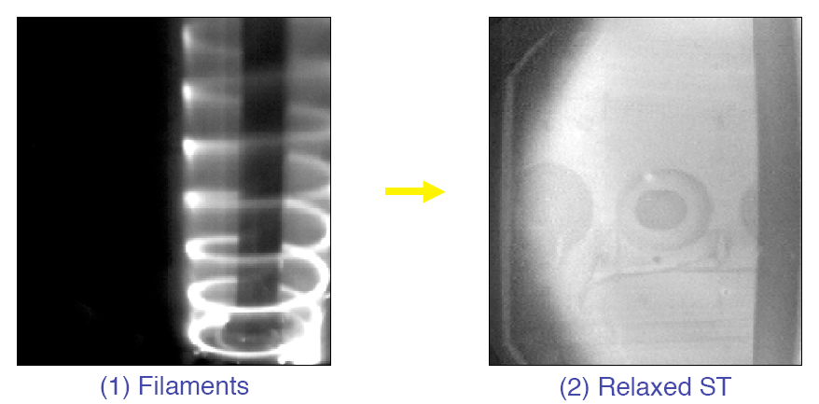
Figure 11: Visible images of the current channel prio to and after relaxation in Pegasus Washer Gun experiments.

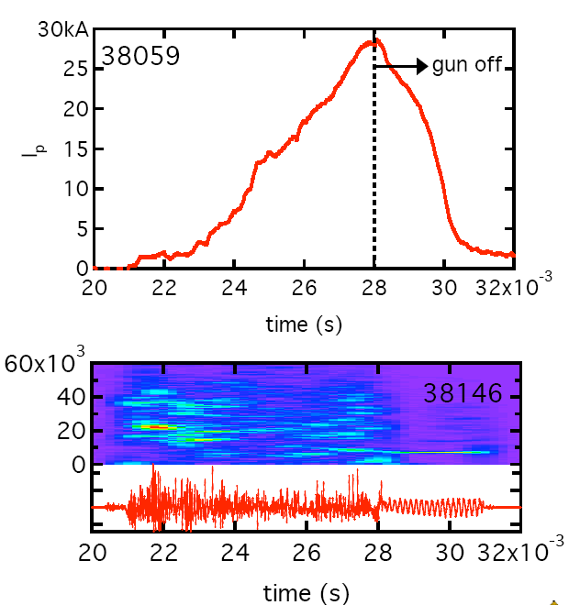
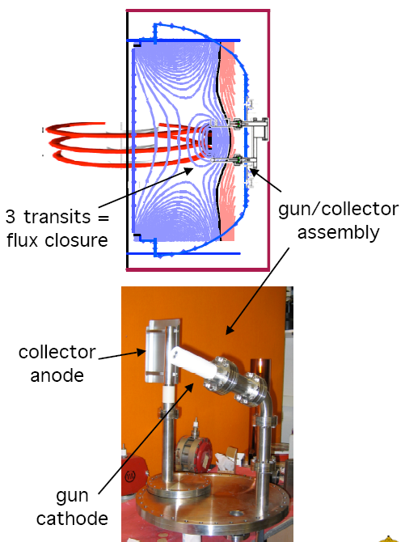

Figure 12: Layout of the mid-plane gun injection system in Pegasus
Figure 13: Plasma current and MHD activity of a discharge during mid-plane gun injection experiments in Pegasus

Figure 14: Shown are in blue an OH only discharge and in red, the same preprogrammed loop voltage applied to a mid-plane gun generated plasma.
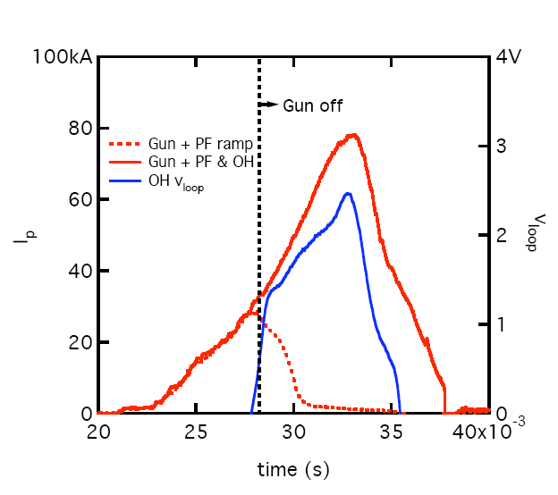

Implementation of the method in NSTX
The method will be implemented on NSTX in a manner similar to the Pegasus mid-plane experiments. A design of the conceptual design is now underway by the Pegasus group.

Schedule (2009 to 2013)
2008: System design for NSTX, including identifying hardware components and installation details.
2009: Installation on NSTX and commissioning tests. Support outer PF start-up experiments, by injecting ionized plasma into the region of field null.
2010-2011: test of plasma startup using the mid-plane gun injection method.
2012-2013: Based on 2011 results, upgrade of the system to higher current levels.

Conclusion and Remarks:
The method is simple in concept and could be easily adapted to larger machines as the gun sources could be withdrawn after plasma startup. Initial results from Pegasus are encouraging. NSTX will test the concept on a larger scale. The method is compatible with outer PF startup and will assist the outer PF startup experiments by providing a pre-ionized source of plasma.

References (these are to be revised)
[1] Jarboe, T.R., “Formation and steady state sustainment of a tokamak by Coaxial Helicity Injection,” Fusion Tech. 15, 7, (1989).
[2] Ono, M., et al., “Steady-state tokamak discharge via dc helicity injection,” Phys. Rev. Lett. 44, (1980) 393.
[3] Nelson, B.A., et al., “Formation and sustainment of a low-aspect ratio tokamak by coaxial helicity injection,” Phys. Plasmas 2 (1995) 2337.
[4] Nagata, M., et al., “Helicity injection current drive of spherical tokamaks and spheromak plasmas in HIST,” 17th IAEA Fusion Energy Conference, Yokohama, IAEA-CN 69/EXP4/10 (1998).
[5] Browning, P.K., et al., “Injection and sustainment of plasma in a preexisting toroidal field using coaxial helicity injection,” Phys. Rev. Lett. 68 (1992) 1722.
[6] Jarboe, T.R., Raman, R, Nelson, B.A., et al., “Current drive experiments on the HIT-II spherical torus,” 17th IAEA Fusion Energy Conference, Yokohama, IAEA-CN 69/PDP/02 (1998).
[7] Raman, R., Jarboe, T.R., Mueller, D., et al., “Non-inductive current generation in NSTX using coaxial helicity injection,” Nucl. Fusion 41, (2001) 1081.
[8] Jarboe, T.R., Raman, R, Nelson, B.A., et al., “Progress with helicity injection current drive,” 19th IAEA Fusion Energy Conference, Lyon, IAEA-IC/P 10 (2002).
[9] M. Ono and W. Choe, “Out-Board “Ohmic Induction” Coil for Low-Aspect-Ratio Toroidal Plasma Start-up”, Princeton University Patent Disclosure 03-2003-1.
[10] C.B. Forest, et al., “Internally Generated Currents in a Small-Aspect-Ratio Tokamak Geometry," Y.S. Hwang, M. Ono and D.S. Darrow, Phys. Rev. Letters 68, 3559 (1992).
[11] Taylor, J.B., “Relaxation of toroidal plasma and generation of reverse magnetic fields,” Rev. Mod. Phys. 28, (1986) 243.
[12] Zakharov, L and Pletzer, A, “Theory of perturbed equilibria for solving Physics of Plasmas 6, 4693 (1999).
[13] Lao, L.L., St. John, H., Stambaugh, R.D., “Reconstruction of current profile parameters and plasma shapes in tokamaks,” Nucl. Fusion 25, 1611 (1985).
[14] Lao, L.L., St. John, H., Stambaugh, R.D., “Separation of βp and li in tokamaks of non-circular cross-sections,” Nucl. Fusion 25, 1421 (1985).
[15] Jardin, S.C., Pomphrey, N., DeLucia, “Dynamic modeling of transport and positional control of tokamaks,” J., Journal of Computational Physics 66, 481 (1986).
[16] Tang, X., “MHD modeling of CHI in NSTX,” 8th International ST Workshop, Nov. 18 – 21, Princeton Plasma Physics Laboratory, Princeton, NJ (2002).
[17] Raman, R., Jarboe, T.R., Nelson, B.A., et al., “Demonstration of plasma startup by coaxial helicity injection,” Phys Rev. Lett. 90, 075005-1 (2003).
[18] Ono, M. et al., “Design Innovations of the Next-Step Spherical Torus Experiment and Spherical Torus Development Path”, IAEA –CN-94/FT/1-4 (2002).
[19] Lloyd, B. et al., “Low Voltage Ohmic and Electron Cyclotron Heating Assisted Startup in DIII-D”, Nuclear Fusion 31, 2031 (1991).
[20] Menard, J. et al., “Ohmic flux consumption during initial operation of the NSTX spherical tirus”. Private Communication”, Nuclear Fusion 41, 1197 (2001).
[21] Takase, Y. et al., “Plasma Current Start-up, Ramp-up, and Achievement of Advanced Tokamak Plasmas without the Use of Ohmic Heating Solenoid in JT-60U”, the Journal of Plasma and Fusion Research, 78, 719-721 (2002).
[22] Menard, J., “High-Harmonic Fast Wave Coupling and Heating Experiments in the CDX-U Spherical Tokamak”, Ph.D Thesis, Princeton University, June 1998.
[23] Jardin, S., “Timescales for Non-Inductive Current Buildup in Low Aspect Ratio Toroidal Geometry”, Nuclear Fusion 40, 1101 (2000).

