Chapter 4
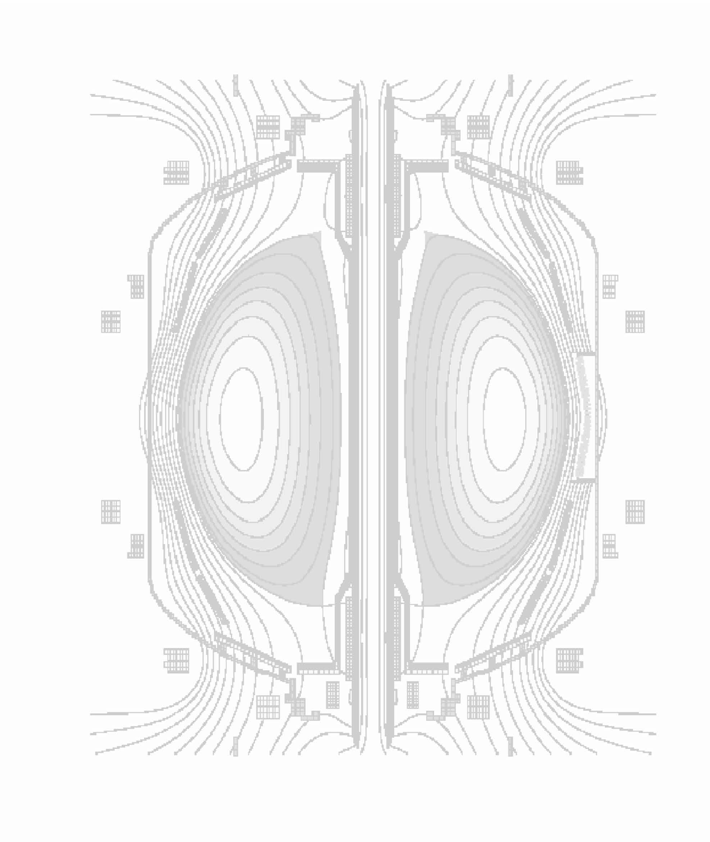

Waves and Energetic Particles

4.0 Overview
Spherical torus (ST) discharges, such as those in NSTX, provide a unique opportunity for studying wave-particle interactions in plasma at high β and dielectric constant. Scenarios that use high harmonic fast wave (HHFW) and electron Bernstein wave (EBW) heating and current drive are being developed and explored in NSTX to assist non-inductive plasma startup, plasma current ramp up and sustained plasma operation at high β. Fast ions produced during neutral beam injection in NSTX have velocities that exceed the Alfvén speed and can consequently resonate strongly with a wide variety of Alfvén waves. Controlling the distribution function of energetic ions through phase-space engineering is an important topic for spherical torus physics, as well as for ITER and tokamak research in general.
The 30 MHz HHFW heating and current drive system has been operational on NSTX since its inception. Recent HHFW experiments and modeling have provided a deeper understanding of the HHFW coupling physics and have led to significantly improved coupling efficiency, with and without neutral beam heating, in L-mode discharges. These new results have led to several proposed changes to the HHFW antenna that will support the 2009 - 2013 research program, and have important implications for future tokamak devices, including ITER. Section 4.1 of this chapter discusses the status of HHFW research and plans for the NSTX HHFW program.
Until recently the EBW research program on NSTX has been focused on determining the EBW coupling efficiency for various plasma scenarios via the measurement of thermal EBW emission, and the theoretical modeling of EBW coupling, propagation, heating and current drive. By 2009 a 28 GHz,
350 kW gyrotron will be installed and operational on NSTX. The installation of additional gyrotrons is proposed for the 2009 - 2013 research program, with the potential for coupling 1 MW of EBW power by 2012. This 28 GHz heating system will allow the first high power EBW coupling and heating tests on NSTX. Section 4.2 presents the status of EBW research and plans for the NSTX EBW program.
Energetic particle research on NSTX has yielded important new results; including the discovery of CAE/GAE modes, multi-mode transport and a new understanding of chirping modes. These experimental results have helped advance theoretical modeling and have significant implications for future burning plasma devices. Included in the 2009-2013 research program is a proposal to install a CAE stochastic ion heating system. Section 4.3 presents the status of energetic particle research and plans for the NSTX energetic particle program.
4.1 High Harmonic Fast Wave Physics

4.1.1 HHFW Research Goals
The ultimate goals of the HHFW program on NSTX are 1) to assist with startup and ramp-up to improve the ST concept for very long pulse operation, and 2) to support heating and current drive of H-mode plasmas to optimize NSTX performance and stability behavior [4.1.1]. Research to date has been directed toward understanding the HHFW coupling physics and improving this efficiency for current drive phasing [4.1.2, 4.1.3, 4.1.4] and, more recently, beginning the exploration of HHFW current drive in
L-mode plasmas. Considerable improvement in coupling efficiency has been obtained in keeping with fast wave modeling by setting conditions to avoid fast wave propagation too close to the antenna/wall surfaces. It turns out that HHFW propagation is rather strongly directed close to the magnetic field direction, which favors propagation in the surface plasma and thus surface damping. Also, GENRAY [4.1.5] and AORSA [4.1.6] modeling show that the waves inside the plasma tend to be localized to the outer half of the plasma, potentially again favoring surface damping. This latter effect, which is particular to the HHFW regime, may also afford a means of localizing the HHFW power deposition off the axis of the plasma and therefore the potential to drive current off-axis if desired.

The near term HHFW research goals for the 2008 experimental campaign and for the period of the next NSTX five year research program are directed toward advancing the present physics basis for L-mode plasmas to include the H-mode regime and the startup/rampup regime. These include:
- Optimize heating and current drive in L-mode and H-mode regimes (2008-13)
- for both startup/ramp-up and sustainment periods
- using theory and modeling to guide experimental optimization
- Increase the plasma-antenna gap to provide for less interaction of NB ions with the antenna and to permit optimization of the heating/current drive of H-mode plasmas
- reduces edge density near the antenna to reduce edge power loss
- helps to avoid arcing & edge MHD
- Enhance coupled RF power by modifying the antenna to have two feedthroughs per strap and to have lower RF-imduced electric fields (2008-9)
- Modify the matching circuit to better couple to H-modes without arcing and use electronic feedback system to avoid coupling power during ELMs (2010-11)
- Further optimize the antenna structure (2011-13)

Efficient HHFW heating of L-mode plasmas has been demonstrated in 2006-7 for heating and current drive antenna phasings, and demonstrated in 2007 in the presence of neutral beam heating. Also, analysis of MSE measurements of current drive is underway to provide as quantitative a comparison to theoretical predictions of the current drive as possible for the power levels launched to date. Optimization of heating and current drive at higher power (goal 1 above) should make very clear the appropriate conditions for applying HHFW to heat and drive current on NSTX and for applying HHFW to future ST devices.
4.1.2 HHFW Physics
HHFW coupling, propagation and damping physics are important areas of research on NSTX. Each must be understood to properly predict core vs. surface heating as well as the location/profile of the heating and current drive. Extensive theoretical/modeling studies have been and are being carried out to address these three critical areas for NSTX as well as for tokamaks generally. These studies, which are supported by the NSTX Project and by other DOE grants to the PSFC-MIT, CompX Corporation, and the RF SciDAC project, include the following efforts:

1.) Analysis of the global 3D structure of the HHFW electric fields, energy flow, and power deposition is under way using both ray tracing [GENRAY] and full wave codes [AORSA, METS, and TORIC]. At the present time, these codes include both linear collisionless and collisional damping mechanisms. However, since experimental results indicate that significant damping may occur in the edge regions due to surface wave propagation, generalized boundary conditions that can treat edge dissipation due to the formation of RF sheaths near the vacuum vessel wall and launcher are now being developed by the RF SciDAC group for inclusion in the full wave modeling codes.

2.) Self-consistent simulations of the HHFW interactions with energetic ions are needed to accurately determine the power deposition and current drive that can be achieved in discharges with co-resonant neutral beam injection (NBI). Experimental observations indicate that the fast ions can interact strongly with HHFW, leading to significant modifications of the fast ion velocity distributions as well as the partitioning of the wave power among the various plasma species. To properly include the effects of these interactions, the wave propagation codes must be coupled with a Fokker-Planck treatment of the ion and electron distribution functions in ST geometry that includes effects of quasilinear diffusion at high cyclotron harmonics, collisions, trapped particle effects, and particle losses. Previously, the main focus of these studies was the GENRAY / CQL3D package, which was used to model the early combined HHFW and NBI experiments on NSTX [4.1.7]. More recently, the 1D and 2D full wave codes have all been generalized to include non-Maxwellian particle distributions in the plasma dielectric response modules. The CQL3D code has been integrated with the AORSA code, and work is currently underway to integrate it with the TORIC code. Since the power deposition and driven current profiles can change significantly as the resonant ion distributions evolve in time, the TORIC code has been integrated into the TRANSP analysis package, and work is currently underway to include CQL3D as well.

3.) In general, wave propagation and deposition codes have simplified models for the wave launcher: the codes assume that the amount of power that is coupled into the plasma is known. However, as the recent experiments on NSTX and previous results from other devices have shown, the core heating efficiency is strongly dependent on the launched wave spectrum as well as the other discharge characteristics. An analysis of the power coupled into the plasma that self-consistently includes the effect of the core absorption and wave propagation dynamics, rather than assuming a radiation boundary condition, is needed to understand the experimental observations on NSTX as well as on other tokamaks, including ITER. As a first step towards the development of this modeling capability, collaborators from the PSFC-MIT and the RF SciDAC group have been developing an interface between the TORIC 3D antenna module and the TORIC full wave code. This package, when complete, will be used to analyze the heating profiles in NSTX for various strap phasings on the NSTX launcher. Results from these studies should indicate regimes of operation in which the driven currents can be optimized for plasma startup, ramp-up, or high performance.

4) The theoretical analysis tools for quantitative, or even semi-quantitative analysis of the PDI phenomenon are not presently available. The AORSA1D all-orders full wave code is being modified to include resonant three-wave interactions. Because AORSA employs a spectral basis set, in essence a complete set of pseudo modes, this modification to account for so-called “extended pump” interactions should be straight forward to implement on a 1D model. This analysis should provide an understanding of PDI interactions on NSTX for HHFW, an ability to evaluate planned HHFW experiments for susceptibility to parasitic PDI losses, and approaches to minimizing these losses and optimizing the current drive efficiency.

The HHFW research to date on NSTX has been focused on how to optimize coupling of the HHFW power to the core plasma. It became clear in 2005 that heating for current drive phasing of the antenna
(-90º between adjacent antenna element currents) was about ½ as efficient as for heating phasing (180º)
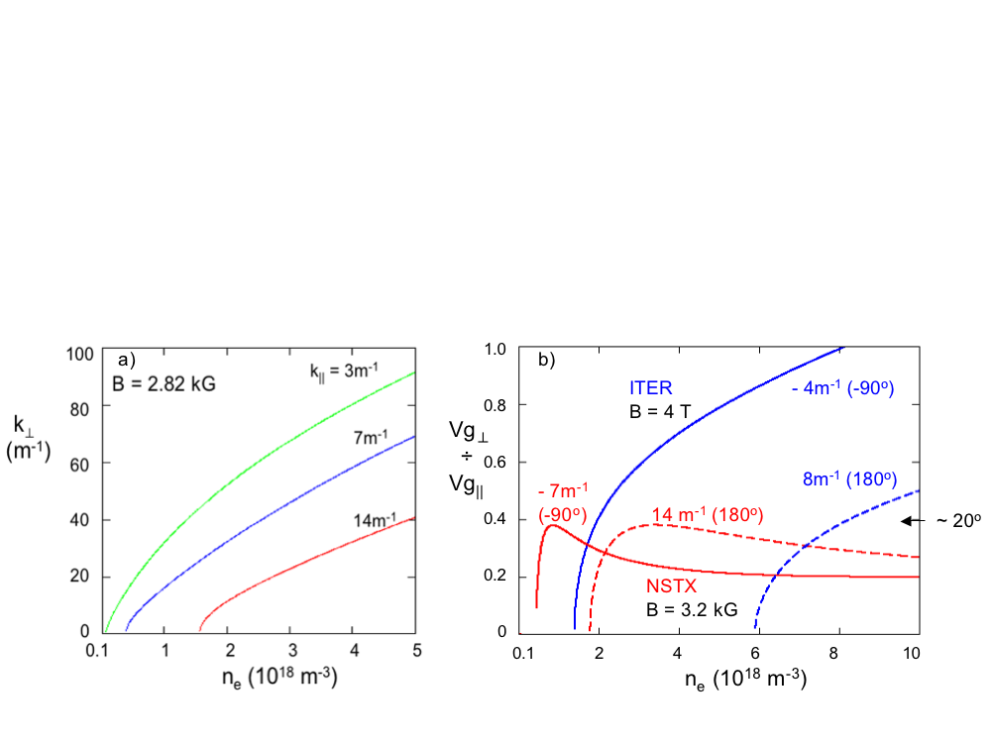
Figure. 4.1.1: Efficient coupling of HHFW power to the core plasma requires avoiding surface wave
interaction with edge plasma and antenna/walls to the extent possible - keeping edge density
near antenna low relative to the onset density for perpendicular propagation (∝B×k||²/ω).
[4.1.8]. The plasma dispersion relation pointed to the onset of perpendicular propagation of the fast waves close to the antenna/wall surface as being a possible contributor to the enhanced surface loss at the lower phasing values (longer wavelength) as shown in Fig 4.1.1.a. Indeed, increasing the magnetic field and lowering the edge density in 2006 resulted in a heating efficiency at -90º being equal to that at 180º [4.1.3]. Also, above onset the direction of the ray path in the HHFW regime is about 20º to the direction of the magnetic field, as opposed to the low harmonic case for which the angle increases with density into the plasma as shown in Fig 4.1.1.b. This results in surface fast waves, especially for higher m modes, and for those waves entering the core of the plasma tends to keep the waves confined to the outer region of the plasma in major radius due to the up-shift in k|| along the ray path. GENRAY analysis shows this effect for a single ray in Fig 4.1.2 [4.1.9] and 3D AORSA modeling demonstrates this effect in the volume of the plasma in Fig 4.1.3 [4.1.10].

The focus of the HHFW theory and modeling efforts during 2008 and the five-year plan period will expand to include other areas of importance including:
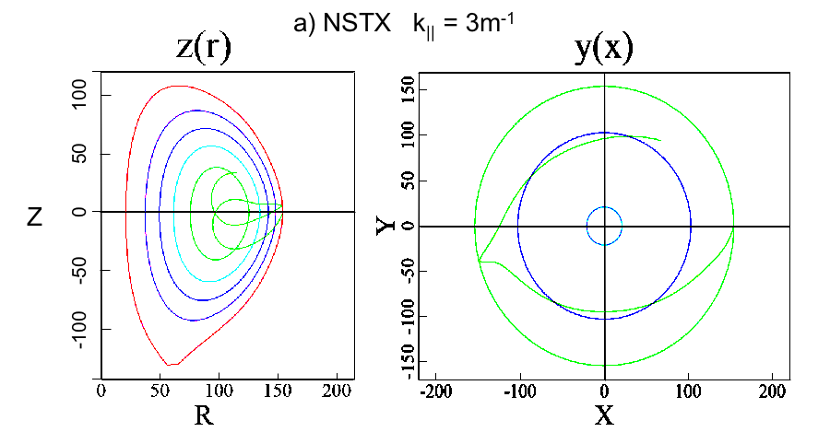

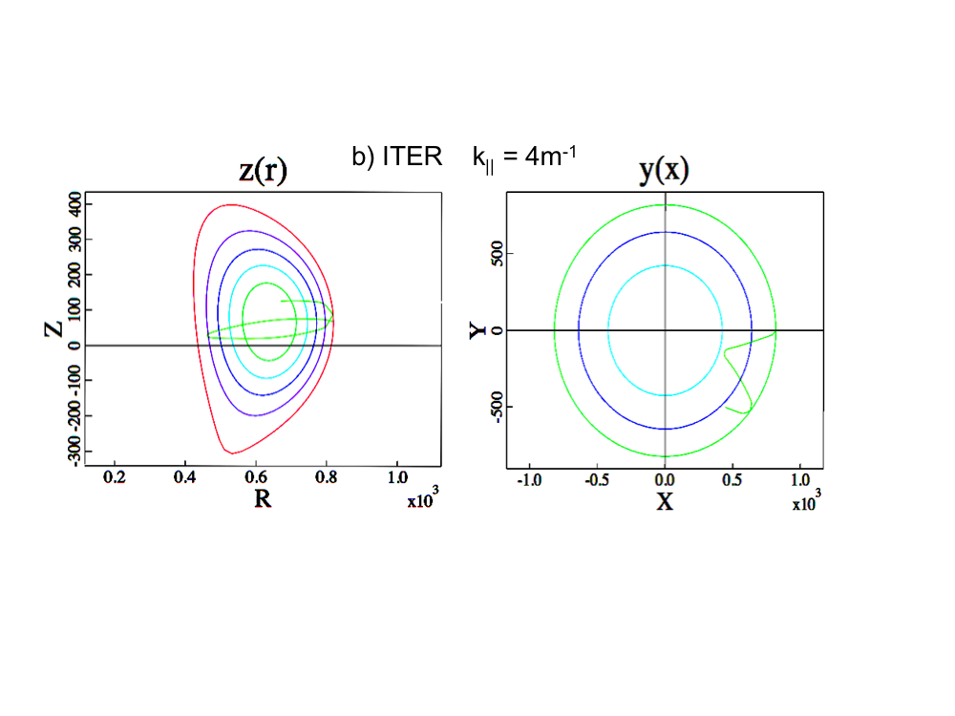

Figure 4.1.2: a) GENRAY modeling of ray path for NSTX conditions with k|| = 3m⁻¹. Note that the ray does not go through the plasma core. b) Similar modeling for ITER conditions with k|| = 4m⁻¹. Note that the ray propagates more radially and goes through the plasma core.

- Mapping out propagation characteristics for L-Mode and H-mode plasmas:
  - Density versus magnetic field along the ray path can affect the path and hence the location of power deposition.
- Understanding the fast wave damping mechanisms:
  - Core: Landau/TTMP and short wavelength mode conversion effects.
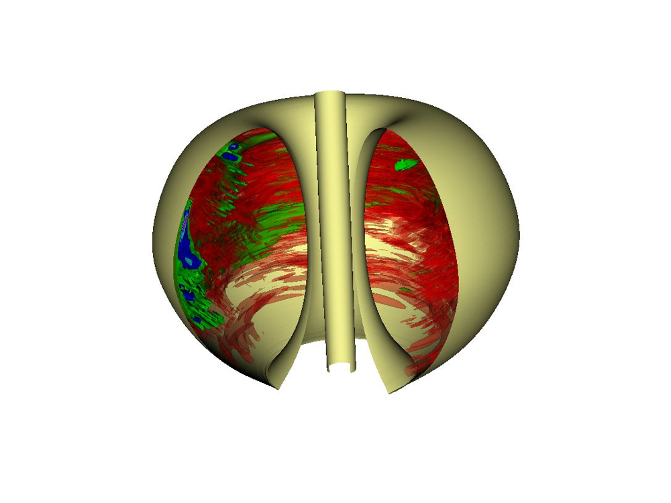
NSTX

Figure 4.1.3: 3-D AORSA modeling shows propagation to be near the wall and primarily outside the major radius on NSTX (-90º case, summed over 81 toroidal modes). The antenna is located on the left hand side of the figure.

  - Edge: Surface wave damping via collisions, sheaths, wall/antenna currents, and parametric decay instability heating.
- Predicting conditions required to optimize plasma heating and current drive (CD):
  - Co vs counter CD
- Can heating and CD be tailored for on and off axis applications?
- Can HHFW CD be used to help stabilize core MHD, e.g., by increasing reverse shear in the core with counter CD?
4.1.3 HHFW Heating System
The present HHFW system on NSTX [4.1.11] has 12 adjacent antenna straps which cover ~ 90º of the torus toroidally as shown in Fig 4.1.4. Pairs of the straps are powered with six sources via a transmission/impedance matching system comprised of 6 long transmission lines, 6 phase shifters, 6 stubs, and 6 decoupling loops (Figure 4.1.5). The system uses digital control of power and phase, and automated matching calculations to facilitate rapid changes in matching for desired phases. To meet the need for more HHFW power with a larger antenna-plasma gap to help avoid bombardment of the antenna, especially for H-mode operation at full beam power, a series of HHFW system upgrades are planned:
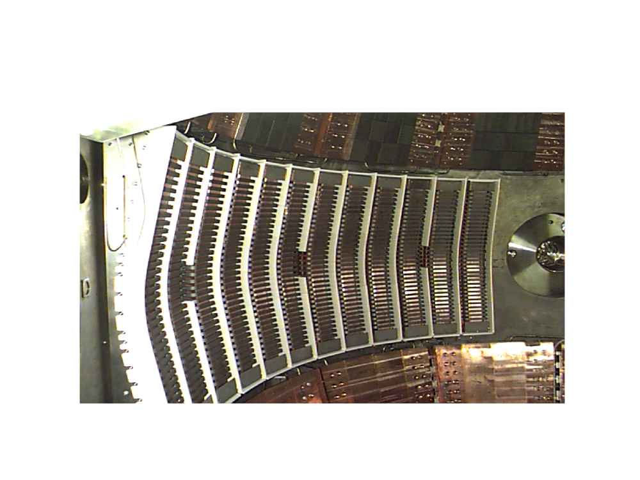

Figure 4.1.4: NSTX HHFW antenna
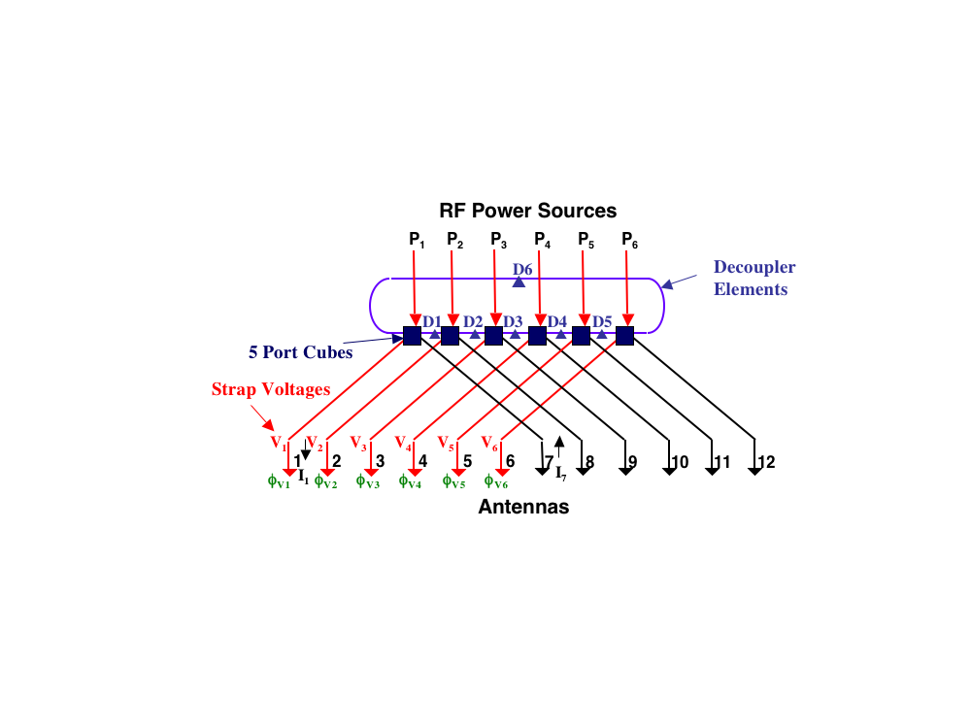
Figure 4.1.5: HHFW Antenna feed system
2008-09:
A major upgrade of the antenna will consist of providing two feedthroughs per antenna strap, as shown in Fig. 4.1.6. This should permit a ~ 3 × increase in power capability for the present antenna at the same RF voltage. It is also planned to reduce the number of antenna straps to 8 to make space for the ECH/EBW system. To compensate for fewer straps, the antenna upgrade design will also minimize RF electric fields to the extent possible for the same voltage to permit the voltage to be increased as well.
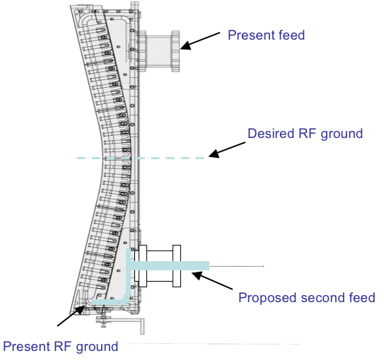
Figure 4.1.6: Planned HHFW antenna upgrade to two feedthroughs per strap

2010-11:
A HHFW system upgrade for resilience to ELMs during H-mode is planned.
- 3 db hybrids are proposed to improve operation in H-mode
- electronics will be provided to avoid feeding ELMs
2011-13:
Further improvements to voltage standoff (to minimize the RF-induced electric field) will be made.
Also, the antenna strap will be changed to have two discreet poloidal segments (ITER-like) to permit reversal of exciting RF current in the poloidal direction made if modeling shows that it could be important for minimizing effects of surface waves and reactive fields on damping.
- This change provides a poloidal spectrum with no m = 0 component which is peaked well away from m = 0
Diagnostics planned for HHFW Research:
In addition to the diagnostics needed to operate and protect the HHFW antenna array (such as acoustic arc detectors in the pressurized transmission lines), information on the rf interaction with both the edge and the core plasma is needed to improve the HHFW performance and reliability. To make progress in modeling development, the codes need both accurate input parameters for their analyses and detailed measurements for output validation.

A wide array of edge diagnostics is presently employed in the study of power coupling/propagation and more will be deployed in the future. A fast ion gauge located behind the array is used to monitor the local neutral pressure. It is observed that the pressure increases with both RF power and with decreasing wavelength; this high neutral pressure can lead to increased collisional damping and breakdown in the antenna. The heating of edge ions is measured with the Edge Rotation Diagnostic, which shows increased heating of edge ions as the wavelength is increased. Langmuir probes positioned between antenna boxes, in the shadow of the local limiter, have seen increases in the local plasma potential with decreasing wavelength. The characteristic spectrum of the parametric decay instability (PDI), postulated as the mechanism for edge ion heating, is observed with both a Langmuir probe and a microwave reflectometer. B-dot probes that measure the rf fields near the wall have seen increased signal strength when plasma conditions and antenna phasing are expected to support surface wave propagation. A visible light camera looking at the Faraday shield has been able to identify hot spot formation as a precursor to some antenna arcs.

Light pipes should be added to the antenna enclosures during the opportunity presented by the HHFW antenna upgrade, giving the ability to look at impurity spectra and to identify internal arc locations. Additional B-dot probes will be added to study and to minimize the power loss associated with surface waves. The RF wave monitoring electronics on the edge density reflectometer will be upgraded for improved operation over a 2-50 MHz range, permitting observation of both the PDI daughter wave spectra (low frequency quasimodes and higher frequency IBW modes). A dedicated IR camera could be used to study the antenna/plasma interaction on the FS.

HHFW power propagation and deposition in the core is inferred from traditional diagnostics such as Thomson scattering, soft x-ray arrays, and CHERS. Progress has been made in reducing the NBI perturbation on the plasma during rf operation, permitting MSE measurements to be made for HHFW current drive. More information is needed on the wave activity in the plasma core with regard to propagation and mode conversion. Direct observation of wave structure in the core, as could be provided by the installation of a phase contrast imaging (PCI) array, and/or the upgrade of the high-k scattering system for detecting at RF frequencies, and/or possibly by extension of the FIReTIP system, is needed to make detailed comparisons to code predictions.
4.1.4 Status of HHFW Research
HHFW Coupling Physics:
It has been demonstrated that keeping the edge density near the antenna low relative to the onset density for perpendicular propagation (∝ Β×k||²/ω) results in a substantial increase in coupling efficiency for current drive phasing k|| ≈ -7m⁻¹ (-90º) [4.1.3, 4.1.4]. This is demonstrated in Fig. 4.1.7 where it is shown that the efficiency at -7m⁻¹ is equal to that for k|| ≈ 14m⁻¹ (180º) for the last two RF power pulses, when the density is at or below the onset density 2 cm in front of the antenna. However, the efficiency for -7m⁻¹ during the first RF power pulse is half the 14m⁻¹ value where the density is ~ 3 × the onset value for
-7m⁻¹. The fact that the placement of the perpendicular propagation onset is an important condition for determining surface wave losses is further illustrated in Fig 4.1.8, where it is shown that at even longer wavelengths (lower k|| or phase) the stored energy falls off with phase. Note that the onset density is proportional to k||² and is pushed against the antenna/wall at the lower phases. Also, whereas the wavelength plays a dominant role in RF surface losses, the data of Fig. 4.1.8 suggests that the cancellation of reactive currents from near strap currents is not as important.
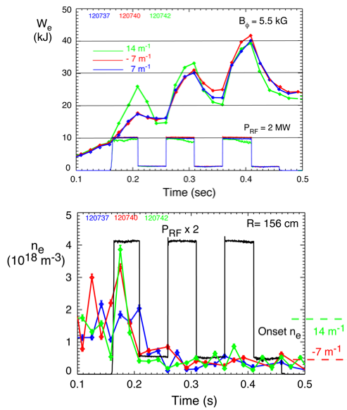

Figure 4.1.7: Role of perpendicular propagation onset close to the antenna/wall on edge power loss is demonstrated (vs edge n and k||)

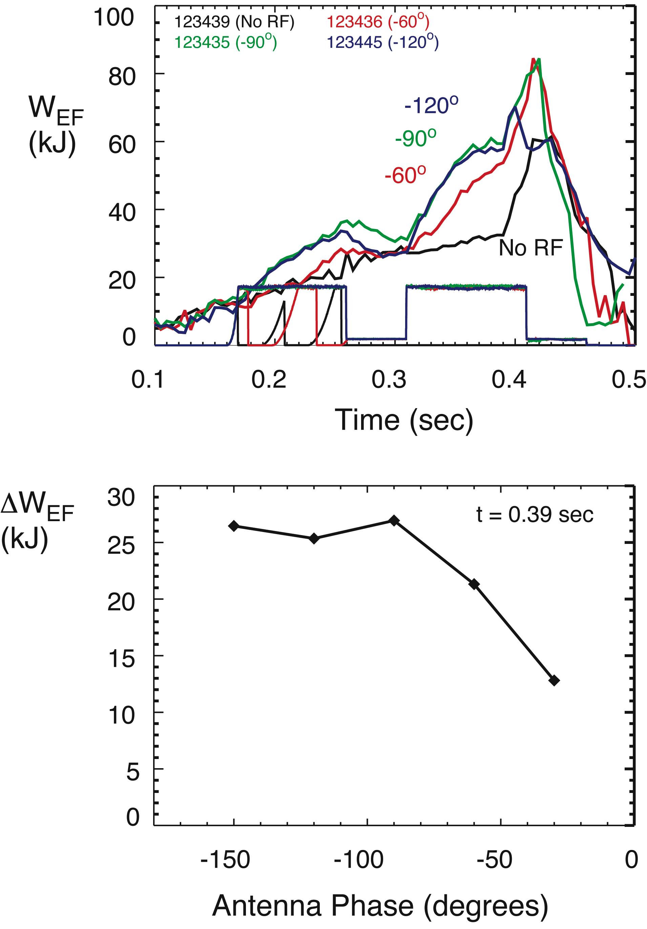

Figure 4.1.8: Heating at longer wavelength is observed with longer RF pulses but with less efficiency than for - 90º (-7 m⁻¹) phasing

Finally, to further demonstrate the surface losses associated with having the onset density above the edge density at the antenna/wall, the core heating has been measured for a relatively long RF pulse during which the phase was changed from -90º to -30º. The results are compared to cases without the phase change and to the no RF case in Fig. 4.1.9. Again, this data shows that the wavelength plays a dominant role in RF surface losses and that these losses do not appear to be dependant on core damping (the increase in central temperature during the -90º period did not result in better heating during the -30º period).
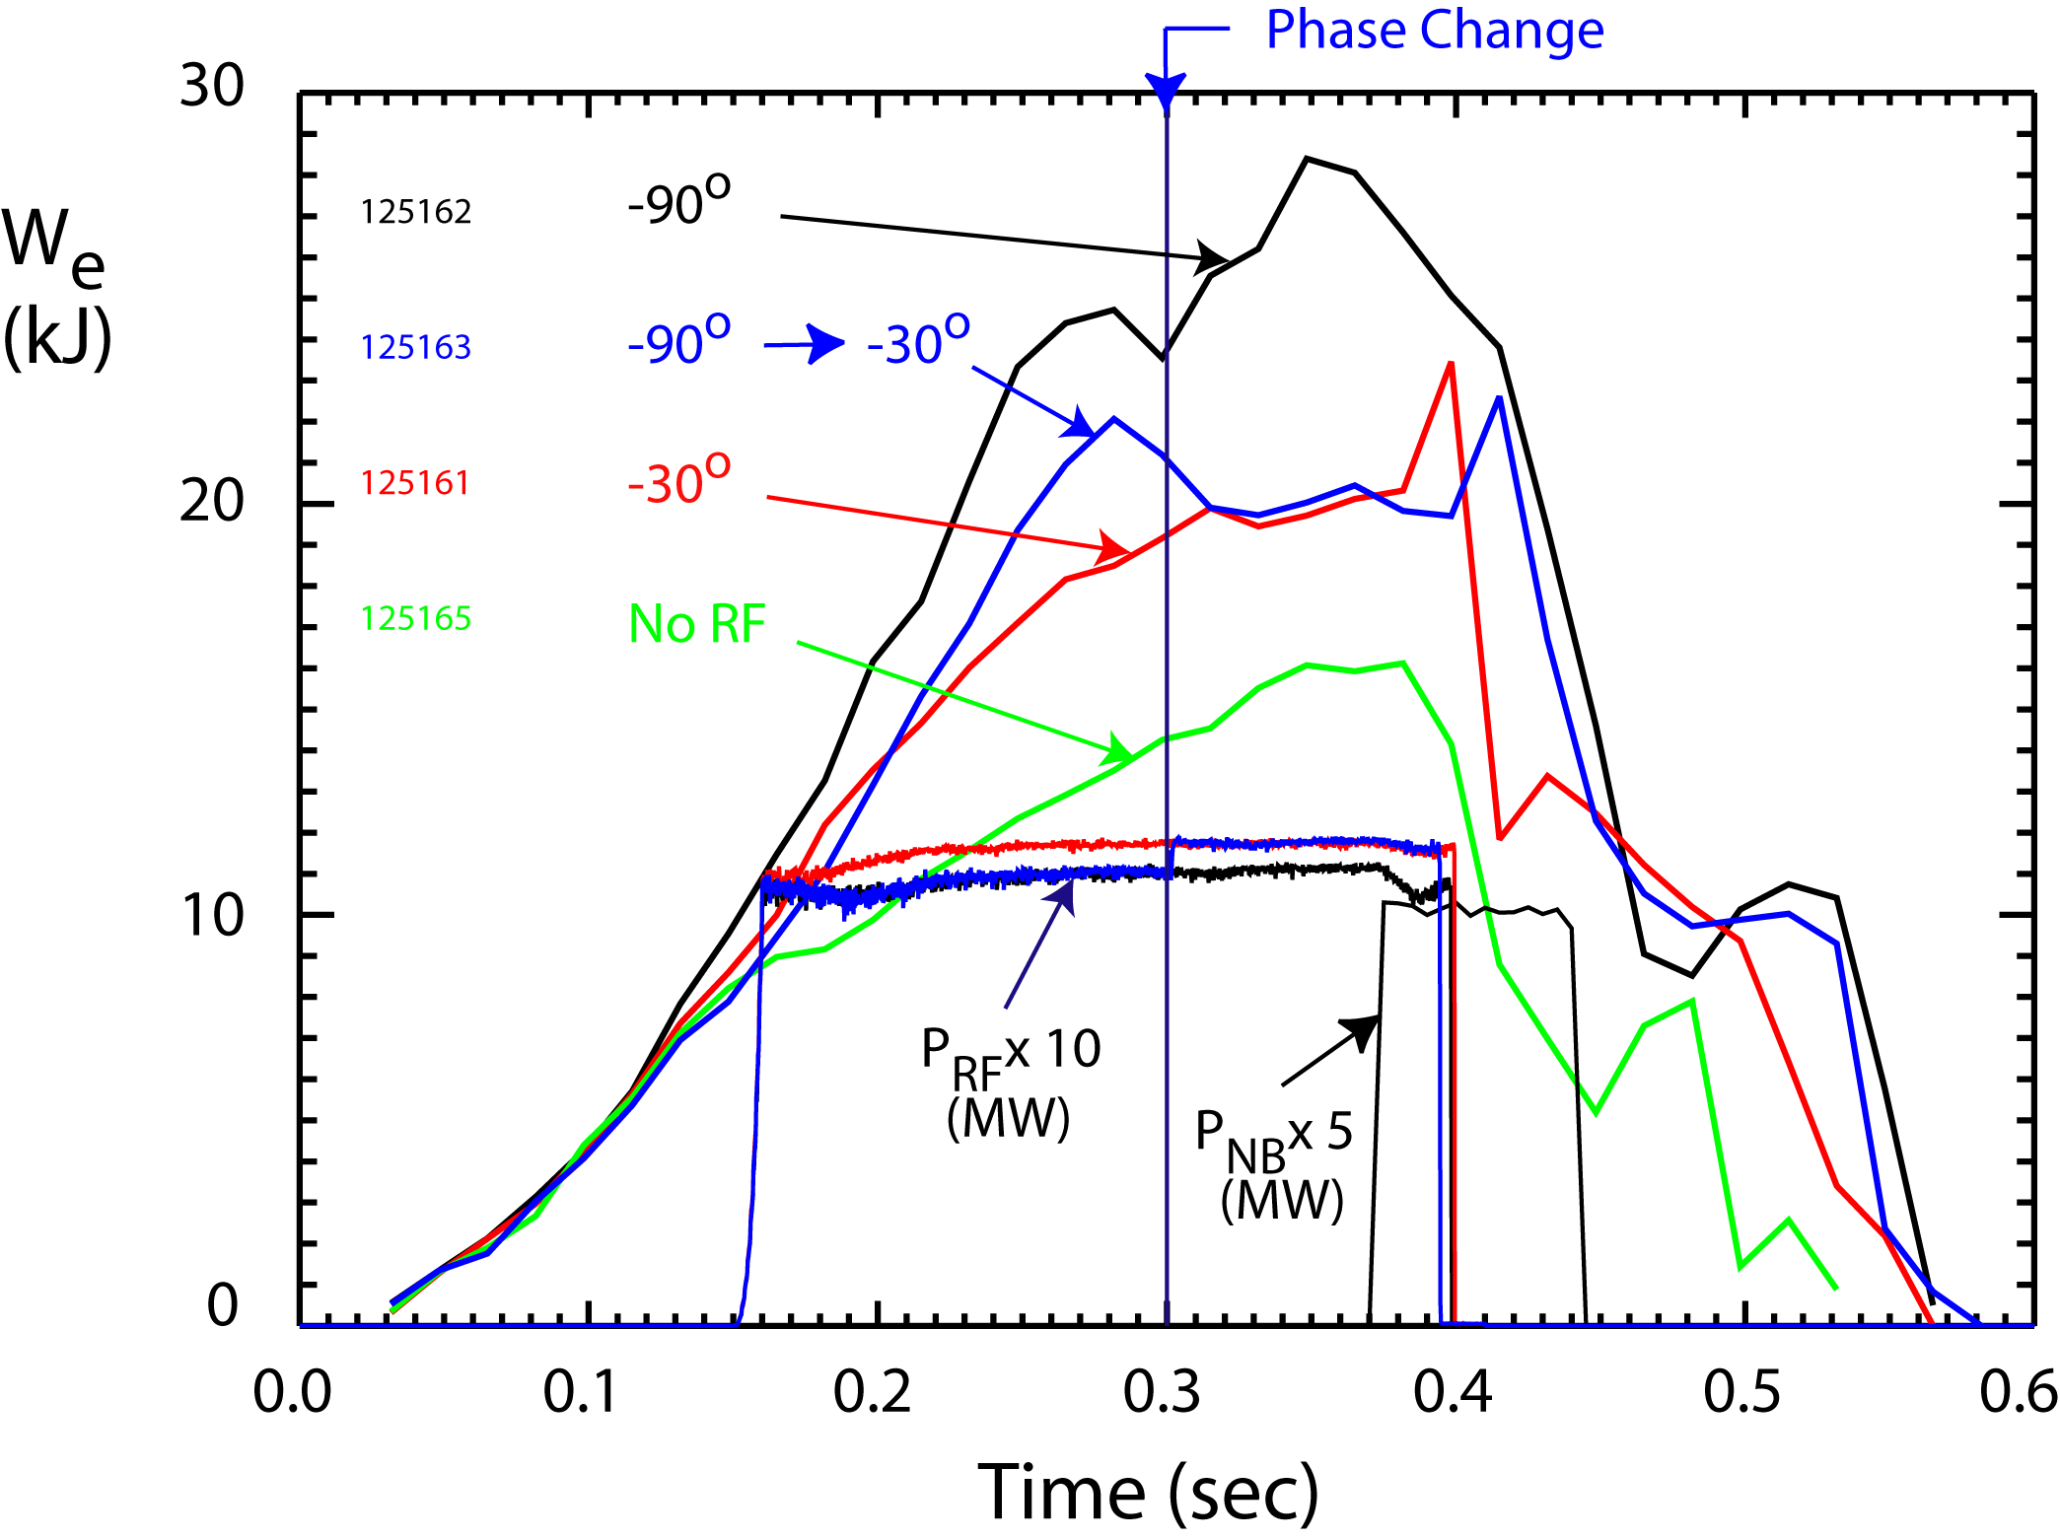
Figure 4.1.9: HHFW Heating at - 30º is ~ 1/2 that at - 90º

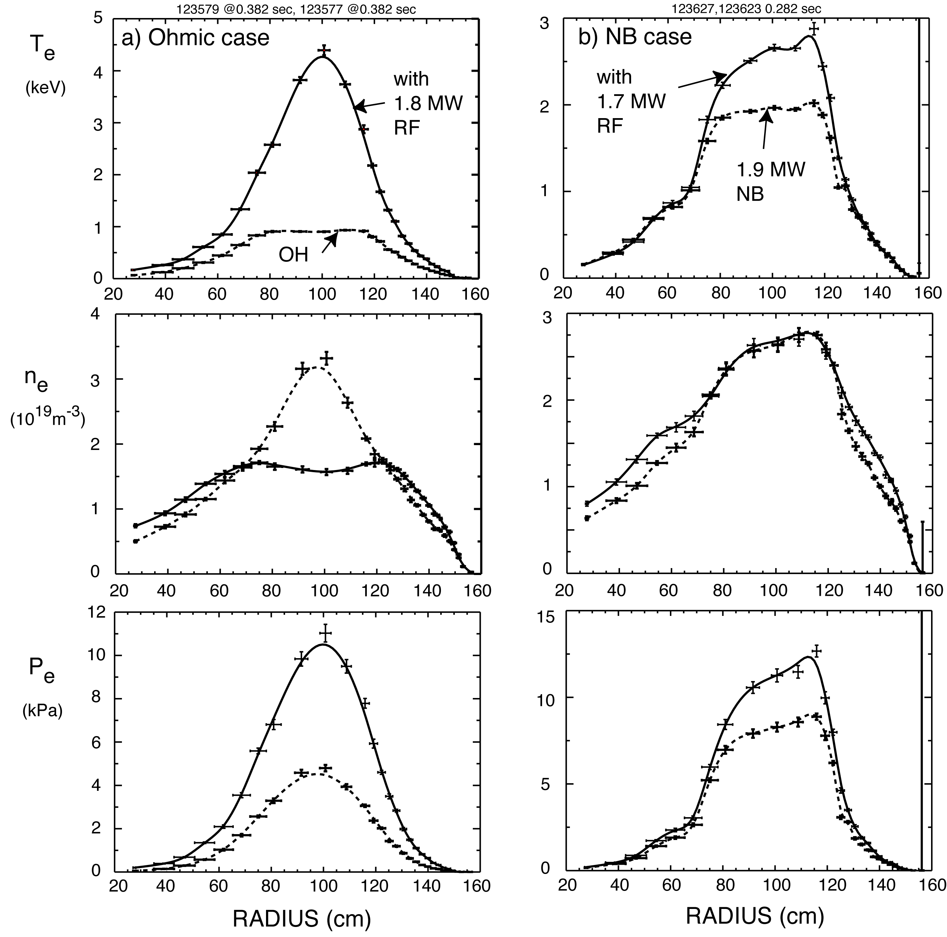
Figure. 4.1.10: a) High Te with HHFW and no NBI, compared to no HHFW case (I_{P} = 600 kA, B_{T} = 5.5 kG). b) Significant HHFW heating in core with NBI, compared to no HHFW case (I_{P} = 1 MA, B_{T} = 5.5 kG)

Initial HHFW Current Drive Studies:
The improved coupling efficiency for current drive phasing (90º) that has been obtained by lowering the edge density now allows current drive measurements to be pursued. Significant HHFW electron heating has been obtained with current drive phasing for L-mode helium discharges with HHFW alone (Fig 4.1.10.a) and in conjunction with neutral beam heating (Fig 4.1.10.b). A 90 keV beam pulse was applied to the case with HHFW only to permit MSE measurements. The MSE measurements obtained for the -90º, -60º and no RF cases of Fig 4.1.8 are compared in Fig 4.1.11. It is evident that current drive effects are present for the -90º current drive case. However, it is not easy to quantify the HHFW current drive effect since it is predicted to be relatively small, the electron heating is large, the total current is held constant, and the redistribution of current caused by the HHFW and that caused by the heating are difficult to separate. MSE analysis is ongoing and theoretical analysis is underway for comparison to permit an estimate of the current drive to be made. For this effort, matched pairs of shots taken with different phases, but having similar electron temperature profiles, have been selected for several cases to permit the current drive effects to be separated from the heating effects.
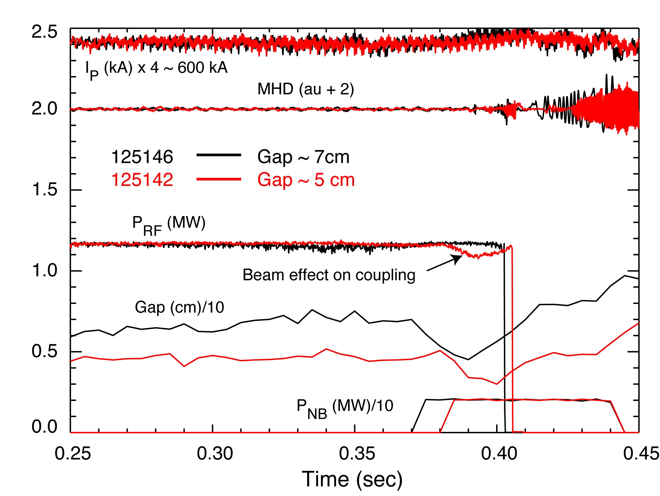
Figure 4.1.12: NBI affects HHFW coupling with smaller gap.
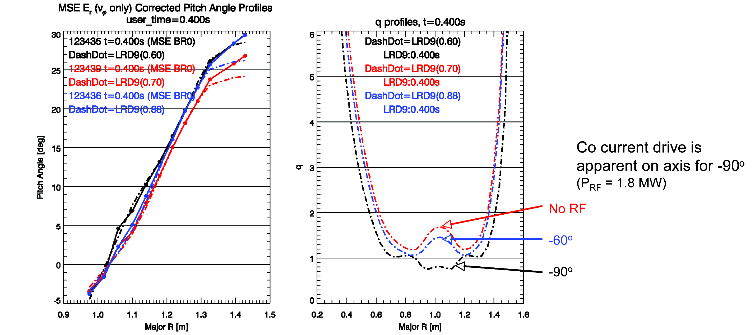
Figure. 4.1.11: MSE CD studies have begun - core HHFW CD effects are evident for -90º phasing
4.1.5 HHFW Research Plan for 2009-2013
The HHFW research in 2008 will be directed toward extending the coupling and current drive studies to deuterium H-mode conditions. For the five-year plan the HHFW research plan includes:
2009-10:
- Optimize heating and current drive operation with NB for L-mode and H-mode with the upgraded antenna and using guidance of modeling.
- Use larger plasma-antenna gap permitting greater stability and at higher power (more voltage standoff and greater power for same voltage). The importance of using a larger gap is illustrated in Fig 4.1.12. For a change of only 2 cm in the gap distance, the RF power coupled at the antenna is no longer affected by the “diagnostic” neutral beam at the end of the RF pulse. Also, faster feedback control of the plasma position would help to reduce the beam interaction with the antenna. An even larger gap will probably be required for operation with all three high-power neutral beam sources in the H-mode regime.
- Begin startup/ramp-up optimization in conjunction with CHI, ohmic, and ECH/EBW systems
2011:
- Begin operations with ELM dump - further optimize H-mode heating and CD operation
2012-13:
- Improve antenna based on previous results and continue startup/rampup and H-mode optimization
4.2 Electron Bernstein Wave Physics
4.2.1 EBW Research Goals
Off-axis radiofrequency-driven current is expected to be critical for stabilizing solenoid-free ST plasmas when β > 20% [4.2.1]. For example, modeling predicts that adding 1 MA of off-axis EBW current drive (EBWCD) to the ST-CTF [4.2.2] would significantly improve the performance of the plasma (Fig. 4.2.1). The long-term research goal for the EBW research program on NSTX is to assess the viability of EBWCD as a tool for generating this critical stabilizing current. There are several intermediate research goals for the 2009-2013 research program that support solenoid-free ST research, these are:
1. Develop ECH-assisted plasma startup in order to increase T_{e} sufficiently for effective HHFW
coupling (2009).
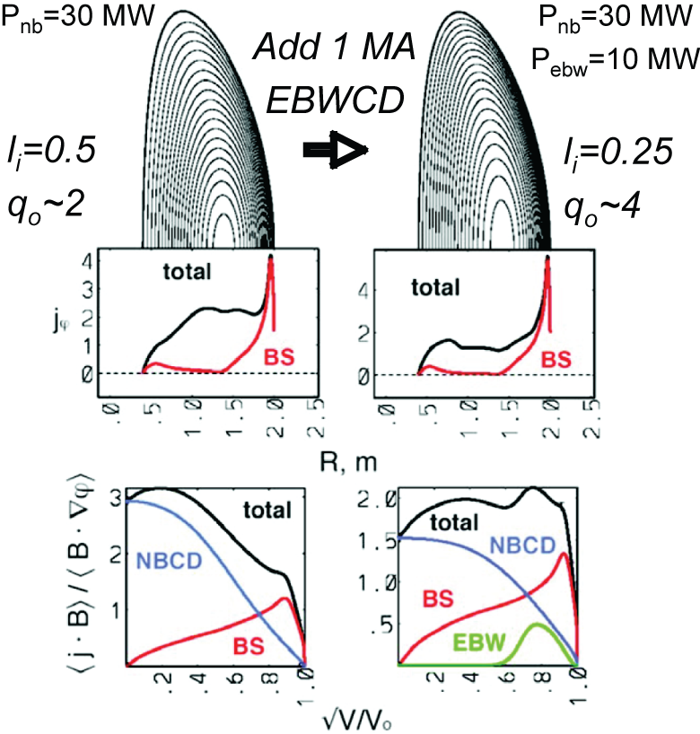
Figure 4.2.1: Adding 1 MA of off-axis EBWCD to CTF plasma generating wall loading of 1 MW/m² can decrease l_{i} from 0.5 to 0.25 & increase q_{o} from ~ 2 to ~ 4

2. Evaluate EBWH-assisted overdense plasma I_{p} ramp-up (2010-11).
3. Study EBW coupling with 250 kW of 28 GHz power (2010-11).
4. Assess the effect of ponderomotive force, heating & parametric decay on EBW coupling efficiency
(2010-13).
5. Test EBW heating with 500 kW of EBW power and benchmark EBW code predictions for heating
efficiency and localization (2011-12).
6. Test off-axis EBWH and core EBWCD with 750 kW of EBW power and benchmark predictions from
EBW codes for core current drive (2012-13).
4.2.2 EBW Physics
When ω_{pe} > 1.6 ω_{ce} , where ω_{pe} is the electron plasma frequency and ω_{ce} is the electron cyclotron frequency, the electrostatic EBW [4.2.3] can propagate across the magnetic field. This regime is normally referred to as the overdense regime, and is a regime that is not accessible to conventional ECRH or ECCD. Except during plasma startup and the initial stages of plasma current ramp-up, NSTX discharges operate well inside this overdense regime. EBWs are strongly absorbed at electron cyclotron resonances and have the potential to provide local electron heating (EBWH) and EBWCD. However, EBWs can only propagate inside the upper hybrid resonance (UHR) that surrounds overdense plasma, so EBWH and EBWCD systems that have microwave launchers external to the plasma, must employ a mode conversion process in the vicinity of the UHR to couple the microwave power to the EBWs. Electromagnetic radiation can couple to EBWs either by tunneling from the extraordinary mode to the EBW (X-B conversion) [4.2.4] or by mode conversion from the ordinary mode, via the slow extraordinary mode, to the EBW (O-X-B conversion) [4.2.5]. For X-B conversion X-mode polarized microwave power is launched normal to the magnetic field (Fig. 4.2.2(a)). The left hand cutoff of the slow X-mode (SX), the UHR, and the right hand cutoff of the fast X-mode (FX) form a cutoff-resonance-cutoff triplet allowing the fast X-mode electromagnetic wave to tunnel through the UHR to the slow X-mode [4.2.4]. For O-X-B conversion (Fig. 4.2.2(b)) elliptically polarized microwave power is launched at an oblique angle to the magnetic field that is chosen to make the X-mode and O-mode cutoffs coincident [4.2.6, 4.2.7]. An O-X-B antenna will be used for the EBW coupling and heating experiments planned for NSTX.
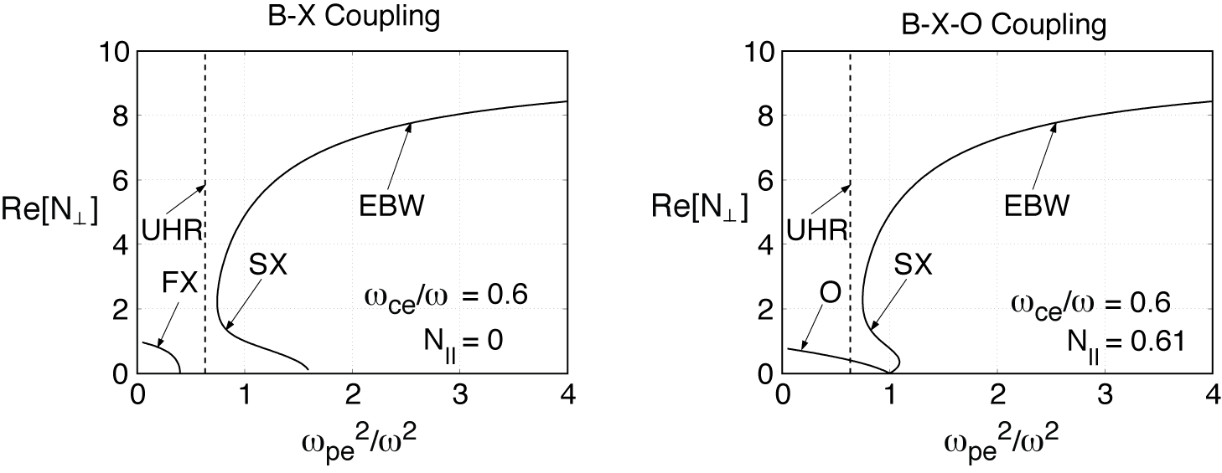
Figure 4.2.2: EBW and electron cyclotron wave roots of the real part of N⊥ as a function ω_{pe}²/ω² for two EBW coupling schemes have been studied on NSTX and other machines: (a) perpendicular (N// = 0) X-B coupling where the fast X-mode (FX) tunnels to the slow X-mode (SX) and (b) oblique O-X-B coupling, where N// = N_{//,opt} = 0.61.

EBWs can exhibit large changes in refractive index after being launched. The change in the parallel refractive index, N//, is given by:
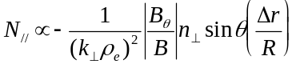 ,
where 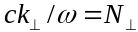, c is the speed of light, ω is the wave angular frequency, ρ_{e} is the electron Larmor radius, B_{θ} is the poloidal component of the magnetic field, |B| is the magnitude of the total magnetic field, θ is the poloidal angle measured from the outboard side of the plasma midplane, Δr is the radial distance of propagation of the ray, and R is the major radius. For θ ∼ 0 the shift in N// is minimal. However, for EBWs launched above or below the plasma midplane the change in N// can be large, since in the outboard edge region of the ST plasma the poloidal and toroidal magnetic field strengths are comparable. EBWs heat electrons and drive current at the Døppler shifted cyclotron resonance, given by:
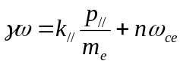 ,
where γ is the Lorentz relativistic factor, p// is the parallel momentum, m_{e} is the electron rest mass, and n is the harmonic number of the electron cyclotron resonance. So the location where electron heating and current drive occurs depends sensitively on 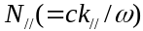, and therefore on where the EBW coupling occurs relative to the plasma midplane. Also, the direction of the driven current depends on whether the EBWs are launched above or below the midplane [4.2.8]. Current drive occurs via two mechanisms; Fisch-Boozer current drive [4.2.9], where EBWs predominantly heat electrons with one sign of v||, creating an asymmetric resistivity, and Ohkawa current drive [4.2.10], where EBWs increase the v⊥ of passing electrons in one direction so that they become trapped, resulting in a net current being driven in the opposite direction. Normally in an ST both these current drive mechanisms are present, driving current in opposite directions. Fisch-Boozer current drive dominates near the magnetic axis and Ohkawa current drive dominates off-axis on the low field side, where there is a large trapped electron population in an ST.
4.2.3 EBW Heating System
A 28 GHz ECH/EBWH system will be installed on NSTX for the 2009 NSTX experimental campaign (Fig. 4.2.3). This system will use a gyrotron with an output power of up to 350 kW for ~ 500 ms. For the 2009 campaign, the system will use a fixed horn antenna on the plasma midplane to launch X-mode microwave power to support ECH-assisted plasma startup experiments.
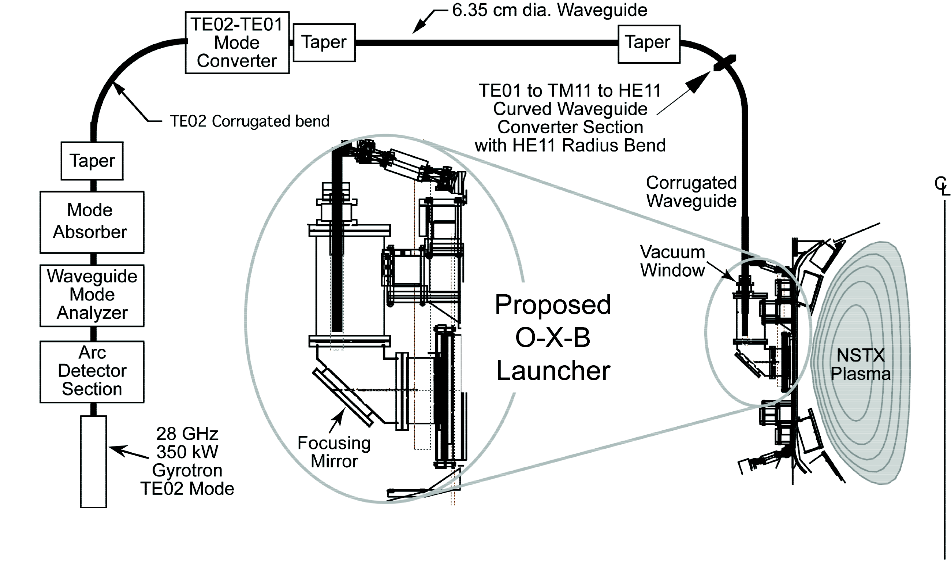
Figure 4.2.3: 350 kW, 28 GHz, 500 ms, heating system being installed on NSTX for initial operation as an ECH system in FY2009, and upgraded to an EBWH system in 2010
The gyrotron for the ECH/EBWH system will be located in the NSTX test cell, providing a relatively short, straight run of 6.35 cm diameter circular waveguide to transport RF power to the antenna. Allowing for transmission losses between the gyrotron and the antenna, the 28 GHz system should provide about 250 kW of on-axis second harmonic ECH in NSTX at B_{t}(0) = 0.5 T. Tests are currently being conducted on a lower power 28 GHz gyrotron, that like the 350 kW gyrotron normally operates in TE02 mode, to assess the possibility of operating the gyrotron in TE01 mode at 15.3 GHz. If these tests are successful, this frequency would provide fundamental ECH/EBWH near the magnetic axis at B_{t}(0) = 0.5 T.
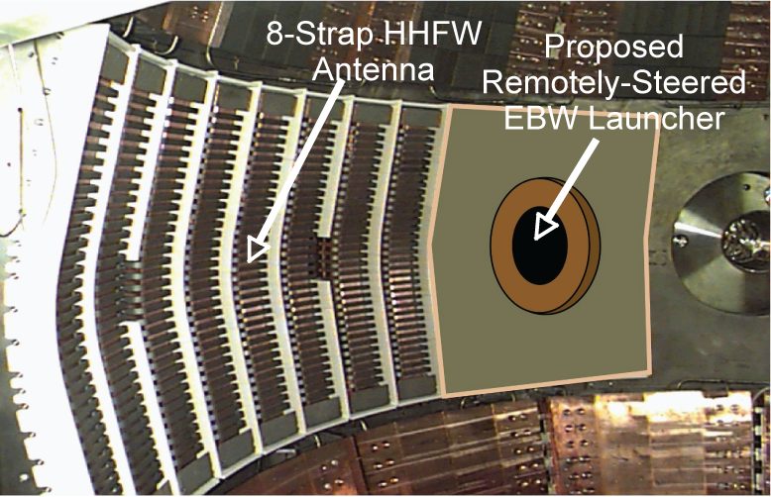

Figure 4.2.4: NSTX double feed HHFW antenna showing proposed EBW launcher (circa 2010)

In 2009 the HHFW antenna, which currently has 12 antenna straps, with a single antenna feed per strap, will be reconfigured to 8 antenna straps, with two feeds per strap (see Section 4.1.3). Following reconfiguration of the HHFW antenna, an O-X-B EBW antenna will be installed in the location previously occupied by the four removed HHFW antenna straps (Fig. 4.2.4). For EBW coupling and heating experiments in 2010 and 2011 this EBW antenna will use a locally steered mirror launcher. The 28 GHz ECH/EBWH system installed in 2009 will have sufficient power supply capability to support up to four gyrotrons. Installation of a second 350 kW, 28 GHz gyrotron is proposed for 2010-11 run campaign. With the addition of this second gyrotron, and assuming transmission and mode conversion losses are about 30%, the 28 GHz ECH/EBWH system will provide up to 500 kW of EBW power for heating experiments. If the initial EBW heating experiments are successful, it is proposed to upgrade the EBW antenna so that the mirror launcher can be remotely steered in 2011-12, providing greater shot-to-shot flexibility to heat a wider range of plasma scenarios. If initial EBW heating experiments are successful, a third 350 kW, 28 GHz gyrotron is proposed for the 2012 run campaign, allowing the 28 GHz ECH/EBWH system to provide up to 750 kW of EBW power for off-axis heating and on-axis EBWCD experiments.
Diagnostics planned for EBW Research:
EBW coupling physics studies will require local measurements of the edge density profile evolution near the EBW launcher. An edge density reflectometer, capable of measuring density fluctuation frequencies up to 100 kHz at densities around the EBW mode conversion density, will be installed close to the EBW launcher port. Also, a lower hybrid probe, capable of measuring both electrostatic and electromagnetic fluctuations, will be installed near the EBW launcher to detect daughter waves from EBW-driven parametric decay. EBW coupling physics studies would also benefit from the additional multi-point Thomson scattering system channels in the plasma scrap off and near the EBW mode conversion layer.
4.2.4 Status of EBW Research
This section summarizes significant advances in experimental EBW research on NSTX and other devices, and in theoretical EBW modeling since the 2004-8 NSTX 5-year research plan was published in 2003.
High levels of EBW coupling efficiency have been measured via thermal EBW emission from the magnetic axis of NSTX and Fokker-Planck modeling of NSTX discharges has predicted that efficient off-axis Ohkawa current drive is achievable in β>20% plasmas. There have also been recent encouraging experimental results on MAST and TCV that show clear indications of O-X-B EBW heating, and recently efficient EBW heating of PF-only startup discharges in MAST has been measured at 28 GHz.
Status of NSTX Experimental EBW Research:
Except for power dependent effects like parametric decay, the O-X-B mode conversion process involved in coupling microwaves to EBWs for EBWH and EBWCD is the reciprocal of the B-X-O mode conversion mechanism involved in coupling thermal EBW emission out of the plasma. So it is possible to study EBW coupling efficiency by measuring thermal EBW emission [4.2.11]. Initial B-X-O coupling studies on NSTX were performed in 2004 with a dual-channel, 8-18 GHz radiometer connected to a fixed, obliquely-viewing, quad-ridged antenna with its ridges aligned to simultaneously measure the radiation temperature of EBE polarized parallel (T//) and perpendicular (T⊥) to the magnetic field at the UHR [4.2.12]. An example of data from this antenna is shown in Fig. 4.2.5, which shows the evolution of the EBW radiation temperature, T_{rad} = (T//+T⊥), for a L-mode plasma with B_{T}(0) = 4 kG and a flattop current. I_{p} = 800 kA between 0.27 and 0.46 s. The EBW coupling efficiency, T_{rad}/T_{e}, where T_{e} is the electron temperature of the EBW emitting layer, was measured to be 80 ± 20% at 16.5 GHz, in good agreement with the ~ 65% EBW coupling efficiency predicted by a model that includes a 1-D full wave calculation of the EBW mode conversion at the UHR, radiometer antenna pattern modeling and 3-D EBW ray tracing and deposition modeling [4.2.13]. Emission at 16.5 GHz was from the fundamental electron cyclotron resonance at the plasma magnetic axis during the I_{p} flattop. The measured EBE polarization ratio, T///T⊥, was also measured to be in reasonable good agreement with theoretical modeling.
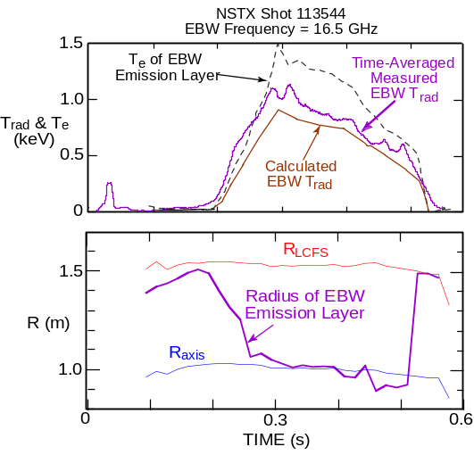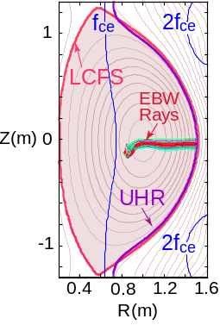

Figure 4.2.5: 80% f_{ce} B-X-O coupling measured in NSTX L-mode edge plasmas, consistent with modeling

In 2005 a pair of remotely steered B-X-O antennas were installed on NSTX [4.2.14], allowing the B-X-O emission process to be studied in more detail. Results showed that the EBW coupling efficiency peaks at a poloidal and toroidal angle that is close to the direction predicted by theory [4.2.15]. Recent studies of B-X-O emission from H-mode plasmas in NSTX show a wide range of behavior; sometimes the coupling efficiency remains relatively high (~ 50%) throughout the H-mode phase, sometimes it gradually decays, and sometimes the coupling efficiency collapses soon after the L to H transition. Measurements and modeling of EBW emission on NSTX are supportive of collsional damping of the EBW, prior to mode conversion, as being a possible major cause for the degradation of EBW emission in H-modes. Collisional damping is expected to become important when T_{e} near the EBW mode conversion layer is < 15 eV. In NSTX H-mode plasmas, measured T_{e} in the B-X-O mode conversion region, particularly for f_{ce} emission, can be as low as 10 eV. There is also evidence from recent experiments on NSTX that Li conditioning can significantly enhance B-X-O emission from H-modes, either by changing the density scale length or increasing T_{e} in the conversion region. It is possible that EBW collisional damping may not be a problem for EBW heating of H-modes if the incident microwave power can heat the EBW mode conversion region sufficiently to avoid EBW collisional loss.
Status of Experimental EBW Research on Other Devices:

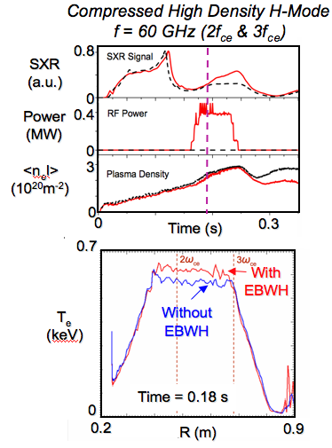
Figure 4.2.6: 60 GHz EBW heating via O-X-B
coupling demonstrated on MAST
Following the first demonstration of O-X-B EBWH in the W7-AS stellarator in 1997 [4.2.16] there have been several O-X-B heating experiments on other devices that show encouraging results. 60 GHz B-X-O EBW heating experiments conducted on the MAST ST used three plasma scenarios [4.2.17].
MAST was the first ST device to use O-X-B heating. The O-X-B coupling efficiency was at least 50% in high-density ELM-free H-mode discharges. In sawtoothing H-mode plasmas, a 10% increase of stored energy was measured during EBWH, and a 10% increase in T_{e} was measured in small ohmic H-mode plasmas [Fig 4.2.6]. Future plans on MAST call for the installation of a 1 MW 18 GHz O-X-B EBWH system. Recently, there have also been plasma startup experiments on MAST that employ a 28 GHz heating system. 90 kW of RF power generated 32 kA of plasma current, without using the central solenoid, in good agreement with modeling [4.2.18]. The resulting plasma had a T_{e} ~ 500 eV and n_{e} ~ 10¹⁸ m⁻³. This result suggests the NSTX 350 kW, 28 GHz ECH system, that will be operational in 2009, should be able to heat the plasma sufficiently to allow effective HHFW heating.

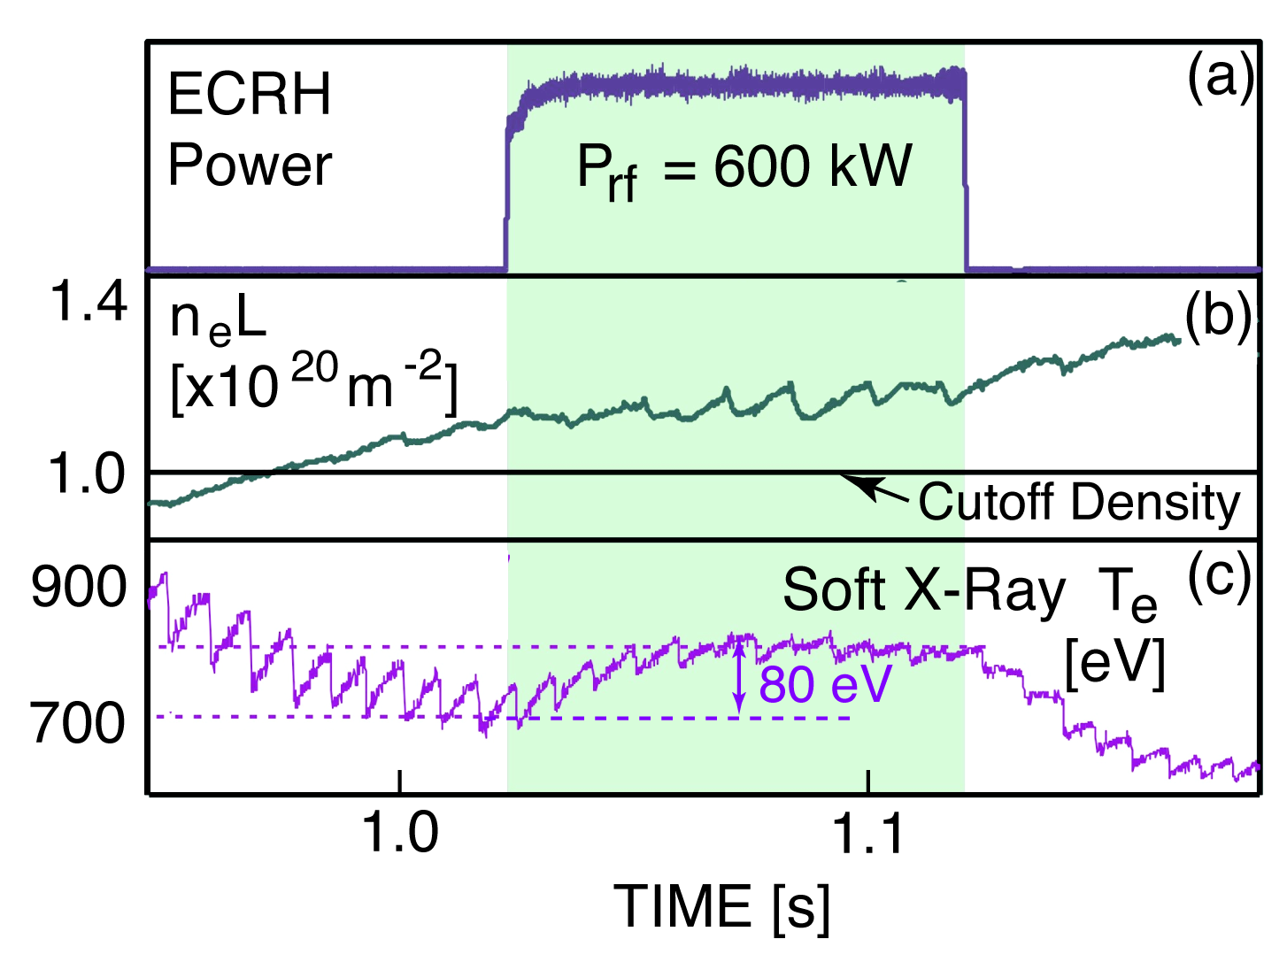
Figure 4.2.7: EBW heating via O-X-B coupling demonstrated on TCV. (a) 600 kW of 82.7 GHz power was coupled into (b) an overdense TCV plasma via O-X-B coupling.(c) At 60% of the RF power was absorbed by the plasma at r/a ~ 0.65, increasing T_{e}, as measured by soft X-rays, by 80 eV.

The first demonstration of EBWH via O-X-B mode conversion in an overdense conventional aspect-ratio tokamak was achieved in the TCV device [4.2.19]. The central electron temperature evolution during 82.7 GHz EBWH was measured to increase by 80 eV when the RF power was increased from 1 to 2 MW [Fig. 4.2.7]. The optimum injection angle for O-X-B conversion was obtained experimentally by measuring the reflected microwave radiation during a two-dimensional angle scan. Ray tracing simulations yielded an optimum launch angle that was in good agreement with the measured angle. About 60% of the RF power was absorbed after conversion to EBWs.
Status of EBW Theory and Numerical Modeling:
The GENRAY numerical ray tracing code [4.2.8, 4.2.20] and the CQL3D Fokker-Planck code [4.2.21] have been used to model EBW propagation, heating and current drive in NSTX discharges with
β ≥ 20%. Efficient off-axis Ohkawa current drive at normalized minor radius, ρ ∼ 0.7, and on-axis Fisch-Boozer current drive is predicted [4.2.22] for a range of plasma and EBW launch scenarios. An example of 28 GHz EBW ray tracing results from the GENRAY code for a β = 20% NSTX plasma with a vacuum toroidal field, B_{t}(0) = 0.55 T is shown in Fig. 4.2.8. EBW power is near the magnetic axis. Figure 4.2.9 shows the EBW power deposition and EBW-driven current profile calculated by the CQL3D Fokker-Planck code. 85% of the EBW power is absorbed by at the Doppler-shifted 2f_{ce} resonance, near ρ = 0.2, the remainder is absorbed at the Doppler-shifted 3f_{ce} resonance, also near the axis. The total EBW-driven current, generated in this case via the Fisch-Boozer current drive mechanism is 29 kA, corresponding to a current drive efficiency of 39 kA/MW.
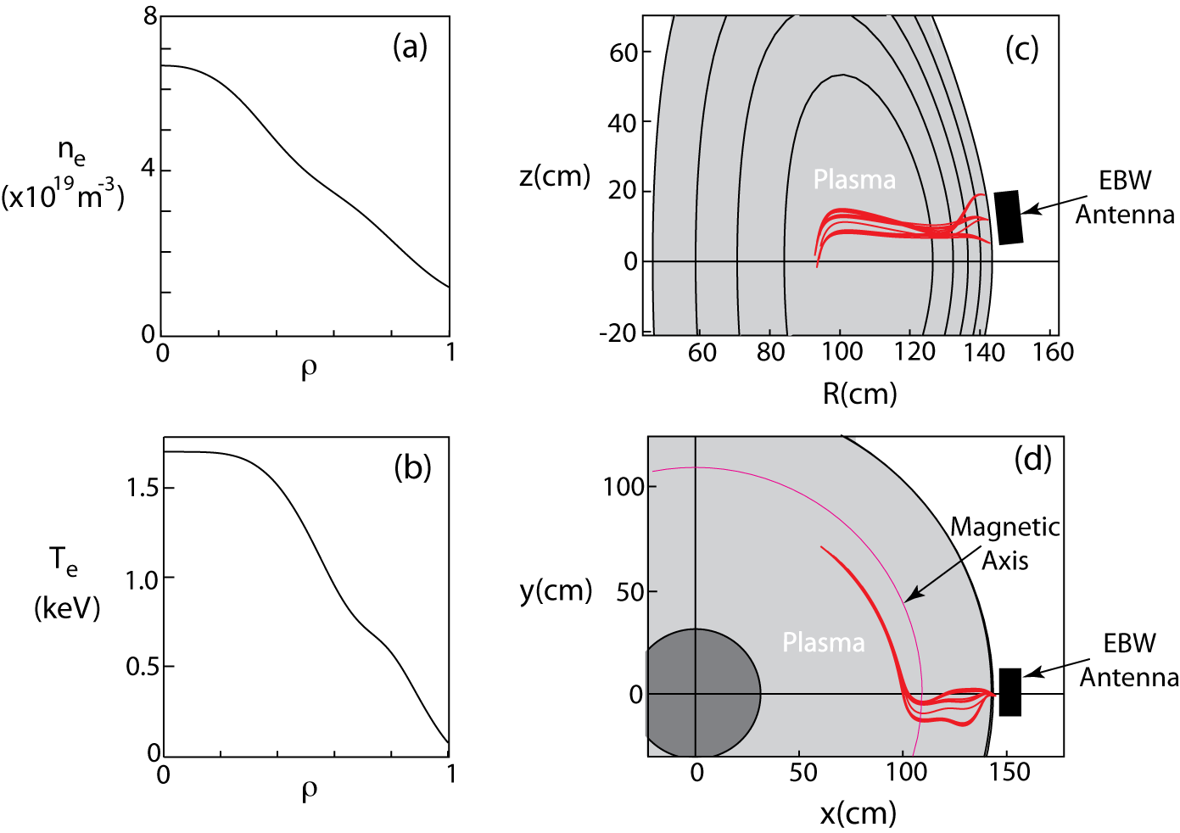
Figure 4.2.8: (a) n_{e} and (b) T_{e} profiles used to model 28 GHz EBW propagation and damping in a
β = 20%, B_{t}(0) = 0.55 T NSTX plasma. (c) Poloidal and (d) toroidal midplane projection of EBW rays calculated by GENRAY for a launched spectrum with N// = -0.55±0.05. 28 GHz EBW power is absorbed near the magnetic axis.

Synergy between EBWCD and the current driven by the electron bootstrap effect has been calculated to be relatively weak, typically <10%. However, the local bootstrap current density increases in proportion to increased plasma pressure, and this effect can significantly affect the radial profile of the RF-driven current density [4.2.23]. Benchmarking between GENRAY/CQL3D and the European code BANDIT-3D [4.2.24] for a NSTX EBWCD case shows good agreement for the magnitude, direction and location of the EBW-driven current. A recent review of the most important theoretical and numerical modeling results for EBWs in ST’s can be found in references 4.2.25 and 4.2.26.
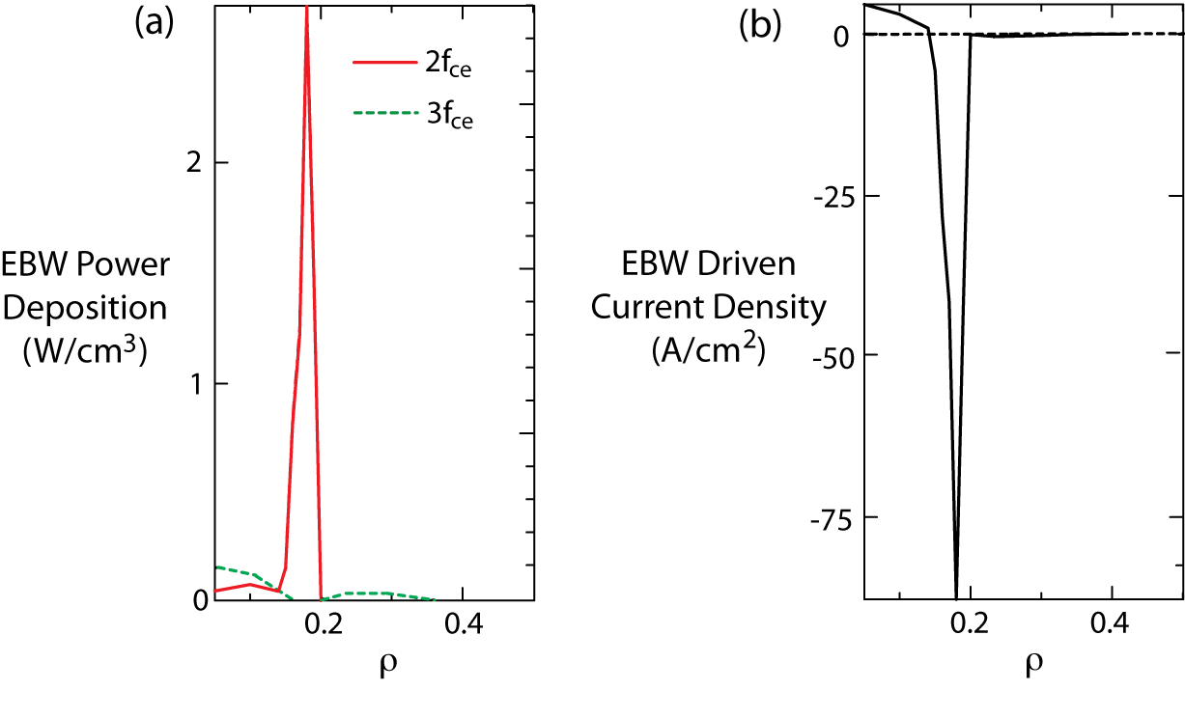
Figure 4.2.9 (a) EBW power deposition to electrons calculated by CQL3D for 750 kW of EBW power coupled into the plasma shown in Fig. 4.2.8. (b) EBW-driven current density calculated by CQL3D.

4.2.5 EBW Research Plan for 2009-2013
A 350 kW 28 GHz heating system will be used for ECH-assisted plasma startup experiments in 2009. Starting in 2010 EBW research on NSTX will be directed towards evaluating EBW heating in NSTX, initially with EBW coupling experiments at power levels up to a few hundred killowatts, and later with experiments to study localization and efficiency of second harmonic EBWH and EBWCD at EBW powers up to 750 kW. If gyrotron operation at reasonable power levels proves possible at 15.3 GHz, fundamental heating experiments will also be conducted.
2009:
A 350 kW, 500 ms, 28 GHz gyrotron will be installed in the NSTX test cell. This system will initially be used for second harmonic X-mode ECH to heat CHI and PF-only startup plasmas and increase the electron temperature sufficiently for effective HHFW coupling. A fixed horn antenna will be installed for the ECH-assisted plasma startup experiments in the locations previously occupied by four of the HHFW antenna straps. Experiments will explore the transition from ECH-assisted startup to HHFW-assisted plasma current ramp up. Recent modeling for a CHI target plasma, with T_{e} = 25 eV and n_{e} = 3.5x10¹⁸m⁻³, indicates about 25% first pass absorption near the magnetic axis for second harmonic, X-mode ECH launched into this plasma.
2010-11:
In 2010 a second 350 kW 28 GHz gyrotron will be installed in the NSTX test cell, bringing the total available 28 GHz power to 700 kW. Assuming coupling and transition losses of about 30%. This level of RF power will allow EBW coupling and heating experiments at EBW powers up to 500 kW. By 2010 the HHFW antenna will have been upgraded to have two antenna feeds per strap, significantly increasing the RF power coupled per strap and allowing more HHFW power to be coupled with eight straps with double feeds to each strap than was previously coupled with 12 straps with single feeds to each strap. This will also allow four HHFW antenna straps to be removed to provide space for an O-X-B mirror launcher. In 2010 the EBW launcher will have only limited local steering, however in 2011 it is proposed upgrade the launcher so it can be steered remotely.

EBW heating experiments in 2010 will study EBW coupling and core heating at EBW powers of about 250 kW. A microwave edge reflectometer will be installed in the vicinity of the EBW launcher to monitor the density profile near the EBW mode conversion layer. A reciprocating antenna probe will be installed inside NSTX to detect parametric decay to lower hybrid waves during the EBW coupling and heating experiments. High resolution edge T_{e} measurements will be made in the mode conversion region with the multi-point Thomson scattering. A fixed O-X-B horn launcher will also be installed for EBW-assisted startup and I_{p} ramp-up experiments in 2010-11.

500 kW EBW core and off-axis heating experiments in 2011 will be conducted with two gyrotrons. These experiments will study the localization and steering capability of the EBW heating system.
2012-13:
If the EBW heating experiments in 2010-11 are successful, a third 350 kW, 28 GHz gyrotron will be installed on NSTX in 2011-12. The additional gyrotron will increase the 28 GHz source power available to 1 MW, providing up to 750 kW of EBW power for experiments during the 2012 run campaign. Experiments in 2012 will study both EBWH and EBWCD.
4.3 Energetic Particle Physics
4.3.1 Energetic Particle Research Goals
An important goal of the present proof-of-principle spherical tokamaks (ST) is to evaluate the role of fast ion driven instabilities in fast ion transport and confinement. The results will be used to benchmark numerical codes such as NOVA/ORBIT and M3D which will be used to predict the effect of fast ion driven instabilities on fast ion transport. The codes may then be used with greater confidence to predict fast ion confinement in either an advanced ST such as NHTX/CTF/ARIES-ST or for tokamak reactors such as ITER and, ultimately, DEMO. Spherical tokamaks have relatively low toroidal field which means that the fast-ion Larmor radius is relatively large (ρ_{fi} ≈ 0.1 – 0.2 a_{p}) and the fast ion velocity is much greater than the Alfvén speed (V_{fi} ≥ 2 V_{Alfvén}), and overlaps the expected fast ion (fusion-alpha) parameters for either tokamak reactors (ITER) or advanced STs. This regime of large Larmor radius and low Alfvén speed is a regime in which fast ion driven instabilities are potentially virulent. Considerable progress was made during the last five year period of operation on NSTX in identifying the broad spectrum of observed fast ion driven modes, as well as the drive and damping mechanisms. Recently added diagnostics (MSE/fast NPA/ssNPA/multi-channel reflectometers) as well as diagnostics planned for the near future (FIDA, PCI, fast reflectometers), will allow for more detailed studies of the saturation amplitude, internal structure, and the effects on fast ion transport. The redistribution or loss of fast ions will impact the interpretation of thermal transport data, beam driven currents and momentum transport, as well as having a potentially direct impact on the design of plasma-facing components in a reactor (due to the potential for localized heating or ablation from lost fast ions).

The presence of weakly damped plasma modes below the cyclotron frequency, revealed through excitation by beam fast ions, has suggested a unique heating method for spherical tokamaks. A large amplitude wave at a fraction of the ion cyclotron frequency can stochastically heat thermal ions. The presence of weakly damped plasma modes in this frequency range suggests excitation of these modes, with a driven antenna, to the threshold amplitude necessary for stochastic heating. The fundamental principles of stochastic heating were developed in the late 1970’s and early 1980’s [4.3.1-4.3.5], and experiments validating the concept were done from the late 1980’s to mid 1990’s [4.3.6-4.3.10]. In the coming five years it is proposed to explore the possibility of using such a stochastic ion heating system on NSTX.

The key to developing the capability to predict the affect of fast-ion driven instabilities on transport of fast ions, are good experimental measurements to benchmark codes developed for this purpose. It is not only necessary to have good measurements of the equilibrium parameters, but the stability thresholds and saturation amplitudes of the fast ion modes must be measured. The impact of these modes on the fast ion distribution must be measured, as well. NSTX has accumulated a comprehensive suite of diagnostics for these studies. Redistribution of fast ions will soon be measured by the existing scanning Neutral Particle Analyzer (NPA), solid-state Neutral Particle Analyzer (ssNPA) and the Fast-Ion D-Alpha emission diagnostic, which is under development. Losses of fast ions are detected with the scintillator Fast Lost Ion Probe (sFLIP), an array of Faraday cups for detecting lost fast-ions (iFLIP), as well as the fast neutron rate diagnostics. The effect of loss or redistribution of fast ions on beam-driven currents, and interpretation of momentum and thermal transport can be documented with current profile evolution measurements based on Motional Stark Effect (MSE) diagnostic data, plasma rotation measurements with the toroidal and poloidal CHarge-Exchange-Recombination (CHERS) diagnostic and complete complement of kinetic profile diagnostics.

Excitation of Alfvén eigenmodes with a coil inside the vacuum vessel and a low power amplifier (≈ 5 kW) is a valuable tool for the study of mode stability. The spectrum of stable modes can be detected and the linear damping rate measured directly. This is very helpful information as stability codes must calculate both the sum of the damping and drive terms, the difference of which is the linear drive for the mode. Thus a direct measurement of the linear damping term also helps to constrain the resonant drive term.

Analysis of the data collected on fast ion instabilities will be supported through an active theoretical program. The NOVA code calculates the linear eigenmode structure, as well as most of the damping and drive terms. While NOVA is a linear code, the saturated amplitudes of the individual modes will be directly measured and can be used to normalize the eigenfunctions calculated with NOVA. The resulting spectrum of eigenmodes, together with the unperturbed fast ion distribution calculated with the TRANSP code, is used by the ORBIT code. The ORBIT code follows the trajectories of many fast ions, in the presence of modes, and can predict the resulting loss or redistribution of fast ions. A fully non-linear code, M3D, can be used to predict saturation amplitudes for comparison with the measured values. M3D is a “δf” code, where only the perturbed component of the fast ion distribution receives full kinetic treatment.

The final goal of this five year proposal will be to evaluate the feasibility of stochastic ion heating of thermal ions with a sub-cyclotron frequency RF system. Necessary input to evaluate the potential of this approach would be a measurement of the spectrum of stable and unstable eigenmodes which might potentially be excited by an antenna. The threshold for stochastic heating will be estimated using NOVA and ORBIT. The linear damping rate can be measured as discussed above. Most of the linear damping can be assumed to be on the electrons, thus with this information the heating power lost through the electron channel at the stochastic heating threshold can be estimated. It will be particularly valuable to measure the coupling efficiency of a prototype antenna to help in the design of a full power system.

4.3.2 Energetic Particle Physics
The transport of fast ions can be greatly enhanced in the presence of multiple modes. This can mean either multiple modes of a similar type, for example several Toroidal Alfvén Eigenmodes (TAE), or potentially modes as disparate from TAE as Compressional Alfvén Eigenmodes (CAE) or fishbones . As the diffusive “step size” from interaction with fast ion instabilities tends to be proportional to the ion gyro-radius, fast ion losses in large, high field devices such as ITER are expected to be through the interaction of multiple modes [4.3.11]. The study of such multimode interactions will be a high priority in the next five years on NSTX. Strongly enhanced transport has been seen when multiple TAE modes interact, a process known as TAE avalanches [4.3.12-4.3.16]. Three-wave coupling of TAE, fishbones (kinks) and higher frequency Alfvén eigenmodes has also been seen [4.3.17], with some data suggesting that these modes may also interact through perturbations of the fast ion distribution.

The impact of these studies on future devices such as NHTX or ITER will be primarily through the numerical simulation code improvements needed to accurately model the NSTX data. The capability to predict stability thresholds for fast-ion driven instabilities in future fusion reactors is an important component of the design and identification of attractive operational regimes. The M3D-K code is a non-linear, δf code which can model the saturation amplitude of modes, frequency chirping and some forms of multimode coupling. An important part of the five year plan will be to utilize this capability to model well documented examples of Alfvénic instability induced fast ion losses. The NOVA-K code calculates the linear mode eigenfunction, as well as drive an damping terms. The eigenfunctions calculated with NOVA can be normalized with experimental data and used in the particle tracking code, ORBIT, to calculate the affect on fast ion transport. These numerical simulations will then be compared to enhancements of fast ion transport as measured with FLIP, NPA and FIDA diagnostics.

The theory of stochastic heating of thermal ions by a large amplitude wave was first described by Smith and Kaufman [4.3.1]. The threshold amplitude for stochastic heating can be expressed in many ways, one of which is that the motion of thermal ions in the wave field becomes stochastic when the bounce-frequency of trapped ions is approximately the cyclotron frequency. The analytical work has been done largely for electrostatic modes, but numerical simulations have been used to predict the stochastic heating threshold for Compressional Alfvén Eigenmodes in an NSTX equilibrium [4.3.18, 4.3.19]. Experiments with large amplitude, current driven Drift-Alfvén mode have found direct evidence for stochastic thermal ion heating. A broad spectrum of weakly damped Alfvén Eigenmodes is seen between ω_{ci}/4 < ω < ω_{ci} which could be excited to the stochastic heating threshold.
4.3.3 CAE Heating System
Stochastic heating of magnetized ions or electrons with large amplitude waves at frequencies just below the cyclotron frequency was proposed in the mid ‘70’s to the early ‘80’s for a variety of modes [4.3.1-4.3.5]. This work was, perhaps, an outgrowth of earlier experiments and theoretical work on heating of plasmas with stochastic waves [4.3.20-4.3.24]. An extensive experimental study of stochastic ion heating by a large amplitude wave was done on the ENCORE tokamak by Paul Bellan’s group between 1986 and 1998. Stochastic heating of thermal ions was measured with a laser-induced fluorescence diagnostic. The wave was a large amplitude drift-Alfvén wave [4.3.25], probably driven by the plasma current. In a fairly extensive set of experiments, good agreement was found with the theory of stochastic heating.

The broad spectrum of CAE and GAE modes in the proper frequency range on NSTX offers an opportunity for stochastic heating. These natural modes are weakly damped, as evidenced by the ease with which they are excited by the neutral beam fast ion population. Based on measurements of the mode damping rate and wave amplitude, and assumptions about the wave localization, only a few 10’s of kWs of power would be required to excite waves to the amplitudes that are seen. Numerical simulations have estimated that wave amplitudes 5 to 10 times higher than the peak so far observed would be necessary for stochastic ion heating. This power heats the electrons, as the damping is primarily electron Landau or continuum damping. A low linear damping rate means that relatively little power would be lost to the electrons when the wave amplitude is excited to the stochastic threshold, and most of the heating power would be deposited in the thermal ion population.

The waves excited by the beams are measured to have about one-half wavelength over the length of an existing HHFW antenna strap, as measured with a poloidal array of four coils. This array will be expanded to provide a more accurate measure of the local poloidal wavelength. Coils also exist to measure the toroidal and poloidal components of the wave field, that is the pitch of the magnetic fluctuations. The antenna will most likely be oriented to couple to both shear and compressional waves.

The first goal is to measure the efficiency with which the existing HHFW antenna couples to the waves. The antenna feed needs to be disassembled, and a voltage divider used to match to a cable to a high-frequency digitizer. This measurement would verify that the antenna matches well enough to pick-up the waves. Following this, low power antenna loading experiments would be done. This would require temporarily modifying the HHFW antenna by taking one strap out of service during the period of the experiment. This might be done as part of the planned upgrade to the HHFW antenna, which includes removal of four of the existing straps. These coupling and loading experiments will be done to aid in the design of a dedicated Alfvén antenna. There were several experimental studies where antennas were used to launch Alfvén waves in the early 1980s [4.3.26-4.3.28].

The second phase of experiments will be low-power antenna loading tests with a 5-10 kW, 0.5 - 1.5 MHz source. A matching network to couple the source to the antenna strap would to be built and control and safety hardware would be devised. Adequate diagnostics to measure antenna loading would have to be installed. Some work might be done in trying to measure loading into generic beam heated plasmas, but the presence of modes excited by the beam ions might complicate this type of experiment. It would probably be best to do the antenna loading experiments into an ohmic or otherwise quiescent plasma. With 5 – 10 kW, it might also be possible to excite waves to the detection threshold of the microwave reflectometer systems on NSTX.

The experiments would be supplemented with numerical calculations, as is done for other forms of RF heating. An effort has begun to develop the full-wave TORIC code for simulations of wave excitation with the HHFW antenna at frequencies below or near the ion-cyclotron frequency. The TORIC full wave code can complement traditional stability codes, such as HYMN, M3D or NOVA-K. TORIC includes finite Larmor radius effects, finite ω/ω_{ci}, cyclotron resonances and a fast ion population. Further, TORIC can attain higher spatial resolution, although in a linear model. Initial simulations have found three waves near the cyclotron frequency, one of which may be a core-localized GAE.

Following design and installation of a dedicated Alfvén wave antenna, higher power experiments would begin. Several RF transmitters exist at PPPL that might be modified to provide 100 – 200 kW of power in the required frequency range. This would easily be enough power to excite waves detectable with the reflectometers, and good estimates of the power necessary to reach the stochastic heating threshold could be made.
4.3.4 Status of Energetic Particle Research
Fishbones and EPMs:
Bursting, chirping modes are seen in NSTX with frequencies starting at over 100 kHz and which can chirp down 10’s of kHz on a timescale of msec [4.3.29-4.3.37]. These modes can be present with q_{min} ≥ 1 and with, sometimes multiple, toroidal mode numbers 1 ≤ n ≤ 4. In plasmas where q_{min} ≈ 1, the modes typically have characteristics resembling the fishbone mode seen on conventional aspect ratio tokamaks. The modes are core-localized with a kink-like structure (no or small islands). Under conditions where q_{min} is believed to be well above unity, the modes often have toroidal mode numbers greater than one. The modes still appear to be core localized and kink-like in nature. Some of these modes have been identified as bounce-precession resonance fishbone modes. They are expected to be unstable in high current, low shear discharges where the conventional precession-resonance drive is weak (due to low precession drift frequency) [4.3.30]. These plasmas have a significant population of trapped particles with a large mean bounce angle, produced by near tangential beam injection into a small aspect ratio device.
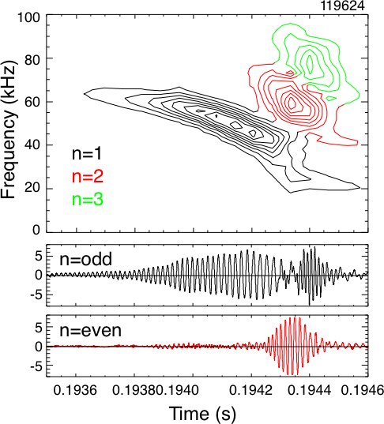
Figure 4.3.1: Fishbone mode showing multimode transport [4.3.37]

The strength of neutron drops (fast ion losses or transport) varies widely for these bursting, chirping modes. Those resembling the classical fishbone modes (n = 1, q_{min} ≈ 1) are most reliably correlated with neutron rate drops. However, many of the bursts involve multiple modes, and in some cases transient losses of fast ions (directly measured with the scintillator Fast Lost Ion Probe, sFLIP) are correlated with periods when multiple modes are present [4.3.37] (see Fig. 4.3.1).
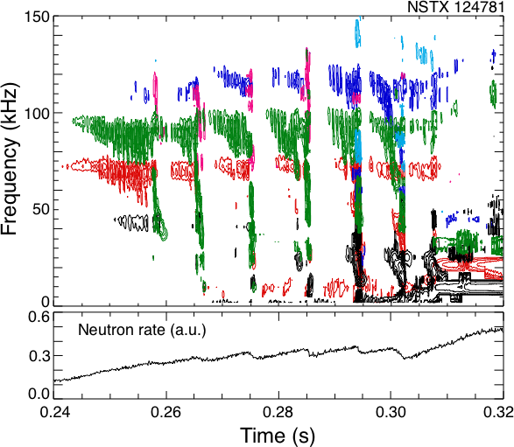
Figure 4.3.2: TAE avalanches and neutron drops indicating fast ion losses

Additional experimental studies of the mode structure, stability boundaries and resonant drive are necessary to develop the ability to predict their appearance and affect on fast ion confinement. At present, even though the mode eigenfunction is relatively well known, simulation of the fast ion losses has not been done.
Toroidal Alfvén Eigenmodes and Avalanches:
Multiple Toroidal Alfvén Eigenmodes (TAE) are commonly observed in beam heated NSTX discharges. However, evidence for significant fast ion transport or loss appears confined to instances of strong, multimode bursts (e.g., Fig. 4.3.2). Fast ion orbits are modified as they interact with the TAE, with those fast ions resonant with the wave becoming trapped in the wavefield, i.e., forming “phase-space islands”. As the mode amplitude increases, more fast ions will be trapped and the islands will become larger. It has been proposed that when the resonances from multiple modes are nearby in phase space, sufficiently large amplitude modes will cause the phase space islands to overlap. The orbits of the formerly trapped ions become stochastic and very rapid transport of fast ions may occur. Additionally, the ensuing modifications to the fast ion distribution function may result in otherwise stable modes being excited, ultimately leading to an “avalanche” effect which further enhances the transport of fast ions [4.3.12-4.3.16]. This mechanism of fast ion transport through an interaction of many modes could be important in ITER [4.3.11].

TAE avalanches, correlated with drops in the neutron rate suggesting fast ion losses, have been studied in NSTX. Recent experiments have documented the internal mode amplitudes, measured with the five-channel reflectometer system, together with MSE documentation of the current profile. It is hoped that these measurements will provide the basis for numerical modeling of the island overlap threshold and enhanced fast ion transport. These experiments were necessarily carried out in L-mode plasmas, necessary to get the reflectometer measurements of the internal structure. As with many of the studies of fast ion driven instabilities, it is important to extend these studies to the high performance, H-mode regimes, even at the expense of detailed measurements of the internal structure.
Beta-induced Alfvén Acoustic Eigenmodes:
New global MHD eigenmode solutions have been found numerically below the geodesic acoustic mode (GAM) frequency in gaps in the low frequency Alfvén -acoustic continuum [4.3.38, 4.3.39]. These new eigenmodes can explain observations of modes with frequencies well below the TAE frequency (Fig. 4.3.3). These global eigenmodes, referred to here as Beta-induced Alfvén-Acoustic Eigenmodes (BAAE), exist in the low magnetic safety factor region near the extrema of the Alfvén-acoustic continuum. In accordance with the linear dispersion relation, the BAAE frequency increases as the safety factor, q, decreases. We show that BAAEs can be responsible for the observations of low frequency modes in relatively high beta > 20% NSTX plasmas. In contrast to the mostly electrostatic character of GAMs, the new global modes also contain an electromagnetic (magnetic field line bending) component due to the Alfvén coupling, leading to wave phase velocities along the field line that are large compared to the sonic speed. Initial measurements with the high-k scattering diagnostics have found evidence of mode conversion to short wavelength kinetic Alfvén waves as the BAAE enters the continuum. The ability to make these measurements will be valuable in the study of other Alfvén waves as well. Qualitative agreement between theoretical predictions and observations are found.
Beta Dependence of Alfvén Cascade Modes:
Alfvén Cascade Modes have been found in low density, low β plasmas on the National Spherical Torus Experiment (Fig. 4.3.4). An extension of the theory of Cascade modes which includes the coupling to Geodesic Acoustic Modes (GAM) [4.3.40-4.3.42] is shown to imply their absence for typical spherical tokamak β (the ratio of thermal to magnetic energy). A scan in β confirmed a threshold for suppression of Cascade modes in accord with theoretical predictions. Further, good agreement was found between the observed onset frequency and the frequency estimated from a simple dispersion relation for GAM.
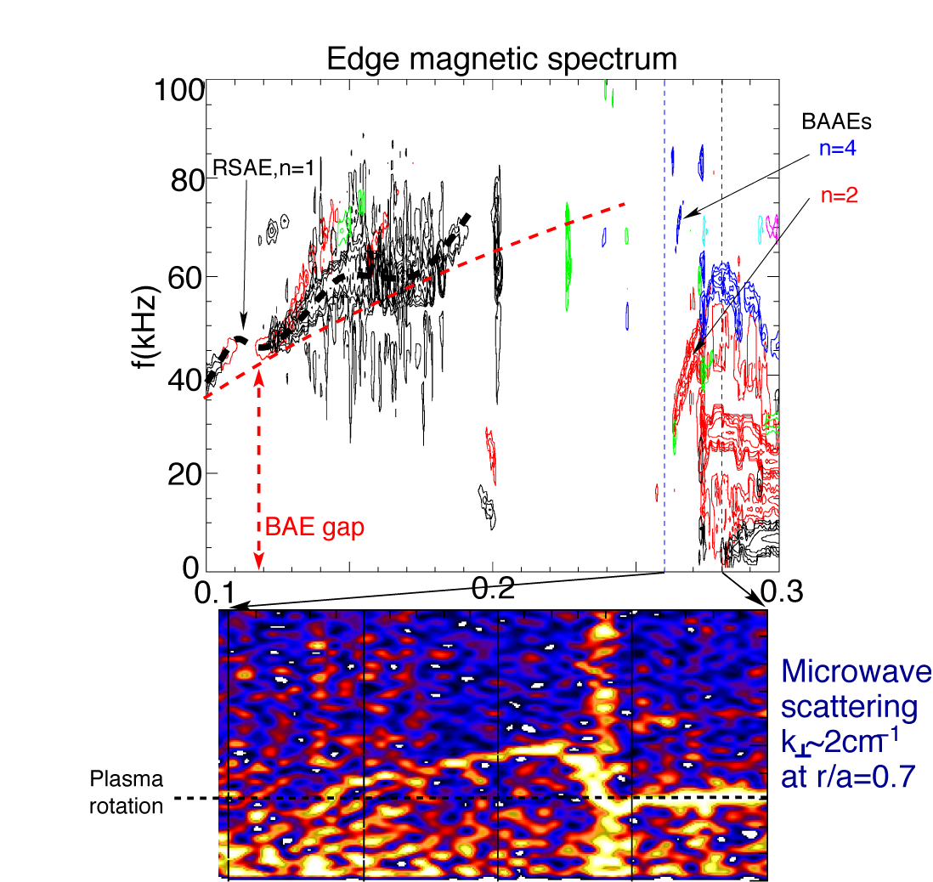

Figure 4.3.3: Beta-induced Alfvén Eigenmodes
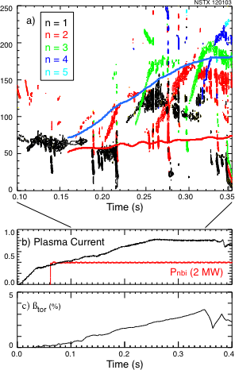

Figure 4.3.4: Alfvén Cascades

The time evolution of q_{min} as calculated from the observed mode frequency sweeping was also found to be in good agreement with that found from equilibrium reconstructions using measurement of the equilibrium magnetic field pitch. This measurement was made with a Motional Stark Effect (MSE) diagnostic.

Some limited measurements have been made of the internal structure of these modes. Future experiments will try to improve on these measurements, with a view, in particular, of detecting changes in the mode structure as the Alfvén Cascade modes saturate at the TAE gap.
These studies have been primarily done in L-mode plasmas. It remains to be seen whether a sufficiently low β H-mode plasma can be made such that AC modes would be present. Finally, no strong evidence has been found to connect these modes to enhanced fast ion transport as has been reported elsewhere. Future experiments could take a closer look at this issue.
CAE (Hole-Clumps):

Neutral Beam Driven Compressional Alfvén Eigenmodes (CAE) at frequencies in the range 0.2 ω_{ci} ≤ ω ≤ ω_{ci} are commonly seen in NSTX plasmas [4.3.43-4.3.45]. The modes typically have a spectrum with multiple frequency peaks, sometimes equally spaced and with sequential toroidal mode numbers. The modes are counter-propagating for moderate mode numbers, 3 ≤ n ≤ 6, and co-propagating for high mode numbers 9 ≤ n ≤ 13. The frequency has a scaling with toroidal field and plasma density consistent with Alfvén waves. The modes have been observed with high bandwidth magnetic pick-up coils and with a reflectometer. The high-k scattering system has again, in some instances, detected coherent modes with frequencies matching those seen on the Mirnov coils, suggesting continuum damping through mode-conversion to kinetic Alfvén waves. Neutral Beam Driven Compressional Alfvén Eigenmodes (CAE) at frequencies in the range 0.2 ω_{ci} ≤ ω ≤ ω_{ci} are commonly seen in NSTX plasmas. The modes typically have a spectrum with multiple frequency peaks, sometimes equally spaced and with sequential toroidal mode numbers. The modes are counter-propagating for moderate mode numbers, 3 ≤ n ≤ 6, and co-propagating for high mode numbers 9 ≤ n ≤ 13. The frequency has a scaling with toroidal field and plasma density consistent with Alfvén waves. The modes have been observed with high bandwidth magnetic pick-up coils and with a reflectometer. The high-k scattering system has again, in some instances, detected coherent modes with frequencies matching those seen on the Mirnov coils, suggesting continuum damping through mode-conversion to kinetic Alfvén waves.

Alfvénic bursts (AB) of either compressional or global Alfvén eigenmodes, with strong frequency chirps have been observed in the early neutral beam-heating phase of discharges (Fig. 4.3.5). The bursts last for < 0.3 – 0.7 ms, and the mode frequency chirps simultaneously up and down. The frequency evolution of the bursts is well described by the “Hole-clump pair” theory of Berk, Breizman, and Petviashvili, [4.3.46]. The AB arises from the generation of a hole in the particle distribution function, paired with a clump, and the non-linear interaction of the instability with the distribution function results in the propagation of the holes and clumps in phase space, which together with background damping, results in the simultaneous upward and downward frequency chirps of the mode. The hole-clump theory relates the rate of the frequency chirp to the linear damping rate of the mode. The damping rate determined by the frequency chirping is found to be in good agreement with predictions of the NOVA-k code.

There still remains ambiguity regarding the identification of these modes as GAE or CAE. Further numerical simulations and improvements in the measurement of the mode polarization, as well as internal structure with the multi-channel reflectometer system might help resolve this question. Likewise, additional work needs to be done to understand the extension of the hole-clump theoretical model to Doppler-shifted cyclotron resonance driven modes as these are believed to be.
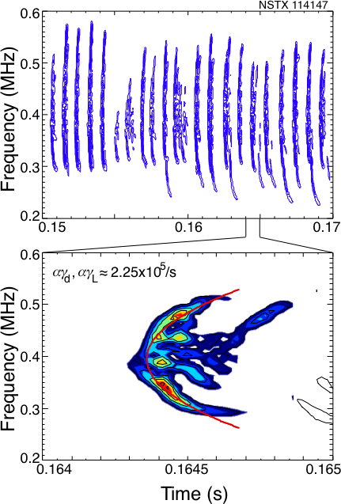
Figure 4.3.5: CAE hole-clumps (Angelfish)

Global Alfvén Eigenmodes:
Initial observations of sub-cyclotron frequency modes, 0.2 ω_{ci} ≤ ω ≤ ω_{ci}, were interpreted as CAE. Simulations with the HYM code, however, found that both CAE and Global Alfvén Eigenmodes (GAE) should be expected for the parameters of typical NSTX plasmas. Evidence for this second type of mode was soon found. The peaks in the frequency spectrum for these new instabilities intersect each other as plasma parameters evolve, whereas the CAE spectral peaks, which depend only upon density, tend to evolve parallel to each other. The shear Alfvén dispersion, ω ≈ k||V_{A} , k|| = (m - nq)/qR allows for more complex behavior as the q profile and density are evolving independently during the discharge. A theory of localized compressional Alfvén eigenmodes (CAE) and global shear Alfvén eigenmodes (GAE) in low aspect ratio plasmas explains the observed high frequency instabilities [4.3.47-4.3.58]. Both classes of modes may be excited through the velocity space gradient of energetic super-Alfvénic beam ions via Doppler shifted cyclotron resonances (or, in the case of CAE, directly through a parallel bump-on-tail). CAE modes were also found on DIII-D in an aspect ratio scaling experiment motivated by the NSTX observations [4.3.59].

Non-linear, three-dimensional 3D hybrid simulations using the HYM code have been employed to study the excitation of both CAE and GAE by energetic ions in NSTX. The HYM simulations for typical NSTX parameters find that GAE are the most unstable modes, for low toroidal mode numbers, 2 ≤ n ≤ 7 at the large injection velocities of beam ions, V_{b} ≈ 3V_{A}. The GAE are localized near the magnetic axis, and have large k||, so that ω ≈ k||V_{b||} ≈ ω_{ci}/2. The perturbed plasma pressure in the poloidal cross-section of an NSTX plasma due to a GAE with n = 4 and m = 2 is shown in Fig. 4.3.6. These modes also have a significant compressional component, B|| ≈ B⊥/3, due to strong coupling to the compressional Alfvén wave. In the HYM simulations for n_{b}/n_{p} ≈ 3 % , the growth rates of the unstable GAEs are found to be of the order γ/ω_{ci} ≈ 0.002 – 0.01 with frequencies ω/ω_{ci} ≈ 0.3 – 0.5, where ω_{ci} is evaluated at the magnetic axis.
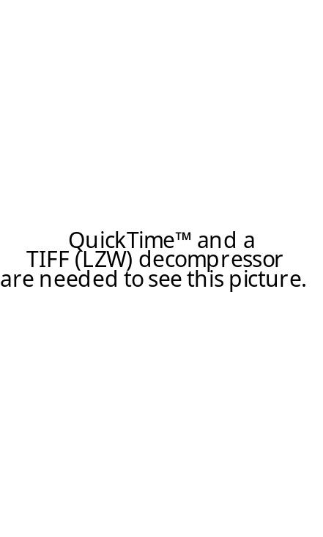
Figure 4.3.6: Color Contours of the fluid pressure perturbation of n = 4, m = 2 GAE mode plotted in the poloidal R , Z plane. Shown also is the last closed magnetic surface of the NSTX plasma. The red color regions indicate the high perturbed pressure, whereas dark blue ones correspond to the negative value of the pressure perturbation.
Stochastic Ion Heating:

With strong neutral beam heating in NSTX a broad spectrum of fluctuations is observed in the frequency range from about 0.2 to 1.2 times the ion cyclotron frequency, demonstrating that there are many weakly damped eigenmodes present for stochastic ion heating. The modes have been identified as Compressional Alfvén Eigenmodes (CAE) or Global Alfvén Eigenmodes. The linear damping rate has been determined from non-linear behavior of the mode frequency under some conditions, and calculated with NOVA-K and HYM.

We simulated this effect in a more complex toroidal geometry (see figure 4) than was reported previously [4.3.58,4.3.60]. Stochastic domains at low energy corresponding to the plasma background ions occurs at a lower amplitude than in the slab plasma. The initial temperature profile of thermal ions is shown as a solid parabolic curve in figure 4. We used 21 CAEs to simulate the measured CAE spectrum by edge Mirnov probes in NSTX. Internal measurements of the rms amplitude of the perturbations is not available and was fixed at δB / B = 0.5 × 10⁻³ in calculations with the collisional frequency ν = 0.01ωc . Mode frequencies were in the range 0.2 < ω/ω_{ci} < 0.8. Calculations indicate that the heating is proportional to the mode numbers if the amplitude is fixed. Stochastic multimode heating by CAEs could provide a way of direct energy channeling from beam ions (fusion alphas) to the thermal plasma ions.
Non-linear Multi-mode Coupling:
Simultaneous bursts of energetic particle mode (EPM) and toroidicity-induced Alfvén eigenmode (TAE) activity that correlate with significant fast-ion loss are observed in beam-heated plasmas. Three-wave interactions between these modes have been conclusively identified, indicating fixed phase relationships [4.3.17]. This nonlinear coupling concentrates the energy of the TAEs into a toroidally localized perturbation frozen in the frame of a rigid, toroidally rotating structure formed by the EPMs. This redistribution of energy is significant because it will modify the effect of the TAEs on fast-ion loss.
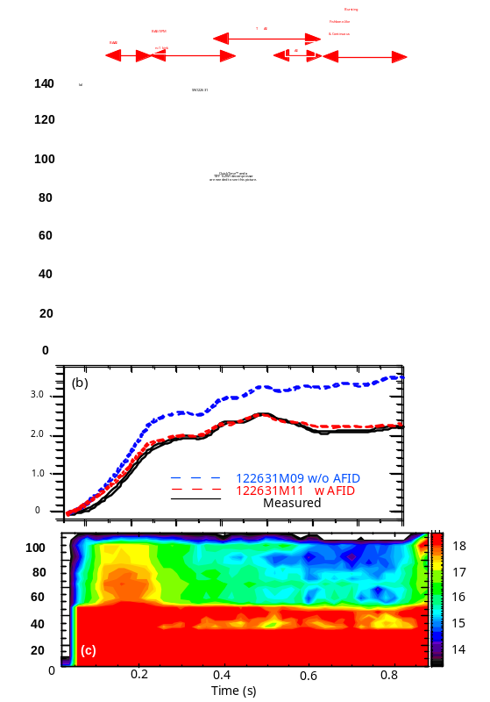

Figure 4.3.7: Mirnov MHD spectrogram (a),measured and TRANSP-calculated neutron rates(b) and NPA energetic ion spectrum(c) for a typical H-mode discharge in NSTX.

Measurements of MHD-induced Energetic Ion Transport or Loss:
In quiescent or MHD-benign NSTX discharges, NPA measurements of the energetic beam ion distribution are consistent with classical behavior [4.3.61]. The appearance of strong, bursting or continuous MHD or Alfvénic activity can have significant effects on energetic (E ~ 10 – 100 keV) deuterium ion populations. Evidence of MHD-induced energetic ion transport or loss in NSTX relies primarily on neutron rate and charge exchange Neutral Particle Analyzer (NPA) [4.3.62] measurements. Neither the volume integrated neutron rate nor the line-integrated NPA effux, however, can distinguish between transport or loss so additional diagnostics, such as sFLIP, FIReTIP and USXR are used to augment these measurements. sFLIP is able to identify ion loss while the others serve to spatially localize MHD-activity for the purpose of analysis using the time, space and energy dependent Anomalous Fast Ion Diffusion (AFID) model in TRANSP that is used to emulate MHD-driven transport or loss of energetic ions. Comparison of MSE-reconstructed toroidal current profiles with calculations taking into account AFID redistribution of NBI driven current helps to identify fast ion redistribution [4.3.63]. The AFID model is iterated to simultaneously match measurements of the neutron yield, NPA change exchange efflux and MSE reconstructed current profiles with the TRANSP simulation.

Although redistribution or loss of energetic ions due to low-frequency (f ~ 10 kHz) kink-type MHD activity has been reported previously [4.3.64], the primary goal of recent work [4.3.65] has been to contrast redistribution or loss due to continuous Energetic Particle Modes (EPM) and Toroidal Alfvén Eigenmode (TAE) activity (f ~ 20 – 150 kHz) modes with the low-f MHD modes, a topic that heretofore has not been investigated in detail for NSTX plasmas.

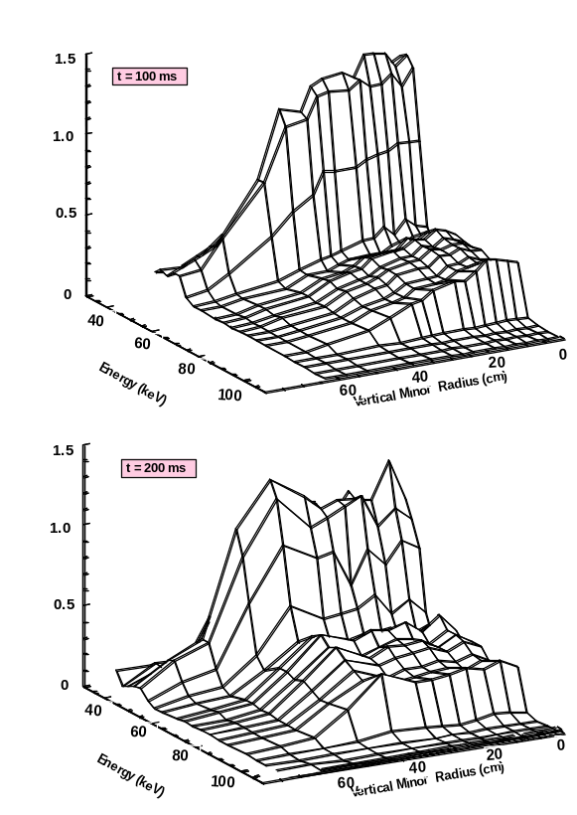
Figure 4.3.8: NPA vertical scan energetic ion spectra during MHD-quiescent (top panel) and MHD-active (bottom panel) discharge periods.

A NPA vertical scan was performed for a series of reproducible H-mode discharges, some characteristics of which are shown in Fig. 4.3.7. In panel (a), the Mirnov spectrogram shows robust activity in the low frequency range (f ~ 0 – 150 kHz) where continuous f < 20 kHz kink-type activity and bursting fishbone-like activity are intermingled with a ‘sea of Alfvénic modes’. A tentative classification of the mode activity is presented in the header. Panel (b) illustrates the typical disparity in neutron yield for H-modes having strong MHD activity wherein the normal TRANSP-calculated rate (blue curve exceeds measurement (black curve), often by as much as 50±20%. The TRANSP-calculated rate using the AFID model (red curve) provides agreement with the measurement. Panel (c) shows a contour plot of the NPA efflux where it can be seen that energetic ion depletion above E > E_{b}/2 starts around t ~ 150 ms (coincident with onset of strong MHD activity) and grows throughout the discharge.

Selected NPA vertically scanning results are shown in Fig. 4.3.8 where the vertical minor radius axis is the distance along a vertical line centered at the intersection of the NPA sightline with the NB footprint (where the NPA efflux is localized by charge exchange on the beam primary and halo neutrals). The NPA flux is displayed on a linear z-axis and the larger efflux at lower energy is the E/2 component of the neutral beam. The spectrum in the top panel corresponding to a MHD-quiescent period (dB ~ 10⁻² Gauss) at t ~ 100 ms shows a monotonically decreasing energetic ion distribution from the core outwards. By contrast, during strong MHD activity (dB ~ 10⁻¹ Gauss) at t ~ 200 ms the energetic ion distribution in the core region is depleted and the core ions are redistributed radially outwards to form a ‘shoulder’ on the measured distribution as evident in the bottom panel. Following this initial redistribution, the NPA spectra continue to exhibit depletion throughout the duration of the ~ 800 ms discharge. This depletion is due in part to attenuation of the charge exchange neutral efflux with increasing plasma density and in part to MHD-induced energetic ion redistribution. TRANSP analysis is used to separate these contributions.

The sFLIP and FIReTIP signal activities (not shown) correlate with the Mirnov coil continuous low frequency (f < 20 kHz) MHD activity (along with sporadic bursting fishbone-like activity). sFLIP energetic ion loss and FIReTIP δn_{e}/n_{e} core fluctuations are conspicuously absent during higher-frequency continuous TAE and CAE/GAE activity in the time interval t ~ 0.43 – 0.9 s except possibly for MHD bursting activity at t ~ 0.78 s and t ~ 0.83 s. The leads to a tentative conclusion that both bursting fishbone-like and low-f kink-type MHD modes drive energetic ion loss whereas continuous TAE-like Alfvénic modes at most cause redistribution and the energetic ions remain confined [4.3.66].

So far, the role regarding energetic ion redistribution or loss of higher-frequency (f ~ 200 – 2000 kHz) CAE/GAE activity that is omnipresent during NSTX H-mode discharges cannot be separated from the lower-frequency activity (f ~ 0 – 100 kHz). Ignoring the higher frequency activity on the grounds that typical amplitudes of the magnetic fluctuations are 1 – 2 orders of magnitude below those for the lower frequency fluctuations remains to be verified.
4.3.5 Energetic Particle Research Plan for 2009-2013
The research plan for energetic particle physics is largely limited by available run time and personnel available to analyze the results of experiments. Analysis of experimental results is relatively labor intensive. However, there will be additional diagnostic capabilities which will improve our understanding of the nature and impact of fast ion driven instabilities. These include improvements to fast ion diagnostics such as the addition of the FIDA diagnostic to measure confined fast ion distributions and higher speed sFLIP data, either through a fast camera, or as a finite number of fast photomultiplier channels to improve correlation of losses with fast ion instabilities. Improvements are planned for the reflectometer system, which is presently the basic diagnostic for internal measurements of mode structures and amplitudes. An upgrade to higher bandwidth is planned for the tangential interferometers, which could provide information on mode amplitudes in H-modes, something not possible with the reflectometers. And there are plans for a PCI diagnostic, which could complement the reflectometer measurements. The high-k scattering diagnostic has not been fully exploited for studies of KAW, a result of continuum damping of Alfvén modes. Active excitation of Alfvén waves is a powerful tool for studying stability thresholds, linear damping rates and the first steps in evaluating the potential for stochastic ion heating. In the following schedule a list of some twenty experiments are apportioned to the five campaigns in 2009 through 2013, although in many cases the ordering is somewhat arbitrary. Undoubtedly, as we learn more, additional ideas for experiments will present themselves.
2009:
In the 2009 campaign we propose six experiments to continue studies of the wide range of energetic article driven instabilities. The use of non-resonant magnetic field braking is a capability of NSTX that hasn’t been fully exploited and could contribute to these experiments. The PCI diagnostic may be available for some experiments. The newly identified, beta-induced Alfvén Acoustic mode (BAAE) will have one day to complete documentation of internal mode structure and begin scaling of threshold parameters (high-k scattering and PCI?). There will be an experiment dedicated to the study of three-wave coupling between fishbone-like modes, TAE and the higher frequency GAE/CAE. Three wave coupling between these modes could affect instability thresholds as well as particle transport. Again, the PCI system would contribute to this experiment. An additional day to complete documentation of the Alfvén Cascade eigenmode evolution to TAE modes. The neutral beam voltage and source dependence of TAE avalanches, a high priority in terms of impact on fast ion transport, would be investigated. An experiment will be dedicated to producing TAE modes and a search for continuum damping via coupling to KAW will be made using the high-k scattering diagnostic. Finally, the first experiments to measure CAE/GAE coupling to an existing HHFW antenna strap will be done. This will provide useful information on the design of a dedicated CAE antenna.
2010:
The fast Mirnov arrays will be upgraded for the 2010 campaign. Additionally, the FIDA diagnostic should be routinely available. The FIDA diagnostic, together with sFLIP and NPA, will be used to look for fast ion redistributions correlated with three-wave coupling. The impact of fishbones on beam driven currents will be revisited with the improved diagnostic capability. Experiments will start the study of Alfvén Cascade modes and TAE avalanches in H-mode plasmas. This is an important regime in which to understand the modes, but it is difficult to study them due to lack of good internal mode diagnostics in H-mode. Additionally, the sensitivity of TAE avalanches to He-D concentration ratios will be studied. This may provide some insight into damping mechanisms for TAE modes. The first low power coupling experiments to Alfvén waves will be done using an existing HHFW strap and a low power amplifier.
2011:
The high frequency upgrade to Firetip should provide some internal mode amplitude and localization data for CAE/GAE frequency modes in H-mode plasmas. An experiment dedicated to the study of CAE/GAE hole-clumps, which provides important understanding of fast ion phase space transport, as well as tests present understanding of the non-linear behavior of energetic particle modes, will document the internal structure, as well as for the first time provide information on the poloidal localization of the modes and on the outboard local wavelength (important for CAE antenna design). Then an experiment will study the suppression of hole-clumps during HHFW heating to understand whether this reflects changes in the equilibrium plasma, or direct changes to the fast ion distribution. The BAAE modes will be revisited with the improved diagnostics to get better mode structure measurements and measurements of fast ion transport. Also, parameter scaling of mode stability will be done. An extensive documentation of fast ion redistribution during TAE avalanches will be performed with the now mature FIDA diagnostic. A five kW amplifier will be used with and internal antenna (either left over HHFW strap or new CAE antenna) for intial Alfvén spectroscopy studies. This would include direct measurements of the TAE linear damping rates and intial attempts to excite CAE/GAE to the level detectable with internal diagnostics (reflectometer/firetip/PCI).
2012:
The dedicated CAE antenna will be installed for this run and the high priority experiments will address coupling, excitation and power loading experiments, still at relatively low power ≈5 kW. Other experiments could address bounce-resonance fishbones and TAE avalanches.
2013:
The 100-200 kW RF source from CDX-U will have been converted to 1-2 MHz and installed for this campaign. At these power levels it is possible that CAE/GAE could be excited to the stochastic heating threshold. Certainly direct measurements of the excited wave structures should be possible with the fast internal diagnostics. A number of the previous experiments, notably those on BAAEs and Alfvén Cascades could benefit from the use of HHFW to control the electron temperature, thus altering the role of the Acoustic mode coupling for these modes.
2009 – 2013 Timeline for Waves and Energetic Particles Research
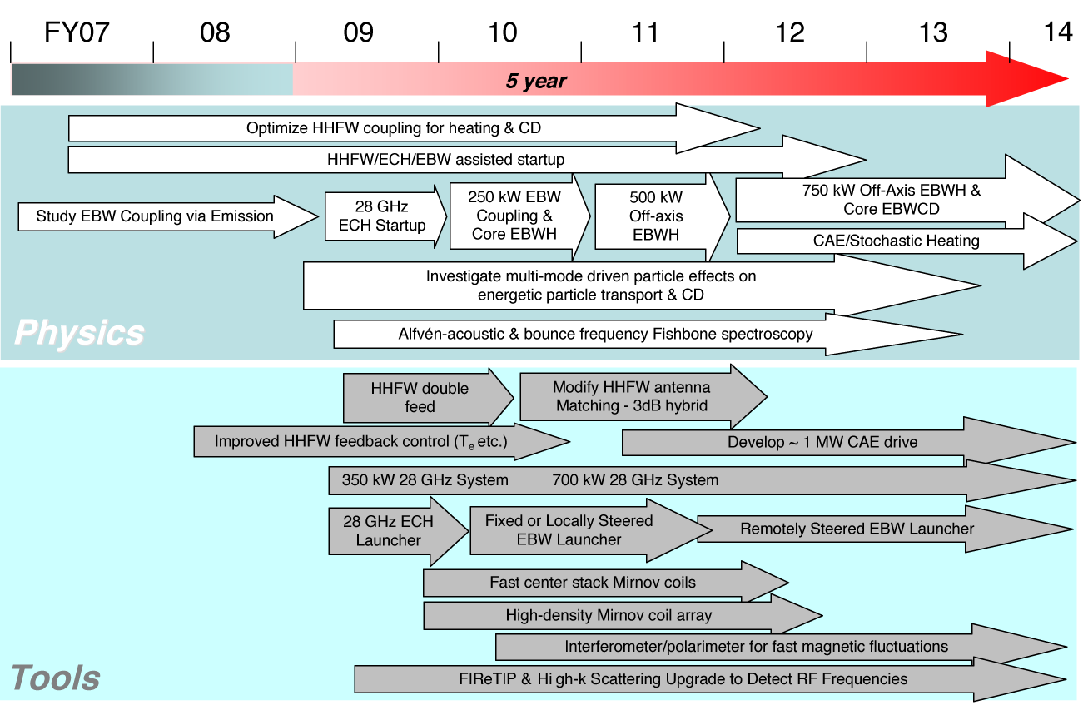
References
4.1.1 M. Ono, Physics of Plasmas 2, 4075 (1995).
4.1.2 J.R. Wilson, et al., 16th Topical Conf. on RF Power in Plasmas, AIP Conf.
Proc. 787, 66 (2005).
4.1.3 J. Hosea, et al., Bulletin of APS 51, No 7 (2006) NO1 11, p183.
4.1.4 J. Hosea, et al., Proc. 17th Topical Conf. on RF Power in Plasmas, (Sand Key, May 2007),
to be published in AIP Conf. Proc.
4.1.5 A.P. Smirnov and R.W. Harvey, Bull. Amer. Phys. Soc. Vol. 40, No. 11 (1995) 8P 35, p1837;
CompX report CompX-2000-01 (2001).
4.1.6 E.F. Jaeger, et al., Nucl. Fusion 46, S397 (2006).
4.1.7 A.L. Rosenberg, et al., Phys. Plasmas 11, 2441 (2004).
4.1.8 J. Hosea, et al., Proc. 16th Topical Conf. on RF Power in Plasmas, AIP Conf. Proc.
787, 82 (2005).
4.1.9 J. Parker, J. et al., to be presented at the APS-DPP meeting (Orlando, November 2007)
4.1.10 P.T. Bonoli, 17th Topical Conf. on RF Power in Plasmas, (Sand Key, May 2007) paper
I-19, to be published in AIP Conf. Proc..
4.1.11 P.M. Ryan, et al., Fusion Eng. and Design 56-57, 569 (2001).
4.2.1 C. E. Kessel, et al., Nucl. Fusion 45, 814 (2005).
4.2.2 Y-K. M. Peng, et al., Plasma Phys. Control. Fusion 47, B263 (2005).
4.2.3 I.B. Bernstein, Phys. Rev. 109, 10 (1958).
4.2.4 A.K. Ram, and S.D. Schultz, Phys. Plasmas 7, 4084 (2000).
4.2.5 J. Preinhaelter and V. Kopécky, J. Plasma Phys. 10, 1 (1973).
4.2.6 E. Mjølhus, J. Plasma Phys. 31, 7 (1984).
4.2.7 F.R. Hansen, et al, J. Plasma Phys. 39, 319 (1988).
4.2.8 C.B. Forest, et al., Phys. Plasmas 7 1352 (2000).
4.2.9 N.J. Fisch and A. Boozer, Phys. Rev. Lett. 45, 720 (1980).
4.2.10 T. Ohkawa, National Technical Information Service Report No. PB2000-108008, 1976 and
General Atomics Report No. GA-A13847, 1976].
4.2.11 A.K. Ram, A. Bers, and C.N. Lashmore-Davies, Phys. Plasmas 9, 409 (2002)
4.2.12 G. Taylor, et al., Phys. Plasmas 12, 052511 (2005).
4.2.13 J. Preinhaelter, et al., AIP Conf. Proc. 787, 349 (2005).
4.2.14 S.J. Diem, et al., Rev. Sci. Instrum. 77, 10E919 (2006).
4.2.15 S.J. Diem, et al., 17th Topical Conf. on RF Power in Plasmas, Orlando, Florida (May 2007).
to be published in AIP Conf. Proc.
4.2.16 H. P. Laqua et al., Phys. Rev. Lett. 78, 3467 (1997).
4.2.17 V. Schevchencko , et al., Fusion Sci. Technology 52, 202 (2007).
4.2.18 V. Schevchencko , private communication (2007).
4.2.19 A. Mueck, et al., Fusion Sci. Technology 52, 221 (2007).
4.2.20 A.P. Smirnov, and R.W. Harvey, Bull. Am. Phys. Soc. 40, 1837 (1995).
4.2.21 R.W. Harvey, and M.G. McCoy, Proceedings of the IAEA Technical Committee on Advances in
Simulation and Modeling of Thermonuclear Plasmas, Montreal, Quebec (International Atomic
Energy Agency, Vienna, 1993), p. 489; USDOC NTIS Doc. No. DE93002962.
4.2.22 G. Taylor, et al., Phys. Plasmas 11, 4733 (2004).
4.2.23 R.W. Harvey and G. Taylor, Phys. Plasmas 12, 051509 (2005).
4.2.24 J. S. McKenzie, M.R. O'Brien and M. Cox, Comp.Phys.Comm. 66, 194 (1991).
4.2.25 A.N. Saveliev, AIP Conf. Proc. 871, 215 (2006).
4.2.26 A.K. Ram, J, Decker and Y. Peysson, Proc. 14th Joint Workshop on ECE and ECRH, (Santorini, Greece, May 2006) ed. Avrilios Lazaros (Heliotopos Conferences Ltd., Athens, Greece, 2006) p. 250.
4.3.1 G R Smith, A N Kaufman, Phys. Rev. Lett. 34, 1613 (1975).
4.3.2 C F F Karney, A Bers, Phys. Rev. Lett. 39, 550 (1977).
4.3.3 C F F Karney, Phys. Fluids 21, 1584 (1978).
4.3.4 J Y Hsu, K Matsuda, M S Chu, T H Jensen, Phys. Rev. Lett. 43, 203 (1979).
4.3.5 J. F. Drake, T. T. Lee, Phys. Fluids 24, 1115 (1981).
4.3.6 J M McChesney, R A Stern, P M Bellan, Phys. Rev. Lett. 59 , 1436 (1987).
4.3.7 J M McChesney, P M Bellan, R A Stern, Phys. Fluids B 3 , 3363 (1991).
4.3.8 A D Bailey III, P M Bellan, R A Stern, Phys. Plasmas 2 , 2963 (1995).
4.3.9 A D Bailey III, R A Stern, and P M Bellan, Phys. Rev. Lett. 71, 3123 (1993).
4.3.10 S J Sanders, P M Bellan, R A Stern, Phys. Plasmas 5 , 716 (1998).
4.3.11 N.N. Gorelenkov, H.L. Berk, and R.V. Budny, Nucl. Fusion 45, 226 (2005).
4.3.12 E.D. Fredrickson, et al., Nucl. Fusion 46, s926 (2006).
4.3.13 H.L. Berk, B.N. Breizman, and H. Ye, Phys. Lett. A 162, 475 (1992).
4.3.14 H.L. Berk, B.N. Breizman, Fitzpatrick J. and Wong H.V. Nucl. Fusion 35, 1661 (1995).
4.3.15 H.L. Berk, B.N. Breizman. and M. Pekker, Nucl. Fusion 35, 1713 (1995).
4.3.16 H.L. Berk, B.N. Breizman. and M. Pekker, Phys. Rev. Lett. 76, 1256 (1996).
4.3.17 N. A. Crocker, et al., Phys. Rev. Lett. 97, 045002 (2006).
4.3.18 D. Gates, R. White, and N. Gorelenkov, Phys. Rev. Lett 87, 205003 (2001).
4.3.19 N.N. Gorelenkov, et al., Nucl. Fusion, 43, 228 (2003).
4.3.20 T H Stix, Phys. Fluids 7, 1960 (1964).
4.3.21 S Puri, Phys. Fluids 9, 2043 (1966).
4.3.22 S Puri, D A Dunn, and K I Thomassen, Phys. Fluids 11, 2728 (1968).
4.3.23 S Q Mah, H M Skaragard, and A R Strilchuk, Phys. Rev. Lett. 25 1409 (1970).
4.3.24 A Hirose, S Q Mah, H M Skarsgard, A R Strilchuk, Phys. Fluids 17, 2147 (1974).
4.3.25 E. Fredrickson and P. M. Bellan, Phys. Fluids 28, 1866 (1985).
4.3.26 G Besson, et al., Plasma Phys. and Cont. Fusion 28, 1291(1986).
4.3.27 G A Collins, et al., Phys. Fluids 29, 2260 (1986).
4.3.28 A B Murphy, Plasma Physics and Cont. Fusion 31, 21 (1989).
4.3.29 E D Fredrickson, et al., Proc. of 29th EPS Conf. on Controlled Fusion and Plasma Physics, Montreaux, 2002, (the European Physical Society, Geneva) ECA vol. 26B (2002), P-1.104.
4.3.30 E D Fredrickson, L Chen, and R B White, Nucl. Fusion 43, 1258 (2003).
4.3.31 E.D. Fredrickson, et al., Phys. of Plasmas 10, 2852 (2003).
4.3.32 S. Kaye, et al., Phys. Plasmas 10, 3953 (2003).
4.3.33 Ya. I Kolesnichenko, VS Marchenko and R B White, Phys. of Plasmas 13, 052504 (2006).
4.3.34 W W Heidbrink, et al., Plasma Phys. Control. Fusion 48, 1347 (2006).
4.3.35 D. S. Darrow, et al., Proc. 19th IAEA Fusion Energy Conference, Lyon, France, 14-19 Oct 2002 (IAEA, Vienna)
4.3.36 H L Berk, et al., Synopsis for 2006 IAEA meeting
4.3.37 D. Darrow, et al., Proc. 34th European Physical Society Conference on Plasma Physics (Warsaw, Poland June 2-6, 2007), paper p1.117.
4.3.38 N N Gorelenkov, et al., Proc. for the 34th European Physical Society Conference on Plasma Physics (Warsaw, Poland June 2-6, 2007) paper I3.006.
4.3.39 N. N. Gorelenkov, et al., submitted to Phys. Lett. A (2007)
4.3.40 B N Breizman and M S Pekker, Phys. Plasmas 12, 112506 (2005).
4.3.41 E. D. Fredrickson, et al., Proc. for the 34th European Physical Society Conference on Plasma Physics (Warsaw, Poland June 2-6, 2007) paper p1.106.
4.3.42 E D Fredrickson, et al., “Beta suppression of Alfvén Cascade Modes in the National Spherical Torus Experiment” (accepted for Physics of Plasmas, 2007).

4.3.43 H L Berk, et al., “Interpretation of Mode Frequency Sweeping in JET and NSTX”, Synopsis for 2006 IAEA meeting
4.3.44 E.D. Fredrickson, et al., Phys. of Plasmas 13, 056109 (2006).
4.3.45 E.D. Fredrickson, et al., “Observation of Hole-Clump Pair Generation at Compressional and Global Alfvén Eigenmode Frequencies” (to be submitted to Physics of Plasmas, 2007)
4.3.46 H.L. Berk, B. N. Breizman, N.V. Petviashvili, Phys. Lett. A 234, 213 (1997).
4.3.47 E.D. Fredrickson, et al., Phys. Rev. Lett. 87, 145001 (2001).
4.3.48 N N Gorelenkov, C Z Cheng, and E Fredrickson, Phys. Plasmas 9, 3483 (2002).
4.3.49 E D Fredrickson, et al., Phys. of Plasmas 9, 2069 (2002).
4.3.50 N N Gorelenkov, et al., Nucl. Fusion 42, 977 (2002).
4.3.51 N N Gorelenkov, et al., Proc. 9th IAEA Fusion Energy Conference, Lyon, France, 14-19 Oct 2002 (IAEA, Vienna) paper IAEA-CN-94/TH/7-1 Ra
4.3.52 N N Gorelenkov, et al., Nucl. Fusion, 43, 228 (2003).
4.3.53 E Belova, et al., “Numerical Study of Instabilities Driven by Energetic Neutral Beam Ions in NSTX” in Proc. of the 30th European Physical Society Conference on Controlled Fusion and Plasma Physics (St. Petersburg, Russia, July 2003).
4.3.54 V. S. Belikov et al., Phys. of Plasmas 10, 4771 (2003).
4.3.55 E. D. Fredrickson, N. N. Gorelekov and J. Menard, Phys. of Plasmas 11, 3663 (2004).
4.3.56 Eliezer Hameiri, Akihiro Ishizawa and Akio Ishida, Phys. Plasmas 12, 072109 (2005).
4.3.57 Ya. Kolesnichenko, R B White, and Yu. V Yakovenko, Phys.of Plasmas 13, 122503 (2006).
4.3.58 N.N. Gorelenkov, et al., Nucl. Fusion, 43, 228 (2003).
4.3.59 W W Heidbrink, et al., Nucl. Fusion 46, 324 (2006).
4.3.60 D. Gates, R. White, and N. Gorelenkov, Phys. Rev. Lett 87, 205003 (2001).
4.3.61 W. W. Heidbrink and G. J. Sadler, Nucl. Fusion 34, 535 (1994).
4.3.62 S. S. Medley and A. L. Roquemore, Rev. Sci. Instrum. 75, 3625 (2004).
4.3.63 J. E. Menard, et al., Phys. Rev. Lett. 97, 095022 (2006).
4.3.64 S. S. Medley, et al., Nucl. Fusion 44, (2004) 1158
4.3.65 S. S. Medley, et al., “Status of Recent Experimental and Analytical Investigation of MHD-Induced Energetic Ion Redistribution or Loss in the National Spherical Torus Experiment” Princeton Plasma Physics Laboratory Report, PPPL-4235 (2007)
4.3.66 S. S. Medley, et al., “Neutral Particle Analyzer Vertically Scanning Measurements of MHD-Induced Energetic Ion Redistribution or Loss in the National Spherical Torus Experiment,” Princeton Plasma Physics Laboratory Report, PPPL-xxxx (Submitted August, 2007)

