Tearing mode / NTM physics

Goal: Generate critical data in the unique and complementary operating regime of low aspect ratio, high beta and poloidal beta, and large ion gyro-radius to provide verification of tearing mode/NTM scaling studies conducted in higher aspect ratio, higher field tokamaks in support of extrapolation to burning plasma experiments. Investigate impact of modes on plasma beta, rotation, fast particle redistribution, and the potential of low aspect ratio operation as being theoretically favorable for NTM stabilization.

Goal: Study neoclassical and classical tearing modes in the unique low aspect ratio, high beta, and large ion gyro-radius plasmas available in NSTX, in order to both extrapolate our understanding to future ST devices and provide data complementary to that from conventional aspect ratio tokamaks. Investigate the impact of these modes on plasma beta, rotation, fast particle redistribution, and the potential of low aspect ratio operation as being theoretically favorable for NTM stabilization. Determine scenarios that allow operation without these deleterious instabilities.

Contributes to:
- ITPA MDC-3 – Joint experiments on neoclassical tearing modes
- ITPA MDC-4 – Neoclassical tearing modes – aspect ratio comparison

(i) physics – results and plans

The neoclassical tearing mode (NTM) is a magnetic island driven by a hole in the bootstrap current. These modes are a likely problem for any high-performance tokamak, leading to confinement degradation (soft β limit) in the case of the m/n=4/3 and 3/2 modes, and potential mode-locking and disruption for the 2/1 NTM []. These modes were studies briefly in early NSTX [] research, and have been observed in MAST []. We plan a renewed focus on NTM physics in the coming research period. Important areas for proposed NTM research include i) investigation of the onset-β and marginal island widths as functions of kinetic parameters and plasma rotation ii) studies of the NTM triggers in q₀>1 regimes, iii), modeling these modes in low-aspect ratio geometry including the effects of flow and flow shear, and iv) studies of the interaction of NTMs with fast particles, including particle redistribution during mode activity.

The degrading effects of a 2/1 NTM on a high performance discharge are shown in Fig 2.1.1-1. The mode amplitude is shown in frame a), with the mode striking at t=0.56 and maintaining it’s saturated state until t=0.71, when it locks; the plasma then disrupts at t=0.75. Frames b) and c) show that β_{N} continually drops during the period of the mode, as does the energy confinement time (both determined by the EFIT code). The mode has a profound effect on the rotation profile: an immediate collapse of the core rotation and transition to rigid-body rotation. Indeed, it is likely both the short-circuiting of the magnetic surfaces [C&C] and the reduction of rotation and rotation shear that result in the severe confinement degradation. It is clear that these modes must be avoided in order to maintain the desired high-β state.

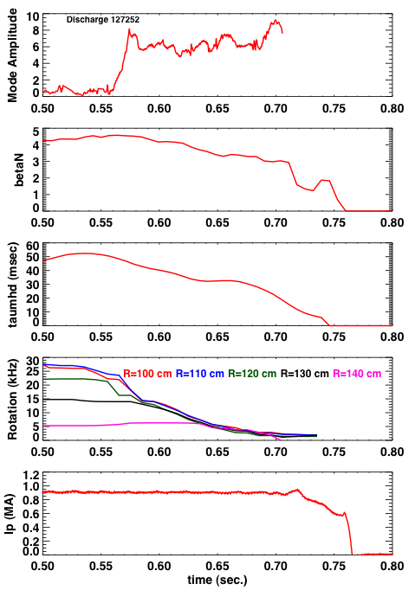
Fig 2.1.1-1: Illustration of the effects of a 2/1 NTM on discharge confinement. From top to bottom are the mode amplitude, β_{N}, τ_{E}, the rotation frequency at five radii, and the plasma current.

The Modified Rutherford equation (MRE) [] provides a convenient basic framework to consider for NTM studies:
(1)
This equation describes the evolution of the full island width (w), including classical tearing stability (Δ’), neoclassical drive due to the bootstrap current missing inside the island (∝ β_{P}/w), stabilizing terms due to toroidal geometry (D_{R}/w ∝ β /w, the “Glasser, Greene and Johnson” term), and threshold effects (w_{d} [Fitz] and w_{pol} [Wael]) which are important for small islands. Given that β can begin to approach β_{P} in NSTX, the GGJ term is expected to be strongly stabilizing [], an effect to be studied as these studies move forward.

Equation 1 predicts that for saturated island sizes larger than w_{d} and w₀, the island width should be proportional to β_{P}. This trend is indeed observed, as illustrated in Fig. 2.1.1-2, where the square root of the magnetic fluctuation amplitude at the wall (∝ to the island width), is plotted against the global β_{P} for four discharges where NBI power ramp downs occurred. The linear relationship is clear. This observation, coupled to the close frequency match between the magnetic fluctuations and the q=2 rotation frequencies and the observation of flat spots at q=2 in the electron temperature profile, confirms that the observed mode is indeed a neoclassical island. Similar observations have been made for 3/2 islands as well, and the physics discussed above and below is typically relevant to both modes.

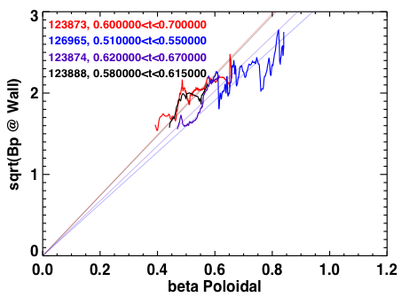
Fig 2.1.1-2: The m/n=2/1 island width is be proportional to β_{P}, as expected for a saturated NTM.

The small island terms in (1), w_{d} and w_{pol}, prevent NTM growth for arbitrarily small islands when classical tearing is stable (Δ’<0). Instead, a seed island must be formed whose width exceeds some value. For the 3/2 NTM, this seed-island is typically provided by sawteeth in conventional aspect ratio tokamaks; ELMs have been suggested to play a similar role for the 2/1 mode in DIII-D and JET. In NSTX, rapid changes in the beam timing have been observed to trigger the 3/2 mode. The NSTX discharge illustrated in Fig. 2.1.1-3, however, shows a large 2/1 NTM growing with no observable trigger. The spectrogram from a single Mirnov coil in the top frame shows the mode growing at t=0.83, with no precursor; this smooth growth is clearly indicated in the mode amplitude plot in the frame below. Neither the H_{a} nor the edge and core USXR signals show a precursor. The NTM eventually locks, as evidenced by the rapid drop of the edge USXR signal, followed by a disruption. It is possible that cases like these begin as classical tearing modes, which transition to neoclassically driven modes when the island width exceeds the critical island width [HR1]. This classical physics can be especially important for high-β plasmas, where a pole in Δ’ occurs at the no-wall limit. This discharge had β_{Ν}=4.3 when the mode struck, near to if not exceeding the no-wall limit. Understanding this triggering will be an important part of NSTX research.

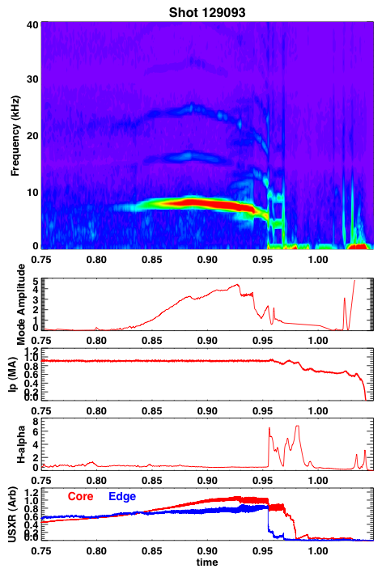
Fig 2.1.1-3: Example of an m/n=2/1 NTM with no clear trigger.

The marginal island width, i.e. the island width where dw/dt=0 for the smallest β_{P} were NTMs are still metastable, is a key parameters for understanding the relevant small island physics and extrapolating to larger and hotter plasmas. Experiments at conventional aspect ratio in DIII-D [], JET [] and ASDEX-U [Mar] suggest that the marginal island width scales empirically with the poloidal gyroradius. Verifying this empirical scaling at low aspect ratio is particularly important, as it predicts that an ST reactor or CTF (or indeed, ITER) will be very susceptible to NTM stabilization, and that NTM control techniques must be implemented. β_{P} ramp down experiments will be conducted to establish the marginal island widths for both the 3/2 and 2/1 NTMs, as a function of parameters such as rotation and poloidal gyroradius. It is planned to make a first complete set of experiments in the FY09-FY11 time-frame. However, the extended field and current capabilities of the upgraded NSTX will expand the parameter regime in quantities like poloidal gyroradius, collisionality, q_{min} and q-shear, providing greater credibility for the results.

The momentum input to a future reactor is likely to be much reduced compared to present experiments; this has lead to great recent interest in how rotation and rotation shear impact the onset and saturation of NTMs. Experiments in JET and DIII-D have also demonstrated the importance of rotation in increasing the NTM threshold []. For the 3/2 NTM, this effect that may be associated with dynamic rotation shielding between the NTM resonant surface and the q=1 surface, where the seed perturbation originate. Experiments in DIII-D have also demonstrated a reduction in the onset β for 2/1 modes when the co-injection beam torque is reduced to and beyond zero [Buttery1].
Experiments in NSTX have already begun to study the dependence the 2/1 mode onset on rotation shear. We have observed at ~20% reduction in onset global β_{N} as the rotation at q=2 is reduced. However, given that the NTM evolution is determined by local parameters, we have undertaken more systematic studies in terms of local bootstrap drive and rotation shear. Fig. 2.1.1-4 shows the local drive bootstrap drive for the island, , as a function of the local rotation shear at q=2, . The discharges in the scan were chosen from a wide variety of experiments which utilized n=3 braking to control the rotation. All were high-κ, high-δ plasmas with I_{P}=1MA and B_{T}=0.45T. There is a clear offset-linear dependence of the bootstrap-drive on rotation shear when the mode strikes, implying the importance of rotation shear in allowing higher-β operation. Importantly, this is the first ever correlation of local the local NTM properties with rotation shear, expanding on the previous DIII-D work.

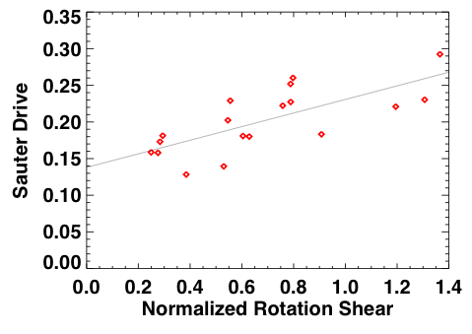
Figure 2.1.1-4 Onset β_{N} as a function of toroidal rotation, for discharges with n=2 magnetic breaking used to control rotation.

The tearing modes in TFTR [EF1], AUG [AG1], and possibly other major tokamaks, are commonly coupled to core kink-like modes. As these internal kink-like modes resemble the fishbone instability, it is reasonable to view this as a mechanism through which NTMs are coupled to the fast ion distribution. Evidence for such coupling, e.g., strong frequency chirping, has not been seen as yet in NSTX, though it has been observed in AUG [Ses] and TFTR. However, NSTX presently operates in a fast ion regime far from typical operating regimes of present large aspect ratio tokamaks. The upgrade to the center stack will allow higher field operation, bringing NSTX fast ion parameters more in line with those of conventional tokamaks. This would allow experiments to clarify the interactions of fast ions, including potential drive mechanism, on NTMs.

These experimental tasks will be executed in parallel with modeling and simulations of NTM dynamics at low aspect ratio. A first step will be to implement solutions of the MRE (equation 1) in full low aspect ratio geometry. These studies were begun in the work by [Rosenberg et al], where PEST-III was used to calculate Δ’, and routines from NIMROD to calculate the bootstrap drive and D_{R}. These steps will allow full calculations of the island growth and decay rates, as well as the saturated island eigenfunctions, for comparison with the experimental measurements derived above. A primary goal of these efforts will be to assess to impact of the GGJ term in the context of experimental measurements.

A more advanced modeling step will be to utilize initial value codes such as M3D and NIMROD to simulate the non-linear evolution of NTMs. Compared to the approach in equation (1), these methods are far more advanced in their treatment of heat conduction around the island, the effects of rotation shear, and self consistent current profile and island width evolution.

Out ability to meet these scientific goals will be augmented through improved diagnostic coverage during this research period. NSTX plasmas are overdense, preventing traditional measurements of island widths via electron cyclotron emission (ECE); measurements to date have relied on edge magnetics and USXR emission to constrain the island size and location. However, the BES system currently under construction will allow core fluctuation measurements, including in the range frequency range of the NTM. The CIF-MSE system also has the ability to measure spatially localized fast magnetic fluctuations at NTM relevant frequencies. This measurement, combined with USXR emission and edge magnetics, should allow detailed studies of the island eigenfunction, including the coupling to internal kink-like modes if present.

(ii) NTM Control

The results in Fig. 2.1.1-1 illustrate that 2/1 NTMs must be avoided in order to maintain optimal performance in NSTX. Experiments in DIII-D, JT-60, and AUG have demonstrated the ability to suppress both the 2/1 and 3/2 NTM with ECCD replacing the missing bootstrap current. This method is not available in the overdense NSTX plasma. Hence, passive control techniques will be employed in the planned research period.
To date, the most successful means of mitigating the 2/1 NTM has been through the use of combined lithium conditioning and dynamic error field correction. This is illustrated in Fig. Figure 2.1.1-5, where the mode activity is compared between discharges with and without lithium evaporation; the rotation frequency in the core and at q=2 are also shown, based on CHERS data and equilibrium reconstruction. Both discharge show a period of MHD activity during and immediately after the current ramp, as the q-profile evolves. The control shot 129013 then develops the large 2/1 mode, the plasma rotation is dramatically reduced, and the shot ultimately disrupts at t=1 sec. after the mode locks. The discharge with DEFC and lithium evaporation shows no sign of the later rotating instability, and ultimately succumbs to a fast-growing external mode, likely a resistive wall mode, at t-1.3 seconds.

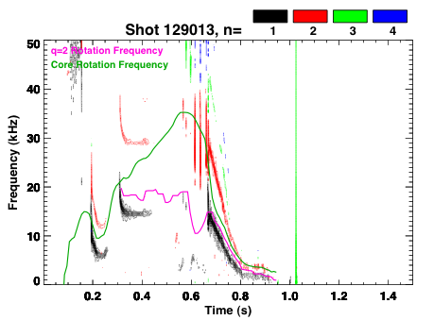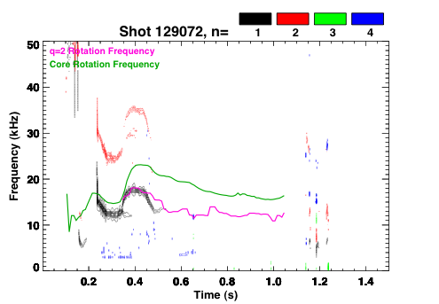
Figure 2.1.1-5: Comparison of low-frequency mode activity in shots without (129013) and with (129072) with lithium evaporation. Also shown are the core (green) and q=2 (magenta) rotation frequencies. The two discharges, designed to determine the effect of lithium evaporation on plasma performance, have all other controlled parameters the same.

The stabilization noted in the above figure was achieved with both lithium evaporation and DEFC; in other more rare cases, simply one of these two ingredients is sufficient to suppress the mode for the duration of the discharge. A high priority for near-term studies is to understand how the current and rotation profiles with lithium and DEFC change the mode stability, including changes in mode triggering. The studies offer exciting prospects for NTM control, as the liquid lithium divertor and NCC should allow a significant extension of these high performance discharge regimes.

In the five-year period starting in FY2014, an additional 3 NBI sources will be added to the NSTX NBI system. As discussed in Chapter X, this upgrade should allow access to fully non-inductive equilibria with q_{min} > 2. This scenario would have the effect of eliminating the more pernicious m/n = 2/1 and 3/2 resonances from the plasma. The effect of higher order NTMs, such as m/m=3/1 and 5/2, can then be studied. Additionally, the current profile control allowed with the more tangential beams may allow stabilization or mitigation of the NTM through modifications to Δ’, in a fashion similar to what was achieved in COMPASS-D [War1].

SUMMARY OF RESEARCH PLANS AND TIMELINE

FY09-FY11 Complete characterization of NTM onset, including triggering physics and the role of rotation, rotation shear, and small island effects.

FY09-FY11 Utilize β_{P} ramp down experiments to characterize the dependencies of the small island physics on kinetic parameters at low aspect ratio

FY09-FY11 Utilize PEST-III for accurate calculations of Δ’ in NSTX geometry. Develop solutions to (1) utilizing low-aspect ratio solutions for all terms. Asses merits of low-A for NTM stability

FY10-FY12 Implement nonlinear initial value simulations of NTMs with NIMROD and M3D. Compare measured island seeding and evolution to simulations.

FY12-FY13 Utilize upgraded NSTX to look for interactions of NTM with fast particles

FY12-FY13 Utilize previously developed knowledge base and new tools to develop routine high-β discharges with no deleterious island activity.

[?] T.C. Hender et al., Progress on the ITER Physics Basis (Chapter 3), Nucl. Fusion 47, S128 (2007).
[?] D.A. Gates, et al., APS 2000 – NTM observation in NSTX reference.
[?] R. Buttery, et al., Phys. Rev. Lett 88, 125005 (2002).
[?] R. J. La Haye, Phys. Plasmas 13, 055501 (2006).
[?] S. Kruger, C.C. Hegna, and J.D. Callen, Phys. Plasmas 5, 455 (1998).
[?] R.J. La Haye, Phys. Plasmas 13, 055501 (2006).
[?] R.J. Buttery et al., 20th IAEA Fusion Energy Conference, (Vilamoura, Portugal 2004), paper IAEA-CN-116/EX/7-1, Conference & Symposium Papers CD ROM, IAEA-CSP-25/CD, ISBN 92-0-100405-2, ISSN 1562-4153, IAEA Vienna (2005).
[?] R. J. Buttery, et al, Rotation and Shape dependence of Neoclassical Tearing Mode thresholds on JET, 28th EPS Conference on Contr. Fusion and Plasma Phys. 2001. [C&C] Z. Chang and J.D. Callen, Nuclear Fusion 30, 219 (1990). [Fitz] R. Fitzpatrick, Phys. Plasmas 2, 825 (1995) [Wael] F. L. Waelbroeck, J.W. Conner, and J.R. Wilson, Phys. Rev. Lett. 87, 215003 (2001) [AG1] A. Gude, S. Gunter, S. Sesnic, and the ASDEX upgrade Team, Nuclear Fusion 39, 127 (1999) [Mar] M. Maraschek, et al, Plasma Phys. Control Fusion 45, 1369 (2003) [Buttery2] R. Buttery, et al, Phys. Plasmas 15, 056115 (2008) [Ses] S. Sesnic, et al, Phys. Plasmas 7, 935 (2000) [Rosenberg] A.L. Rosenberg, et al, Phys. Plasmas 9, 4567 (2002) [War1] C.D. Warrick, et al, Phys. Rev. Lett 85, 574 (2000)

