Princeton Plasma Physics Laboratory
Procedure
Procedure Title:
Installation of the Upper and Lower MGIs

Number:  D-NSTX-IP-3637 |  | Revision:  1 |  |  | Effective Date: 10/29/14  Expiration Date: 10/29/17  (3 yrs. unless otherwise stipulated)
Procedure Approvals
Author: |  |  |  |  |  | Date
ATI: |  |  |  |  |  | Date
RLM: |  |  |  |  |  | Date
Responsible Division: NSTX Operations
Procedure Requirements
Designated by RLM
1101****MGI1

LABWIDE:
x | Work Planning Form (ENG-032) |  |  | Lockout/Tagout (ESH-016)
 | Confined Space Permit (5008, Sec 8, Chap. 5) |  |  | Lift Procedure (ES-MECH-007)
 | Master Equip. List Mod (GEN-005)) |  | x | ES&H Review (NEPA, IH, etc.)
 | RWP (HP-OP-20) |  |  | Independent Review
 | ATI Walkdown |  | x | Pre-Job Brief
x | Post-job Brief |  | x | Hazard Analysis
 | Run Copy Required (performance of procedure must be documented and archived per ENG-030 page 10) |  |  | Special archiving requested for completed Run Copies:
D-SITE SPECIFIC:
x | D-Site Work Permit (OP-AD-09) |  |  | Door Permit (OP-G-93)
 | Tritium Work Permit (OP-AD-49) |  |  | USQD (OP-AD-63)
x | Pre-Job Brief (OP-AD-79) |  |  | T-Mod (OP-AD-03)

REVIEWERS (designated by RLM)
Accountable Technical Individual | J. Winston
Test Director
Independent Reviewer
D-Site Shift Supervisor
NSTX | M. Cropper
Work Control Center | D. McBride
Vacuum
Computer
Health Physics | HP rep
Quality Assurance/Quality Control | QA rep
AC Power
Maintenance and Operations Division
Energy Conversion System/Motor Control System
Engineering
Environmental Restoration & Waste Management Division
Water
Neutral Beam Heating (Heating Systems Branch of Electrical Engineering)
Radiofrequency (Heating Systems Branch of Electrical Engineering)
Facilities
Diagnostics | R. Raman
Environmental, Safety, & Health | IH rep

TRAINING (designated by RLM)
No training required ______x_____ | Instructor _____ _____
Personnel (group, job title or individual name) |  | Read Only* | Instruction | Hands On
RLM
*”Read Only” training for Administrative, Alarm Response, and Emergency Operations procedures must be documented on a Record of Training form (attachment 6). The completed Run Copy will serve as the documentation of “Read Only” training for all other types of procedures.
1. PURPOSE
The purpose of this procedure is to give guidance for the installation of the upper Massive Gas Injector (MGI) and supports and the lower MGI supports to the TIV.
2. SCOPE
This procedure includes the installation of the upper MGI, support brackets, TIV, air lines and gas delivery lines from the MGI to outside the umbrella structure. For the lower MGI, this procedure includes the installation of the injection tube/bellows inside the umbrella, the tube support bracket, TIV and air lines. The installation of the lower MGI and support brackets will be covered in a separate procedure.
3. REFERENCES
E-EA3502 Upper MGI System Details
E-EA3504 Lower MGI System Details
E-EA3506 MGI Valve Adapter Spool Piece
A-EA3507 Custom Flange
A-EA3508a Bolt Insulator
A-EA3508b Bolt Insulator
E-EA3510 Upper MGI Support Assembly
E-EA3511 Lower MGI Assembly
E-EA3513 Upper MGI Assembly
E-DC1738 TF Inner Core and Center Stack Assembly

4. PRECAUTIONS

Individuals are not permitted to lift more than 50 lbs. at any one time. If an object weighs in excess of 50 lbs., then it shall be lifted by more than one individual, or with the aid of mechanical system(s).

An approved method of fall protection shall be established for individuals working at elevated positions.

Use appropriate PPE (per JHA) and or per guidance from Industrial Hygiene

There shall be no materials removed from the NSTX Test Cell without being surveyed by Health Physics.

5. prerequisites

a. The workers and ATI have reviewed the Job Hazard Analysis for this job.

_______________________ ATI

b. Work Control Center (WCC) has logged in this procedure and has approved the work package. Under no circumstances should the work proceed without the approved “blue or yellow folder” from the WCC. _______________________ ATI

c. A Pre-job Briefing must be completed prior to work starting. The only personnel allowed to work under this procedure are those that attend this briefing.

Completed: __________________________ Date: __________ ATI

d. If filing or grinding etc. is required, use vacuum cleaners to keep chips and filings to a minimum.

6. PROCEDURE - Upper MGI (MGI-3) (Attachments A & B)

Install 2 ¾” air valve (label AV148) with body facing radially outward (Attachment A) on 2 1/8” to 2 ¾” adapter spool piece at the Bay L top organ pipe (345 degree).
Loosely bolt support rod base plates (part #3 of E-EA3502) to the threaded rod on center stack structure adjacent to 2 1/8” to 2 ¾” adapter spool piece (Attachment B).
Thread the 3/8”-16 threaded rod (part #10) into the base plate until it bottoms out
Loosely double nut the tab (part #7) onto the 3/8-16 rod
Adjust until tab is vertically centered on the upper flange of the 2 1/8” to 2 ¾” adapter spool piece and tighten up bolts.
Tack weld tab to 2 ¾” flange
Install adapter spool piece with bolt insulators and washers (E-EA3502 and E-EA3508a), insulating flange (E-EA3507) and the MGI (Attachment A).
NOTE: Do not tighten rotatable flange until ¼” holes in center of top plate (part #5) line up with holes on top of the MGI valve.
Install the 1” thick G10 insulator (part #8), and the support pieces (with bolt insulators and washers) (parts 1, 5, 6 and E-EA3507b) and align ¼” holes in the center of the top plate (part #5) with the holes on the top of the MGI.
NOTE: The base plates (tabs), (part #2), are not welded to the back plate, (part #1), to allow for some field fit adjustments
Loosely bolt the base plate (part #2) to the CS ½” threaded rod and adjust base plate to back plate
Tighten 1/2” nut and tack weld base plate to the back plate.
Locate on the center stack structure the location where the 3/8” rod (part #11) will be welded for the base plate.
Disassemble the entire assembly and complete the 1/16” weld of the tab to the 2 1/8” to 2 ¾” adapter spool piece drawing (E-DC1738)
QA__________________

PROCEDURE - Upper MGI (cont.)

Complete the weld of the base plate tabs (part #2) to the back plate (part #1, as per E-EA3502)
QA______________________
Weld the 3/8” rod (part #11) to the CS structure as per drawing E-DC1738
QA______________________
Re-install the entire assembly and bolt a 4 ft long grounding strap to the MGI body using one of the radially outer bolts on the bottom side of the MGI casing.
Install the 2 gas lines (~4’ long) on the MGI with compression fittings with leads exiting the Bay L umbrella scallop.
Install the air lines to the 2 ¾” TIV

Comments: __________________________________________________________________________

____________________________________________________________________________________

____________________________________________________________________________________

____________________________________________________________________________________

____________________________________________________________________________________

7. PROCEDURE - Lower MGI (MGI-1) (Attachments C & D)

Bolt the G10 bracket (E-EA35604, part #8) to the SS bracket (part #9) (Attachment D).
Bolt the feed tube (parts 1, 2, 3, and 4 of E-EA3504) to the 2 1/8” to 2 ¾” adapter elbow at the lower 180 degree organ pipe (Attachment C). Do not tighten the elbow to allow for angular adjustment.
Adjust the feed tube angular location such that the G10 bracket (part 8) is flush with the outside of the umbrella and clamp brackets to the umbrella. Ensure this location is clear of the PF bus work going through the Bay F scallop.
Install 2 ¾” CFF air valve, label AV140 and ensure clearance with the dust collector.
Note: If there is an interference with the dust collector, contact C. Skinner and W. Blanchard prior to making and modifications
Locate on the umbrella the location of the (4) 3/8-16 studs (part #10, as per E-EA3502) to be welded to the umbrella
Tack weld the SS bracket (part #9) to the 1 ½” tube
Disassemble the injector and weld the SS bracket to the 1 ½” tube per drawing E-EA3504
QA____________________
Weld the (4) 3/8-16 studs (part #10, as per E-EA3502) to the umbrella per drawing E-EA3511
QA____________________
Reinstall the assembly and install the air lines to the TIV

8. Completion signoff
This procedure and post job brief has been completed and verified by the signatures below.

Lead Technician
 | Signature |  | Date
ATI
 | Signature |  | Date
QA/QC Representative
 | Signature |  | Date
Field Supervisor
 | Signature |  | Date

Return this completed procedure to the Work Control Center

Comments:

Note: The run copy of this procedure shall be returned to the operations center upon completion

Attachment A Upper MGI

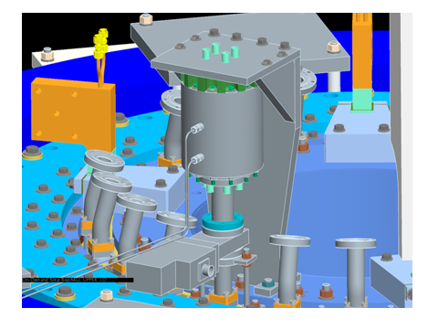–

Attachment B Upper MGI

Attachment C Lower MGI

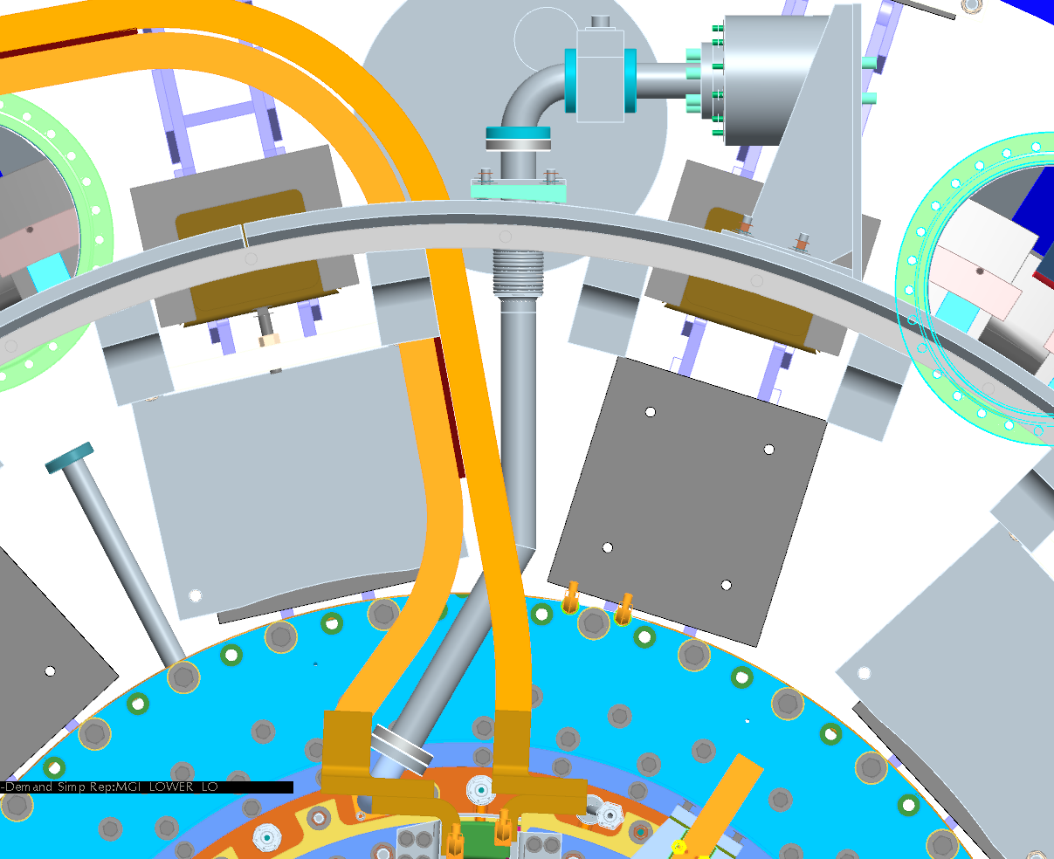

Attachment D Lower MGI

