Application Note:
Spyder 3 GigE Vision Camera Micro-Code Field Upgrade Instructions

Introduction
This document provides step-by-step instructions on how to perform a field upgrade of the Spyder 3 Gige Vision camera's micro-controller firmware using the Xmodem Bootloader.
The Xmodem Bootloader allows you to reprogram the camera’s software code using a standard terminal program, such as HyperTerminal, when new software code updates become available for the camera. This application was designed to assist in the download of software code into the camera without having to return the camera to DALSA for reprogramming and without exposing the ISP or JTAG interface.

Requirements
- PC running Microsoft Windows running the Coyote application (located from Start > Programs > Pleora Technologies Inc > iPort software > Coyote Application).
- HyperTerminal (installed with Windows).
- A serial port connection using either: Serial (RS232) null modem cable (DB9-DB9). Or, a virtual serial port software. Some good virtual serial port software are available at: http://www.softinfinity.com/ and http://www.virtual-serial-port.com/.

Part One: Establish a serial port connection
- Start the Coyote application program. On the Windows task bar, click the Start button > Programs > Pleora Technologies Inc > iPort software > Coyote Application.
- Establish a connection with a camera by clicking Detect button.
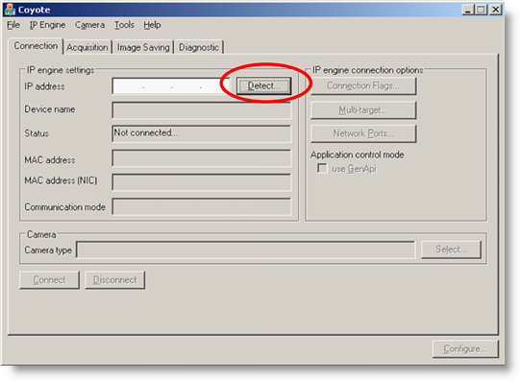
- Select the detected GigE Vision camera.
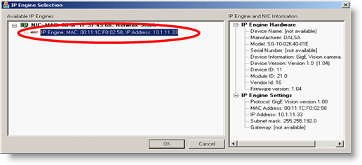
- Click the Connect button.
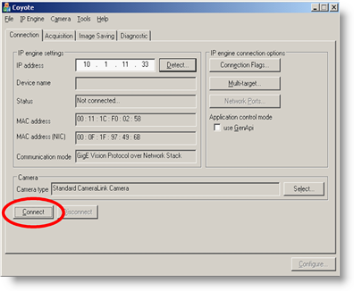
- Using either Method A (Virtual Serial Port) or Method B (Physical Serial Port), described below, establish a serial port connection.
Method A (virtual serial port)
Open your virtual serial port software (see Requirements, above, for some options) and establish a connection between any two COM ports.
Refer to your virtual serial port software documentation if you require more information about how to connect serial ports.
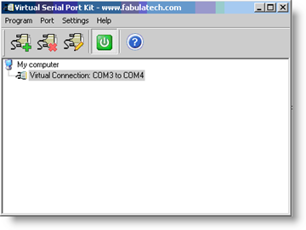
Method B (physical serial port)
Connect any two free, physical COM ports using a null modem cable.
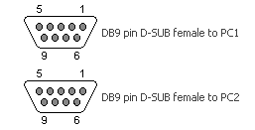
- After establishing a serial port connection, ensure that the Connection tab is selected in Coyote. Note: This step is important.
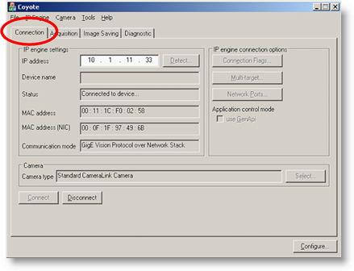
- From the menu bar, select the IP Engine menu.
- From the IP Engine dropdown menu, select the Serial COM port link... item.
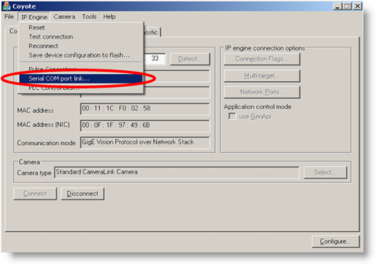
- The Serial Port Configuration dialog box opens and allows you to attach the serial channel in the Coyote application to one port in a serial port pair, either a physical pair or virtual pair. Therefore, an external application needs simply to connect to the other serial port of the pair in order to communicate with the camera.
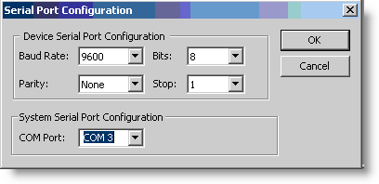
- Click OK.

Part Two: Set up the HyperTerminal connection
- Open the HyperTerminal application by clicking the Start button > Programs > Accessories > Communications > HyperTerminal.
- If you get the Connection Description dialog box, name the connection and associate an icon with it. Click OK.
- In the Connect To dialog box, select the COM port from the Connect using: dropdown menu.
- ...Different if the terminal already exists or is created new...Co ?
- Select File > Properties in order to open the New Connection Properties dialog box.
- Select the other COM port from the Connect using: dropdown box.
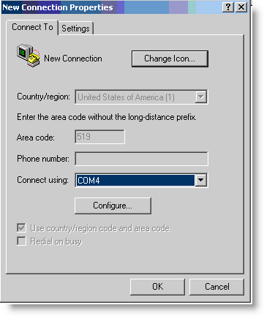
- Click the Configure… button.
- The COM Properties dialog box displays.
- Set the Port Settings as shown:
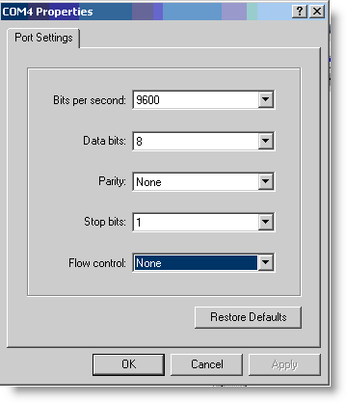
- Press OK to accept the settings.
- In the Properties dialog box, select the Setttings tab.
- Click the ASCII Setup... button.
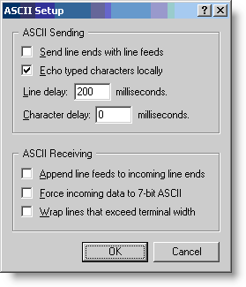
- Check the Echo typed characters locally box.
- Click OK to accept the changes.
- Click OK in the Properties dialog box.

Part Three: Upgrade the camera code
With the HyperTerminal application running:
- Press the Return key to get the OK> prompt in the HyperTerminal window.
- Start the Bootloader by sending the pjb command. This feature is used to upload the new micro-controller firmware.
- The following message displays:
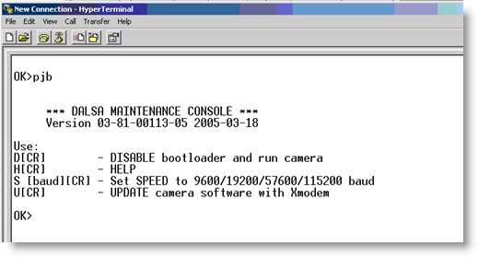
Bootloader command.
- Enter the command U to begin the file upgrading process.
- On the HyperTermincal menu bar, select the Transfer menu.
- From the Transfer dropdown menu, select the Send File… item.
- The Send File dialog window displays.
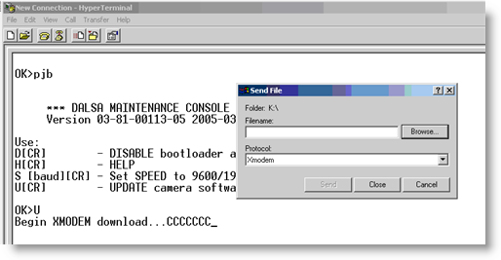
Upgrade command.
- In the Filename box, enter the filename of the new firmware code. Or, browse to the location of the code to download (e.g. 03-81-00138-00.hex).
- In the Protocol dropdown list, select the Xmodem protocol.
- Click the Send button.
- The Xmodem file send window displays showing the progress of the download.
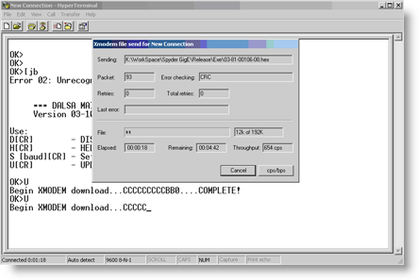
- Once the camera code has been completely written to FLASH, the XModem Bootloader responds with a COMPLETE! message.
- Press Enter on the keyboard and type the command d to return to normal camera operation mode.

Appendix A: Revision History
Revision Date | Revision Number | Change Description
July 24, 2007 | 00 | Preliminary release

