This is the How-To guide to using the PPPL Dataspace Archive.

Why does this website exist?

The Department of Energy/U.S. Gov requires that any publication supported by public funding must archive its data, in perpetuity, for access and download. Princeton University is providing a permanent digital data solution for this requirement, called the ‘Princeton University Dataspace’, or Dataspace for short. Only a subset of PPPL employees, called ‘Gatekeepers’, may upload data to the Dataspace. PPPL authors must submit their data to a Gatekeeper to be reviewed and the Gatekeeper will upload the data to the ‘Dataspace’. This website provides a tool for authors to upload and submit their data for review and submission to the Gatekeeper.

What you should know/be cognizant of as you write your paper.
Data representations. Think about how the figures and plots in your paper are generated and how to most efficiently store the numerical data represented in the figures/plots.
Data reproduction. Prepare to explain how to use the stored numerical data to reproduce the figures/plots in your paper.

I am ready to submit my manuscript! Now what?!?
Just do it! Submit the manuscript! But, don’t delete your data quite yet…

Gather metadata and prepare your archived dataset for your paper.

Gather Metadata
Title of paper
Author(s)
Name of Journal
etc.

Prepare your Abstract
Prepare a plain ASCII text (.txt) file that includes the text of the abstract of the paper. Do not include special characters. Expand special text representations (tex, etc.). This version of the abstract is only used for the Dataspace metadata – it does not affect your published abstract., but you should ensure that it reproduces the official abstract as closely as possible.

Prepare your dataset
Prepare a plain ASCII text (.txt) file, called ‘readme.txt’. This file should include sufficient instructions on how to use the attached data file(s) to reproduce every figure/plot/table in your paper.

Prepare the data file(s). You can store your data in a variety of formats: .txt, .csv, .hdf5 are a few examples of file formats that are popular. Most proprietary formats should be avoided, including.xls, .sav, and .mat, to name a few. There are few restrictions on how you choose to store your data. You may choose to have one file for each figure, multiple figures in a single data file, multiple files for a single figure, or a combination of above. You may even put all of your data into a single file. The key is to ensure that your ‘readme.txt’ file includes enough detail for the reader to be able to reproduce your figure(s) from the data file with minimal effort.

Login to the PPPL Dataspace Archive Website: http://pppl-dspace.pppl.gov/

Enter your Author ID (PPPL ID) in the box and click on the ‘login’ button. This is not case-sensitive. DO NOT ENTER YOUR PASSWORD ON THIS WEBSITE.

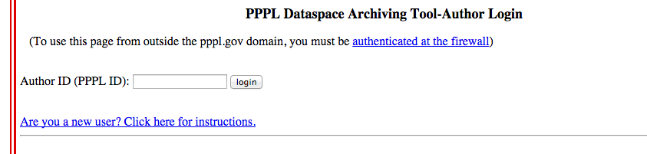

If you have any existing entries, they will appear in the list here. If this is your first visit, click the ‘Create New’ button to start a new archive entry.

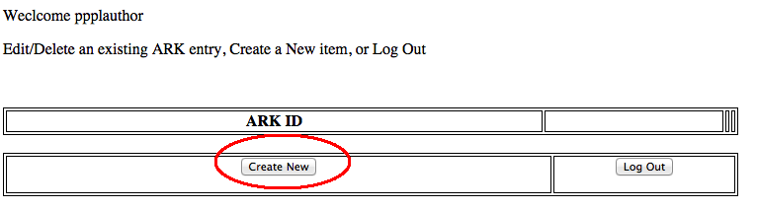

Create a new Dataspace entry

Enter a unique (to you) ‘ark_tag’ to identify your submission.

Fill out the metadata form. Upload the abstract file you created earlier by clicking the ‘Choose File’ button and finding the path to the file.

The form does not need to be completely filled out right now. You can come back and edit it later.

Save the form by clicking on the ‘Next’ button.

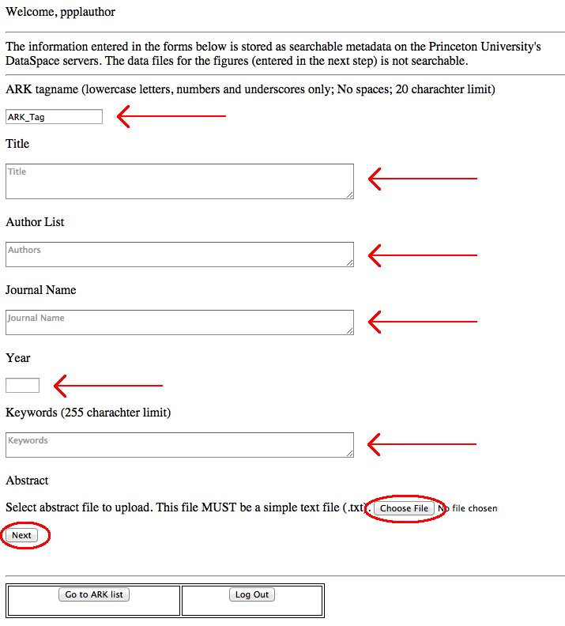

You will now see the entry for your archive. You may upload your data now, or later.

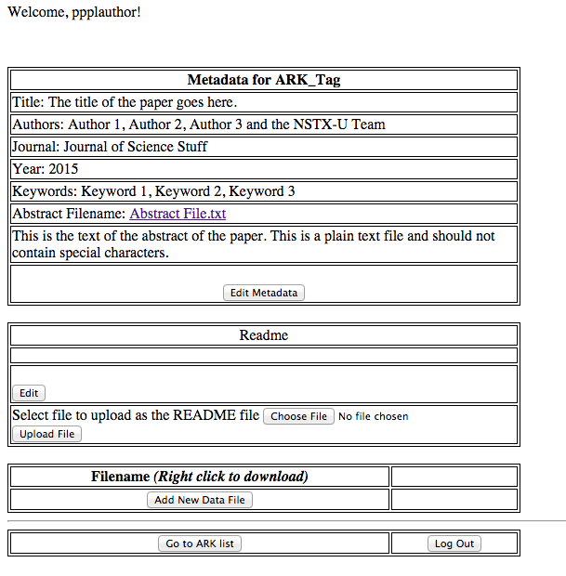

To upload new data, click on the ‘Add New Data File’ button, and follow the on-screen instructions.

You can log out at any time. You may return to this sight later to modify the metadata, readme or data files as your paper is revised. You may also delete data files.

As soon as your paper is accepted for publication, submit the proposed metadata and data set for approval.

Step 1: Select the appropriate Gatekeeper for your publication: NSTX-U (Stan Kaye), PS&T (Brent Stratton), etc.
Step 2: Click on ‘Submit for archival’.
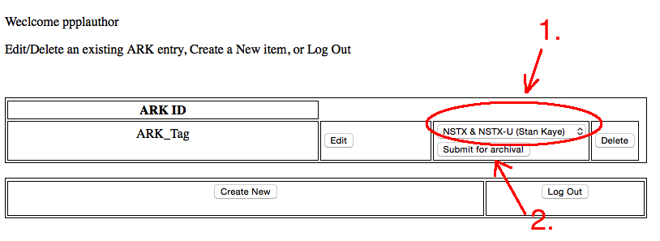

The Gatekeeper will ensure the submission satisfies the requirement of the USDOE and upload the data to the Princeton University Dataspace. When the data is archived, and permanent ARK/URI is generated for the paper and data submission. The Gatekeeper will contact the Author if there are any issues with the submission.

Optional: For the Final Proofs of the paper, update the reference to the Dataspace archive in your paper with the permanent URI. The Gatekeeper will send you the permanent URI for your publication after the data has been archived to the Dataspace.

