Princeton Plasma Physics Laboratory
NSTX Experimental Proposal
Title: Long pulse double null development at high κ and δ
OP-XP-508 | Revision: | Effective Date:  (Ref. OP-AD-97)  Expiration Date:  (2 yrs. unless otherwise stipulated)
PROPOSAL APPROVALS
Author: D. Gates |  |  | Date 3/2/2005
ATI – ET Group Leader: R. Maingi |  |  | Date
RLM - Run Coordinator: J. Menard, S. Sabbagh (Deputy) |  |  | Date
Responsible Division: Experimental Research Operations
Chit Review Board (designated by Run Coordinator)
MINOR MODIFICATIONS (Approved by Experimental Research Operations)

NSTX EXPERIMENTAL PROPOSAL
Long pulse double null development at high κ and δ OP-XP-508

1. Overview of planned experiment
The goal is to develop and study long pulse plasmas at high elongation and triangularity, taking advantage of the upgraded PF1A coil. The plasma will be shaped as early as feasible and the plasma will be ramped as quickly as possible, so as to minimize internal inductance. Early H-mode will also be attempted. Upon completion of the ramp-up phase of the XP, a toroidal field and plasma current scan will be performed.

2. Theoretical/ empirical justification
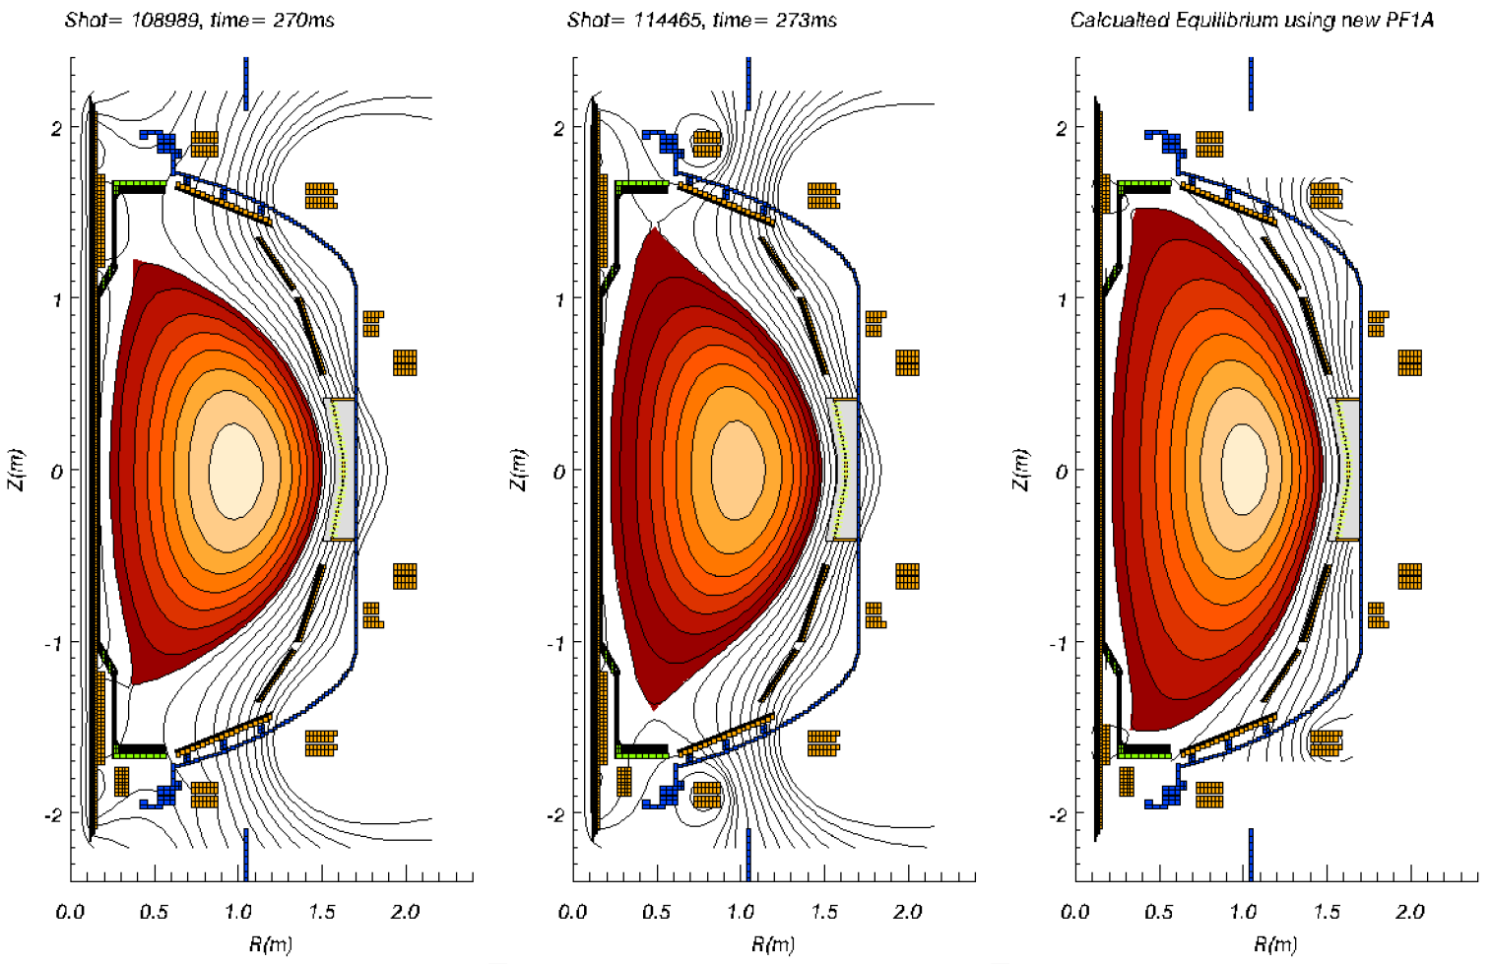
This experiment is the most recent in a series of experiments designed to investigate the performance of highly shaped double null plasmas. Both MHD stability calculations and time dependent integrated scenario modeling indicates that the modified PF1A coil, which enables the simultaneous achievement of high elongation and high triangularity, is capable of supporting interesting plasma performance regimes. This experiment directly addresses the goals of the NSTX five year plan.
Figure 1: Shape Evolution for NSTX double null plasmas since 2002.

3. Experimental run plan

1. Using the suggested coil currents below, attempt to ramp plasma to full shape as early as possible. Ramp plasma current at rates of 7MA/s through 10MA/s. Use 4.5kGauss. (15 shots)
PF1AU 13.0kA/MA
PF2U 0
PF3U -3.7kA/MA
PF5 -10.5kA/MA (feedback controlled)
PF3L -3.7kA/MA
PF2L 0
PF1AL 13.0kA/MA

2. Vary timing of current flat spot to induce early H-mode. Bias plasma downwards if necessary to help induce H-mode. Vary beam timing to optimize Ip flattop and stored energy. (15 shots)
3. Vary secondary current ramp rate to avoid MHD. Reduce from 8MA/s in 1MA/s second steps (10 shots).
4. Do Ip scan between 0.8 and 1.2MA. Bt scan between 3.0kGauss and 4.5kGauss. (30 shots)
Case | Bt | Ip
1 | 4.5kGauss | 1MA
2 | 4.0kGauss | 1MA
3 | 3.5kGauss | 1MA
4 | 3.0kGauss | 1MA
5 | 4.5kGauss | 1.2MA
6 | 4.5kGauss | 0.8MA
7 | 4.0kGauss | 1.2MA
8 | 3.5kGauss | 1.2MA
9 | 3.0kGauss | 1.2MA
10 | 4.0kGauss | 0.8MA
11 | 3.5kGauss | 0.8MA
12 | 3.0kGauss | 0.8MA

5. Do beam power scan for promising cases below to optimize sustained β (criteria to maintain q(0)>1 at lowest field possible).

4. Required machine, NBI, RF, CHI and diagnostic capabilities
Reliable high power NBI is a prerequisite. Thomson is required. CHERS and MSE are highly desirable. A recent boronization is required. It would be best to have investigated the use of the movable glow probe ahead of time.

5. Planned analysis
EFIT is required. TRANSP will be run on select shots according to data availability. TSC analysis is a possibility.

6. Planned publication of results
These types of discharges have typically been the subject of our invited talks about long pulse and steady state (Physics of Plasmas, Nucl. Fusion). If performance is as expected, this should be the case again. The usual single null double null comparisons will also be made.

PHYSICS OPERATIONS REQUEST
Long pulse double null development at high κ and δ OP-XP-508
Machine conditions (specify ranges as appropriate)
I_{TF} (kA): 36kA-54kA Flattop start/stop (s): N/A
I_{P} (MA): 0.8 - 1.2MA Flattop start/stop (s): 200ms/as long as possible
Configuration: Double Null
Outer gap (m): 10cm, Inner gap (m): 2-4cm
Elongation κ: 2.5, Triangularity δ: 0.8
Z position (m): 0.00
Gas Species: D, Injector: Midplane
NBI - Species: D, Sources: A/B/C, Voltage (kV): 90kV, Duration (s): 400ms
ICRF – Power (MW): None, Phasing: N/A, Duration (s): N/A
CHI: Off
Either: List previous shot numbers for setup: See chart above.
Or: Sketch the desired time profiles, including inner and outer gaps, κ, δ, heating, fuelling, etc. as appropriate. Accurately label the sketch with times and values.
DIAGNOSTIC CHECKLIST
Stability limits vs. normalized current at high delta with new PF1A OP-XP-508
Diagnostic | Need | Desire | Instructions
Bolometer – tangential array |  | 
Bolometer array - divertor |  | 
CHERS |  | 
Divertor fast camera |  | 
Dust detector |  | 
EBW radiometers |  | 
Edge deposition monitor |  | 
Edge pressure gauges |  | 
Edge rotation spectroscopy |  | 
Fast lost ion probes - IFLIP |  | 
Fast lost ion probes - SFLIP |  | 
Filtered 1D cameras |  | 
Filterscopes | 
FIReTIP |  | 
Gas puff imaging
Infrared cameras |  | 
Interferometer - 1 mm |  | 
Langmuir probe array
Magnetics - Diamagnetism | 
Magnetics - Flux loops | 
Magnetics - Locked modes |  | 
Magnetics - Pickup coils | 
Magnetics - Rogowski coils | 
Magnetics - RWM sensors |  | 
Mirnov coils – high frequency |  | 
Mirnov coils – poloidal array |  | 
Mirnov coils – toroidal array |  | 
MSE |  | 
Neutral particle analyzer
Neutron measurements | 
Plasma TV | 
Reciprocating probe
Reflectometer – core
Reflectometer - SOL
RF antenna camera
RF antenna probe
SPRED |  | 
Thomson scattering | 
Ultrasoft X-ray arrays |  | 
Visible bremsstrahlung det. |  | 
Visible spectrometers (VIPS) |  | 
X-ray crystal spectrometer - H
X-ray crystal spectrometer - V
X-ray PIXCS (GEM) camera
X-ray pinhole camera
X-ray TG spectrometer

