Princeton Plasma Physics Laboratory
NSTX Experimental Proposal
Title: Edge Turbulence in High Density Ohmic Plasmas on NSTX
OP-XP-??? | Revision: | Effective Date:  (Ref. OP-AD-97)  Expiration Date:  (2 yrs. unless otherwise stipulated)
PROPOSAL APPROVALS
Author: Kyron Williams, Jose Boedo, Stewart Zweben, Charles Bush, Rajesh Maingi |  |  | Date 5/25/06
ATI – ET Group Leader: Rajesh Maingi |  |  | Date
RLM - Run Coordinator: Roger Raman |  |  | Date
Responsible Division: Experimental Research Operations
Chit Review Board (designated by Run Coordinator)

MINOR MODIFICATIONS (Approved by Experimental Research Operations)

NSTX EXPERIMENTAL PROPOSAL
OP-XP-???

1. Overview of planned experiment
The goal of this experiment is to study edge turbulence in high-density Ohmic plasmas. The
experiment consists of a shot to shot density scan to examine the behavior of edge turbulence at or
near the density limit in NSTX.

2. Theoretical/ empirical justification
In previous campaigns density scans have been performed on NSTX, usually with the use of beams and gas injection. The intent of this experiment is to perform a density scan in Ohmic LSN plasmas to further understand edge turbulence in plasmas at or near the density limit in NSTX. It is important for this experiment to reach the Ohmic density limit and observe the changes in edge turbulence at this limit. A density scan in Ohmic plasmas provides the advantage of being able to make consistent turbulence measurements without any of the other changes introduced by NBI, for example, increased rotation and heating.
The theoretical justification for this experiment is that there is presently no clear theoretical understanding of the density limit in tokamaks. However, it is widely believed that edge turbulence can play a role in establishing this limit [1]. The proposed experiment will investigate the density limit in the simplest possible plasmas in a device in which there are excellent edge turbulence diagnostics. This information is potentially useful for checking theoretical models which could then be applied to evaluate the density limit in ITER.
The main measurements for this experiment are those of edge turbulence made using the GPI diagnostic and the scanning Langmuir probe. The GPI diagnostic is particularly ideal because it provides a 2D view of the radial and poloidal evolution of edge turbulence [2]. Edge turbulence has a intermittent “blob-like” 2D structure which has been observed in NSTX [3] and many other devices. For example, it has been shown in DIII-D that these intermittent structures increase in frequency with increasing density [4]. It has also been shown that these structures can move either radially or poloidally through the edge on NSTX [3] and Alcator C-Mod [5].
An experiment was done in March 2006 in NSTX to perform a density scan in NBI heated plasma [XP 604, “Density Scan” by Boedo et al]. Preliminary results from GPI diagnostic for this experiment indicate an increase in relative fluctuation and radial cross correlation coefficient with increasing density (Figure 1). Although this experiment covered a wide range of normalized density from 0.4 to 1.2 times the Greenwald density n_{G}, the density limit was not actually reached. For the proposed experiment this scan will be repeated in Ohmic plasmas and the density will be raised as far as possible up to the density limit.

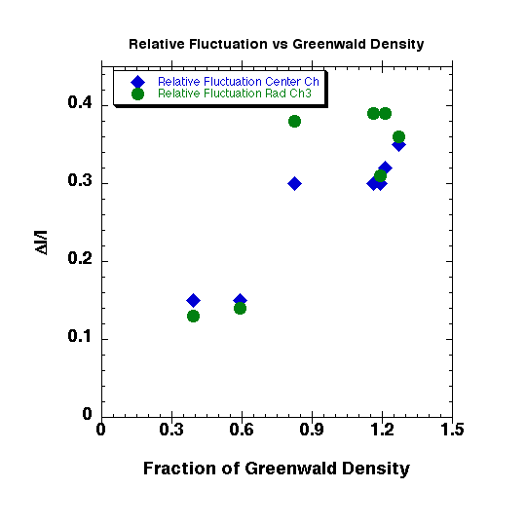
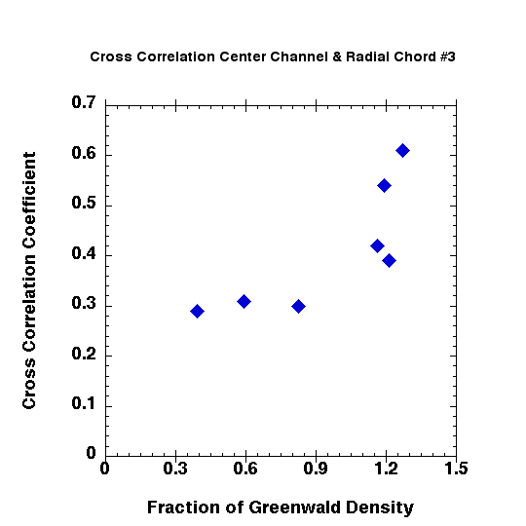

Figure 1: Results from XP 604 - Plots of the relative fluctuation and cross correlation coefficient versus density of the center channel and radial channel 3 @ I_{p}=800kA, P_{B} =2MW, and B_{T}=4.5kG. The relative fluctuations of the two channels increase with increasing density. The cross correlation coefficient between the channels also increases with increasing density. This trend in the cross correlation coefficient is indicative of an increase in the radial size of the turbulence as the density is increased.

References:
[1] Greenwald, M, Plasma Phys. Cont. Fusion 44, R27 (2002)
[2] Maqueda, R.J., et al, Rev. Sci. Instr. 74, 13 (2003)
[3] Zweben, S. J. et al. Nucl. Fusion 44, 134 (2004)
[4] Boedo, J., et al, Phys. Plasmas 10, 134 (2003)
[5] Grulke, O., et al, Phys. Plasmas 13, 012306 (2006)

3. Experimental run plan

This experiment calls for Ohmic lower single null discharges in L-mode. Outboard gas fueling will be used to maintain the L-mode. LSN, Ohmic L-mode Deuterium plasma w/ Deuterium puff on GPI [I_{p}=800kA, P_{B}=2MW, B_{T}=4.5kG, κ=1.7, outergap=5cm, aspect ratio=1.3, flattop=400ms].

Reference shot #119942 n_{G}=0.4 at 0.35 sec from XP621 (“Small ELM comparison” by Maingi)

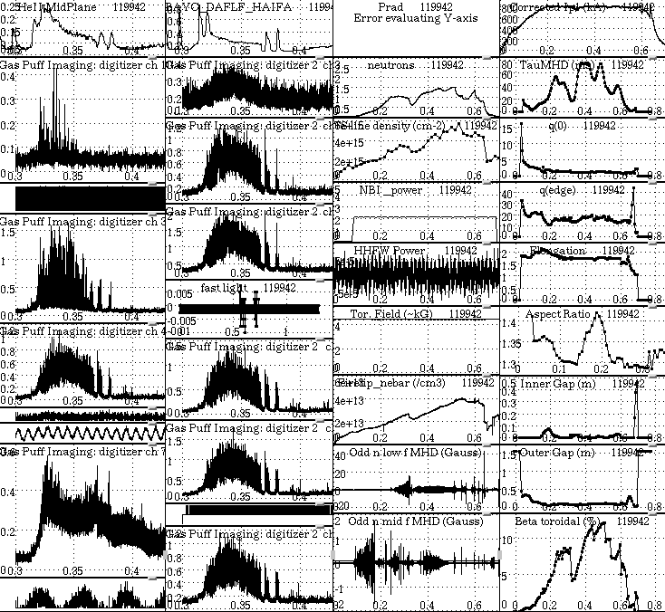

Figure 3: Some parameters from shot #119942 indicating desired conditions.

Proposed shot list:

0.4 n_{G} (2 shots to establish baseline same as 119942)

0.6 n_{G} (2 shots, raise gas puffing strength somewhat)

0.8 n_{G} (2 shots raise gas puffing strength somewhat)

1.0 n_{G} (2 shots raise gas puffing strength somewhat)

1.2 n_{G} (2 shots raise gas puffing strength somewhat)

1.3 n_{G} (2 shots raise gas puffing strength somewhat)

highest possible density >1.3 n_{G} (2 or more shots)

Total number of shots=16 (approx)

4. Required machine, NBI, RF, CHI and diagnostic capabilities
Boronized vessel, GPI high-speed camera, Thomson scattering 30ch, CHERS, fast probe, divertor probe, plasma TV, edge rotation diagnostic. It would be highly desirable to have fast camera views of the main chamber and/or divertor, in addition to the GPI fast camera view.

It is important that the outer gap be kept constant during the density scan in this experiment, since the GPI and scanning probe diagnostics need to have a consistent measurement window with respect to the outer separatrix.

5. Planned analysis
EFIT/LRDFIT and standard TRANSP confinement analysis.
Turbulence analysis will be conducted on chord data, camera and probe data. Chord and probe data will be analyzed to determine the turbulence level, relative fluctuation, autocorrelation time, radial and poloidal correlation lengths as well as the intermittency at the increased density. Blob frequency will also be characterized, from camera data, versus density, beam power, and other parameters. Analysis of turbulence data will be compared with data from previous L-mode and H-mode plasmas

6. Planned publication of results
If successful, data and analysis will be presented at APS DPP meeting and published iPhysics of Plasmas, Nuclear Fusion, or similar journal.
PHYSICS OPERATIONS REQUEST
Reference shot: 119942 OP-XP-???
Machine conditions (specify ranges as appropriate)
B_{TF} (kG): 4.5 Flattop start/stop (s): _____/_____
I_{P} (MA): 0.8 Flattop start/stop (s): _____/_____
Configuration: LSN
Outer gap (m): 0.05, Inner gap (m): _____
Elongation κ: 1.7 , Triangularity δ: _____
Z position (m): 0.00
Gas Species: D, Injector: Midplane / Inner wall / Lower Dome
NBI - Species: none, Sources: , Voltage (kV): _____, Duration (s): _____
ICRF – Power (MW): 0, Phasing , Duration (s): _____
CHI: Off
Either: List previous shot numbers for setup: _____________________________
Or: Sketch the desired time profiles, including inner and outer gaps, κ, δ, heating, fuelling, etc. as appropriate. Accurately label the sketch with times and values.
DIAGNOSTIC CHECKLIST
Error: Reference source not found OP-XP-???

Diagnostic | Need | Desire | Instructions
Bolometer – tangential array
Bolometer array - divertor
CHERS | x
Divertor fast camera | x
EBW radiometer
Edge pressure gauges
Edge rotation spectroscopy |  | x
Fast lost ion probes |  | x
Filterscopes |  | x
FIReTIP | x
Gas puff imaging | x
H camera - 1D |  | x
Infrared cameras
Interferometer - 1 mm
Langmuir probe array |  | x
Magnetics - Diamagnetism
Magnetics - Flux loops | 
Magnetics - Locked modes
Magnetics - Pickup coils | 
Magnetics - Rogowski coils | 
Magnetics - RWM sensors
Mirnov coils – high frequency
MSE
Neutral particle analyzer
Neutron measurements
Plasma TV | 
Reciprocating probe
Reflectometer – core
Reflectometer - SOL | x
SPRED
Thomson scattering | x
Ultrasoft X-ray arrays
Visible bremsstrahlung det.
Visible spectrometer (VIPS)
X-ray crystal spectrometer - H
X-ray crystal spectrometer - V
X-ray GEM camera
X-ray pinhole camera

