Princeton Plasma Physics Laboratory
NSTX-U Experimental Proposal
Title: Comparison of Private Flux Region with Conventional Mid-plane MGI on NSTX-U
OP-XP-1519 | Revision: 0 | Effective Date:  (Approval date unless otherwise stipulated)  Expiration Date:  (2 yrs. unless otherwise stipulated)
PROPOSAL APPROVALS
Responsible Author: R. Raman |  |  | Date 7/2/2015
SG, TSG or TF Leader (assigned by RC): J. Berkery, J-K Park |  |  | Date
Run Coordinator (RC): J.E. Menard |  |  | Date
Responsible Division: Experimental Research Operations: S.P. Gerhardt
RESTRICTIONS or MINOR MODIFICATIONS
(Approved by Experimental Research Operations)

NSTX-U EXPERIMENTAL PROPOSAL
TITLE: Comparison of Private Flux Region with Conventional Mid-plane MGI on NSTX-U | No. OP-XP-1519
AUTHORS: R. Raman, S.P Gerhardt, D. Mueller,  D. Battaglia, J. Berkery, L-A. Delgado, A. Diallo, N. Eidietis,  V.A. Izzo, T.R. Jarboe, B.P. LeBlanc, W-S. Liang,  S.A. Sabbagh, F. Scotti, V. Soukhanovskii, K. Tritz, others… | DATE: 7/2/2015

1. Overview of planned experiment
Asses benefits of Massive Gas Injection (MGI) into the Private Flux Region (PFR) vs. the conventional Low Field Side (LFS) Mid-plane injection.
- Part A (Establish critical trigger times)
  - Establish Thomson trigger times
  - Establish calibration settings for diagnostics
  - Test diagnostics in a MGI triggered disruptive plasma
- Part B (Comparison or PFR vs. LFS injection)
  - Measure vessel halo currents and divertor heat loads from a reference disruptive discharge without MGI mitigation
  - Inject MGI from location 1 and 2 into a DN or LSN discharge to assess benefits

2. Theoretical/ empirical justification
- Predicting and controlling disruptions is an important and urgent issue for ITER. Reactors based on the ST and Tokamak concepts will carry several MA of plasma current and therefore have the potential to disrupt, which can cause expensive and unacceptable levels of vessel damage.
- Several tokamaks have studied the use of massive gas injection from the low field side to safely terminate tokamak discharges.
- NSTX-U MGI research will improve the knowledge base on Disruption Mitigation (DM) with MGI by studying the importance of the poloidal gas injection location, especially from the private flux region.
- This is the first MGI experiment to be conducted on NSTX/NSTX-U, so a primary objective is to implement MGI capability on NSTX-U to support the FY16 JRT on DM research.

3. Experimental run plan
Part I (16 shots) – Day 1
Comparison of Mid-Plane to Lower Divertor Injection
- Start with Config-1 for Mid-Plane MGI
- Load the reference low current shot with the PFR over the MGI gas port (2 reference shots)
- At t1 = 400ms, inject using the mid-plane MGI (2 shots)
- Conduct 20 minutes HeGDC between shots
- Repeat by injection using the lower divertor MGI (2 shots)
- On two shots, vertically disrupt the plasma to measure divertor heat loading and divertor halo currents (2 shots). This will be done by freezing the voltage in the PF3U/PF3L coils at the values at 400ms (in the PCS System Category) and then imposing a +30V increment to the PF3U voltage.
- Repeat Mid-plane and Lower-divertor injections at two different times (t2 and t3) so that there is a measurable difference in the proximity of the q = 2 surface to the plasma edge (8 shots)
Part II (8 shots) – Day 2
Pre-TQ Duration and Radiated Power to MGI Proximity to Plasma
- Use Config. 3 for Mid-plane MGI
- Restore Reference shot from Part -I (2 shots)
- At the same three times inject form the Mid-plane MGI location (2 shots at each condition for the q=2 surface) (6 shots)
Part III (6-8 shots) – Day 2
Test of MGI conditions for a high power H-mode discharge
- Now Load a 1MA, 4-6 source H-mode discharge (2 shots)
- At a suitable time, inject using the mid-plane injector (2 shots)
- Vertically disrupt the discharge to obtain divertor heat loading and halo-current data (2 shots)
- It time permits, repeat using the lower divertor MGI at the same injection time (2 shots)

4. Required machine, NBI, RF, CHI and diagnostic capabilities
- 200 Torr.L of Ne will be used for all experiments (based on FY2013 and 2014 DIII-D experience)
- Will conduct XP after the vessel Li is nearly used up
- Will rely on long HeGDC to restore operating conditions
- Will use NBI heated L-mode discharge (~700 kA). This is the low current plasma. The toroidal filed will be limited to 0.4 to 0.45 T
  - Will use H-mode plasmas if possible
- Will use Double Null or Lower Single Null discharge with PFR over injection port.
- NBI will be turned off at MGI injection time
- Will conduct a limited set of experiments using a high-current H-mode discharge to begin to develop plasma conditions for FY16 JRT

An XMP must be run before this XP to:
- Develop and Test the 700kA and 1MA discharges for use in this XP
- Test the VDE implementation in these discharges
- To establish the Thomson trigger time and gain attenuation settings
- To adjust gains on all the other diagnostics (Visible camera, SXR, bolometers,
Spectroscopic detectors, two color divertor IR camera

5. Planned analysis
- Compare the following parameters for the three cases:
  - Duration of pre-TQ and TQ
  - Power radiated, and profile during pre-TQ and TQ
  - Divertor heat loading
  - Divertor halo currents
  - Gas assimilated by the discharge
- Case 1: PFR vs. Mid-plane injection - (PFR injection, Mid-plane injection, and Un-mitigated VDE)
- Case 2: Mid-plane with Short and Long connection tubes
- Case 3: High-power and Low-Power discharges with short connection mid-plane tubes

Details of analysis:
Thomson scattering, EFIT, interferometer
- Physics of gas penetration (fraction that penetrates separatrix)]
H-alpha array, Spectroscopic detectors
- System response time (gas trigger time to first detection of injected gas interacting with the plasma edge)
Multi-color Soft X-ray, H-alpha, Ip, EFIT, Thomson scattering, Mirnov coils
- Delay in current quench after the gas contacts plasma edge, and the Pre-TQ and TQ phases
- Rate of current quench and vertical dynamics of the plasma
- 3-D MHD response to the whole equilibrium and MHD activity
- Thermal quench evolution & pedestal collapse
Bolometer array
- Core radiated power dynamics
Halo current sensors
- Dependence on halo current amplitude on gas assimilation (Mitigated vs. a VDE disruption)
Two color divertor fast infrared camera and Eroding thermocouples
- Spatial distribution of Thermal loads & fast heat flux measurements

6. Planned publication of results

Even the data obtained from the first 8 hours devoted to commissioning the MGI system (the MGI XMP) is publishable, and suitable for the 2016 IAEA meeting

Data collected during the second 8 hours provides results from mid-plane to PFR injection comparison, which are all internationally new results (6 good shots are adequate for this work). The additional data at two additional values of the q=2 location substantially improves the data set.

Data from the third day will determine if installing the MGI closer to the vessel allows more gas to be assimilated, or if the pre-TQ duration simply gets shorter. It also provides data on the overall response time of the MGI system for the short, and the more-realistic long injection configurations. The implications of the pre-TQ data is quite important for ITER MGI implementation.

The limited data from the 1MA discharge is to begin to prepare for the FY16 JR, and to identify any difficulties associated with running these high current cases.

7. Estimated Neutron Production
Based on the number of shots, plasma current levels, and expected durations, estimate the maximum neutron production of this experiment. See calculator in Appendix #2 for this calculation.
# of Shots used in Estimate: 32 Estimated Total Neutron Production: 4.28E15
PHYSICS OPERATIONS REQUEST
TITLE: Comparison of Private Flux Region with Conventional Mid-plane MGI on NSTX-U | No. OP-XP-1519
AUTHORS: R. Raman, S.P Gerhardt, D. Mueller,  D. Battaglia, J. Berkery, L-A. Delgado, A. Diallo, N. Eidietis,  V.A. Izzo, T.R. Jarboe, B.P. LeBlanc, W-S. Liang,  S.A. Sabbagh, F. Scotti, V. Soukhanovskii, K. Tritz, others… | DATE: 7/2/2015

Brief description of the most important operational plasma conditions required and any special hardware requirement:
Approximately 700 kA, L-mode, 2-3 NBI sources, with private flux region (PFR) over lower divertor gas injection port, at BT ~0.4 to 0.45T, without
Approximately 1MA, H-mode, 4-6 NBI sources, BT=0.55T (like 129120)
Previous shot(s) which can be repeated:
Previous shot(s) which can be modified: Lo-current shot: Need to develop this shot, but shape similar to 134986
High Current shot – Like 129120 (800 kA, 6MW NBI, H-mode)
Machine conditions (specify ranges as appropriate, strike out inapplicable cases)
B_{T} Range (T): 0.4-0.55 Flattop Duration (s): 1s
I_{P} Range (MA): 0.7 – 1.0 Flattop Duration (s): 0.5s
Configuration: DN / LSN
Equilibrium Control: Outer gap or Isoflux (rtEFIT)
Outer gap (m): NA Inner gap (m): NA Z position (m): NA
Elongation: NA Triangularity (U/L): NA OSP radius (m): *
Private Flux Region over lower divertor gas injector
Gas Species: D2 + Ne Injector(s): Any + MGI
NBI Species: D Heating Duration (s): 0.5s
Any suitable beam combination is OK. We will reproduce these shots over and over again under less than ideal wall conditions, so the important note is that the discharge should reproduce easily.
ICRF Power (MW): 0 Phase between straps (°): Duration (s):
CHI: Off Bank capacitance (mF):
LITERs: Off Total deposition rate (mg/min) or dose per discharge (mg):
EFC coils: Off

DIAGNOSTIC CHECKLIST [1]
TITLE: Comparison of Private Flux Region with Conventional Mid-plane MGI on NSTX-U | No. OP-XP-1519
AUTHORS: R. Raman, S.P Gerhardt, D. Mueller,  D. Battaglia, J. Berkery, L-A. Delgado, A. Diallo, N. Eidietis,  V.A. Izzo, T.R. Jarboe, B.P. LeBlanc, W-S. Liang,  S.A. Sabbagh, F. Scotti, V. Soukhanovskii, K. Tritz, others… | DATE: 7/2/2015

Note special diagnostic requirements in Sec. 4
Diagnostic | Need | Want
Beam Emission Spectroscopy
Bolometer – midplane array | X
CHERS – poloidal
CHERS – toroidal
Divertor Bolometer (LADA) | X
Divertor visible cameras | X
Dust detector
Edge deposition monitors [2]
Edge neutral density diag.
Edge MIGs [2]
Penning Gauges [2]
Edge rotation diagnostic
Fast cameras – divertor [2] | X
Fast ion D_alpha - poloidal
Fast ion D_alpha - toroidal
Fast lost ion probes - IFLIP
Fast lost ion probes - SFLIP
Filterscopes [2] | X
FIReTIP | X
Gas puff imaging – divertor
Gas puff imaging – midplane
Hα cameras - 1D [2] | X
Infrared cameras [2] | X
Langmuir probes – divertor | X
Langmuir probes – RF
Langmuir probes – RF ant.
Magnetics – Diamagnetism | X
Magnetics – Halo currents | X
Magnetics – RWM sensors | X

Note special diagnostic requirements in Sec. 4
Diagnostic | Need | Want
MAPP
Mirnov coils – high f. | X
Mirnov coils – toroidal array | X
MSE-CIF
MSE-LIF
Neutron detectors [2] | X
Plasma TV | X
Reflectometer – 65GHz
Reflectometer – correlation
Reflectometer – FM/CW
Reflectometer – fixed f
Reflectometer – SOL
SSNPA [2]
RF edge probes
Spectrometer – divertor | X
Spectrometer – MonaLisa | X
Spectrometer – VIPS | X
Spectrometer – LOWEUS | X
Spectrometer – XEUS | X
TAE Antenna
Thomson scattering | X
USXR – pol. Arrays | X
USXR – multi-energy | X
USXR – TG spectr. | X
Visible Brems. det. [2]
Notes:
[1] Check marks in this table do not guarantee diagnostic availability. Check with diagnostic physicists or research operations management to ensure diagnostic coverage.

[2] In some cases, a given line represents multiple diagnostics. For instance, there are multiple SSNPAs, multiple IR cameras, multiple neutron detectors, and multiple Langmuir probe arrays.

Appendix #1: Allowed Neutral Beam Power vs. Pulse Duration

Heating of the primary energy ion dump limits the beam duration to that given in the following table:
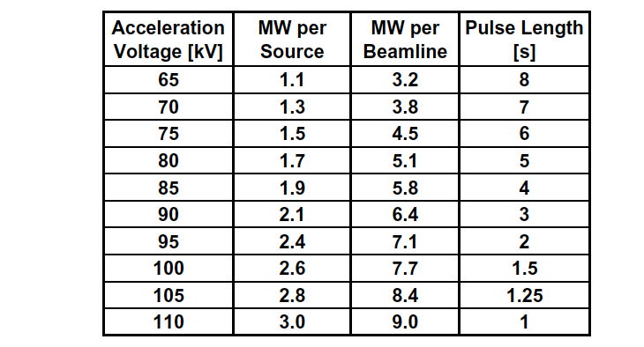
Table A1: Beam power and pulse length as a function of acceleration voltage

Appendix #2: Table for neutron rate estimations:

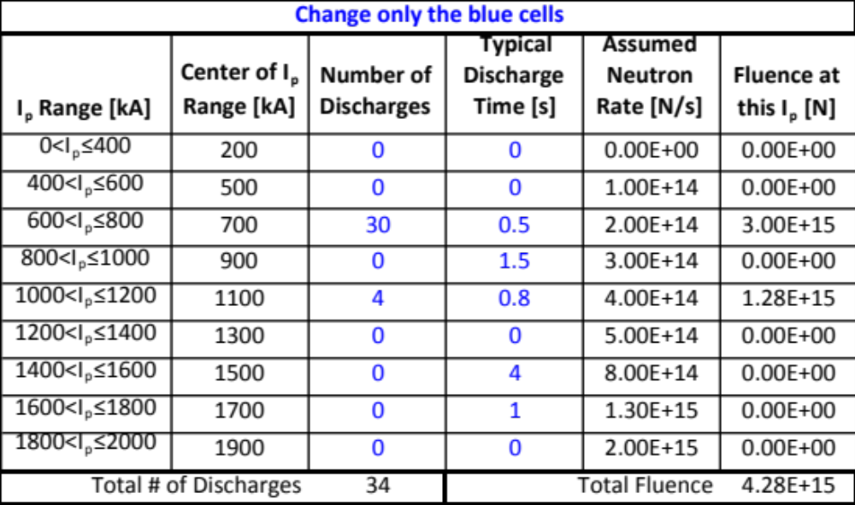
Table A2: Neutron Emission Rate Calculator. Double click to open in excel for automatic calculation. Change only the blue cells.

