+Princeton Plasma Physics Laboratory
NSTX Machine Proposal
Title: Develop optimal SGI parameters for perturbative particle transport experiment
OP-XMP- |  | Revision: 0 |  |  | Effective Date:  Expiration Date:  (2 yrs. unless otherwise stipulated)
Proposal Approvals
Responsible author: Yang Ren |  |  |  |  |  | Date 04/05/2015
ATI (NSTX Physics Ops): |  |  |  |  |  | Date
RLM (NSTX Expt. Research Ops): |  |  |  |  |  | Date
Responsible Division: Experimental Research Operations
Procedure Requirements
designated by RLM
 | NSTX Work Permit |  |  | T-MOD (OP-AD-03)
 | Independent Review |  |  | ES&H Review
RESTRICTIONS AND MINOR MODIFICATIONS
Approved by RLM

REVIEWERS (designated by RLM)
Organization/Position | Name | Signature
ATI | D. Mueller
Test Director
Independent Reviewer
NB system
RF systems
FCPC systems
Diagnostics

TRAINING (designated by RLM)
Training required: No Yes Instructor _____________________

Personnel (group, job title or individual name) | Read Only | Instruction | Hands-On
RLM _______________________________
NSTX MACHINE PROPOSAL
TITLE: Develop optimal SGI parameters for perturbative particle transport experiment | No. OP-XMP-
AUTHORS: Y. Ren, W. Guttenfelder, S.M. Kaye, S. Gerhardt, A. Diallo, S. Kubota, J. Lang, B.P. LeBlanc, R.E. Bell, V. Soukhanovskii, D.R. Smith, W. Wang, H. Yuh | DATE: 04/03/2015

1. Overview:
Particle transport in STs is not well understood, and its understanding is important for predicting density profile for future devices. Perturbative particle transport measurement has been established in conventional tokamaks: density perturbation resulting from repetitive gas puff is measured by reflectometry, and particle diffusivity and pinch are inferred from the amplitude and phase of the induced density perturbations. NSTX-U has a fast gas puff system (SGI) and with appropriate modulation cycle, NSTX-U’s multi-point Thomson scattering system can be used to measure density perturbations.

2. Justification:
An XMP is needed to establish optimal SGI parameters (perturbation period, duty cycle and gas puff amount) for perturbative particle transport experiment using NSTX-U MPTS diagnostic. The MPTS time resolution of 16 ms requires that the gas puff cycle has to be much larger than 16 ms. In order to obtain good phase and amplitude resolution for the fundamental Fourier component of the density perturbation, we would like to obtain at least 10 measurement points within a perturbation cycle and have at least 4 cycles for Fourier analysis. This requires that the perturbation period to be >160 ms and quasi-steady period of the shot to be > 640 ms.

3. Plan:
The optimal timing for this XMP is to follow Deyong Liu’s XMP where a MHD-quiescent L-mode scenario will be established and after long shot capability is obtained. The long shot capability can significantly reduce the number of shot needed for this XMP [to optimize the utilization of shots, a minimum flattop length of 1.62 s is needed (see below)].
The SGI system can be used as a regular gas injector with normal plenum pressure (2500 Torr) or with higher gas pressure to provide supersonic gas flow. This XMP will explore which configuration is optimal for density perturbation purpose. One very useful feature of the SGI system is that it can provide almost arbitrary gas injection waveform. In this XMP, we will exploit this feature.
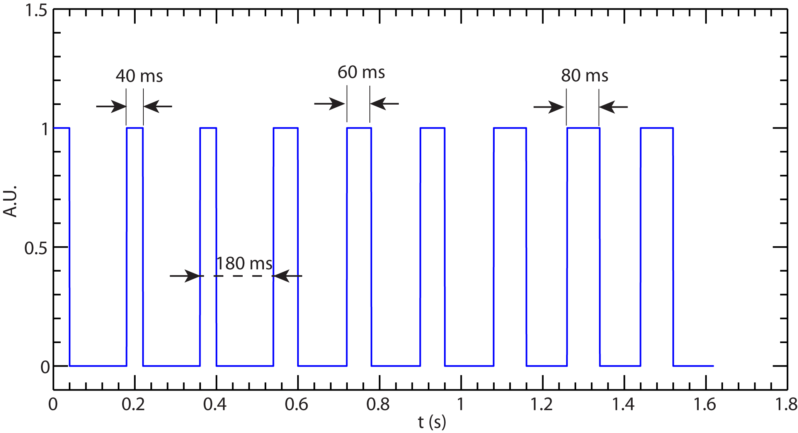
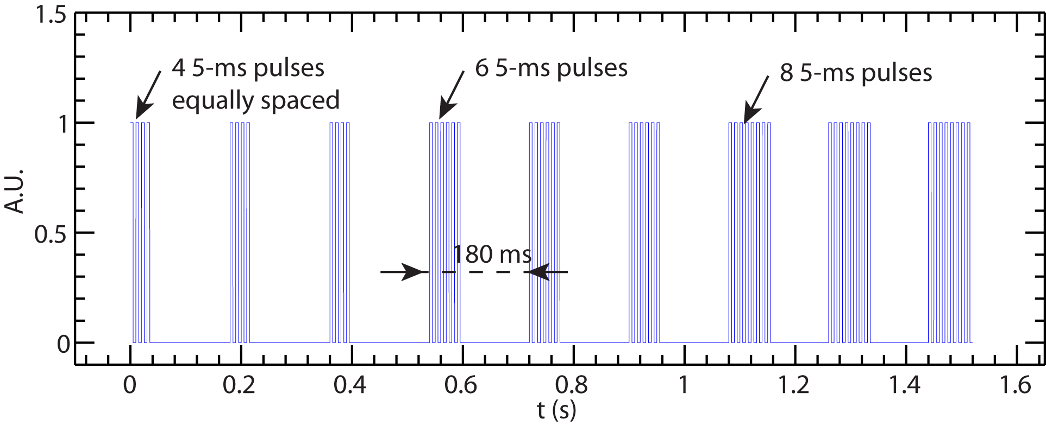
MAST has already explored their optimal parameters for perturbative gas puff: 20 ms/40 ms duty cycle (60 ms cycle period). We would like to start with longer cycle period (180 ms) with similar duty cycle ratio (60 ms/120 ms). The criterion of optimal density modulation is that it should allow us to achieve nearly sinusoidal density perturbation without density accumulation. Depending on the result, we will increase/decrease the SGI puff time by 20 ms increment to assess density modulation. Here we can utilize the arbitrary gas injection waveform capability of the SGI coupled with long shot capability of NSTX-U. We are planning to have 3 cycles with 40/140 ms duty cycle, another 3 cycles with 60/120 ms duty cycle and another 3 cycles with 80/100 ms duty cycle (see Fig. 1). This requires that the current flattop is at least1.62 s long. Also note that if the SGI nozzle is open for the full 60 ms, the supersonic feature cannot be used since too much gas would be injected. Thus, we will first try to use the SGI as a regular gas injection system with lower plenum pressure. We also would like to test the supersonic feature of the SGI and, to do this, we will need to avoid opening the valve for the whole 40/60/80 ms duration and we are planning to use a cluster of short pulses (5 ms puff time) to inject gas. The number of short pulses can be determined by matching the amount of gas puffed in with the regular gas injection configuration. The regular gas puff rate is about 100 Torr∙L/s which leads to a gas puff amount of 4/6/8 Torr∙L for 40/60/80 ms, respectively. The SGI puff rate is higher, ~200 Torr∙L/s (from a SGI calibration conducted in 2008), which leads to a gas puff amount of 1 Torr∙L for one 5 ms short pulse. Thus, in order to match 4/6/8 Torr∙L total gas puff amount as for the previous configuration, 4/6/8 5-ms SCI short pulses in the 40/60/80 ms duration are needed, respectively (see Fig. 2). Of course, the number of short pulses will be adjusted after newest SGI calibration is performed in the near future.
Figure 1 Proposed SGI puff waveform with SGI used as a regular gas injection system.
Figure 2 Proposed SGI puff waveform with supersonic injection.
Here is the shot plan:
- Shot 1: use SGI configuration as shown in Fig. 1 and the SGI is configured as a regular gas injection system.
- Shot 2: adjust SGI cycle time and duty cycle according to experimental results from shot 1:
- If density perturbation drops too fast than the intended cycle time of 180 ms, increase gas puff time to 90/100/110 ms. If density perturbation is already strong and increasing gas puff time is not a choice, reduce perturbation cycle time to observed density perturbation cycle time. However, the cycle time should not drop below 128 ms. If this is the case, reduce SGI plenum pressure and increase puff time to 90/100/110 ms (plenum pressure reduced with the amount gas puffed kept constant).
- If density accumulation occurs, increase cycle time to 220 ms with the same gas puff time
- Shot 3: use SGI configuration as shown in Fig. 2 with supersonic gas injection.
- Shot 4: adjust SGI cycle time and duty cycle according to experimental results from shot 3
- If density perturbation drops too fast than the intended cycle time of 180 ms, increase gas puff time to 9/10/11 5-ms pulses. If density perturbation is already strong and increasing gas puff time is not a choice, reduce perturbation cycle time to observed density perturbation cycle time. However, the cycle time should not drop below 128 ms. If this is the case, reduce SGI plenum pressure and increase gas puff time to 9/10/11 5-ms pulses (plenum pressure reduced with the amount gas puffed kept constant).
- If density accumulation occurs, increase cycle time to 220 ms with the same gas puff time
4. Required machine, beam, ICRF and diagnostic capabilities:
(Note any special requirements or configurations for equipment or diagnostics)
Need long quasi-stationary MHD-quiescent L-mode plasma
SGI calibration needed before the XMP can be carried out.

5. Sign off at run time:
5.1 Permission to Proceed:
Physics Operations Head
5.2 Documentation of results:
Documentation of the results completed, attached to proposal and sent to Ops. Center with copies to Cognizant Physicist and Head of Physics Operations.

Cognizant Physicist/Test Director

