Notes from 1/20/17 meeting

Assess downsizing TS beam dump supporting structure to leave more space for high-k
The modification of the support is satisfactory to UC-Davis and Labik is fine with the modification
Stratton discussed this with LeBlanc. He is content with this solution. We need to coordinate the scheduling of the MPTS modification and High K installation. Aim to get drawing done by the end of Feb. Still pending, but we can use our new Bay L layout to define the modifications.

Explore alternative options for high-k receiving optics, e.g. using mirror to redirect scattering beams downward (UC-Davis)
CDR carried out on September 26th
Lens-based system will be used as shown in CDR
Certain radial locations and rotation angles limited by interference with FPD; PPPL will investigate possible solution.
Working on CAD layout on Bay L including FPD, MPTS, High K, cameras, shutters.

PPPL will determined the required thickness of high-k exit window and UC-Davis will get quote with the information provided by PPPL (price not likely to go up much with increase thickness if required) (Ellis, Sibilia, Domier)
In acquisition, on track for 1/27/2017 delivery.

Look into Bay G port arrangement this week
Sibilia has sent bay G photos to UC-Davis
PPPL to assess space at bay G;
UC-Davis has sent launching optics design to PPPL;
A side from Sibilia showed in CDR
Visually inspect Bay G against CAD arrangement (Ellis)
Should be ok. Maybe minor field modifications.

High-k exit window shutter design (Ellis)
Conceptual design is done
Ready for drafting. Aim to start drafting after laser exhausting drafting is done. Put in draft request early next week.
Drafting is in progress. Started this week.

Start Bay G launching window acquisition; UC-Davis will provide specs; PPPL will determine the window thickness; UC-Davis will get a quote for the window (Domier, Ellis)
In acquisition;
Check with procurement (Kaita and Ellis) Received. Leak checked. The necessity of over-pressure test is to be determined.

Schedule of the delivery of high-k laser
Remain in UC-Davis until optics system finished; to be shipped early next year
Vent system to be taken care of Bower and Kai; need mechanical drafting (Scott and Ren coordinating) Drafting request in place. Work has started. Evan Scott met with designer.
Drafting nearly finished. Talk to designer next Monday.
Drafting complete.

Interference to high-k view line from MSE-LIF shutter (Ellis, Domier)
Investigation is ongoing ; Narrow high-k beam or modify shutter design
Do in-situ measurement to determine the interference. Next week maybe.
Ellis generated a layout of beam, steering, shutter, vacuum vessel. Have modeled intersection with shutter, inserted points on cut which will be used to define an elliptical cut. Hope to confirm with an in-vessel measurement next week. We discussed this at a videoconference on January 12.
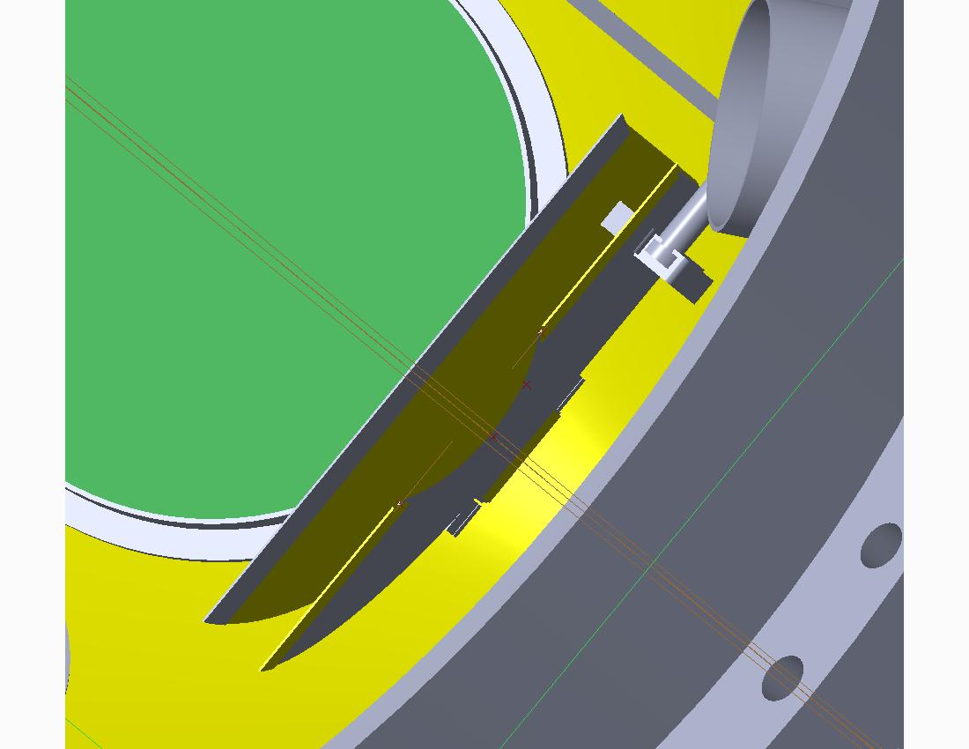

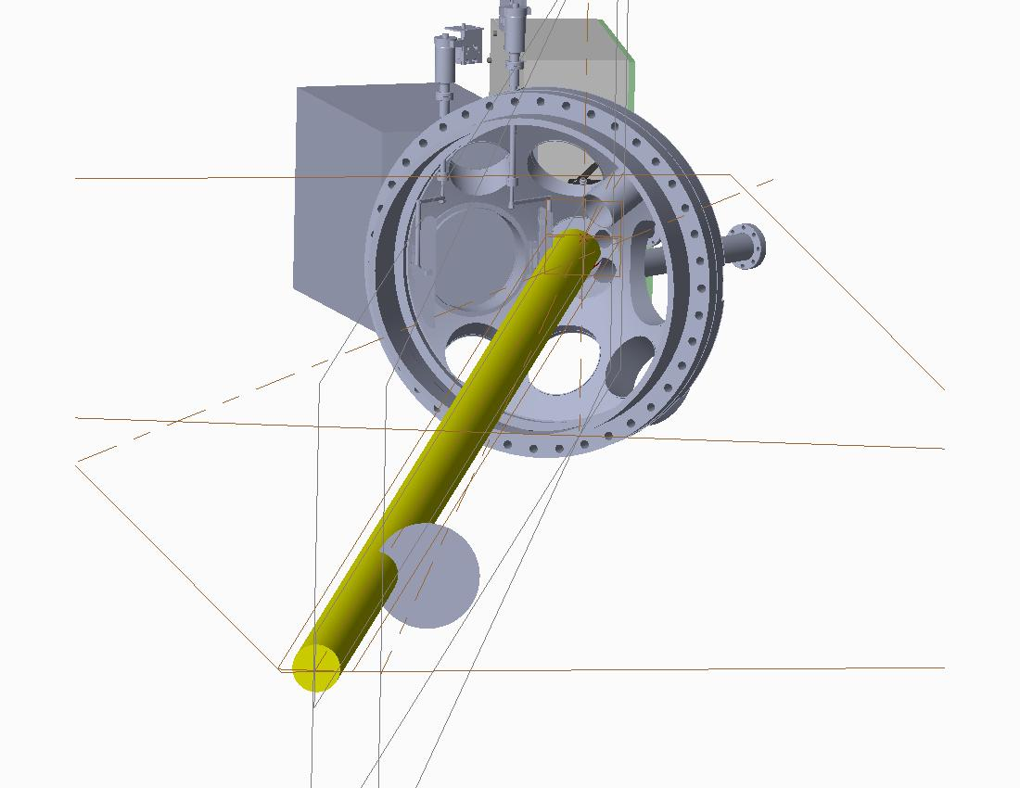
Assess location, space and AC power for high-k reference mixer box (Ellis, Domier)
This continues on PPPL side. We have a proposed location. Ellis has estimated electromagnetic moment on the box. ~140 foot-pounds assuming 5 mm thick aluminum box. We will have a designer add the box to the general arrangement.
13’’x9”x7” box design right now and PPPL needs to determine the limitation. This size is acceptable. UC-Davis has completed the assembly.

Waveguide installation (Ellis)
FIReTIP waveguide procedure has been approved. Assembling Engineering Work Package [Blue Folder]. FIReTIP waveguide drawings have been approved. Assembly of mockup FIReTIP and High K waveguides has started. Mock up in progress. High-k waveguide can be installed after the FIReTIP waveguide. FIReTIP waveguide installation has started.

To determine the time of FDR (Ellis)
Try for the third week of January. (Date TBD)
More like February 12-13.

UC-Davis is to send Ellis the latest CAD model for interference check (done).
Ellis will check

To check the status of the FIReTIP retroreflector (Scott)
To be done. Check existing photos of NSTX-U interior. Have somebody take a photo for us or try to use a mirror on a stick to examine the retroreflector.

Evan Scott will coordinate the transfer of power supply information from UC Davis to PPPL’s Electrical Drafting for the E-stop installation.

