Notes from 02/03/17 meeting

Assess downsizing TS beam dump supporting structure to leave more space for high-k
The modification of the support is satisfactory to UC-Davis and Labik is fine with the modification. Stratton discussed this with LeBlanc. He is content with this solution. We need to coordinate the scheduling of the MPTS modification and High K installation. Aim to get drawing done by the end of Feb. Still pending, but we can use our new Bay L layout to define the modifications. May start next week (week of 02/06/2017).

Explore alternative options for high-k receiving optics, e.g. using mirror to redirect scattering beams downward (UC-Davis)
CDR carried out on September 26th
Lens-based system will be used as shown in CDR
Certain radial locations and rotation angles limited by interference with FPD; PPPL will investigate possible solution.
Working on CAD layout on Bay L including FPD, MPTS, High K, cameras, shutters and internal coils.

PPPL will determined the required thickness of high-k exit window and UC-Davis will get quote with the information provided by PPPL (price not likely to go up much with increase thickness if required) (Ellis, Sibilia, Domier)
In acquisition, on track for 1/27/2017 delivery (delivered; QA in process)

Look into bay G port arrangement this week
Sibilia has sent bay G photos to UC-Davis
PPPL to assess space at bay G;
UC-Davis has sent launching optics design to PPPL;
A side from Sibilia showed in CDR
Visually inspect Bay G against CAD arrangement (Ellis)
Should be ok. Maybe minor field modifications.

High-k exit window shutter design (Ellis)
Conceptual design is done
Drafting is in progress. Started this week. Almost finished 90%.

Start Bay G launching window acquisition; UC-Davis will provide specs; PPPL will determine the window thickness; UC-Davis will get a quote for the window (Domier, Ellis)
In acquisition;
Check with procurement (Kaita and Ellis) Received. Leak checked. The necessity of over-pressure test is to be determined.

Schedule of the delivery of high-k laser
Remain in UC-Davis until optics system finished; to be shipped early next year
Vent system to be taken care of Bauer and Cai; need mechanical drafting (Scott and Ren coordinating) Drafting request in place. Work has started. Evan Scott met with designer.
Drafting finished. Writing a NEPA form is needed.
Interference to high-k view line from MSE-LIF shutter (Ellis, Domier)
Investigation is ongoing ;Ellis generated a layout of beam, steering, shutter, vacuum vessel. Have modeled intersection with shutter, inserted points on cut which will be used to define an elliptical cut. Hope to confirm with an in-vessel measurement next week. We discussed this at a videoconference on January 12. Will show a model to MSE people in the week of 02/06/2017.
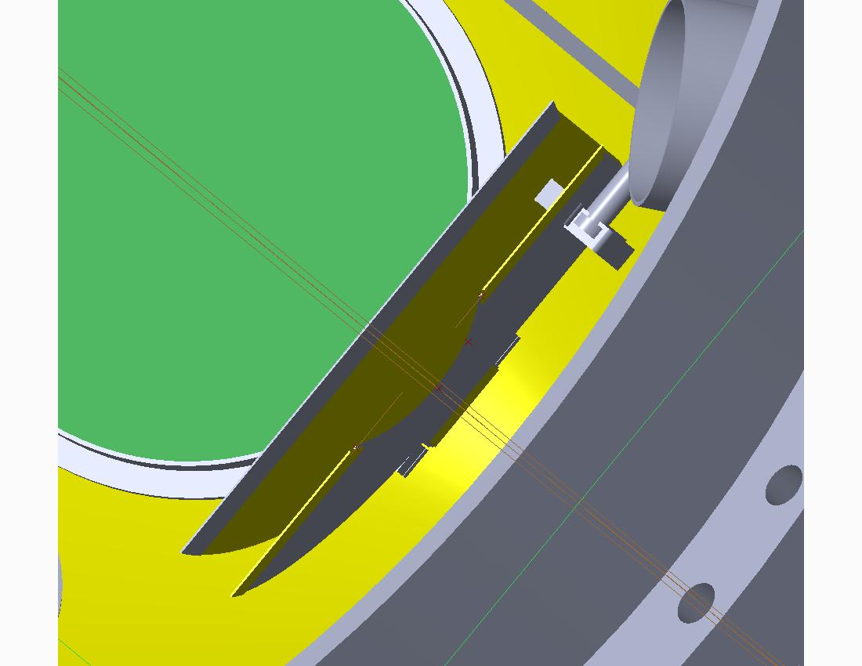

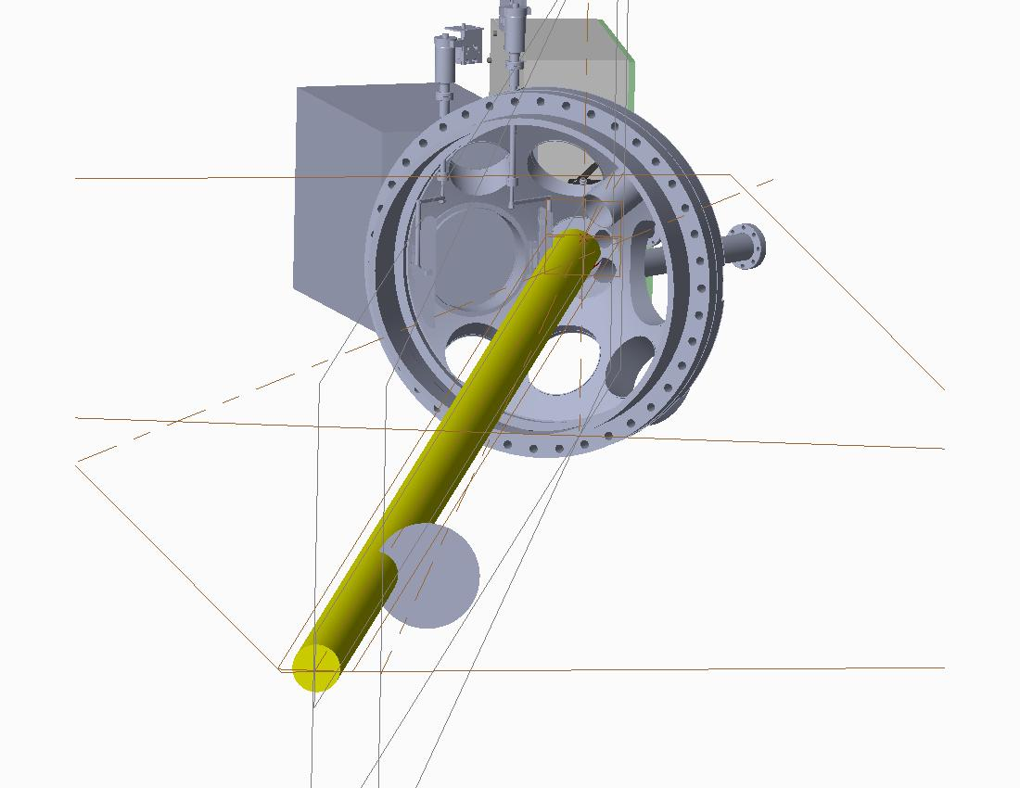
Assess location, space and AC power for high-k reference mixer box (Ellis, Domier)
This continues on PPPL side. We have a proposed location. Ellis has estimated electromagnetic moment on the box. ~140 foot-pounds assuming 5 mm thick aluminum box. We will have a designer to add the box to the general arrangement.
13’’x9”x7” box design right now and PPPL needs to determine the limitation. This size is acceptable. UC-Davis has completed the assembly.

Waveguide installation (Ellis)
FIReTIP waveguide procedure has been approved. Assembling Engineering Work Package [Blue Folder]. FIReTIP waveguide drawings have been approved. Assembly of mockup FIReTIP and High K waveguides has started. Mock up in progress. High-k waveguide can be installed after the FIReTIP waveguide. FIReTIP waveguide installation is in progress. Plan to level waveguides through penetration on 02/06/2017.

To determine the time of FDR (Ellis)
More like the week of February 13th

UC-Davis is to send Ellis the latest CAD model for interference check (done).
Ellis will check

To check the status of the FIReTIP retroreflector (Scott)
To be done. Check existing photos of NSTX-U interior. Have somebody take a photo for us or try to use a mirror on a stick to examine the retroreflector. Picture was taken. Two faces look good and the third face is covered. May be able to install a blocker to protect it. Need to figure out how to remove the coating. Need to have the coating analyzed.

Evan Scott will coordinate the transfer of power supply information from UC Davis to PPPL’s Electrical Drafting for the E-stop installation (done)
FIReTIP installation is FY18 NSTX-U diagnostic milestone.
High-k installation and commissioning is FY19 NSTX-U diagnostic milestone.

