Notes from 3/3/17 meeting

Assess downsizing TS beam dump supporting structure to leave more space for high-k
The modification of the support is satisfactory to UC-Davis and Labik is fine with the modification. Stratton discussed this with LeBlanc. He is content with this solution. We need to coordinate the scheduling of the MPTS modification and High K installation. Aim to get drawing done by the end of Feb. Still pending, but we can use our new Bay L layout to define the modifications. Need to wait for Bay L receiving optics adjustment.

Explore alternative options for high-k receiving optics, e.g. using mirror to redirect scattering beams downward (UC-Davis)
CDR carried out on September 26th
Lens-based system will be used as shown in CDR
Certain radial locations and rotation angles limited by interference with FPD; PPPL will investigate possible solution. Wedges eliminate the need to move above midplane. Wedges can be manually or remotely, depending on the priorities of PPPL and Yang Ren.
Working on CAD layout on Bay L including FPD, MPTS, High K, cameras, shutters and internal coils.
Step file sent to UC-Davis by Bob E.

High K exit window. PPPL will determined the required thickness of high-k exit window and UC-Davis will get quote with the information provided by PPPL (price not likely to go up much with increase thickness if required) (Ellis, Sibilia, Domier)
In acquisition, on track for 1/27/2017 Delivered

Look into bay G port arrangement this week
Sibilia has sent bay G photos to UC-Davis
PPPL to assess space at bay G;
UC-Davis has sent launching optics design to PPPL;
A side from Sibilia showed in CDR
Visually inspect Bay G against CAD arrangement (Ellis)
Should be ok. Maybe minor field modifications.

High-k exit window shutter design (Ellis)
Conceptual design is done
Drafting is in progress. Started this week. Almost finished 90-95%. Need to make sure the shutter does not interfere with RF camera view. RF and NB camera views are OK.Checking drawings

Start Bay G launching window acquisition; UC-Davis will provide specs; PPPL will determine the window thickness; UC-Davis will get a quote for the window (Domier, Ellis)
In acquisition;
Check with procurement (Kaita and Ellis) Received. Leak checked. The necessity of over-pressure test is to be determined. The pressure test will not overstress the epoxy, based on initial calculations [61 psi shear stress]. Ellis will confirm actual measurements of window week of 3/6-3/10.We will proceed with the overpressure test.

Schedule of the delivery of high-k laser
Remain in UC-Davis until optics system finished; to be shipped early next year
Vent system to be taken care of Bauer and Cai; need mechanical drafting (Scott and Ren coordinating) Drafting request in place. Work has started. Evan Scott met with designer.
Drafting finished. Writing a NEPA form is needed. NEPA form is finished. Being reviewed. Scott is to check how to get the drawing released. Drawing has been released.
Interference to high-k view line from MSE-LIF shutter (Ellis, Domier)
Investigation is ongoing ;Ellis generated a layout of beam, steering, shutter, vacuum vessel. Have modeled intersection with shutter, inserted points on cut which will be used to define an elliptical cut. Hope to confirm with an in-vessel measurement next week. We discussed this at a videoconference on January 12. Talk to MSE people in the week of 02/20/2017. Need to find the actual dimension of the MSE-LIF shutter. Had meeting with MSE group. They agree in principle with our plan.
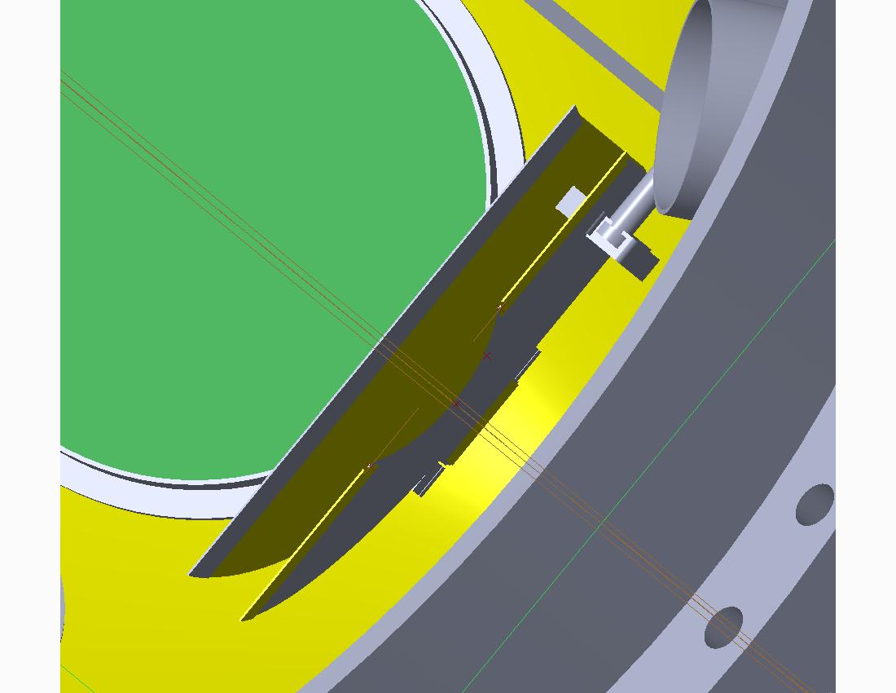

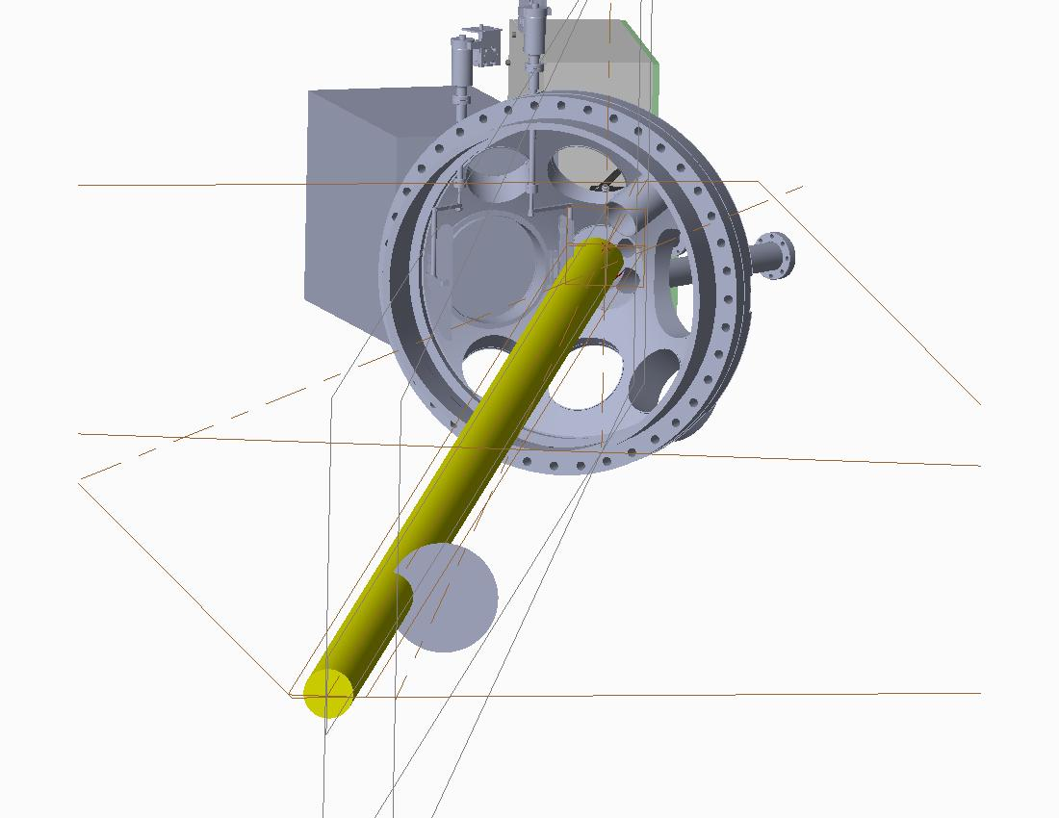
Assess location, space and AC power for high-k reference mixer box (Ellis, Domier)
This continues on PPPL side. We have a proposed location. Ellis has estimated electromagnetic moment on the box. ~140 foot-pounds assuming 5 mm thick aluminum box. We will have a designer to add the box to the general arrangement together with high-k waveguides. The ECN for adding the High K waveguide to our drawing is with drafting.
13’’x9”x7” box design right now and PPPL needs to determine the limitation. This size is acceptable. UC-Davis has completed the assembly.

Waveguide installation (Ellis)
FIReTIP waveguide procedure has been approved. Assembling Engineering Work Package [Blue Folder]. FIReTIP waveguide drawings have been approved. Assembly of mockup FIReTIP and High K waveguides has started. Mock up in progress. High-k waveguide can be installed after the FIReTIP waveguide. FIReTIP waveguide installation is in progress. Leveling waveguides through penetration is in progress. The section of waveguide in the penetration has been leveled.High K waveguide is installed and aligned up to Bay G.

To determine the time of FDR (Ellis)
More like the week of March 22nd. Week of April 10.

UC-Davis is to send Ellis the latest CAD model for interference check (done).
Ellis will check

To check the status of the FIReTIP retroreflector (Scott)
To be done. Check existing photos of NSTX-U interior. Have somebody take a photo for us or try to use a mirror on a stick to examine the retroreflector. Picture was taken. Two faces look good and the third face is covered. May be able to install a blocker to protect it. Need to figure out how to remove the coating. Need to have the coating analyzed.

Evan Scott will coordinate the transfer of power supply information from UC Davis to PPPL’s Electrical Drafting for the E-stop installation (done)
FIReTIP installation is FY18 NSTX-U diagnostic milestone.
High-k installation and commissioning is FY19 NSTX-U diagnostic milestone.

