TO: C. Neumeyer, J. Menard, S. Gerhardt
FROM: M.L. Reinke
Subject: Revising The GRD reversed field requirement and impact on shaping of PFC tiles

RECOMMENDATION: The requirement to reverse only the toroidal field direction should be removed from the NSTX-U General Requirements Document (GRD), allowing for designs of toroidally shaped tile geometries for surfaces that encounter a single magnetic field helicity. Sufficient ‘bi-directional’ shaping that would hide leading edges from diagnostics and gaps has a significant negative impact for heat flux handing at shallow impact angles expected for NSTX-U. Thus, high heat flux surfaces that could see either helicity should be shaped to allow a single dominant field line angle and NSTX-U operations restricted accordingly.

- While exploration of the I-mode operating space would benefit from reversed field operation to exploit near-term particle control techniques which are expected in lower single null plasmas, initial experiments to explore NSTX-U exploitation of the regime are possible in forward field, upper single null configuration.

- The so-called inboard divertor horizontal surface (IBDH) is proposed to be used as strike point location for either the inner or outer divertor leg which would preclude it being designed for a fixed helicity. While the impact on operational space needs further discussion, it is shown that IBDH outboard strike point heat flux handling would be compromised to gain meaningful inboard divertor heat flux handling. It is recommended that the IBDH be designed to only be used as an outer divertor and NSTX-U operational space reduced.

- The ability to reverse both the current and field directions, thus maintaining the helicity should remain for Boundary Science experiments, but initially only allow Ohmic and RF heating.

The present version of the GRD requires the ability to reverse the direction of the toroidal field. There is a physics purpose for this activity as it changes the direction of the so-called ‘grad-B drift’ relative to the vacuum vessel coordinate system. For NSTX-U and throughout this MEMO, ‘forward’ field is a toroidal field direction that is clockwise when viewed from the top down, which makes the direction of the $∇ \vec{B}×\vec{B}$ drift to be in the $-\hat{Z}$ direction. Many tokamaks have the flexibility to reverse the toroidal field, but at the same time also reverse the direction of the plasma current to maintain the same helical winding of the magnetic field. In NSTX-U, ‘forward’ current is in the counter clockwise direction when viewed from the top down, in the direction the neutral beams are pointing. Reversing the current direction (if even allowed per the present GRD), would significantly change the fast-ion transport from the neutral beam injection, significantly increasing fast-ion loss [J.A. Rome, et al. Nucl. Fusion v16 pg55 (1976)]. RF and Ohmic heating should be equally as effective in forward and reversed field, so plasma operations are still possible, but not at high heat flux and at peak performance. Reversing the plasma current direction also requires changing the direction of the poloidal field coils for systems that are not bi-polar.

From a plasma physics perspective, the direction of the toroidal field and thus the grad-B drift matter less if the plasma facing components are up-down symmetric like in NSTX-U. Unlike JET, AUG, ITER and many others, NSTX-U can run a biased upper null equilibrium which from a physics perspective would look identical to a biased lower single null in reversed field. Generally, devices with up-down symmetric PFCs do not have up-down symmetric diagnostic sets. While NSTX-U has many diagnostics for the upper divertor, the set is not symmetric, although future evolution is pushing in that direction as double null plasmas are of great interest. Present PFC conditioning via LiTER covers only the lower half of the chamber and the planned installation of the cryopump would be in the lower divertor. These make current and future particle control techniques up/down asymmetric.

Thus, some operational and physics research space would be impacted by removing the ability to run at reversed toroidal field. In particular, the I-mode operational regime [D.G. Whyte, et al. Nucl. Fusion v50 pg105005 (2010)] would benefit from reversed field to take advantage of particle control techniques in the lower divertor on NSTX-U. It has been demonstrated on conventional aspect ratio devices and is proposed as physics experiment on NSTX-U and is aligned with the high level goals of the facility. I-mode features L-mode like particle transport, and recent NSTX-U L-mode experiments demonstrated quasi-stationary operations without Li or cryopumping [W. Guttenfelder, et al. 59th APS-DPP G06.00004 (2016)], suggesting that the lack of both in the upper divertor may not be a problem. Access and sustainment of high performance I-modes is not yet known for spherical tokamaks. Lower absolute field has been shown to limit performance at R/a ~ 3 [A. Hubbard, et al. Nucl. Fusion v56 pg086003 (2016)], but there is a known increase in the L-H threshold power as aspect ratio drops [K.E. Thome, et al. Phys. Rev. Letters v116 pg175001 (2016)] that could influence the L-I-H transition phenomenology. Never the less, I-mode transition experiments and a baseline understanding of possible benefits of an ST-based I-mode device can be explored in an upper single null, forward field NSTX-U.

The reversal of the field also changes the direction of drifts active in the divertor region thought to play a role in changing the power sharing between the divertors. This is an important plasma physics phenomenon which can be explored by comparing upper and lower single nulls in devices with matched diagnostics, PFCs and fueling. The lack of this symmetry would mean NSTX-U boundary science would benefit from being able to study matched plasmas in lower single null configuration for both forward and reversed field. A reversal of the plasma current at the same time would maintain the helicity, and thus maintain the wetted area on any toroidally shaped tiles. But, a restriction needs to be made that input power be limited to RF and Ohmic power, neither of which are strongly impacted by changing the poloidal field. It may be possible to run low-power NBI, but this needs further study to examine fast-ion loss mechanisms and the GRD, or other requirements/system description document(s), could be updated in the future. Other devices have made important scientific contributions from studying boundary physics in Ohmic and low power RF-heated L-mode plasmas so we benefit from keeping fixed helicity, forward and reversed field options open for exploitation by the NSTX-U team.

Table 1 summarizes the combination of toroidal field (BT) and plasma current (IP) directions that should be considered to be allowable on NSTX-U as well as the auxiliary power that should be available.

CASE | BT | IP | ALLOWED | HEATING
1 | F | F | Y | FULL
2 | F | R | N | ---
3 | R | F | N | ---
4 | R | R | Y | RF+Ohmic Only
 | F=forward | R=reverse
Table 1: Description of proposed allowable combinations of toroidal and plasma currents and the auxiliary power. Forward for toroidal field defined as clockwise from the top down, while forward for current is defined as counter-clockwise from the top-down.
If the helicity for high power operations are fixed, then tiles can be shaped toroidally and/or poloidally to hide leading edges or diagnostic penetrations, referred to as ‘fish-scaling’. While this reduces risk from creating enhanced plasma contamination from sublimation (carbon) or melting (high-Z) leading edges, it results a reduction in the wetted area, as shown in Appendix A, limiting the peak heat flux that a (unrealistically) flat surface could accept. The toroidal slope of the tile, $β$, is defined by the maximum allowable attack angle, $α_{max}$, for all expected NSTX-U equilibria and results in an enhancement of heat flux directed at a flat surface that goes approximately as $1+{\sin{β}}/{α_{heat}}$. Here, $α_{heat}$ is the total angle the field makes to a flat surface during operations. High poloidal flux expansion scenarios have envisioned $α_{heat}<1^{0}$ while tile sizes and gaps suggest $0.5< β<1.0$. Thus, fish-scaling has a non-negligible impact on the nominally conformal surface heat flux that would otherwise be acceptable. This type of uni-directional fish-scaling could be used for IBDV and OBD surfaces as well because they see a fixed helicity, assuming Table 1 is followed. The CS sees a helicity that changes along the axis dependent upon the plasma location. Also because heat fluxes are expected to be lower and due to radiation, the benefit of tile shaping is unlikely to be significant. If the GRD can be amended, it would be expected that requirements for tile shaping will be included explicitly for each region of the machine in NSTX-RQMT-RD-002-XX.

For the IBDH tiles, the situation is more complicated because scenarios outlined in the original scope of NSTX-U [J. Menard, et al. Nucl. Fusion v52 pg083015 (2012)] could use this surface as either an inner or outer strike point. Tile shaping could still be used to hide leading edges, but at more substantial cost to wetted area if equivalent power sharing in both directions is desired.. This is done by creating a bi-directional fish-scaled surface as shown in Appendix B. To create surfaces able to accept heat flux in both directions, the surface of the area of the devoted to a fixed helicity would be reduced, but to combine this with shaping sufficient to hide gaps and account for build error dramatically reduces heat handling capabilities. Known plasma physics effects could be exploited to mitigate this. Assuming a forward field geometry, a strongly lower single null inner divertor has an approximate power loading of 30%, while the outer divertor is approximately 70%. In contrast, a strongly upper single null plasma would result in much closer to a 50/50 split between the inner and outer. In near double null plasmas, less power is directed to the inner divertor, but this is still at the 10-20% level. These numbers are based on MAST data shown in [R. Wenniger, et al. 26th IAEA-FEC FIP/P7-14 (2016)]. If a bi-directional fish-scale shape were employed in the lower divertor, more area could be devoted to its use as an outer divertor. But when practically running through the numbers similar to existing tile shapes, it is clear that to gain any worthwhile heat flux handling in the reversed helicity, i.e. for the IBDH to be an inner divertor in forward field, would dramatically compromise its ability to operate as a surface to accept high heat flux as an outer divertor. This is shown in Figure 1, generated from the equations derived in Appendix B, where the enhancement factor, $EF≡{(w+g)}/{l_{wet}}$, is defined to be the ratio of the flat tile surface to the wetted area of the shaped tile. To avoid a substantial increase in handling forward directed heat flux requires maintaining a small area of the tile to handling reversed directed heat flux, but via a geometry that substantially reduces wetted area for shallow angles of incidence. If tiles are nominally temperature limited, then accommodating a heat flux well above would could be accepted by a flat surface would mean reducing the duration of the plasma by the square of the enhancement factor. While maintaining the front surface enhancement to be ~2, similar to uni-directional fish-scaling, only large angles of reversed incidence could be considered, by at fractions of a second. Thus to gain any meaningful amount of heat flux handing in the reversed helicity for a surface design designed to handle $a_{max} \sim 6^{o}$ would dramatically reduce it’s ability to handle forward helicity power deposition.

For these reasons, it is recommended that the helicity in the IBDH be fixed to handle an outer divertor in the F/F or R/R Bt, Ip configuration defined in Table 1. This would allow the uni-directional fish-scale design to be implemented. This necessitates removal of the reversed field requirement from the GRD as well as inclusion of added requirements in the plasma control system to avoid stationary equilibria that have an inner strike point on the IBDH. The extent of the existing NSTX-U IBDH surface that is shaped to accept an outboard divertor strike point needs to be considered in more detail with input from all Science Groups. Moving the outer strike point from the IBDH to the OBD while keeping the inner strike point on the IBDV needs to be demonstrated to be within acceptable coil limits, both for physics operations but also to allow for strike point sweeping in high heat flux scenarios. In addition, the IBDH should not be considered to be designed symmetrically. The upper IBDH location changes relative to the OBD due to Lorentz and thermal expansion during the discharge creating a vertical mismatch.

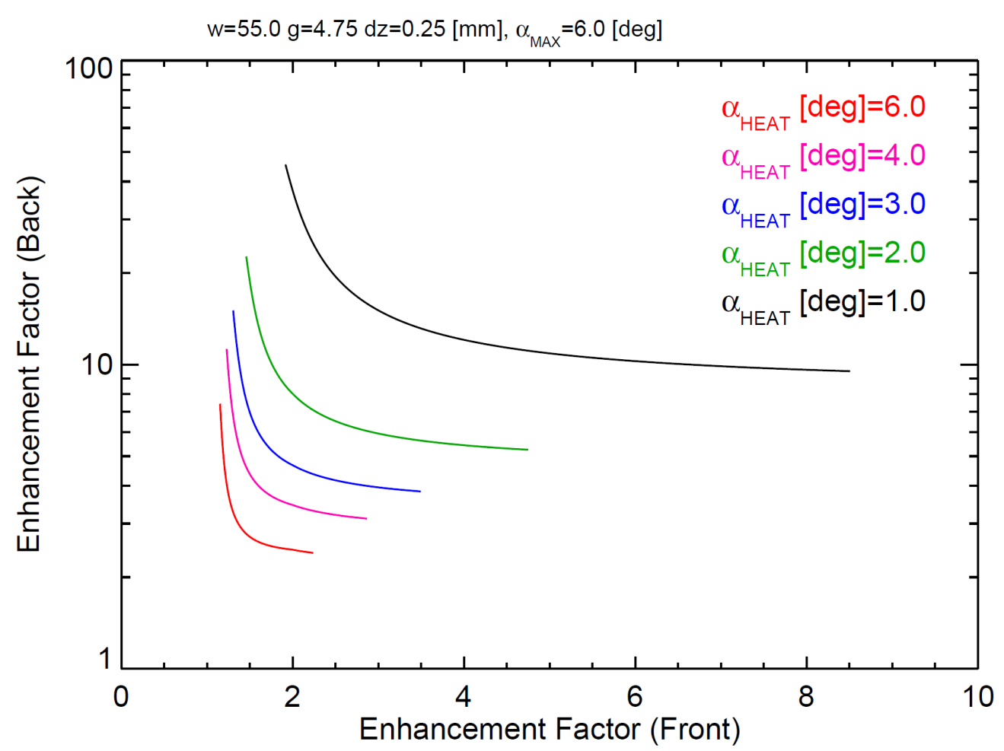
Figure 1: By varying the surface devoted to handling forward directed heat flux compared to reversed field, the heat flux enhancement relative to a conformal flat surface can be derived for both the front facing and back facing surfaces.

APPENDIX-A: Diagrams & Equations for Uni- Directional Fish-Scaling

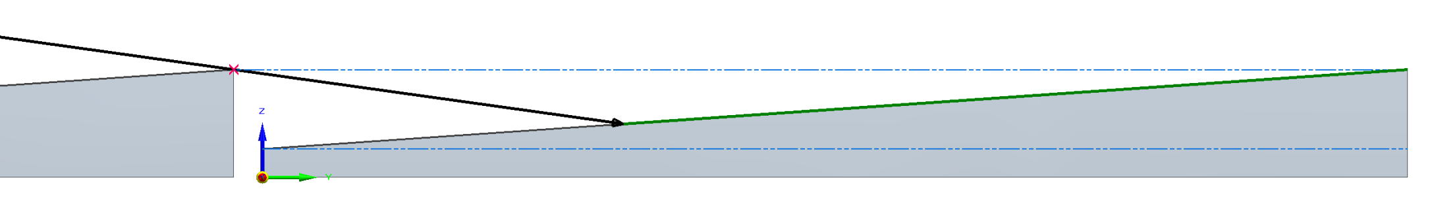
Tiles of length $w$ are designed to have an inclination angle, $β$, which should be minimized to avoid increasing heat flux at shallow angle of incidence from the plasma, $α_{heat}$. $β$ is determined by the maximum angle of incidence expected from the plasma, $α_{max}$, necessary to avoid creating a leading edge across a gap, $g$, and accounting for tile to tile build uncertainty, $δz$.
$$β$$
$$α_{heat}$$
$$w+g$$
$$l_{wet}$$

$$\tan{α_{max}=\frac{w\tan{β-δz}}{g} }$$

$$\tan{β=\frac{δz+g\tan{α_{max}}}{w}}$$

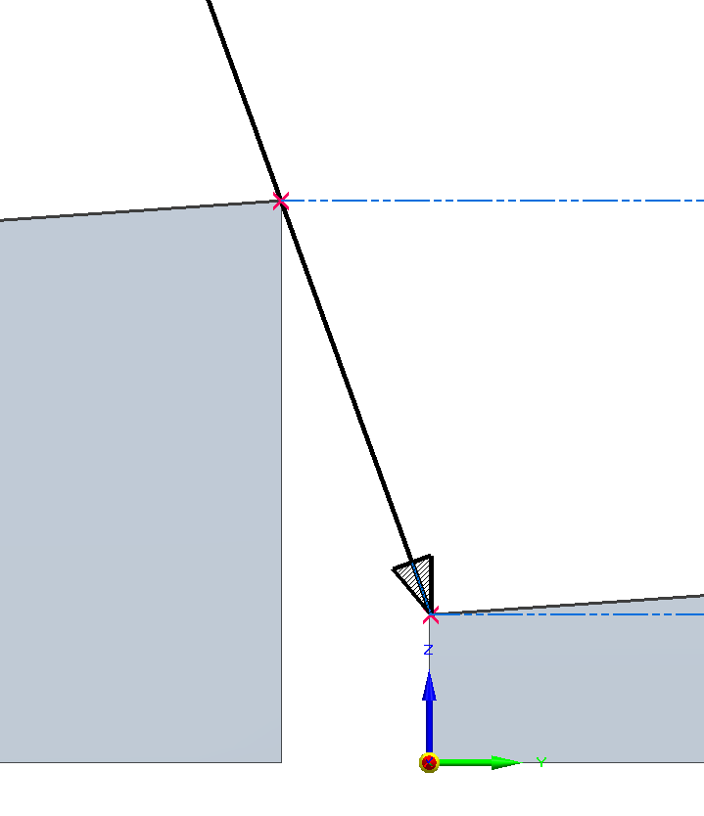
Knowing this angle, the impact on the heat loading can be derived. This is the enhancement factor, $EF≡{(w+g)}/{l_{wet}}$., for the heat flux that a fish-scaled tile would see relative to a continuous surface. This assumes the heat is directed in the same plane as the tile shaping.
$$g$$
$$α_{max}$$
$$w\tan{β}-δz$$
$$δz$$
Law of sines is used to relate $w+g$ to $l_{wet}$ as shown below,

$$\frac{\sin{α_{heat}}}{l_{wet}}=\frac{\sin\left(π-α_{heat} -β\right)}{w+g}$$

$$\frac{\sin{α_{heat}}}{l_{wet}}=\frac{\sin\left(α_{heat}+β\right)}{w+g}$$

$$\frac{w+g}{l_{wet}}=\frac{\sin{α_{heat}\cos{β+\cos{α_{heat}\sin{β}}}}}{\sin{α_{heat}}}$$

$$EF≡\frac{w+g}{l_{wet}}=\cos{β+}\frac{\sin{β}}{\tan{α_{heat}}}\sim 1+\frac{\sin{β}}{{\sin{α}}_{heat}}$$

The last equation shows a simplification for small angels of incidence, which if both $β$ and $α_{heat}$ are small further reduces the amplification to $1+β/{α_{heat}}$. For NSTX-U scenarios that are looking to employ poloidal flux expansion, and making $α_{heat}\sim 1^{o}$, fish-scaling will impact the heat loading. For tiles similar to the IBDH which are ~2” wide and need to shadow a 0.187” diameter hole for tool access and account for a 0.01” tile-to-tile vertical build error, then for $α_{max}=6^{o}$, $β\sim {0.85}^{o}$. In reality, this would be increased to shadow both the tile-to-tile gaps and the tool access, but designing new tiles should work to combine these two features to avoid unnecessarily increasing the enhancement factor.

APPENDIX-B: Diagrams & Equations for Bi-Directional Fish-Scaling Tiles

To derive the heat load enhancement factor for tile that can hide gaps and leading edges but still have some amount of heat flux handling in both directions is more complicated. The maximum impingement angle coming at the front, $α_{max,f}$ and the back, $α_{max,b}$ are both required. This, along with the tile to tile gap, $g$ and the vertical built uncertainty, $δz$, can be used to define the relationship for the back fish-scale angle, $β_{b}$.

$$\tan{α_{max,f}=\frac{l_{b}\sin{β_{b}-g\tan{α_{max,b}-δz}}}{l_{b}\cos{β_{b}+g}}}$$

To make further progress, a user-defined ratio of how much of the horizontal tile is given to forward and backward facing surface is defined,

$$r≡\frac{l_{b}\cos{β_{b}}}{l_{f}\cos{β_{f}}}$$

While the bottom surfaces combine to the tile length, $w$, the vertical heights are slightly different because the back surface is lower to hide the tile gap, so by this convention, the ‘front’ of the tile will always have higher heat flux handling than the ‘back’. Using the relationship for the tile length,

$$l_{f}\cos{β_{f}}+{l_{b}\cos{β_{b}=w}}$$

and the definition of $r$,

$$\frac{rw}{1+r}=l_{b}\cos{β_{b}}$$

$$\frac{rw}{1+r}\tan{β_{b}}=l_{b}\sin{β_{b}}$$

resulting in a relation to find $β_{b}$

$$\tan{β_{b}}=\left(\tan{α_{max,f}\left(\frac{rw}{1+r}+g\right)+g\tan{α_{max,b}+δz}}\right)\frac{1+r}{rw}$$

If the gap and vertical build uncertainty are set to zero, this reduces to $β_{b}=α_{max,f}$ and if $r→0$, then $β_{b}={90}^{o}$, as expected for a uni-directional fish-scale. The length of angled back surface is thus,

$$l_{b}=\frac{rw}{\cos{β_{b}}(1+w)}$$

and the relation for the vertical extent of the back and front surface triangles,

$$l_{f}\sin{β_{f}+g\tan{α_{max,b}}}=l_{b}\sin{β_{b}}$$

can be used to find front fish-scale angle, $β_{f}$ and front angled surface length, $l_{f}$, in terms of other calculated values or given parameters,

$$\tan{β_{f}=\frac{l_{b}\sin{β_{b}-g\tan{α_{max,b}}}}{w-l_{b}\cos{β_{b}}}}$$

$$l_{f}=\frac{w-l_{b}\cos{β_{b}}}{\cos{β_{f}}}$$

For the limiting case of $β_{b}→{90}^{o}$, it can be shown that the equation for $\tan{β_{f}}$ will reduce back to the single uni-directional fish-scale. The enhancement factor can be derived for each surface as in Appendix A since for various angles of incidence from the plasma, the wetted area will still be less than the full extent of the surface.

${EF}_{f}≡$ $\frac{w+g}{l_{wet,f}}=\left(\cos{β_{f}+\frac{\sin{β_{f}}}{\tan{α_{heat}}}}\right)$
The enhancement factor for the back surface is slightly more complicated. If $β_{f}<α_{max,b}$ then the front surface can actually accept heat flux when $α_{heat,b}$ becomes greater then $β_{f}$. This is a minor effect until the plasma heat flux has a somewhat steep impingent angle so is unlikely to play a major role in scenarios of interest, but has been included for completeness. The spillover heat flux will be small since it is spread over the larger front facing surface.

${EF}_{b}≡$ $\frac{w+g}{l_{wet,b}}=\left(\cos{β_{b}+\frac{\sin{β_{b}}}{\tan{α_{heat}}}}\right) for α_{heat}< β_{f}$

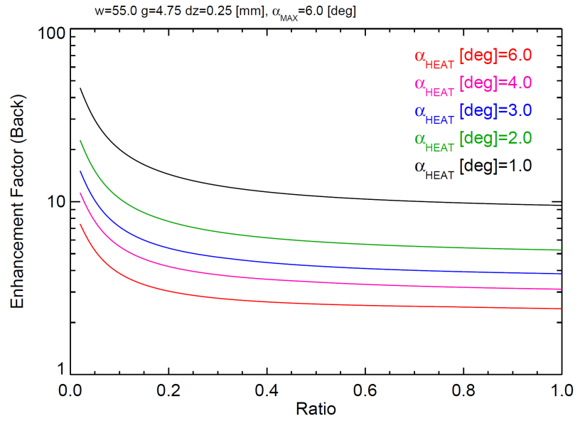
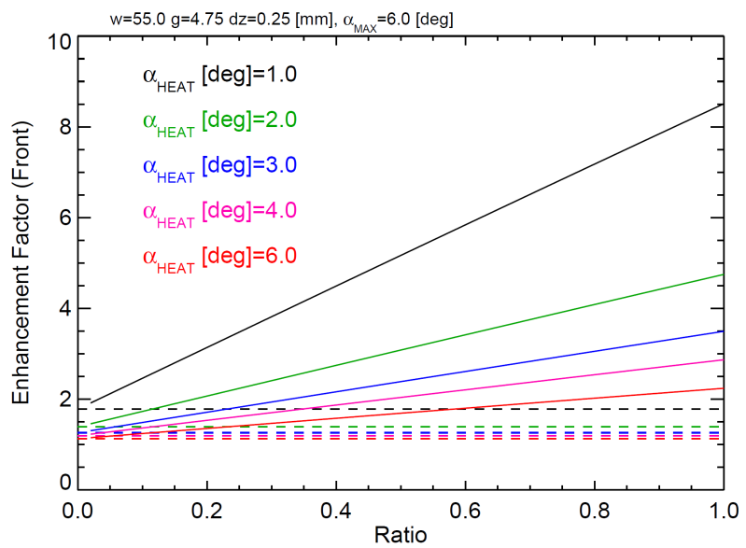
${EF}_{b}≡$ $\frac{w+g-dw}{l_{wet,b}}=\left(\cos{β_{b}+\frac{\sin{β_{b}}}{\tan{α_{heat}}}}\right)\left(1-\frac{l_{f}}{w+g}\frac{\sin\left(α_{heat}-β_{f}\right)}{\cos{α_{heat}}}\right) for α_{heat}> β_{f}$
Figure 2: The enhancement factors for the back (top) and front (bottom) surfaces as the ratio, $r$, is varied.

Figure 2 shows the calculation of $EF_{b}$ and $EF_{f}$ as the ratio, $r$, is varied over the interval $0→1$. For $r=0$, $EF_{f}$ converges to the uni-directional fish-scale which is given by the dashed lines. $EF_{b}$ increases strongly for small values of $r$ and asymptotes to large values as $α_{heat}$ is reduced indicating that you’re simply making the front surface heat flux handling worse for no gain on the back-surface. Note that both $EF_{b}→2$ and $EF_{f}→2$ as $r→1$ for the largest values of $α_{heat}$. This limit is that case that surface area is equivalent in both directions and there is little shadowing because the attack angle is large relative to both $β_{f}$ and $β_{b}$.

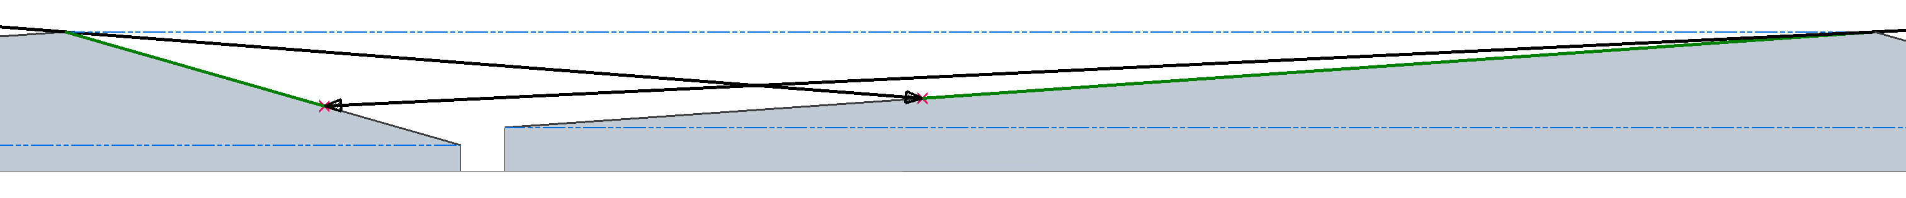
$$β_{b}$$
$$w+g$$
$$l_{wet,f}$$

$$β_{f}$$
$$l_{wet,b}$$

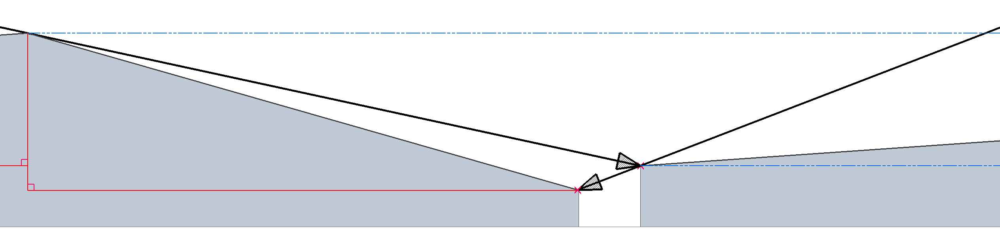
$$α_{max,f}$$
$$α_{max,b}$$
$$l_{b}\sin{β_{b}}$$
$$δz$$
$$l_{f}$$

$$l_{b}$$

$$g$$

Record of Changes

Rev. | Date | Description of Changes
0 | 4/17/2017 | Initial draft release to PFCR-WG

