TO: R. Hawryluk, C. Neumeyer
FROM: S.P. Gerhardt (PPPL), M.L. Reinke (ORNL)
SUBJECT: Heat Fluxes on the Inboard Divertor Horizontal and Near Outboard Divertor Regions (Rows 1 and 2)

1: Objectives 1
2: Results 2
3: Methods 3
4: Stationary H-Modes 3
4.1: Double-Null Cases 3
4.2: Lower Single Null Cases 5
4.3: Common Features of the Stationary Scans 7
5: Stationary Cases with Large Poloidal Flux Expansion 9
5.1: Stationary Profiles on the Inboard Divertor Horizontal Surface. 9
5.2: Stationary Profiles on Row 1 Equivalent Tiles 12
6: Heat Fluxes Associated with Swept Divertors 14
6.1: Sweeping Profiles on the Inboard Divertor Horizontal Target 14
6.2: Sweeping Profiles on the Near Outboard Divertor Target 15
7: Reversed Helicity 16
8: Generic Observation 16
References 16

1: Objectives
The objectives of this document are to identify heat flux requirements for the Inboard Divertor Horizontal surface (IBDH), and for the first two rows of the Outboard Divertor (OBD-R1,2), also referred throughout as the ‘near’ OBD. The Inboard Divertor Vertical (IBDV) heat fluxes are addressed in a separate memo [1], as are heat loads on the Center Stack Angled Surface (CSAS) and far (R [m] > 0.85) regions of the Outboard Divertor (OBD-R3,4,5) [2]. The basis for these studies are the memos prepared by NSTX-U Topical Science Groups (TSGs) [3-8], written by the TSG leaders to reflect their group’s operational needs in order to ensure that the plasma facing component (PFC) requirements capture scenarios that can support a robust science mission for NSTX-U.

Operating at high power at max field and current for durations of 5 seconds was previously anticipated to be challenge [Menard, et al. Nucl. Fusion v52 pg083015 (2012)]. There are two robust techniques that can be used to reduce the heat flux on the IBDH and OBD surfaces:

- Large poloidal flux expansion (Section 5) : Given the presence of many divertor coils (PF-1a, PF-1b, PF-1c, PF-2), it is possible to control the poloidal flux expansion along these surfaces. Large values of poloidal flux expansion can reduce the heat flux, but will make attack angles more shallow, challenging the tolerances of PFCs. Note that the the present coil layout does not allow such tailoring of the heat flux on the vertical target.

- Strikepoint Sweeping (Section 6): Sweeping of the strikepoints across the PFC surface can be used to reduce the time-averaged heat flux. This method can be applied simultaneously to both the inner and outer strikepoints.

Both of these methods of reducing heat fluxes are addressed in this memo and contrasted to the limitations of operating without either (Section 4).

2: Results

IBDH | Case # -> | 1 | 2 | 3 | 4 | 5
Range of Application | m | 0.48 < R < 0.6 |  |  | R < 0.6 | R < 0.48
Max Angle | degrees | 1.0 | 5.0 | 3.6 | -1 | 4.0
Min Angle | degrees | 1.0 | 1.5 | 3.6 | -5 | 1.0
Heat Flux | MW/m² | 7.0 | 5.5 | 14 | 1 | 3.5
Duration | sec | 5 | 5 | 1 | 1 | 5
Reference Scenario | --- | Stationary High Ip/Bt w/ large poloidal flux expansion  (Table 5.1) | High Ip/Bt Long Pulse Swept Case  (Table 6.1) | Stationary High Power Short Pulse (Table 4.1.1) | Reversed Helicity Requirement  (Section 7) | Spill Over From HHF Regions  (Section 8)
Table 2.1: Suggested heat flux requirements for the IBDH

The requirements for the IBDH PFCs are as provided in Table 2.1. The Case#1 and Case#2 requirements reflect two different approaches to operating at I_{p}=2 MA, B_{T}=1 T P_{NBI}=10 MW using high poloidal flux expansion and divertor sweeping, respectively. Case#3 and Case#4 capture examples of research needs from the DivSOL TSG [3]. As mentioned in Section 8, there is a region for R<0.48 that simulations indicate does not need to be a high heat flux handling surface and best engineering practice should be applied (chamfer choice, no too-large pre-load), but high thermal performance is not required.

Near OBD  (aka R1,R2) | Case # -> | 1 | 2 | 3 | 4
Max Angle | degrees | 1.0 | 5.0 | 4.4 | 6.0
Min Angle | degrees | 1.0 | 1.5 | 2.6 | 6.0
Heat Flux | MW/m² | 6.0 | 5.5 | 3.0 | 11
Duration | sec | 5 | 5 | 5 | 1
Reference Scenario | --- | ‘Spillover’ for stationary large poloidal flux expansion  (Table 5.2.2) | ‘Spillover’  for High Ip/Bt Long Pulse Swept Case  (Table 6.1) | Swept Case on OBD  (Table 6.2) | High Power Short Pulse  (Table 6.2, 4.2.2-4.2.4)
Table 2.2: Suggested heat flux requirements for the Near OBD (0.6 < R < 0.85).

The requirements for the Near OBD PFC region previously made up of ‘Row 1 and Row 2’ are as provided in Table 2.2. The Case#1 and Case#2 requirements are also motivated by achieving the I_{p}=2 MA, B_{T}=1 T P_{NBI}=10 MW operation, but in this case, the OBD acts to accommodate the ‘spillover’ heat flux from a strike point on the IBDH. In contrast, the Case#3 and Case#4 requirements are driven by specific requests to operate with strike points on the OBD from the MPFC [8] and PED [5] TSGs. Note that these different roles would allow the 0.6 < R < 0.85 region of the OBD be further subdivided with different requirements if necessary.

3: Methods
The methods in this memo are described in Section 3 of the memo Heat Fluxes on the CSAS and Far OBD Region [2]. Note that the Heuristic Drift Scaling of the SOL width is used, and a 30% radiation fraction is assumed. Both of these are likely to be conservative assumptions, i.e. provide large projected heat fluxes. In double null (DN) plasmas, 40% of the power is assumed to be deposited on each of the upper and lower outer divertors, while in strongly lower single null (LSN), 70% is assumed. Calculations are based on the original NSTX-U PFC boundary. If that boundary is moved as in the expected CDR designs, the heat fluxes for the chosen equilibria may change.

4: Stationary H-Modes
The simplest plasmas have a stationary magnetic geometry, with limited usage of the divertor coils to increase poloidal flux expansion. Cases such as this are described here for requests from various TSGs.

4.1: Double-Null Cases
The TSG memos requested double null plasmas in a number of cases. These requests result in the heat fluxes shown in the tables below. Table 4.1.1 describes DN scenarios requested by DivSOL [3], with requested durations of 1-2 seconds. Tables 4.1.2 and 4.1.3 provide data on scans requested by the ASC group [4], with requested durations of up to 5 seconds.

 | I_{P} | B_{T} | P_{inj} | q_{peak} | Angle at Peak
 | MA | T | MW | MW/m² | degrees
1-01 | 0.5 | 0.5 | 3.0 | 2.8 | 3.6
1-02 | 1.0 | 0.5 | 4.0 | 13 | 9.5
1-05 | 0.5 | 0.75 | 3.0 | 2.0 | 1.9
1-06 | 1.0 | 0.75 | 5.0 | 13 | 5.6
1-07 | 1.5 | 0.75 | 7.0 | 33 | 9.1
1-09 | 0.5 | 1.0 | 4.0 | 1.9 | 1.1
1-10 | 1.0 | 1.0 | 7.0 | 14 | 3.6
1-11 | 1.5 | 1.0 | 9.0 | 37 | 6.5
1-12 | 2.0 | 1.0 | 10.0 | 63 | 9.2
Table 4.1.1: Heat flux parameters for the DN scenarios on the IBDH to support DivSOL research.

gfile name | I_{P} | B_{T} | P, NBI | q_{peak} | Angle
-- | MA | T | MW | MW/m² | degrees
g116313.00860_ASC_S-01 | 1 | 0.5 | 7.5 | 14 | 5.9
g116313.00860_ASC_S-02 | 1.2 | 0.5 | 8 | 19 | 7.1
g116313.00860_ASC_S-03 | 1.4 | 0.5 | 8.5 | 26 | 8.9
g116313.00860_ASC_S-07 | 1 | 0.75 | 7.5 | 12 | 3.7
g116313.00860_ASC_S-08 | 1.2 | 0.75 | 8 | 17 | 4.7
g116313.00860_ASC_S-09 | 1.4 | 0.75 | 8.5 | 23 | 5.6
g116313.00860_ASC_S-10 | 1.6 | 0.75 | 9 | 28 | 6.3
g116313.00860_ASC_S-11 | 1.8 | 0.75 | 9.5 | 35 | 7.2
g116313.00860_ASC_S-12 | 2 | 0.75 | 10 | 43 | 8.2
g116313.00860_ASC_S-13 | 1 | 1 | 7.5 | 9.4 | 2.3
g116313.00860_ASC_S-14 | 1.2 | 1 | 8 | 12 | 2.7
g116313.00860_ASC_S-15 | 1.4 | 1 | 8.5 | 17 | 3.4
g116313.00860_ASC_S-16 | 1.6 | 1 | 9 | 23 | 4.1
g116313.00860_ASC_S-17 | 1.8 | 1 | 9.5 | 30 | 4.8
g116313.00860_ASC_S-18 | 2 | 1 | 10 | 37 | 5.6
Table 4.1.2: Heat flux parameters for the DN scenarios on the IBDH to support ASC research , using elongation of 2.3 and triangularity of 0.65.

gfile name | I_{P} | B_{T} | P, NBI | q_{peak} | Angle
-- | MA | T | MW | MW/m² | degrees
g116313.00860_ASC_T-01 | 0.75 | 0.5 | 6.0 | 4.4 | 2.3
g116313.00860_ASC_T-02 | 1.0 | 0.5 | 7.0 | 7.0 | 2.9
g116313.00860_ASC_T-03 | 1.25 | 0.5 | 8.0 | 11 | 3.7
g116313.00860_ASC_T-04 | 1.5 | 0.5 | 9.0 | 15 | 4.5
g116313.00860_ASC_T-07 | 0.75 | 0.75 | 6.5 | 4.3 | 1.5
g116313.00860_ASC_T-09 | 1.25 | 0.75 | 8.0 | 7.4 | 1.9
g116313.00860_ASC_T-10 | 1.5 | 0.75 | 9.0 | 15 | 3.0
g116313.00860_ASC_T-11 | 1.75 | 0.75 | 10.0 | 19 | 3.5
g116313.00860_ASC_T-12 | 2.0 | 0.75 | 10.0 | 23 | 4.0
g116313.00860_ASC_T-13 | 0.75 | 1.0 | 6.5 | 4.0 | 1.1
g116313.00860_ASC_T-14 | 1.0 | 1.0 | 7.0 | 6.5 | 1.5
g116313.00860_ASC_T-15 | 1.25 | 1.0 | 8.0 | 9.8 | 1.8
g116313.00860_ASC_T-16 | 1.5 | 1.0 | 9.0 | 14 | 2.2
g116313.00860_ASC_T-17 | 1.75 | 1.0 | 10.0 | 19 | 2.6
g116313.00860_ASC_T-18 | 2.0 | 1.0 | 10.0 | 22 | 3.0
Table 4.1.3: Heat flux parameters for the DN scenarios on the IBDH to support ASC research, using elongation of 2.42 and triangularity of 0.66.

4.2: Lower Single Null Cases
Lower single null plasmas were requested by a number of TSGs, including DivSOL and PED. Table 4.2.1 describes data satisfying DivSOL requests for LSN plasmas, while tables 4.2.2 through 4.2.4 describe PED requests for LSN plasmas. In all cases, durations of 1-2 seconds were requested.

 | I_{P} | B_{T} | P_{inj} | R_{OSP} | q_{peak} | Angle at Peak
 | MA | T | MW | m | MW/m² | degrees
1-13 | 0.5 | 0.5 | 3.0 | 0.52 | 3.7 | 3.2
1-14 | 1.0 | 0.5 | 4.0 | 0.51 | 18 | 8.1
1-17 | 0.5 | 0.75 | 3.0 | 0.53 | 2.9 | 1.8
1-18 | 1.0 | 0.75 | 5.0 | 0.51 | 18 | 4.8
1-19 | 1.5 | 0.75 | 7.0 | 0.51 | 50 | 8.2
1-21 | 0.5 | 1.0 | 4.0 | 0.54 | 3.0 | 1.1
1-22 | 1.0 | 1.0 | 7.0 | 0.52 | 21 | 3.3
1-23 | 1.5 | 1.0 | 9.0 | 0.51 | 57 | 5.8
1-24 | 2.0 | 1.0 | 10.0 | 0.51 | 96 | 8.1
Table 4.2.1: Heat flux parameters for the IBDH dr_{sep}=-0.6 cm DivSOL research request

PED Scenarios | lower triangularity | P_{NBI}+P_{HHFW} | R_{OSP} | q_{peak} | Angle at Peak
 | --- | MW | m | MW/m² | degrees
1-05 | 0.42 | 6 | 0.84 | 17 | 6.0
1-06 | 0.51 | 6 | 0.77 | 13 | 4.5
1-17 | 0.42 | 10 | 0.84 | 27 | 6.0
1-18 | 0.51 | 10 | 0.77 | 21 | 4.5
Table 4.2.2: Heat flux parameters on the OBD to support PED research with dr_{sep}=-1.5 cm for B_{T}=0.65 T and I_{p}=1.2 MA.

PED Scenarios | lower triangularity | P_{inj}+P_{HHFW} | R_{OSP} | q_{peak} | Angle at Peak
 | --- | MW | m | MW/m² | degrees
2-04 | 0.36 | 8 | 0.89 | 23 | 4.4
2-05 | 0.44 | 8 | 0.85 | 29 | 5.3
2-06 | 0.52 | 8 | 0.80 | 27 | 4.7
Table 4.2.3: Heat flux parameters on the OBD to support PED research with dr_{sep}=-1.5 cm for B_{T}=1.0 T and I_{p}=1.4 MA.

PED Scenarios | lower triangularity | P_{inj}+P_{HHFW} | R_{OSP} | q_{peak} | Angle at Peak
 | --- | MW | m | MW/m² | degrees
2-16 | 0.35 | 10 | 0.89 | 40 | 5.8
2-17 | 0.43 | 10 | 0.85 | 44 | 6.1
2-18 | 0.51 | 10 | 0.79 | 38 | 5.0
Table 4.2.4: Heat flux parameters on the OBD to support PED research with dr_{sep}=-1.5 cm for B_{T}=1.0 T and I_{p}=1.8 MA.

4.3: Common Features of the Stationary Scans
Common features from these scans are shown in Fig. 4.3.1 and 4.3.2. The peak heat flux is shown as a function of plasma current in Fig. 4.3.1. At even modest current, heat fluxes exceeding 20 MW/m² are prediction for these stationary plasmas.

The field line angle at the strikepoint is shown as a function of plasma current in Fig. 4.3.2. Field line angles as low as 1 degree occur for low current and high field, and as high as 9 degrees for higher current cases. These cases with large angles of incidence is what drives cases to extreme cases, > 50 MW/m², of peak heat flux.

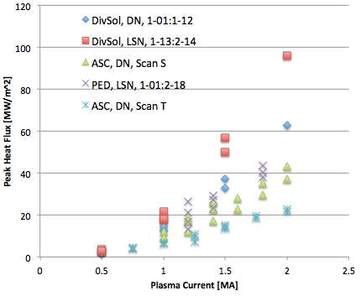
Fig. 4.3.1: Peak heat flux on the lower target as a function of plasma current, for the scans described in this section.

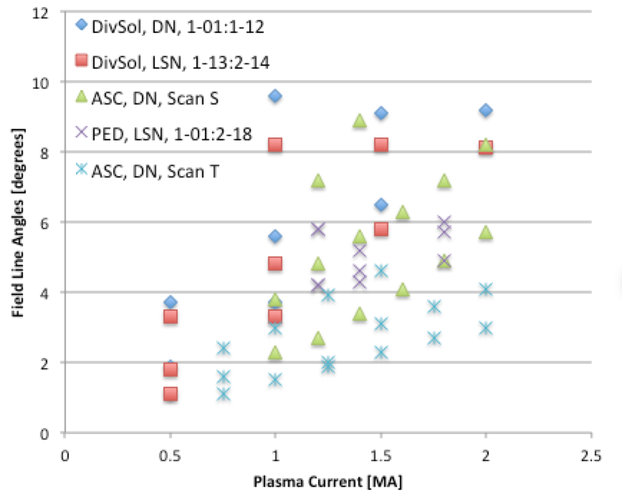
Fig. 4.3.2: Field line angle at the strikepoint as a function of plasma current, for the scans described in this section.

Heat flux limits for isotropic graphite and 5 second duration are likely in the range of 5-8 MW/m². This would prevent all ASC cases in Table 4.1.2 and many in Table 4.1.3 from being feasible. Fulfilling many of the DivSOL and PED requests would also be challenging, assuming a the peak heat flux corresponds to a surface temperature limit (e.g. scales like the square root of duration). In Table 2.1, the requirement Case#3 is taken from Table 4.1.1 to be: 14 MW/m² for 1 second at a 3.6 degree impact angle to ensure the PFCs are compatible with some amount of short pulse, high power operation.

From this analysis, it is clear that some heat flux mitigation method is required to widen NSTX-U operating space. Three such methods are i) operation with large poloidal flux expansion, ii) strike point sweeping, and iii) developing scenarios with increased divertor radiation. The first two of these are addressed in the next sections. To enhance the experimental flexibility in using the latter, private flux region gas puffing has been added to the PFC Requirements. It is important to note that if uni-directional tile shaping is employed, a maximum angle is required for design optimization. Presently Table 2.1 specifies to be 5.0 degrees for the IBDH, thus many cases in Section 4 at high angle of incidence will likely remain incompatible even if substantial reductions in heat flux can be obtained through radiation and/or partial detachment. This is similar to the near OBD, thus to support a wide range of PED activities captured in Table 4.2.2-4.2.4, requirement Case#4 in Table 2.2 is established to be: 11 MW/m² for 1 second at 6.0 degrees angle of incidence. This has heat flux below any of the given PED scenarios, so would require demonstration of compatibility and control at a much higher radiation fraction during post-Recovery commissioning.

5: Stationary Cases with Large Poloidal Flux Expansion

5.1: Stationary Profiles on the Inboard Divertor Horizontal Surface.
To provide the most robust experimental demonstration, it is desired that the horizontal targets accommodate stationary heat fluxes, where stationary refers to an unchanging magnetic equilibrium, with durations up to the 5 seconds. To do this at high power, field and current requires large poloidal flux expansion, resulting in field line angles falling to levels at or below 1.0 degrees. This is summarized in a large table [9], with more information available upon request. That spreadsheet lists many equilibria, including those with steeper field lines and heat fluxes substantially above 10 MW/m². A subset are selected here and presented in Table 5.1.

The equilibria and predicted heat flux profiles are shown in Figs. 5.1.1 through 5.1.4. In each case, the left side shows the topology and the profile of q_{perp}. The right side shows additional radial profiles, including the parallel heat flux, poloidal field angle, and total angle. Exponential fits are shown for the parallel and perpendicular heat fluxes which have varying levels of success. Note quantitative data should be taken from Table 5.1, as minor differences from the figures exist due to their being produced by an older version of the heat flux modeling codes. Full profiles of heat flux, angles, and field vectors are available on request.

Case Name | GEQDSK File | Peak Heat Flux | Strike Point Radius | Angle at Peak
 | --- | MW/m² | m | degrees
1.1 | NfHz0+_0 | 6.0 | 0.55 | 0.94
1.7 | NfHz0+_6 | 6.3 | 0.55 | 1.0
1.8 | NfHz0+_7 | 7.2 | 0.51 | 1.1
2.10 | NfHz0+wj | 6.0 | 0.50 | 0.92
Table 5.1.1: Heat flux characteristics for I_{p}=2.0 MA, B_{T}=1.0 T and P_{INJ}=10 MW DN stationary cases with strike points on the inboard divertor horizontal surface

Data from Table 5.1.1 is used to generate the Case#1 requirement in Table 2.1 for the IBDH as: 7.0 MW/m² for 5 seconds at an angle of 1.0 degrees. Such a shallow field line angle will be impacted by shaping of the tiles, creating shadowed areas which can increasing the effective surface heat flux. This is set by the maximum field line angle in requirement Case#2, described in Section 6.

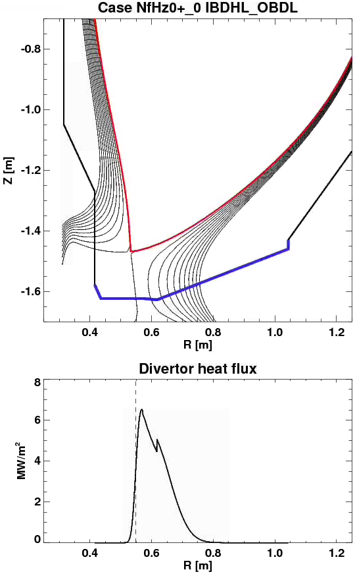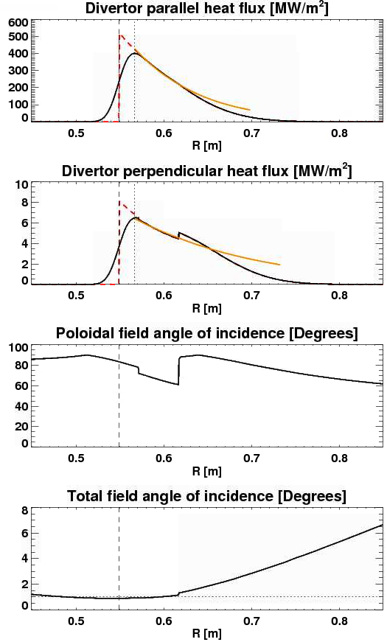
FIg. 5.1.1: Geometry and profiles from high flux expansion case 1.1.
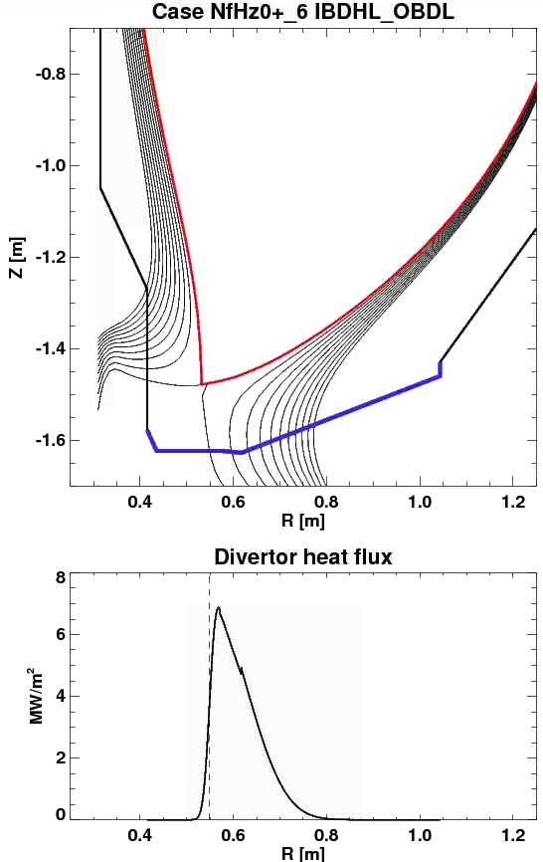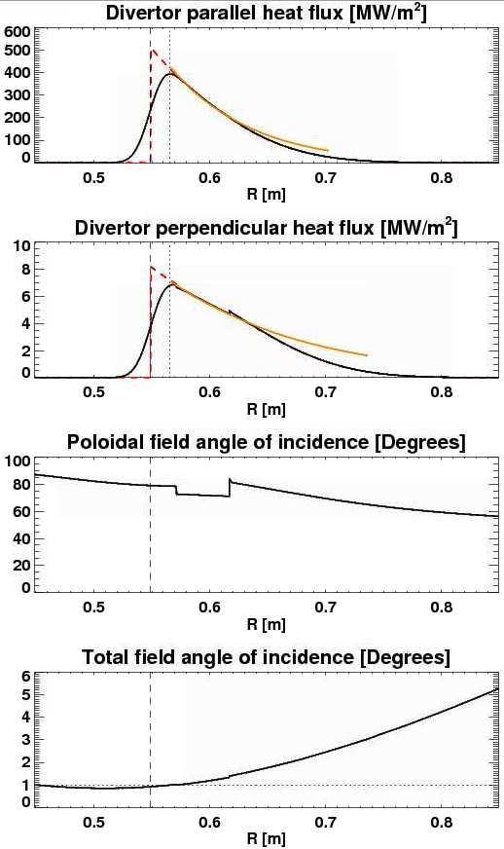
FIg. 5.1.2: Geometry and profiles from high flux expansion case 1.7.

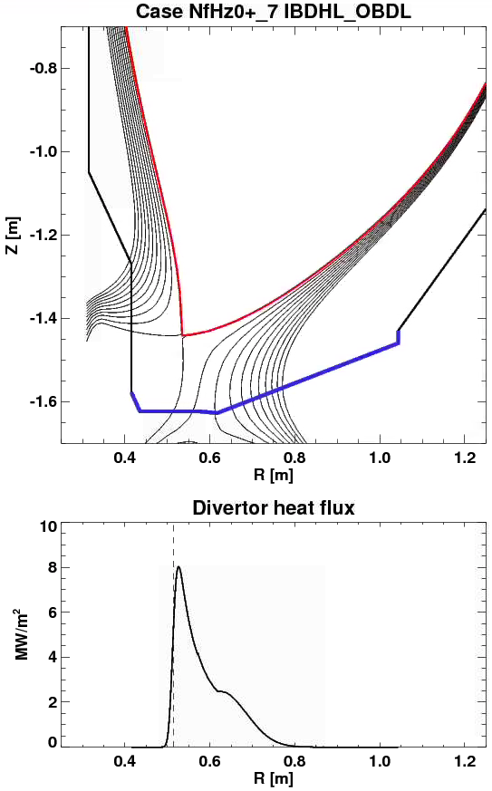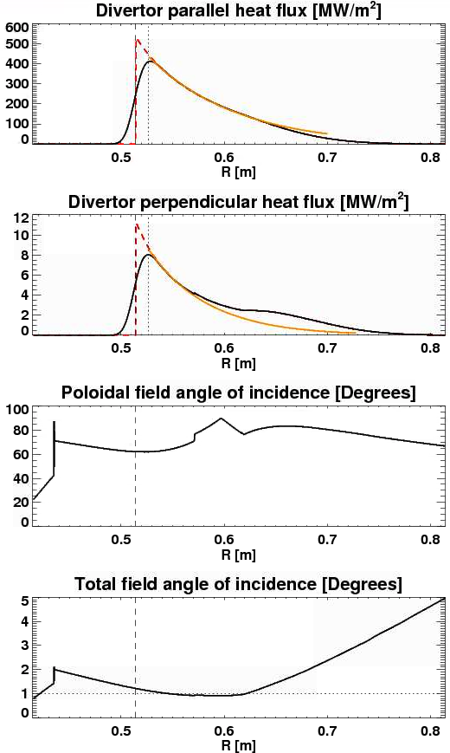
FIg. 5.1.3: Geometry and profiles from high flux expansion case 1.8.
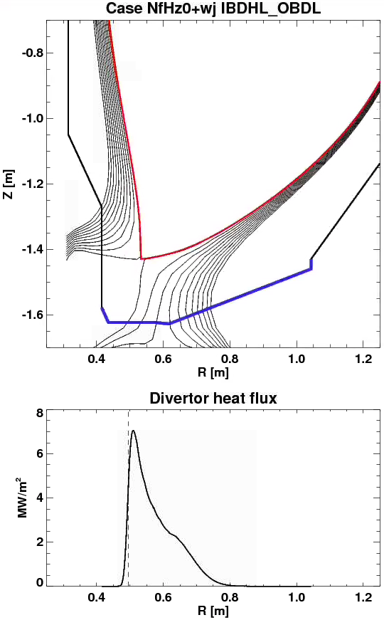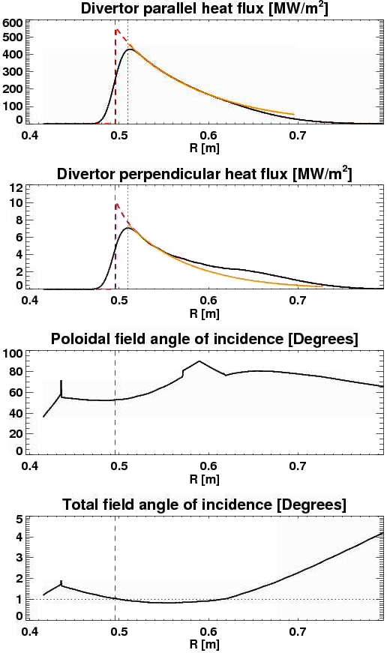
FIg. 5.1.4: Geometry and profiles from high flux expansion case 2.10.

5.2: Stationary Profiles on Row 1 Equivalent Tiles
Scenarios using high poloidal flux expansion for strike points on the outboard divertor can be developed as was done for the IBDH. These cases are listed in Table 5.2.1. and plotted in Figures 5.2.1-5.2.2. Even small increase in the field line angles lead to an increase in the heat flux to levels beyond what could be expected for isotropic graphite PFCs. Thus stationary cases at high field, current and power with strike points on the OBD may be feasible, but present modeling prediction only at durations below 5 seconds. Note, equlibria in Table 5.2.1 did not use PF1b, so further optimization may be possible.

Another use case of the OBD near the IBDH interface, R ~ 0.6 [m], is to manage the ‘spillover’ heat flux from the cases listed Section 5.2. Table 5.2.2 summarizes these examples.

Case Index | GEQDSK File | Peak Heat Flux | q_{peak} Radius | Strike Point Radius | Angle at Peak
 | --- | MW/m² | m | m | degrees
1.21 | NfHz0+_k | 8.6 | 0.62 | 0.59 | 1.6
1.6 | NfHz0+_5 | 8.2 | 0.62 | 0.59 | 1.6
Table 5.2.1: Heat flux characteristics for I_{p}=2.0 MA, B_{T}=1.0 T and P_{INJ}=10 MW DN stationary cases with peak heat flux on the OBD.

Designs for the OBD near the IBDH interface would benefit from having equivalent heat flux handling as the IBDH, allowing the strike point location to move as far out in major radius. In Table 2.2 the requirement Case#1 for the OBD is to allow for 6.0 MW/m² for durations of 5 seconds at field line angles of 1.0 degrees. Additionally, the interface region between the OBD and IBDH may need further requirements to specify how to manage poloidal shadowing and accommodate the asymmetry in the upper and lower interface due to the former’s movement from thermal and Lorentz forces on the center column.
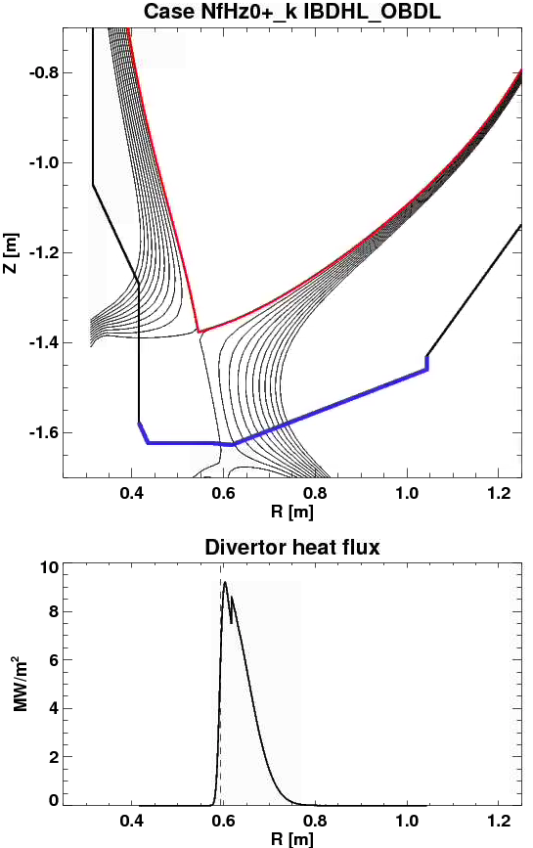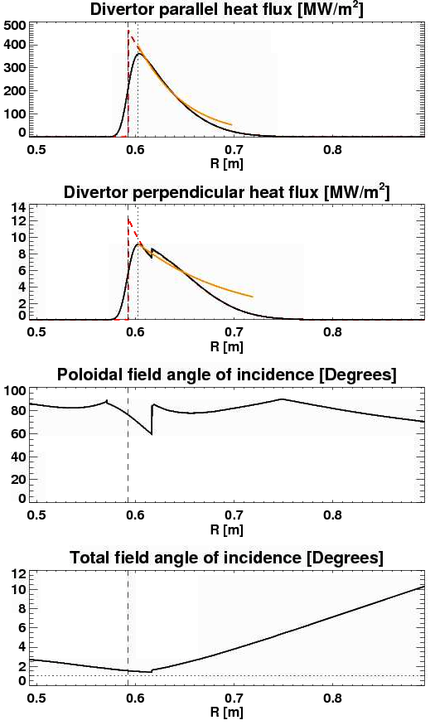
FIg. 5.2.1: Geometry and profiles from high flux expansion case 1.21.
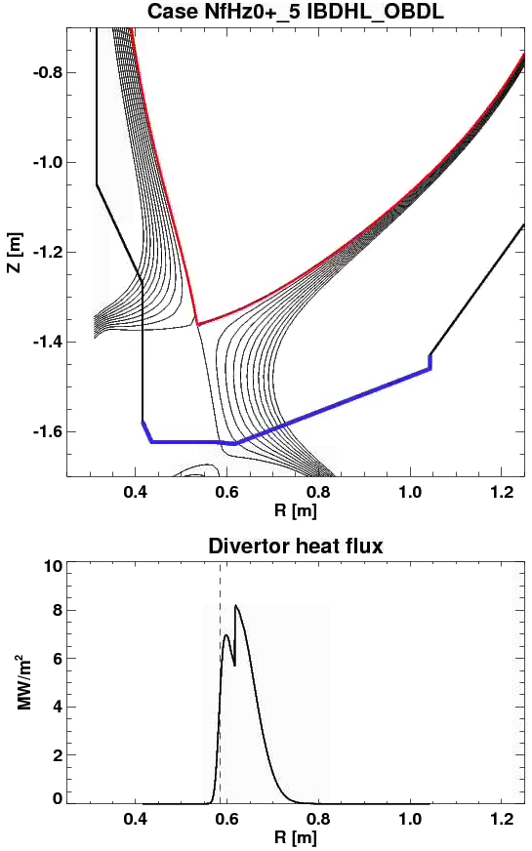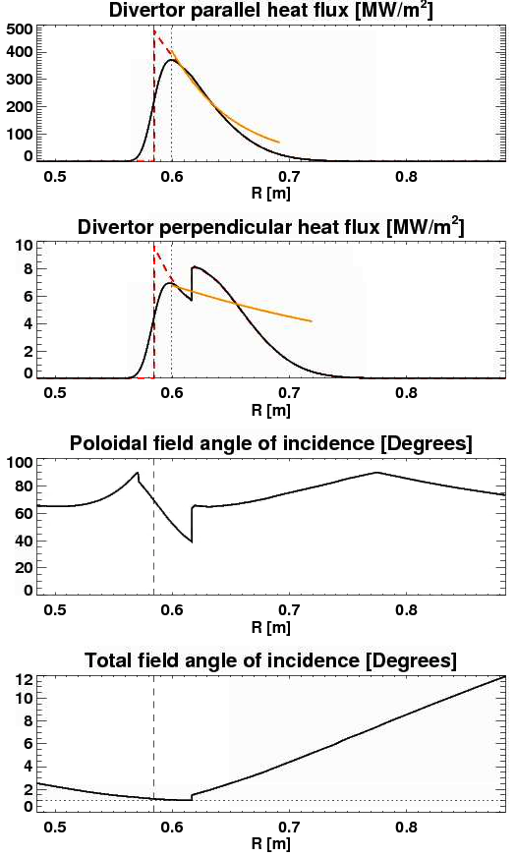
FIg. 5.2.2: Geometry and profiles from high flux expansion case 1.6.

Case Name | GEQDSK File | Heat Flux at R=0.62 | Strike Point Radius | Angle at R=0.62
 | --- | MW/m² | m | degrees
1.1 | NfHz0+_0 | 5.0 | 0.55 | 1.4
1.7 | NfHz0+_6 | 4.8 | 0.55 | 1.4
1.8 | NfHz0+_7 | 2.5 | 0.51 | 1.0
2.10 | NfHz0+wj | 2.4 | 0.50 | 1.0
Table 5.1.1: Characteristics of ‘spillover’ heat flux onto OBD for I_{p}=2.0 MA, B_{T}=1.0 T and P_{INJ}=10 MW DN stationary cases with strike points on the IBDH

6: Heat Fluxes Associated with Swept Divertors
As shown in Section 4, stationary cases with weak poloidal flux expansion are generally expected to be incompatible with IBDH and OBD designs. Various sweeping studies have been completed in order to quantify the reduction in time-averaged surface heat flux. Scans dominantly on the IBDH (0.415 < R [m] < 0.6) are presented in in Section 6.1 and those for the near OBD (0.6 < R [m]< 0.85) are described on 6.2.

6.1: Sweeping Profiles on the Inboard Divertor Horizontal Target
A series of DN strikepoint sweeping schemes were developed, in support of ASC, MS [7], and T&T [6] research goals. These are referred to with names like “Case 2, Scan 4” in the text below, and are described in Table 6.1. These are intended to support durations up to 5 seconds. Additional images of these equilibria can be found in Ref. [1].

Scan | [I_{P},B_{T},P_{heat}] | dr_{sep} | Radial Range of OSP Sweep | Peak Instantaneous Heat Flux | Peak Swept Heat Flux | Angle at R_{min} | Angle at R_{max}
--- | [MA,T,MW] | cm | m | MW/m² | MW/m² | degrees | degrees
Case 2, Scan 4 | [2, 1, 10] | 0 | [0.48, 0.63] | 49 | 5.9 | 6.2 | 2.0
Case 2, Scan 5 | [2, 1, 10] | 0 | [0.49, 0.60] | 30 | 4.9 | 3.9 | 1.1
Case 2, Scan 6 | [2, 1, 10] | 0 | [0.50, 0.60] | 13 | 5.5 | 1.8 | 0.92
Case 3, Scan 1 | [2, 1, 10] | 0 | [0.48, 0.61] | 50 | 5.4 | 6.3 | 0.80
Case 3, Scan 2 | [2, 1, 10] | 0 | [0.48, 0.62] | 31 | 4.5 | 4.1 | 0.25
Case 4, Scan 1 | [2, 1, 10] | 0 | [0.50, 0.62] | 53 | 6.8 | 7.0 | 3.8
Case 4, Scan 2 | [2, 1, 10] | 0 | [0.52, 0.61] | 36 | 7.6 | 4.8 | 2.3
Case 4, Scan 3 | [2, 1, 10] | 0 | [0.54, 0.62] | 23 | 8.1 | 3.2 | 2.0
Table 6.1: Heat flux information for swept cases on the inboard divertor horizontal target

From Table 6.1, the Case 2, Scan 4 and Scan 5 examples are combined to form the Case#2 requirement in Table 2.1: 5.5 MW/m² for 5 seconds at field line angles ranging from 1.5-5.0 degrees. High poloidal flux expansion cannot be sustained across the full target while sweeping, so the maximum field line angle must increase as compared to Case#1. This also allows a healthy fraction of scenarios from Tables 4.1.1-4.1.3 to be run with increased mitigation from radiation.

6.2: Sweeping Profiles on the Near Outboard Divertor Target
Sweeping scenarios were developed for LSN cases. These are shown in Table 6.2. Additional images of these equilibria can be found in Ref. [1].

Scan | [I_{P},B_{T},P_{heat}] | dr_{sep} | Radial Range of OSP Sweep | Peak Instantaneous Heat Flux | Peak Swept Heat Flux | Angle at R_{min} | Angle at R_{max}
--- | [MA,T,MW] | cm | m | MW/m² | MW/m² | degrees | degrees
DivSol, 8-01 | [2, 1, 10] | -0.6 | [0.52, 0.64] | 73 | 12 | 4.4 | 6.9
DivSol, 8-02 | [2, 1, 10] | -0.6 | [0.69, 0.78] | 43 | 14 | 0.8 | 5.1
DivSol, 8-03 | [1, 1. 8] | -0.6 | [0.73, 0.84] | 31 | 7.6 | 1.3 | 5.8
DivSol, 8-06 | [1.8, 1, 10] | -1.0 | [0.80, 0.89] | 55 | 12 | 1.4 | 7.9
PED, 1-05 | [1.2,0.65,6] | -1.5 | [0.80,0.84] | 17 | 11 | 3.4 | 5.8
PED, 1-17 | [1.2,0.65,10] | -1.6 | [0.80,0.84] | 27 | 17 | 3.4 | 5.8
MPFC, 2-01 | [1.25, 0.76, 3] | -1.5 | [0.70, 0.81] | 8.4 | 3.0 | 2.6 | 4.4
Case 1, Scan 7 | [2, 1, 10] | 0.0 | [0.59, 0.81] | 53 | 4.3 | 7.3 | 11
Case 1, Scan 8 | [2, 1, 10] | 0.0 | [0.63, 0.80] | 41 | 4.7 | 3.5 | 8.6
Table 6.2: Heat fluxes for swept cases on the near outboard divertor ( 0.6 < R [m] < 0.85)

In Table 6.2, there are a number of scans that are expected to be compatible with the Case#1 and Case#4 requirements in Table 2.2. The MPFC scenario is meant for testing the compatibility of high-Z PFCs in regions away from the high-triangularity operating space and would be desired for durations of up to 5 seconds. This has been included as requirement Case#2 in Table 2.2 to ensure that long pulse at modest field line angles are compatible with new OBD designs.

7: Reversed Helicity
The inboard divertor horizontal target tiles, from 0.42 < R [m] < 0.6, shall accept the stationary reversed helicity heat flux as per Table 7.1. This is included in Table 2.1 as requirement Case#4 and comes from a need to handle power on the reversed leg of a snowflake divertor [3]. Note that there is not a validated means to project the power that will flow on the inner legs of a snowflake divertor, and therefore, this estimate has larger than normal uncertainty.

Case Index | Geqdsk file | Average Heat Flux | Duration | |Inclination Angle|
--- | --- | MW/m² | s | degrees
NA | NA | 1 | 1 | 1-5
Table 7.1: Heat flux characteristics cases on the inboard divertor horizontal surface for the reversed helicity case.

8: Generic Observation
It is worth noting that none of the equilibria examined placed significant heat flux over R<0.48 m. Therefore, this region should be considered to be lower heat flux region, and may be utilized for larger holes and other features. The requirement Case#5 is added to Table 2.1 that these regions default back to the levels expected for ‘modest improvements’, 3.5 MW/m² for 5 seconds, employed elsewhere in NSTX-U, but with the expectation of more grazing angles of incidence, from 1.0-4.0 degrees.

References
[1] Memo PFCR-MEMO-009-00: Heat Fluxes on the Vertical Target
[2] Memo PFCR-MEMO-008-00: Heat Fluxes on the CSAS and Far OBD Region
[3] Memo DivSol-170524-VS-02: Impact of Polar Regions on DivSol Research
[4] Memo ASC-170523-DB-02, Impact of Proposed Polar Region Modifications on Research and Scenarios for ASC Topical Science Group
[5] Memo PED-171805-AD-02: Impact of Potential Polar Region Modifications on Research and Scenarios for TSG-PED.
[6] Memo TT-170523-WG-01, Impact of Potential Polar Region Modifications on Research and Scenarios for Transport and Turbulence Topical Science Group
[7] Memo MS-170523-JB-04: Impact of Potential Polar Region Modifications on Research and Scenarios for the Macroscope Stability Topical Science Group
[8] Memo MPFC-170523-MJ-02: Impact of Potential Polar Region Modifications on Research and Scenarios for the Material and Plasma Facing Components Topical Science Group
[8] NSTX-U_simulation_results_combined_Menard_v3.xlsx

Distribution
Jon Menard
Doug Loesser
Mike Mardenfeld
Brian Linn
Ankita Jariwala
Nate Dean
Andre Khodak
Marc Sibilia
Dang Cai
Peter Titus
Art Brooks
Bob Ellis
Filippo Scotti
Vlad Soukhanovskii
Mike Jaworski
Devon Battaglia
Ahmed Diallo
Jack Berkery
Walter Guttenfelder
Stan Kaye
Rajesh Maingi
NSTX-U File

