Princeton Plasma Physics Laboratory
NSTX Machine Proposal
Title: Develop quasi-steady-state MHD quiescent L-mode plasms
OP-XMP-119 |  | Revision: 0 |  |  | Effective Date:  Expiration Date:  (2 yrs. unless otherwise stipulated)
Proposal Approvals
Responsible author: Yang Ren |  |  |  |  |  | Date 04/05/2015
ATI (NSTX Physics Ops): |  |  |  |  |  | Date
RLM (NSTX Expt. Research Ops): |  |  |  |  |  | Date
Responsible Division: Experimental Research Operations
Procedure Requirements
designated by RLM
 | NSTX Work Permit |  |  | T-MOD (OP-AD-03)
 | Independent Review |  |  | ES&H Review
RESTRICTIONS AND MINOR MODIFICATIONS
Approved by RLM

REVIEWERS (designated by RLM)
Organization/Position | Name | Signature
ATI | D. Mueller
Test Director
Independent Reviewer
NB system
RF systems
FCPC systems
Diagnostics

TRAINING (designated by RLM)
Training required: No Yes Instructor _____________________

Personnel (group, job title or individual name) | Read Only | Instruction | Hands-On
RLM _______________________________
NSTX MACHINE PROPOSAL
TITLE: Develop quasi-steady-state MHD quiescent L-mode plasms | No. OP-XMP-
AUTHORS: Y. Ren, W. Guttenfelder, D. Liu, D. Smith, S. Gerhardt et al. | DATE:

1. Overview:
This XMP aims to establish several quasi-steady-state MHD quiescent NBI-heated L-mode plasma conditions that are useful for several XPs and XMPs. MHD quiescence and a flattop duration of at least 0.5 s should be achieved (0.8 s needed for the density perturbation experiment, 2.5 second needed for combining different XPs). A combination of neutral beam sources will be tested in this XMP.

2. Justification:
Establishing quasi-steady-state MHD quiescent NBI-heated L-mode plasma is important for 5 XPs and 4 XMPs from multiple TSGs and SGs:
Validation of gyrokinetic codes in NSTX-U NBI-heated L-mode plasmas (XP-1521, T&T TSG); Perturbative particle transport experiment with SGI in NSTX-U L and H-mode plasmas (XP, T&T TSG); Perturbative momentum transport in NSTX-U L and H modes (XP, T&T TSG); Beam ion confinement of 2nd NBI (XP-1522, EP TSG); Multi-machine studies of the L-H power threshold dependence on aspect ratio (XP-1511, PS TSG); FIDA and SSNPA checkout (XMP-110, EP TSG); Develop optimal SGI parameters for perturbative particle transport experiment (XMP-124, T&T TSG); MPTS commissioning (XMP-111); CHERS modulation study (XMP-114)

This XMP may also be important for RF group XMPs and XPs that need L-mode scenario developed.

3. Plan
Start with configuration of reference discharge NSTX 141716 (exact conditions are not crucial): density 3-4x10¹³ cm⁻³, deuterium gas, center-stack limited L mode, elongation~ 1.7, triangularity ~ 0.3-0.4. The following table shows the target parameters for the L-mode (based on the reference shot) (by S. Gerhardt):
141716, t=0.5, efit02
I_{p} = 0.7 MA, B_{T} = 0.65, betaN = 2.0
kappa | A | R0 | betaT | q95 | IPF3 | IPF5 | IPF3 / IPF5 | IPF1A | qstar | Ip | Bt | a
1.7 | 1.54 | 0.9 | 3.56 | 6.47 | -2.86 | -8.07 | 0.35 | 6.635 | 3.43 | 0.7 | 0.65 | 0.58

A template of NBI configuration is shown in Fig. 1, where two NBI source 1A pulses at 2 MW (90 kV) are present during the current ramp-up (60-200 ms) and at the end of the current flattop (600-700 ms) to provide preheating and measurements (CHERS and MSE), respectively. Different combinations of NBI sources will be used between the two 1A pulses to achieve stationary MHD-quiescent L-mode plasmas. This XMP will be based on XMP-128 (initial L-mode development).
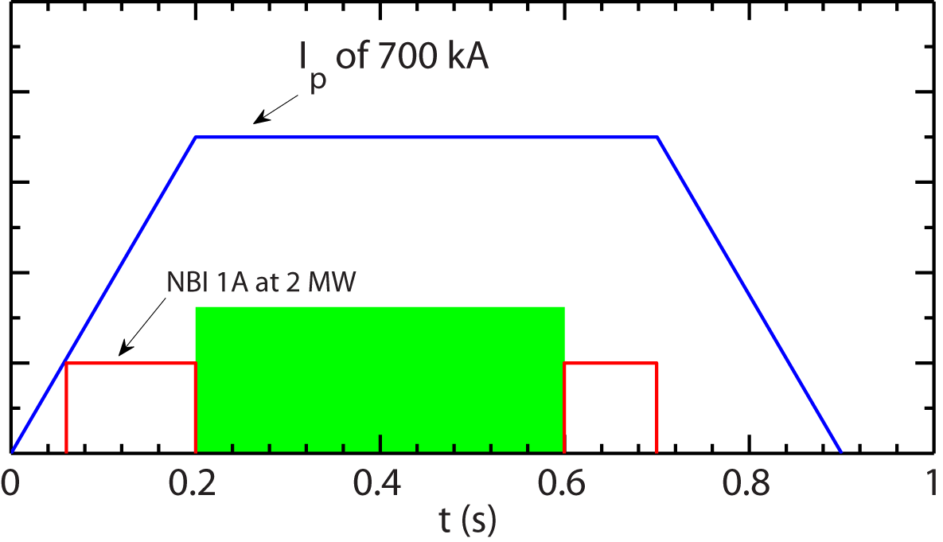
Figure 1 A template of NBI configuration. The green shaded region will accommodate different combinations of NBI sources.

The following is the shot list. The goal of this XMP is to develop the needed scenario for a combination of I_{p} and B_{T}, i.e. (0.7 MA, 0.65 T), (0.55 MA, 0.65 T) and (0.55 MA, 0.5 T). We start with (0.7 MA, 0.65 T). We will assess MHD activities and plasma profile evolution after each attempt, i.e. different combination of NBI sources/modulation as shown in the shot plan below. Once plasma achieves quasi-steady-state and MHD quiescence, we skip the rest of short plan and move on to (0.55 MA, 0.65 T). We will repeat the same shot plan for the new I_{p}. If successful, we then move on to (0.55 MA, 0.5 T). Also note that the shot numbers listed only indicate the needed good shots for each attempt.
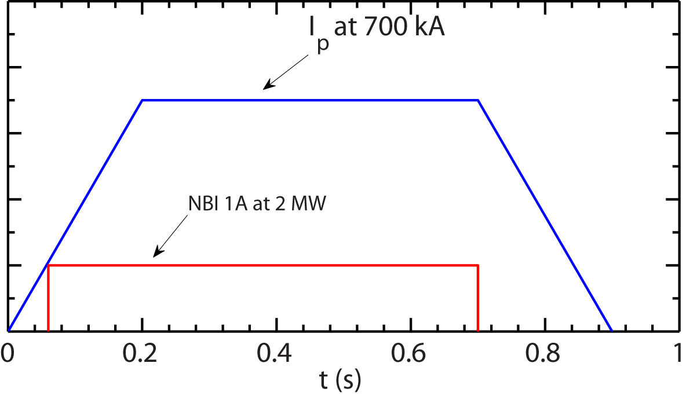
Figure shot 1-3: NBI 1A at 2 MW (90 kV) is used from 60 to 700 ms.

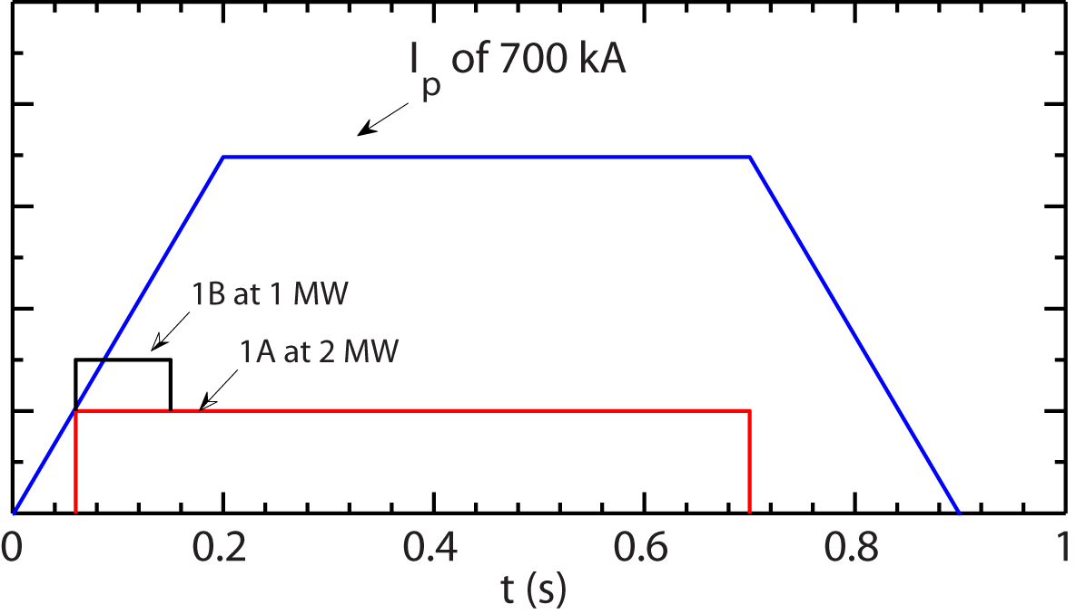
Figure shot 4-7: NBI 1A at 2 MW (90 kV) is used from 60 to 700 ms with 1C at 2 MW from 60 to 150 ms.

Shot 1-3: to establish the baseline shaping of the L-mode plasmas. NBI source 1A at 2 MW is used throughout the discharge (from 60 to 700 ms) to assess MHD activity and profile evolution (see Fig. shot 1-3). Check CHERS measurement. If carbon content is too low for good CHERS measurements, consider puffing methane to increase carbon content (<10 Tor∙L/s, duty cycle start with 50/100 ms for supersonic injection) or raising density by gas puffing.
Shot 4-7: If MHD activity is unacceptable during current ramp-up phase, consider using NBI 1B pulse (60 to 150 ms) at 1 MW to increase preheating (see Fig. shot 4-7) and other method: change beam timing, plasma current and/or plasma density, modifying early gas puff fueling.
Shot 8-10: If plasmas are not quiescent during current flattop, use 2A/2B/2C at 2 MW during current flattop and assess MHD activities and profile evolution (see Fig. shot 8-10). The last 1A pulse is from 600 to 700 ms.
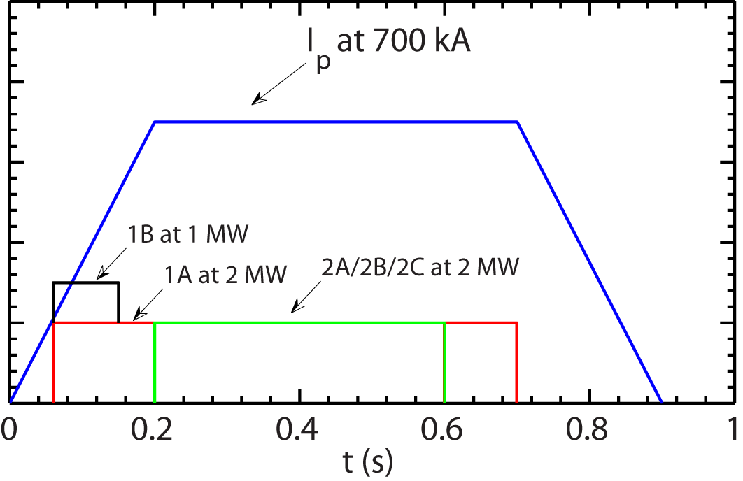
Figure shot 8-10: NBI 2A/2B/2C at 2 MW from 200 to 600 ms.

Shot 11-13: If plasmas are not quiescent during current flattop, modulate 1A/2A (50/50 ms), 1A/2B, 1A/2C at 2 MW during current flattop and assess MHD activities and profile evolution (see Fig. shot 11-13). The last 1A pulse is from 650 ms to 720 ms.
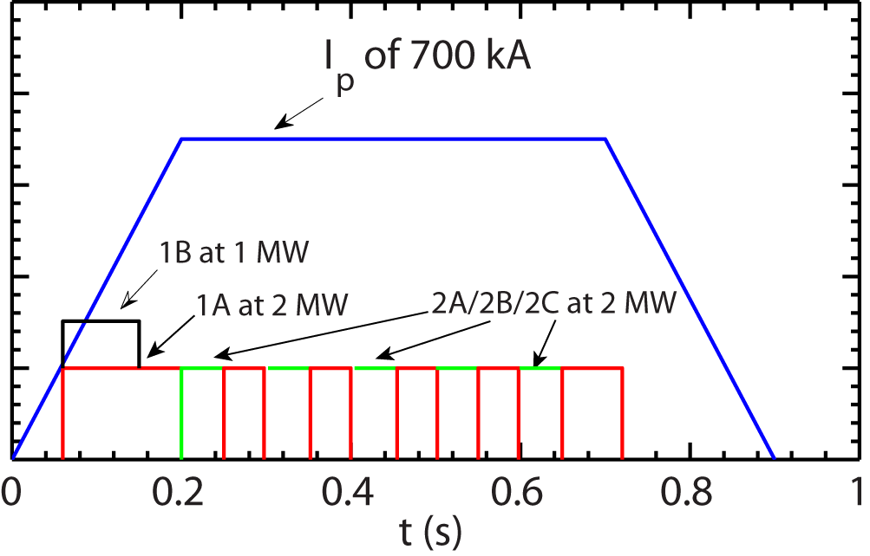
Figure shot 11-13: Alternate 1A and 2A/2B/2C at 2 MW from 200 to 800 ms.

Shot 14-17: If plasmas are not quiescent during current flattop, modulate 1A, 2A, 2B and 2C at 2 MW with 50/50 ms duty cycle during current flattop (the last 1A pulse is from 650 to 720 ms) and assess MHD activities and profile evolution (see Fig. shot 14-17).
Shot 18-21: If plasmas are not quiescent during current flattop, use 1B/2A/2B/2C at 1MW during current flattop and assess MHD activities and profile evolution (see Fig. shot 18-21).
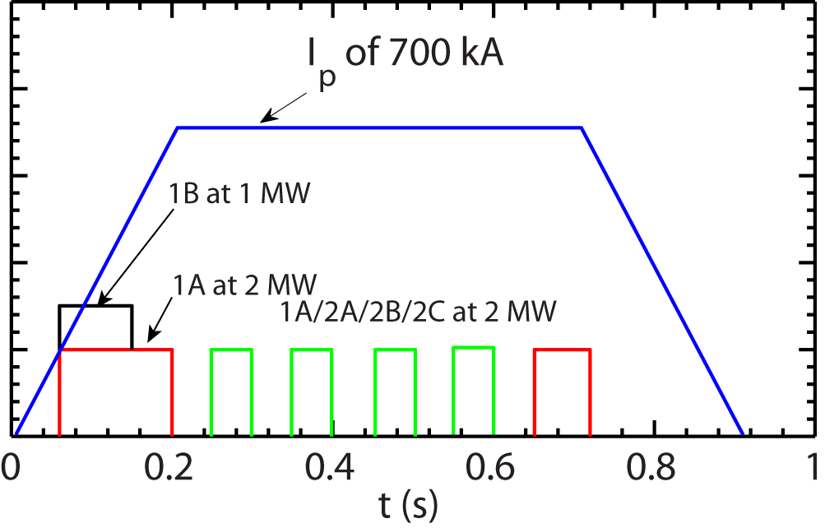
Figure shot 14-17: Modulate 1A/2A/2B/2C at 2 MW with 100 ms/100 ms duty cycle from 200 to 600 ms.

Shot 22-24: If plasmas are not quiescent during current flattop, modulate 1B/2A (50 ms/50 ms), 1B/2B, 1B/2C at 1 MW during current flattop and assess MHD activities and profile evolution (see Fig. shot 22-24).
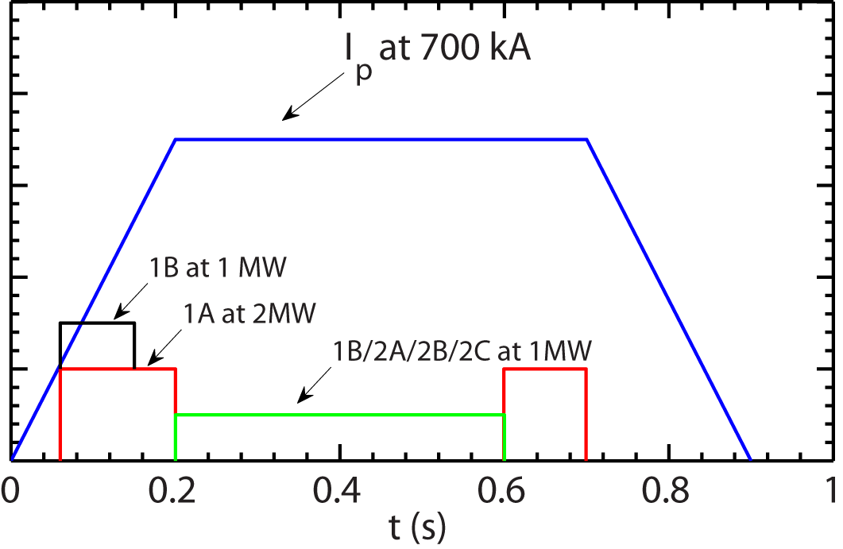
Figure shot 18-21: NBI 1B/2A/2B/2C at 1 MW from 200 to 600 ms.

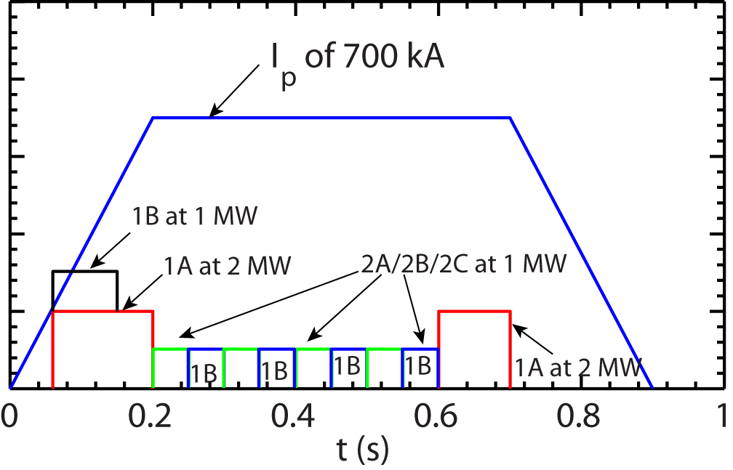
Figure shot 22-24: Alternate 1B and 2A/2B/2C at 1 MW from 200 to 600 ms.

4. Required machine, beam, ICRF and diagnostic capabilities:
All beam sources should be available with 1B at 65 kV initially and all other sources at 90 kV initially. Modulation capability of all NBI sources is required.
B_{T}=0.65 T and I_{p}=700 kA is required.
All profile diagnostics (Thomson, CHERS, MSE etc) are needed.
BES is desired.
Need deuterated methane for supersonic injection.

5. Sign off at run time:
5.1 Permission to Proceed:
Physics Operations Head
5.2 Documentation of results:
Documentation of the results completed, attached to proposal and sent to Ops. Center with copies to Cognizant Physicist and Head of Physics Operations.

Cognizant Physicist/Test Director

