Princeton Plasma Physics Laboratory
NSTX Experimental Proposal
Title: Density Scan
OP-XP-604 | Revision: 1.0 | Effective Date: 01/26/2006  (Ref. OP-AD-97)  Expiration Date: 01/26/2008  (2 yrs. unless otherwise stipulated)
PROPOSAL APPROVALS
Author: J. Boedo, K. Williams, C. Skinner, R. Maingi |  |  | Date 01/26/2006
ATI – ET Group Leader: R. Maingi |  |  | Date
RLM - Run Coordinator: R. Raman |  |  | Date
Responsible Division: Experimental Research Operations
Chit Review Board (designated by Run Coordinator)

MINOR MODIFICATIONS (Approved by Experimental Research Operations)

NSTX EXPERIMENTAL PROPOSAL
Density Scan XP 604

1. Overview of planned experiment
Start with experiments on carbon deposition/erosion memory by using fiducial discharges. Then move on to perform a shot to shot density scan by using the Li pumping capability. Then perform density scans (N/Ng~ 0.2, 0.4, 0.6, 0.8, 1.0) in 1 source, LSN H-mode, move on to LSN L-mode and then to DN H-mode, followed by DN L-mode. The GPI camera and the edge reciprocating probe are set for a 32-38° pitch angle. Consequently, the experiments should be performed at ~800-900 kA plasma current and a ~4.5 kG toroidal field, conditions that also have been shown to have long duration H-modes. Run with 1 full NBI source (de-rated ~ 60 kV if no L-mode obtained, or 750 kW) and add a second when needed by the plan.

2. Theoretical/ empirical justification

The fiducial discharges will try to shed light on some observations that the first shot of the day always has dominant deposition. Subsequent shots have net erosion or deposition depending on plasma conditions; most of them unknown. Dependence on density will be investigated this day.
The density scan will serve three different purposes.
1-Edge turbulence scaling with particular attention to the proposed (M. Greenwald) confinement destruction by interchange stability at high density/Greenwald fraction.
2-Study under which plasma conditions erosion and/or deposition occur by using quartz microbalances spread poloidally.
3-Investigate the heat flux to the divertors and inner post as a function of density and power, paying particular attention to the transition from determine boundary transition from flux-limited to sheath limited power flow

1-Edge turbulence justification

A density scan will be first priority since the edge turbulence is predicted to depend crucially on a combination of Ballooning/Resistive X-point interplay as can be seen in Fig. 1. The simulations indicate that as the density is increased (at constant pressure), the turbulence peaks more strongly on the LFS midplane and its intensity increase. Although NSTX does not have poloidally resolved turbulence diagnostics yet, the changes in turbulence intensity should be clearly observable.

The second data set concentrates on comparing the LSN configuration to a double null diverted (DND) plasma in L and H-mode. The physics basis for this comparison is the addition of a second X-point and the corresponding resistive mode. The expectation is that a second X-point not only would increase the source but also pin down the existing mode and thus the fluctuation levels should increase on the LFS.
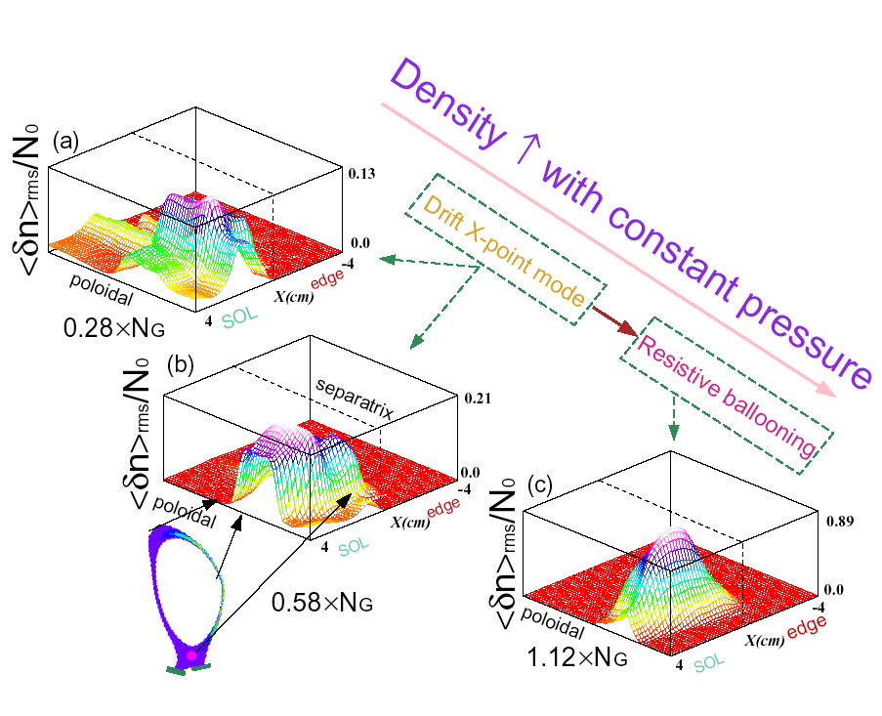
Figure 1. BOUT-predicted poloidal/radial variation of normalized density fluctuations with Greenwald factor (DIII-D simulation).

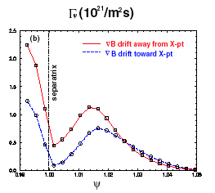
Figure 2. BOUT-predicted variation of the surfaced-averaged particle flux with change in the direction of the Grad-B drift. Factors of ~2 at the LCFS.

Another BOUT prediction is that the ExB velocity shear levels will change substantially when the configuration is shifted from LSN to DN. An example of changes induced by modifying the grad-B direction (or the location of the X-point) is shown in Fig. 2, where the turbulent radial particle flux varies by factors of ~2 inside the LCFS.

Justification for deposition/erosion
The erosion and deposition patters in NSTX are quite complex so there are three quartz micro balances (qmbs) poloidally located as shown in Fig. 3-bottom. Existing data indicate that the temporal and spatial distribution of erosion and deposition varies depending on many parameters, but most puzzling is that the first discharge of the day always shows deposition.
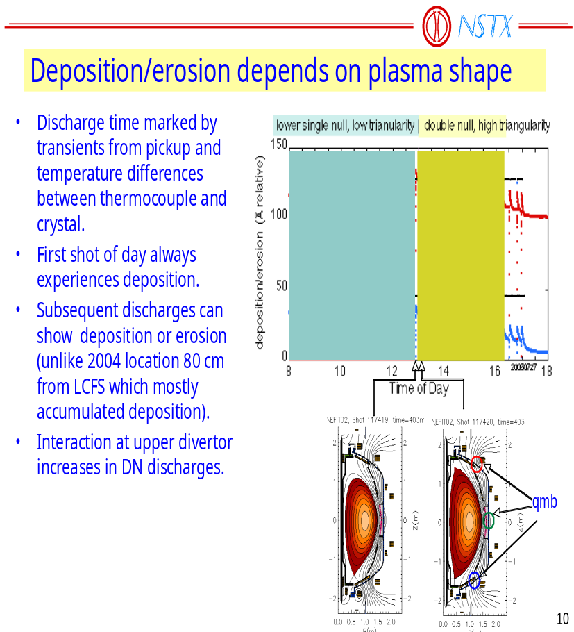

Figure 3. Deposition/erosion at the three microbalances as a function of time (top) and microbalance location (bottom).

In an effort to parameterize the dependence of the erosion/deposition on discharge parameters, we propose to: 1) take several fiducial discharges at the beginning of the run, before and after GDC, in order to gain information on the always-deposition on first shot issue, and 2) to vary the density (and thus edge radial anomalous transport) to try to uncover any dependence on anomalous edge/SOL fluxes. Finally we propose to explore the dependence on power by taking data on fixed discharge conditions while changing power form 1 to 2 sources.

Justification for heat flux work.
Density and collisionality play a major role in the edge power flow regime. Specifically, tokamaks can see a high T_{e} sheath limited heat transport regime, a medium T_{e} conduction flux limited regime, and a low T_{e} detached divertor regime. The density scan will allow us to effectively characterize the transition between the sheath limited and flux limited regimes in H-mode. In addition, the single-null vs. double-null shape comparison will allow us to measure the complete up/down power balance for the first time, as all three IR cameras (lower divertor, center stack, upper divertor) are working for the first time.

3. Experimental run plan
Discharges will be run 0.45T, 800 kA with a desired flattop of about 500 ms. An appropriate template is 117988 (see Figs. 4,5 below)
PART A:
Fiducial shot #1 2 source LSN, 1 MA, such as 117726, or equivalent obtained this year 2006.

30 min GDC

Fiducial 2 117726, followed by 15 min GDC

Long flat top fiducial. Best from Jon Menard’s XP on long pulse LSN run 2 days prior.

Short (ramp up and down) fiducial. Previous shot but without the IP flattop. Approximately 200 ms ramp up, 200 ms rampdown.
PART B:
Create a shot to shot density scan by using the Li pumping capability.
1-Start with 1 source (perhaps de-rate if too hot for probe penetration) LSN H-mode at 0.45 T and 800 kA. Scan the density in Greenwald fractions of [0.2, 0.4, 0.6, 0.8, 1.0]. Linger a bit in the 1.0 limit to get good data and study the source of the turbulence. Obtain shots with 2 NBI sources at 0.4 and 0.8 Ng.
2-Repeat in L-mode by puffing gas on outer edge. Scan the density in Greenwald fractions of [0.2, 0.4, 0.6, 0.8, 1.0]. Linger a bit in the 1.0 limit to get good data and study the source of the turbulence. No power scan.

3-Move on to DN. Repeat 1 above. If tight on time reduce the density scan to [0.2, 0.6, 1.0] or even [0.2, 0.8]

4-Stay in DN and repeat 2 above. If tight on time reduce the density scan to [0.2, 0.6, 1.0] or even [0.2, 0.8]

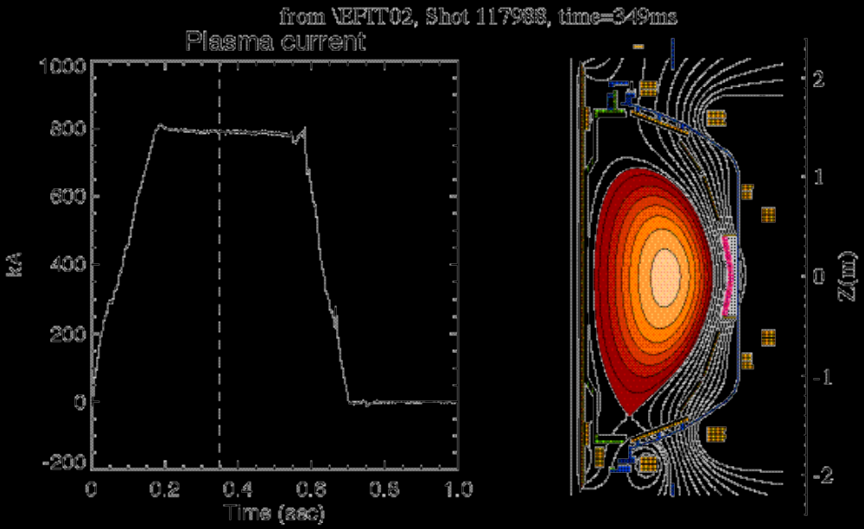
Fig. 3 Template shot 117988. LSN, 800 KA discharge with a 0.4s flat top.
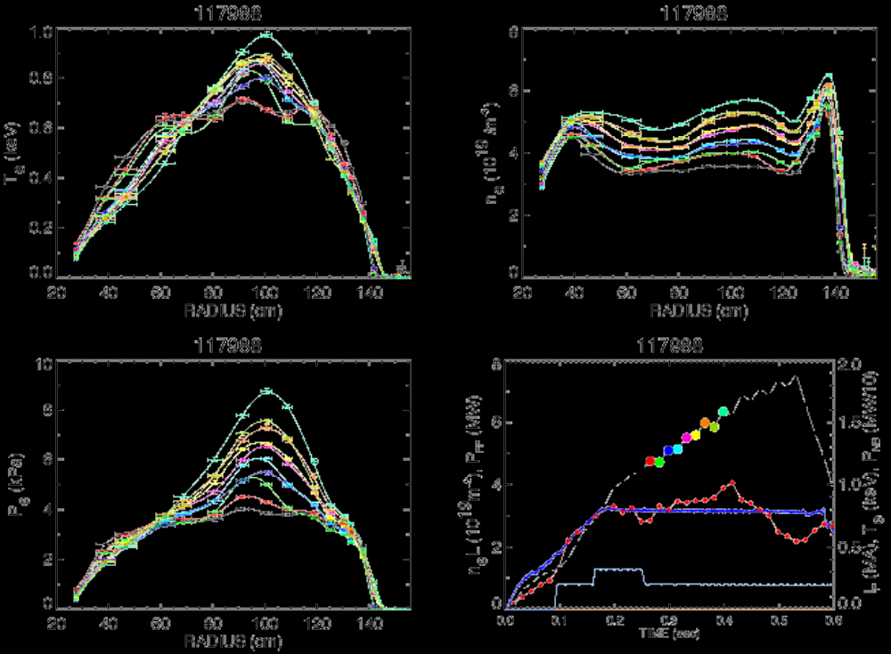
Fig. 4 TS data showing Ne and Te profile evolution in template shot 117988.

4. Required machine, NBI, RF, CHI and diagnostic capabilities
No RF, no CHI. Need 2 sources NBI for 4 MW total heating.
Outboard gas puff will be required
Lithium conditioning will be required for density control.
Key diagnostics are:
- Fast Probe for edge fluctuations and profiles
- Reflectometers
- GPI edge camera for edge fluctuations
- H_{α}/D_{α} cameras and diodes particle inventory/transport analysis
- Divertor Langmuir probes for divertor electron density, temperature, and particle flux
- IR cameras looking at lower and top divertors and central post.

5. Planned analysis
We will need EFIT with high edge resolution.
The GPI will be active and the diode chords will be analyzed for scaling of fluctuations in time and space. Particularly, searching for the behavior of turbulence near the density limit.
Probe data will be analyzed to obtain rms profiles of density and potential fluctuations as well ad conditional averaging of the blobs and double probe data to get Te, Ne profiles.
IR camera data for plasmas at various densities and powers will be analyzed to determine the heat flux scaling and determine the transition of heat flux-limited regimes.

6. Planned publication of results
GPI data will be published by Kyron Williams, in 06, probe data will be published by J. Boedo in PoP and NF, in 06, IR camera data will be published by R. Mainig at the 2006 PSI meeting.
PHYSICS OPERATIONS REQUEST
Error: Reference source not found OP-XP-604
Machine conditions (specify ranges as appropriate)
I_{TF} (kA): Flattop start/stop (s): _____/_____
I_{P} (MA): 800 Flattop start/stop (s): _____/_____
Configuration: Inner Wall / Lower Single Null / Upper SN / Double Null
Outer gap (m): _____, Inner gap (m): _____
Elongation κ: _____, Triangularity δ: _____
Z position (m): 0.00
Gas Species: D / He, Injector: Midplane / Inner wall / Lower Dome
NBI - Species: D, Sources: A/B/C, Voltage (kV): 100, Duration (s): 0.5
ICRF – Power (MW): 0, Phasing: Heating / CD, Duration (s): _____
CHI: Off
Either: List previous shot numbers for setup: 117726 for fiducial, 117988 for Ne scan
Or: Sketch the desired time profiles, including inner and outer gaps, κ, δ, heating, fuelling, etc. as appropriate. Accurately label the sketch with times and values.
DIAGNOSTIC CHECKLIST
Error: Reference source not found OP-XP-604
Diagnostic | Need | Desire | Instructions
Bolometer - tangential array | ✓
Bolometer array - divertor | ✓
CHERS
Divertor fast camera | ✓
Dust detector
EBW radiometers
Edge deposition monitor | ✓
Edge pressure gauges | ✓
Edge rotation spectroscopy | ✓ |  | Only available by special request of T. Biewer @ MIT
Fast lost ion probes – IFLIP
Fast lost ion probes – SFLIP
Filtered 1D cameras
Filterscopes | ✓
FIReTIP | ✓
Gas puff imaging | ✓
High-k scattering
Infrared cameras | ✓
Interferometer – 1 mm | ✓
Langmuir probes - PFC tiles | ✓
Langmuir probes - RF antenna
Magnetics – Diamagnetism | ✓
Magnetics – Flux loops | ✓
Magnetics – Locked modes
Magnetics – Pickup coils | ✓
Magnetics - Rogowski coils | ✓
Magnetics - RWM sensors
Mirnov coils – high frequency | ✓
Mirnov coils – poloidal array | ✓
Mirnov coils – toroidal array | ✓
MSE
Neutral particle analyzer
Neutron Rate (2 fission, 4 scint)
Neutron collimator
Plasma TV | ✓
Reciprocating probe | ✓
Reflectometer - FM/CW | ✓
Reflectometer - fixed frequency homodyne quadrature | ✓
Reflectometer - homodyne correlation | ✓
Reflectometer - HHFW/SOL | ✓
RF antenna camera
RF antenna probe

Solid State NPA
SPRED
Thomson scattering - 20 channel | ✓
Thomson scattering - 30 channel | ✓
Ultrasoft X-ray arrays | ✓
Ultrasoft X-ray arrays - 2 color | ✓
Visible bremsstrahlung det. | ✓
Visible spectrometers (VIPS) | ✓
X-ray crystal spectrometer - H | ✓
X-ray crystal spectrometer - V | ✓
X-ray pinhole camera | ✓

