13-001206-PJH-01
To: Distribution
From: P. Heitzenroeder
Subject: Results of Cooling and Shear Stress Analysis for NSTX TF Center Stack with No Active Cooling on Turn Six and Resulting Operational Limitations

References:
- A. Brooks; Memo # 13-001205-AWB-01; “Impact of Loss of Coolant on Cool Down of TF Coil Inner Leg”
- C. Neumeyer; Memo # 13-001206-CLN-02; “ TF Limits vs. Temperature”
- HM Fan; Interim ANSYS Shear Analysis of NSTX TF Center Stack with No active Cooling on Turn Six . (Currently being formally written up).
- J. Chrzanowski; Doc. No. 13-970430; “NSTX Center Stack Research and Development Final Report”.

A water leak in the cooling tube of the TF Center Stack Turn no. 6 required that the cooling water to it be shut off. Analyses were performed [ref. 1&2] to determine if cooling of turn 6 by conduction to its neighbors would be adequate to permit safe interim operation until the leak can be repaired during the scheduled opening beginning in January. The analyses considered both the cooling performance and the shear stress that would result from the temperature differential between the uncooled turn and its neighbors.

Figure 1 [from ref. 1] shows the maximum temperature difference between turns for the worst case end of the center stack, which occurs at the inlet end. As Art notes in his report, the analysis is linear , so although the vertical axis is labeled as Temp. C, it can be thought of as % of the peak conductor temperature during a shot . It shows that the maximum temperature difference is ~58% of the peak temperature during a shot and occurs ~30 sec. after the end of the shot due to the rapid cooling of the actively cooled turns and the much longer time constant of the heat flow from the uncooled turn through the interturn insulation to the cooled neighbors. The analyses indicates that the conduction cooling to adjacent turns is adequate to achieve complete cool down of Turn 6 in ~360 s (6 minutes).
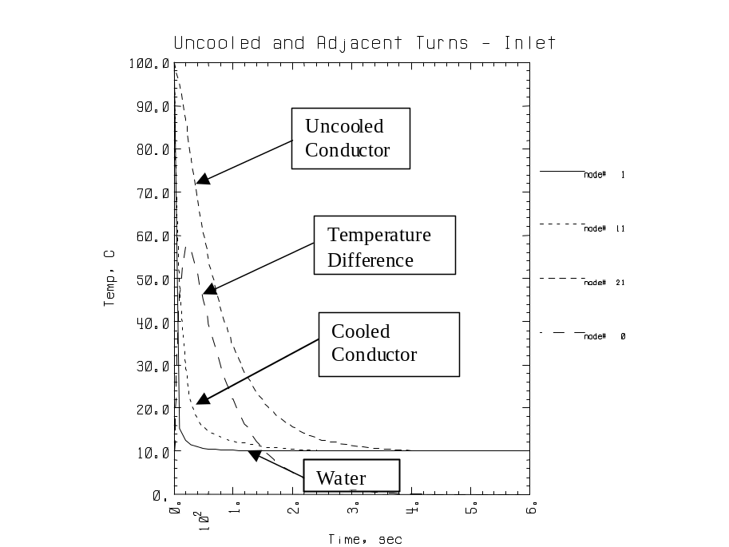
I verified Art’s calculation by performing an independent calculation of the thermal time constant. In both analyses, the thermal conduction coefficient, k, of the interturn insulation was approximated by using the k of G-10 glass/epoxy laminate. This was done because the k of the actual CTD-112 glass/epoxy b-stage that is used for the interturn insulation was not measured during the R&D phase since normal operation would not require the calculation of heat transfer through it. It should also be noted that significant variation was found in published values for the k of G-10. Consequently, the cool down performance shown is only approximate and may be expected to be in the range of 6-12 minutes. Since it is planned to actually measure the temperature of turn 6, this will not be a concern.

The shear stress resulting from the temperature difference dT between turn 6 and its neighbors was calculated using ANSYS [3]. For these calculations, dT was chosen as 20 C based on guiding hand calculations and a review of the R&D shear stress results given in [4]. ( As indicated in Ref. [1], a pulse of B_{T} = 3.5 kG is permissible for a temperature rise of. 20 C, even in the case of an I²T trip. This provides a “built in” safety factor since the maximum temperature differential between turns is only 58% of this, or 11.6 C for a fault , and 8.3 C for a normal shot ) The ANSYS results are summarized n Figs. 2-4:

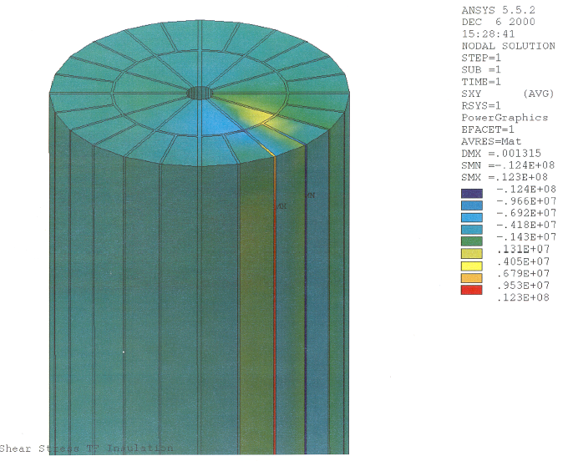

Fig. 2. Radial Shear Stress in NSTX Center Stack Interturn Insulation with Turn 6 Uncooled and 20 C dT
Peak is ~12 MPa (1.7 ksi)
Turn 6
Shear Stress in Pa

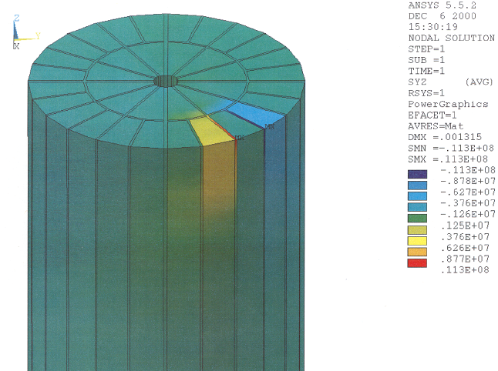

Fig. 3. Longitudinal (Z) Shear Stress in TF Insulation in NSTX Center Stack with Turn 6 Uncooled and dT=20 C. Peak is ~10 MPa (1.4 ksi).

Uncooled Turn 6

Shear stress in MPa

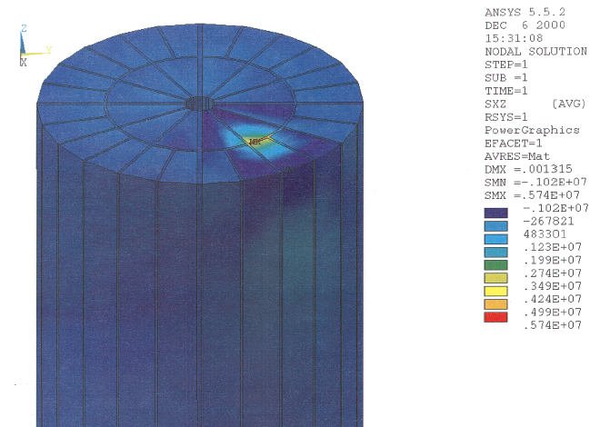

Fig. 4. Shear Stress Between Layer 1 and Uncooled Turn No. 6 with dT=20 C. Maximum is ~5 MPa (0.9 ksi).

To summarize the ANSYS results:

Max. vertical shear stress between turn 6 and the adjacent turn: ~1.4 ksi
Max. radial shear stress “ ~1.7 ksi
Max. shear stress between turn 6 and layer 1: ~0.9 ksi

A combined shear stress analysis is underway. In the interim, if we assume that the max. vertical and radial shear stresses occur at the same point (which they don’t), the combined shear would be ~2.2 ksi.

Table 2-4 , (below) from the NSTX R&D report [4], shows the results of biaxial shear tests at 60 C. The average shear with 600 psi compressive load is 6063 psi (42 MPa). In this case, if we make the conservative assumption of only uniaxial shear loading, we must “back out” the shear component due to the compression. Assuming a coefficient of friction of 0.3, the shear component due to compression is only 180 psi, and the extrapolated 0 compression shear stress would be 5883 psi. If we apply an allowable factor of 50%, a shear of 2.9 ksi (20.3 MPa) would be permitted. Since the pessimistic combined shear is 2.2 ksi, the shear stresses resulting from a dT of 20 C is acceptable.
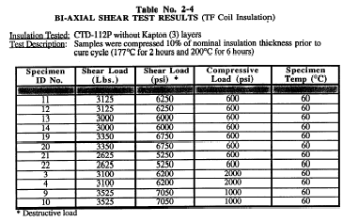 [from Ref. 4]

Conclusion:

Based on the above, we conclude that it is permissible to run with a maximum temperature differential of 20 C until the leak can be repaired in the January opening. The 3.5 kG pulse recommended in [1] is safely within this limit, and it is recommended that this limit be used until HM Fan’s combined stress calculations are completed and thermal measurements are made which would permit the cooldown calculations to be benchmarked . At that time, we could re-evaluate if it is permissible to increase the I²T. Flowing nitrogen gas through the Turn 6 cooling passage is not very effective for cooling, but, if the flow rate is slow enough to permit the exit gas temperature to be at the conductor temperature, it will be a good way to provide an electrically isolated thermocouple measurement of the conductor temperature for the benchmarking measurements.

Distribution:
R. Hawryluk
M. Williams
C. Neumeyer
J. Levine
M. Ono
A. Brooks
J. Chrzanowski
HM Fan

