MAST Overview

NSTX/MAST Engineering Workshop
Princeton Plasma Physics Laboratory

21-24 September 2001

Garry Voss

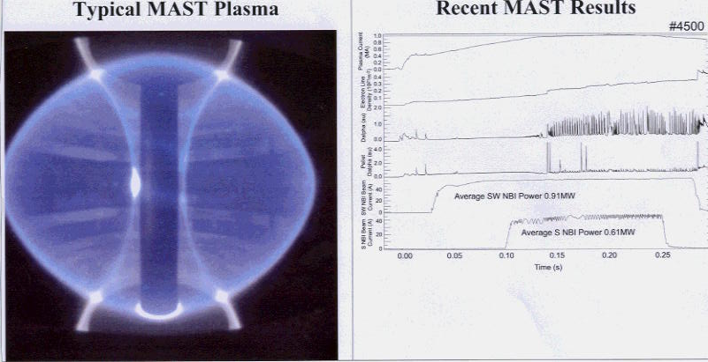
MAST Parameters  Aspect Ratio ≥1.3  Plasma Elongation ≤2.5  Plasma triangularity 0.3  Major radius 0.7m  Minor radius 0.5m  Plasma current ≤2 MA  Centre rod current ≤2.2MA  Solenoid flux swing ≤1Vsec.  Additional heating power ≤6.5MW  Pulse length ≤5sec.  Number of TF coils 24  Maximum solenoid current 55kA  Number of turns of solenoid 328  Inner radius of solenoid 114mm  Outer radius of solenoid 166mm  Vessel diameter 4m | 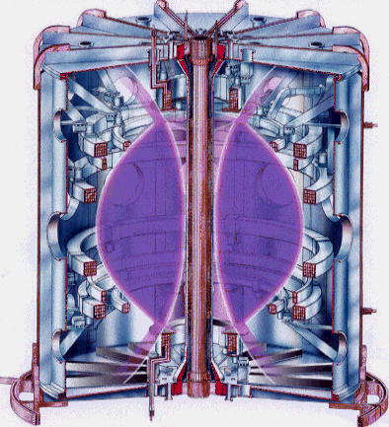
MAST Vessel
Vessel being Lowered Through Roof  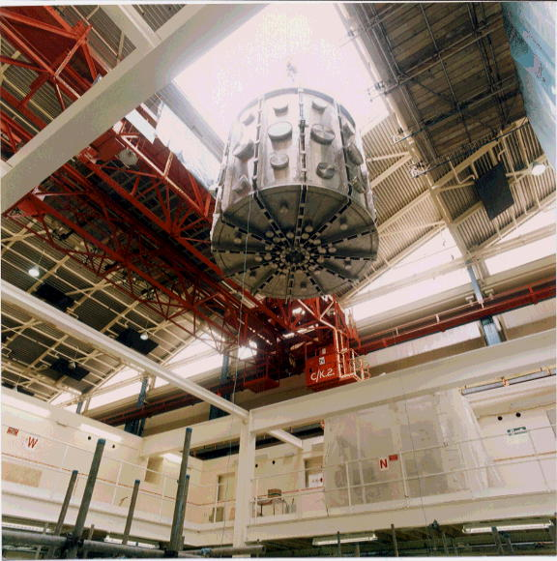 | Vessel Installed  

