MAST Manufacture and R & D
Contents
• Centre Rod Manufacture
• OH Solenoid manufacture
• Sliding Joint Development

NSTX/MAST Engineering Workshop
Princeton Plasma Physics Laboratory

21-24 September 2001
Garry Voss
Centre Rod Manufacture
Extruded wedge conductors tape wrapped and assembled  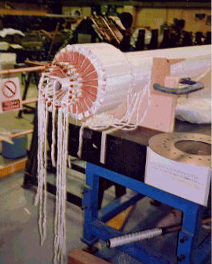 | Rod Conductors Assembled in Complete Mould  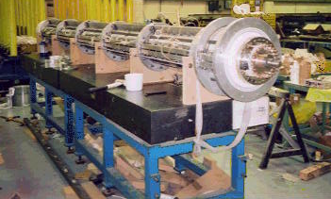

Centre Rod Manufacture
Centre Rod Conductor Assemblies  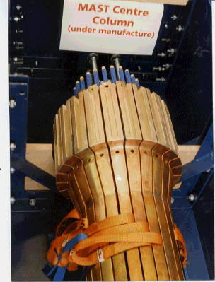 | Rod Conductors Assembled in part of Mould  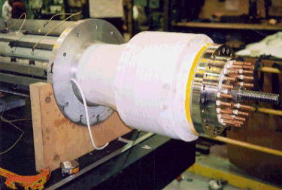
OH Solenoid Manufacture
Solenoid Wound 2-in-hand with Kapton film between layers  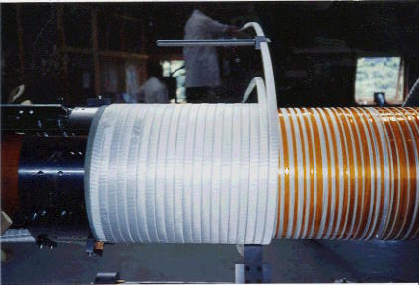 | Slip–plane strips extracted from each end after vacuum impregnation and curing of coil  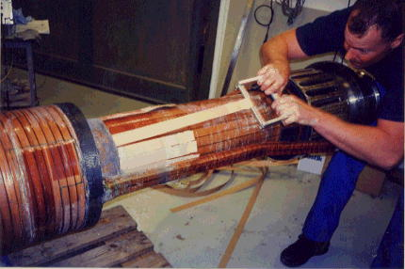

OH Solenoid Manufacture
Solenoid end-turn showing carbon fibre composite banding and quadrupole tail formation  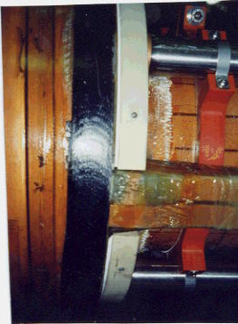 | Solenoid upper tails and solenoid support structure  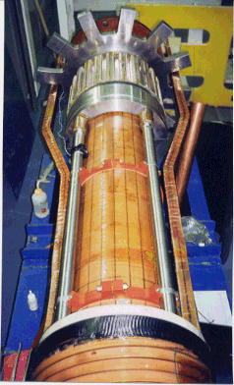
Sliding Joint Development
1/3 Scale Test Rig Connected in series with TF Power Supply  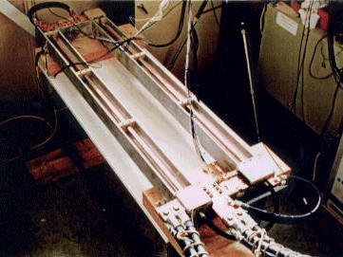 | 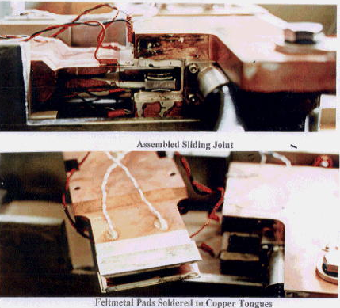

Sliding Joint Development
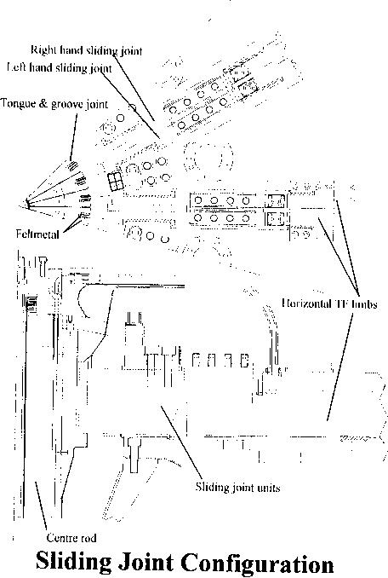 | £D Current density analysis used to optimise sliding joint geometry  

