National Spherical Torus Experiment (NSTX)

Engineering Overview & Research Results 1999-2000

C. Neumeyer and the NSTX Team
(PPPL, ORNL, Univ. of Washington, GA, LANL, Columbia University)
c/o Princeton University Plasma Physics Laboratory*
P.O. Box 451, Princeton, NJ 08543
(609) 243-2159

ABSTRACT

The NSTX is a new US facility for the study of plasma confinement, heating, and current drive in a low aspect ratio, spherical torus (ST) configuration. The ST configuration is an alternate magnetic confinement concept which is characterized by high β (ratio plasma pressure to magnetic field pressure) and low toroidal field compared to conventional tokamaks, and could provide a pathway to the realization of a practical fusion power source. NSTX achieved first plasma in February 1999, and since that time has completed and commissioned all components and systems within the machine proper. Routine operation with inductively driven plasma current ≤ 1MA and flat top ≤ 0.3 seconds has been established, and the ohmic characterization phase of the research program is underway. Radio Frequency (RF) and Neutral Beam Injection (NBI) systems have been installed and the first heating experiments are now underway. This paper describes the NSTX mission, gives an overview of the engineering design, and summarizes the research results obtained thus far.

I. INTRODUCTION

NSTX is an alternate concept “Proof of Principle” experiment whose mission is to demonstrate the physics and technology of the “Spherical Torus” plasma¹. This idea is in accordance with the US Department of Energy “Roadmap” for fusion development where a particular approach progresses through the stages Concept Development→Proof of Principle→Proof of Performance→Energy Technology→DEMO.

If the NSTX experiment is successful then the next step would be a “Proof of Performance” experiment such as a D-T burning experiment of the scale of the TFTR/JET/JT-60 machines. Referring to Figure 1, in general, an ST device is one with low aspect ratio (A=R₀/a) of order 1.2 to 2.0, high elongation κ ≥ 2 and high triangularity δ ≥ 0.2, such that the overall shape is nearly spherical.

As depicted in Figure 2, the ST confinement scheme lies somewhere between the conventional tokamak (toroidal current dominates) and the compact toroid (poloidal current dominates). The fact that the field line length on the inboard side is greater than on the outboard side is favorable for confinement and stability because the inboard B field is higher, and the inboard curvature limits the inward expansion of the plasma toward higher B (magnetic well effect).

Figure 1 – Geometry of an ST Plasma

Figure 2 –Confinement Schemes

The features of the ST which are attractive in the context of a reactor are:
- Efficient magnetic confinement (high β_{T} = 2µ₀<p>/B₀²≈ 50%), reduced B_{T} requirement
- Natural elongation, lower applied B_{P} requirement for shape control, flux expansion in divertor, reduced wall power density
- Enhanced MHD stability and confinement, reduced turbulence and transport
- High bootstrap current (f_{bs} ≈ 90%)
- Reduced disruption severity

The NSTX mission consists of Physics and Technology components². The Physics objective is to characterize ST confinement and transport, determine MHD and stability limits, and to study non-inductive current drive (RF, pressure driven (bootstrap), and Coaxial Helicity Injection (CHI)), High Harmonic Fast Wave (HHFW) RF heating, and power and particle handling. The technology component is focused on the challenge posed by the fact that the central region of the torus must be very compact, meaning that the TF current density must be quite high and, eventually, plasma current must be initiated and sustained using non-inductive techniques. Therefore the technology focus is on the “center stack” engineering, and the CHI and RF current drive.

II. NSTX Engineering³

Figure 3 is a recent photograph of the NSTX machine, located at PPPL in the former TFTR facility, in the Hot Cell adjacent to the TFTR Test Cell. Extensive use is made of existing facilities such as AC Power, Magnet Power Supplies, RF Systems, NBI Systems, Water Systems, Building and HVAC systems, and many components from TFTR. First plasma was achieved in February 1999. The total project cost was $23.6M; however the estimated value of the site credits is of order $77M, such that the project is of the $100M scale. The machine ratings are summarized in Table 1.
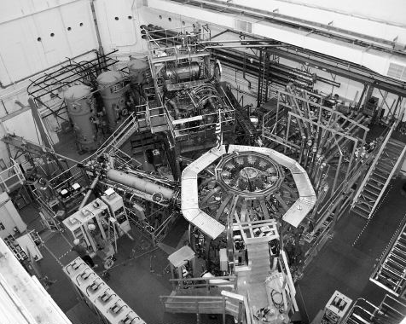

Figure 3 – NSTX Machine (September 2000)

A simplified cross section of the machine is depicted in Figure 4, and of the center stack in Figure 5. The unusual construction of the machine is a consequence of the need to minimize the radial build of the center core, and the fact that the toroidal field is relatively low. The core consists of a narrow center stack (CS) bundle which contains the inner legs of the Toroidal Field (TF) coil, an Ohmic Heating (OH) solenoid coil wound on to a tension cylinder, a pair of inner Poloidal Field (PF) coils, thermal insulation, and a center stack casing (CSC) which forms the inner wall vacuum vessel boundary. The CSC is electrically isolated from the remainder of the machine via ceramic insulator assemblies which permits the use of CHI. The outer VV consists of a 5/8” continuous stainless steel structure with 12 major midplane ports. The outer PF coils are taken from the retired S-1 machine at PPPL.

Table I – NSTX Ratings
Plasma | Major Radius (R₀) | 85.4 cm
 | Aspect Ratio (R/a) | 1.26
 | Volume | 12m³
 | Elongation | 1.6 ≤ κ ≤ 2.2
 | Triangularity | 0.2 ≤ δ ≤ 0.5
 | Current | 1.0 MA
 | Ramp Time | 0.2 - 0.4 sec
 | Flat Top (Inductive) | 0.5 sec per 600 sec
 | Flat Top (non-Inductive) | 5.0 sec per 300 sec
Toroidal  Field | Field @ R₀ | 3.0/6.0 kG
Ohmic  Heating | Flux (double swing) | 0.6 volt-sec
 | Initiation Loop Voltage @ R₀ | 5.0 volt/turn
Heating/  Current  Drive | High Harmonic Fast Wave (HHFW) RF | 6.0 MW, 30MHz, 5 sec
 | Coaxial Helicity Injection (CHI) | 500kA via 50kA injection @ 1kV
 | Neutral Beam Injection Upgrade (NBI) | 5.0 MW, 80kV, 5 sec
Pre-  Ionization | Electron Cyclotron | 30kW, 18GHz, 0.1 sec
Bakeout | Bakeout Temperature | 350ºC PFCs, 150ºC VV

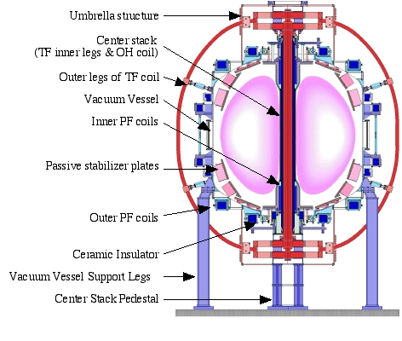
Figure 4 – NSTX Cross Section

Figure 5 – Center Stack Quarter Section

Within the center stack the 36 turn, 72kA/turn, 1kV TF coil consists of two layers of nested water cooled copper conductors, which make efficient use of the space and facilitate the fabrication process. The OH tension cylinder provides a reaction against the launching load on the coil and provides a spool during the winding procedure. The ≈ 1000 turn, +/- 24kA/turn, 6kV OH coil is wound from four layers, each two-in-hand. All OH turns are connected in series electrically by there are eight separate parallel water paths to promote rapid cool-down between pulses. A 10mm gap between the OH coil and the center stack casing contains an efficient thermal insulation (Microtherm) along with various magnetic diagnostics and associated wiring.

The mechanical support scheme is unique. The center stack rests on a pedestal on the floor of the test cell. The TF inner leg assembly thermal growth is accounted for by allowing the assembly to slide within the OH tension tube, by the connection to the outer legs via flexible joints, and by connection to the top umbrella assembly via a sliding spline joint. The torsion on the inner leg assembly is transferred via the hub assemblies to the outer VV. The TF outer leg dead weight load and overturning moment are taken by turnbuckles mounted to the outer VV. The OH thermal growth is accounted for by allowing it to slide over the tension tube and inside of the center stack casing, and via a compression washer stack at the top. The center stack thermal growth is taken up by the bellows. The outer VV thermal growth is accounted for by the sliding joints with the support legs, umbrella structures, outer PF coils, and spline.

Key engineering features are as follows:
• Compact, removable center stack
- Nested, two-tier TF inner legs
- Four layer, two-in-hand OH solenoid
- Tight tolerances, precision assembly
- Compact inner wall PFC design
- Miniature diagnostic sensors
- Microtherm insulation
• Unique support scheme and load paths
• Extensive use of the TFTR facility/parts
• EPICS and MDS+ software packages for process control and data acquisition

III. RESEARCH PLAN

An outline of the NSTX Research Plan is given in Table II. The three basic phases correspond to the gradual evolution of the current drive methodology from fully inductive (OH only, full +/- swing) to partial inductive (OH half swing + RF + CHI + bootstrap) to non-inductive (no OH).

IV. NSTX STATUS & ACCOMPLISHMENTS

Following the 1st plasma campaign in February 1999, NSTX was opened for 6 months to finish the installation of the internal hardware. The first bakeout of the machine was performed in August 1999 via resistive heating of the center stack casing up to 300ºC and pressurized water through the outer VV piping raising it up to 125ºC.

The 1999 operational campaign began in September and ended in January 2000, total of 12 run weeks. During this time all of the coil an power supply systems were commissioned to their full rated currents, except for the TF 6kG capability which remains held in reserve. The Plasma Control System (PCS) was commissioned, and a 1MA plasma current was obtained. HHFW RF power was injected up to 2MW, and electron heating was obtained. Initial CHI experiments were performed in which 20kA of current injection yielded plasma current up to 130kA.

The 2000 operational campaign began in July and is still underway. The most significant accomplishments thus far are the commissioning of the Multi-Point Thompson Scattering System and the achievement of CHI current of 240kA with a multiplication factor of 10, NBI heating at 2.8MW and HHFW RF heating at 2.3MW. Production of inboard limited, single null X-point, and double null X-point plasmas with I_{p} ≤ 1MA, and flat top time ≤ 0.3 second is now routine. Levels of performance achieved thus far are summarized in Table III. Figure 6 shows waveforms from a typical shot, along with an EFIT reconstruction.

Table II – NSTX Research Plan Outline

Table III – NSTX Plasma Performance
Plasma Current I_{p} | ≤ 1.0 MA
I_{p} Flat Top | ≤ 300 mS
dI_{p}/dt | ~5.5 MA/sec
Ejima Coeff = ∫V_{res}dt/µ₀R₀I_{p} | ~ 0.35
Stored Energy W | ~ 90kJ
Confinement Time τ_{E} | ~ 45 mS
β_{T} = 2µ₀<p>/B₀2 | ~ 18%
T_{E} | ~ 1keV
n_{E} | 1 ~ 6 x 10⁻¹⁹ m⁻³
n_{E}/n_{greenwald} | ~ 1
P_{nbi} | ≤ 2.8MW
P_{hhfw} | ≤ 2.3MW
Z_{eff} | ~ 3

REFERENCES

1. M. Peng, “Spherical Torus Pathway to Fusion Power”, Journal of Fusion Energy, Vol. 17, No. 1, 1998
- S. Kaye, M. Ono, et al; “Physics Design of the NSTX”, Fusion Technology, Vol. 36, July 1999
- C. Neumeyer, et al; “Engineering Design of the NSTX”, PPPL-3446, Fusion Engineering Design, FUSION 1778

Figure 6 – Typical Plasma Shot Waveforms and EFIT Equilibrium Reconstruction

* Under USDOE Contract #DE-AC02-76-CHO3073

