13_040219_CLN_01.doc

TO: DISTRIBUTION
FROM: C NEUMEYER
SUBJECT: ANALYSIS OF TF COMMISSIONING ISTP RESULTS

This memo serves to document the TF-related results of ISTP-001 conducted between 1/16 and 1/20/4 to commission the new TF coil system and to restart NSTX. In addition it discusses the rationale for the present TF operating envelope of 4.5kG/1.0 second and outlines plans for follow-on work required to justify higher operating levels.

Summary

TF shots in the ISTP-001 Test Plan consisted of four TF-only shots at increasing levels which imposed equal increments of in-plane EM load and approximately equal increments of ∫i²(t)dt, followed by two additional test shots which include combined field out-of-plane loads. These latter two shots are representative of plasma operation and form the basis for the combined field 50% and 100% level standard daily test shots. The shots were planned in advance of the ISTP and were analyzed using the FEA models with the aim of comparing predicted quantities to measured quantities as part of the ISTP.

The ISTP test results show areas of agreement as well as areas of disagreement with the analytic predictions. Also, the joint-to-joint variation is larger than anticipated. And, the results are not generally consistent with the prototype testing in terms of the effect of applied EM loads versus joint resistance. Therefore follow-on activities have been initiated to develop refinements to the analytic model with the aim of benchmarking it against the measurements. Another round of prototype tests may be performed as well.

In the interim, the present operating envelope allows 4.5kG and a maximum I²T of 3.6e9A²-sec, which represents 56% of the in-plane EM load, 75% of the out-of-plane EM load, and 77% of the maximum thermal load, with respect to the 6kG design basis case.

This envelope is judged to be safe, despite the aforementioned discrepancies, based on the fact that the energy dissipation at the worst case joints is estimated to be of the same order as that allowed for in the analysis of the design basis 6kG pulse. The situation is really far more complex, however, considering the non-uniform current densities, pressures and conductivities (electrical and thermal) along the joint, along with the time dependencies of the thermal diffusion away from the joint. Nevertheless, an encouraging factor is that stable operation at 4.5kG has been demonstrated. But clearly more work needs to be done to develop a reliable predictive model and a better understanding of the behavior. At this time efforts are underway to develop modified FEA models which represent the locality of the joint in greater detail than previously. The expectation is that the greater level of detail will lead to better agreement between the predicted voltage, temperature, and strain measurements, and that the model will still predict acceptable conditions at 6kG.

General Questions To Be Addressed

1) Does measured behavior agree with analytic model?

- How much difference exists between measurements and predictions?
- Does model need to be changed?
- Does operating envelope need to be reconsidered?

2) Do all joints of the same type behave the same way?

- What variation exists joint-to-joint?
- Are any joints significantly different than others?

- Is behavior changing as more load cycles are applied?

Measurement Details

Voltage across each joint is measured using probes as shown in figure 1 below.

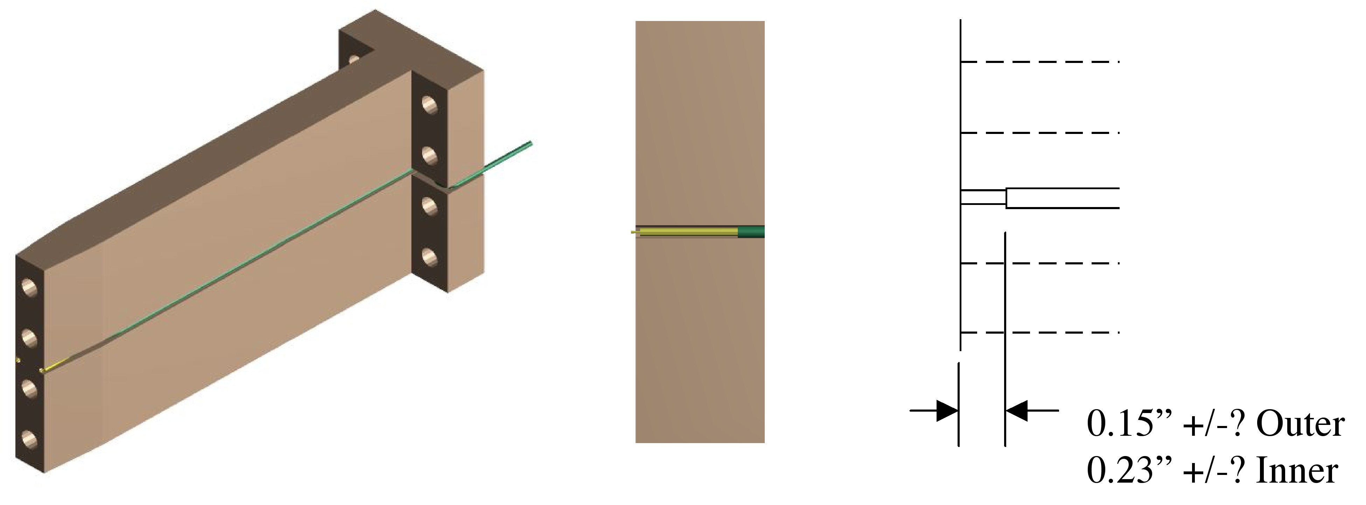
Figure 1 – Voltage Probe Arrangement

Voltage drop necessarily includes bulk resistance effect due to distance over which probe barrel is in contact with copper. Nominal dimensions are shown in the figure. However, due to the final clean-up machining step, the tolerance on this dimension is unknown, and could be quite variable.

Theoretical resistance measurement is based on the following curve showing the effect of contact pressure on contact resistivity.

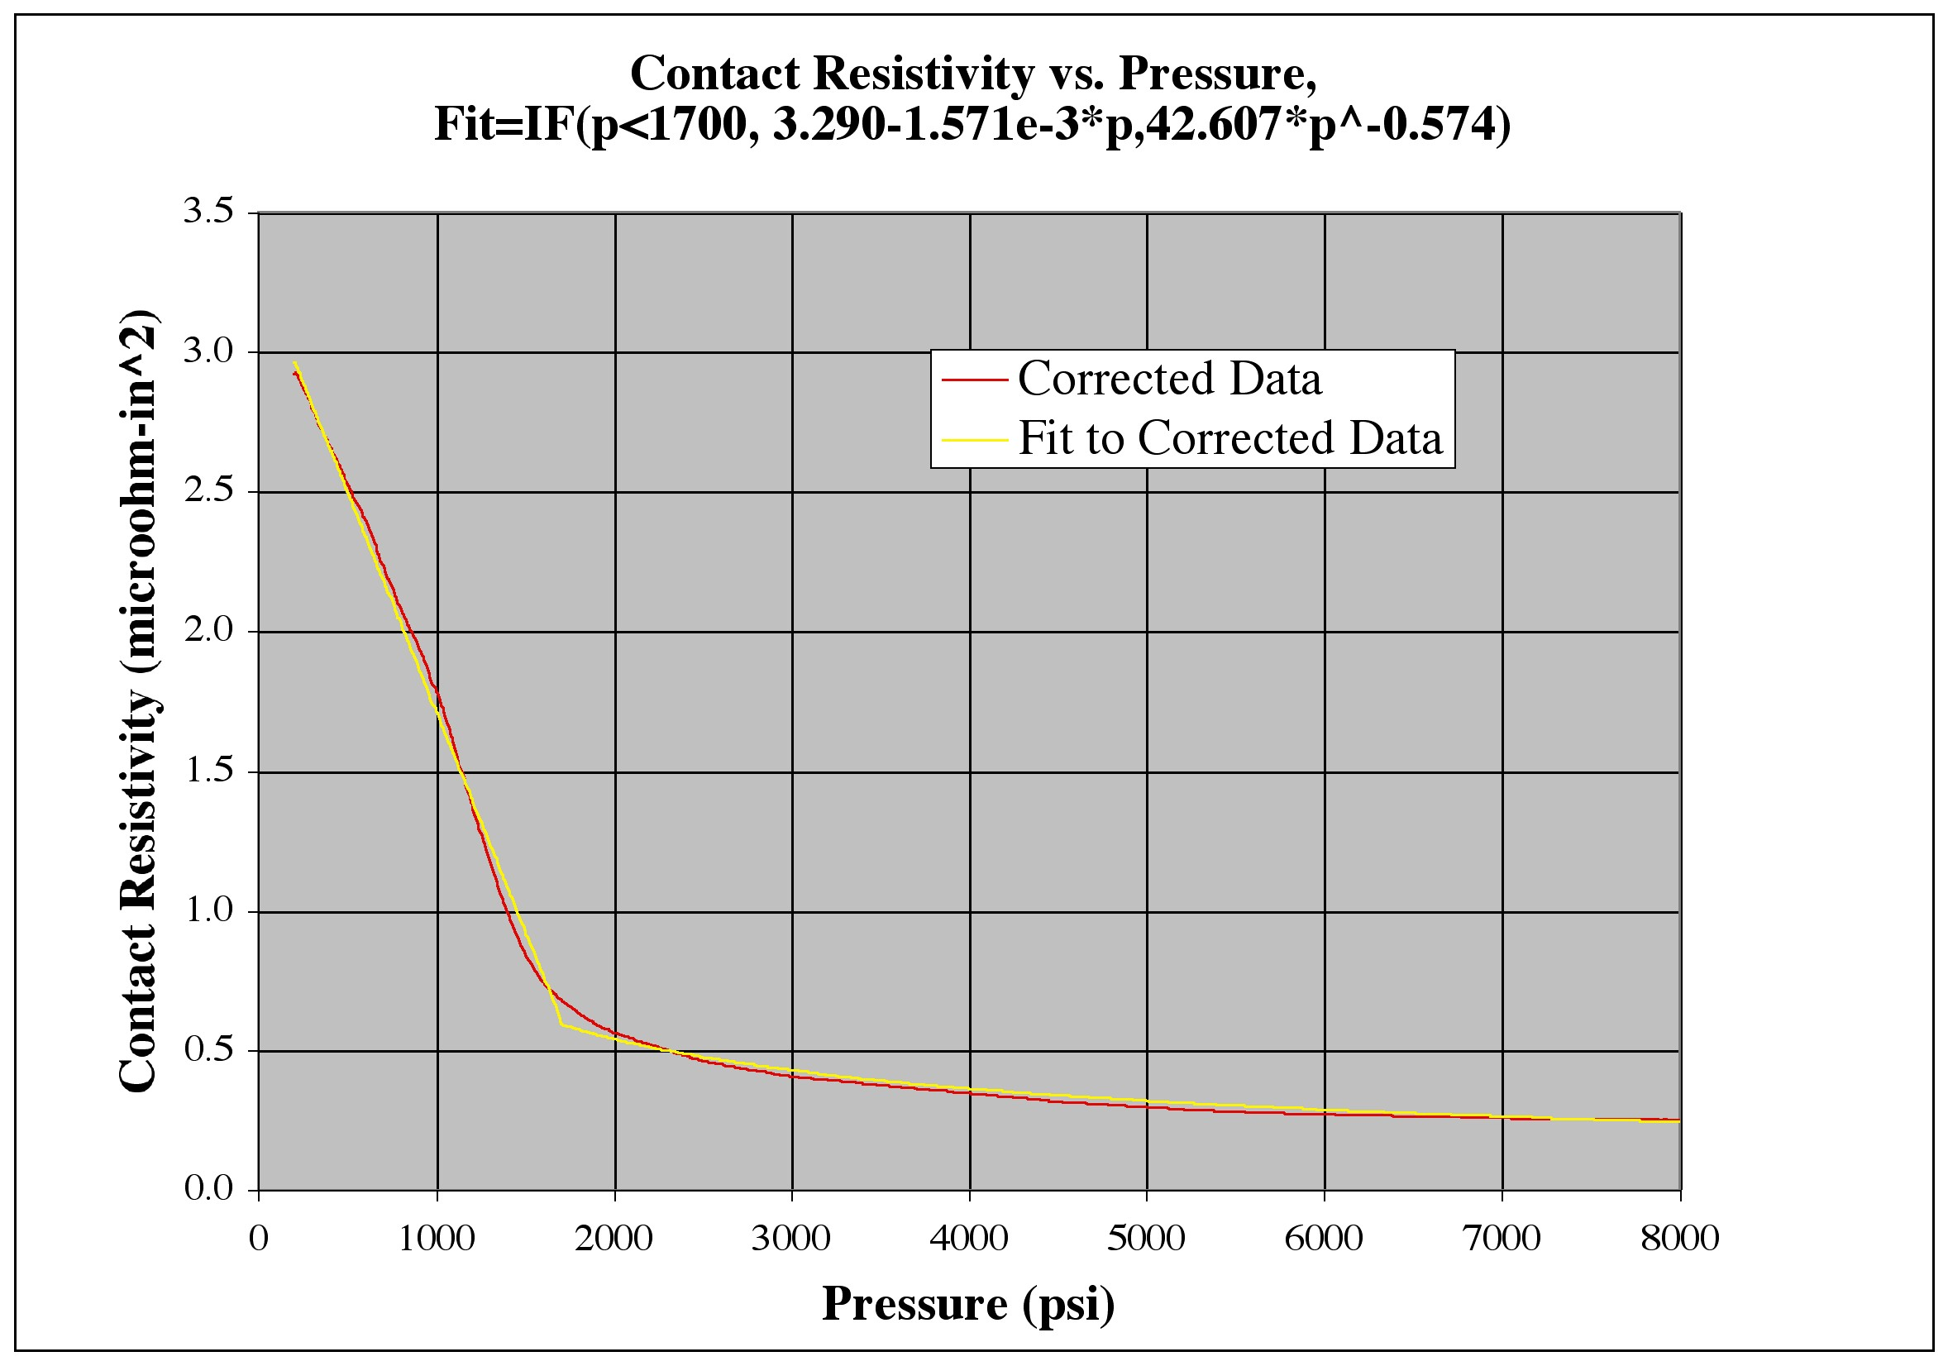
Figure 2 – Contact Resistivity vs. Pressure

On this basis, and the nominal flag stud tension, predicted resistances under no load at 20C are as shown in Table 1.

TABLE 1 – PREDICTED JOINT RESISTANCE VALUES
 | Outer Layer, Nominal | Inner Layer, Nominal
Probe Gap | 0.15 | 0.23 | in
Height | 5 | 5 | in
Width | 0.781 | 1 | in
Hole Dia | 0.563 | 0.563 | in
Groove Dia | 0.048 | 0.048 | in
Groove Depth | 0.142 | 0.142 | in
CSA | 2.90 | 3.99 | in^2
20C Bulk Resistance | 0.035 | 0.039 | microohm
Force | 20000 | 20000 | lbf
Pressure | 6906 | 5011 | psi
Contact Resistivity | 0.114 | 0.224 | microohm-in^2
Contact Resistance | 0.039 | 0.056 | microohm
Temperature(200A) | 20 | 20 | C
Bulk Resistance(200A) | 0.035 | 0.039 | microohm
Total Resistance(200A) | 0.074 | 0.095 | microohm

The above predicts an average resistance of around 75 nano-Ohm (nΩ) for the outer layer flags and 95 nΩ for the inners, whereas the actual measured values following initial installation had averages of 40 nΩ and 75 nΩ. The following figure gives an indication of the kind of variability initially measured.

Figure 3 – Outer Flag Joint Resistance (nΩ) vs. Joint Number,
Average of “A” and “B” probes,
and difference between “A” and “B” probes

Figure 4 – Outer Flag Joint Resistance (nΩ) vs. Joint Number,
Average of “A” and “B” probes,
and difference between “A” and “B” probes

TABLE 2 – FIRST 200A MEASUREMENT
OF JOINT RESISTANCES
Location | nΩ
Ravg_Outer_Top | 40
Ravg_Outer_Bott | 40
Ravg_Outer | 40
Rstdv_Outer | 10
Ravg_Inner_Top | 75
Ravg_Inner_Bott | 70
Ravg_Inner | 73
Rstdv_Inner | 17

Strain and temperature probes are installed in four flags (2 top (1 inner, 1 outer) and 2 bottom (1 inner and 1 outer) and their shear shoes as indicated in the figure 5.

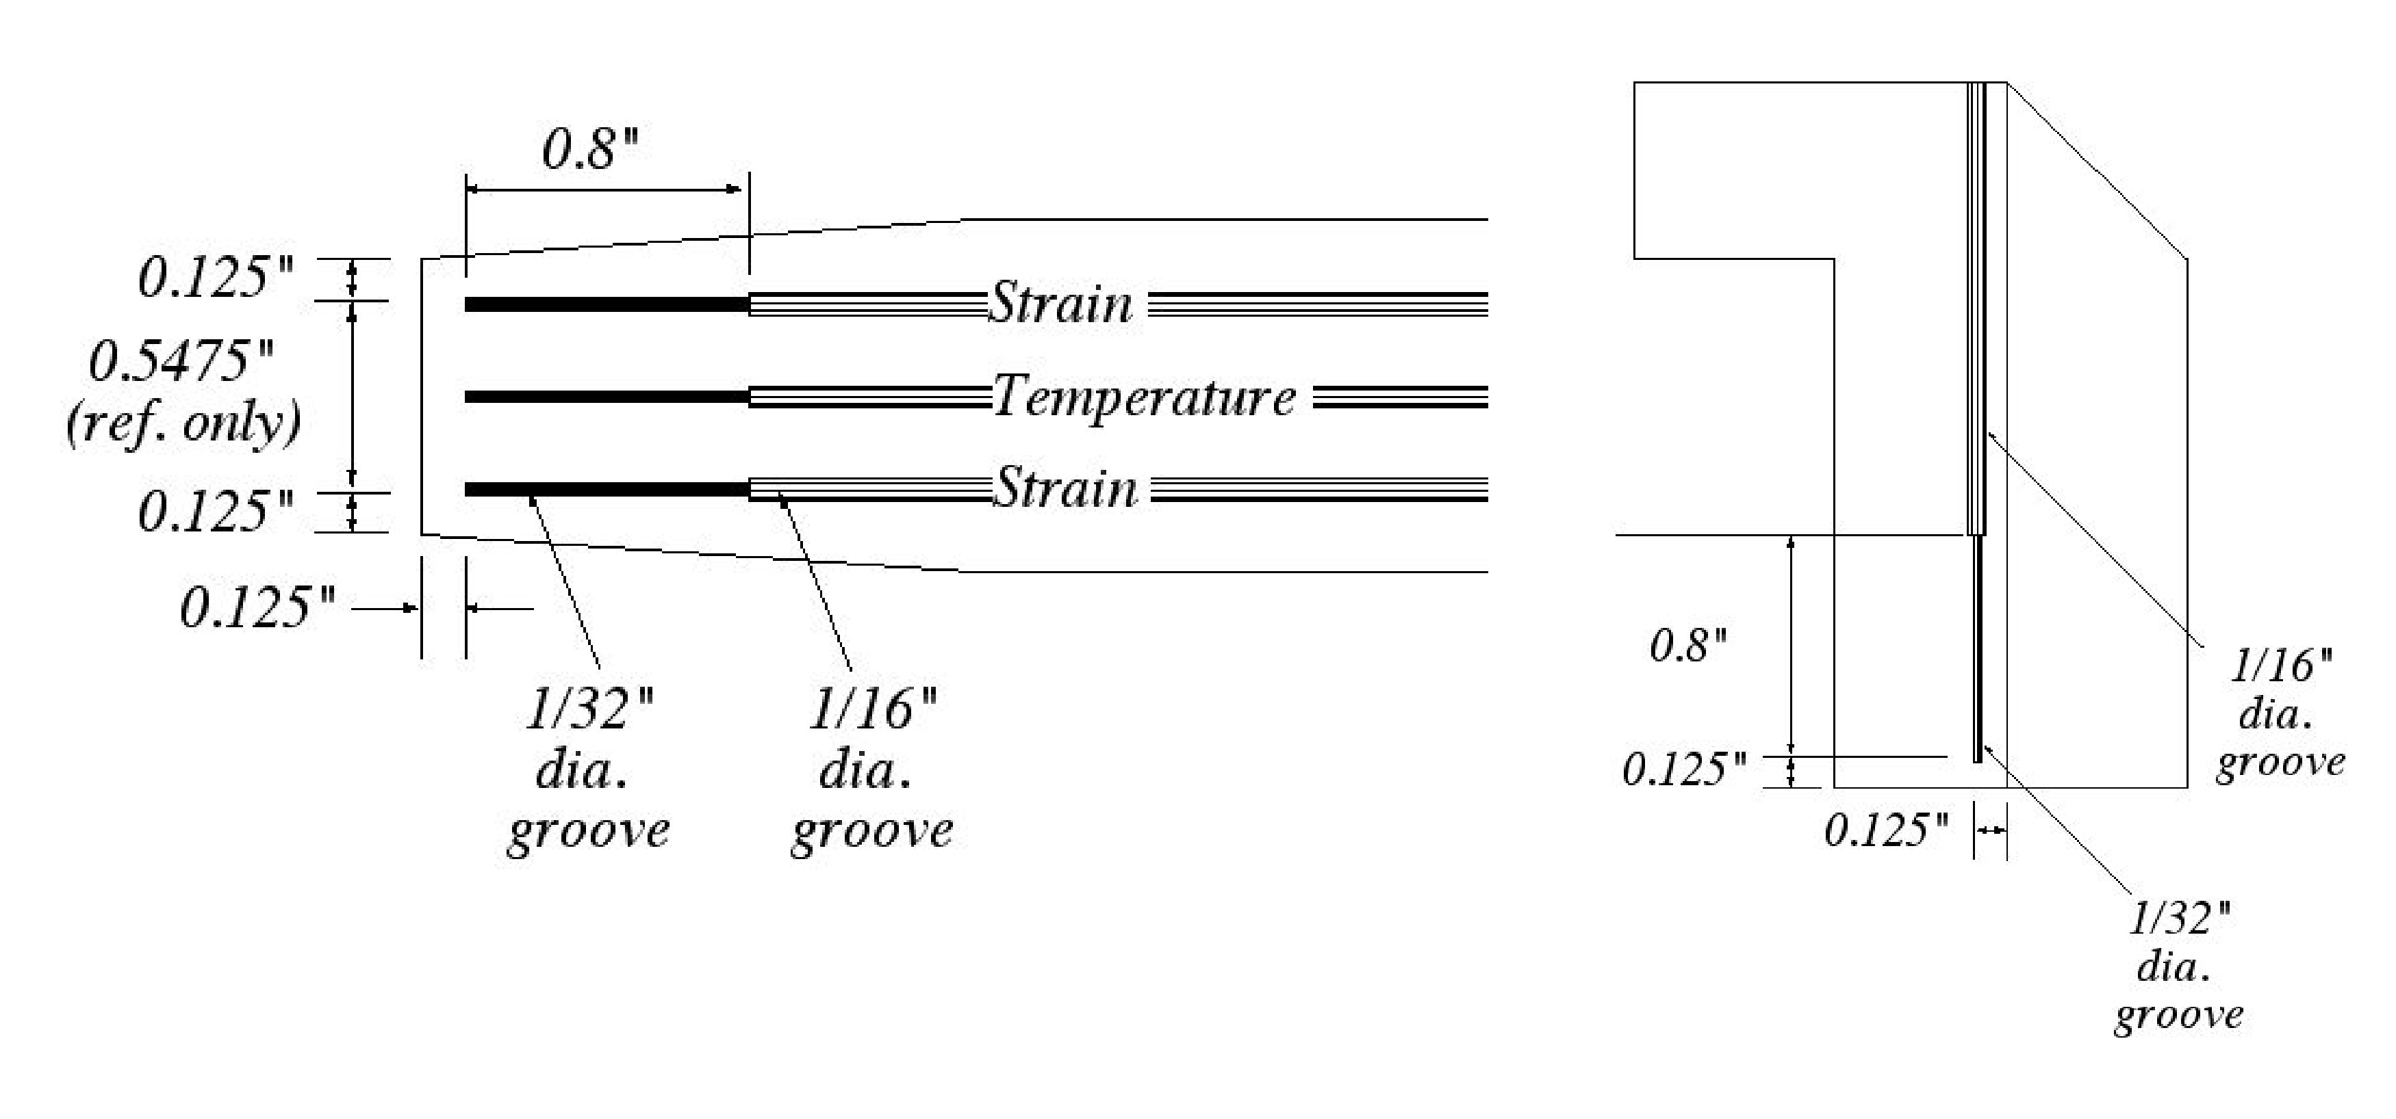
Figure 5 – Contact Resistivity vs. Pressure

It is noted that the temperature probes have an active length of ~ 0.75” and are epoxied into a groove. Per the manufacturer, the time response of the probe time alone is 30mS, but the response in this configuration, with the epoxy, is not known at this time. The range of the probes is 0-150C, and the scale factor is TBD volts/ºC (i.e. TBD degrees/volt).

The range of the strain probes is –2500 (compression) to 200 (tension) microstrain. The strain probes have an active length of ~ 0.4” and are also epoxied into grooves.

G-10 rods were affixed to several flag ends and displacement transducers affixed to the umbrella structure to measure the toroidal displacement at the ends of the rods as a measure of the angular twist of the TF bundle. Total radius out to the transducers is TBD inches on outer flags and TBD inches on inner flags, so the scale factor is TBD inch/degree for the outers and TBD inch/degree on the inners. Then, considering that the scale factor of the probe is 10V/inch, the final signal scale factor is TBD volts/degree (i.e. TBD degrees/volt) on the outers and TBD volts/degree (i.e. TBD degrees/volt) on the inners.

One displacement transducer was affixed to the top of the machine to measure the axial displacement of the TF bundle at the spline with respect to the umbrella cover. The scale factor is 10V/inch (i.e. 100mils/volt).

ISTP Shot Summary

Shot list and FISO signal conditioner channel usage is shown in the following table.

TABLE 3 – ISTP SHOT SUMMARY
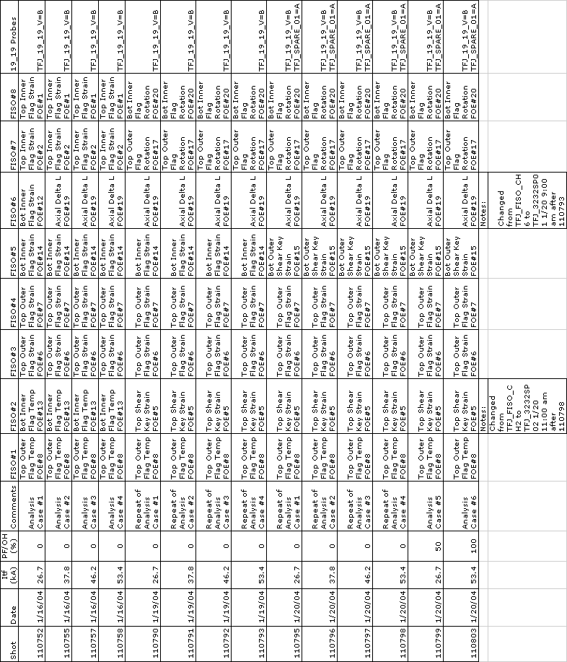

FISO Probe Details

FISO probe details are given in the following table.

TABLE 4 – FISO DETAILS
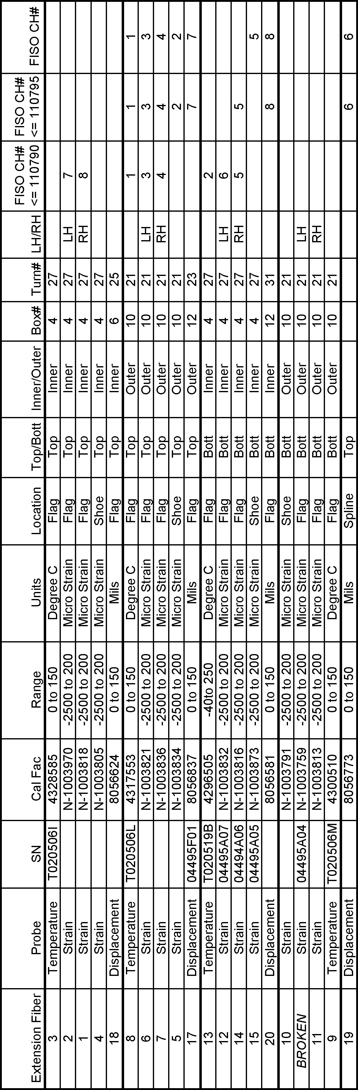

Shot Details and Analysis Predictions

Specifications and shot numbers for the 6 types of test shots is given in the following table.

TABLE 5 – SHOT DETAILS

 | Shot | Bt | dT | Tflat | PF | Time | ITF | IOH | IPF1A | IPF1B | IPF2 | IPF3 | IPF5
1 | 110795 | 2.25 | 11 | 1 | 0% | SOFT | 26.7 | 0.0 | 0.0 | 0.0 | 0.0 | 0.0 | 0.0
 |  |  |  |  |  | EOFT | 26.7 | 0.0 | 0.0 | 0.0 | 0.0 | 0.0 | 0.0
2 | 110796 | 3.18 | 23 | 1 | 0% | SOFT | 37.8 | 0.0 | 0.0 | 0.0 | 0.0 | 0.0 | 0.0
 |  |  |  |  |  | EOFT | 37.8 | 0.0 | 0.0 | 0.0 | 0.0 | 0.0 | 0.0
3 | 110797 | 3.90 | 36 | 1 | 0% | SOFT | 46.2 | 0.0 | 0.0 | 0.0 | 0.0 | 0.0 | 0.0
 |  |  |  |  |  | EOFT | 46.2 | 0.0 | 0.0 | 0.0 | 0.0 | 0.0 | 0.0
4 | 110798 | 4.50 | 50 | 1 | 0% | SOFT | 53.4 | 0.0 | 0.0 | 0.0 | 0.0 | 0.0 | 0.0
 |  |  |  |  |  | EOFT | 53.4 | 0.0 | 0.0 | 0.0 | 0.0 | 0.0 | 0.0
5 | 110799 | 2.25 | 50 | 1 | 50% | SOFT | 26.7 | -12.0 | 0.0 | 0.0 | 0.0 | -2.5 | 0.0
 |  |  |  |  |  | OHSS | 26.7 | 12.0 | -7.5 | 0.0 | -10.0 | 10.0 | 10.0
 |  |  |  |  |  | EOFT | 26.7 | 0.0 | 0.0 | 0.0 | 0.0 | 0.0 | 0.0
6 | 110803 | 4.50 | 50 | 1 | 100% | SOFT | 53.4 | -24.0 | 0.0 | 0.0 | 0.0 | -2.5 | 0.0
 |  |  |  |  |  | OHSS | 53.4 | 24.0 | -15.0 | 0.0 | -10.0 | 10.0 | 10.0
 |  |  |  |  |  | EOFT | 53.4 | 0.0 | 0.0 | 0.0 | 0.0 | 0.0 | 0.0

Corresponding analytic predictions are given in the following table.

TABLE 6 – ANALYTIC PREDICTIONS

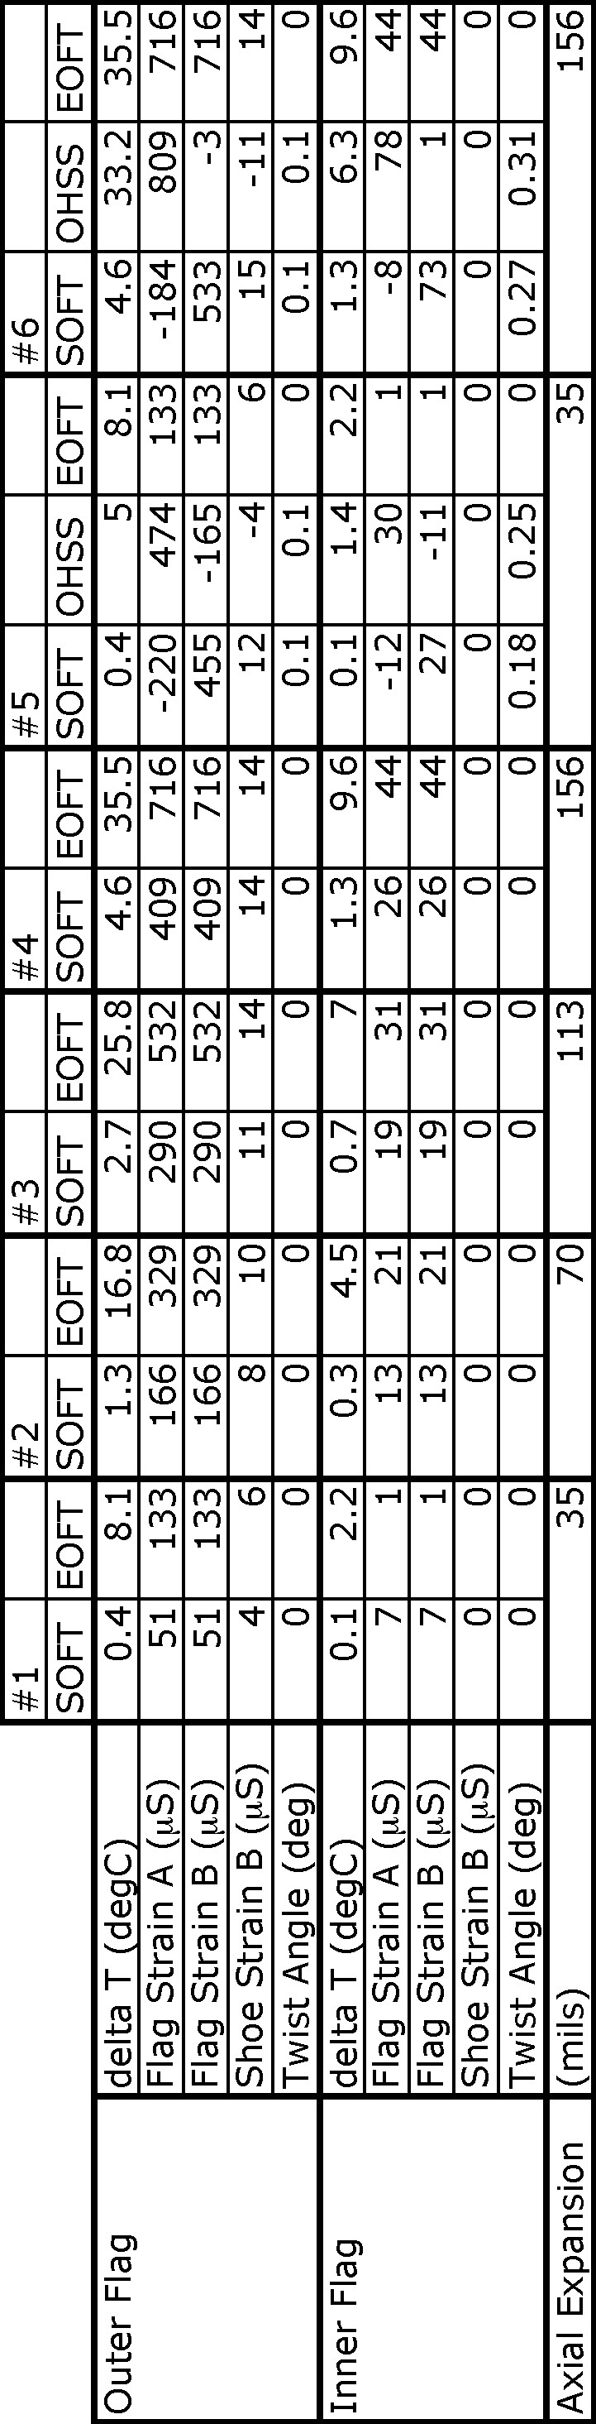
TF-Only Shots

The following results focus on the outer layer turn number 21 on the top of the machine which is referred to as 21_21. This is one of the turns which was instrumented with the fiber optic strain and temperature probes. Response of the voltage probes on 21_21 to the four TF-only shots is shown in figure 6.

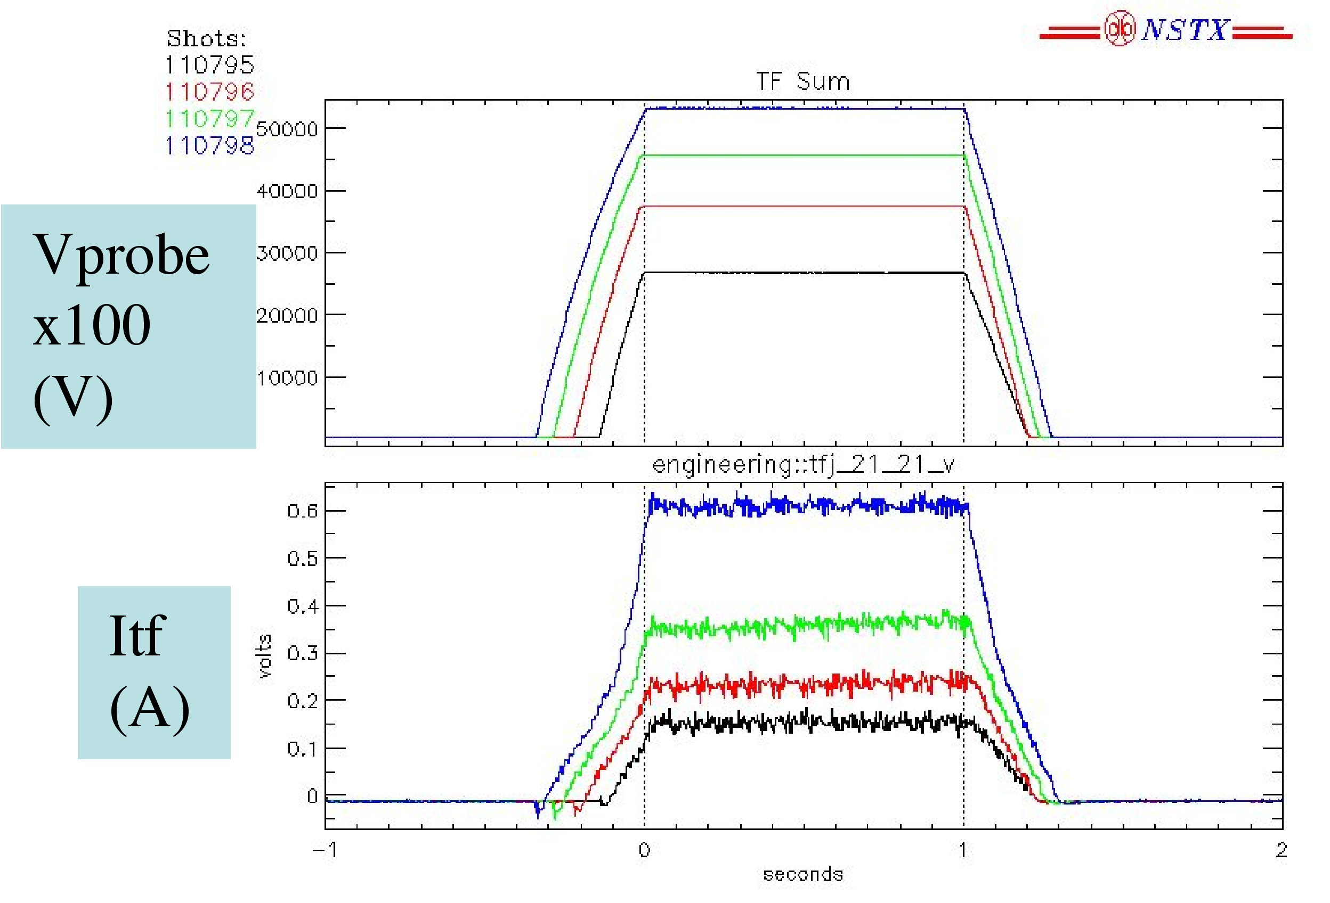
Figure 6 – Voltage Probe Response to In-Plane Loading

Response of the temperature probe on 21_21 to the four TF-only shots is shown in figure 7. The behavior of the last shot (110798) is noticeably different than the others.

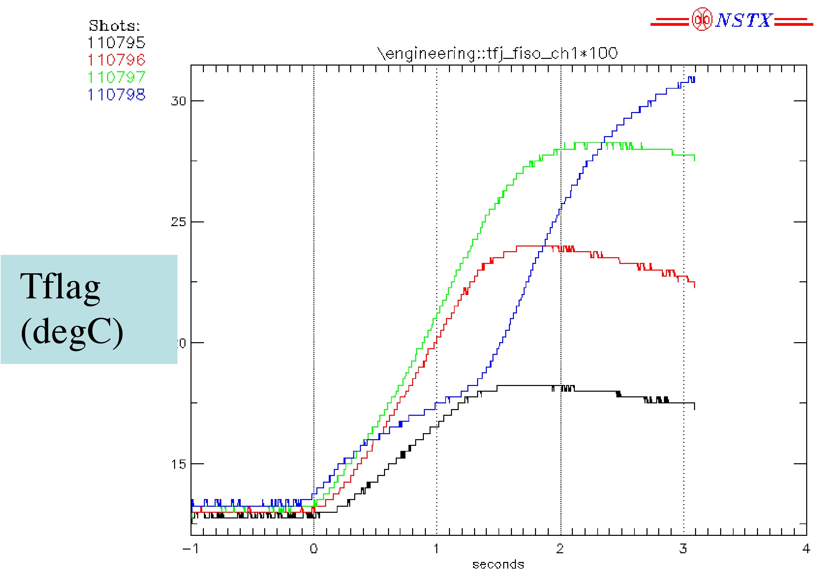
Figure 7 – Temperature Probe Response to In-Plane Loading
The temperature pattern during the pulse (t < 1.2) is counterintuitive, considering that the four pulses have equal increments of ∫i²(t)dt. However, the temperatures are noted to redistribute some time after the pulse (t ≥ 2 seconds) into a pattern which follows the ∫i²(t)dt.

Response of the flag strain probes on 21_21 to the four TF-only shots is shown in figure 8. Again, the behavior of the last shot (110798) is noticeably different than the others. Also, on the third shot (110797) a difference begins to develop between the strain probes on either side of the joint. Note that strain develops both as a function of the EM loads and of the temperature. After t=1.2 seconds or so, the EM field is off and the remaining strain can be attributed solely to temperature, and the strain level is noted to equalize on the two probes after this time. It is noted, further, that both the EM (in-plane) and thermal loads result in positive strain at this location. So, the most likely explanation for the last shot is that the temperature at the probe location was less (during the pulse) than during the prior shot, which is consistent with the observations in figure 7. One would expect, for pure in-plane loading, that there would be no side-to-side variation but clearly some effect is present here (most noticeably in the third shot (110797).

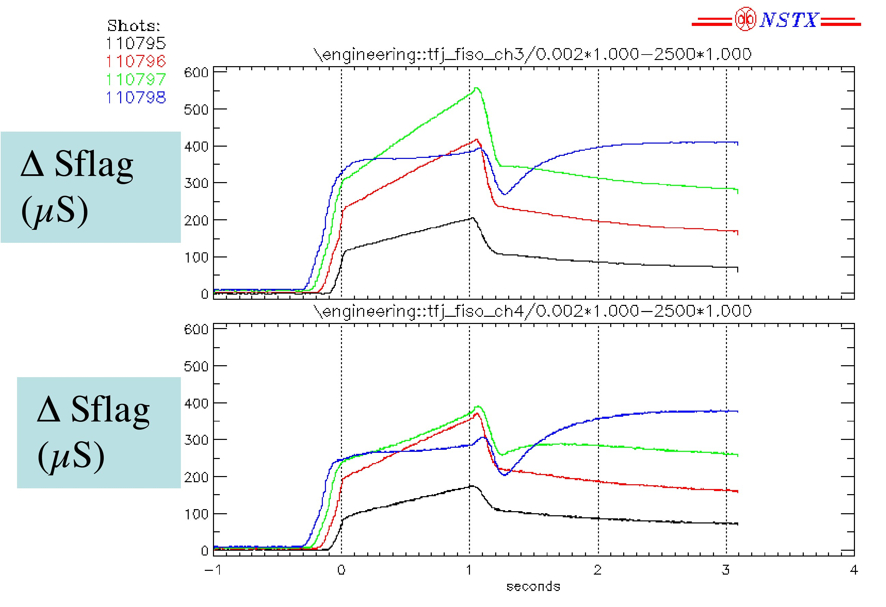
Figure 8 – Flag Strain Probe Response to In-Plane Loading

Response of the shear shoe strain probe on 21_21 to the four TF-only shots is shown in figure 9. Increasing levels of compression are noticeable in the last two shots, which one would expect at the shear shoe begins to pick up load.

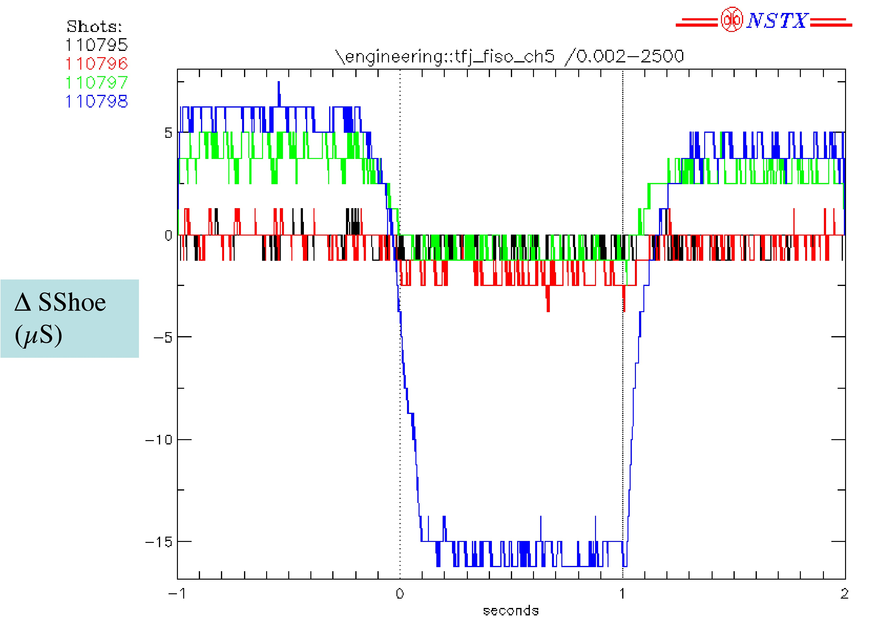
Figure 9 – Shoe Strain Probe Response to In-Plane Loading

Response of the axial displacement probe to the four TF-only shots is shown in figure 10. It is noted that the peaks occur at the end of flat top (t=1.0) and that after the EM load goes away (t ≥ 1.2 seconds) only the thermal effect remains.

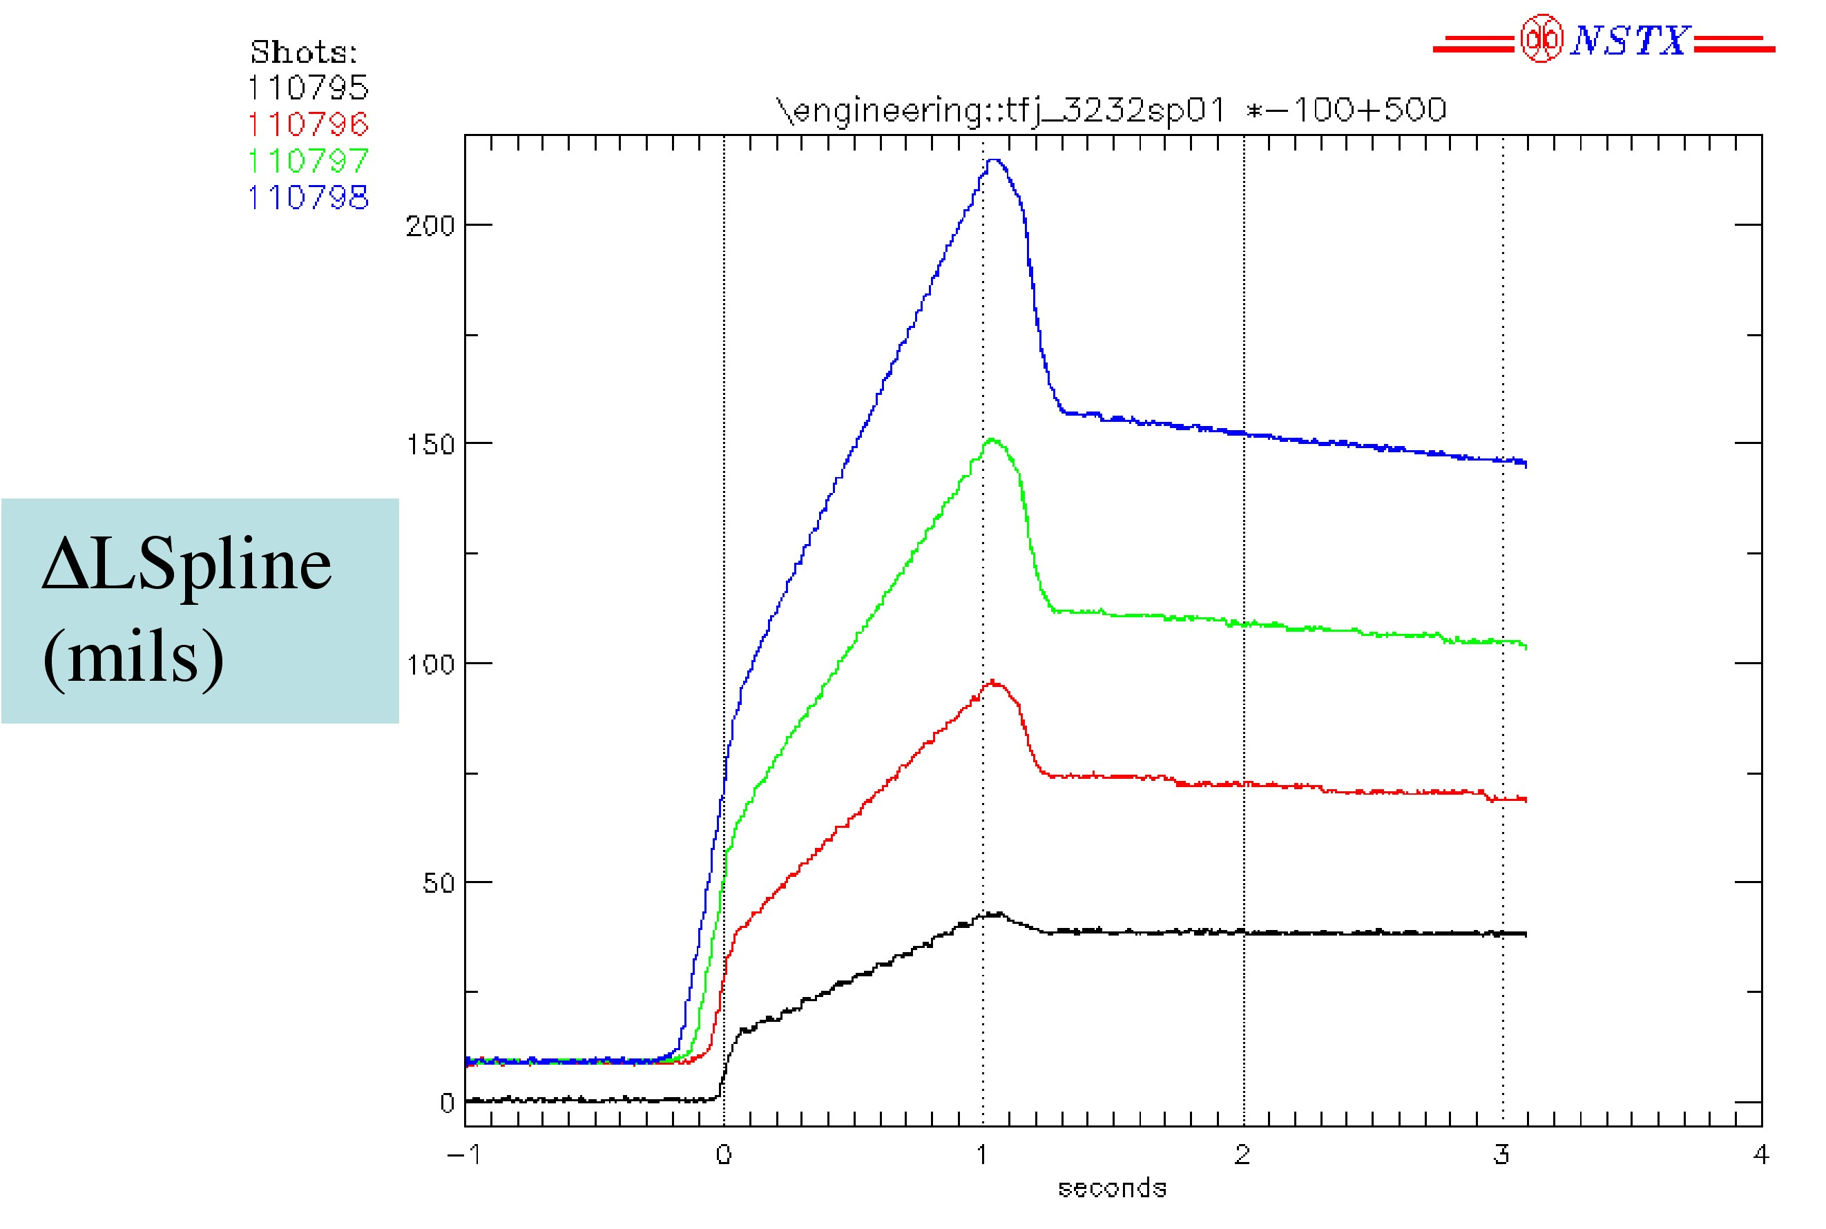
Figure 10 – Shoe Strain Probe Response to In-Plane Loading

Combined Field Shots

Voltage probe response to the two combined field shots (110799:50% and 110803:100%) are shown overlaid with the TF-only shots with the same TF level (110795 and 110798) in figure 11. Also shown are the OH waveforms. Other PF coil waveforms are not shown, but are of less significance. The effect of the OH is clearly evident on the combined field signals.
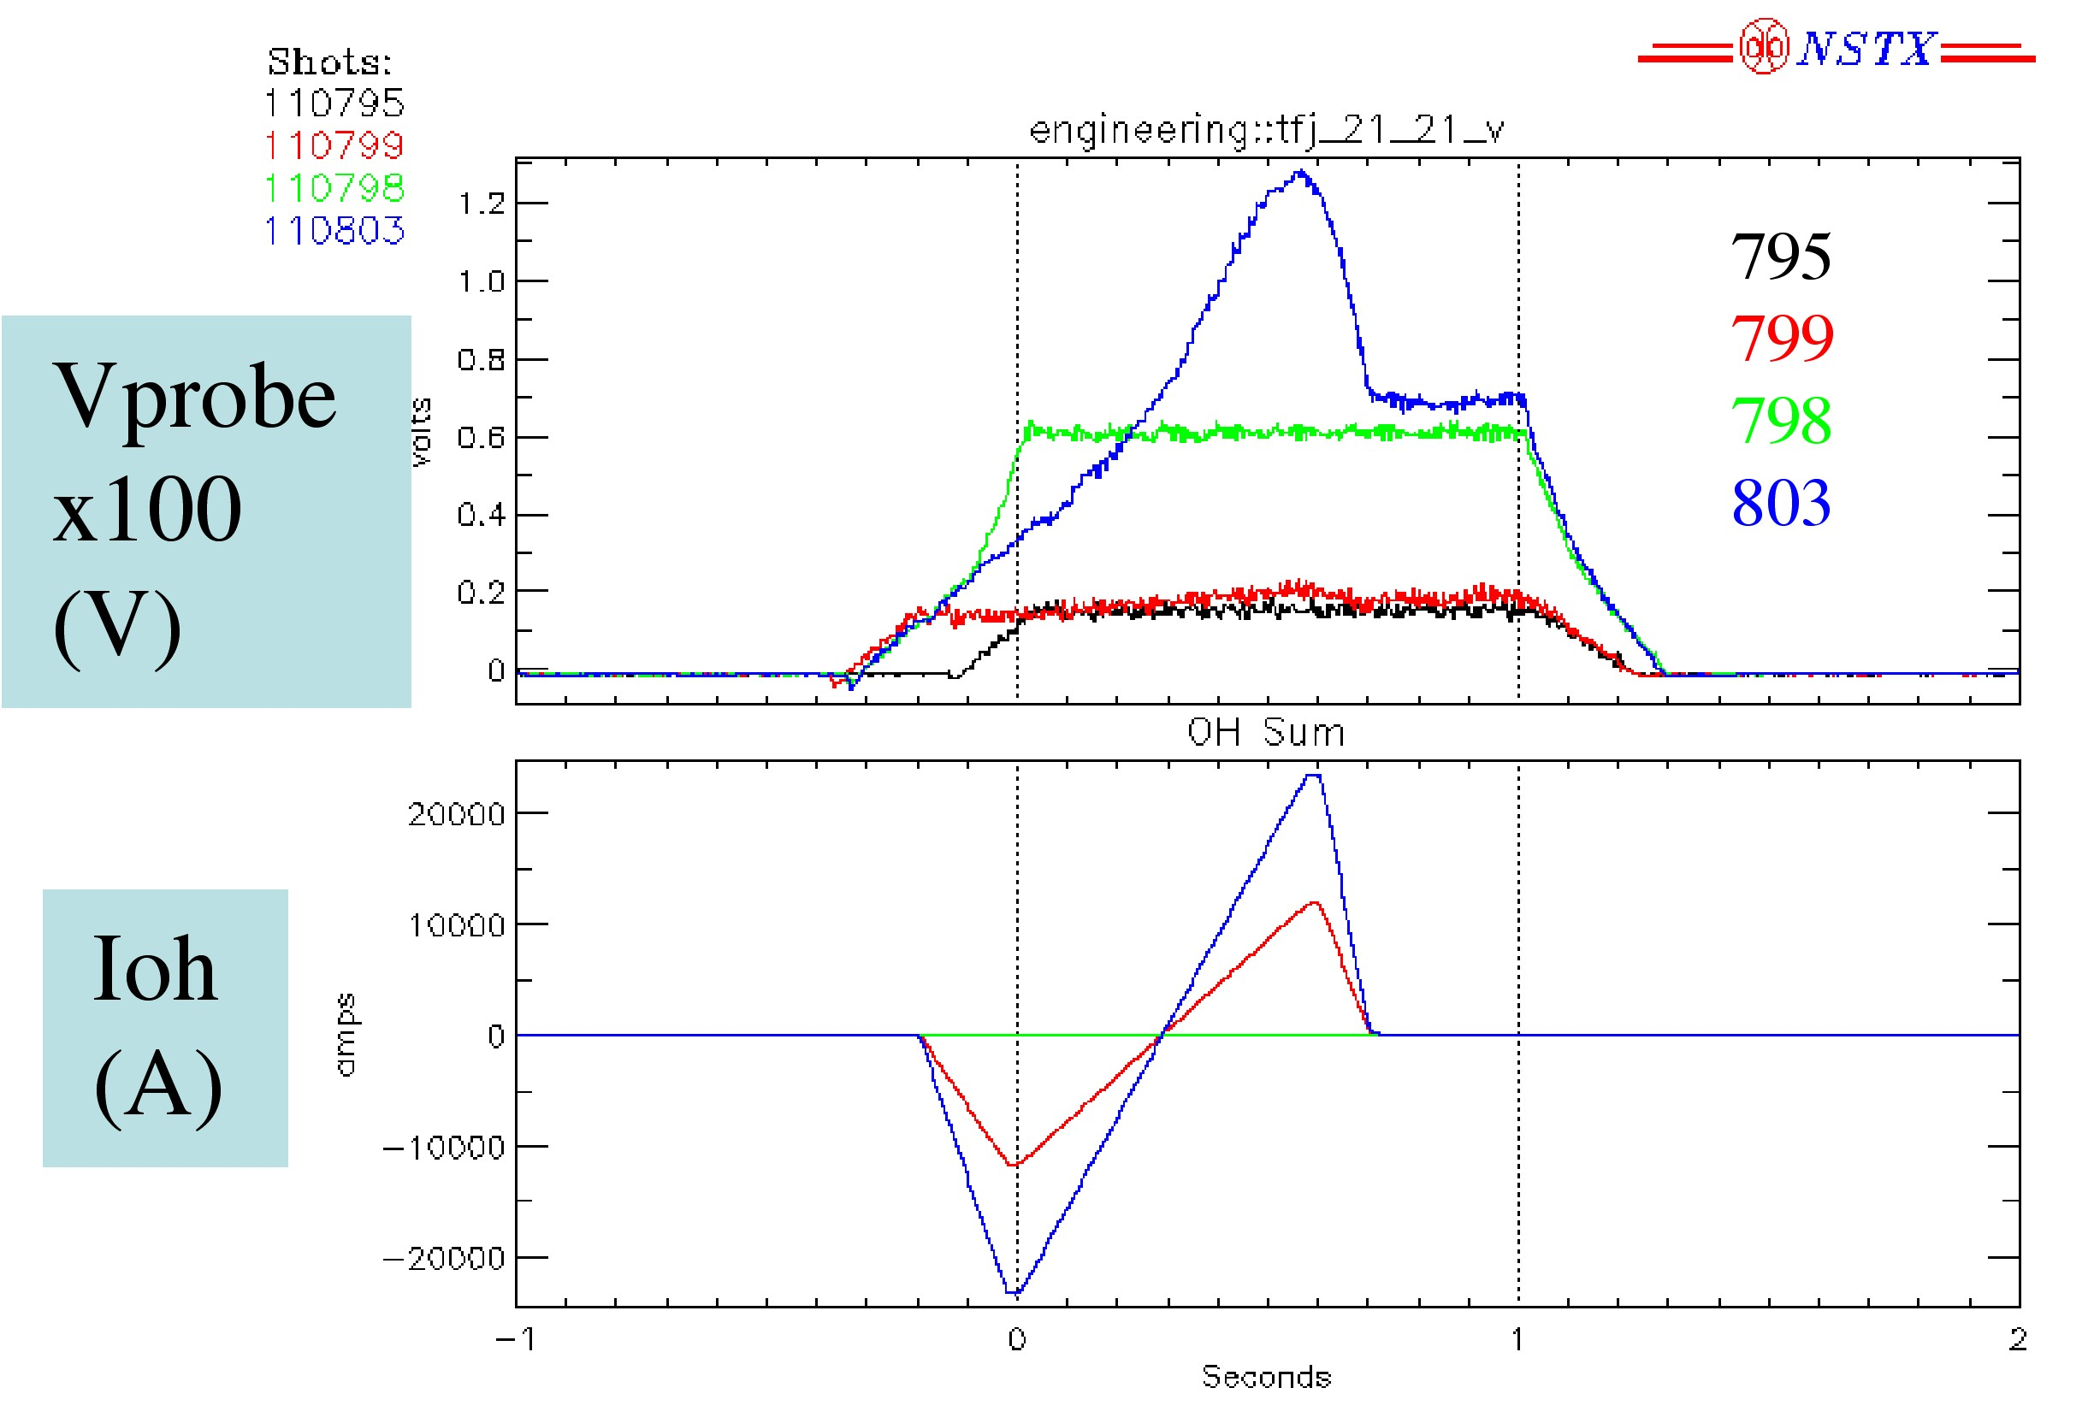
Figure 11 – Voltage Probe Response

Temperature probe response to the two combined field shots are shown overlaid with the TF-only shots with the same TF level in figure 12. No significant difference is noted between the in-plane and out-of-plane cases.

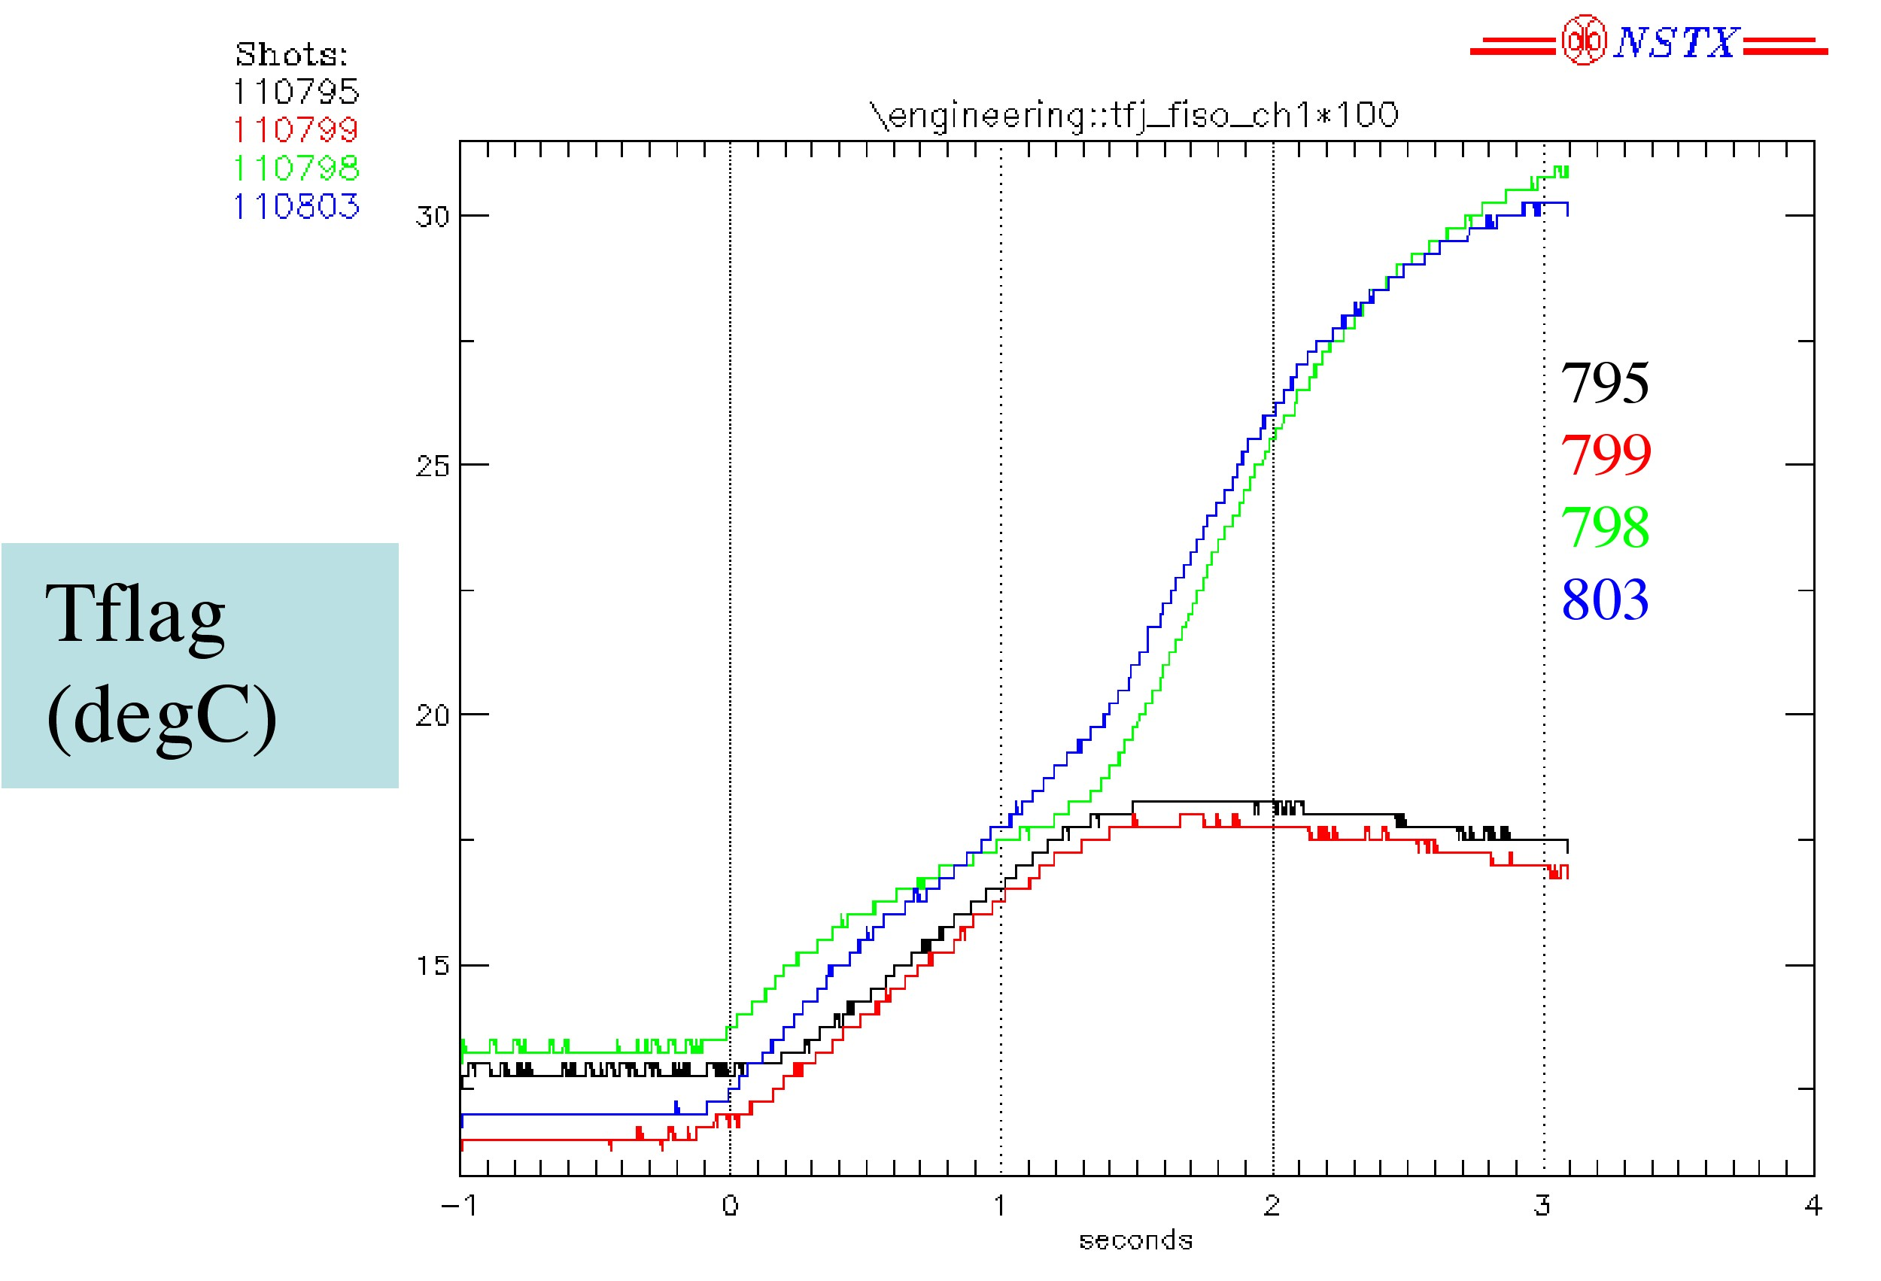
Figure 12 – Temperature Probe Response
Response of the flag strain probes on 21_21 to the combined-field shots is shown in figure 13. The effect of the OH is clearly evident, causing a response which is has an inverse relationship on the two sides of the flag, i.e. when one goes up, the other goes down, and vice-versa.

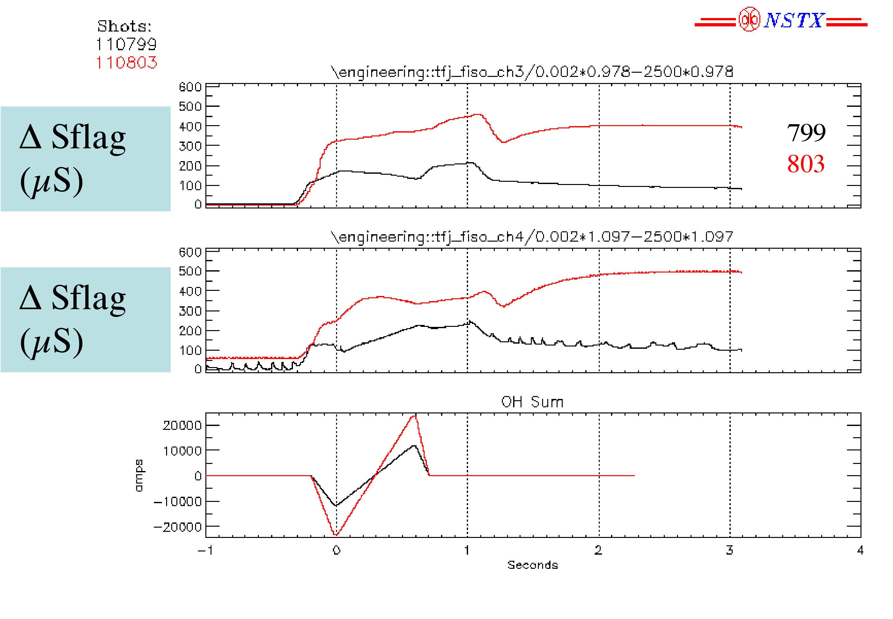
Figure 13 – Flag Strain Response

Response of the axial displacement to the combined field shots is shown in figure 14. Additional effects due to the operation of the OH and PF systems are noted.

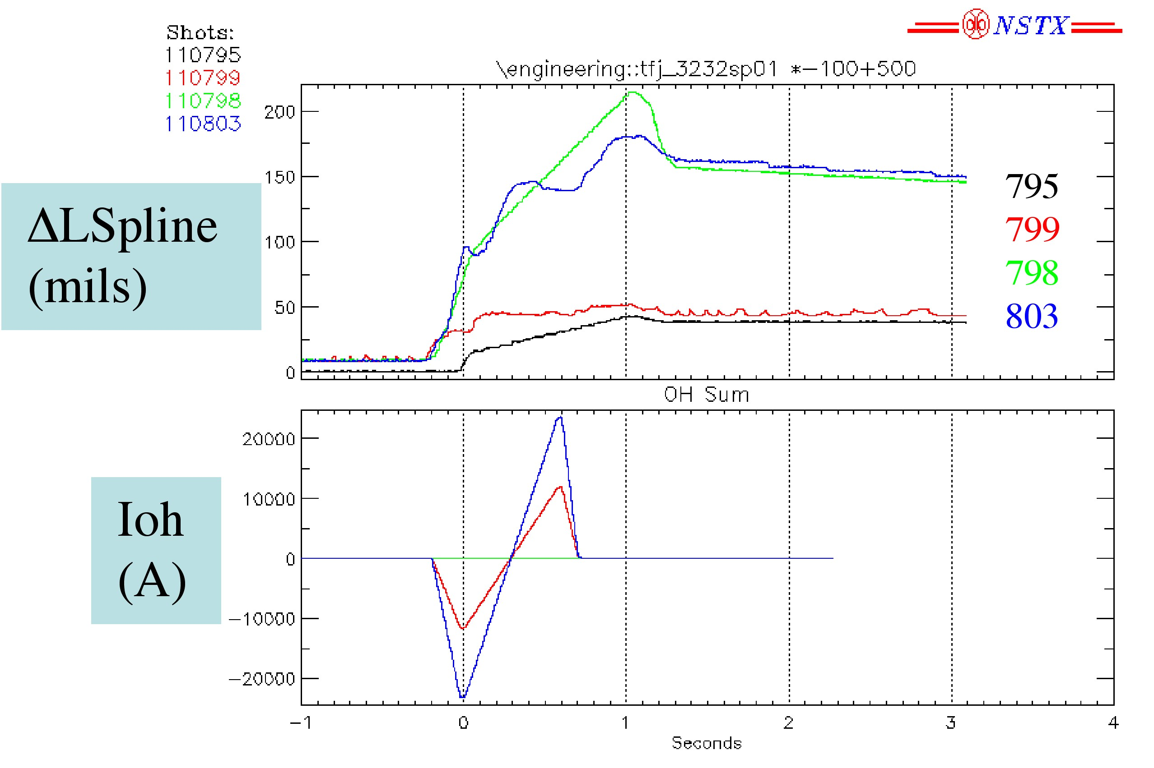
Figure 14 – Axial Displacement with Combined Field Loading
Figure 15 shows an overlay between the nominal combined field shot (110803) and another subsequent shot (110809) during which an OH fault occurred, and a rapid shutdown of the OH took place. It is postulated that the OH drives eddy currents in the umbrella cover such that, when the OH current is decreasing in magnitude, an attractive force is developed between the coil and the cover, causing a downward deflection. Then, when the current stops (and its derivative goes to zero), the cover is released from the force and undergoes a mechanical vibration.

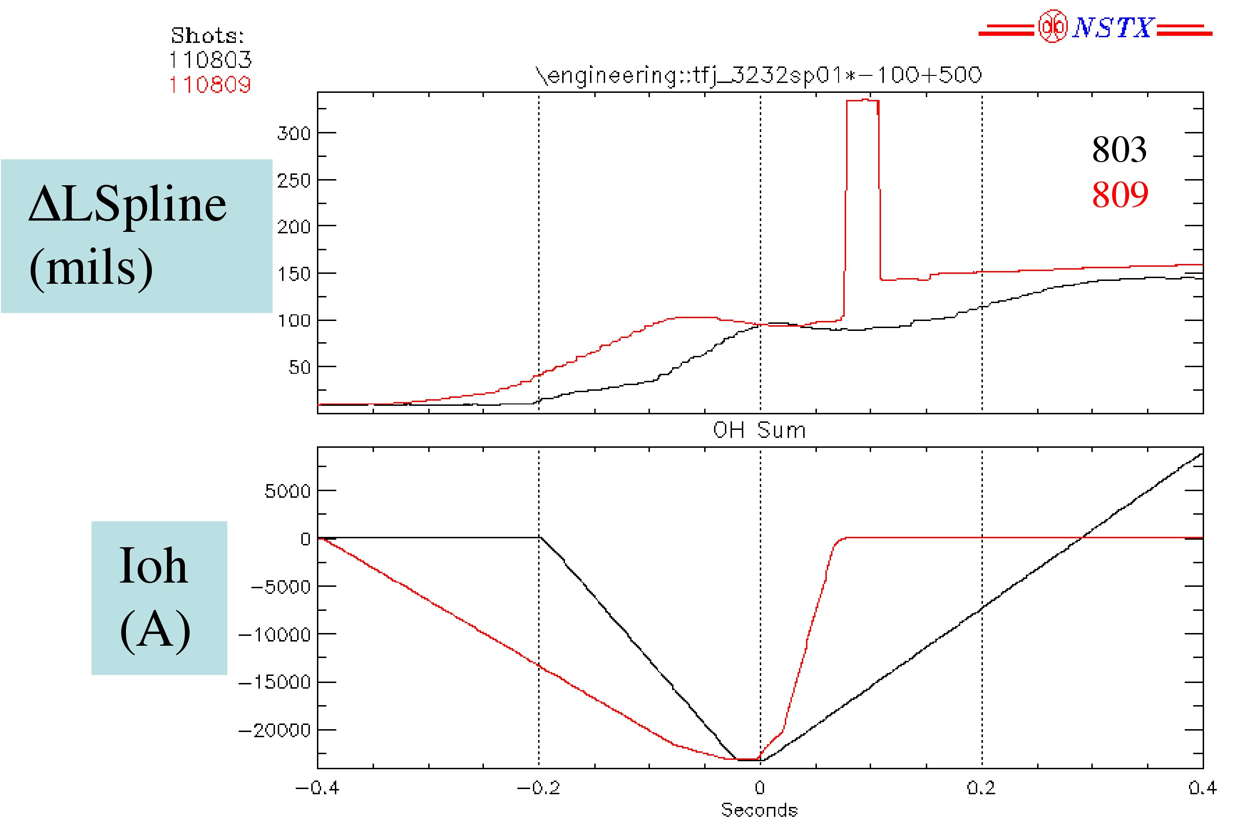
Figure 15 – Axial Displacement During OH Misoperation

Response of the angular twist at the end of flag TBD_TBD to the combined field shots is shown in figure 16. The twist during the pure in-plane shots is unexpected. The effect of the OH in the combined field shots is clearly evident.

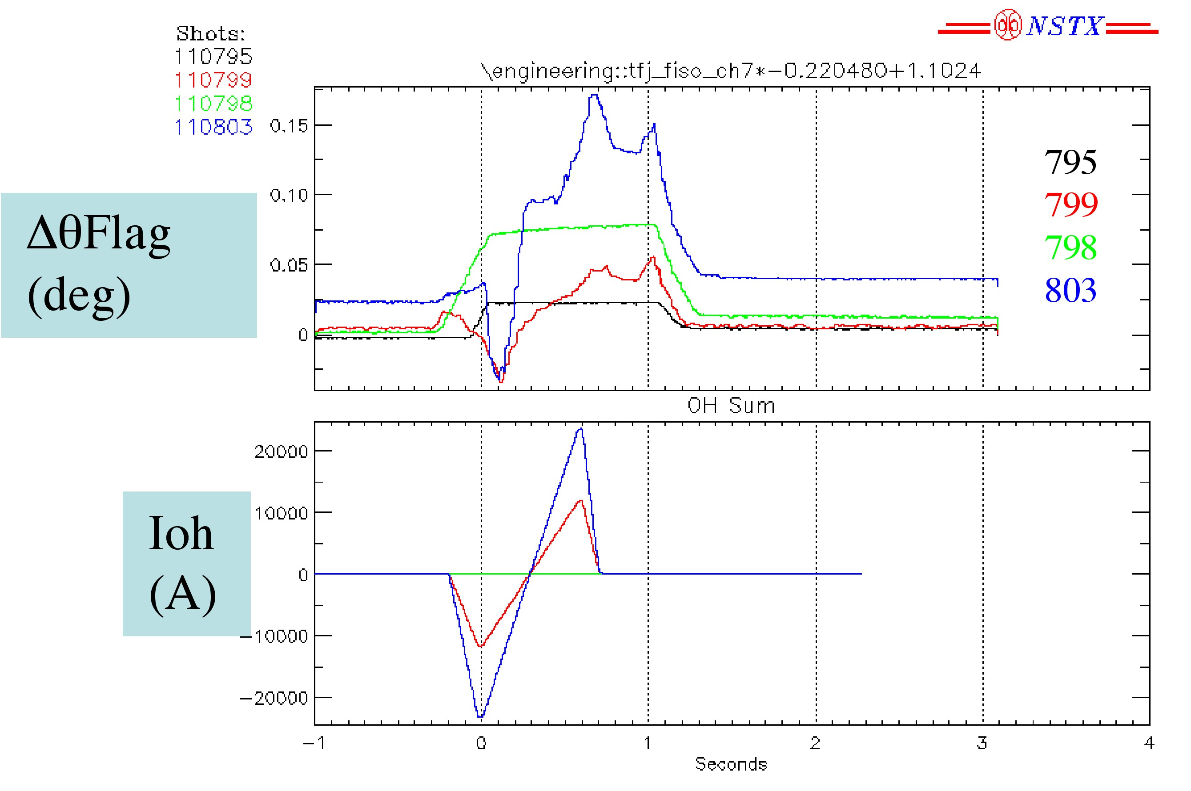
Figure 16 – Angular Twist of Outer Layer Flag

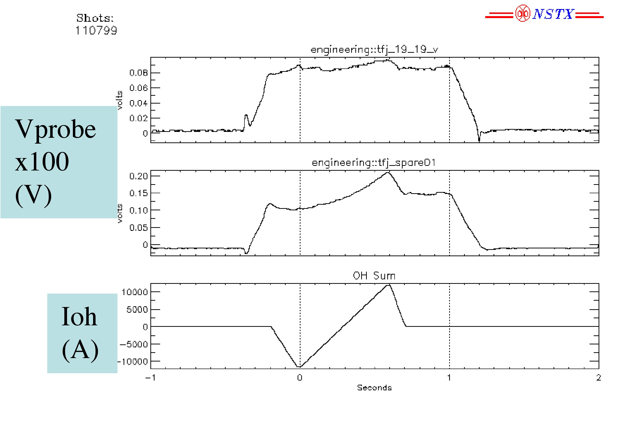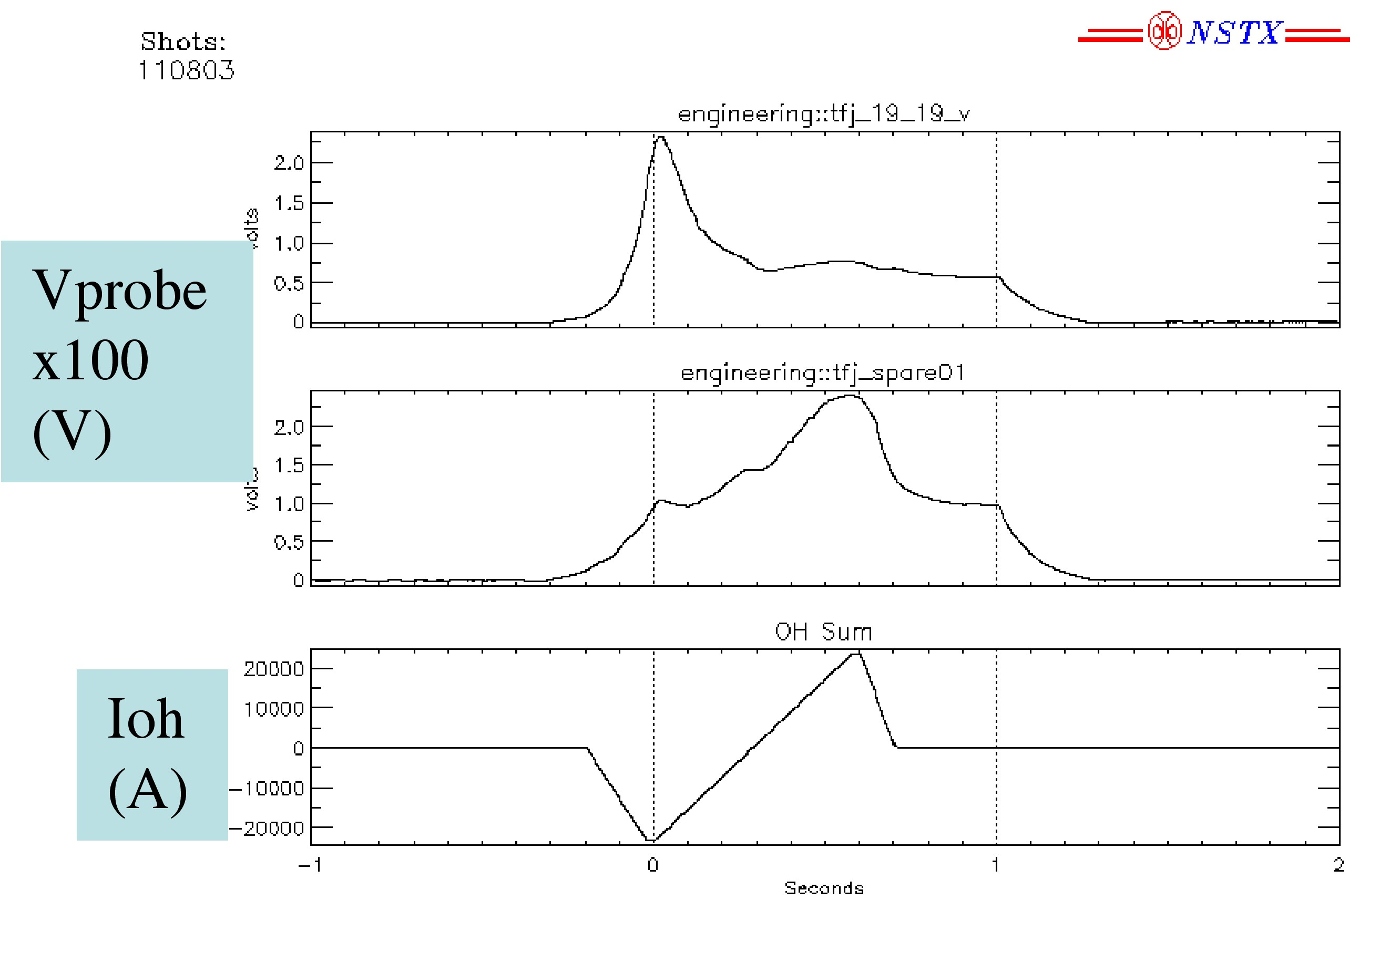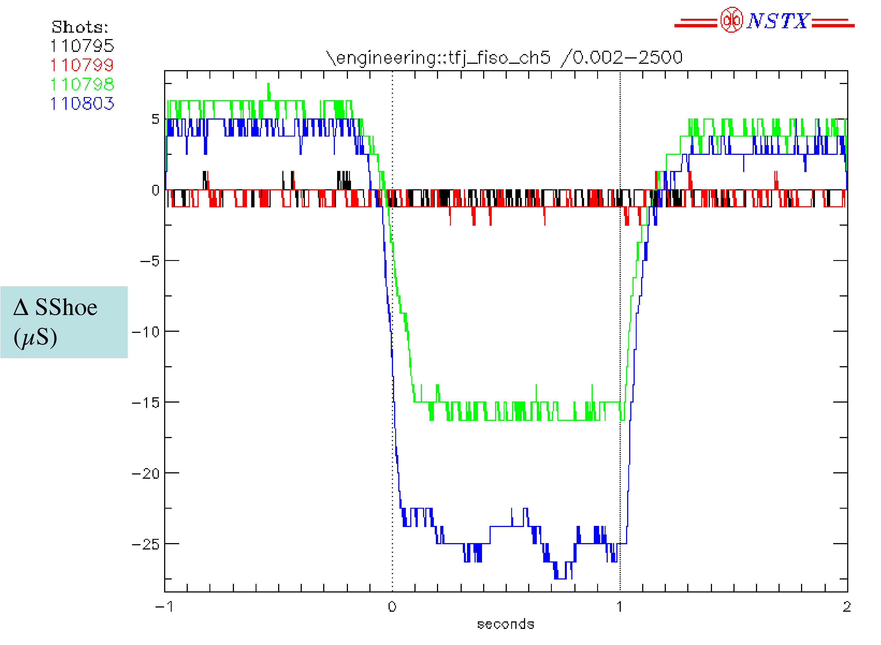

Comparison between Measurements and Analytic Predictions

Resistance
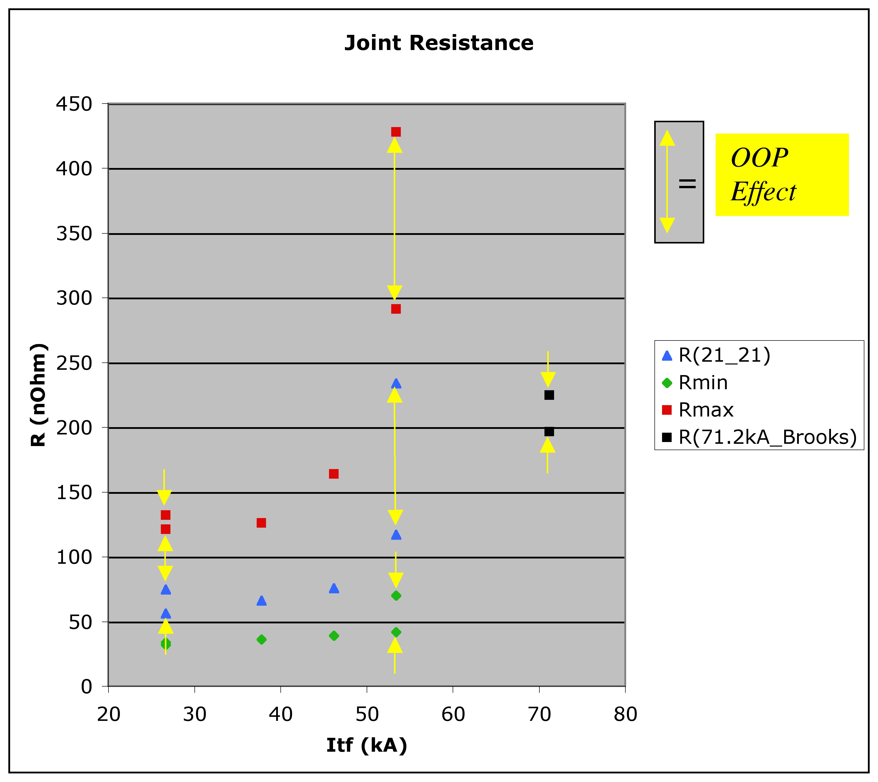

Pulse # | Shot #
110795 | 9
110796 | 10
110797 | 11
110798 | 12
110799 | 13
110803 | 16

Temperature

Strain

Displacement

Trends

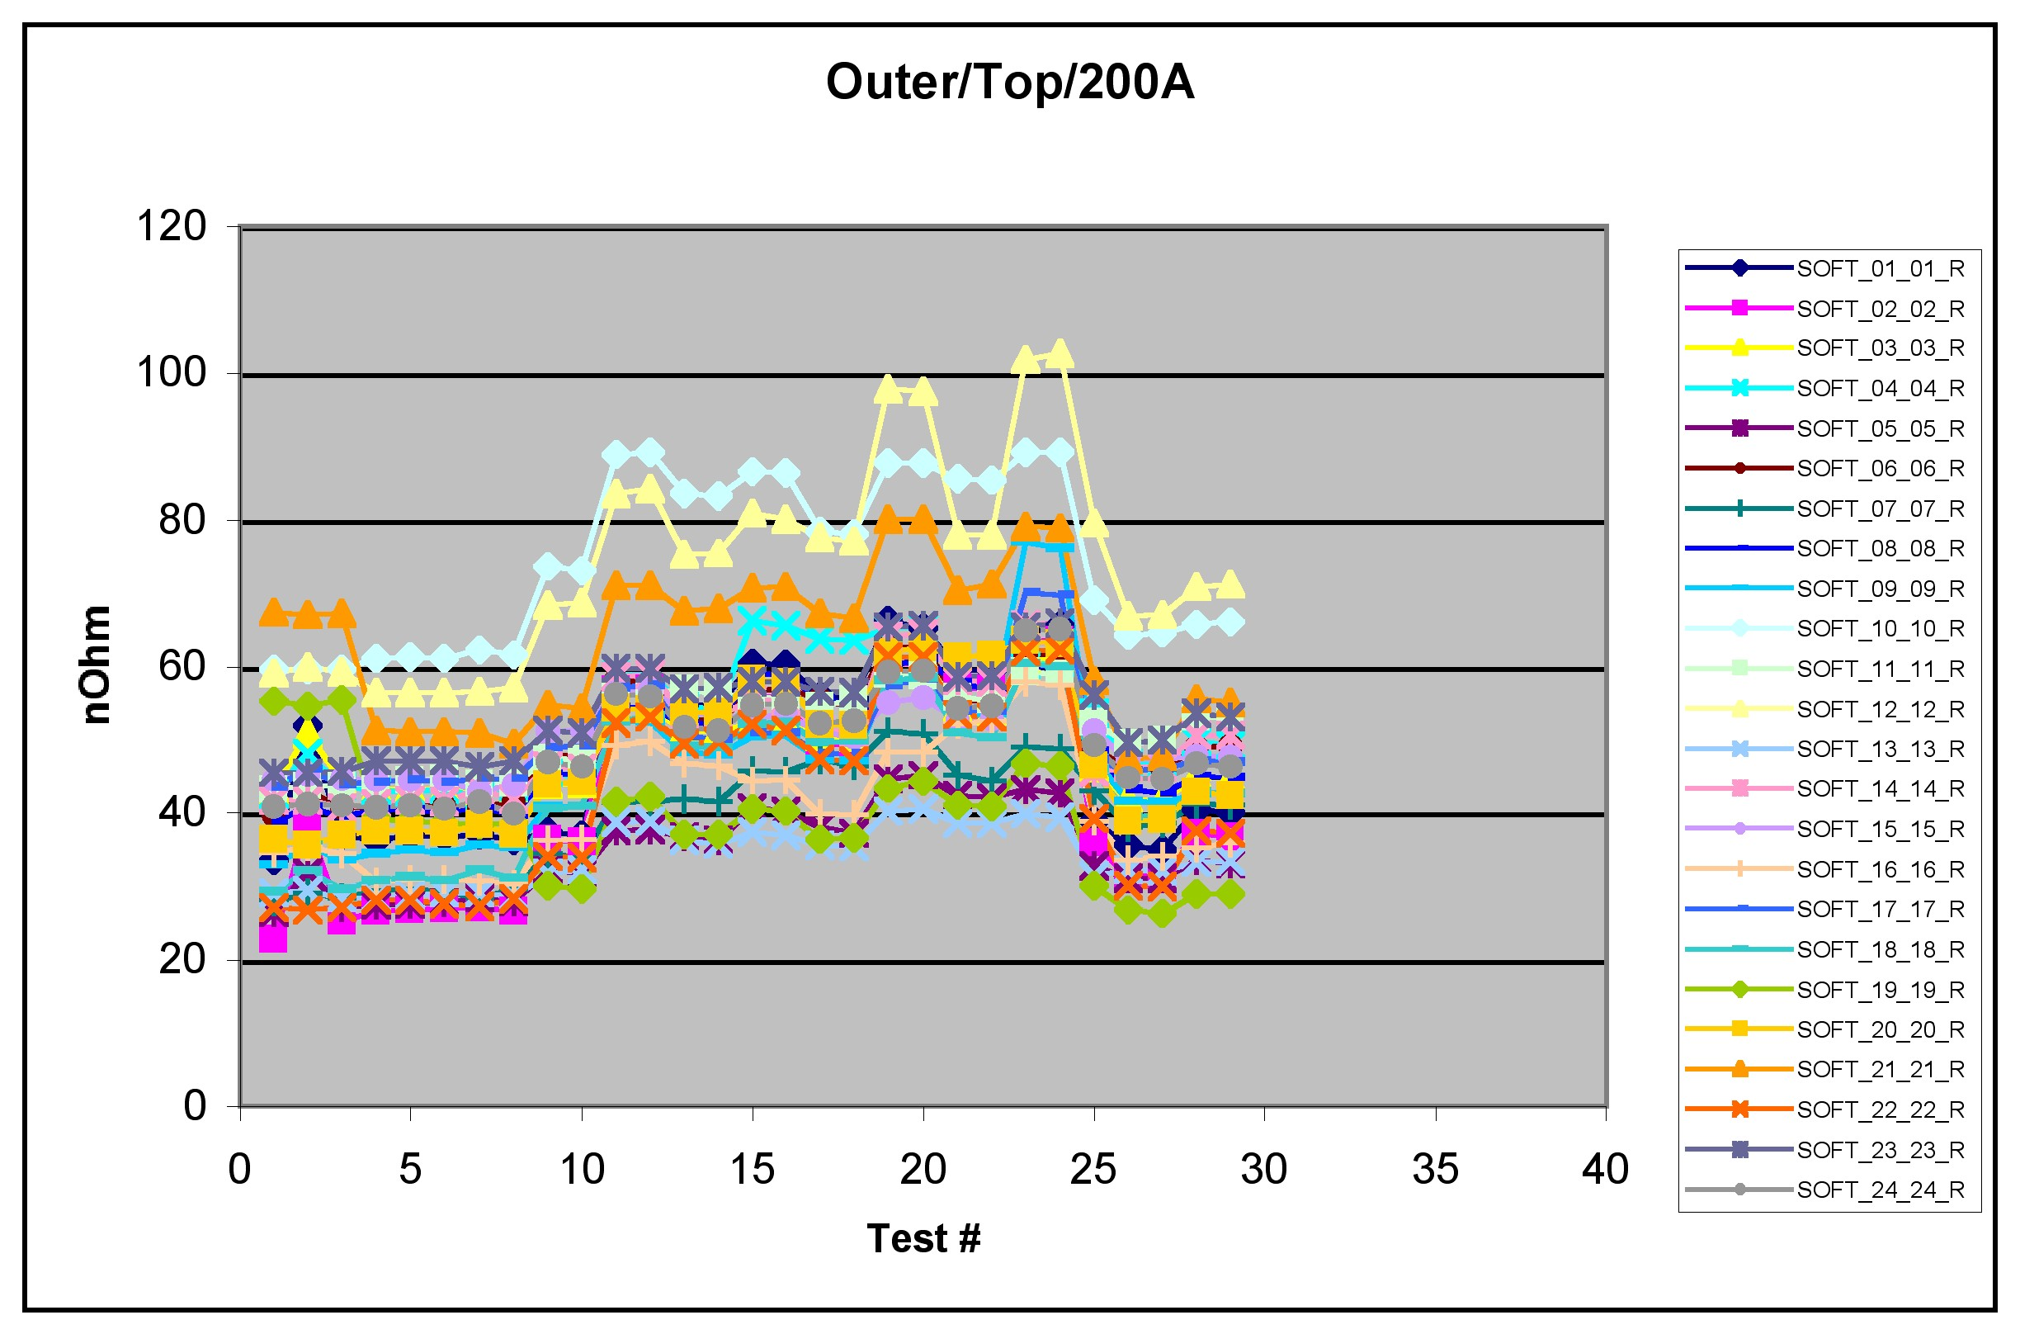
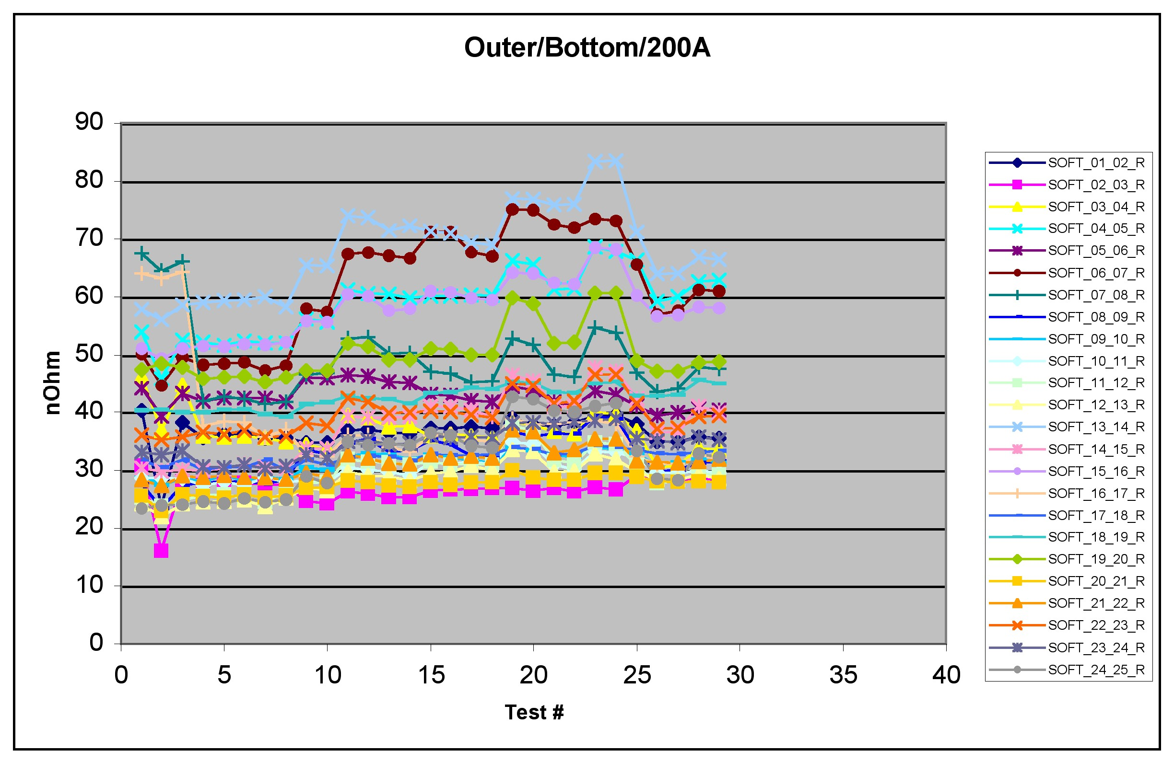

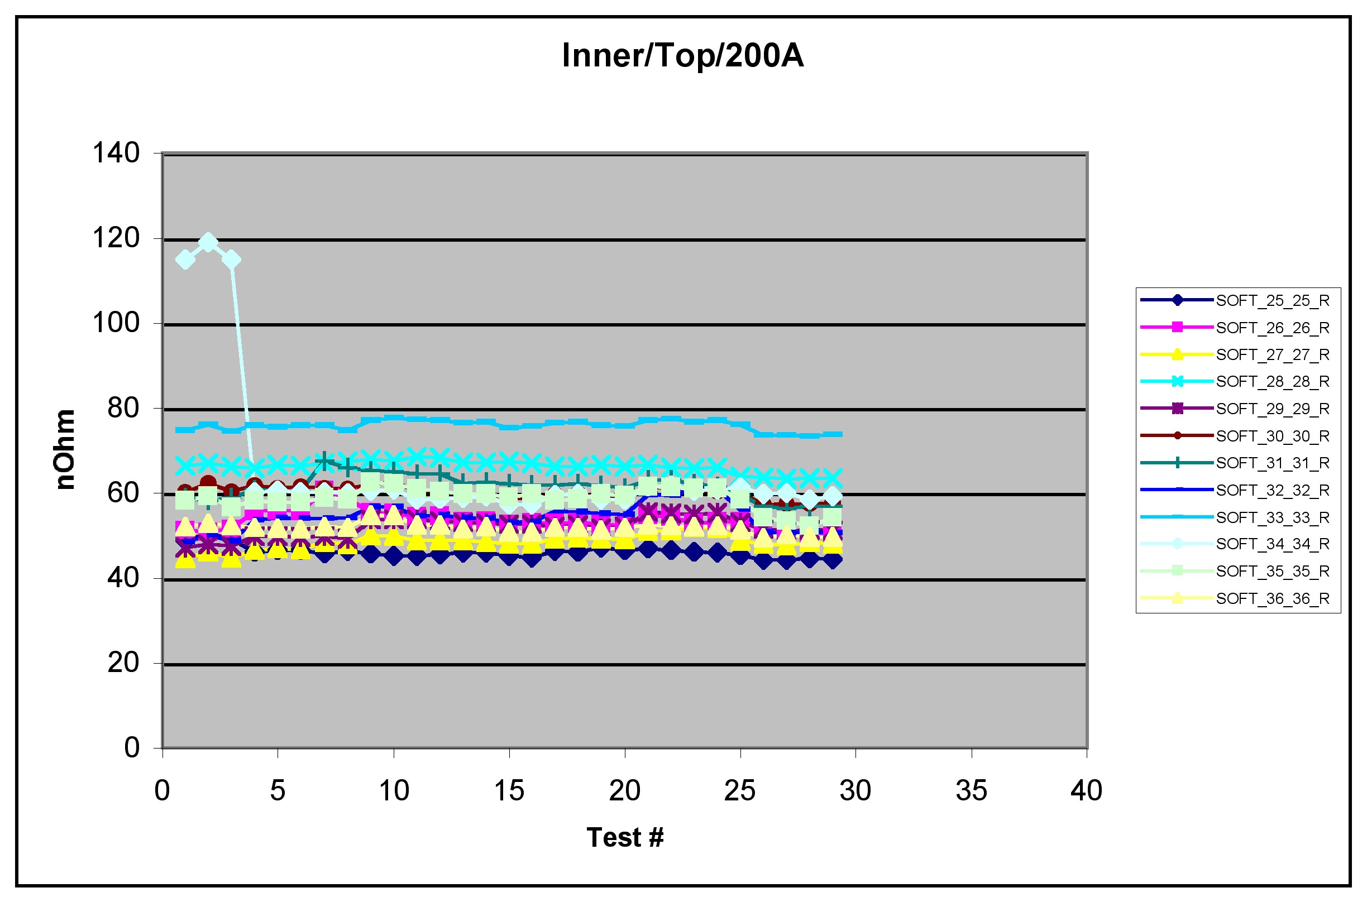

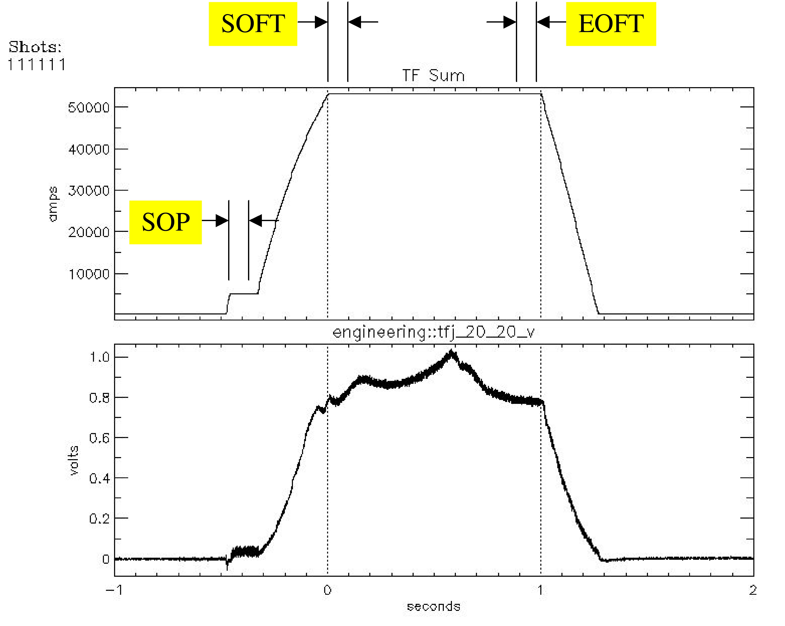

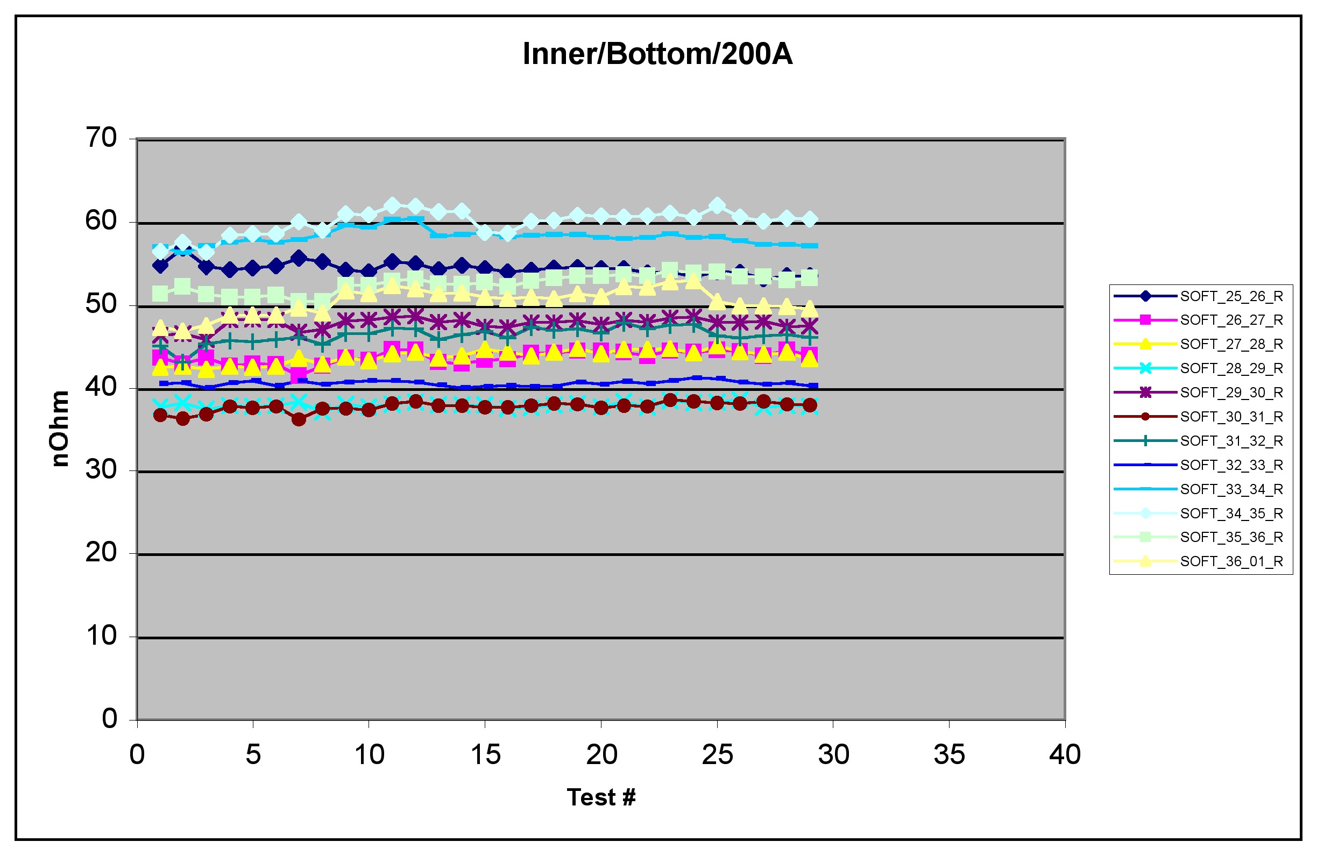

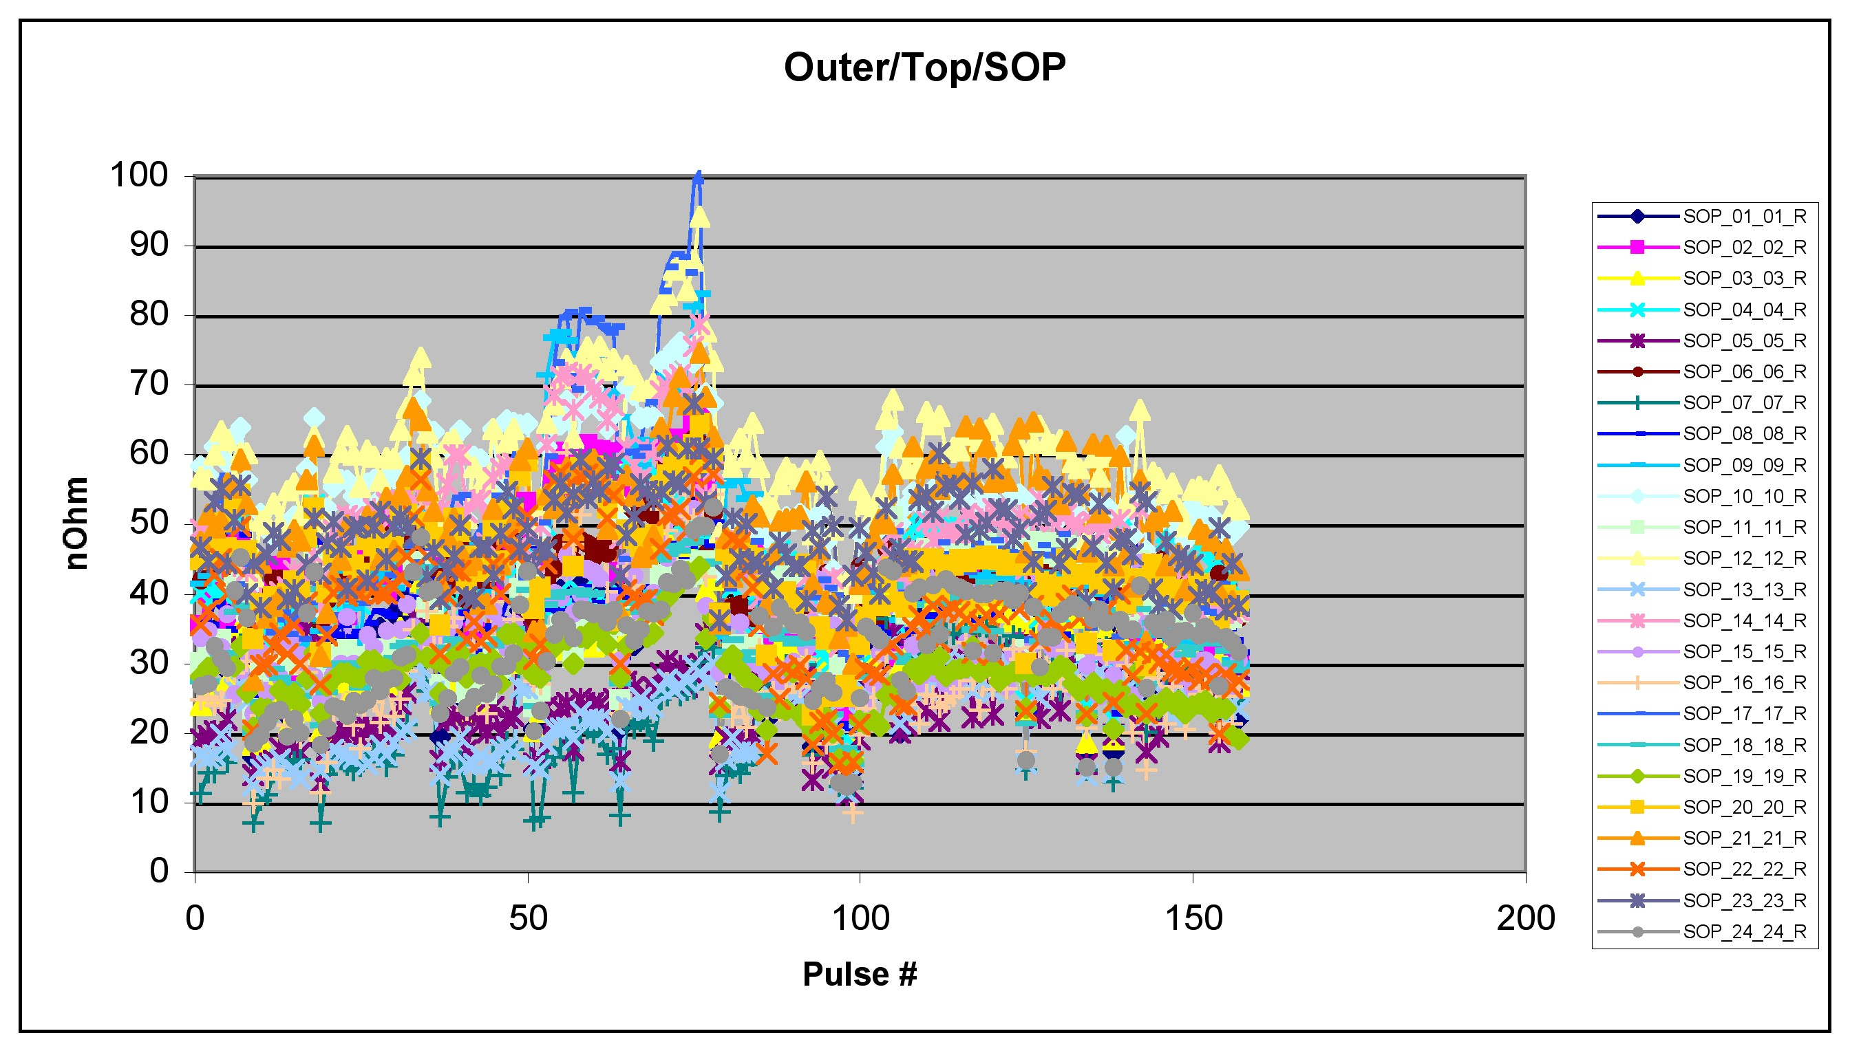

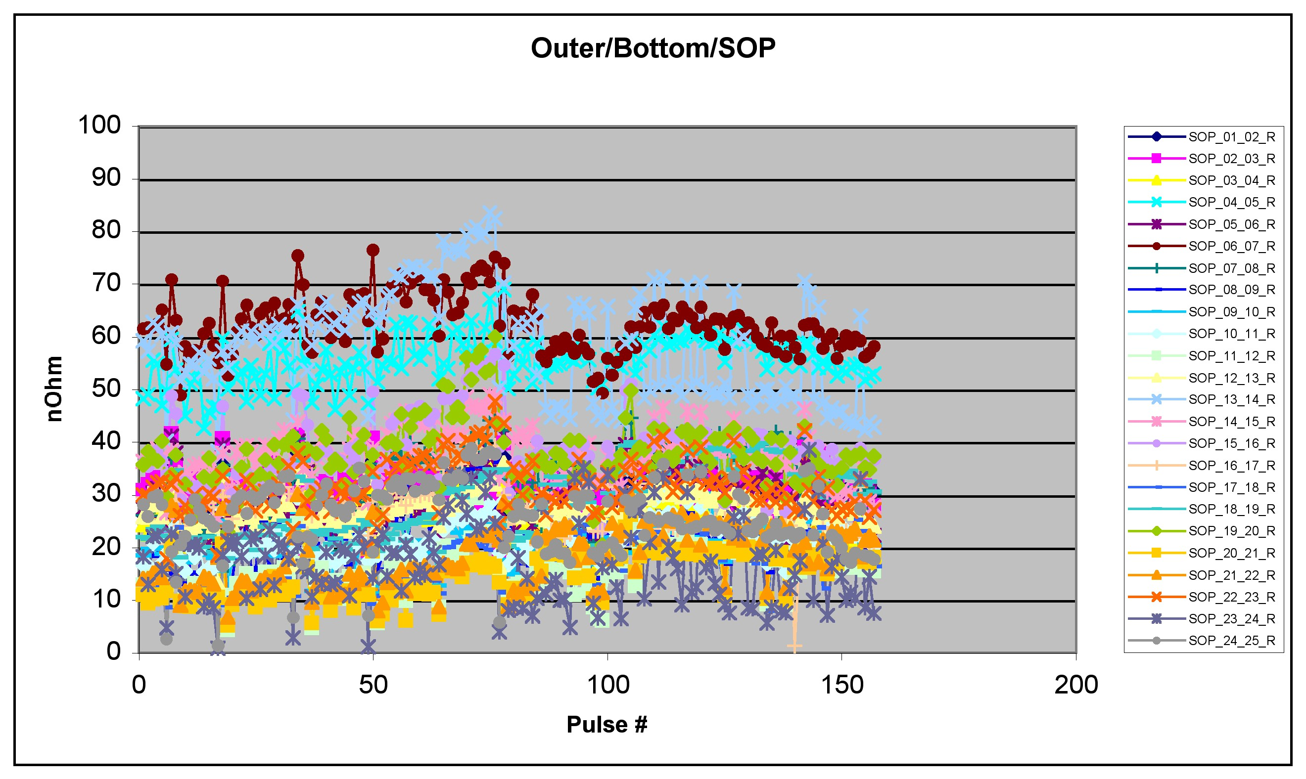

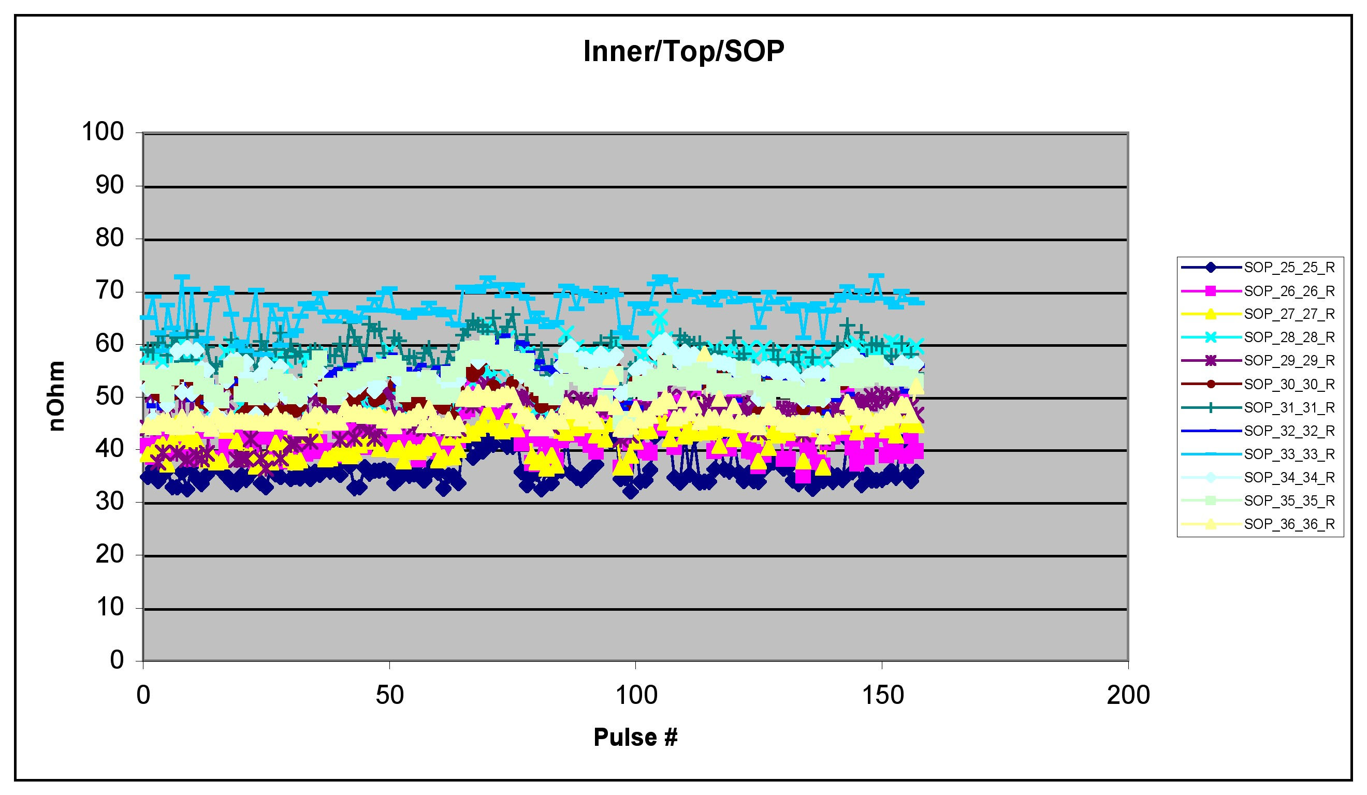
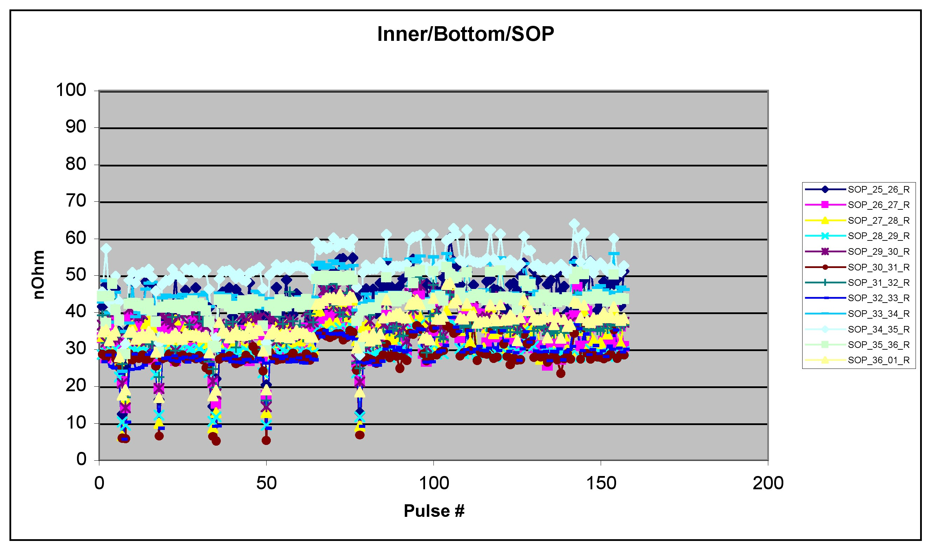

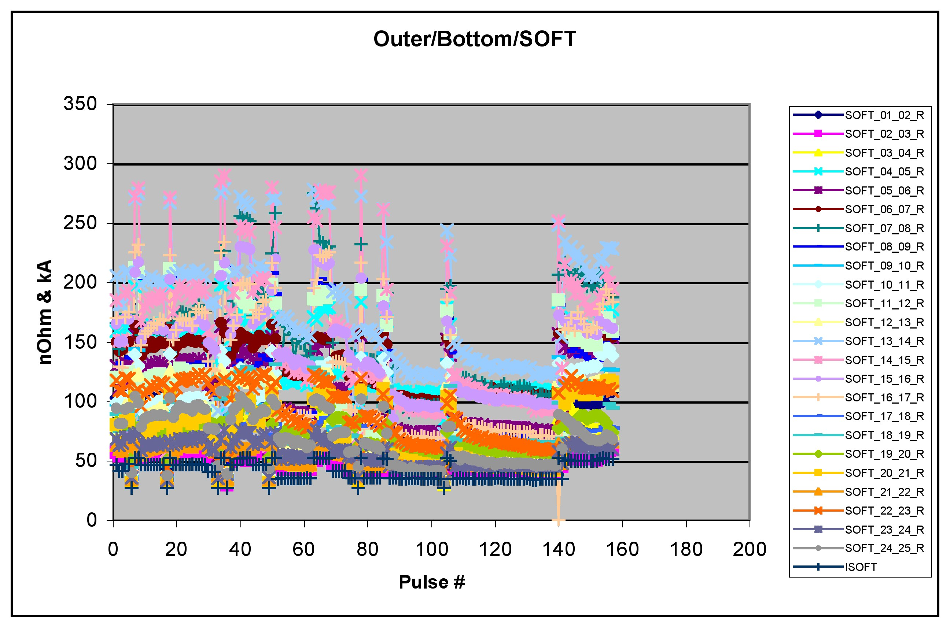

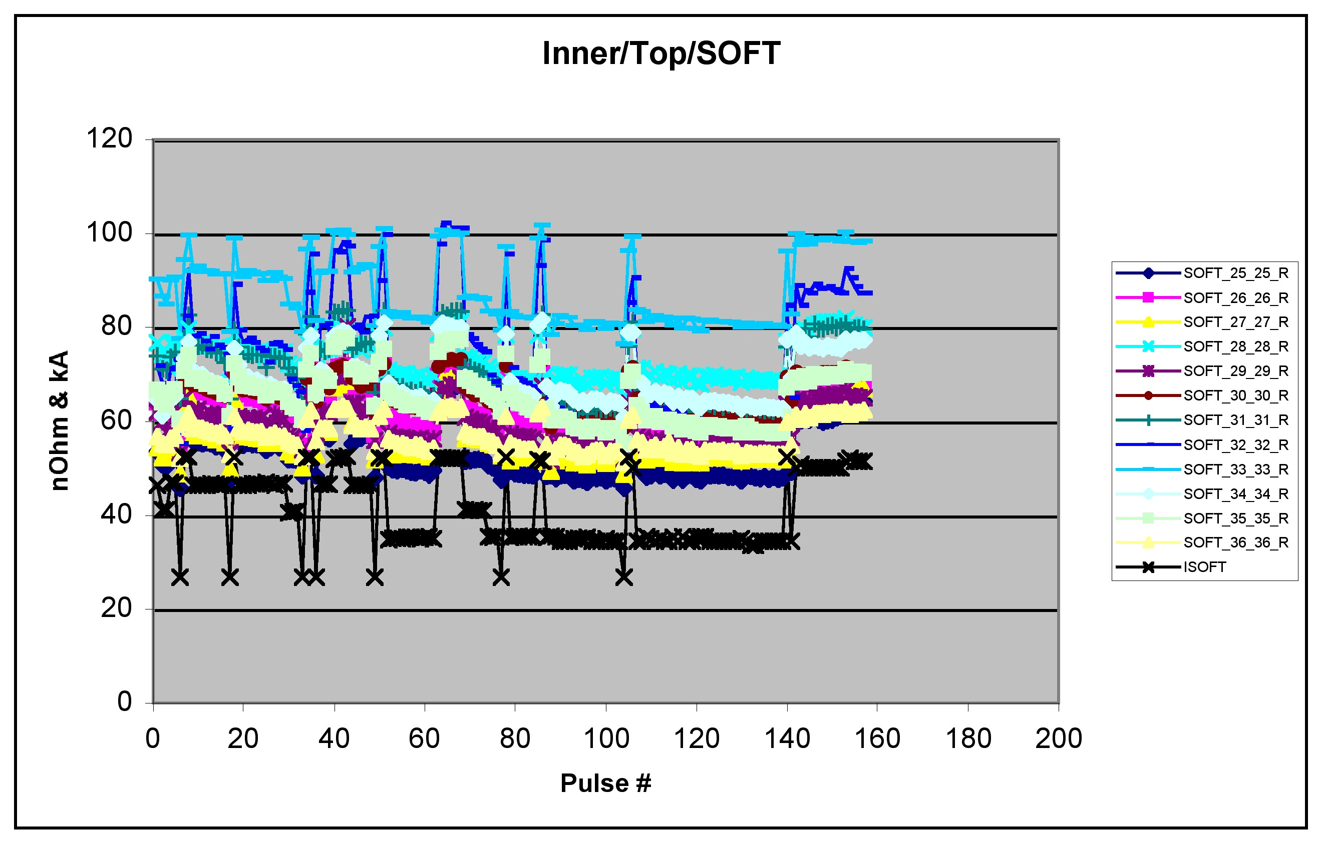
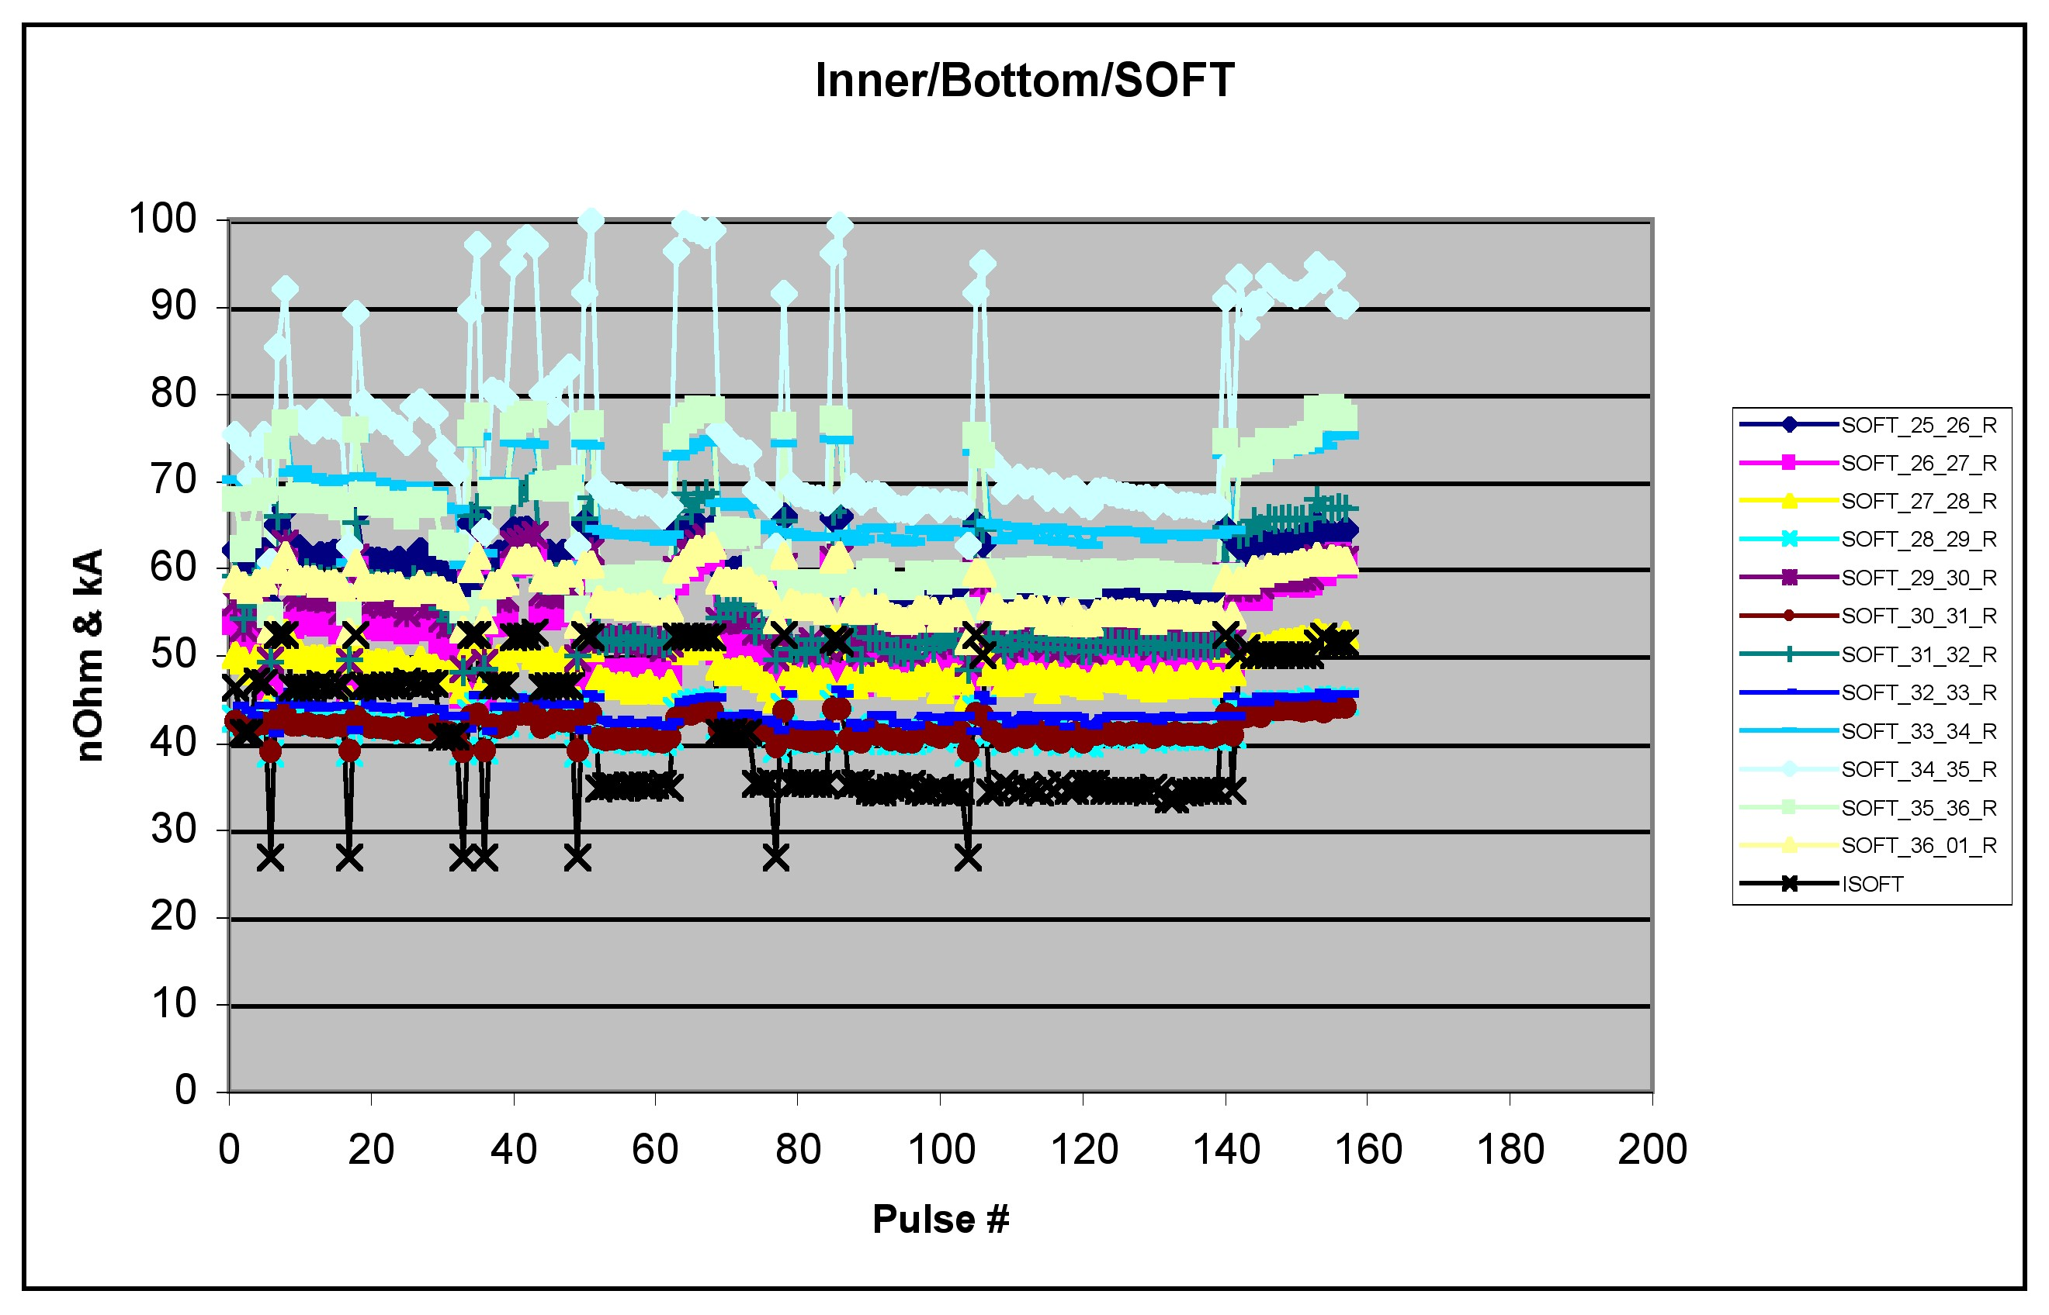

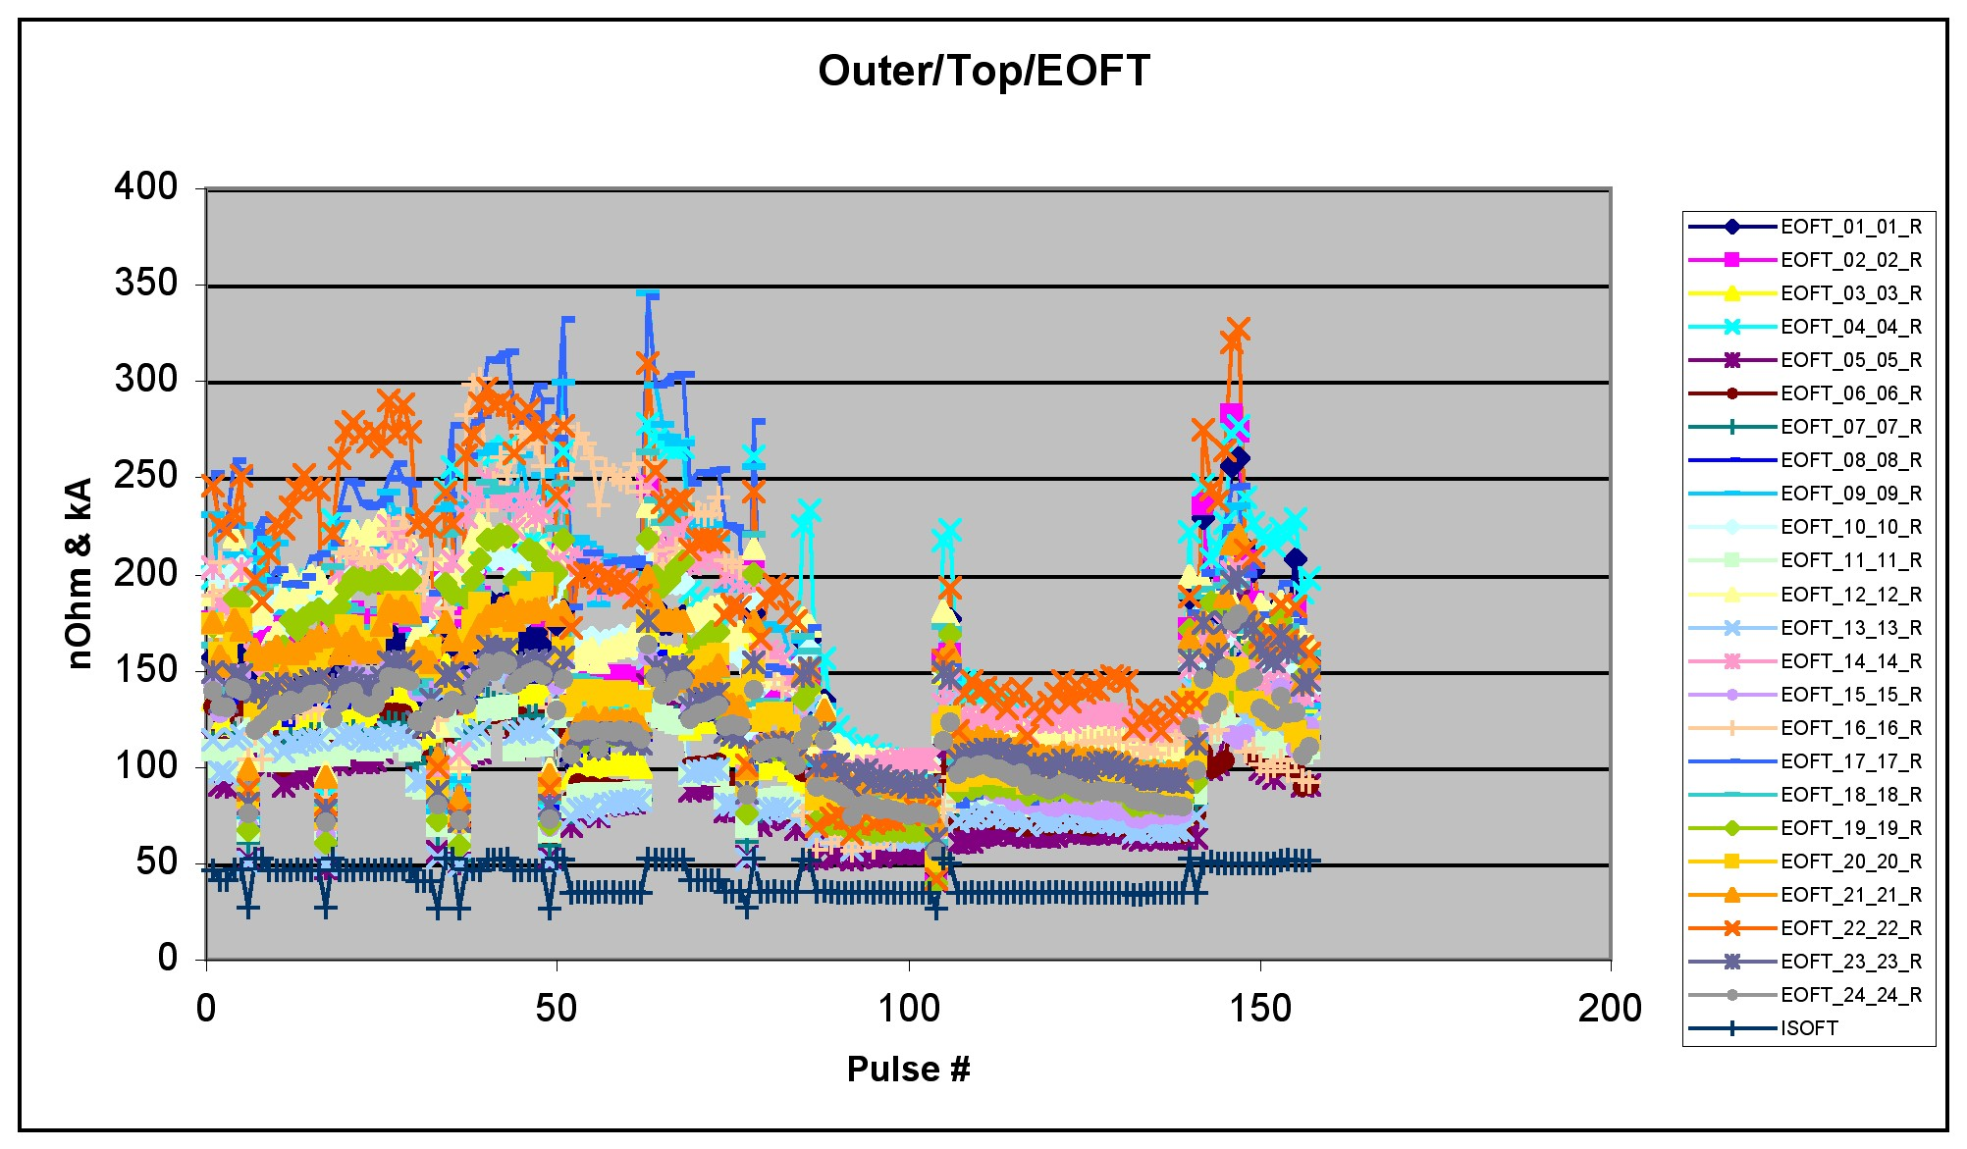
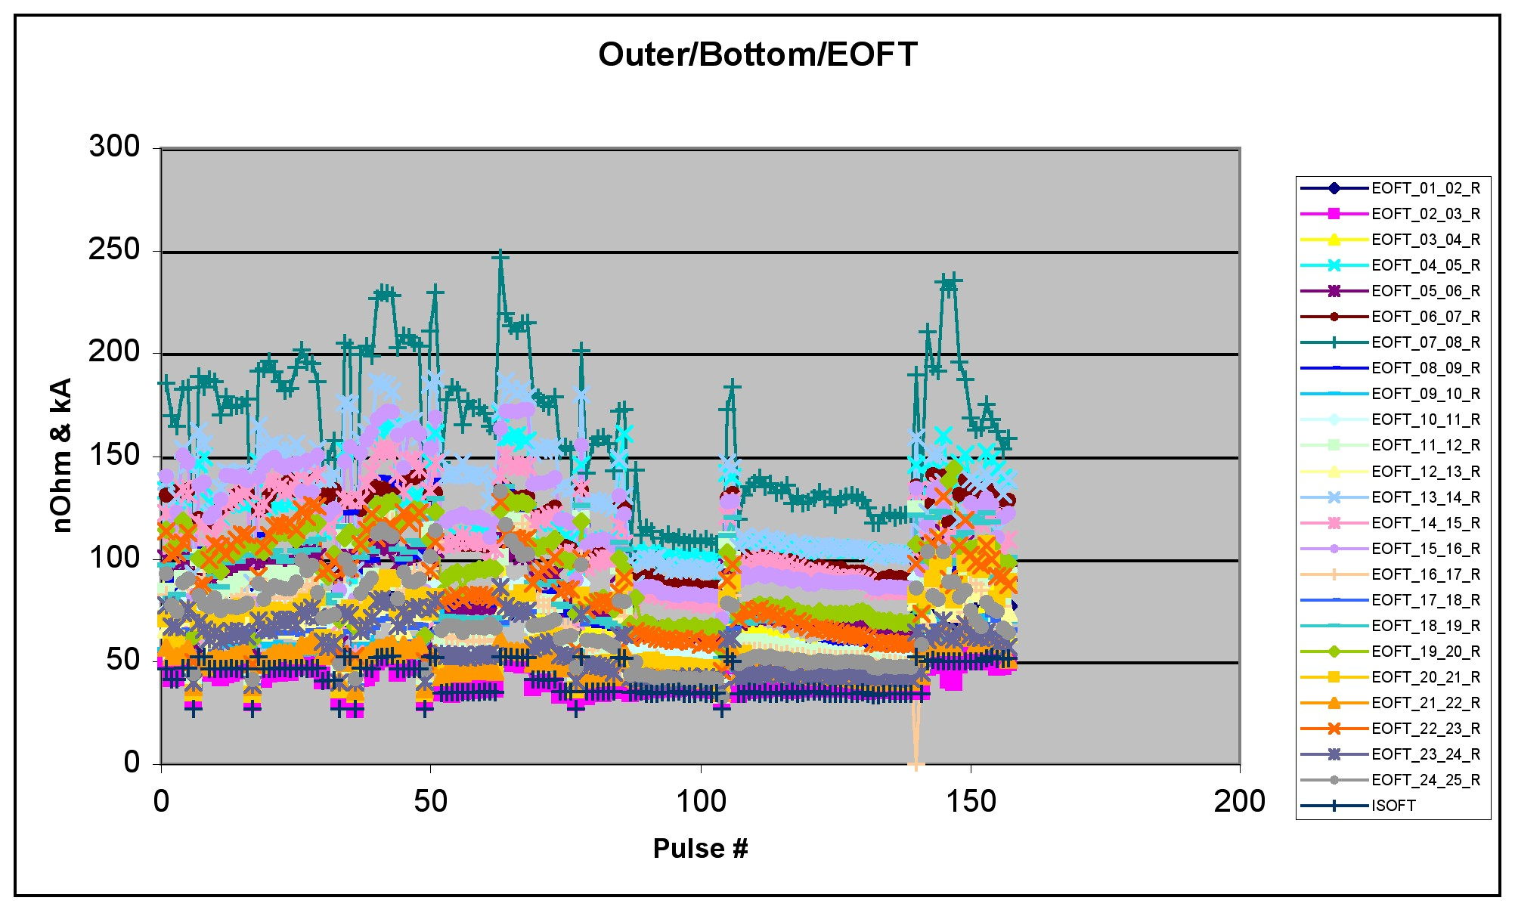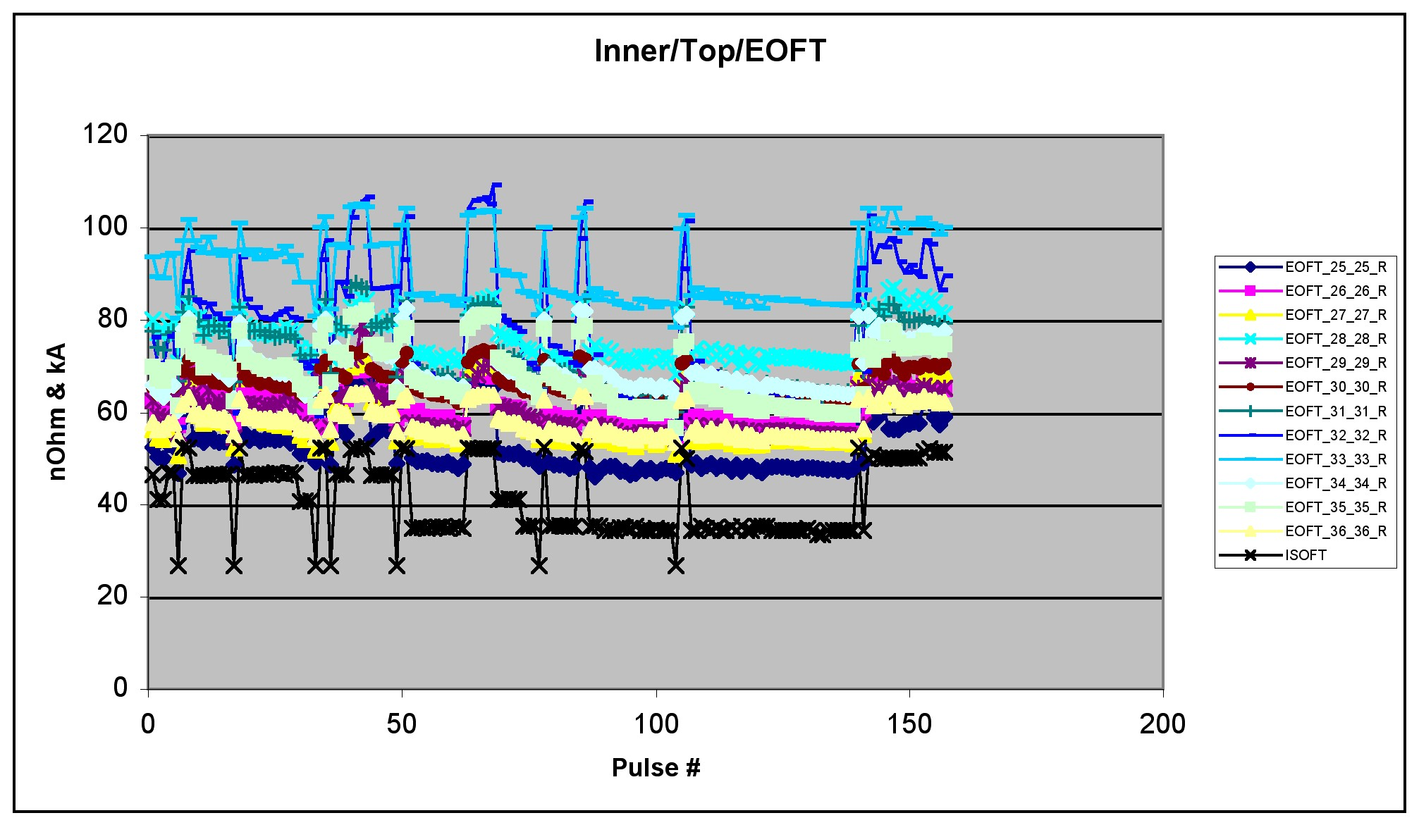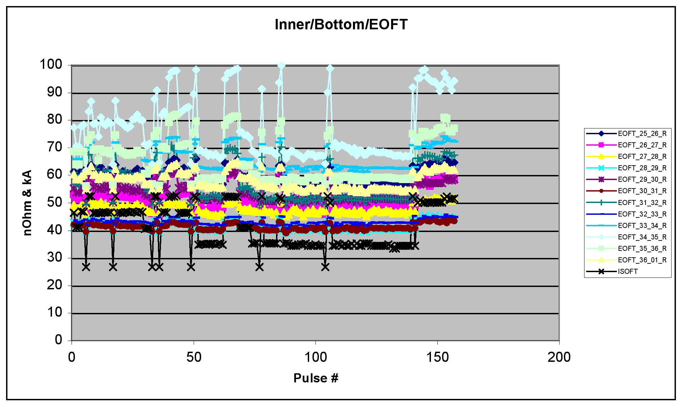

“TF Recommissioning Sequence”, 13_031203_CLN_01.doc
TF Joint Measurements by H Schneider and R Marsala 12/12/3

