13_041208_CLN_01.doc

TO: DISTRIBUTION
FROM: C NEUMEYER
SUBJECT: LOADS ON FLAG BOX/HUB FRICTION INTERFACE

Reference:

[1] “Update of NSTX Influence Matricies and EM Loads”, 13_041123_CLN_01

This memo presents results from an analysis performed to estimate loads on the friction interface between the hub disks and flag boxes. The method is based on a simplification which reduces the analysis to a statics problem. It is assumed that the flag/box assembly is a simple rigid body, and that the friction response of the interface can be modeled as point responses at the radii of the box bolts. The latter assumption is based on the idea that the pressure at the hub/box interface is concentrated in concentric regions around the box bolts. Figure 1 shows a FEMLAB simulation of the pressure distribution under a ½” stainless steel plate resulting from the application of 5500lbf over the annular region of a 1” OD washer on the other side of the plate. While this is a simplification of the actual condition, it supports the idea that the box bolt reaction can be modeled by a point response at the bolt radius.

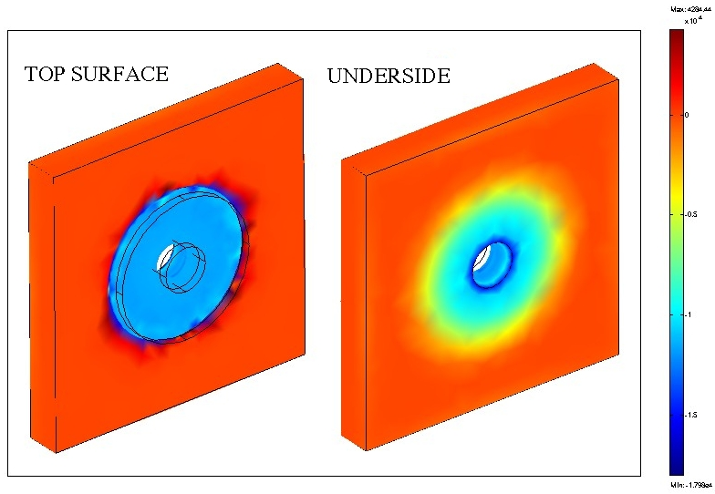

Figure 1 – FEMLAB Model of Box Bolts at 5500lbf applied on 1” OD Washer

Statics model is shown in figure 2. Moment on bundle is replaced by F_bundle acting at bundle radius. F1, F2, F3 represent the box bolt reactions, and F_lateral is the equivalent point force due to the out-of-plane EM load. Reactions out through the flex links are ignored, since that load path is relatively soft.

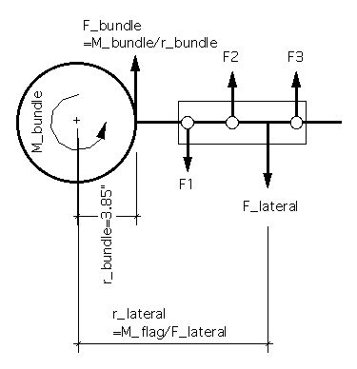
Figure 2 – Simplified Model of Load and Reactions on Flag Boxes

With the applied EM loads at bundle and on flag given, along with their radius, and the radii of the three box bolts know, one can solve for F1, F2, and F3 based on ∑F=0 and ∑M=0, assuming that F2 is linearly related to F1 and F3 based on the spacing of the bolts.

The above result applies to a single flag/box considered in 2d fashion. In reality each flag box has two surfaces. See figure 3.

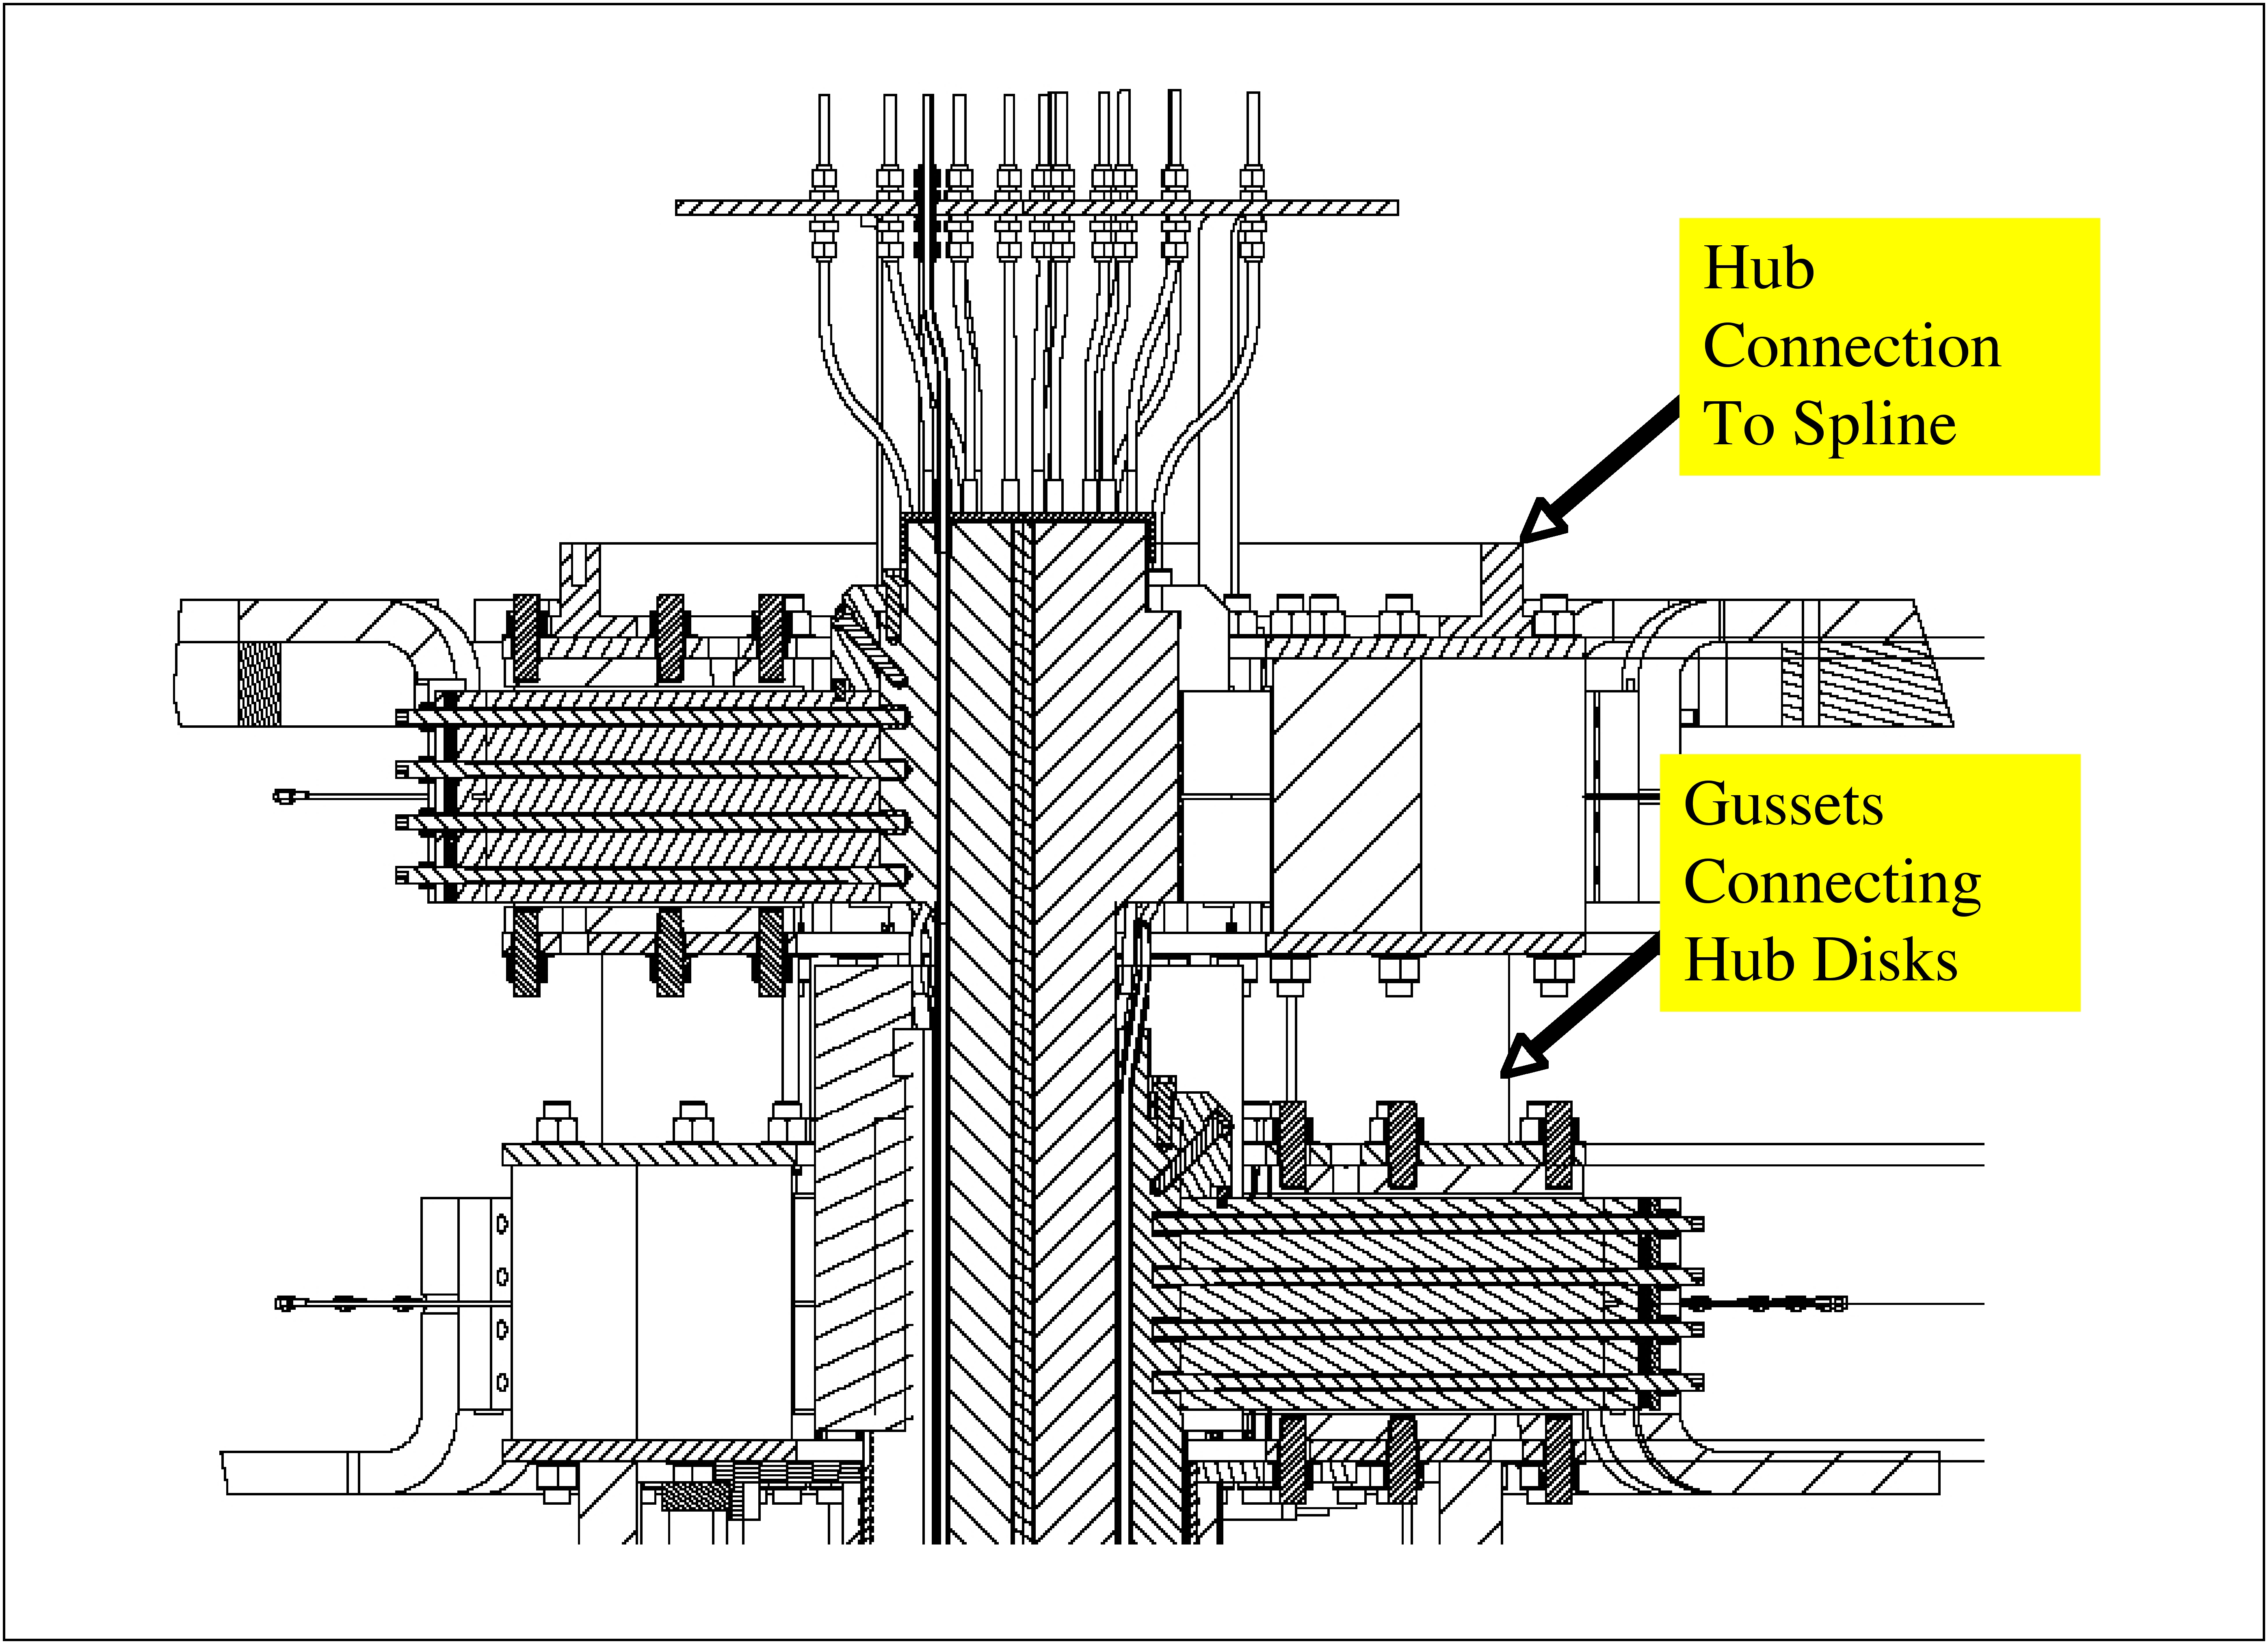
Figure 3 – Arrangment of Flags, Boxes, and Disks in Upper Half Plane

The outer layer flag boxes have two friction shear surfaces. Let us refer to the inner surface as the one closest to the midplane, and the outer surface as the one furthest from the midplane.

The inner surface interfaces with a hub disk element which has no connection to anything other than the boxes. In the original TF design it had a connection to the torque collar, but not in the latest design. Therefore, all it can do is react moments; it can't react any net out of plane force. The outer surface interfaces with a hub disk which has a connection, via a gusset to the inner layer flag boxes, and from there out to the spline to the VV. This surface, therefore, provides the reaction against the out of plane loads.

In the statics analysis the three forces F1, F2, and F3 represent the reaction of the box bolts which is necessary for static equilibrium, considering the load coming on to the flag from the bundle, along with the EM load on the flag itself. Adding F1+F2+F3 together has a net resultant value F which is the out of plane load which has to get out via the hub. Considering this in the allocation of the loads to the box bolts on the two surfaces, the forces on the inner surface bolts are assumed to be F1/2-F/3, F2/2-F/3, and F3/3-F/3, and on the outer surface, F1/2+F/3, F2/2+F/3, and F3/2+F/3. In this way the total force and moment (adding all six bolt loads together) is the same as calculated in the original 2d procedure, but the extra toroidal shear load is allocated to the three bolts on the outer surface, since this is where the load gets out.

On the inner layer flags, a similar situation exists with respect to the self-generated loads, but the total load includes that load flowing out of the outer layer flags. It is assumed here that this load flows equally through the three bolts on each surface, with due consideration of polarity.

With the above method used to estimate the out-of-plane friction shear loading, the in-plane component previously estimated can be factored in to calculate the total resultant shear load.

The following tables shows the result of this calculation with Bt=6kG for the following PF current combinations (see figure 4):

SOFT: Start of flat top
OHZC: OH zero crossing
EOFT: End of flat top
MAXMAX: Condition where all OH/PF coils are simultaneously at maximum value in the same polarity
OTHER: Solved for current combination in which all OH/PF coils are within their allowed current range but with polarity consistent with plasma operations, which minimizes the friction safety factor

Figure 4 – Typical Pattern of Currents

Note that it is assumed that 80% of the moment generated on the TF bundle is reacted through the outer flag joints and 20% through the inner flag joints. Also, while the in-plane box bolt shear loads are reduced based on the NASTRAN FEA findings, the out-of-plane loads are taken as 100% of the values estimated using the technique outlined above. The box bolt torque variation is not considered. COF =0.6 is assumed based on the small sample tests of the high friction coating.
Table 1 – Outer Flag Box Calculations
 | SOFT | OHZC | EOFT | MAXMAX | OTHER
M_bundle | 26851 | 753 | -26063 | -30025 | -25518 | ft-lbf
 | 322217 | 9036 | -312751 | -360299 | -306217 | in-lbf
R_bundle | 3.85 | 3.85 | 3.85 | 3.85 | 3.85 | in
F_bundle | 83736 | 2348 | -81276 | -93633 | -79578 | lbf
#Inner Turns | 12 | 12 | 12 | 12 | 12
#Outer Turns | 24 | 24 | 24 | 24 | 24
f_Inner | 0.20 | 0.20 | 0.20 | 0.20 | 0.20
f_Outer | 0.80 | 0.80 | 0.80 | 0.80 | 0.80
Bt | 6 | kG
In-Plane Moment at 6kG | 70653 | in-lbf
In-Plane EM Moment @ Bt | 70653 | in-lbf
% In Plane Load to Hub/Box Shear | 42%
Moment Arm to Interface | 3.25 | in
In Plane Shear Load per Interface | 4569 | lbf
In Plane Shear Load per Bolt | 1523 | lbf
F_Bundle_Flag | 2791 | 78 | -2709 | -3121 | -2653 | lbf
M_Lateral_Flag | -6309 | 3119 | 7758 | 40421 | -24019 | in-lbf
F_Lateral_Flag | -503 | 211 | 591 | 3077 | -1790 | lbf
F_net_Flag | 2288 | 290 | -2118 | -44 | -4443 | lbf
R_Lateral | 12.55 | 14.75 | 13.13 | 13.14 | 13.42 | in
R_bolt1 | 6.51 | 6.51 | 6.51 | 6.51 | 6.51 | in
R_bolt2 | 9.14 | 9.14 | 9.14 | 9.14 | 9.14 | in
R_bolt3 | 12.89 | 12.89 | 12.89 | 12.89 | 12.89 | in
F1 | -3297 | 0 | 3261 | 4227 | 2656
F2 | -1080 | -84 | 1026 | 541 | 1628
F3 | 2088 | -206 | -2168 | -4724 | 159
∑F_bolt | -2288 | -290 | 2118 | 44 | 4443
F1_Inner_Surface | -886 | 97 | 925 | 2099 | -153
F2_Inner Surface | 223 | 54 | -193 | 256 | -667
F3_Inner_Surface | 1807 | -6 | -1790 | -2377 | -1401
F1_Outer_Surface | -2411 | -96 | 2337 | 2128 | 2809
F2_Outer Surface | -1303 | -139 | 1219 | 285 | 2295
F3_Outer_Surface | 281 | -199 | -378 | -2348 | 1560
Max bolt | 2411 | 199 | 2337 | 2377 | 2809
f_FEA | 100% | 100% | 100% | 100% | 100%
OOP Shear Load | 2411 | 199 | 2337 | 2377 | 2809 | lbf
IP Shear Load | 1523 | 1523 | 1523 | 1523 | 1523
Resultant Shear Load | 2852 | 1536 | 2789 | 2823 | 3195 | lbf
COF | 0.60 | 0.60 | 0.60 | 0.60 | 0.60
Bolt Force | 5500 | 5500 | 5500 | 5500 | 5500 | lbf
Resisting Force/bolt | 3300 | 3300 | 3300 | 3300 | 3300 | lbf
SF_MIN | 1.2 | 2.1 | 1.2 | 1.2 | 1.0

Table 2 – Inner Flag Box Calculations

 | SOFT | OHZC | EOFT | MAXMAX | OTHER
M_bundle | 26851 | 753 | -26063 | -30025 | -25518 | ft-lbf
 | 322217 | 9036 | -312751 | -360299 | -306217 | in-lbf
R_bundle | 3.85 | 3.85 | 3.85 | 3.85 | 3.85 | in
F_bundle | 83736 | 2348 | -81276 | -93633 | -79578 | lbf
#Inner Turns | 12 | 12 | 12 | 12 | 12
#Outer Turns | 24 | 24 | 24 | 24 | 24
f_Inner | 0.20 | 0.20 | 0.20 | 0.20 | 0.20
f_Outer | 0.80 | 0.80 | 0.80 | 0.80 | 0.80
Bt | 6 | kG
In-Plane Moment at 6kG | 17663 | in-lbf
In-Plane EM Moment @ Bt | 17663 | in-lbf
% In Plane Load to Hub/Box Shear | 42%
Moment Arm to Interface | 3.25 | in
In Plane Shear Load per Interface | 1142 | lbf
In Plane Shear Load per Bolt | 381 | lbf
F_Bundle_Flag | 1396 | 39 | -1355 | -1561 | -1326 | lbf
M_Lateral_Flag | -10935 | 980 | 9618 | 65160 | -38267 | in-lbf
F_Lateral_Flag | -973 | 33 | 838 | 5077 | -2754 | lbf
F_net_Flag | 423 | 72 | -516 | 3517 | -4080 | lbf
F_Lateral_Outers | 4577 | 579 | -4237 | -88 | -8885
R_Lateral | 11.24 | 29.99 | 11.47 | 12.83 | 13.90 | in
R_bolt1 | 6.51 | 6.51 | 6.51 | 6.51 | 6.51 | in
R_bolt2 | 9.14 | 9.14 | 9.14 | 9.14 | 9.14 | in
R_bolt3 | 12.89 | 12.89 | 12.89 | 12.89 | 12.89 | in
F1 | -1542 | 41 | 1534 | 2583 | 695
F2 | -316 | -16 | 342 | -703 | 1277
F3 | 1435 | -97 | -1360 | -5396 | 2108
∑F_bolt | -423 | -72 | 516 | -3517 | 4080
F1_Inner_Surface | -2156 | -148 | 2007 | 2493 | 1949
F2_Inner Surface | -1543 | -177 | 1411 | 850 | 2240
F3_Inner_Surface | -667 | -218 | 560 | -1497 | 2656
F1_Outer_Surface | 614 | 190 | -473 | 90 | -1254
F2_Outer Surface | 1227 | 161 | -1069 | -1553 | -963
F3_Outer_Surface | 2102 | 120 | -1920 | -3900 | -548
Max bolt | 2156 | 218 | 2007 | 3900 | 2656
f_FEA | 100% | 100% | 100% | 100% | 100%
OOP Shear Load | 2156 | 218 | 2007 | 3900 | 2656 | lbf
IP Shear Load | 381 | 381 | 381 | 381 | 381
Resultant Shear Load | 2189 | 439 | 2043 | 3918 | 2683 | lbf
COF | 0.60 | 0.60 | 0.60 | 0.60 | 0.60
Bolt Force | 5500 | 5500 | 5500 | 5500 | 5500 | lbf
Resisting Force/bolt | 3300 | 3300 | 3300 | 3300 | 3300 | lbf
SF_MIN | 1.5 | 7.5 | 1.6 | 0.8 | 1.2

Table 3 – Summary of Currents and Safety Factors

Bt | 6.0
CASE | SOFT | SOFT | OHZC | EOFT | MAXMAX | OTHER | Min | Max
Ioh | -24.0 | -24.0 | 0.0 | 24.0 | 24.0 | 24.0 | -24.0 | 24.0
Ipf1a | 0.0 | 0.0 | -24.0 | -24.0 | 24.0 | 5.0 | -24.0 | 5.0
Ipf1b | 0.0 | 0.0 | 0.0 | 0.0 | 20.0 | -20.0 | -20.0 | 0.0
Ipf2 | 0.0 | 0.0 | -10.0 | -10.0 | 20.0 | -20.0 | -20.0 | 0.0
Ipf3 | -2.5 | -2.5 | 10.0 | 10.0 | 20.0 | -20.0 | -20.0 | 20.0
Ipf4 | 0.0 | 0.0 | 0.0 | 0.0 | 0.0 | 0.0 | 0.0 | 0.0
Ipf5 | 0.0 | 0.0 | 10.0 | 10.0 | 20.0 | 0.0 | 0.0 | 20.0
Itf | 71.2 | 71.2 | 71.2 | 71.2 | 71.2 | 71.2 | 0.0 | 71.2
Min Box Bolt Friction SF Outer | 1.2 | 1.2 | 2.1 | 1.2 | 1.2 | 1.0 | 1.0
Min Box Bolt Friction SF Inner | 1.5 | 1.5 | 7.5 | 1.6 | 0.8 | 1.2 | 1.0

These results indicate that margins are small but finite at 6kG based on the assumptions made. As more data is extracted from the FEA it can be used to refine the assumptions. Confirmatory tests on the friction coefficient on the large hub disk samples will refine the COF assumption. Due to the transfer of loads from the outer layer flag/boxes through the inner layer flag/boxes, the inners are at least as critical as the outers, and the high friction coating is essential. A scheme needs to be developed to provide for inspection of the flag/hub interfaces to determine if any slippage has occurred.

J Chrzanowski L Dudek P Heitzenroeder M Kalish T Kozub
M Ono J Schmidt A Von Halle M Williams R Woolley
I Zatz

