22-020801-CLN-01

TO: DISTRIBUTION
FROM: C NEUMEYER
SUBJECT: CHI ABSORBER FIELD NULLING COIL DESCRIPTION

This memo provides basic information concerning the CHI Absorber Field Nulling Coils

Coil Descriptions

As shown in figure 1, there are two coils, named PFAB1 and PFAB2 (“PF” stands for poloidal field, “AB” stands for absorber). Note also the flux loop “FL” locations above and below PFAB1.

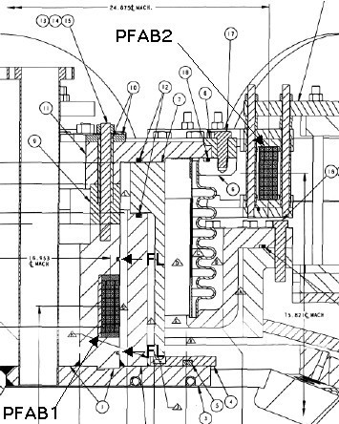

FIGURE 1: PF ABSORBER FIELD NULLING COILS (Dwg. E-DC1277)

Coil construction details are shown in figures 2 and 3.

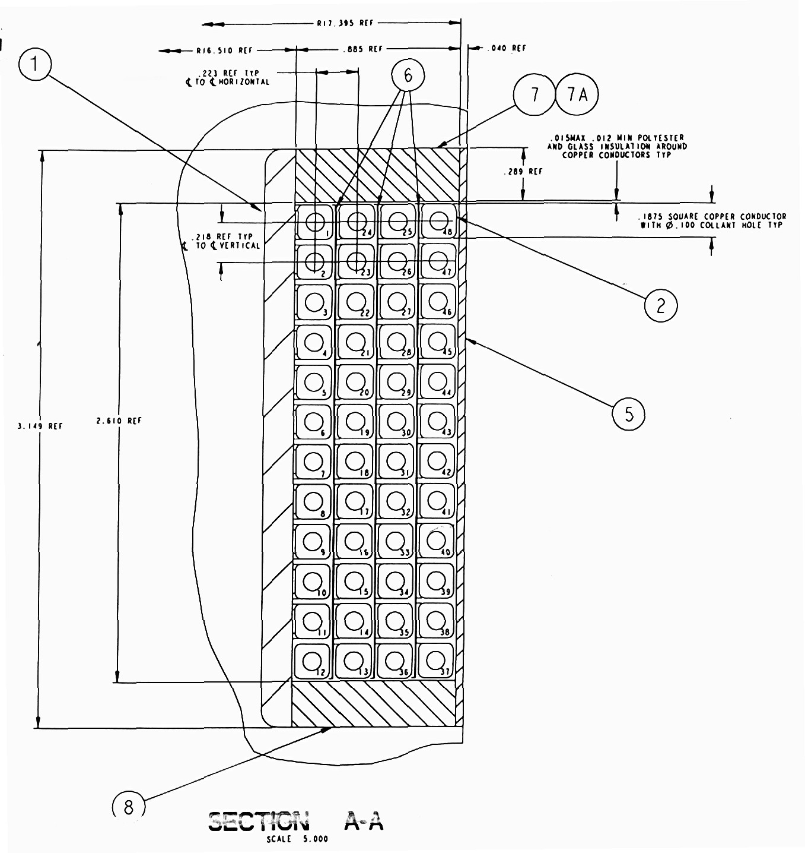

FIGURE 2: PFAB-1 (Dwg. E-DC1284)

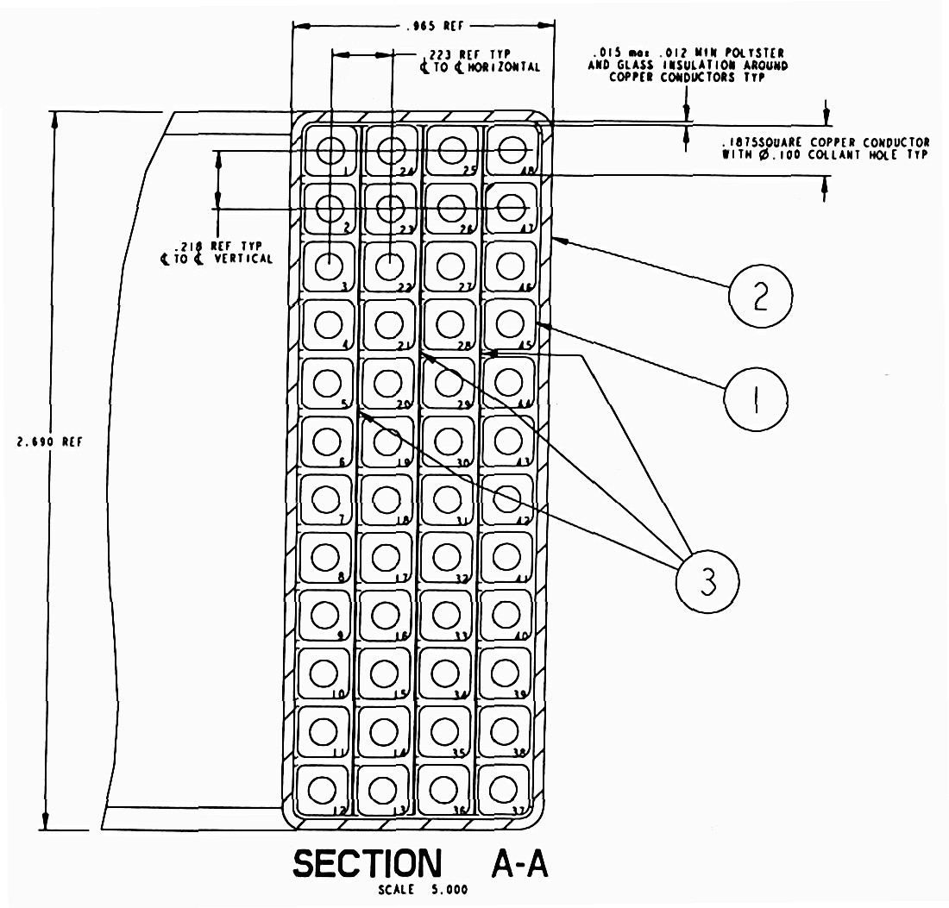
FIGURE 3: PFAB-2 (Dwg. E-DC1286)

Coil dimensions are given in Table 1, and electrical impedances in Table 2. Coil electrical ratings are given in Table 3.

Table 1: CHI Absorber Coil Dimensions
Coil | Rcenter  (m) | Zcenter  (m) | ∆Z  (m) | ∆R  (m) | #turns | Packing Fraction
PFAB1 | 0.4306 | 1.7565 | 0.06788 | 0.02176 | 48 | 0.561
PFAB2 | 0.6318 | 1.9259 | 0.06788 | 0.02176 | 48 | 0.561

Table 2: CHI Absorber Coil Impedances
Coil | R  (mΩ) | L  (mH)
PFAB1 | 129.7 | 3.93
PFAB2 | 190.2 | 6.46

Table 3: CHI Absorber Coil Electrical Ratings
Peak Current | 1.0 kA
Equivalent Square Wave (∆T=80ºC) | 4.0 sec
∫I²(t)dt (∆T=80ºC) | 4 x 10⁶ A²-sec
Terminal to Terminal Voltage | 1kV
Maximum Voltage to Ground | 2kV
Hipot Voltage to Ground | 5kV

Notes:

- The above is based on a conductor cross section of 0.1875” x 0.1875” with 0.1” diameter cooling hole and 0.025” corner radius. Adjustments may have to be made based on actual as-built measurements.
- PFAB1 is mounted on the inner VV, and can therefore see a total of 1kV from its power supply plus 1kV from CHI, total of 2kV
- PFAB2 is mounted on the outer VV, and can therefore see a total of 1kV from its power supply plus 1kV from CHI, total of 2kV

Coil Support Structures

As shown in figure 1, PFAB1 is wound into a stainless steel ring, with cross section of ∆Z=7.3” and ∆R=2.0”. The ring is welded to the flange of the center stack casing.

As shown in figure 1 and figure 4, PFAB2 is secured by 11 clamps which contain the coil between a stainless steel support ring located underneath the coil, and a set of 6 tabs located above the coil which the attach to the top side of the PF2 coil support clamps. The support ring cross section is ∆Z=0.5” and ∆R=2.5”. Bolting hardware is 3/8” diameter.

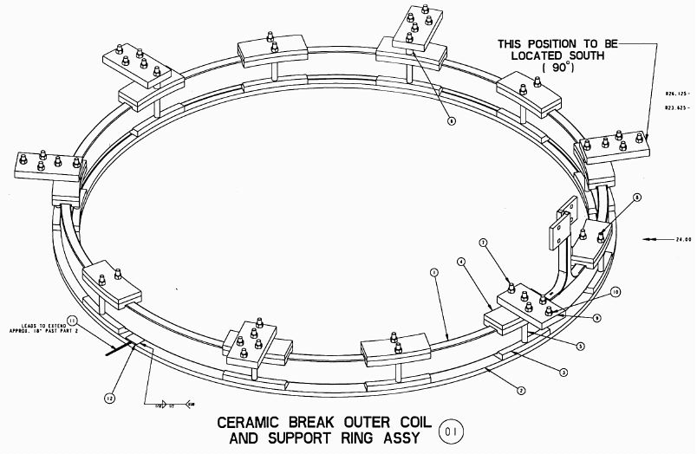
FIGURE 4: PFAB-2 Support Scheme (Dwg. E-DC1285)

Mutual Inductances

Overall NSTX PF system mutual inductance matrix including the subject coils is given in Table 4.

Table 4: PF Coil Inductances (Henry)
 | OH | PF1AU | PF1AL | PF1B | PF2U | PF2L | PF3U | PF3L | PF4 | PF5 | PFAB1 | PFAB2
OH | 1.30E-02 | 7.31E-04 | 7.31E-04 | 3.74E-04 | 2.76E-04 | 2.76E-04 | 2.95E-04 | 2.95E-04 | 3.79E-04 | 5.28E-04 | 6.18E-04 | 4.86E-04
PF1AU | 7.31E-04 | 3.76E-04 | 1.95E-07 | 2.25E-07 | 7.23E-05 | 1.35E-06 | 6.04E-05 | 5.29E-06 | 3.16E-05 | 4.16E-05 | 1.95E-04 | 1.22E-04
PF1AL | 7.31E-04 | 1.95E-07 | 3.76E-04 | 9.01E-05 | 1.35E-06 | 7.23E-05 | 5.29E-06 | 6.04E-05 | 3.16E-05 | 4.16E-05 | 8.07E-07 | 1.45E-06
PF1B | 3.74E-04 | 2.25E-07 | 9.01E-05 | 5.36E-04 | 1.66E-06 | 1.86E-04 | 6.61E-06 | 1.01E-04 | 4.15E-05 | 5.43E-05 | 9.69E-07 | 1.78E-06
PF2U | 2.76E-04 | 7.23E-05 | 1.35E-06 | 1.66E-06 | 1.98E-03 | 1.03E-05 | 7.31E-04 | 4.11E-05 | 2.64E-04 | 3.45E-04 | 6.50E-04 | 1.84E-03
PF2L | 2.76E-04 | 1.35E-06 | 7.23E-05 | 1.86E-04 | 1.03E-05 | 1.98E-03 | 4.11E-05 | 7.31E-04 | 2.64E-04 | 3.45E-04 | 5.92E-06 | 1.10E-05
PF3U | 2.95E-04 | 6.04E-05 | 5.29E-06 | 6.61E-06 | 7.31E-04 | 4.11E-05 | 5.18E-03 | 1.66E-04 | 1.16E-03 | 1.49E-03 | 3.57E-04 | 7.42E-04
PF3L | 2.95E-04 | 5.29E-06 | 6.04E-05 | 1.01E-04 | 4.11E-05 | 7.31E-04 | 1.66E-04 | 5.18E-03 | 1.16E-03 | 1.49E-03 | 2.35E-05 | 4.39E-05
PF4 | 3.79E-04 | 3.16E-05 | 3.16E-05 | 4.15E-05 | 2.64E-04 | 2.64E-04 | 1.16E-03 | 1.16E-03 | 5.16E-03 | 4.81E-03 | 1.48E-04 | 2.79E-04
PF5 | 5.28E-04 | 4.16E-05 | 4.16E-05 | 5.43E-05 | 3.45E-04 | 3.45E-04 | 1.49E-03 | 1.49E-03 | 4.81E-03 | 1.23E-02 | 1.93E-04 | 3.66E-04
PFAB1 | 6.18E-04 | 1.95E-04 | 8.07E-07 | 9.69E-07 | 6.50E-04 | 5.92E-06 | 3.57E-04 | 2.35E-05 | 1.48E-04 | 1.93E-04 | 3.93E-03 | 1.33E-03
PFAB2 | 4.86E-04 | 1.22E-04 | 1.45E-06 | 1.78E-06 | 1.84E-03 | 1.10E-05 | 7.42E-04 | 4.39E-05 | 2.79E-04 | 3.66E-04 | 1.33E-03 | 6.46E-03

Coupling with PF2 and Nearby Structure

To facilitate the evaluation of the coupling effects with PF2 and nearby structure the electrical characteristics of the simplified configuration shown in Figure 5 (to scale) was modeled. Parts can be recognized by comparison with Figure 1. Dimensions are summarized in Table 5, resistances in Table 6, and mutual inductances in Table 7. Note that all of the structure is 304SS (ρ=7.7e-7Ω-m) except for the CS casing flange and ceramic insulator sealing ring which are Inconel (ρ=1.3e-6Ω-m).

FIGURE 5: Simplified Model of absorber coils, structure, and PF2
Table 5: Dimensions
Inches.... | Rcenter | Zcenter | ∆Z | ∆R
PFAB1 | 16.953 | 69.155 | 2.673 | 0.857
PFAB2 | 24.857 | 75.821 | 2.673 | 0.857
SS Ring | 16.400 | 71.773 | 2.064 | 2.000
SS Ring | 15.847 | 69.155 | 3.047 | 0.894
SS Ring | 16.400 | 66.843 | 1.438 | 2.000
SS Ring | 24.857 | 73.985 | 0.500 | 2.500
Inconel Ring | 18.297 | 69.905 | 7.688 | 1.000
Inconel Ring | 16.828 | 65.624 | 0.938 | 10.250
SS Ring | 22.078 | 68.530 | 0.875 | 2.563
SS Ring | 22.984 | 71.061 | 4.063 | 0.750
SS Ring | 24.734 | 72.593 | 0.938 | 2.688
SS Ring | 24.859 | 71.593 | 0.938 | 2.438
SS Ring | 24.109 | 69.343 | 3.438 | 0.938
SS Ring | 16.703 | 76.405 | 2.000 | 1.750
SS Ring | 20.484 | 76.905 | 1.000 | 5.750
PF2Ua | 31.464 | 76.123 | 2.676 | 6.406
PF2Ub | 31.464 | 72.939 | 2.676 | 6.406
Meters.... | Rcenter | Zcenter | ∆Z | ∆R
PFAB1 | 0.4306 | 1.7565 | 0.0679 | 0.0218
PFAB2 | 0.6314 | 1.9259 | 0.0679 | 0.0218
SS Ring | 0.4166 | 1.8230 | 0.0524 | 0.0508
SS Ring | 0.4025 | 1.7565 | 0.0774 | 0.0227
SS Ring | 0.4166 | 1.6978 | 0.0365 | 0.0508
SS Ring | 0.6314 | 1.8792 | 0.0127 | 0.0635
Inconel Ring | 0.4647 | 1.7756 | 0.1953 | 0.0254
Inconel Ring | 0.4274 | 1.6668 | 0.0238 | 0.2604
SS Ring | 0.5608 | 1.7407 | 0.0222 | 0.0651
SS Ring | 0.5838 | 1.8050 | 0.1032 | 0.0191
SS Ring | 0.6282 | 1.8438 | 0.0238 | 0.0683
SS Ring | 0.6314 | 1.8184 | 0.0238 | 0.0619
SS Ring | 0.6124 | 1.7613 | 0.0873 | 0.0238
SS Ring | 0.4243 | 1.9407 | 0.0508 | 0.0445
SS Ring | 0.5203 | 1.9534 | 0.0254 | 0.1461
PF2Ua | 0.7992 | 1.9335 | 0.0680 | 0.1627
PF2Ub | 0.7992 | 1.8526 | 0.0680 | 0.1627

Table 6: Resistances

Element | R(Ω)
PFAB1 | 1.30E-01
PFAB2 | 1.90E-01
SS Ring | 7.57E-04
SS Ring | 1.11E-03
SS Ring | 1.09E-03
SS Ring | 3.79E-03
Inconel Ring | 7.65E-04
Inconel Ring | 5.63E-04
SS Ring | 1.88E-03
SS Ring | 1.43E-03
SS Ring | 1.87E-03
SS Ring | 2.07E-03
SS Ring | 1.43E-03
SS Ring | 9.08E-04
SS Ring | 6.78E-04
PF2U | 4.17E-03

Table 7: Inductance Matrix (Henry)

 | PFAB1 | PFAB2 | SS Ring | SS Ring | SS Ring | SS Ring | Inc Ring | Inc Ring | SS Ring | SS Ring | SS Ring | SS Ring | SS Ring | SS Ring | SS Ring | PF2U
PFAB1 | 3.93E-03 | 1.33E-03 | 5.02E-05 | 6.28E-05 | 5.30E-05 | 3.05E-05 | 5.66E-05 | 3.77E-05 | 4.26E-05 | 3.80E-05 | 3.27E-05 | 3.36E-05 | 3.62E-05 | 2.62E-05 | 2.71E-05 | 6.50E-04
PFAB2 | 1.33E-03 | 6.46E-03 | 2.93E-05 | 2.39E-05 | 2.25E-05 | 1.02E-04 | 3.41E-05 | 2.21E-05 | 4.45E-05 | 6.14E-05 | 8.08E-05 | 7.13E-05 | 5.48E-05 | 3.34E-05 | 6.15E-05 | 1.83E-03
SS Ring | 5.02E-05 | 2.93E-05 | 1.56E-06 | 1.00E-06 | 6.96E-07 | 6.50E-07 | 1.03E-06 | 5.58E-07 | 7.36E-07 | 7.47E-07 | 6.72E-07 | 6.69E-07 | 6.71E-07 | 7.39E-07 | 6.80E-07 | 1.32E-05
SS Ring | 6.28E-05 | 2.39E-05 | 1.00E-06 | 1.51E-06 | 1.06E-06 | 5.45E-07 | 9.54E-07 | 7.33E-07 | 7.34E-07 | 6.64E-07 | 5.79E-07 | 5.92E-07 | 6.35E-07 | 5.11E-07 | 5.04E-07 | 1.17E-05
SS Ring | 5.30E-05 | 2.25E-05 | 6.96E-07 | 1.06E-06 | 1.65E-06 | 5.22E-07 | 9.47E-07 | 1.01E-06 | 7.94E-07 | 6.62E-07 | 5.67E-07 | 5.93E-07 | 6.71E-07 | 4.06E-07 | 4.34E-07 | 1.18E-05
SS Ring | 3.05E-05 | 1.02E-04 | 6.50E-07 | 5.45E-07 | 5.22E-07 | 2.93E-06 | 7.81E-07 | 5.22E-07 | 1.09E-06 | 1.56E-06 | 2.20E-06 | 1.87E-06 | 1.38E-06 | 6.76E-07 | 1.15E-06 | 3.88E-05
Inc Ring | 5.66E-05 | 3.41E-05 | 1.03E-06 | 9.54E-07 | 9.47E-07 | 7.81E-07 | 1.37E-06 | 7.91E-07 | 1.04E-06 | 9.60E-07 | 8.31E-07 | 8.46E-07 | 8.96E-07 | 6.53E-07 | 7.05E-07 | 1.62E-05
Inc Ring | 3.77E-05 | 2.21E-05 | 5.58E-07 | 7.33E-07 | 1.01E-06 | 5.22E-07 | 7.91E-07 | 1.08E-06 | 8.48E-07 | 6.70E-07 | 5.74E-07 | 6.11E-07 | 7.24E-07 | 3.53E-07 | 3.99E-07 | 1.24E-05
SS Ring | 4.26E-05 | 4.45E-05 | 7.36E-07 | 7.34E-07 | 7.94E-07 | 1.09E-06 | 1.04E-06 | 8.48E-07 | 2.43E-06 | 1.63E-06 | 1.25E-06 | 1.37E-06 | 1.78E-06 | 5.46E-07 | 7.18E-07 | 2.42E-05
SS Ring | 3.80E-05 | 6.14E-05 | 7.47E-07 | 6.64E-07 | 6.62E-07 | 1.56E-06 | 9.60E-07 | 6.70E-07 | 1.63E-06 | 2.33E-06 | 1.83E-06 | 1.90E-06 | 1.88E-06 | 6.45E-07 | 9.35E-07 | 2.91E-05
SS Ring | 3.27E-05 | 8.08E-05 | 6.72E-07 | 5.79E-07 | 5.67E-07 | 2.20E-06 | 8.31E-07 | 5.74E-07 | 1.25E-06 | 1.83E-06 | 2.77E-06 | 2.39E-06 | 1.64E-06 | 6.48E-07 | 1.03E-06 | 3.74E-05
SS Ring | 3.36E-05 | 7.13E-05 | 6.69E-07 | 5.92E-07 | 5.93E-07 | 1.87E-06 | 8.46E-07 | 6.11E-07 | 1.37E-06 | 1.90E-06 | 2.39E-06 | 2.84E-06 | 1.92E-06 | 6.16E-07 | 9.48E-07 | 3.68E-05
SS Ring | 3.62E-05 | 5.48E-05 | 6.71E-07 | 6.35E-07 | 6.71E-07 | 1.38E-06 | 8.96E-07 | 7.24E-07 | 1.78E-06 | 1.88E-06 | 1.64E-06 | 1.92E-06 | 2.53E-06 | 5.57E-07 | 7.97E-07 | 3.08E-05
SS Ring | 2.62E-05 | 3.34E-05 | 7.39E-07 | 5.11E-07 | 4.06E-07 | 6.76E-07 | 6.53E-07 | 3.53E-07 | 5.46E-07 | 6.45E-07 | 6.48E-07 | 6.16E-07 | 5.57E-07 | 1.64E-06 | 1.04E-06 | 1.39E-05
SS Ring | 2.71E-05 | 6.15E-05 | 6.80E-07 | 5.04E-07 | 4.34E-07 | 1.15E-06 | 7.05E-07 | 3.99E-07 | 7.18E-07 | 9.35E-07 | 1.03E-06 | 9.48E-07 | 7.97E-07 | 1.04E-06 | 1.76E-06 | 2.27E-05
PF2U | 6.50E-04 | 1.83E-03 | 1.32E-05 | 1.17E-05 | 1.18E-05 | 3.88E-05 | 1.62E-05 | 1.24E-05 | 2.42E-05 | 2.91E-05 | 3.74E-05 | 3.68E-05 | 3.08E-05 | 1.39E-05 | 2.27E-05 | 1.98E-03

cc:

M Bell J Chrzanowski D Gates R Hatcher M Kalish
D Lotz R Marsala J Menard B Nelson M Ono
S Ramakrishnan R Raman A Von Halle I Zatz

