22-050721-CLN-01

TO: DISTRIBUTION
FROM: C NEUMEYER
SUBJECT: HIPOT REQUIREMENTS FOR 1.5KV CHI CAP BANK OPERATION

A meeting was held on 7/21/05 to discuss the hipot requirements for the upcoming CHI cap bank operations at 1.5kV. In attendance were M. Bell, C. Neumeyer, M. Ono, R. Raman, and M. Williams.

It was decided that the existing regular practice of hipot testing the inner vacuum vessel (IVV) at 5kV DC (with the TF, outer VV (OVV), and all other circuits grounded) is adequate to ensure reliable operation of CHI in the cap bank mode at 1.5kV.

This memo documents the logic behind this decision.

Of primary concern is the insulation which separates the TF and CHI circuits, depicted schematically in the following figure.

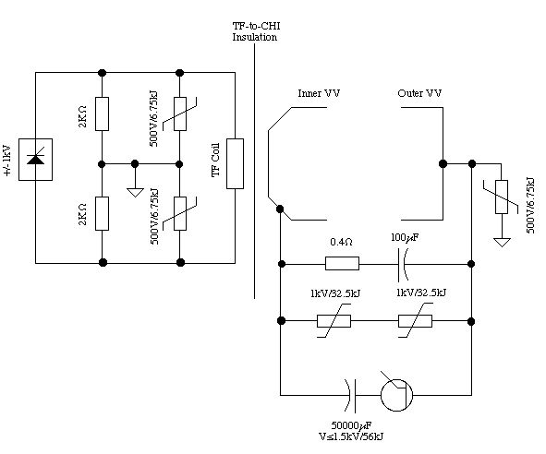
Simplified Schematic of TF and CHI Circuits

Since the Center Stack Casing (which is the CHI IVV electrode) is electrically in common with the TF flag box/hub assembly (and OH tension tube and ground plane), a special concern is the insulation on the TF flag boxes, which sees the full differential voltage between the TF and the CHI as shown in the following figures.

Elevation View of TF Flag/Box/Hub

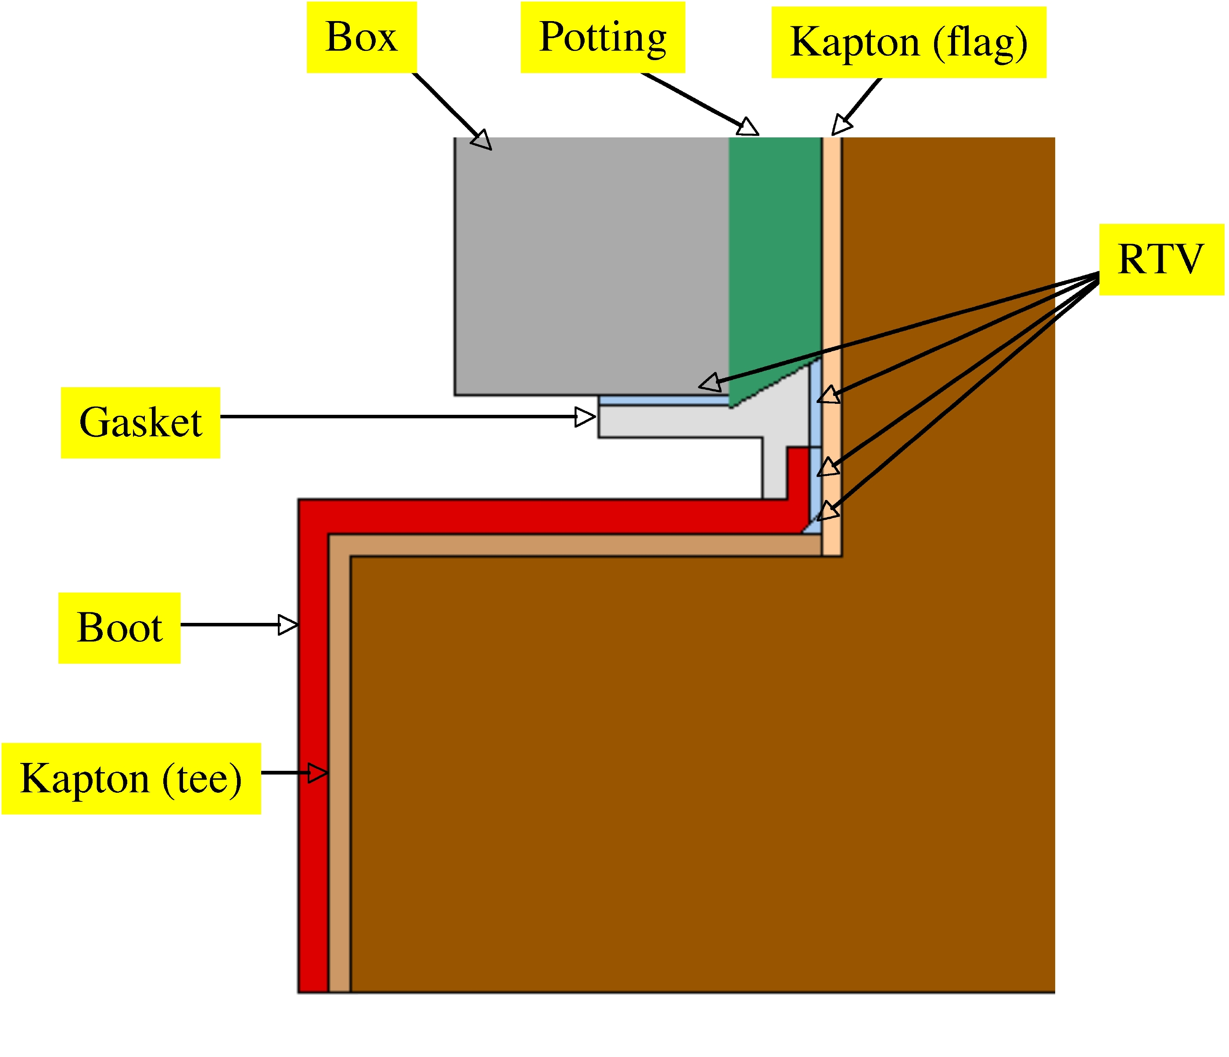
Details of Flag Box Insulation at Tee-end
Since the TF power supply operates up to 1kV, and the CHI cap is proposed to operate up to 1.5kV, the differential voltage between TF and CHI circuits can be as high as 1+1.5=2.5kV. Our normal practice following the 2E+1 rule would call for a hipot of 2*2.5+1=6kV between the TF and CHI circuits.

A 6kV hipot could be accomplished by applying 6kV to TF with all other circuits grounded, or applying 6kV to the CHI IVV electrode with all other circuits grounded, or by applying voltages of opposite polarity to the TF and CHI circuits such that the differential voltage is 6kV.

Because the voltage rating of the TF joint instrumentation system is ~ 5kV, and the outer legs and remainder of the TF circuit (outer legs, DC cables, and power supplies) do not normally operate above 1kV, it is undesirable to hipot these systems above 3kV.

Since the CHI IVV electrode is in a very congested area and has suffered failures in the past on the bushings which insulate the mounting bolts, it is undesirable to hipot this system above 5kV, which is an established level based on the desire to some day operate CHI at 2kV (2*2+1=5kV). Hipots of this system are routinely performed at 5kV with all other systems grounded.

While a differential hipot involving two simultaneous hipots of opposite polarities to ground is possible in principle, it is undesirable from a complexity point of view.

So the essential question is whether or not the hipot test of the IVV at 5kV with other systems, including TF, grounded, is adequate to ensure reliable CHI cap bank operation at 1.5kV.

While the 5kV level falls somewhat short of the normally applied 2E+1=6kV practice, the following arguments are supportive of it….

- While the TF flag box insulation scheme was prototype tested to 28kV, and production tested to 10kV, there were some failures experienced after rework which reduces confidence in the withstand voltage of these assemblies;
- Application of 2E+1 rule with E=1kV for TF is conservative due to center point grounding of TF (factor of 2) and fact that Vchi is applied while TF is at flat top (another factor of 2), although there are scenarios where these factors could be lost;
- Operation in the CHI cap bank “voltage source” mode has proven to be relatively free of voltage transients (compared to CHI power supply “current source” mode) since cap bank tends to hold the voltage steady. Prior testing shows voltage noise spikes are less than 120% of nominal applied voltage;
- Even if surge currents elevate surge arrestor voltage to 150% of MCOV level, voltage between TF and CHI will not exceed ~ 1.5*(1+2) = 4.5kV;
- Hipot tests were peformed during TF installation which imposed 7kV across the TF-to-CHI insulation, which satisfies the 2E+1 objective, although several months ago;
- Differential hipot with two simultaneous hipots to ground seems complex and error prone, and should be avoided if possible;

Based on the above considerations, it was judged that an increase in the hipot level beyond 5kV would only serve to increase risk, not decrease it. Therefore it was decided to proceed to the 1.5kV CHI cap bank level on the basis of the existing 5kV IVV hipot procedure.

cc:

M Bell R Hatcher M Ono S Ramakrishnan R Raman
A Von Halle MWilliams

NSTX File

Surge suppressor voltages noted are maximum continuous overvoltage ratings (MCOV), actual clamp voltage depends on current, can be ~ 1.5x at high discharge currents
Prior to potting all flag boxes were disassembled to remove 2 of the glass layers, then reassembled. During this process some damage occurred to some of the boxes which had to be reworked in order to pass a 7kV pre-potting and 10kV post-potting production hipot.

