55_040206_CLN_01.doc

TO: DISTRIBUTION
FROM: C NEUMEYER
SUBJECT: SIMULATION OF RWM/FEC SPA

This memo presents results of a simulation of a Switching Power Amplifier (SPA) to be used for Resistive Wall Mode (RWM) and Field Error Correction (FEC). The simulation was performed using the Power Systems Computer Aided Design (PSCAD) software.

MODELING

The overall PSCAD setup is shown in the following figure. One SPA, consisting of two parallel H-bridge choppers, is simulated, being fed from a Transrex 6-pulse rectifier through realistic cable impedances corresponding to the SPA being located in the mezzanine of the Neutral Beam Power Conversion (NBPC) building. In addition, a 0.3 ohm series current limiting resistor is added to limit inrush current. In actuality, three SPAs would be fed, and the load on the Transrex would be 3x the amount simulated. However, the load is relatively low, and the voltage drop will be insignificant.

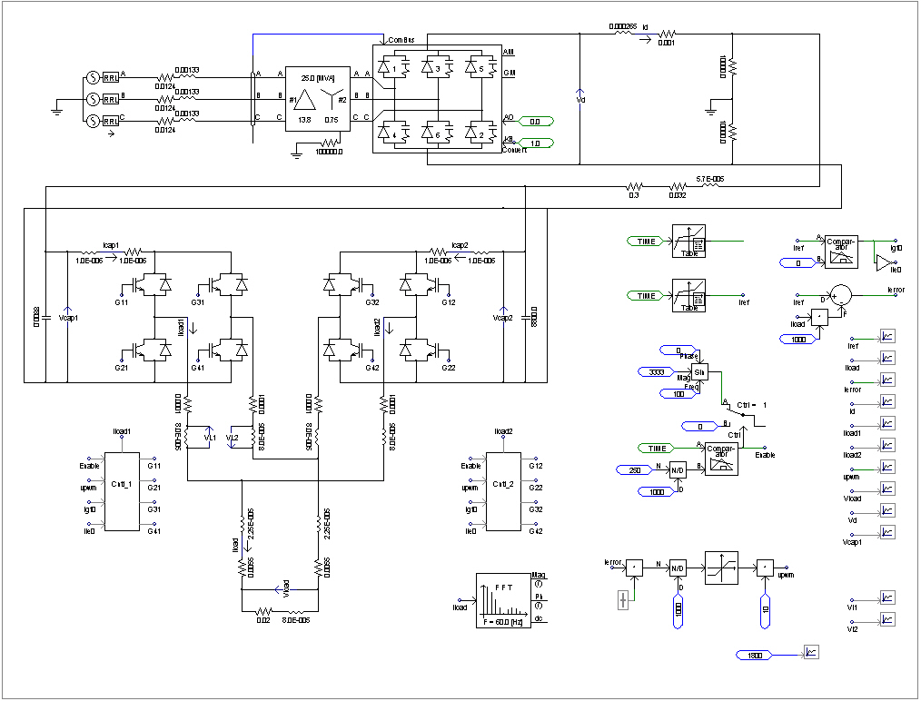

A zoomed view of the SPA model and load is given in the following figure. There are two parallel H-bridge choppers which operate at 2.5kHz. The 80microH inductors in each leg of each chopper output are added for purposes of balancing the current between parallel out-of-phase choppers. The cable impedances which connect to the 20mOhm, 80microH load are realistic for the SPA being located in the NBPC mezzanine and the coils in the NSTX Test Cell (NTC). The blocks labeled “Cntl_1” and “Cntl_2” represent the SPA IGBT firing pulse controls.

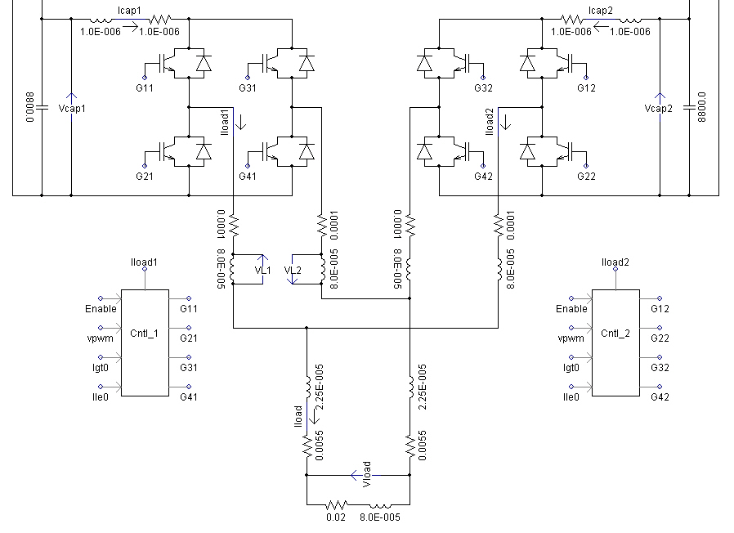

The control logic typical of Cntl_1 and Cntl_2 is shown in the following figures. A triangle wave “vtr” at 2.5kHz and its intersections with a Pulse Width Modulation (PWM) feedback control reference demand “vpwm” control the time at which IGBT firing pulses to G1, G2, G3, and G4 IGBTs are issued. The vpwm is generated based on a simple proportional control (gain = 10 ohms) on the current error. The firing pulse duration will follow the demand called for by vpwm unless the chopper current “Iload1” reaches its allowable limit. Once a firing pulse to an IGBT is issued during the corresponding 1/2 cycle of vtr, a blank-out period of 1/2500=400 microSec is established such that no additional switching operations take place until that amount of time has elapsed. This is required to avoid overheating the IGBT devices.

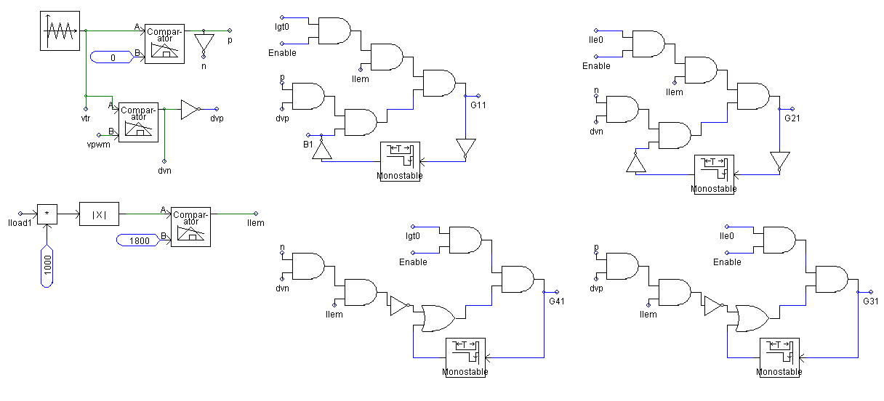

The utilization of the four H-bridge IGBTs to produce positive and negative voltage under conditions of positive and negative load current (4-quadrant operation) is shown in the following figure.

To test the SPA, its response to a square pulse and its response to a 100Hz sine wave was simulated, in each case with a peak current of 3333A reference.

SQUARE PULSE RESPONSE

In the following figure, the top graph shows the load current Iload, reference current Iref, and chopper branch currents Iload1 and Iload2. The next graph shows the Transrex output Vd, the SPA cap bank voltage Vcap1, and the voltage on the 80microH, 20mOhm load coil. The next graph shows the Transex current Id (x3) and the error in the load current (Iref-Iload). The last graph shows the vpwm signal. Note that, with the selected values of series resistor and SPA cap bank, the cap voltage drop under load is modest, as is the Transrex inrush current and current during the SPA pulse. This will permit the use of a relatively light cable.

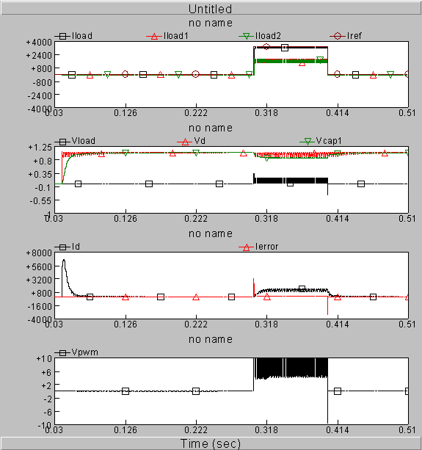

The following figure shows a zoom-in during the square pulse. Note again the cap voltage drop under load and the Transrex current during the SPA pulse.

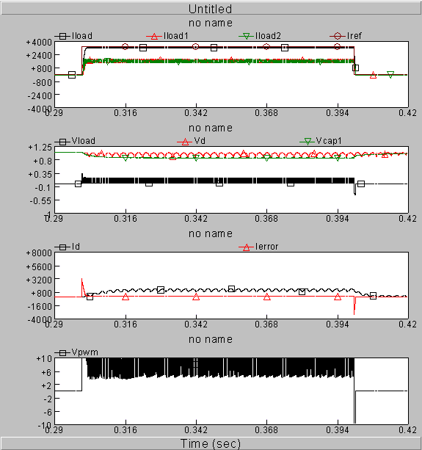

The following figure shows a zoom-in on the front edge of the square pulse. Note that the rise time of the current is of order 1.5mS. During this time the feedback controller is saturated (vpwm is railed) and the duty cycle is 100%. It then begins to back off from 100% as the IGBT currents run up against their 1800A limit (at which point the control logic turns them off).

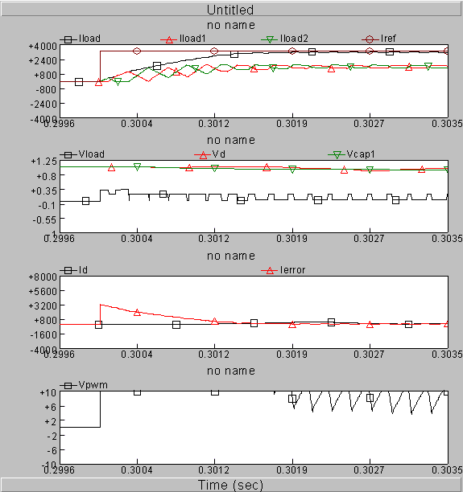

The following figure shows another zoom-in on the front edge of the square pulse. Again, one can see where the duty cycle backs off from 100% as the IGBT currents run up against their 1800A limit (shown as a horizontal line on the figure). Also important to note is the magnitude of the ripple in the IGBT currents. In order to avoid overload, it is necessary to limit this ripple to a peak value of 3333/2-1800=133 amps. This criteria determines the minimum value of the inductance in each output leg of the choppers. A value of 80microH was found necessary to meet the criteria. So, the total loop inductance is then 2*80+2*22.5+80=285microH, and the load is only 80/285=28% of this. As a result, only a relatively small fraction of the source voltage is noted to appear across the load itself during the PWM pulses.

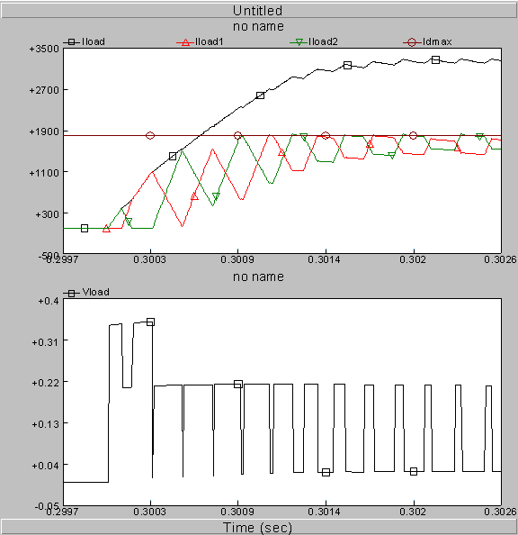

The following figure shows a zoom-in of the flat top of the square pulse. Note that the average current is of order 3240A (there is an error of 3333-3240=90A due to the simple proportional control) with a peak-to-peak ripple of about 80A. The fundamental is at 5kHz.

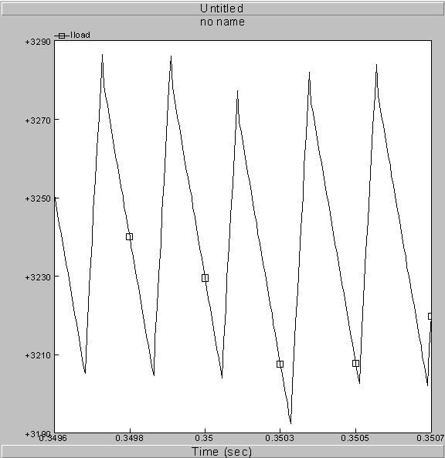
SINE WAVE RESPONSE

In the following figure, the top graph shows load current Iload, reference current Iref, and chopper branch currents Iload1 and Iload2, and the second graph shows the load voltage.

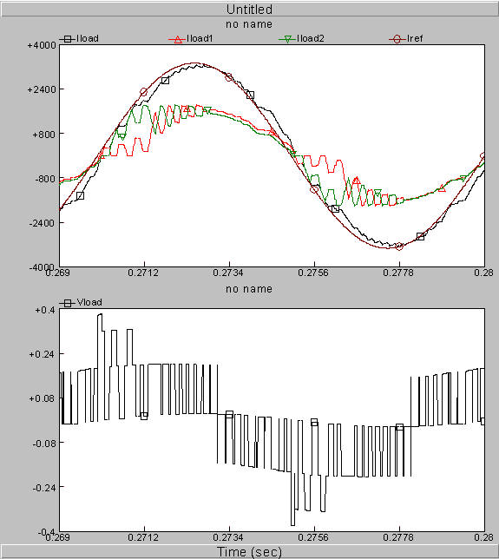
The following figure shows a zoom-in on the load current and the reference. The shift in their peaks is around 200 microsec which amounts to 7.2 degrees at 100Hz. This could probably be reduced if an integral term was included in the feedback.

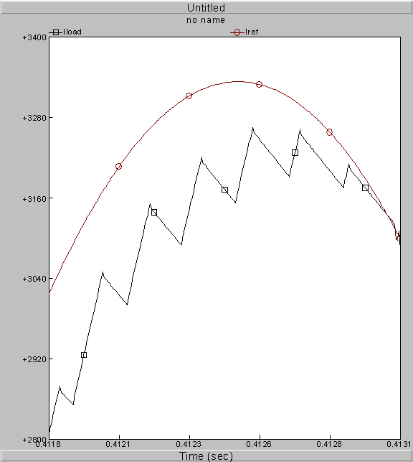

SUMMARY

The PSCAD simulation demonstrates one possible incarnation of the SPA. Details of control logic will probably differ in the actual equipment, but the use of two parallel 2.5kHz choppers is shown to produce a response equivalent to that obtainable via a single 5kHz chopper. The maximum latency in the step response in the output voltage for such as system is 200microseconds, which would occur if a sudden demand were to take place immediately after an IGBT turn-off event at very low duty factor.

Operation at higher switching frequency should be possible, but if the IGBT devices are selected for a 6 second SPA pulse at 3.33kA when switching at 5kHZ, then a de-rating in the current or pulse duration would be necessary. However, this is an option worth considering. The ultimate controller would, in fact, consider the time history of current and switching duty and simulate the device temperatures in real-time, and allow the switching frequency to vary during a pulse.

Cc:

M Bell J Bialek D Gates R Hatcher G Labik
J Menard D Mueller M Ono S Ramakrishnan
S Sabbagh A Von Halle

