71-000222-CLN-01
TO: DISTRIBUTION
FROM: C NEUMEYER
SUBJECT: OH REP RATE MINIMIZATION, MINUTES OF MEETING

A meeting was held to discuss options for removing undue constraints on the OH repetition rate so as to improve the utilization of the NSTX machine while still providing reliable protection of the OH coil against overheating.

Following persons were in attendance:

M Bell R Marsala D Mueller C Neumeyer S Ramakrishnan

The attached presentation was made.

Conclusions/recommendations are as follows:

- Ultimately, a feature needs to be provided to allow the COE to select from three possible repetition periods as follows:

• 300 seconds: corresponds to rated Unipolar OH operations, and two NBI periods @ 150 seconds each

• 450 seconds: three NBI periods, allowable OH ∫i²(t)dt TBD (probably of order 200 kA²-sec, roughly 80% of present allowable, 2/3 of ultimate allowable)

• 600 seconds: corresponds to rated Bipolar OH operations, and four NBI periods

- Upon resuming operations this summer, the 450 second repetition period should be adopted. Based on cool down temperature vs. time measurements made during prior ISTP runs, it seems that this will permit pulsing at 200 kA²-sec with temperature ratcheting up to 25C at the start of pulse, 87.5C end of pulse, 95C in case of L/R decay following nominal 200 kA²-sec. According to information compiled by M Bell, the present NSTX OH operations is such that the ∫i²(t)dt demand does not approach the allowable for the vast majority of shots, and tends in fact to be lower for the better behaved plasmas.

ACTIONS:

- C Neumeyer to resurrect detailed model of cool down and determine appropriate ∫i²(t)dt and water interlock settings for 450 second period

- M Kalish to implement permanent thermocouple monitoring of OH coil outlet water temperatures and interface with water system PLC, and from PLC into EPICs

- Effort should be initiated to provide features required to allow for selection, by the COE from the control room, any one of the three repetition periods. The following tasks need to be undertaken:

• ACP OH period timer needs to be modified to allow for the selection of any one of the three repetition periods

• Water system PLC needs to be modified to allow for the selection of any one of the three maximum start-of-pulse temperatures corresponding to the three repetition periods

• Digital coil protection needs to be implemented to provide accurate simulation of OH coil heating and cooldown, to replace the function of the RIS which only provides a simple single time constant simulation

Whether or not the selection of the repetition period is implemented via a switch in the control room, or by instruction from the COE to the operators in the field, is TBD, but features should be provided to allow for rapid (< repetition period being selected) and reliable transition from one period to the next.

Further it is noted that the resurrection of the TFTR Coil Protection Calculator may prove to be a cost effective way to provide the digital coil protection.

ACTION:

- C Neumeyer to develop a plan (including cost/schedule) for executing the above tasks required for the repetition period selection feature.

- The possibility of increased flow rate in the OH coils should be investigated. At present, the pressure drop across the coil is 100 psi (base) + 100 psi (booster pump), total 200 psi, and the hydrostatic test is performed at 650 psi. An increase from 200 psi to 300 psi would result in a 20% increase in flow in the outer layer windings and a reduction in the bulk average thermal time constant from 250 to 200 seconds. As a result, the derating of the allowable ∫i²(t)dt in the case of the 300 and 450 second repetition periods would be reduced.

ACTION:

M Kalish to investigate and develop a plan (including cost/schedule).

cc:

M Bell
W Blanchard
R Camp
D Gates
J Chrzanowski
W Blanchard
T Egebo
R Herskowitz
M Kalish
S Kaye
R Marsala
J Menard
D Mueller
M Ono
G Pearson
M Peng
S Ramakrishnan
A Von Halle
M Williams

NSTX File

OH Rep Rate Minimization

C Neumeyer 2/22/00
• Objective

- remove undue constraints on rep rate so as to improve utilization of machine
- provide reliable protection of OH coil against overheating

• Facts

- four layer coil, wound 2-in-hand, 8 windings, 8 cooling paths
- range of path length 88 to 110 m
- range of nominal flow 0.6 to 0.8 GPM chosen to equalize thermal time constant (≈ 250 sec) and transit time of water through ≈ 40 sec
- max flow in outer layer set by 200 psi limitation (100 psi booster pump)
- coil temperature rise ≈ 85C with 10C starting temperature and ∫i2(t)dt ≈ 300kA^2-sec
- an L/R decay following fault can add ≈ 30kA^2-sec

Water Flow Rates in 8 Cooling Paths

- actual flow rates, and trip points, vary from nominal

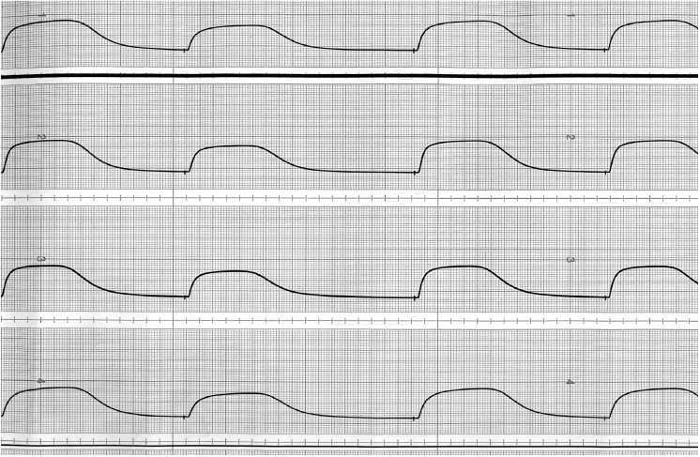
Strip Chart Measurements of OH Outlet Water (4 paths)

Strip Chart Waveform vs. Simple Exponential

- cool down of coil is a complex process, which does not follow a simple exponential decay
- cool down waveforms show that 600 seconds is sufficient to avoid significant ratcheting

• Present Status of ∫i²(t)dt Related Protection

- ACP period timer set to 600 seconds
- ACP I_{oc} ≈ 24kA and pulse timer to 1.0 sec (not effective for ∫i²(t)dt protection)
- Outlet water temperature permissive set at 11 deg C
- RIS ∫i²(t)dt set at 240kA^2-sec, corresponding to ∆T ≈ 65C starting from 10C
- RIS τ set at 274 seconds

• Issues

- one solution is to drop the ACP period timer and drop the water interlock; however we then depend exclusively on the RIS, which is too risky.

- the PSRTC is frequently started and stopped, such that the history of coil heating and cooling is lost

- we do not at present have OH coil outlet water temperature monitoring (8 water paths) available to the computer system. The aforementioned interlock is a go/no go temperature switch on each path

- we do not really know the OH ∫i2(t)dt of the next pulse, because it depends on the plasma control; the current waveform is not directly programmed.

- a completely variable rep rate would complicate NSTX operations, especially when NBI conditioning comes into play (it has to be synchronized with the 150 sec clock cycle).

- nearly all OH operations consume the fully allowed ∫i2(t)dt, except of course for CHI in which case the OH is not operated, and the ACP period timer does not pick up at all in the OH channel.

- in the long run we will want to frequently go back and forth between OH unipolar and bipolar modes. In this the ability to toggle back and forth between two rep rates may become quite important.

- ultimately we need a digital coil protection system, and to scrap (or set out of range) the ACP and RIS.

• Solutions

- adjust ∫i2(t)dt settings, water interlock, and ACP timer to reflect more realistically the present use of the OH coil

- install proper OH water outlet temperature monitoring

- provide features in software (PSRTC, Pre-pulse check?) which check that cool down is sufficient for next pulse prior to its execution
- provide more sophisticated cool down algorithm in PSRTC
- provide digital coil protection with real cool down simulation

• Analysis of Rep Rate vs. I2T limit

Tmax | 95 | deg C
Gmax | 1.73593E+16 | (A/m^2)^2-sec
CSA/turn | 1.41E-04 | m^2
∫i2(t)dt fault | 30000000 | A^2-sec
∫j2(t)dt fault | 1.50E+15 | (A/m^2)^2-sec
Geop | 1.59E+16 | (A/m^2)^2-sec
Teop | 85.7 | deg C

Tinitmax | ∫i2(t)dt pulse
55.8 | 100.0
53.0 | 110.0
50.2 | 120.0
47.4 | 130.0
44.6 | 140.0
41.9 | 150.0
39.2 | 160.0
36.5 | 170.0
33.8 | 180.0
31.2 | 190.0
28.6 | 200.0
26.0 | 210.0
23.5 | 220.0
21.0 | 230.0
18.5 | 240.0
16.0 | 250.0
13.5 | 260.0
11.1 | 270.0

I2T Allowable vs. Initial Temperature

Temperature Decay from 87.5 deg C

