CHI Current persistence studies: Aug 24, 2005
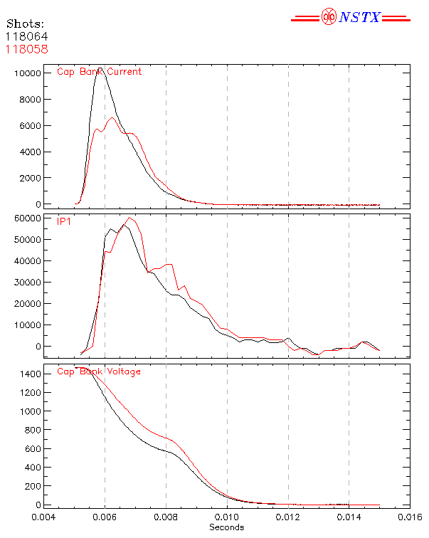
Conducted a Toroidal Field scan (21kA, 26kA, 34kA, 38kA, 42kA) – CHI discharges generated at all fields.
- gives future operational flexibility

Conducted a scan in the injector flux.
- at reduced injector flux (2 to 3kA in PF1B coil current), obtained current persistence
- fast camera image shows plasma detaching from the injector at 10 to 12ms.

Conducted few shots using PF2L as the injector flux coil
- At 4kA in this coil, obtained a CHI discharge
- Additional tests are needed to develop startup scenarios using this coil

CHI plasma coupling to induction
Plasma sustained at about 40kA after loop voltage application (3V) from the CS
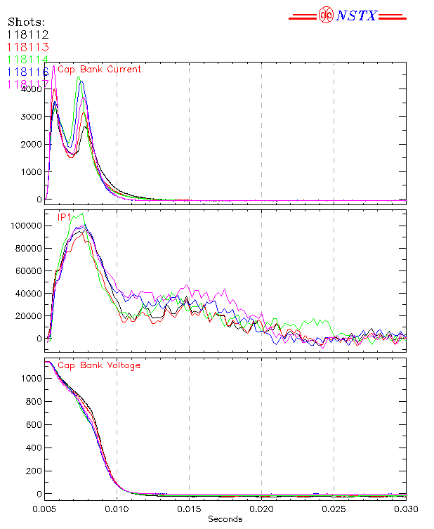
- CHI plasma couples to induction
- CHI plasma quality not too far off from inductive plasmas
- some small improvements needed

Initial plasma pulled into injector. Later plasmas detached and moved towards upper divertor after injector current was zero
- additional coil current adjustments needed

Could not produce an inductive discharge using induction alone
- probably needs wall conditioning
- CHI had last day of run after boronization
- similar to results seen on HIT-II

Could not use RF heating
- noise induced trips caused large delays in operation
- will use lower power RF in future

Operational window restricted by negative Ip spikes
- New gas valve may extend operational window
- Initial 3 hours needed to test new gas valve
- followed by additional runs to improve these plasmas
(lower gas injection, boronization, lower power HHFW heating)

