Selected Orals from 2007 EPS (Warsaw)
(red name indicates plenary session, black parallel session)

Fritz Wagner (awarded the Alfven Prize) – History of the H-mode
Pietro Barabaschi (EFDA) - Engineering /physics basis of a Tokamak
Vladimir Fortov (Moscow) – Plasmas under extreme conditions
Philip Andrew (JET) – JET: ELM / Disruption loads on main chamber
Klaus Hallatschek (Garching) – 3D flows from gyrokinetics
Matthew Zepf (Belfast) – keV photons from oscillating surfaces
Zhong Lin (Irvine) – GTC: simulations of ETG & CTEM
Virginia Grandgirard (Cadarache) – GYSELA: full-f gyrokinetic sim’s
Terry Rhodes (UCLA) – DIII-D reflectometry measurements
Basil Duval (EPFL) – TCV plasma rotation
Tuomas Tala (JET) – JET toroidal & poloidal rotation
Wayne Solomon (PPPL) – DIII-D momentum confinement
Gunther Janeschitz (Karlsruhe) – ITER session
Gerard Mourou (Palaiseau) Relativistic laser-matter interactions
Alberto Loarte (EFDA) ITER ELMS & Disruptions
Ian Chapman (UKAEA) – Sawteeth destabilisation
Hiroshi Yamada (NIFS) – LHD large densities
Gabriella Saibene (EFDA) – JET H-mode TF ripple effects
Peter deVries (UKAEA) – JET ITB TF ripple effects
Diego del-Castillo-Negrete (ORNL) – Non-local transport
Xavier Litaudon (Cadarache) – Development of steady state
Yunfeng Liang (Julich) – JET: Error field control of Type-I ELM’s
Emanuel Joffrin (Cadarache) – Advanced tokamak scenarios
Details from selected EPS orals:

Fritz Wagner – History of the H-mode
’82 in ASDEX, ’84 in PDX, now everywhere
Hysteresis (lower P_{aux} sufficient after L-H)
E_{r} well forms inside separatrix before L->H
E_{r} changes fast, grad(p) slow; v_{tor} B_{pol} or v_{pol} B_{tor}, fast
Conjecture: E_{r} well caused by zonal flows

Pietro Barabaschi - History of fission energy & implications for fusion
many competing designs & revisions of fission reactors -> 2 designs
Finnish reactor -> few GW @ 2-3cents/kW-H for 60 years
Fusion power: “Tokamaks may not be best”
ITER: “At some point we have to live with our mistakes”

Vladimir Fortov – Plasmas under extreme conditions
Explosions to drive shocks in cryogenic H, D, Ar, He, ..
2 Million Atm, 100x liquid density
Boltzman -> Fermi statistics
Pressure ionization from overlap of waves

Philip Andrew – JET: ELM & disruption heat to main chamber
New fast IR camera for wide & narrow views
ELM filaments n_{tor} ~ 8-16, 2-3 % of ELM energy to wall sequence for disruptions:
1) no ITB: thermal energy conducted slowly to divertor before
2) ITB: can disrupt with full stored energy (pressure driven-kink)

Klaus Hallatschek – 3D flows from gyrokinetics
Movies of φ and n fluctuations
Zonal flows vs GAM’s
3D effect: q-dependent shielding of zonal flows
Zonal flows can’t explain H-mode (q too high in pedestal)

Matthew Zepf – keV photons from oscillating surfaces
Vulcan petawatt laser laser blow-off from high quality mirrors
relativistic plasma waves upshift energy of reflected photons by γ³
find 10⁴ harmonics -> filter -> 10⁻¹⁹ s pulses of few keV

Zhong Lin – GTC: ETG & CTEM
GTC code to study ETG in the “cyclone” case
Approximate kinetic el effects with hybrid: fluid – kinetic
200-2000 particles / cell to test noise: convergence past 400
Compares correlation times:
wave-ptcl < paral < perp < resonance-broadening < eddy-turnover
< auto-correl < linear growth
Quasi-linear approx good

Virginia Grandgirard – GYSELA: full-f global gyrokinetic sim’s
Electrostatic, still no collisions
Benchmarked with ORB5 (from Lausanne)
Bohm -> gyro-Bohm in simulation of cyclone plasma
Working on adding collisions
Working on Transport version to compute T(x) from fluxes

Basil Duval – TCV plasma rotation measured
TCV CX data with very little applied torque (NBI near perp)
v_{tor} sign flips in limiter L-mode plasmas as n_{e} increases
contrary phenomena in diverted L-mode

Tuomas Tala – JET toroidal & poloidal rotation
NBI & torque modulation -> profiles of amp & phase
Model with JETTO (GLF23, Weiland models)
Compare LINART & GYRO gyrokinetic simulations
Conclude existence of explicit inward V_{pinch}

Gunther Janeschitz – ITER session
Organization of working groups WG1-8
Issue cards
2nd NNBI will be delayed 3 years
Possibility of more ICRH, ECH power to compensate
Possible Voluntary contributions of LHCD
Issue of bronze sleeves for supporting super-conductors

Gerard Mourou - Relativistic laser-matter int
HIPER-PETAL : warm-dense matter, fast ignition
ELI : high energy particle beams, attosec pulses
Radiation pressure particle drive
->TeV beams from a 10 micron chip!
-> study black hole event horizons!
Ian Chapman – Sawteeth destabilisation
ITER needs fast sawteeth to avoid triggering NTM’s
MISHKA-F and HAGIS codes for stability: δW_{kink-mode}
Good agreement for JET, MAST, TEXTOR; predictions for ITER
NBI: ctr on axis & co off axis destabilising
flow shear effects modify q and trapped contribution -> asymmetry
ICRH: increase in magnetic shear at q=1 and reduction of
ITER: 33MW of off-axis NNBI needed to destabilise

Hiroshi Yamada (NIFS) – LHD: large densities
New results from LHD with pellet injection and outward shift
-> n_{e} = 8x10²⁰/m³, pressure = 0.1 MPa
Friction from outward flow screens impurities
G. Saibene: TF ripple effects on H-modes in JET

scan ripple by turning down current in every other TF coil

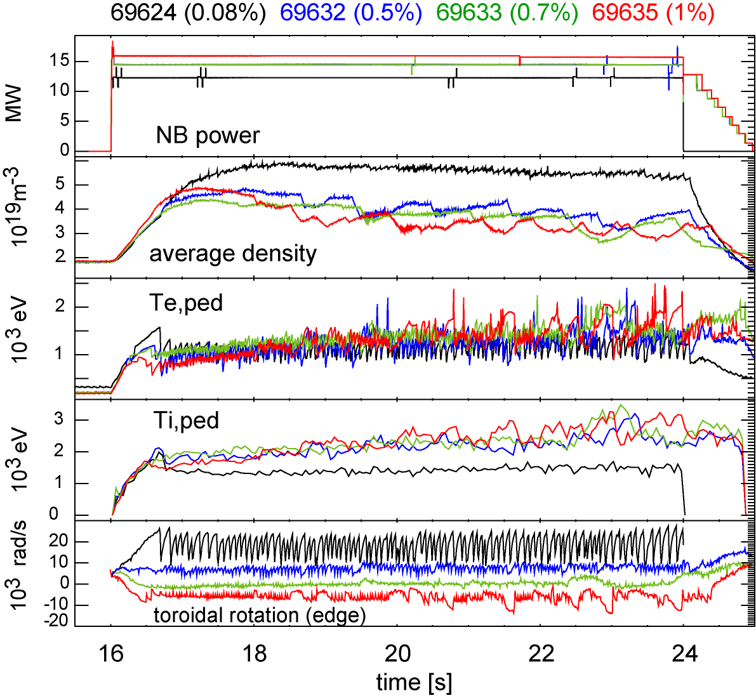suggests δB_{T} <0.5% in ITER à required to achieve Q_{DT}=10 goal & reduce uncertainty on confinement and plasma rotation extrapolations

Peter deVries (UKAEA) – TF ripple effects in JET ITB

Aberto Loarte - Transient energy fluxes in tokamaks : Physical processes and consequences for next step devices,
Advances in understanding ELM transient load physics:
Relation between ΔW_{ELM} and n_{ped}, T_{ped} and convection/conduction
ELM time for energy transport to divertor determined by high E sheath
ELM energy transport to main wall is determined by ion convection
ELM power deposition areas on PFCs & relation to ELM trigger
Despite this quantitative predictions of power fluxes in ITER have some uncertainty: ΔW_{ELM}, τ_{ELMMH}D, V_{rELM}(ΔW_{ELM})
Advances in understanding disruption transient loads:
Degradation of plasma confinement before thermal quench for resistive-MHD disruptions
Broadening of power footprint at thermal quench and influence of plasma movement for high β collapses on PFC loads
Correlation of plasma collapse behaviour and timescale for disruption fluxes to PFCs
Evaluation of radiative fluxes and asymmetries during current quench
Understanding of processes in disruptions much less advanced (physics & measurements intrinsic difficulties) à larger uncertainties in ITER

Diego del-Castillo-Negrete – Non-local transport

Yunfeng Liang – JET error field control of Type-I ELMs

R. Budny – Gyrokinetic sim’s of n_{e} fluct in JET & TFTR
Nonlinear GYRO runs with 3 kinc species to simulate reflectometry
Good agreement with data from TFTR supershots & JET L-mode

