Princeton Plasma Physics Laboratory
Procedure
Procedure Title:
Installation of the Midplane and Lower MGIs

Number:  D-NSTX-IP-3815 |  | Revision:  0 |  |  | Effective Date:  Expiration Date:  (3 yrs. unless otherwise stipulated)
Procedure Approvals
Author: Nicole Allen |  |  |  |  |  | Date
ATI: Joe Winston |  |  |  |  |  | Date
RLM: Brent Stratton |  |  |  |  |  | Date
Responsible Division: NSTX-U
Procedure Requirements
Designated by RLM
LABWIDE:
x | Work Planning Form # 2165 (ENG-032) |  |  | Lockout/Tagout (ESH-016)
 | Confined Space Permit (5008, Sec 8, Chap. 5) |  |  | Lift Procedure (ES-MECH-007)
 | Master Equip. List Mod (GEN-005)) |  | x | ES&H Review (NEPA, IH, etc.)
 | RWP (HP-OP-20) |  |  | Independent Review
 | ATI Walkdown |  | x | Pre-Job Brief
x | Post-job Brief |  |  | Hazard Analysis
 | Run Copy Required (performance of procedure must be documented and archived per ENG-030 page 10) |  |  | Special archiving requested for completed Run Copies:
D-SITE SPECIFIC:
x | D-Site Work Permit (OP-AD-09) |  |  | Door Permit (OP-G-93)
 | Work on Tritium Contaminated Sys. (OP-AD-77) |  |  | Activity Certification Committee Review
x | Pre-Job Brief (OP-AD-79) |  |  | T-Mod (OP-AD-03)

REVIEWERS (designated by RLM)
Accountable Technical Individual J. Winston
Test Director
Independent Reviewer
D-Site Shift Supervisor
NSTX E. Perry, M. Cropper
Work Control Center D. McBride, F. Jones
Vacuum
Computer
Tritium
Quality Assurance/Quality Control J. Boscoe
AC Power
Maintenance and Operations Division
Energy Conversion System/Motor Control System
Engineering N. Allen
Environmental Restoration & Waste Management Division
Water
Neutral Beam Heating (Heating Systems Branch of Electrical Engineering)
Radiofrequency (Heating Systems Branch of Electrical Engineering)
RF
Diagnostics R.Raman, R. Ellis
Environmental, Safety, & Health W.Slavin

TRAINING (designated by RLM)
No training required ___________ | Instructor _____________________________
Personnel (group, job title or individual name) |  | Read Only* | Instruction | Hands On
Lead Tech |  |  | ✓
Technicians Performing Task |  |  | ✓
NSTX Field Supervisors |  |  | ✓
NSTX Construction Manager |  | ✓
QC |  |  | ✓
RLM
*”Read Only” training for Administrative, Alarm Response, and Emergency Operations procedures must be documented on a Record of Training form (attachment 6). The completed Run Copy will serve as the documentation of “Read Only” training for all other types of procedures.

Purpose:

This procedure provides instructions for the installation at Bay “I” of the midplane Massive Gas Injection (MGI) Valve, its support bracket, and the vacuum piping between the injection valve and the TIV. This procedure also provides information and guidance on how to execute the job safely and efficiently. It also covers the installation of the lower MGI valve, spool and support on the lower umbrella.

scope

Complete this procedure using the following cost center: 1101 **** MGI1

The procedure covers the installation of the Bay “I” midplane MGI valve, support brackets and vacuum piping to the TIV. It also covers he installation of the lower MGI valve and support bracket.

references

Drawing No. E-EA3503: Mid- Plane MGI System Weldments & Details

Drawing No. E-EA3504: Lower & Mid- Plane MGI System Details

Drawing No. E-EA3506: MGI Valve Adapter Spool Piece

Drawing No. A-EA3507: Custom Flange

Drawing No. A-EA3508-2: Bolt Insulator B

Drawing No. E-EA3511: Lower MGI Assembly

Drawing No. E-EA3512: Mid-Plane MGI Assembly and Installation

Drawing No. E-EA3530: Mid- Plane MGI Valve Support Bracket Assembly

Drawing No. E-EA3534: Mid- Plane MGI Valve Miscellaneous Part Details

precautions

Individuals are not permitted to lift more than 50 lbs. at any one time. If an object weighs in excess of 50 lbs., then it shall be lifted by more than one individual, or with the aid of mechanical system(s).

An approved method of fall protection shall be established for individuals working at elevated positions.

Use appropriate PPE (per JHA) and or per guidance from Industrial Hygiene.

Before removal Health Physics shall survey all materials that were in the test cell during the last run of NSTX or any material or tools left in the test cell overnight.

prerequisites

The workers and ATI have reviewed the Job Hazard Analysis for this job.

_______________________
ATI

Work Control Center (WCC) has logged in this procedure and has approved the work package. Under no circumstances should the work proceed without the approved “blue or yellow folder” from the WCC.

_______________________
ATI

A Pre-job Briefing must be completed prior to work starting. The only personnel allowed to work under this procedure are those that attend this briefing.

Completed: __________________________ Date: __________

ATI

A hi-pot to 9kV between the midplane MGI valve and its spool assembly E-EA3511-8, E-EA3506-01 is required prior to installation. The hi-pot may be performed on the bench.

A hi-pot to 9 kV between the lower MGI valve and its spool assembly E-EA3511-8, E-EA3506-01, E-EA3504-02, and also between the lower MGI valve and its support bracket E-EA3511-6, is required prior to final installation.

PROCEDURE

Place the G10 bracket (E-EA3512-8, E-EA3530-01) on the 109” platform on the drawing E-EA3512. Leave its mounting bolts and nuts finger tight.

Challenge the TIV where the MGI piping will be connected.

Leak Tight.
Lead Machine Tech:______________

Remove the blank off flange from the TIV.

Attach the mid-plane straight feed tube weldment (E-EA3503-02) to flange on the TIV. Torque bolts to 8 ft-lbs.

Attach the mid-plane MGI 90 degree elbow 1” pipe stub weldment (E-EA3503-01) to the straight feed tube weldment (E-EA3503-02). Leave the bolts finger tight.

Attach the midplane MGI valve feed tube weldment (E-EA3512-3, E-EA3504-03) to the 90 degree E-EA3503-01 as shown on drawing E-EA3512.

Attach Pneumatic gate valve E-EA3512-5 and 90 degree elbow E-EA3512-4 according to drawing E-EA3512.

Attach the midplane MGI valve/spool assembly to the support bracket E-EA3512-8, and connect the vacuum flange to the elbow E-EA3512-4.

Gradually tighten all flange bolts. Shim as required under the support bracket E-EA3512-8 so that the bellows E-EA3504-3 is unstressed.

Torque vacuum flange bolts to 8 Ft-lbs.

Lock the gate valve E-EA312-5 open.

Pump out and leak check.

The midplane assembly is now ready for the TIV to be opened.

Bring the lower MGI valve/spool/bracket assembly (E-EA3511-1,2,6,8) to the 100 ft level, below the MGI TIV as shown on E-EA3511. Hold in position and mark the location for the mounting studs E-EA3511-4.

Remove the valve/spool/bracket assembly and weld the 4 3/8-16 studs E-EA3502-10 to the umbrella. Inspect the stud welds.

Install the valve/spool/bracket assembly. Gradually tighten the bolts and nuts on the vacuum flange and the mounting studs, shimming the bracket as necessary.

Pump out and leak check.
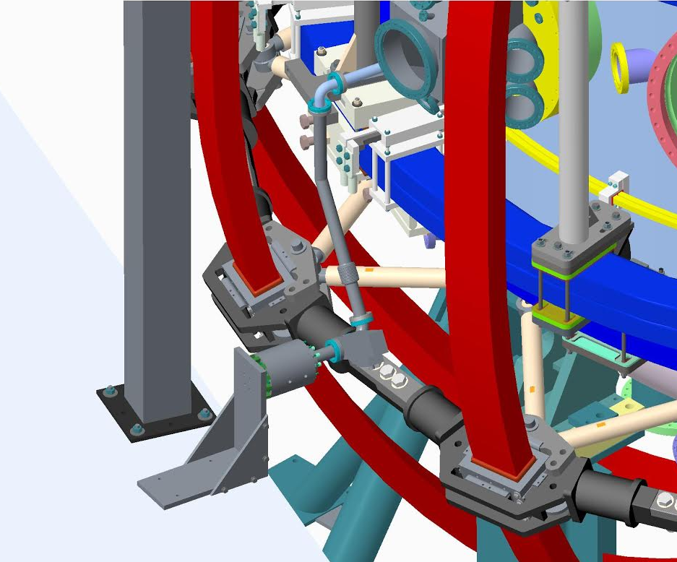

final conditions

Completion signoff
This procedure and post job brief has been completed and verified by the signatures below.

Lead Technician
 | Signature |  | Date
ATI
 | Signature |  | Date
QA/QC Representative
 | Signature |  | Date
Field Supervisor
 | Signature |  | Date

Return this completed procedure to the Work Control Center

Comments:

Note: The run copy of this procedure shall be returned to the operations center upon completion

