71-030211-CLN-01

TO: DISTRIBUTION
FROM: C NEUMEYER
SUBJECT: RESISTIVE WALL MODE SYSTEM SCOPING STUDY
Reference: 72-030123-JM-01 “Preliminary Requirements For NSTX Resistive Wall Mode And Error Field Feedback Coils And Power Supplies”, J. Menard, S. Sabbagh

Summary

The purpose of this memo is to 1) identify the design issues, 2) develop the design concepts and 3) outline the tasks related to the implementation of a Resistive Wall Mode (RWM) and error field correction system on NSTX.

Since a GA/PPPL collaboration has already deployed an RWM system on DIIID it is advantageous for NSTX to build upon this experience and utilize coil and power supply concepts already developed. Therefore a starting point for this study is to determine to what extent the GA coil and power supply designs can be adopted for NSTX duty.

It is concluded herein that the DIIID internal coil design can be adopted on NSTX, but there are many challenges to in-vessel installation. As an alternative, external coils can formed from power cables (preferably 2 turns), but installation will again be challenging due to small available space and many obstructions. Further study is necessary to 1) quantify the performance difference (VALEN code) and 2) quantify the cost/schedule difference between internal and external coils. The information contained herein should provide the necessary input to these steps.

The Robicon Switching Power Amplifiers (SPAs) used by GA appear to be suitable for the NSTX application. However, one or more DC source power supplies need to be identified. The PPPL Transrex power supplies could be used, but their voltage does not match. The cost of procuring new DC source power supplies needs to be traded off against the cost of modifying one or more Transrex supplies to run at a lower voltage. It does appear that the SPAs and DC source supplies can be installed at FCPC without excessive DC line impedance. However, this needs to be confirmed.

More effort is required to estimate the costs. However, some information is already in hand regarding the cost of the main components, namely the coil and power supplies. Based on the GA experience the GA style coils, assembled in-vessel, would cost $100K-$150K per coil, so 6 coils would cost $600K-$900K. If they could be assembled ex-vessel and passed through a port then the cost could be significantly less, but this needs to be determined. External coils formed from cable would be less expensive, but their performance and feasibility needs to be demonstrated.
The GA style SPA costs approximately $150K. If a new DC source power supply is required, then the cost of one 1.5MW unit which would feed one SPA would be of order $175K. For the SPA/DC source combination, ultimately three units would be required, but initial operations could commence with one unit. So, the initial cost for the power supplies, might be of order $325K, and for the final system, $975K.

It must be kept in mind that the above costs are only those of the main components. There will be other costs associated with other components and the overall system integration.

Follow-on work outlined in this memo aims to develop a design concept and cost estimate for the entire system.

Requirements

Per the reference memo and discussions with J. Menard et al the proposed NSTX system requirements are summarized in the following table.

RWM System Requirements Summary
Number of Coils | 6
Coil Location | Centered about midplane
Coil Connections | Diametrically opposite coils connected in anti-series forming 3 independently controllable circuits
Coil height | Approximately equal to gap between passive plates ~ 1 m.
DC Field at r=R0+0.6*a | 50 gauss
AC Field at 1kHz, r=R0+0.6*a | 10 gauss
Maximum Ripple | +/- 2% of full load DC
Pulse Length | 5 sec
Repetition Period | 300 sec

GA RWM System

Coil Systems

GA started their RWM experimental program with a coil system consisting of a set of 6 external coils centered about the mid-plane. The coils were wound using 4 turns of 750MCM cable carrying up to 5kA for 10s. These were designed to produce 30 gauss at the plasma edge. They were located at approximately R=2.56m, or 0.22m from the plasma edge. See figure 1. Note the support scheme, including the struts mounted off of the VV on the right hand side of the figure.

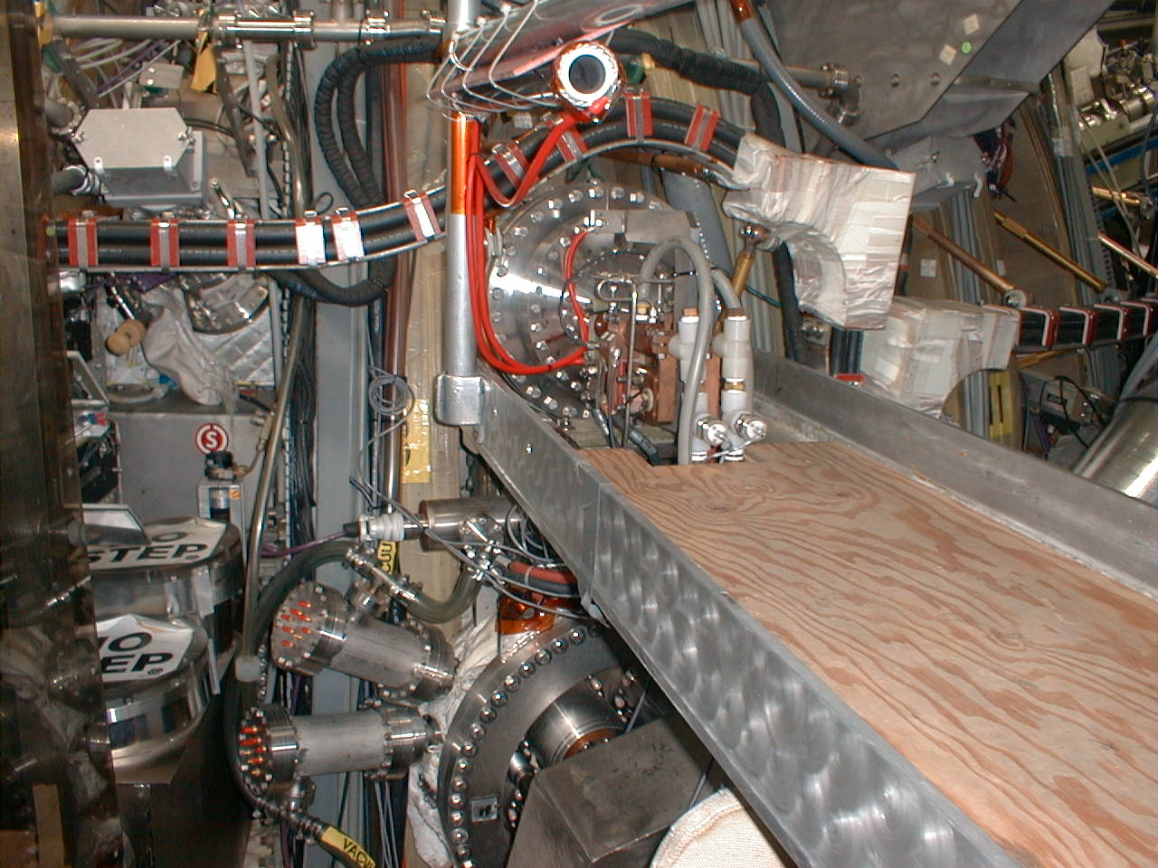
Figure 1 – DIIID External Coils

More recently an internal coil system has been added which consists of 12 coils, 6 above and 6 below midplane. See figure 2.

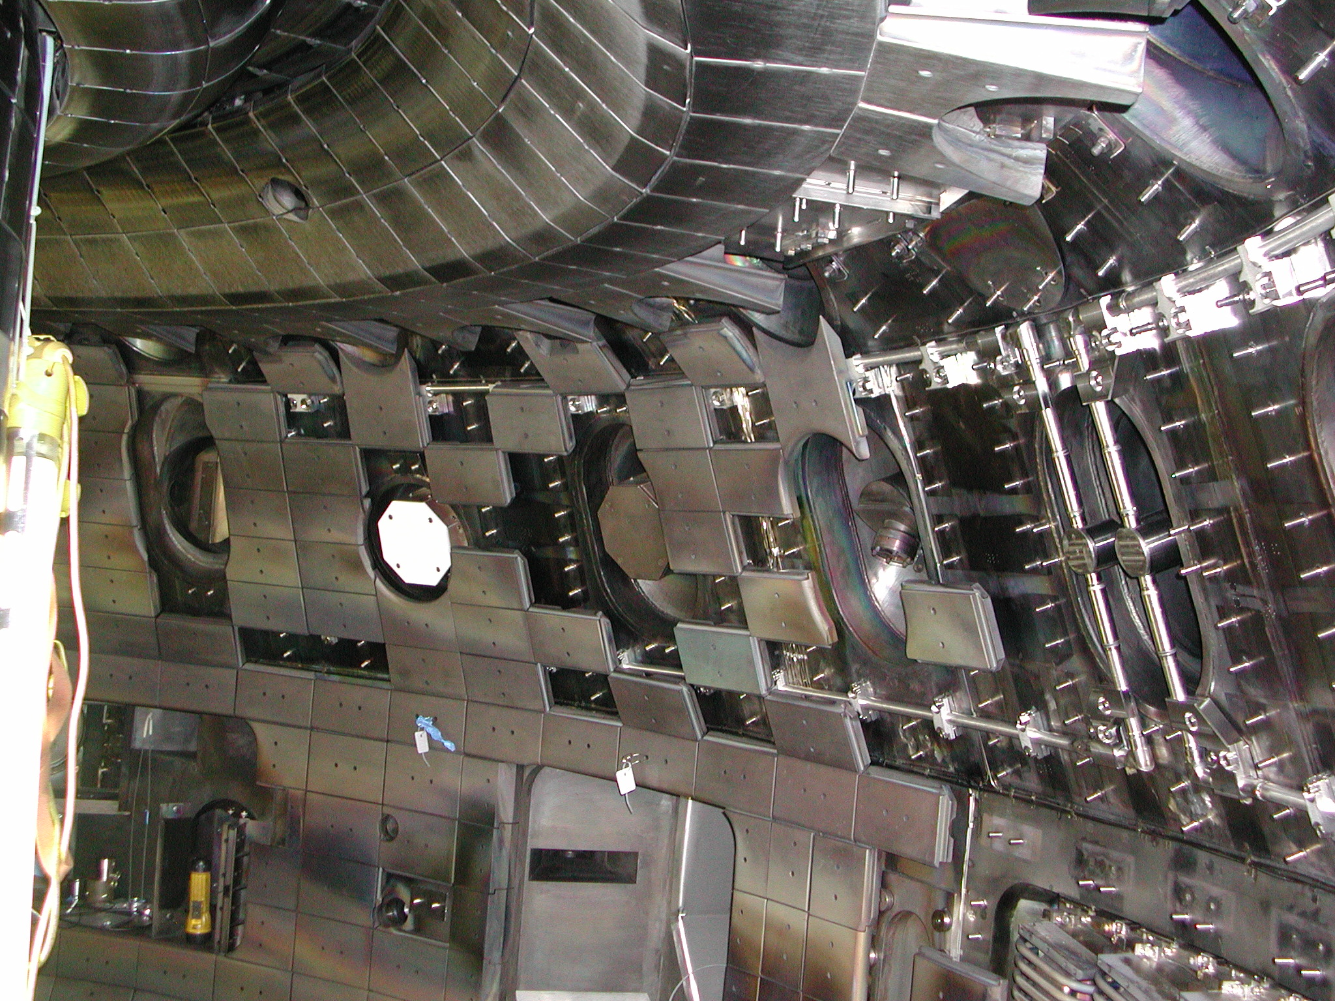
Figure 2 – DIIID Internal Coils

The coils are approx. 0.5 m tall by 2.0 meter wide, single turn water cooled tubular copper conductors (14.4mm OD, 8.6mm ID) wrapped with one half-lapped layer of polyamide (0.5mm (0.002”) thickness Kapton) insulation, a 1.7 mm thick Vespel spacer, and an additional layer of Kapton tape, all encased in a 304SS tube (19mm OD). The coils are capable of 7kA continuous with 5.5m/sec water cooling. Because a fully assembled coil cannot be passed into the vessel, the coil is fabricated outside the vessel in three pieces; a lower conductor assembly, an upper conductor assembly and a 35 mm diameter concentric lead assembly. Leads are brought out from two coils at a time through 10” diameter openings.

The design requires in-vessel joining of copper with three induction brazes and six orbital welds of the stainless vacuum jacket. The coils are installed under PFC tiles and are baked to 350°C. The design provides a double barrier of copper and stainless steel against water leakage into the machine. In order to detect water leaks in the copper or leaks through the stainless into the vessel, the insulation space is sealed in two places outside the vessel using machined polyamide and “O” rings. During the initial bake of the vessel, this space is vacuum pumped to remove moisture and gases that evolve. After cool down, dry nitrogen gas is back filled to about 0.7 bar, and sealed off. The pressure in this trapped volume is monitored to detect either water leaks through the copper (higher pressure) or stainless sheath leaks to the vacuum (lower pressure). During vessel baking, the cooling water in the coils is replaced with dry nitrogen in order to limit oxidization of the copper.

An extensive R&D program was conducted in ’00 and ’01 which led to the installation of two prototype coils in DIIID. After their removal they were hipot tested (to destruction) and found to withstand 5kV.

The 12 production coils were fabricated during the first 6 months of ’02 and then installed during a 3 month opening. So far there have been no leaks or any other problems with the coils.

The total cost associated with the fabrication and installation of the 12 production coils was $2M, most of which was for labor costs. However this figure includes costs for a significant amount of PFC tile removal, modification, and re-installation, along with the relocation and replacement of some magnetic diagnostics. So the cost associated with the coils themselves was perhaps of the order of $1.5-$1.8M or approx. $100K-$150K per coil.

If NSTX elects to install internal coils, the GA design could be adapted, taking advantage of their prior R&D and experience. Furthermore the coils could be fabricated by GA and they could lead in the installation task, especially the in-vessel brazing and welding operation. In fact the NSTX installation would be simpler and less demanding due to the lower bakeout requirement (the coils would be attached to the vessel wall at 150°C), simpler geometry (the coils on the mid-plane would conform to the cylindrical shape of the vessel), and lower fields (and forces). It may be possible to install the coils through Bay K on NSTX (future NBI port) and avoid much of the in-vessel fabrication, which would be a great simplification. Similarly, if the coils were installed during a center stack removal then would be possible to pass them into the vessel via the opening at the top of NSTX. One additional challenge presented by NSTX is the CHI operation which places a 1kV bias on center stack casing. But part of the voltage can appear on the resistive grounded outer VV. So RWM coils mounted on the outer VV of NSTX should be designed for a hipot of 2*1+1=3kV. GA tests of their insulation scheme, to destruction, indicate a dielectric strength of 5kV.

Power Supplies

The power supplies consist of two parts, a rectifier DC source and an IGBT chopper “Switching Power Amplifier” (SPA). One DC source can be connected to supply one or more SPA units.

The SPA choppers are subdivided into three parallel modules which can be controlled separately and connected to three independent loads or combined in parallel to drive one load. The DC inputs to the three chopper modules are connected in parallel, and each to chopper module input includes an input filter capacitor and output filter inductor. See figure 3.

Figure 3 – DIIID DC Supply and SPA Configuration

The SPAs were specified and procured by PPPL and manufactured by Robicon. Cost per SPA is of order $150K. The DC source supplies were obtained from LLNL surplus. SPA characteristics are given in the following table.

Pulse Current per Module | 1.667kA
Pulse Current (3 parallel module) | 5kA
Pulse Duration | 10 sec
Pulse Period | 180 sec
Input Voltage | 300Vdc
Switching Frequency | 3.5kHz (first version)  7.0kHz (second version)
Input Filter Capacitance (3 parallel module) | 0.2835 millifarad, 800V
Output Filter Inductor (per module) | 11 microhenry
Output Filter Inductor (3 parallel module) | 3.67 microhenry
Cabinet Footprint Dimensions | 6’ wide x 6’ deep x 8’ tall

The SPA IGBTs consist, in each bridge arm, 2 parallel IGBT devices (EUPEC 400A/1200V).

If NSTX elects to procure the same SPA units then there is a possibility that they could be operated at a somewhat higher voltage. The 300Vdc number probably originated from the surplus LLNL supplies. The IGBTs and caps can probably operate a bit higher.

For the DC source, it may be possible to utilize PPPL Transrex rectifiers which at present produce a DC voltage of 1012.85Vdc at alpha=0. It would be necessary to either supply the Transrex units with a lower AC input voltage (e.g. 4.16kV would yield approx. 300Vdc) or control them to a lower voltage with suitable accessories to prevent overvoltage. Alternativly, new DC source power supplies could be procured or obtained from surplus TBD.

Analysis of Implementation Options

A spreadsheet analysis was performed for several NSTX design options. This was helpful in identifying the issues. The GA internal and external coil designs were also analyzed so as to provide a benchmark.

The complexities of the magnetics (mutual coupling to VV and resultant eddy current effects) were not included in the model. However, skin effect was accounted for. In arriving at the results in the GA cases, the physical dimensions, circuit resistances and inductances, including choke values, were based on information extracted from several GA publications^{1,2},. In the NSTX cases the choke value was chosen so as to limit the peak-to-peak ripple to 4% of the total amp-turns.

The following table provides a summary of the cases studied.

 | GA  Internal  Coil | GA  External  Coil | NSTX  Internal  Coil | NSTX External  Coil | NSTX External  Coil
#Turns | 1 | 4 | 1 | 1 | 2
Peak DC Current | 5kA/5kA-turn | 5kA/20kA-turn | 5kA/5kA-turn | 5kA/5kA-turn | 5kA/10kA-turn
Rcoil | R0+a=2.34m (note 1) | 2.56m | 1.68m (5/8” inside VV wall) | 1.85m (6” outside VV wall) | 1.85m
dZcoil | 1.02m | 1.6m | 1.0m | 1.0m | 1.0m
Rpoint (target for field) | R0+0.6*a=2.07m | 2.07m | R0+0.6*a=1.26m | 1.26m | 1.26m
Br @ Rpoint (note 2) | 9.6e-3 gauss/amp-turn | 6.65e-3 gauss/amp-turn | 9.05e-3 gauss/amp-turn | 6.98e-3 gauss/amp-turn | 6.98e-3 gauss/amp-turn
Br @ Rpoint @ Peak DC Curr | 48.1 gauss | 133.0 gauss | 45.2 gauss | 34.9 gauss | 69.8 gauss
Br @ Rpoint @ 1kHz | 4.8 gauss | 1.1 gauss | 6.3 gauss | 4.9 gauss | 4.9 gauss
Coil Conductor | GA | 750MCM cable | GA | 500MCM cable | 250MCM cable
Coil Impedance | Rdc=1.33mΩ  L=6.6µH | Rdc=1.64mΩ  L=128µH | Rdc=1.1mΩ  L=5.1µH | Rdc=0.5mΩ  L=5.25µH | Rdc=1.86mΩ  L=22.6µH
#Series Coils | 2 | 2 | 2 | 2 | 2
DC Feed Cable | Rdc=6.3mΩ  L=32.8µH | Rdc=6.3mΩ L=32.8µH | 2x250’ 500MCM cable  Rdc=35.1mΩ  L=56.3µH | 2x250’ 500MCM cable Rdc=35.1mΩ  L=56.3µH | 2x250’ 500MCM cable Rdc=35.1mΩ  L=56.3µH
SPA Switching Frequency | 3.5kHz | 3.5kHz | 7.0kHz | 7.0kHz | 7.0kHz
SPA Voltage | 300V | 300V | 300V | 300V | 300V
Lchoke | 50µH | 0 | 1.4µH | 1.2µH | 0
Peak-peak ripple (note 3) | 5.7%/  2.8gauss | 1.9%/  2.5gauss | 4.0%/  1.8gauss | 4.0%/  1.4gauss | 4.0%/  2.8gauss
Notes:
- GA Internal coils consist of 2 sets, one above and one below mid. This radius chosen to simulate such coils using 1 set centered about the mid-plane.
- Br estimated based on planar, anti-series coil pair
- % based on amp-turns

The following curves depict the dependence of current, field, and pulse length on frequency for the various cases, considering the variation in inductive impedance as well as the skin effect on resistance.

Figure 4 – Available Peak Current (amp-turns) vs. Frequency

Figure 5 – Radial Field vs. Frequency

Figure 6 – Available Equivalent Square Wave vs. Frequency for Cable Formed Coils

Based on the analysis performed, the following observations are made.

1 – All of the designs come close to meeting the requirement for 50 gauss under DC conditions. However they all fall short of the requirement for 10 gauss at 1kHz, even with the simple model used which does not simulate the demagnetizing effect of the eddy currents in the VV. It appears that 10 gauss is only available up to around 500Hz.

2 – The necessity of the additional choke, and higher switching frequency for the new GA internal coils so as to keep the ripple down, appears evident.

3 – At least for the simple model used herein, the ripple requirement dictates the minimum allowable circuit inductance for a given driving voltage. This imposes, therefore, a fundamental limit on system performance. It may actually be advantageous to reduce the base DC voltage (nominally 300 volts) under certain conditions to reduce the ripple.

4 – The effect of the VV is probably very important in determining the ripple response. Considering that the NSTX VV is 5/8” (0.625”) thick 304SS, and the skin depth at 1kHz is only 0.550” in 304SS (resistivity = 7.7e-7 ohm-m), the VV may serve as an effective ripple filter, reducing or eliminating the need for external inductance (choke).

5 – If the VV does serve effectively as a ripple filter, then the noise pick-up on in-VV magnetic diagnostics would be reduced in the case of external RWM coils.

6 – For NSTX, it would appear that the resistive and inductive impedance of a cable run from the NTC to FCPC, assumed here to be 250’, can be tolerated, allowing the equipment to be installed at FCPC. If closer study finds too small a margin in this regard, perhaps the DC source voltage can be increased above 300V to compensate.

7 – For the cable formed coils (the GA external coil from 4 turns @ 750MCM, the NSTX external coil from 2 turns @ 250MCM, the NSTX coil from 1 turn @ 500MCM) the available pulse length (equivalent square wave) is a function of frequency. For the 500MCM and 750MCM conductors, the allowable pulse length at peak DC current exceeds 5 seconds with a 300 second repetition rate (rated NSTX pulse length and duty factor). However, if a 250MCM cable is used (e.g. to conserve space and allow a 2 turn external coil to be formed) then the pulse length at the low end of the frequency range would be less than 5 seconds as shown in figure 6.

8 – Since the water cooled GA conductor is designed for 7kA continuous then, as long as the DC feeds, etc., are 500MCM or larger, then the RWM could run at rated current for the full 5 second pulse.

9 – The net field available from 3 coil pairs will be higher than that available from one. Figure 7 shows the spatial variation of Br (at r=R0+0.6*a) on the mid-plane for the case of the 1 turn NSTX external coil when all three coil pairs are identically operated. The ratio of multi-coil to single coil field in this case is 2.37.

Figure 7 – Spatial Variation of Br at r=R0+0.6*a on Midplane for 1T External Coil

Installation Issues

Installation of either internal or external coils on NSTX will be extremely challenging due to the limited space.

Internal Coils

Since there are 6 coils there will be pairs of vertical limbs every 60 degrees in the toroidal direction. Since the NSTX RF antennae span a 90 degree sector (associated with ports C, D, and E), there must be two passages of vertical limbs in the antenna region. As can be seen in Figure 8 there is insufficient room to pass the vertical limbs in the gaps between the faraday shields and boron nitride shields. There is a gap, however, of order 3/4" between the inner wall of the VV and the boron nitride mounting plate, on the outboard side of the box (note gap on left side of figure 8). This gap could be increased by perhaps 1/4" by removing some of the material on the mounting plate. If the conductor (assume GA conductor 19mm dia, approx 3/4") was routed in this location then the current center would be, at best, 3/4"+1/4"-(3/4")/2 = 5/8" from the inside edge of the wall. The edge of the conductor would be 1/4" from the wall.
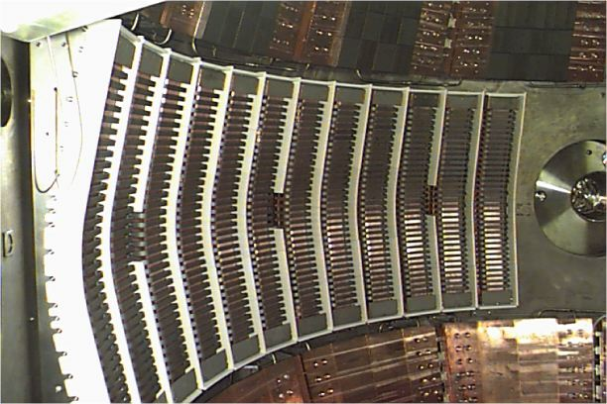

Figure 8 – NSTX RF Antenna Assembly

Another potential interference exists with the NBI protective plates which are centered at port H. See figure 9.

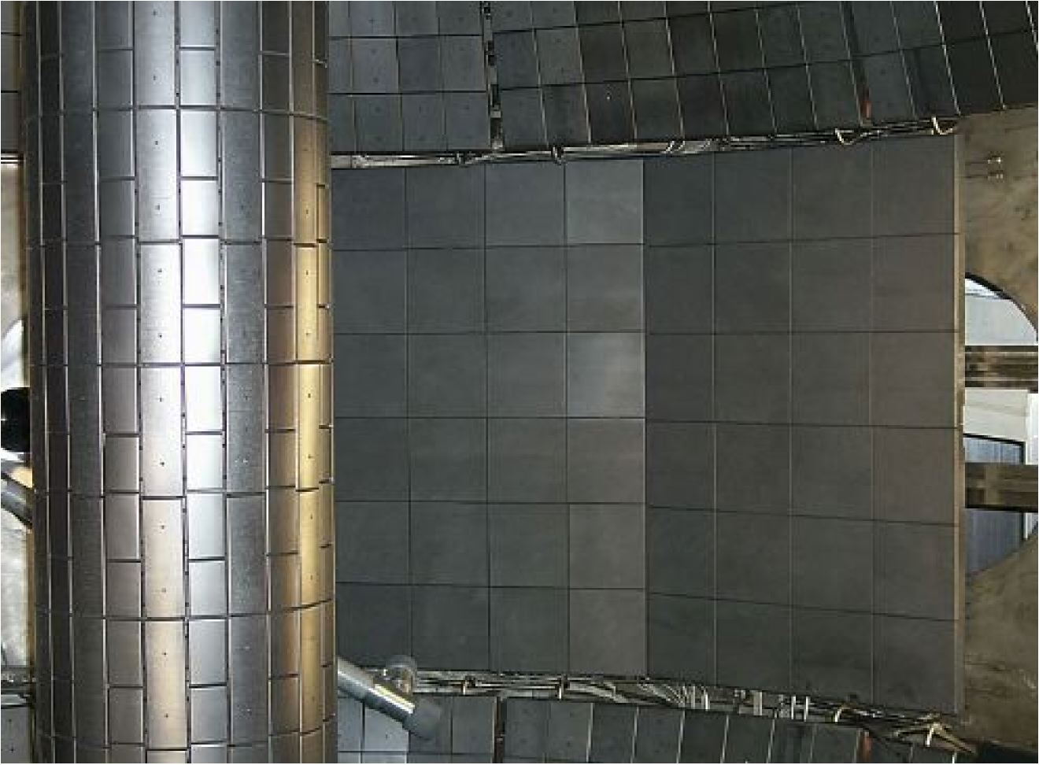
Figure 8 – NSTX NBI Protective Plates

These plates consist of 1" graphite tiles attached to 0.5" SS backing plates. There are four plates (2 x 2) ~20" high by 26" wide. The radial gap to the VV wall is estimated by D. Loesser to range from 2.5-4.0".

Finally, there may be interferences with the heating/cooling tubing associated with the passive plate sytem.

Based on these considerations it seems that the best orientation for the RWM coils would be 6 spans as follows: B-D, D-F, F-H, H-J, J-L, L-B. Coil leads would, presumably, be brought out via penetrations in existing port covers. But it is concievable that new penetrations could be created, e.g. on the midplane in the gap between existing midplane ports.

The feasibility of in-VV coil installation needs to be confirmed, and the extent of tasks (e.g. modifying/relocating other parts) needs to be quantified.

External Coils

An external coil system could be installed using the route presently taken by the locked mode sensor coils. The horizonal limbs of the coils would follow the bore of the PF5 coils and could be supported from same. The vertical limbs could perhaps use the PF5 U/L support struts for mechanical support. However, the space is extremly tight and congested. It is unlikely that an ideal picture frame shape could be realized. The effect of non-ideal coil configuration would need to be addressed. Because of the superior performance, a 2 turn system would be preferred, if it can fit. The coils would be formed using 250MCM, 600V power cable which has an OD of 0.92 inches and a minimum bend radius of 4*0.92=3.6”.

Coil Supports

The RWM coils, whether inside or outside the VV, will experience EM forces due to interaction with the TF, and the poloidal field from the PF coils and plasma. The forces need to be calculated and the support system designed accordingly.

Power Supplies

It appears that the inductance and resistance of a 500MCM cable run from FCPC to the NTC, assumed 250’, is tolerable in terms of circuit performance. This means that the SPA and DC source power supplies could be located in FCPC. On the other hand, the SPA power supplies could be located in the NBPC building at the present location of the workshop mezzanine. The cable run exposed to the high frequency current would then be reduced to perhaps 100’. However it is likely that the DC source power supplies need to be located at FCPC due to the high AC power input (3*5kA*0.3kV=4.5MW) and the possibility of use of one or more of the Transrex units.

Implementation Plan

NSTX Physics would like, ideally, to install the RWM system during the summer ’03 opening. This of course depends on funding availability, and feasibility of completing the work during the available time (the in-VV coils may prove impossible because of this). To reduce initial cost impact, the power supply system should be divided into two stages. The first consisting of one SPA and one DC source power supply, and the second stage adding two more SPA units and, if necessary, two more DC source units.

Job Planning

In order to develop a plan for the job, cost and schedule estimates need to be performed. The following table lists the tasks to be performed, along with proposed assignments. It would be highly desirable to develop an estimate by March 15, 2003. The estimate should include M&S, labor, and minimum calendar time to accomplish each task.

Task | Assignment
Compare performance of in-VV vs. ex-VV (1T and 2T) coils, including power supply response model | J Bialek
Estimate forces on coils | C Neumeyer
Assess feasibility and cost of in-VV coils | L Dudek
a. Interference with RF antenna system
b. Interference with NBI protective plate
c. Interference with passive plate cooling lines
d. Attachment technique
e. Lead penetrations
f. Fabrication/assembly tasks (can coils be passed through bay K, other modifications/interferences)
Estimate costs to fabricate in-VV coils | P Anderson (GA)
Assess feasibility and cost of ex-VV coils (preferrably 2T) | G Labik
a. Routing
b. Method of support
c. Extent of deviation from ideal rectangular shape
Develop concept for power supply design | S Ramakrishnan
a. Identify DC source
b. Select location(s) for SPA and DC source(s)
c. Develop design of DC circuit including cable runs, disconnect/grounding switches
d. Develop protection/interlock design
Model power supply performance using PSCAD, include model of coupling to VV | R Hatcher
Develop concept for control system (interface with existing Sky PSRTC/PCS) | R Marsala

cc: T Egebo J Menard M Ono M Peng
A Von Halle M Williams

“Resistive Wall Mode Feedback System on DIIID”, J. Scoville et al, 18th SOFE, Albuquerque, Oct. 1999
“Design, Fabrication, Installation and Testing of In-Vessel Control Coils for DIIID”, P. Anderson et al, 22nd SOFT, Helsinki, Sept 2002
Operating & Maintenance Manual, PU PO#S-04108-G, Robicon SO#1-64739
“Modeling and Design of A Resistive Wall Mode Stabilization System with Internal Field Coils In DIIID”, G. Jackson et al, 44th APS, Orlando, Nov. 2002

