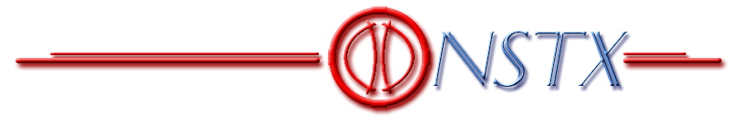

NSTX TF Flag Joint

Chit Resolution Document

Resolution of Chits from
April 10, 2003 Design Review

July 31, 2003

Cognizent Engineer:

C Neumeyer

Responsible Line Manager:

A. Von Halle

Appendix 1 of this document lists the content of the original chits and indicates how they have been condensed into “super chits”. These super chits contain the intent of the originals but eliminate duplication and exclude those which were not accepted by the review committee, as well as those which referred to the e-beam welded joint design which has been dropped since the original review.

The original chits are included as Appendix 2 to this document.

The resolution of the super chits is given in the following sections.

SuperChit #1 (ref. Chit #2) (J Chrzanowski)

Suggest measuring current TF coil surfaces to determine parallelness for attachment of new centerpost. This should verify if 0.010” requirement for stainless steel cans on flags is adequate.

The Project elected not to take measurements of the original center stack. Due to the significant rework of these surfaces, their present condition does not represent achievable tolerances.

However, the following points are noted with regard to the tolerance issues.

Concerning tolerance errors in the poloidal direction, these will arise mainly from errors in the machining of the conductor and flag faces. The allowable error, as specified on the drawings and inspected for during QC at the manufacturer, is 0.003” from perpendicularity. Even with worst case error on both parts, a 0.006”error would result in the potting thickness reduction of only 0.012” out of 0.125” nominal.

Accuracy in the toroidal direction will be dominated by the fixturing which holds the conductor ends axisymmetric during the molding process, for which the tolerance is 0.25º. This angle error would result in a potting thickness reduction of 0.044” out of the 0.125” nominal. However, to accommodate this error, oversize holes are provided on the hub disk where the box bolts (actually studs) are engaged. The holes are dimensioned 1/16” over which allows +/-0.032”. Therefore the maximum error to be taken by potting thickness reduction would be 0.048”- 0.032”=0.016” out of 0.125”.

SuperChit #2 (ref. Chit #3) (C Neumeyer)

Can the proposed voltage tap pick up a locally high contact resistance at the far corner where the current wants to flow?

Sensitivity to locally high contact resistance was examined using ANSYS FEA (ref. NSTX-CALC-13-21, “TF Joint Voltage vs. Contact Resistivity”). Results are given in the following two figures, which show the difference in voltage probe measurement as a function of nominal contact resistivity for between a joint with constant contact resistivity and one where the corner region of the joint is at 1.1x and 2x nominal resistivity, for various lengths extending beyond the corner (0 length corresponding to no abnormal region at all).

Tests are underway to quantify the resolution the joint resistance measurement system which is being designed to measure joint voltage drop while 200A is injected through the TF coil system during maintenance. This measurement is challenging, due to the low voltage and various effects such as thermoelectric potentials in the wiring, bulk resistance changes in copper resistivity vs. temperature, etc.. We expect to experience nominal joint contact resistivity on the order of 2 micro-ohm-in² or less, in which case the typical joint voltage drop at 200A should be of order 100 microvolt. Based on preliminary results, however, it is expected that the system will be able to resolve down to 5microvolt or better. On this basis, from the above two figures, 110% resistivity regions in the corner of the joint will be marginally detectable, but 200% abnormalities will be easily detected.

SuperChit #3 (ref. Chits #4,8,12,16,20,21,23,28,30,45) (I Zatz)

Concerning the analysis:

- add the upper tier flag/hub assembly to the model
- include sliding with friction in the flag-to-box interface
- add out-of-plane loads to the model
- calculate design margins for all of the load bearing components based on bracketing conditions of friction coefficient and temperature (SOFT/EOFT), and preload
- express contact pressure safety margin as (contact pressure)/(required contact pressure)
- is the design able to withstand cases where 2 of 3 load paths are functional?
- Will cyclic loading cause the flag to “walk” upwards with increasing load applied to the shear shoe?

All of the above points have been addressed in the FEA model, and will be reported on under separate cover.

The finite element analyses indicate that the inner NSTX flag will slip vertically and butt up against the shear key when subjected to full EM loads. Slip occurs when the vertical component of the EM load overcomes the friction forces due to bolt pre-load. This slip is measured by the analyses to be less than a mil. The initial condition is assumed to be that the flag is in contact with the shear key. Since all structural components are assumed to behave elastically (stresses are well within material allowables), it can be assumed that the shear key will 'push' the flag back into its original position after each pulse. Each shear key acts as a stiff spring which is held in place by two pre-loaded bolts. Unless the shear key or the copper it bears against suffers a permanent deformation, this elastic spring behavior should act as an effective means to keep the flag in place from load cycle to load cycle.

SuperChit #4 (ref. Chit #4) (M Kalish)

How are the allowables for the hub/center stack connection (wet lay-up) derived from the test data?

Shear test samples were designed to have the same axial dimension and radial thicknesses (Scotchply and wet lay-up) as the actual collar. FEA was performed using ANSYS to determine the peak to average stress ratio in the wet lay-up. Results are shown in the following figures.

FEA Model

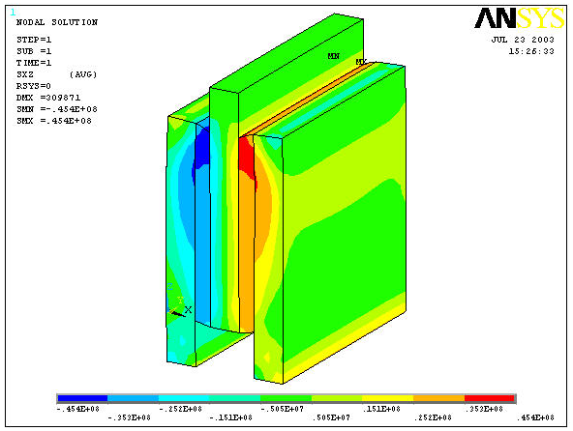
Distribution of Shear Stress (xz): max= 45.4MPa (6.6ksi)

This results shows that the ratio of peak to average shear stress is 6.6/4=1.65 for this configuration. Therefore, when calculating safety factors based on the test data results, the failure stress is interpreted to be 1.65 times the average. This failure stress can be compared directly to the peak stresses predicted by the overall joint FEA.

Additional tests were performed to determine the effect of normal compression on strength. To account for compression, the following model was used…

$$s_{\text{failure}}=s_{0}+k_{N}s_{N}$$
where:

σ_{failure} = shear stress to failure
σ₀ =shear stress to failure with zero compression
k _{N} =coefficient applied to normal stress
σ_{N} =normal stress

In interpreting the raw test data, values of σ₀ and k _{N} were first determined using a least squares curve fit. Then, based on this k _{N}, a σ₀ value was determined for each data point, and a average and standard deviation was taken of these values. Using these results a peak stress failure model is….

$${\hat{s}}_{\text{failure}}=k_{\text{PA}}\left[{\bar{s}}_{0}−3s+k_{N}s_{N}\right]$$
where:

${\hat{s}}_{\text{failure}}$ = peak shear stress to failure
${\bar{s}}_{0}$ = average shear stress to failure with zero compression = 2617psi
σ = standard deviation of ${\bar{s}}_{0}$= 746psi
k _{N} =coefficient applied to normal stress = 1.27
σ_{N} =normal stress
k _{PA} =peak/average ratio for test sample configuration = 1.65

SuperChit #5 (ref. Chit #5) (I Zatz/A Brooks)

The assumption of a uniform contact resistance presumes a uniform contact pressure. Is the contact pressure near the fasteners approximately the same as away from the fasteners? (A fine mesh would be required to pick this up). Does it stay constant with out of plane loads? Is current distribution and temperature rise consistent with pressure distribution? The uniform contact resistance assumption is non-conservative.

Measurements of contact resistivity for a silver plated joint were made at varying pressures, and a curve fit was obtained as indicated in the figure below.

FEA runs using ANSYS, with contact pressure distribution from NASTRAN runs, were made for the SOFT and EOFT conditions. The results indicate that the variation in contact pressure does not result in significant deviations from runs which assume constant pressure distribution and joint resistivity of 1 micro-ohm-in². This is due in part to the fact that the pressure is maintained at high levels across the joint, plus the fact that the current takes the path of least resistance, so that the phenomenon is somewhat self-correcting. See following figures. The first shows the FEA elemental contact pressures and corresponding resistivities. The second shows the resulting temperature at EOFT.

SOFT Pressure (psi) |  | SOFT Resistivity (μΩ-in²) |  |  | EOFT Pressure (psi) |  | EOFT Resistivity (μΩ-in²)
14727 | 11877 | 0.336 | 0.366 |  | 15662 | 12639 | 0.328 | 0.357
10092 | 7835 | 0.390 | 0.431 |  | 10152 | 7808 | 0.389 | 0.431
9022 | 6719 | 0.408 | 0.458 |  | 8707 | 6344 | 0.413 | 0.468
7752 | 5380 | 0.433 | 0.499 |  | 7137 | 4736 | 0.447 | 0.525
6903 | 4513 | 0.453 | 0.535 |  | 6083 | 3732 | 0.476 | 0.576
6683 | 4272 | 0.459 | 0.547 |  | 5774 | 3453 | 0.486 | 0.594
6793 | 4408 | 0.456 | 0.540 |  | 5869 | 3617 | 0.483 | 0.583
6478 | 4068 | 0.464 | 0.557 |  | 5534 | 3297 | 0.494 | 0.605
5696 | 3215 | 0.488 | 0.611 |  | 4689 | 2393 | 0.527 | 0.686
5054 | 2552 | 0.512 | 0.669 |  | 3928 | 1631 | 0.565 | 0.797
4858 | 2329 | 0.520 | 0.693 |  | 3624 | 1313 | 0.583 | 1.228
5033 | 2519 | 0.512 | 0.672 |  | 3803 | 1512 | 0.572 | 0.821
4840 | 2295 | 0.520 | 0.697 |  | 3836 | 1528 | 0.570 | 0.818
4207 | 1587 | 0.550 | 0.806 |  | 3681 | 1286 | 0.579 | 1.285
3840 | 1202 | 0.570 | 1.458 |  | 4011 | 1554 | 0.560 | 0.812
3985 | 1312 | 0.562 | 1.230 |  | 4995 | 2505 | 0.514 | 0.674
4316 | 1633 | 0.544 | 0.797 |  | 6219 | 3719 | 0.472 | 0.577
4060 | 1503 | 0.558 | 0.823 |  | 6923 | 4417 | 0.452 | 0.539
3005 | 917 | 0.627 | 2.049 |  | 6364 | 3904 | 0.467 | 0.566
2087 | 306 | 0.724 | 3.318 |  | 6681 | 3013 | 0.459 | 0.627

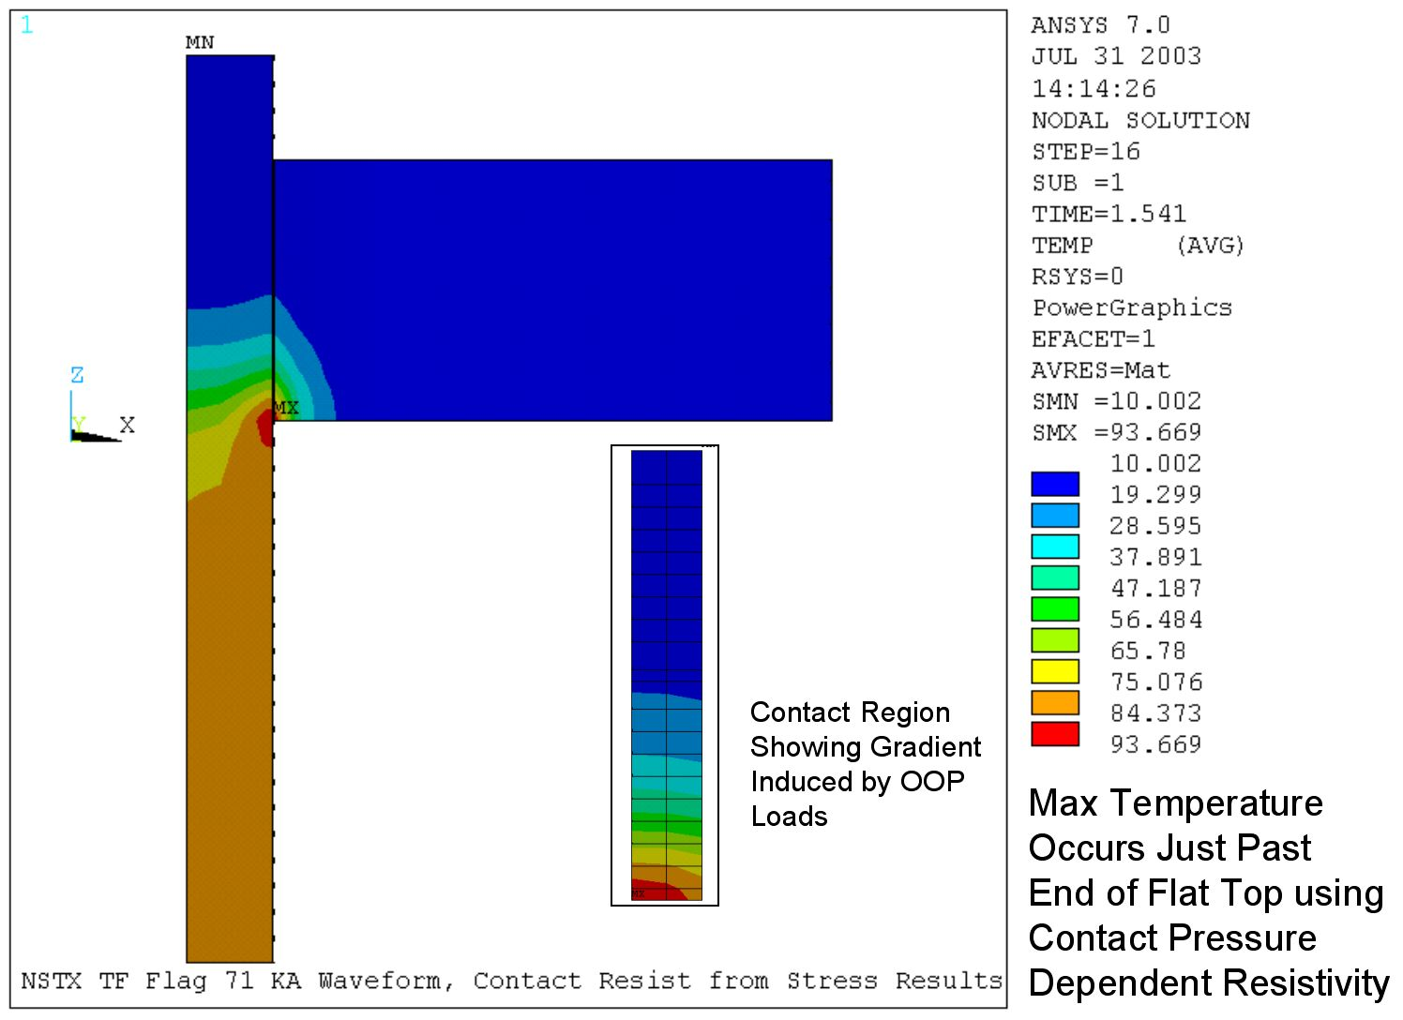

It is noted that the above simulation is for a 0.7 second flat top (vs. 0.6 second requirement), but does not attempt to model the effect of the bolt holes. From prior runs using constant pressure and resistivity, this effect is noted to add approximately 10ºC to the peak temperature. In any case it is clear that the new design meets the criteria of 0.6 second flat top at 6kG with peak temperature below 120 ºC.

SuperChit #6 (ref. Chit #6) (I Zatz)

Stress analysis of the TF bundle should be performed with the new “back-to-back” arrangement of the cooling tubes to verify acceptability. To improve hoop pressure, add insert close to coolant tube insert.

FEA was performed using ANSYS. Results are shown in the following figures.

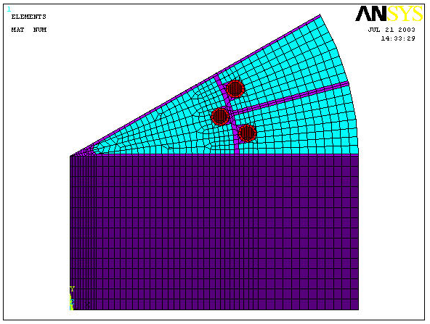
Finite Element Model

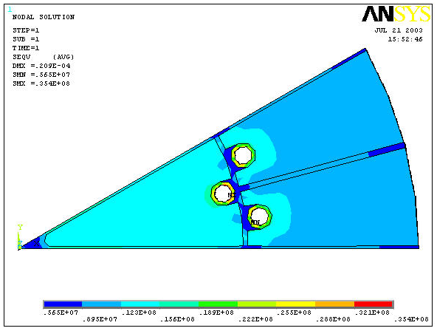
Von Mises Stress Distribution at 6kG (71.2kA/turn)
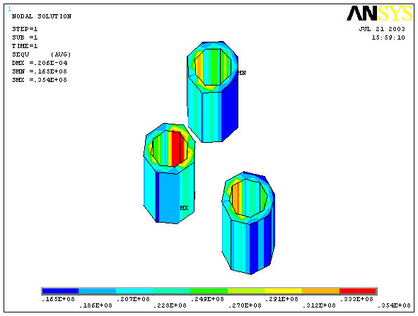
Peak Stresses Occuring In Cooling Tubes

The peak stresses occur in the cooling tubes are are of order 35MPa (5ksi). These levels of stress are not a matter of concern. In addition, since the region around the tube within the groove is completely filled with solder, an additional copper strip behind the tube would not be particularly beneficial.

SuperChit #7 (ref. Chits #9,10,46) (C Neumeyer)

How to ensure that the maximum local temperature does not exceed 120C? Administratively limit I2T based on worst case assumptions for contact resistance? Predicating the design on a maximum contact resistance of 2.2 micro-ohm/sq-in appears unrealistic in light of actual data following limited operation. When the coil has been installed and the flag contact resistance has been established, an upper limit for the contact resistance should be established.

Operating envelope will consist of field limit and I2T limit, as enforced by existing protective devices. The I2T limit is a function of field limit and maximum contact resistance assumption. At high field limits (e.g. 6kG) the time available for heat to diffuse away from the joint is the least, so this is the limiting case. At lower field limits, more time would be available and the use of the high field I2T limit would be conservative. For now, since NSTX has not yet begun long pulse, non-inductively sustained operations, setting of the I2T limit based on the high field limit will not be unduly restrictive to operations, so this will be the first consideration.

ANSYS calculations have been used to establish the peak temperature behavior during a 6kG pulse at various fixed values of contact resistance, as well as contact resistance variable with the pressure along the joint. Precision measurements of contact resistance versus pressure have been made to characterize the typical silver plated joint. Using this information, along with more information which will be gathered as we progress through the prototype testing and commissioning, the following type of rule system will be established for setting the operating envelope.

- Choose allowable peak temperature for the joint (up to 120C)
- Obtain maximum no-load average contact resistance from maintenance measurement at 200A (worst of all 72 joints)
- Apply factor TBD from prototype tests and initial operating experience which relates no-load contact resistance to resistance with EM and thermal loads applied (call it K_{nlfl} for no-load to full-load adjustment)
- Apply additional safety margin K_{sm}
- Choose field limit (e.g. 6kG)
- Utilize ANSYS results to choose I2T limit

Once the operating limit has been set, subsequent maintenance measurements will be made on a periodic basis. A pass/fail criteria will have to established to determine the level at which the worst of the 72 joints has deviated sufficiently from the established operating limit in order that corrective action has to be taken (change the limit, or retorque/rework the joint). Depending on the repeatability of the actual measurements, which are not yet characterized, a criteria can be set (e.g. take action of the worst case joint resistance becomes 10% higher than the worst case which was used to set the operating envelope).

SuperChit #8 (ref. Chits #11,15,49) (I Zatz)

Document the design criteria that the NSTX project is going to use in evaluating the acceptability of the design. Design criteria should address creep and fatigure at elevated temperature. Copper fatigue should be at 120C. Need to establish allowables and performance for shear shoe connection.

NSTX has adopted a suitably edited version of the design criteria document which has been developed by PPPL for various machines in the past (TPX, NCSX, etc.).

Allowables have been established based on published material data and test data as appropriate.

For the threaded inserts, cyclic fatigue tests were performed at 100ºC which is representative of the temperature of the local copper environment they will see.

SuperChit #9 (ref. Chit #13) (M Kalish)

Cyclic testing should be done at elevated temperature. Fatigue and creep are sensitive to temperature.

Cyclic testing of pull-out from inserts in copper was performed at 100C. However, cyclic testing of pull-out directly from copper, and shear of wet lay-up, was performed at room temperature. This is justified based on the analytic results shown in the following figures.

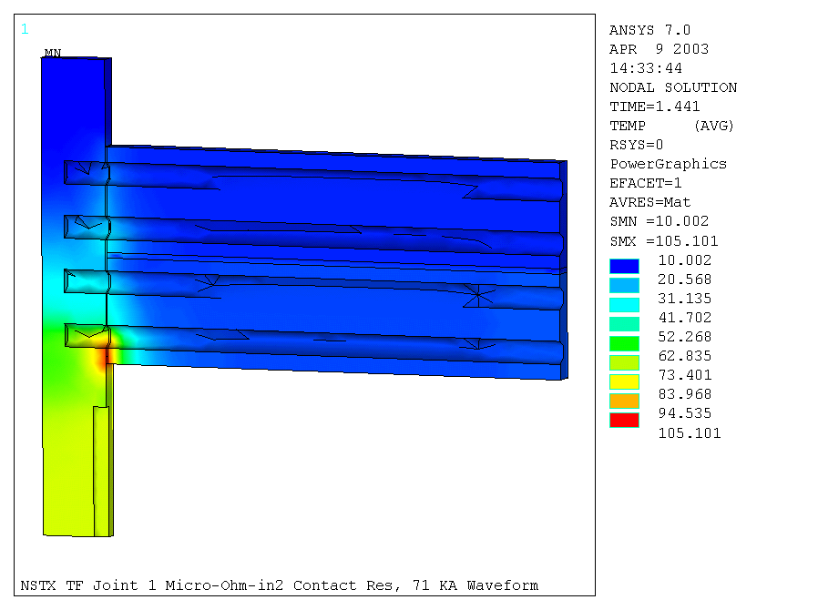
EOFT Temperatures

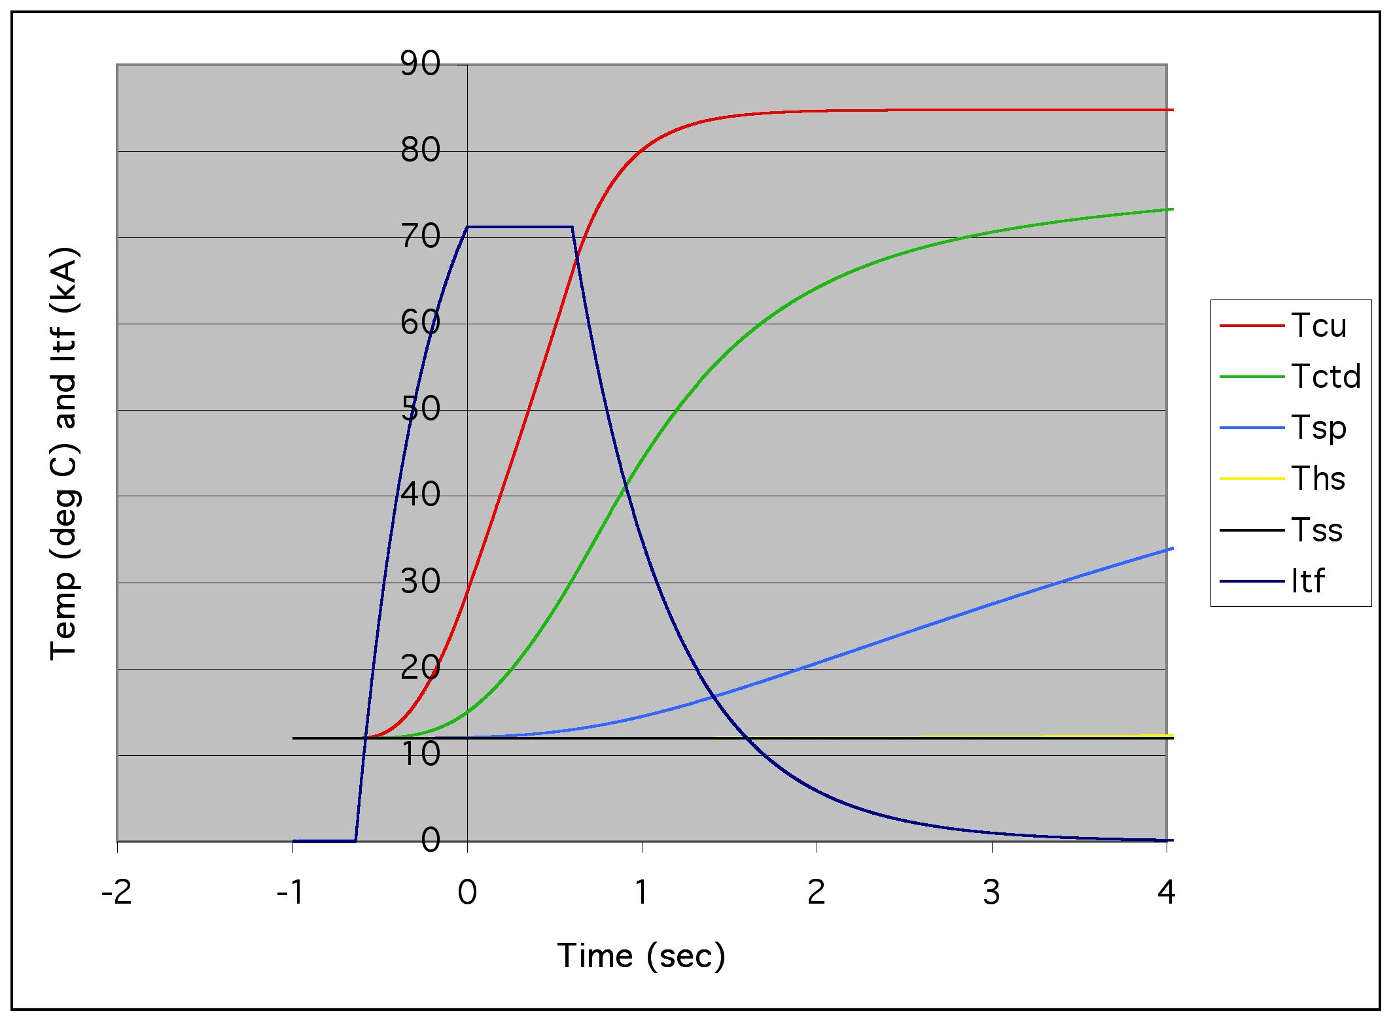
Temperatures of Copper (Cu), Turn Insulation (CTD),
Ground Insulation (SP), Wet Lay-up (HS) and Collar (SS) vs. Time

These results show that only the threaded inserts need to be tested at elevated temperature to simulate actual conditions.

SuperChit #10 (ref. Chits #17,24,41) (M Kalish)

Use Fuji paper during joint fit-up to confirm adequate pressure.

Fuji paper has been purchased and will be used during fit-up of prototype joints and during actual machine assembly.

SuperChit #11 (ref. Chit #18) (I Zatz)

Quantify spline load. Make certain it always helps.

As shown on the following figure, any friction force generated at the spline/umbrella interface will be directed inward, in a direction opposite to the vertical EM force.

The total torque generated by the 36 flags, accounting for the forces midway through the flex link, is of order 140,000 ft-lbs. At the spline radius, approximately 22”, the corresponding reaction to be supplied by the spline is 81,000lbf. Taking a coefficient of friction of 0.5, the vertical force imposed by the umbrella would be of order 40,000lbf. This is to be compared to the total vertical EM force which is approximately 250,000lbf.

SuperChit #12 (ref. Chit #19) (I Zatz)

No scuffing is observed on G-10 spline. It may be because the loads are low or because the flex joints are picking up lateral load which would load the flag.

In fact, closer examination reveals that scuffing has taken place on the spline (ref. 13_030626_CLN_01.doc, “TF Axial Thermal Displacement And Spline Action”). The following photo show the typical wear pattern.

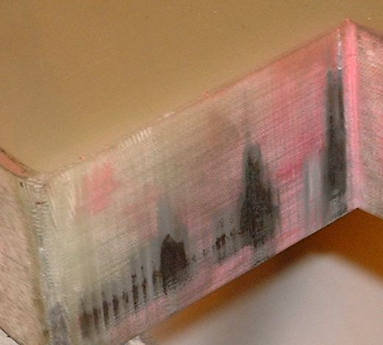
Typical wear on G10

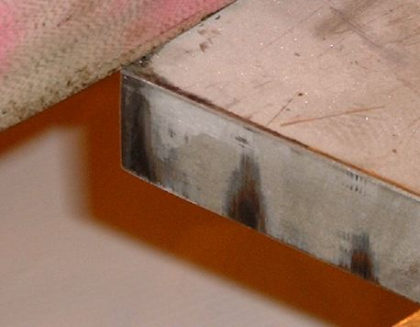
Mating surface on umbrella steel

The pattern observed in these photos is typical for the spline surfaces which would engage with a counter-clockwise twist of the TF, viewed from above. There is also wear on the opposite surfaces, but it is less.

Since NSTX has run exclusively with Bt clockwise, and Ip counter-clockwise, the OH precharge magnetic field is such as to create JxB in the counter-clockwise direction. This is consistent with the observation of the wear, considering that OH always precharges to full field but usually does not swing fully in the opposite direction.

The wear pattern extends well beyond 3/8” in the vertical direction. No explanation is offered at this time. The fact that some regions are darker than others is attributed to the lack of flatness on the mating surfaces.

An additional observation is that the spline is somewhat loose fitting. It can be placed in the engaged position without application of any force; there appears to be a gap of order 1/32” to 1/16”. The Project plans to develop a scheme for shimming to limit the angular twist before engagement occurs.

Concerning the flex joints picking up side loads, there is evidence that they were doing so to a large degree. Note the deformation of the TF outer leg connections shown in the following photo.

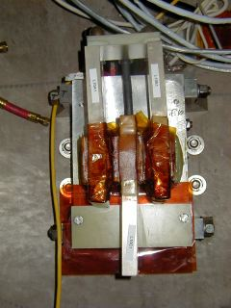
Deformation of Outer Leg Connection Tabs

It is speculated that, in the original design, because the G10 wedge blocks were not securely supported against movement in the toroidal direction, much of the flag out-of-plane load was transmitted out through the flex links to the outer legs, rather than through the intended path. The new design, with the flags in boxes, provides very still lateral support for the flags.

SuperChit #13 (ref. Chit #21) (P Heitzenroeder)

Are box bolts to ring modeled discretely or is the model merged?

In the FEA model the box bolt-to-hub connection is not explicitly modeled. However, it has been analyzed separately (ref. NSTX-CALC-13-24, “TF Flag Box/Hub Connection”). The total lateral load on an outer layer, inner tier flag is 4700lbf, taking the sum of the forces generated midway through the flex link. There are a total of six bolts (actually studs, Belleville washers, and nuts), three top and three bottom, which attach each box to the hub. These are 5/8” diameter and are preloaded to approximately 5000lbf per bolt. Assuming a coefficient of friction of 0.39, the safety factor against side loads is 6*5000*.39/4700=2.5.

SuperChit #14 (ref. Chit #22) (C Neumeyer)

Load from eddy in hubs should be added to design load – or split the hub.

A calculation was performed (ref. NSTX-CALC-13-27, “Estimate of Eddy Currents in TF Hub Assembly”) to estimate the forces due to eddy currents in the hub disks, which form loops for toroidal current flow. Since toroidal current is in quadrature with the toroidal field, there is no interaction with same. However, the toroidal current interacts with the radial field from the OH and PF coils, causing a vertical force. The four hub disks were modeled as filaments with resistance based on 304SS. The self inductance of the filaments and the mutual coupling between the filaments and the OH and PF coils was calculated. Then the maximum current derivative was calculated for the OH and PF coils at maximum current, i.e. Idot=V_{no-load}-I_{max}*(R_{reg}-R_{coil}))/L_{coil}, ignoring mutual coupling effects between coils. The voltage induced on the hub elements was then calculated based on V_{hub}=∑(M*Idot), and the current I_{hub}=V_{hub}/R_{hub}. Then the field at each hub disk due to each coil at maximum current was calculated, assuming all coils simultaneously energized at maximum current. Finally, the force on each disk was calculated based on F=IlxB. The results indicated current flow of 6.5kA, 4.9kA, 3.6kA, and 2.8kA in the four disks, respectively from innermost to outermost, and corresponding vertical forces of 566lbf, 272lbf, 138lbf, and 77lbf. These forces are less than 1% of the vertical self-forces on the flags, and are therefore ignorable.

SuperChit #15 (ref. Chit #25) (M Kalish)

Consider adding shear shoe/dog.

A shear shoe has been added as depicted below. It is attached to the conductor using two 3/8” diameter bolts threaded directly into the copper. The vertical and angled bolts are employed to react, primarily, the vertical load and moment, respectively.

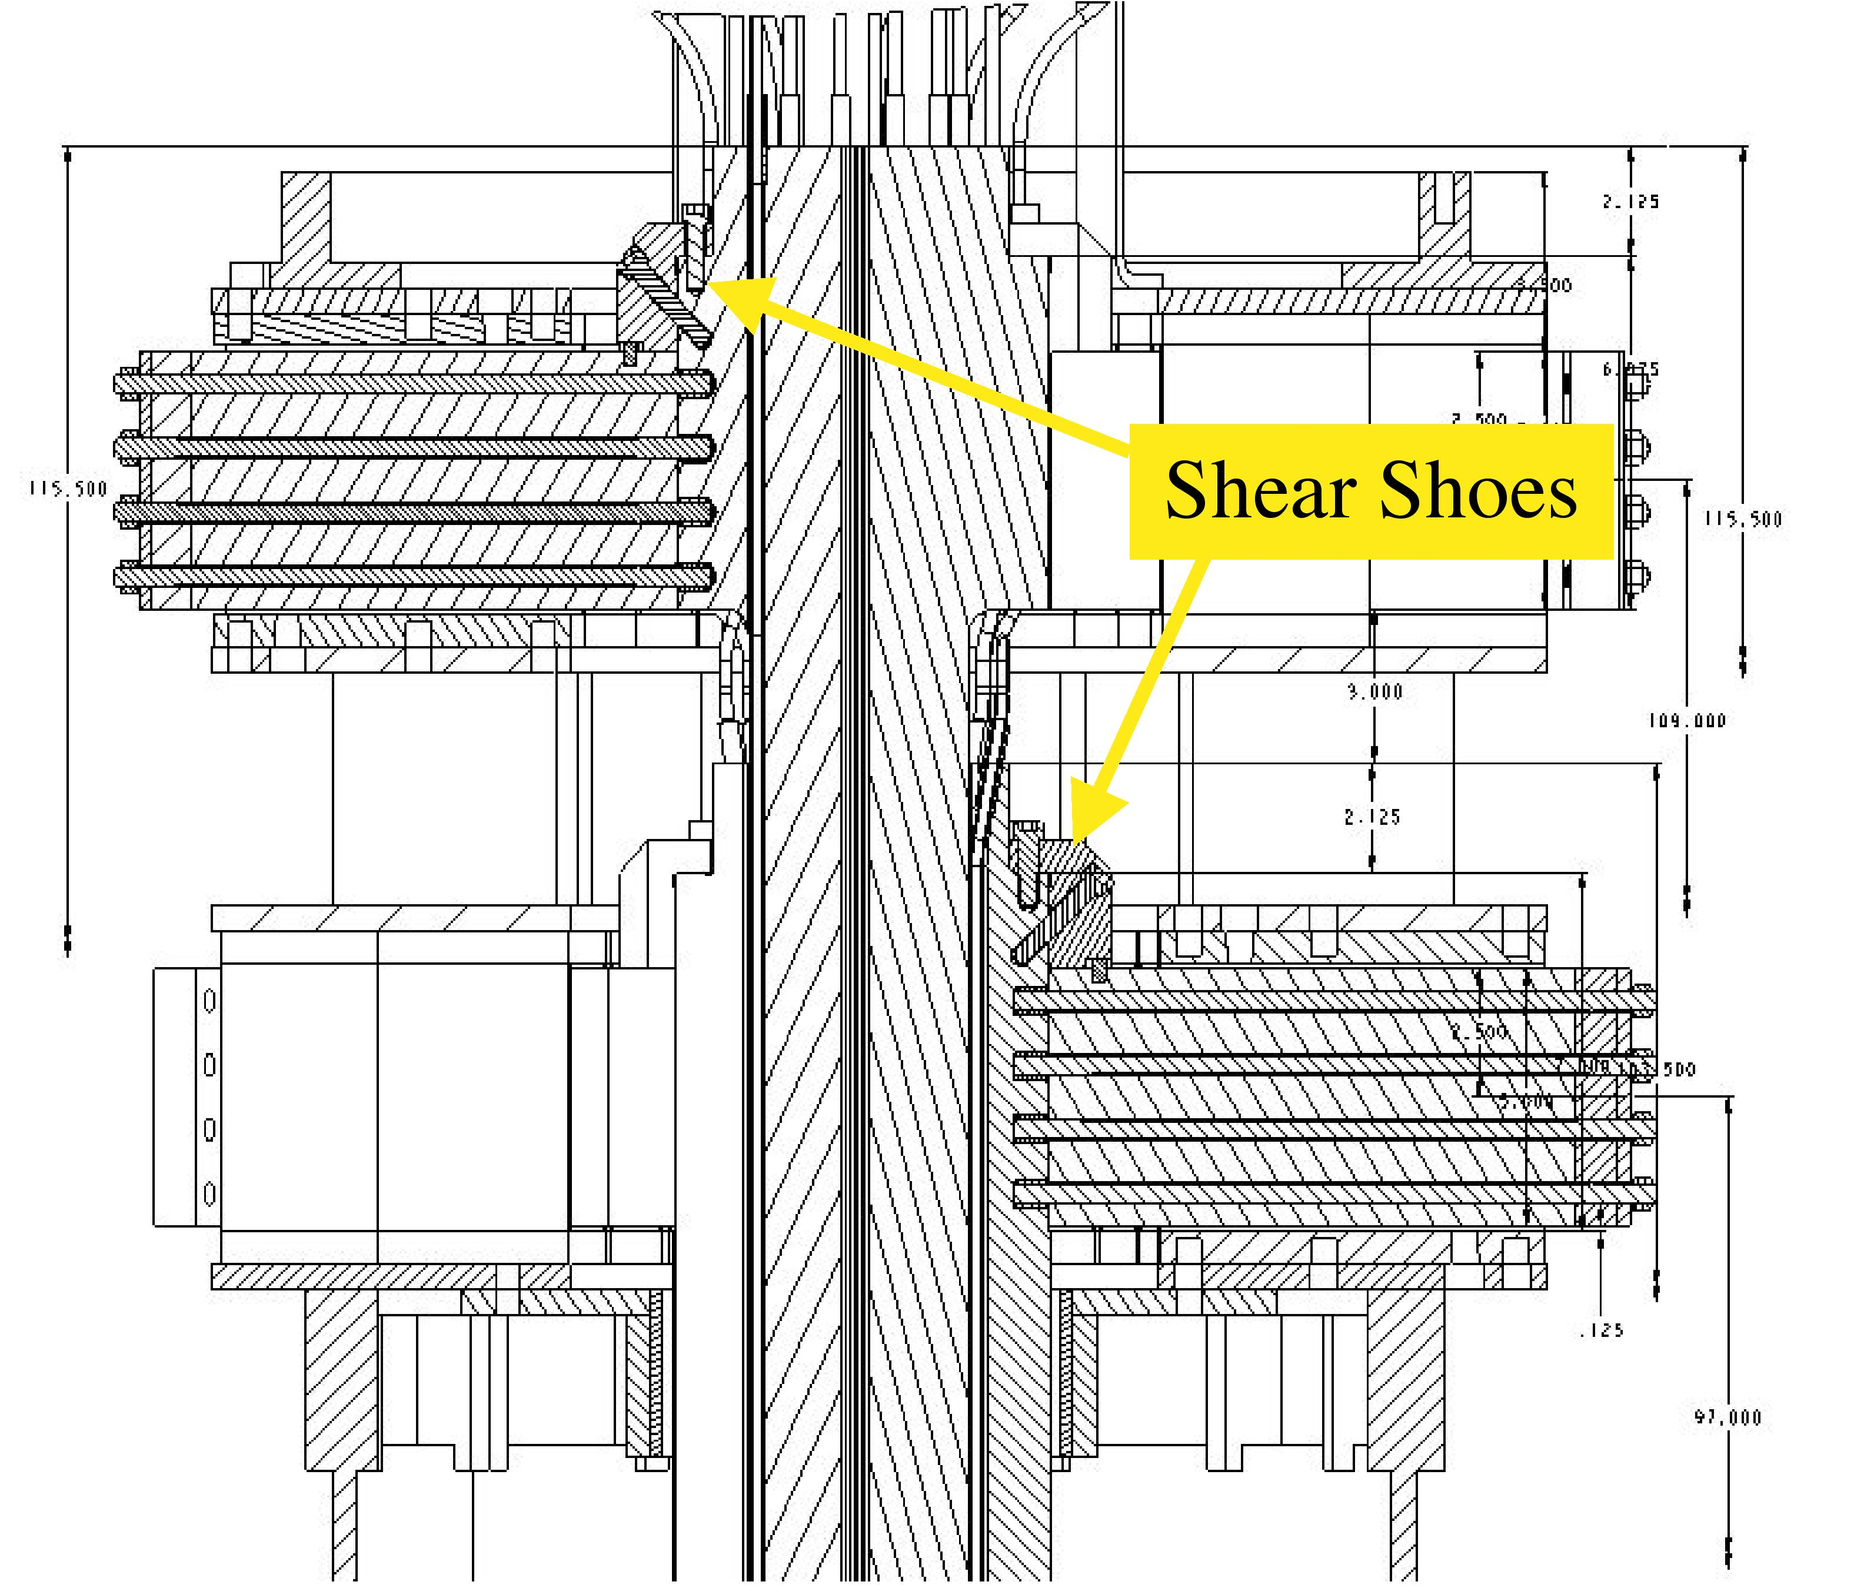

SuperChit #16 (ref. Chit #26) (J Chrzanowski)

Investigate sleeve bladder to eliminate seals during process of potting the flags in the boxes.

Trials were made sealing the copper flag to the stainless steel box using silicone rubber insulation along with RTV. A successful trial was performed, as shown in photo below. This method allows the conductor to move relative to the stainless steel box.

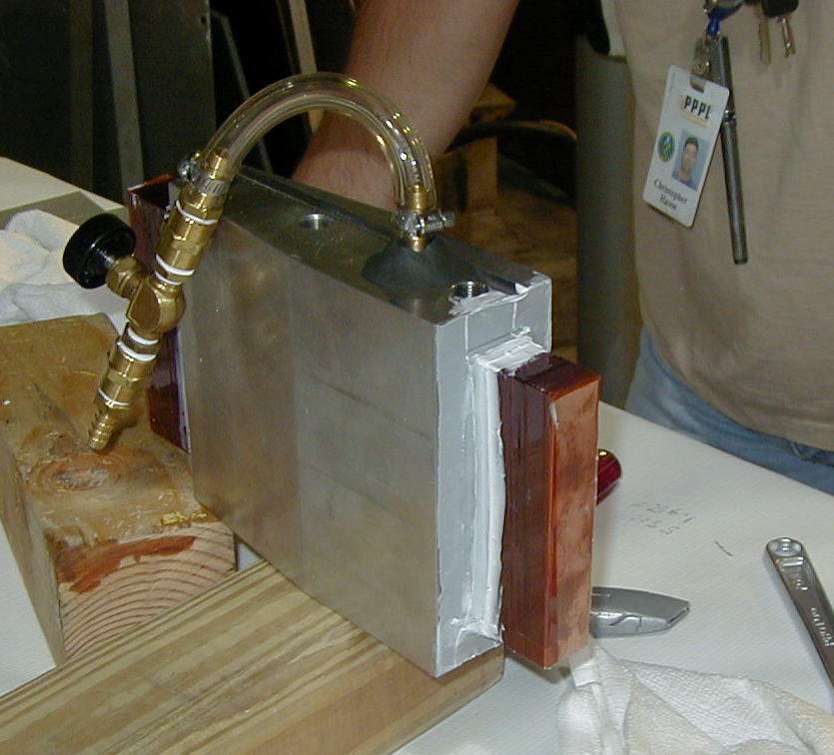

SuperChit #17 (ref. Chit #27,48) (M Kalish)

Consider (Inconel) 718 studs preloaded to 0.9 yield for preload. Add more Belleville washers.

Inconel 718 will be used for the 4 flag bolts (studs). The yield strength of the Inconel is high enough that we can comfortably remain below 2/3 yield (yield = 185 ksi) and maintain more than adequate compressive force (5,000 lbf preload). The weakest member of the assembly remains the threaded Taplok insert. The advantages of using a higher preload (approaching .9 yield) are offset by the loss in safety margin with respect to the Taplok insert pull out strength.

SuperChit #18 (ref. Chits #29,51 ) (L Dudek)

Analyze pitting on flags to understand cause.

One of the TF Flags exhibiting the “scuff” marks on the contact faces was dissected and inspected using an optical microscope and also with a SEM. Under the optical microscope, the area appeared to be eroded away. The erosion was only present between the clamped faces. The photos taken of the area clearly show signs of spark erosion. The depth of the mark photographed is approximately 0.003” at the lower edge of the flag.

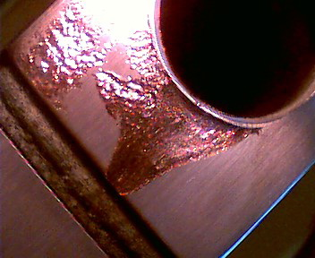 | 10x Optical Microscope  SEM photos were taken in this area on one of the flags that exhibited “scuff “ marks.  The erosion only occurred where the two faces were opposite each other. Here a small ring of copper is left where the edge was deformed by the bolt shoulder.

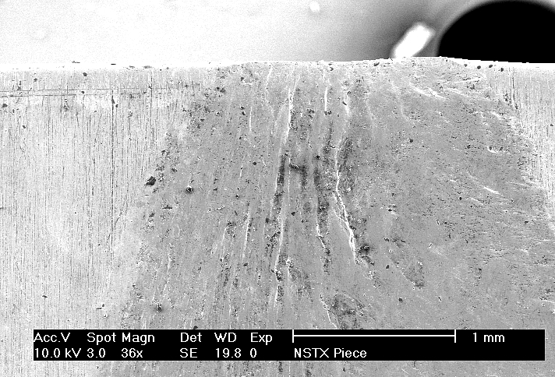 | File NSTX_01  36x Magnification  This spot was picked, |  4 more pictures of increasing mag. follow this picture.  Similar process used for all pictures. 1 picture at ~36x mag showing area where images were taken from, then several of increasing mag.
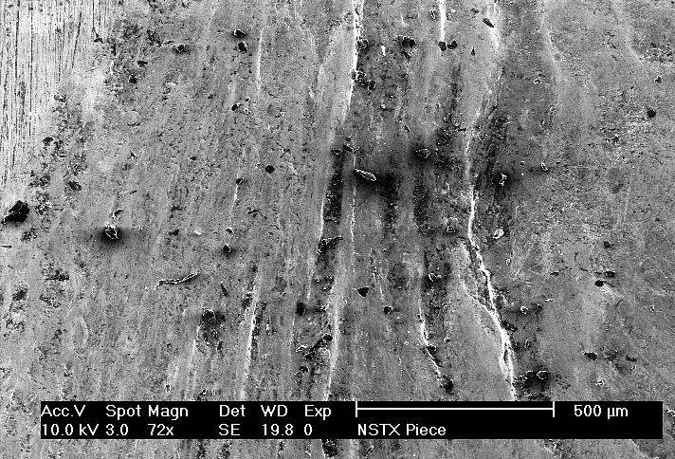 | File NSTX_02  72x Magnification

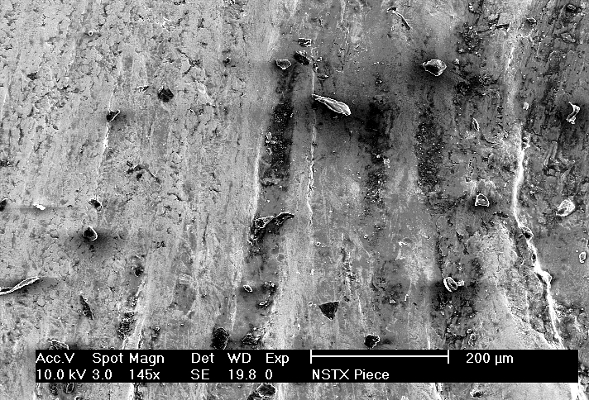 | File NSTX_03  145x Magnification
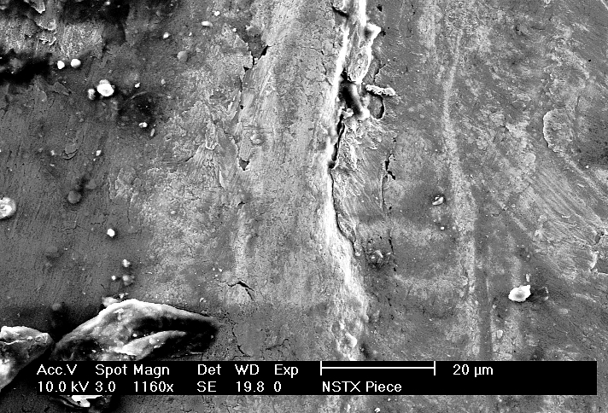 | File NSTX_04  1160x Magnification

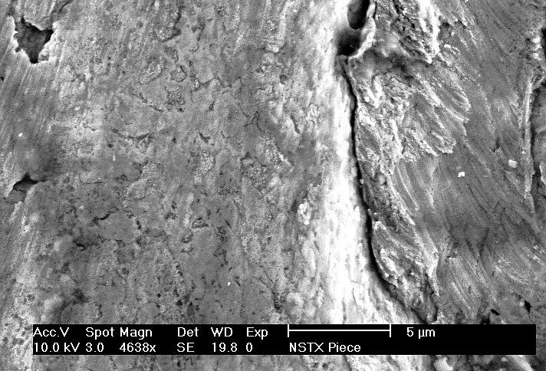 | File NSTX_05  4638x Magnification

SuperChit #19 (ref. Chit #31 ) (M Kalish)

Need to perform fatigue tests on collar to TF bundle epoxy joint.

Fatigue tests are being performed. As of this time, three samples have been exposed to > 50,000 cycles at 0.5Hz. Shear/compression values were 1304/242, 1311/157, and 1500/1000psi.

SuperChit #20 (ref. Chit #33 ) (J Chrzanowski)

Consider removal of centerstack to facilitate TF reassembly. Perform schedule impact study.

There is no advantage removing the Centerstack from the machine to complete the TF repairs. The present plan reduces the re-assembly time and allows the TF bundle to be mated directly with the Centerstack with little difficulty.

SuperChit #21 (ref. Chit #35 ) (M Kalish)

Is there sufficient room for a stud tensioner? Are the studs long enough?

A potential vendor for a stud tensioner has been identified and they have presented us with a design capable of fitting into our envelope. The stud is designed with 5/8” of thread protrusion which is more than adequate for the stud tensioner.

SuperChit #22 (ref. Chit #39 ) (M Kalish)

Run taplock tests at actual bolt to taplock engagements.

The tests were run with Taplok inserts assembled into actual conductor samples using the final design parameters for the hole. The test fixture bolt was threaded to the bottom of the hole just as the actual stud will be threaded to the end of the hole in the real conductor.

SuperChit #23 (ref. Chits #3,9,40,42,43,44,50 ) (C Neumeyer)

Concerning TF joint instrumentation:

- bolt preload should be monitored via preventative maintenance or continuously including real time
- contact resistance should be monitored via preventative maintenance or continuously including real time
- consider temperature monitoring (fiber optic phosphorescent detectors)
- use linear position sensors on top and bottom of center stack to measure center stack displacement with respect to umbrella covers, umbrella covers displacement with respect to vacuum vessel, and vacuum vessel displacement with respect to ground
- Consider strain gauges to measure stresses in hub structure to determine load distribution
- Conduct pre-op testing measuring deflections to assure that the design is behaving as predicted

Instrumentation can potentially serve the following purposes:

- provide measure of joint condition as a maintenance function while machine is not operating
- provide confirmation during commissioning that various aspects of the design are performing as expected
- provide monitoring of joint behavior during day-to-day operations to ensure that joints are not deteriorating

Decisions as to what instrumentation should be deployed are guided by technical and management principles which consider feasibility, redundancy, risk, and cost. The following is a discussion of the considerations related to each instrumentation option.

Voltage Drop Measurements

The joint voltage drop measurements are considered to be the top priority. They provide the best “end result” indication as to whether all of the various elements of the system are working properly. Voltage drop measurements during maintenance with a low current (200A) injected continuously will provide an excellent and precise means of assessing the condition of the joints, albeit without large EM loads applied. Voltage drop measurements made during actual pulsing will provide a real-time indication that the structural support systems are working properly, maintaining adequate contact pressure on the joints. Although non-trivial due to 5kV voltage isolation requirement, low signal level, and high noise environment, prior experience on MAST and C-MOD indicate that these measurements can be made successfully. NSTX envisions the trending of the real-time voltage drop signals, at least from the daily test shots (where noise from RF, NBI, and plasma is absent), as a means of monitoring joint integrity between maintenance intervals.

Temperature Measurements

If temperature measurements local to the critical corner region of the joint could be made with sufficient ease and time response, then they would provide an excellent “end result” measurement. Thermocouples are not suitable for this purpose due to time response, voltage isolation, and signal to noise issues. The NSTX Project has investigated a fiber optic temperature measurement system (www.fiso.com) which offers a probe with a step response e-folding time as short as 750mS. However, even this relatively fast time response would render the measurement only marginally useful during a pulse. Cooldown between pulses, and ratcheting, could be monitored effectively. Since the cost is relatively high (around $4K/channel for hardware) we could not consider deployment on a large number of joints.

Strain Measurements

Strain measurements would provide design verification information during commissioning. Although electrically-based strain measurements have been made successfully by MAST, these measurements are very difficult due to the 5kV isolation requirement (even the hub structure, etc., is at elevated potential on NSTX because of CHI), low signal level, and high noise environment. The aforementioned fiber optic system offers strain, as well as temperature measurement at around $4K/channel. Another option would be to place load cell washers under the bolts heads of the flag fasteners. These consist of strain gauges within washers, which ORNL has used successfully in the past in similar applications. The washers themselves are not costly, but the electronics would again be challenging due to the 5kV isolation requirement, low signal level, and high noise environment. FEA results have indicated that the force on the fasteners is not highly variable during a pulse, and may not be a sensitive measurement of overall joint behavior.

Displacement Measurements

Displacement measurements can be made to detect the axial thermal expansion and/or angular rotation of the top of the hub assembly at the spline, with respect to the umbrella cover. Concerning the axial thermal expansion , the height of the TF coil will increase by 0.351” in while heating from 10 to 100ºC. Assuming that there is no binding between the spline and the umbrella cover, the displacement should take place between these two parts. To the extent that binding does occur (e.g. as the system overcomes the friction between the teeth) the umbrella cover will elastically deform in a dish shape, but the resultant force will be beneficial overall, as it pushes inwards against the in-plane magnetic pressure which pushes outwards (see SC#11). Concerning the angular displacement, according to the FEA, which assumes perfect fit at the spline, the angular rotation will be very small, with a toroidal displacement of approximately 0.0025” at a radius of 11”(the inner edge of the G-10 spline), corresponding to an angle of 0.013 degrees. To the extent that the spline fit is imperfect, more twist will occur. Both the axial and angular displacements would be useful measurements to confirm that the spline is working as intended. And, the actual angular displacement due to imperfect spline fit could be measured and fed back to the analysis to quantify its effect. Since these measurements are located on the vacuum vessel, which is grounded through a medium resistance value to permit CHI biasing, the voltage isolation requirements are not too severe, around 500V. Other useful displacement measurements could be made on various parts of the joint support structure, e.g. between hub and collar, to verify proper operation (e.g. sliding of torsion anchor points w.r.t. torque collar attachment.

Considering the above, the NSTX Project has come to the following positions.

- voltage tap monitoring will be implemented on all 72 joints, and will have dual gain capability so that it can measure joint resistance at 200A during maintenance testing, and can measure joint voltage drop in “real time” during actual NSTX operations.
- the fiber optic measurement system, which can in principle measure temperature, strain, and displacement in real time, is under evaluation. If implemented, a few (e.g. 4) channels would be procured but temperature, strain, and displacement transducers (e.g. 4 of each, 12 total) would be installed, positioned and plugged into the channels as required.
- if the fiber optic system is not procured and implemented, then some type of measurement scheme will be adopted for the spline axial and angular displacement. It would probably consist of two linear potentiometers with voltage source and buffered output.

SuperChit #24 (ref. Chit #48 ) (C Neumeyer)

Does through bolt (stud) carry current and lengthen?

The following table summarizes a calculation which indicates that the bolt heating will be minimal.

Flag length | 11 | inch
Flag width | 1 | inch
Flag height | 5 | inch
Fastener hole | 0.435 | inch
Flag resistivity | 1.74E-08 | ohm-m
Flag resistance | 1.71E-06 | ohm
Fastener dia | 0.375 | inch
Fastener resistivity | 7.70E-07 | ohm-m
Fastener resistance | 3.02E-03 | ohm
Total resistance | 1.71E-06 | ohm
Current | 71600 | amp
Voltage | 1.22E-01 | volt
Imbalance factor | 2.0
Current per fastener | 81.0 | amp
Dissipation per fastener | 19.8 | watt
ESW | 0.6 | sec
Energy | 11.9 | Joule
Specific Heat | 0.46 | J/gm-degC
Density | 7.92 | gm/cc
Volume | 19.9 | cc
Mass | 157.7 | gm
Heat Capacity | 72.5 | J/degC
Temperature Rise | 0.2 | degC

SuperChit #25(ref. Chit #53 ) (M Kalish)

Consider use of threaded shear keys

As shown in the figure below, threaded shear keys would be threaded into the inner lag conductor. Then the flag would be attached over the keys with tight fitting holes, and attached via the fasteners.

This configuration was considered but not adopted due to the difficulty inherent in fitting up the shear keys, which would have to fit perfectly for them to evenly share the load.

# | SC# | Origin | Summary | Action
1 | x | Anderson | Analyze bolted joint at end of e-beam welded flag | e-beam dropped
2 | 1 | Anderson | Measure contact surfaces of existing assembly to determine achievable precision | Chrzanowski
3 | 23 | Reiersen | Maintenance of bolt preload and low contact resistance is essential for the health of the joint. These parameters should be monitored regularly (preventative maintenance program) or better yet, continuously. | Neumeyer
 | 2 |  | Can voltage taps pick up locally high contact resistance at far corner? | Neumeyer/Brooks
4 | 3 | Reiersen | a. Add upper tier to FEA model | Zatz
 | 4 |  | b. How are allowables for collar wet lay-up derived from test data? | Kalish
5 | 5 | Reiersen | Use actual distribution of contact pressure in analysis of joint heating | Zatz/Brooks
6 | 6 | Dudek | Analyze bundle stress considering back-back cooling tubes | Zatz
7 | 6 | Titus | Add insert strip behind coolant tube to improve hoop pressure distribution | Zatz
8 | 3 | Reiersen | Perform analysis over the range of conditions to establish design margins and operating envelope | Zatz
9 | 7 | Reiersen | How will operating envelope be chosen to ensure Tpeak<120C, given variability of contact resistance? Consider temperature monitoring. | Neumeyer
10 | 7 | Reiersen | Reconsider design assumption for nominal contact resistance. | Neumeyer
11 | 8 | Reiersen | Document design criteria, considering creep and fatigue at elevated temperatures | Zatz
12 | 3 | Reiersen | Comprehensive assessment of design margins lacking. | See 8
13 | 9 | Reiersen | Perform cyclic testing at elevated temperature | Kalish
14 | x | Reiersen | Perform friction tests on prototype joint | Disagree
15 | 8 | Reiersen | Copper fatigue criteria should be based on 120C | See 11
16 | 3 | Titus | Express margin as contact pressure/req'd contact pressure | Zatz
17 | 10 | Titus | Use Fuji paper to confirm adequate pressure | Kalish
18 | 11 | Titus | Quantify spline load with thermal expansion of inner leg, confirm that it always helps | Zatz
19 | 12 | Titus | If spline shows no scuffing, are the lateral loads being taken by the flex joints (which would load the flags?) | Zatz
20 | x | Titus | a. Perform fatigue test on e-beam weld | e-beam dropped
 | 3 |  | b. Test max/min friction coefficient | Zatz
 | x |  | c. Add fillet radius to e-beam joint | e-beam dropped
21 | 3 | Titus | a. Analyze high friction-no thermal case | Zatz
 | 13 |  | b. Are box bolts to ring modeled discretely or is the model merged? | Zatz
 | 3 |  | c. Exercize model with fit-up variations | Zatz
 | 3 |  | d. Include proper friction between box and flag | Zatz
22 | 14 | Titus | Include loads due to eddy currents in hubs | Neumeyer
23 | 3 | Titus | Concern about high friction case | See 21a
24 | 10 | Titus | Perform local analysis of interface to see if fabrication tolerances are such that joint contact is maintained everywhere | See 17
25 | 15 | Voss | Consider shear dog | Kalish
26 | 16 | Titus | Investigate sleeve bladder to eliminate seals at ends of boxes during potting | Chrzanowski
27 | 17 | Titus | a. Consider Inconel 718 studs preloaded to 0.9 yield | Kalish
 | 17 |  | b. Add more bellevilles | Kalish
28 | 3 | Hawryluk | a. Consider out of plane loads | Neumeyer/Zatz
 | 3 |  | b. Consider high friction, low termperature case | See 21a
29 | 18 | Dudek | Analyze pitting on existing flags to understand cause | Dudek
30 | 3 | Bell | What is min contact pressure without shear key and box? | See 8
31 | 19 | Dudek | Need to perform fatigue tests on collar wet lay-up | Kalish
32 | x | Voss | Run transient analysis for e-beam welded joint | e-beam dropped
33 | 20 | Hawryluk | Consider removal of centerstack to facilitate TF reassembly. Perform schedule impact. | Chrzanowski
34 | x | Hawryluk | FMEA for e-beam welded joint | e-beam dropped
35 | 21 | Hawryluk | Is there enough room for a stud tensioner? Are the studs long enough? | Kalish
36 | x | Titus | Add fillet radius to e-beam joint. | e-beam dropped
37 | x | Voss | Add fillet radius to e-beam joint. | e-beam dropped
38 | x | Irby | Electro-form instead of e-beam weld. | e-beam dropped
39 | 22 | Dudek | Run taplok tests at actual bolt-to-taplok engagements | Kalish
40 | 23 | Irby | Consider continuous monitoring of joint resistance | Marsala
41 | 10 | Irby | Use contact film (Fuji paper) | See 17
42 | 23 | Voss | Install linear position sensors to measure thermal displacement of TF inner leg assembly | Schneider
43 | 23 | Anderson | Recommend monitoring of thermal growth of centerpost | See 42
44 | 15 | Voss | Consider strain gauges to measure stresses in hub to determine load distribution | Zatz/Marsala
45 | 3 | Voss | Cyclic loading may cause friction joint to "walk" causing more load to be passed to shear pin | Zatz
46 | 7 | Petersen | Establish upper limit on allowable joint resistance during maintenance measurement | Neumeyer
47 | x | Bell | Maintain 2kV CHI capability | Out of scope
48 | 17 | Bonanos | a. Is bolt hotter than flag at any time during pulse sequence? | Kalish
 | 24 |  | b. Does bolt carry current and lengthen? | Neumeyer
 | 17 |  | c. Add more belleville washers in series | See 27b
49 | 8 | Reiersen | Establish allowables and performance for pin connection | See 11
50 | 23 | Reiersen | Conduct pre-ops tests with deflection measurements to confirm predicted behavior | Neumeyer
51 | 18 | Irby | More analysis needed of pitting damange | See 29
52 | x | Mueller | Consider use of short bolts and making the flags more flexible | Disagree
53 | 25 | Lewicki | Consider use of threaded shear keys | Kalish

WP # 1032 (ENG-032)
PPPL DESIGN REVIEW CHIT CHIT # 1
COMPONENT/SUBSYSTEM/SYSTEM NSTX FLAG JOINT  Cognizant Design Engineer C Neumeyer Date of Review 4/10/3 |  | PEER  CDR  PDR  FDR
SUBJECT: (CHECK AS APPLICABLE)

Requirements Hardware Safety
Analysis Configuration Cost/Schedule
Performance Reliability/Maintainability Quality

Comment/Concern/Recommendation

Analyze bolt loads, contact pressures, etc., for e-beam welded, bolted plate on end of flag. Is this better than a split can design with integral flange on conductor?

Originator__P. Anderson________

Name/Organization ______GA______

REVIEW BOARD COMMENT/RECOMMENDATION

x Concur
0 DISAGREE
0 OTHER CHAIRPERSON L. Dudek Date: 4/10/3
Cognizant Design Engineer’s Response/Disposition:

This chit is no longer applicable since e-beam welded flags have been dropped from the design.

Signature C. Neumeyer Date: 6/24/3
Responsible RLM Review
0 APPROVE COG DISPOSITION  0 DISAPPROVE COG DISPOSITION | Signature Date:
Cognizant Design Engineer Close-Out

Signature Date:

WP # 1032 (ENG-032)
PPPL DESIGN REVIEW CHIT CHIT # 2
COMPONENT/SUBSYSTEM/SYSTEM NSTX FLAG JOINT  Cognizant Design Engineer C Neumeyer Date of Review 4/10/3 |  | PEER  CDR  PDR  FDR
SUBJECT: (CHECK AS APPLICABLE)

Requirements Hardware Safety
Analysis Configuration Cost/Schedule
Performance Reliability/Maintainability Quality

Comment/Concern/Recommendation

Suggest measuring current TF coil surfaces to determine parallelness for attachment of new centerpost. This should verify if 0.010” requirement for stainless steel cans on flags is adequate.

Originator__P. Anderson________

Name/Organization ______GA______

REVIEW BOARD COMMENT/RECOMMENDATION

x Concur
0 DISAGREE
0 OTHER CHAIRPERSON L. Dudek Date: 4/10/3
Cognizant Design Engineer’s Response/Disposition:

See SuperChit #1

Signature C. Neumeyer Date: 6/24/3
Responsible RLM Review
0 APPROVE COG DISPOSITION  0 DISAPPROVE COG DISPOSITION | Signature Date:
Cognizant Design Engineer Close-Out

Signature Date:

WP # 1032 (ENG-032)
PPPL DESIGN REVIEW CHIT CHIT # 3
COMPONENT/SUBSYSTEM/SYSTEM NSTX FLAG JOINT  Cognizant Design Engineer C Neumeyer Date of Review 4/10/3 |  | PEER  CDR  PDR  FDR
SUBJECT: (CHECK AS APPLICABLE)

Requirements Hardware Safety
Analysis Configuration Cost/Schedule
Performance Reliability/Maintainability Quality

Comment/Concern/Recommendation

- Maintenance of bolt preload and low contact resistance is essential for the health of the joint. These parameters should be monitored regularly (preventative maintenance program) or better yet, continuously.
- Can the proposed voltage tap pick up a locally high contact resistance at the far corner where the current wants to flow?

Originator__W. Reiersen________

Name/Organization ______PPPL______

REVIEW BOARD COMMENT/RECOMMENDATION

Run new ANSYS analysis to consider.

x Concur
0 DISAGREE
0 OTHER CHAIRPERSON L. Dudek Date: 4/10/3
Cognizant Design Engineer’s Response/Disposition:

For part 1), see SuperChit #23, for part 2) see SuperChit #2

Signature C. Neumeyer Date: 6/24/3
Responsible RLM Review
0 APPROVE COG DISPOSITION  0 DISAPPROVE COG DISPOSITION | Signature Date:
Cognizant Design Engineer Close-Out

Signature Date:

WP # 1032 (ENG-032)
PPPL DESIGN REVIEW CHIT CHIT # 4
COMPONENT/SUBSYSTEM/SYSTEM NSTX FLAG JOINT  Cognizant Design Engineer C Neumeyer Date of Review 4/10/3 |  | PEER  CDR  PDR  FDR
SUBJECT: (CHECK AS APPLICABLE)

Requirements Hardware Safety
Analysis Configuration Cost/Schedule
Performance Reliability/Maintainability Quality

Comment/Concern/Recommendation

Add upper flag/hub assembly in Irv’s model to allow calculating stresses at collar. The stiffer hub assembly should increase the loads at the collar, which might become the weak link. How are the allowables for the hub/center stack connection (wet lay-up) derived from the test data?

Originator__W. Reiersen________

Name/Organization ______PPPL______

REVIEW BOARD COMMENT/RECOMMENDATION

x Concur
0 DISAGREE
0 OTHER CHAIRPERSON L. Dudek Date: 4/10/3
Cognizant Design Engineer’s Response/Disposition:

See SuperChit #3, #4

Signature C. Neumeyer Date: 6/24/3
Responsible RLM Review
0 APPROVE COG DISPOSITION  0 DISAPPROVE COG DISPOSITION | Signature Date:
Cognizant Design Engineer Close-Out

Signature Date:

WP # 1032 (ENG-032)
PPPL DESIGN REVIEW CHIT CHIT # 5
COMPONENT/SUBSYSTEM/SYSTEM NSTX FLAG JOINT  Cognizant Design Engineer C Neumeyer Date of Review 4/10/3 |  | PEER  CDR  PDR  FDR
SUBJECT: (CHECK AS APPLICABLE)

Requirements Hardware Safety
Analysis Configuration Cost/Schedule
Performance Reliability/Maintainability Quality

Comment/Concern/Recommendation

The assumption of a uniform contact resistance presumes a uniform contact pressure. Is the contact pressure near the fasteners approximately the same as away from the fasteners? (A fine mesh would be required to pick this up). Does it stay constant with out of plane loads? Is current distribution and temperature rise consistent with pressure distribution? The uniform contact resistance assumption is non-conservative.

Originator__W. Reiersen________

Name/Organization ______PPPL______

REVIEW BOARD COMMENT/RECOMMENDATION

See Chit #17

x Concur
0 DISAGREE
0 OTHER CHAIRPERSON L. Dudek Date: 4/10/3
Cognizant Design Engineer’s Response/Disposition:

See SuperChit #5

Signature C. Neumeyer Date: 6/24/3
Responsible RLM Review
0 APPROVE COG DISPOSITION  0 DISAPPROVE COG DISPOSITION | Signature Date:
Cognizant Design Engineer Close-Out

Signature Date:

WP # 1032 (ENG-032)
PPPL DESIGN REVIEW CHIT CHIT # 6
COMPONENT/SUBSYSTEM/SYSTEM NSTX FLAG JOINT  Cognizant Design Engineer C Neumeyer Date of Review 4/10/3 |  | PEER  CDR  PDR  FDR
SUBJECT: (CHECK AS APPLICABLE)

Requirements Hardware Safety
Analysis Configuration Cost/Schedule
Performance Reliability/Maintainability Quality

Comment/Concern/Recommendation

Stress analysis of the TF bundle should be performed with the new “back-to-back” arrangement of the cooling tubes to verify acceptability.

Originator__W. Reiersen________

Name/Organization ______PPPL______

REVIEW BOARD COMMENT/RECOMMENDATION

x Concur
0 DISAGREE
0 OTHER CHAIRPERSON L. Dudek Date: 4/10/3
Cognizant Design Engineer’s Response/Disposition:

See SuperChit #6

Signature C. Neumeyer Date: 6/24/3
Responsible RLM Review
0 APPROVE COG DISPOSITION  0 DISAPPROVE COG DISPOSITION | Signature Date:
Cognizant Design Engineer Close-Out

Signature Date:

WP # 1032 (ENG-032)
PPPL DESIGN REVIEW CHIT CHIT # 7
COMPONENT/SUBSYSTEM/SYSTEM NSTX FLAG JOINT  Cognizant Design Engineer C Neumeyer Date of Review 4/10/3 |  | PEER  CDR  PDR  FDR
SUBJECT: (CHECK AS APPLICABLE)

Requirements Hardware Safety
Analysis Configuration Cost/Schedule
Performance Reliability/Maintainability Quality

Comment/Concern/Recommendation

To improve hoop pressure, add insert close to coolant tube insert.

Originator__P. Titus________

Name/Organization ______MIT_____

REVIEW BOARD COMMENT/RECOMMENDATION

See Chit #6

x Concur
0 DISAGREE
0 OTHER CHAIRPERSON L. Dudek Date: 4/10/3
Cognizant Design Engineer’s Response/Disposition:

See SuperChit #6

Signature C. Neumeyer Date: 6/24/3
Responsible RLM Review
0 APPROVE COG DISPOSITION  0 DISAPPROVE COG DISPOSITION | Signature Date:
Cognizant Design Engineer Close-Out

Signature Date:

WP # 1032 (ENG-032)
PPPL DESIGN REVIEW CHIT CHIT # 8
COMPONENT/SUBSYSTEM/SYSTEM NSTX FLAG JOINT  Cognizant Design Engineer C Neumeyer Date of Review 4/10/3 |  | PEER  CDR  PDR  FDR
SUBJECT: (CHECK AS APPLICABLE)

Requirements Hardware Safety
Analysis Configuration Cost/Schedule
Performance Reliability/Maintainability Quality

Comment/Concern/Recommendation

Calculation of design margins (relative to allowables) should be based on min/max assumptions for key parameters such as friction coefficient, SOFT/EOFT, contact resistance, Belleville flat
and not flat, high/low bolt preload, not just nominal values. This is especially important when multiple load paths exist and proper sharing is required for the design to work. May require extending analysis program in parallel with center stack job to establish allowable operating envelope.

Originator__W. Reiersen________

Name/Organization ______PPPL_____

REVIEW BOARD COMMENT/RECOMMENDATION

x Concur
0 DISAGREE
0 OTHER CHAIRPERSON L. Dudek Date: 4/10/3
Cognizant Design Engineer’s Response/Disposition:

See SuperChit #3

Signature C. Neumeyer Date: 6/24/3
Responsible RLM Review
0 APPROVE COG DISPOSITION  0 DISAPPROVE COG DISPOSITION | Signature Date:
Cognizant Design Engineer Close-Out

Signature Date:

WP # 1032 (ENG-032)
PPPL DESIGN REVIEW CHIT CHIT # 9
COMPONENT/SUBSYSTEM/SYSTEM NSTX FLAG JOINT  Cognizant Design Engineer C Neumeyer Date of Review 4/10/3 |  | PEER  CDR  PDR  FDR
SUBJECT: (CHECK AS APPLICABLE)

Requirements Hardware Safety
Analysis Configuration Cost/Schedule
Performance Reliability/Maintainability Quality

Comment/Concern/Recommendation

How are you going to ensure that the maximum local temperature does not exceed 120C? Administratively limit I2T based on worst case assumptions for contact resistance?

Originator__W. Reiersen________

Name/Organization ______PPPL_____

REVIEW BOARD COMMENT/RECOMMENDATION

Consider fiber optic phosphorescent detectors (recommended by P Titus). MAST uses t/c’s (Voss)

x Concur
0 DISAGREE
0 OTHER CHAIRPERSON L. Dudek Date: 4/10/3
Cognizant Design Engineer’s Response/Disposition:

See SuperChit #7

Signature C. Neumeyer Date: 6/24/3
Responsible RLM Review
0 APPROVE COG DISPOSITION  0 DISAPPROVE COG DISPOSITION | Signature Date:
Cognizant Design Engineer Close-Out

Signature Date:

WP # 1032 (ENG-032)
PPPL DESIGN REVIEW CHIT CHIT # 10
COMPONENT/SUBSYSTEM/SYSTEM NSTX FLAG JOINT  Cognizant Design Engineer C Neumeyer Date of Review 4/10/3 |  | PEER  CDR  PDR  FDR
SUBJECT: (CHECK AS APPLICABLE)

Requirements Hardware Safety
Analysis Configuration Cost/Schedule
Performance Reliability/Maintainability Quality

Comment/Concern/Recommendation

Predicating the design on a maximum contact resistance of 2.2 micro-ohm/sq-in appears unrealistic in light of actual data following limited operation.

Originator__W. Reiersen________

Name/Organization ______PPPL_____

REVIEW BOARD COMMENT/RECOMMENDATION

Joint resistances should be monitored.

x Concur
0 DISAGREE
0 OTHER CHAIRPERSON L. Dudek Date: 4/10/3
Cognizant Design Engineer’s Response/Disposition:

See SuperChit #7

Signature C. Neumeyer Date: 6/24/3
Responsible RLM Review
0 APPROVE COG DISPOSITION  0 DISAPPROVE COG DISPOSITION | Signature Date:
Cognizant Design Engineer Close-Out

Signature Date:

WP # 1032 (ENG-032)
PPPL DESIGN REVIEW CHIT CHIT # 11
COMPONENT/SUBSYSTEM/SYSTEM NSTX FLAG JOINT  Cognizant Design Engineer C Neumeyer Date of Review 4/10/3 |  | PEER  CDR  PDR  FDR
SUBJECT: (CHECK AS APPLICABLE)

Requirements Hardware Safety
Analysis Configuration Cost/Schedule
Performance Reliability/Maintainability Quality

Comment/Concern/Recommendation

Document the design criteria that the NSTX project is going to use in evaluating the acceptability of the design. Design criteria should address creep and fatigure at elevated temperature.

Originator__W. Reiersen________

Name/Organization ______PPPL_____

REVIEW BOARD COMMENT/RECOMMENDATION

x Concur
0 DISAGREE
0 OTHER CHAIRPERSON L. Dudek Date: 4/10/3
Cognizant Design Engineer’s Response/Disposition:

See SuperChit #8

Signature C. Neumeyer Date: 6/24/3
Responsible RLM Review
0 APPROVE COG DISPOSITION  0 DISAPPROVE COG DISPOSITION | Signature Date:
Cognizant Design Engineer Close-Out

Signature Date:

WP # 1032 (ENG-032)
PPPL DESIGN REVIEW CHIT CHIT # 12
COMPONENT/SUBSYSTEM/SYSTEM NSTX FLAG JOINT  Cognizant Design Engineer C Neumeyer Date of Review 4/10/3 |  | PEER  CDR  PDR  FDR
SUBJECT: (CHECK AS APPLICABLE)

Requirements Hardware Safety
Analysis Configuration Cost/Schedule
Performance Reliability/Maintainability Quality

Comment/Concern/Recommendation

No comprehensive assessment of design margins presented by component, by load case, by assumption.

Originator__W. Reiersen________

Name/Organization ______PPPL_____

REVIEW BOARD COMMENT/RECOMMENDATION

x Concur
0 DISAGREE
0 OTHER CHAIRPERSON L. Dudek Date: 4/10/3
Cognizant Design Engineer’s Response/Disposition:

See SuperChit #3

Signature C. Neumeyer Date: 6/24/3
Responsible RLM Review
0 APPROVE COG DISPOSITION  0 DISAPPROVE COG DISPOSITION | Signature Date:
Cognizant Design Engineer Close-Out

Signature Date:

WP # 1032 (ENG-032)
PPPL DESIGN REVIEW CHIT CHIT # 13
COMPONENT/SUBSYSTEM/SYSTEM NSTX FLAG JOINT  Cognizant Design Engineer C Neumeyer Date of Review 4/10/3 |  | PEER  CDR  PDR  FDR
SUBJECT: (CHECK AS APPLICABLE)

Requirements Hardware Safety
Analysis Configuration Cost/Schedule
Performance Reliability/Maintainability Quality

Comment/Concern/Recommendation

Cyclic testing should be done at elevated temperature. Fatigue and creep are sensitive to temperature.

Originator__W. Reiersen________

Name/Organization ______PPPL_____

REVIEW BOARD COMMENT/RECOMMENDATION

x Concur
0 DISAGREE
0 OTHER CHAIRPERSON L. Dudek Date: 4/10/3
Cognizant Design Engineer’s Response/Disposition:

See SuperChit #9

Signature C. Neumeyer Date: 6/24/3
Responsible RLM Review
0 APPROVE COG DISPOSITION  0 DISAPPROVE COG DISPOSITION | Signature Date:
Cognizant Design Engineer Close-Out

Signature Date:

WP # 1032 (ENG-032)
PPPL DESIGN REVIEW CHIT CHIT # 14
COMPONENT/SUBSYSTEM/SYSTEM NSTX FLAG JOINT  Cognizant Design Engineer C Neumeyer Date of Review 4/10/3 |  | PEER  CDR  PDR  FDR
SUBJECT: (CHECK AS APPLICABLE)

Requirements Hardware Safety
Analysis Configuration Cost/Schedule
Performance Reliability/Maintainability Quality

Comment/Concern/Recommendation

Friction testing should be performed on prototypical joint. Design should be robust to changes in friction due to wear.

Originator__W. Reiersen________

Name/Organization ______PPPL_____

REVIEW BOARD COMMENT/RECOMMENDATION

0 Concur
x DISAGREE
0 OTHER CHAIRPERSON L. Dudek Date: 4/10/3
Cognizant Design Engineer’s Response/Disposition:

None required.

Signature C. Neumeyer Date: 6/24/3
Responsible RLM Review
0 APPROVE COG DISPOSITION  0 DISAPPROVE COG DISPOSITION | Signature Date:
Cognizant Design Engineer Close-Out

Signature Date:

WP # 1032 (ENG-032)
PPPL DESIGN REVIEW CHIT CHIT # 15
COMPONENT/SUBSYSTEM/SYSTEM NSTX FLAG JOINT  Cognizant Design Engineer C Neumeyer Date of Review 4/10/3 |  | PEER  CDR  PDR  FDR
SUBJECT: (CHECK AS APPLICABLE)

Requirements Hardware Safety
Analysis Configuration Cost/Schedule
Performance Reliability/Maintainability Quality

Comment/Concern/Recommendation

Copper fatigue should be at 120C. Do elastic plastic shakedown.

Originator__W. Reiersen________

Name/Organization ______PPPL_____

REVIEW BOARD COMMENT/RECOMMENDATION

See Chit #13

x Concur
0 DISAGREE
0 OTHER CHAIRPERSON L. Dudek Date: 4/10/3
Cognizant Design Engineer’s Response/Disposition:

See SuperChit #8

Signature C. Neumeyer Date: 6/24/3
Responsible RLM Review
0 APPROVE COG DISPOSITION  0 DISAPPROVE COG DISPOSITION | Signature Date:
Cognizant Design Engineer Close-Out

Signature Date:

WP # 1032 (ENG-032)
PPPL DESIGN REVIEW CHIT CHIT # 16
COMPONENT/SUBSYSTEM/SYSTEM NSTX FLAG JOINT  Cognizant Design Engineer C Neumeyer Date of Review 4/10/3 |  | PEER  CDR  PDR  FDR
SUBJECT: (CHECK AS APPLICABLE)

Requirements Hardware Safety
Analysis Configuration Cost/Schedule
Performance Reliability/Maintainability Quality

Comment/Concern/Recommendation

Express margin as (contact pressure) / (required contact pressure)

Originator__P. Titus________

Name/Organization ______MIT_____

REVIEW BOARD COMMENT/RECOMMENDATION

x Concur
0 DISAGREE
0 OTHER CHAIRPERSON L. Dudek Date: 4/10/3
Cognizant Design Engineer’s Response/Disposition:

See SuperChit #3

Signature C. Neumeyer Date: 6/24/3
Responsible RLM Review
0 APPROVE COG DISPOSITION  0 DISAPPROVE COG DISPOSITION | Signature Date:
Cognizant Design Engineer Close-Out

Signature Date:

WP # 1032 (ENG-032)
PPPL DESIGN REVIEW CHIT CHIT # 17
COMPONENT/SUBSYSTEM/SYSTEM NSTX FLAG JOINT  Cognizant Design Engineer C Neumeyer Date of Review 4/10/3 |  | PEER  CDR  PDR  FDR
SUBJECT: (CHECK AS APPLICABLE)

Requirements Hardware Safety
Analysis Configuration Cost/Schedule
Performance Reliability/Maintainability Quality

Comment/Concern/Recommendation

Use Fuji paper at fit-up to confirm adequate pressure.

Originator__P. Titus________

Name/Organization ______MIT_____

REVIEW BOARD COMMENT/RECOMMENDATION

x Concur
0 DISAGREE
0 OTHER CHAIRPERSON L. Dudek Date: 4/10/3
Cognizant Design Engineer’s Response/Disposition:

See SuperChit #10

Signature C. Neumeyer Date: 6/24/3
Responsible RLM Review
0 APPROVE COG DISPOSITION  0 DISAPPROVE COG DISPOSITION | Signature Date:
Cognizant Design Engineer Close-Out

Signature Date:

WP # 1032 (ENG-032)
PPPL DESIGN REVIEW CHIT CHIT # 18
COMPONENT/SUBSYSTEM/SYSTEM NSTX FLAG JOINT  Cognizant Design Engineer C Neumeyer Date of Review 4/10/3 |  | PEER  CDR  PDR  FDR
SUBJECT: (CHECK AS APPLICABLE)

Requirements Hardware Safety
Analysis Configuration Cost/Schedule
Performance Reliability/Maintainability Quality

Comment/Concern/Recommendation

Quantify spline load. Make certain it always helps.

Originator__P. Titus________

Name/Organization ______MIT_____

REVIEW BOARD COMMENT/RECOMMENDATION

x Concur
0 DISAGREE
0 OTHER CHAIRPERSON L. Dudek Date: 4/10/3
Cognizant Design Engineer’s Response/Disposition:

See SuperChit #11

Signature C. Neumeyer Date: 6/24/3
Responsible RLM Review
0 APPROVE COG DISPOSITION  0 DISAPPROVE COG DISPOSITION | Signature Date:
Cognizant Design Engineer Close-Out

Signature Date:

WP # 1032 (ENG-032)
PPPL DESIGN REVIEW CHIT CHIT # 19
COMPONENT/SUBSYSTEM/SYSTEM NSTX FLAG JOINT  Cognizant Design Engineer C Neumeyer Date of Review 4/10/3 |  | PEER  CDR  PDR  FDR
SUBJECT: (CHECK AS APPLICABLE)

Requirements Hardware Safety
Analysis Configuration Cost/Schedule
Performance Reliability/Maintainability Quality

Comment/Concern/Recommendation

No scuffing is observed on G-10 spline. It may be because the loads are low or because the flex joints are picking up lateral load which would load the flag.

Originator__P. Titus________

Name/Organization ______MIT_____

REVIEW BOARD COMMENT/RECOMMENDATION

See Chit #18

x Concur
0 DISAGREE
0 OTHER CHAIRPERSON L. Dudek Date: 4/10/3
Cognizant Design Engineer’s Response/Disposition:

See SuperChit #12

Signature C. Neumeyer Date: 6/24/3
Responsible RLM Review
0 APPROVE COG DISPOSITION  0 DISAPPROVE COG DISPOSITION | Signature Date:
Cognizant Design Engineer Close-Out

Signature Date:

WP # 1032 (ENG-032)
PPPL DESIGN REVIEW CHIT CHIT # 20
COMPONENT/SUBSYSTEM/SYSTEM NSTX FLAG JOINT  Cognizant Design Engineer C Neumeyer Date of Review 4/10/3 |  | PEER  CDR  PDR  FDR
SUBJECT: (CHECK AS APPLICABLE)

Requirements Hardware Safety
Analysis Configuration Cost/Schedule
Performance Reliability/Maintainability Quality

Comment/Concern/Recommendation

- e-beam weld fatigue test
- test max and min friction coefficient
- add radius at corner of e-beam welded flag

Originator__P. Titus________

Name/Organization ______MIT_____

REVIEW BOARD COMMENT/RECOMMENDATION

x Concur
0 DISAGREE
0 OTHER CHAIRPERSON L. Dudek Date: 4/10/3
Cognizant Design Engineer’s Response/Disposition:

Parts 1) and 3) of this chit are no longer applicable since e-beam welded flags have been dropped from the design. Concerning part 2), see SuperChit #3.

Signature C. Neumeyer Date: 6/24/3
Responsible RLM Review
0 APPROVE COG DISPOSITION  0 DISAPPROVE COG DISPOSITION | Signature Date:
Cognizant Design Engineer Close-Out

Signature Date:

WP # 1032 (ENG-032)
PPPL DESIGN REVIEW CHIT CHIT # 21
COMPONENT/SUBSYSTEM/SYSTEM NSTX FLAG JOINT  Cognizant Design Engineer C Neumeyer Date of Review 4/10/3 |  | PEER  CDR  PDR  FDR
SUBJECT: (CHECK AS APPLICABLE)

Requirements Hardware Safety
Analysis Configuration Cost/Schedule
Performance Reliability/Maintainability Quality

Comment/Concern/Recommendation

FE Model comments
- analyze high friction – no thermal
- are box bolts to ring modeled discretely or is the model merged
- exercise model with fit-up variations
- friction between box and flag

Originator__P. Titus________

Name/Organization ______MIT_____

REVIEW BOARD COMMENT/RECOMMENDATION

See Chit #8

x Concur
0 DISAGREE
0 OTHER CHAIRPERSON L. Dudek Date: 4/10/3
Cognizant Design Engineer’s Response/Disposition:

Parts 1), 3) and 4), see SuperChit #3. For part 2), see SuperChit #13.

Signature C. Neumeyer Date: 6/24/3
Responsible RLM Review
0 APPROVE COG DISPOSITION  0 DISAPPROVE COG DISPOSITION | Signature Date:
Cognizant Design Engineer Close-Out

Signature Date:

WP # 1032 (ENG-032)
PPPL DESIGN REVIEW CHIT CHIT # 22
COMPONENT/SUBSYSTEM/SYSTEM NSTX FLAG JOINT  Cognizant Design Engineer C Neumeyer Date of Review 4/10/3 |  | PEER  CDR  PDR  FDR
SUBJECT: (CHECK AS APPLICABLE)

Requirements Hardware Safety
Analysis Configuration Cost/Schedule
Performance Reliability/Maintainability Quality

Comment/Concern/Recommendation

Load from eddy in hubs should be added to design load – or split hub.

Originator__P. Titus________

Name/Organization ______MIT_____

REVIEW BOARD COMMENT/RECOMMENDATION

x Concur
0 DISAGREE
0 OTHER CHAIRPERSON L. Dudek Date: 4/10/3
Cognizant Design Engineer’s Response/Disposition:

See SuperChit #14

Signature C. Neumeyer Date: 6/24/3
Responsible RLM Review
0 APPROVE COG DISPOSITION  0 DISAPPROVE COG DISPOSITION | Signature Date:
Cognizant Design Engineer Close-Out

Signature Date:

WP # 1032 (ENG-032)
PPPL DESIGN REVIEW CHIT CHIT # 23
COMPONENT/SUBSYSTEM/SYSTEM NSTX FLAG JOINT  Cognizant Design Engineer C Neumeyer Date of Review 4/10/3 |  | PEER  CDR  PDR  FDR
SUBJECT: (CHECK AS APPLICABLE)

Requirements Hardware Safety
Analysis Configuration Cost/Schedule
Performance Reliability/Maintainability Quality

Comment/Concern/Recommendation

The design is sensitive to having too high a friction coefficient. If more load is picked up in friction then ther will be more tendency to lift off.

Originator__P. Titus________

Name/Organization ______MIT_____

REVIEW BOARD COMMENT/RECOMMENDATION

See Chit #21

x Concur
0 DISAGREE
0 OTHER CHAIRPERSON L. Dudek Date: 4/10/3
Cognizant Design Engineer’s Response/Disposition:

See SuperChit #3

Signature C. Neumeyer Date: 6/24/3
Responsible RLM Review
0 APPROVE COG DISPOSITION  0 DISAPPROVE COG DISPOSITION | Signature Date:
Cognizant Design Engineer Close-Out

Signature Date:

WP # 1032 (ENG-032)
PPPL DESIGN REVIEW CHIT CHIT # 24
COMPONENT/SUBSYSTEM/SYSTEM NSTX FLAG JOINT  Cognizant Design Engineer C Neumeyer Date of Review 4/10/3 |  | PEER  CDR  PDR  FDR
SUBJECT: (CHECK AS APPLICABLE)

Requirements Hardware Safety
Analysis Configuration Cost/Schedule
Performance Reliability/Maintainability Quality

Comment/Concern/Recommendation

Do local analysis of interface with fab tolerances to make sure nominal bolt compression actually maintains contact.

Originator__P. Titus________

Name/Organization ______MIT_____

REVIEW BOARD COMMENT/RECOMMENDATION

See Chit #17

x Concur
0 DISAGREE
0 OTHER CHAIRPERSON L. Dudek Date: 4/10/3
Cognizant Design Engineer’s Response/Disposition:

See SuperChit #10

Signature C. Neumeyer Date: 6/24/3
Responsible RLM Review
0 APPROVE COG DISPOSITION  0 DISAPPROVE COG DISPOSITION | Signature Date:
Cognizant Design Engineer Close-Out

Signature Date:

WP # 1032 (ENG-032)
PPPL DESIGN REVIEW CHIT CHIT # 25
COMPONENT/SUBSYSTEM/SYSTEM NSTX FLAG JOINT  Cognizant Design Engineer C Neumeyer Date of Review 4/10/3 |  | PEER  CDR  PDR  FDR
SUBJECT: (CHECK AS APPLICABLE)

Requirements Hardware Safety
Analysis Configuration Cost/Schedule
Performance Reliability/Maintainability Quality

Comment/Concern/Recommendation

Consider adding shear shoe/dog.

Originator__G. Voss________

Name/Organization ______UKAEA_____

REVIEW BOARD COMMENT/RECOMMENDATION

x Concur
0 DISAGREE
0 OTHER CHAIRPERSON L. Dudek Date: 4/10/3
Cognizant Design Engineer’s Response/Disposition:

See SuperChit #15

Signature C. Neumeyer Date: 6/24/3
Responsible RLM Review
0 APPROVE COG DISPOSITION  0 DISAPPROVE COG DISPOSITION | Signature Date:
Cognizant Design Engineer Close-Out

Signature Date:

WP # 1032 (ENG-032)
PPPL DESIGN REVIEW CHIT CHIT # 26
COMPONENT/SUBSYSTEM/SYSTEM NSTX FLAG JOINT  Cognizant Design Engineer C Neumeyer Date of Review 4/10/3 |  | PEER  CDR  PDR  FDR
SUBJECT: (CHECK AS APPLICABLE)

Requirements Hardware Safety
Analysis Configuration Cost/Schedule
Performance Reliability/Maintainability Quality

Comment/Concern/Recommendation

Investigate sleeve bladder to eliminate seals (Teflon outer sleeve, epoxy fill, bondable inner
skin).

Originator__P. Titus________

Name/Organization ______MIT_____

REVIEW BOARD COMMENT/RECOMMENDATION

x Concur
0 DISAGREE
0 OTHER CHAIRPERSON L. Dudek Date: 4/10/3
Cognizant Design Engineer’s Response/Disposition:

See SuperChit #16

Signature C. Neumeyer Date: 6/24/3
Responsible RLM Review
0 APPROVE COG DISPOSITION  0 DISAPPROVE COG DISPOSITION | Signature Date:
Cognizant Design Engineer Close-Out

Signature Date:

WP # 1032 (ENG-032)
PPPL DESIGN REVIEW CHIT CHIT # 27
COMPONENT/SUBSYSTEM/SYSTEM NSTX FLAG JOINT  Cognizant Design Engineer C Neumeyer Date of Review 4/10/3 |  | PEER  CDR  PDR  FDR
SUBJECT: (CHECK AS APPLICABLE)

Requirements Hardware Safety
Analysis Configuration Cost/Schedule
Performance Reliability/Maintainability Quality

Comment/Concern/Recommendation

Consider (Inconel) 718 studs preloaded to 0.9 yield for preload. Add more bellevilles to reduce S_{ult}.

Originator__P. Titus________

Name/Organization ______MIT_____

REVIEW BOARD COMMENT/RECOMMENDATION

See Chit #18

x Concur
0 DISAGREE
0 OTHER CHAIRPERSON L. Dudek Date: 4/10/3
Cognizant Design Engineer’s Response/Disposition:

See SuperChit #17

Signature C. Neumeyer Date: 6/24/3
Signature Date:
Responsible RLM Review
0 APPROVE COG DISPOSITION  0 DISAPPROVE COG DISPOSITION | Signature Date:
Cognizant Design Engineer Close-Out

Signature Date:

WP # 1032 (ENG-032)
PPPL DESIGN REVIEW CHIT CHIT # 28
COMPONENT/SUBSYSTEM/SYSTEM NSTX FLAG JOINT  Cognizant Design Engineer C Neumeyer Date of Review 4/10/3 |  | PEER  CDR  PDR  FDR
SUBJECT: (CHECK AS APPLICABLE)

Requirements Hardware Safety
Analysis Configuration Cost/Schedule
Performance Reliability/Maintainability Quality

Comment/Concern/Recommendation

Need to include out of plane loads. Design appears to depend upon a very small amount of slippage to avoid the moment being taken out. If the slippage does not occur what is the impact on the design? Need to explore a wider range of friction coefficients and thermal loads (Start
of Flat Top, End of Flat Top).

Originator__R. Hawryluk________

Name/Organization ______MIT_____

REVIEW BOARD COMMENT/RECOMMENDATION

x Concur
0 DISAGREE
0 OTHER CHAIRPERSON L. Dudek Date: 4/10/3
Cognizant Design Engineer’s Response/Disposition:

See SuperChit #3

Signature C. Neumeyer Date: 6/24/3
Responsible RLM Review
0 APPROVE COG DISPOSITION  0 DISAPPROVE COG DISPOSITION | Signature Date:
Cognizant Design Engineer Close-Out

Signature Date:

WP # 1032 (ENG-032)
PPPL DESIGN REVIEW CHIT CHIT # 29
COMPONENT/SUBSYSTEM/SYSTEM NSTX FLAG JOINT  Cognizant Design Engineer C Neumeyer Date of Review 4/10/3 |  | PEER  CDR  PDR  FDR
SUBJECT: (CHECK AS APPLICABLE)

Requirements Hardware Safety
Analysis Configuration Cost/Schedule
Performance Reliability/Maintainability Quality

Comment/Concern/Recommendation

Analyze pitting on flags to understand cause.

Originator__L. Dudek________

Name/Organization ______PPPL_____

REVIEW BOARD COMMENT/RECOMMENDATION

x Concur
0 DISAGREE
0 OTHER CHAIRPERSON L. Dudek Date: 4/10/3
Cognizant Design Engineer’s Response/Disposition:

See SuperChit #18

Signature C. Neumeyer Date: 6/24/3
Responsible RLM Review
0 APPROVE COG DISPOSITION  0 DISAPPROVE COG DISPOSITION | Signature Date:
Cognizant Design Engineer Close-Out

Signature Date:

WP # 1032 (ENG-032)
PPPL DESIGN REVIEW CHIT CHIT # 30
COMPONENT/SUBSYSTEM/SYSTEM NSTX FLAG JOINT  Cognizant Design Engineer C Neumeyer Date of Review 4/10/3 |  | PEER  CDR  PDR  FDR
SUBJECT: (CHECK AS APPLICABLE)

Requirements Hardware Safety
Analysis Configuration Cost/Schedule
Performance Reliability/Maintainability Quality

Comment/Concern/Recommendation

What is the minimum contact pressure with preload of 5000 lbf per bolt, without shear key and box structure, under EM load? Is this acceptable (i.e. can friction take shear and can
resistance be maintained low enough)?

Originator__G. Voss________

Name/Organization ______UKAEA_____

REVIEW BOARD COMMENT/RECOMMENDATION

x Concur
0 DISAGREE
0 OTHER CHAIRPERSON L. Dudek Date: 4/10/3
Cognizant Design Engineer’s Response/Disposition:

See SuperChit #3

Signature C. Neumeyer Date: 6/24/3
Responsible RLM Review
0 APPROVE COG DISPOSITION  0 DISAPPROVE COG DISPOSITION | Signature Date:
Cognizant Design Engineer Close-Out

Signature Date:

WP # 1032 (ENG-032)
PPPL DESIGN REVIEW CHIT CHIT # 31
COMPONENT/SUBSYSTEM/SYSTEM NSTX FLAG JOINT  Cognizant Design Engineer C Neumeyer Date of Review 4/10/3 |  | PEER  CDR  PDR  FDR
SUBJECT: (CHECK AS APPLICABLE)

Requirements Hardware Safety
Analysis Configuration Cost/Schedule
Performance Reliability/Maintainability Quality

Comment/Concern/Recommendation

Need to perform fatigue tests on collar to TF bundle epoxy joint.

Originator__L. Dudek________

Name/Organization ______PPPL_____

REVIEW BOARD COMMENT/RECOMMENDATION

x Concur
0 DISAGREE
0 OTHER CHAIRPERSON L. Dudek Date: 4/10/3
Cognizant Design Engineer’s Response/Disposition:

See SuperChit #19

Signature C. Neumeyer Date: 6/24/3
Responsible RLM Review
0 APPROVE COG DISPOSITION  0 DISAPPROVE COG DISPOSITION | Signature Date:
Cognizant Design Engineer Close-Out

Signature Date:

WP # 1032 (ENG-032)
PPPL DESIGN REVIEW CHIT CHIT # 32
COMPONENT/SUBSYSTEM/SYSTEM NSTX FLAG JOINT  Cognizant Design Engineer C Neumeyer Date of Review 4/10/3 |  | PEER  CDR  PDR  FDR
SUBJECT: (CHECK AS APPLICABLE)

Requirements Hardware Safety
Analysis Configuration Cost/Schedule
Performance Reliability/Maintainability Quality

Comment/Concern/Recommendation

Run transient electric current density and thermal analysis for e-beam welded flag design.

Originator__G. Voss________

Name/Organization ______UKAEA_____

REVIEW BOARD COMMENT/RECOMMENDATION

x Concur
0 DISAGREE
0 OTHER CHAIRPERSON L. Dudek Date: 4/10/3
Cognizant Design Engineer’s Response/Disposition:

This chit is no longer applicable since e-beam welded flags have been dropped from the
design.

Signature C. Neumeyer Date: 6/24/3
Responsible RLM Review
0 APPROVE COG DISPOSITION  0 DISAPPROVE COG DISPOSITION | Signature Date:
Cognizant Design Engineer Close-Out

Signature Date:

WP # 1032 (ENG-032)
PPPL DESIGN REVIEW CHIT CHIT # 33
COMPONENT/SUBSYSTEM/SYSTEM NSTX FLAG JOINT  Cognizant Design Engineer C Neumeyer Date of Review 4/10/3 |  | PEER  CDR  PDR  FDR
SUBJECT: (CHECK AS APPLICABLE)

Requirements Hardware Safety
Analysis Configuration Cost/Schedule
Performance Reliability/Maintainability Quality

Comment/Concern/Recommendation

Since you need to reassemble the lower hub assembly would it be better to remove the centerstack and assemble it once? Are we introducing reassembly problem by the sequence
of events? What is the schedule impact of this approach?

Originator__R Hawryluk________

Name/Organization ______PPPL_____

REVIEW BOARD COMMENT/RECOMMENDATION

Consider in design.

x Concur
0 DISAGREE
0 OTHER CHAIRPERSON L. Dudek Date: 4/10/3
Cognizant Design Engineer’s Response/Disposition:

See SuperChit #20

Signature C. Neumeyer Date: 6/24/3
Responsible RLM Review
0 APPROVE COG DISPOSITION  0 DISAPPROVE COG DISPOSITION | Signature Date:
Cognizant Design Engineer Close-Out

Signature Date:

WP # 1032 (ENG-032)
PPPL DESIGN REVIEW CHIT CHIT # 34
COMPONENT/SUBSYSTEM/SYSTEM NSTX FLAG JOINT  Cognizant Design Engineer C Neumeyer Date of Review 4/10/3 |  | PEER  CDR  PDR  FDR
SUBJECT: (CHECK AS APPLICABLE)

Requirements Hardware Safety
Analysis Configuration Cost/Schedule
Performance Reliability/Maintainability Quality

Comment/Concern/Recommendation

An FEMA for the e-beam welded joint needs to be done.

Originator__R. Hawryluk________

Name/Organization ______PPPL_____

REVIEW BOARD COMMENT/RECOMMENDATION

x Concur
0 DISAGREE
0 OTHER CHAIRPERSON L. Dudek Date: 4/10/3
Cognizant Design Engineer’s Response/Disposition:

This chit is no longer applicable since e-beam welded flags have been dropped from the
design.

Signature C. Neumeyer Date: 6/24/3
Responsible RLM Review
0 APPROVE COG DISPOSITION  0 DISAPPROVE COG DISPOSITION | Signature Date:
Cognizant Design Engineer Close-Out

Signature Date:

WP # 1032 (ENG-032)
PPPL DESIGN REVIEW CHIT CHIT # 35
COMPONENT/SUBSYSTEM/SYSTEM NSTX FLAG JOINT  Cognizant Design Engineer C Neumeyer Date of Review 4/10/3 |  | PEER  CDR  PDR  FDR
SUBJECT: (CHECK AS APPLICABLE)

Requirements Hardware Safety
Analysis Configuration Cost/Schedule
Performance Reliability/Maintainability Quality

Comment/Concern/Recommendation

Is there sufficient room for a stud tensioner? Are the studs long enough?

Originator__R. Hwaryluk_______

Name/Organization ______PPPL_____

REVIEW BOARD COMMENT/RECOMMENDATION

Investigate.

x Concur
0 DISAGREE
0 OTHER CHAIRPERSON L. Dudek Date: 4/10/3
Cognizant Design Engineer’s Response/Disposition:

See SuperChit #21

Signature C. Neumeyer Date: 6/24/3
Responsible RLM Review
0 APPROVE COG DISPOSITION  0 DISAPPROVE COG DISPOSITION | Signature Date:
Cognizant Design Engineer Close-Out

Signature Date:

WP # 1032 (ENG-032)
PPPL DESIGN REVIEW CHIT CHIT # 36
COMPONENT/SUBSYSTEM/SYSTEM NSTX FLAG JOINT  Cognizant Design Engineer C Neumeyer Date of Review 4/10/3 |  | PEER  CDR  PDR  FDR
SUBJECT: (CHECK AS APPLICABLE)

Requirements Hardware Safety
Analysis Configuration Cost/Schedule
Performance Reliability/Maintainability Quality

Comment/Concern/Recommendation

Add radius to e-beam side to improve stress concentration.

Originator__P. Titus________

Name/Organization ______MIT_____

REVIEW BOARD COMMENT/RECOMMENDATION

See Chit #20

x Concur
0 DISAGREE
0 OTHER CHAIRPERSON L. Dudek Date: 4/10/3
Cognizant Design Engineer’s Response/Disposition:

This chit is no longer applicable since e-beam welded flags have been dropped from the
design.

Signature C. Neumeyer Date: 6/24/3
Responsible RLM Review
0 APPROVE COG DISPOSITION  0 DISAPPROVE COG DISPOSITION | Signature Date:
Cognizant Design Engineer Close-Out

Signature Date:

WP # 1032 (ENG-032)
PPPL DESIGN REVIEW CHIT CHIT # 37
COMPONENT/SUBSYSTEM/SYSTEM NSTX FLAG JOINT  Cognizant Design Engineer C Neumeyer Date of Review 4/10/3 |  | PEER  CDR  PDR  FDR
SUBJECT: (CHECK AS APPLICABLE)

Requirements Hardware Safety
Analysis Configuration Cost/Schedule
Performance Reliability/Maintainability Quality

Comment/Concern/Recommendation

Consider adding a radius to the flag/inner leg e-beam weld. The current density concentration
at this inner corner will be high with no high resistance joint to spread the current density
axially. Even a small radius will help.

Originator__G. Voss________

Name/Organization ______UKAEA_____

REVIEW BOARD COMMENT/RECOMMENDATION

See Chit #20

0 Concur
0 DISAGREE
x OTHER CHAIRPERSON L. Dudek Date: 4/10/3
Cognizant Design Engineer’s Response/Disposition:

This chit is no longer applicable since e-beam welded flags have been dropped from the
design.

Signature C. Neumeyer Date: 6/24/3
Responsible RLM Review
0 APPROVE COG DISPOSITION  0 DISAPPROVE COG DISPOSITION | Signature Date:
Cognizant Design Engineer Close-Out

Signature Date:

WP # 1032 (ENG-032)
PPPL DESIGN REVIEW CHIT CHIT # 38
COMPONENT/SUBSYSTEM/SYSTEM NSTX FLAG JOINT  Cognizant Design Engineer C Neumeyer Date of Review 4/10/3 |  | PEER  CDR  PDR  FDR
SUBJECT: (CHECK AS APPLICABLE)

Requirements Hardware Safety
Analysis Configuration Cost/Schedule
Performance Reliability/Maintainability Quality

Comment/Concern/Recommendation

Electroform rather than e-beam weld?

Originator__J. Irby________

Name/Organization ______MIT_____

REVIEW BOARD COMMENT/RECOMMENDATION

Consider

x Concur
0 DISAGREE
0 OTHER CHAIRPERSON L. Dudek Date: 4/10/3
Cognizant Design Engineer’s Response/Disposition:

This chit is no longer applicable since e-beam welded flags have been dropped from the
design.

Signature C. Neumeyer Date: 6/24/3
Responsible RLM Review
0 APPROVE COG DISPOSITION  0 DISAPPROVE COG DISPOSITION | Signature Date:
Cognizant Design Engineer Close-Out

Signature Date:

WP # 1032 (ENG-032)
PPPL DESIGN REVIEW CHIT CHIT # 39
COMPONENT/SUBSYSTEM/SYSTEM NSTX FLAG JOINT  Cognizant Design Engineer C Neumeyer Date of Review 4/10/3 |  | PEER  CDR  PDR  FDR
SUBJECT: (CHECK AS APPLICABLE)

Requirements Hardware Safety
Analysis Configuration Cost/Schedule
Performance Reliability/Maintainability Quality

Comment/Concern/Recommendation

Run taplock tests at actual bolt to taplock engagements.

Originator__L. Dudek________

Name/Organization ______PPPL_____

REVIEW BOARD COMMENT/RECOMMENDATION

x Concur
0 DISAGREE
0 OTHER CHAIRPERSON L. Dudek Date: 4/10/3
Cognizant Design Engineer’s Response/Disposition:

See SuperChit #22

Signature C. Neumeyer Date: 6/24/3
Responsible RLM Review
0 APPROVE COG DISPOSITION  0 DISAPPROVE COG DISPOSITION | Signature Date:
Cognizant Design Engineer Close-Out

Signature Date:

WP # 1032 (ENG-032)
PPPL DESIGN REVIEW CHIT CHIT # 40
COMPONENT/SUBSYSTEM/SYSTEM NSTX FLAG JOINT  Cognizant Design Engineer C Neumeyer Date of Review 4/10/3 |  | PEER  CDR  PDR  FDR
SUBJECT: (CHECK AS APPLICABLE)

Requirements Hardware Safety
Analysis Configuration Cost/Schedule
Performance Reliability/Maintainability Quality

Comment/Concern/Recommendation

Joint resistance should be measured continuously in real time.

Originator__J. Irby________

Name/Organization ______MIT_____

REVIEW BOARD COMMENT/RECOMMENDATION

Should consider

x Concur
0 DISAGREE
0 OTHER CHAIRPERSON L. Dudek Date: 4/10/3
Cognizant Design Engineer’s Response/Disposition:

See SuperChit #23

Signature C. Neumeyer Date: 6/24/3
Responsible RLM Review
0 APPROVE COG DISPOSITION  0 DISAPPROVE COG DISPOSITION | Signature Date:
Cognizant Design Engineer Close-Out

Signature Date:

WP # 1032 (ENG-032)
PPPL DESIGN REVIEW CHIT CHIT # 41
COMPONENT/SUBSYSTEM/SYSTEM NSTX FLAG JOINT  Cognizant Design Engineer C Neumeyer Date of Review 4/10/3 |  | PEER  CDR  PDR  FDR
SUBJECT: (CHECK AS APPLICABLE)

Requirements Hardware Safety
Analysis Configuration Cost/Schedule
Performance Reliability/Maintainability Quality

Comment/Concern/Recommendation

Contact film should be used.

Originator__J. Irby________

Name/Organization ______MIT_____

REVIEW BOARD COMMENT/RECOMMENDATION

See Chit #17

x Concur
0 DISAGREE
0 OTHER CHAIRPERSON L. Dudek Date: 4/10/3
Cognizant Design Engineer’s Response/Disposition:

See SuperChit #10

Signature C. Neumeyer Date: 6/24/3
Responsible RLM Review
0 APPROVE COG DISPOSITION  0 DISAPPROVE COG DISPOSITION | Signature Date:
Cognizant Design Engineer Close-Out

Signature Date:

WP # 1032 (ENG-032)
PPPL DESIGN REVIEW CHIT CHIT # 42
COMPONENT/SUBSYSTEM/SYSTEM NSTX FLAG JOINT  Cognizant Design Engineer C Neumeyer Date of Review 4/10/3 |  | PEER  CDR  PDR  FDR
SUBJECT: (CHECK AS APPLICABLE)

Requirements Hardware Safety
Analysis Configuration Cost/Schedule
Performance Reliability/Maintainability Quality

Comment/Concern/Recommendation

Fit linear position sensors to top and bottom of rod to measure displacement of rod end to
vessel. Also fit position sensor from vessel to ground.

Originator__G. Voss________

Name/Organization ______UKAEA_____

REVIEW BOARD COMMENT/RECOMMENDATION

Consider

x Concur
0 DISAGREE
0 OTHER CHAIRPERSON L. Dudek Date: 4/10/3
Cognizant Design Engineer’s Response/Disposition:

See SuperChit #23

Signature C. Neumeyer Date: 6/24/3
Responsible RLM Review
0 APPROVE COG DISPOSITION  0 DISAPPROVE COG DISPOSITION | Signature Date:
Cognizant Design Engineer Close-Out

Signature Date:

WP # 1032 (ENG-032)
PPPL DESIGN REVIEW CHIT CHIT # 43
COMPONENT/SUBSYSTEM/SYSTEM NSTX FLAG JOINT  Cognizant Design Engineer C Neumeyer Date of Review 4/10/3 |  | PEER  CDR  PDR  FDR
SUBJECT: (CHECK AS APPLICABLE)

Requirements Hardware Safety
Analysis Configuration Cost/Schedule
Performance Reliability/Maintainability Quality

Comment/Concern/Recommendation

Recommend monitoring of thermal growth of centerpost to assure valid assumption used in analysis.

Originator__P. Anderson________

Name/Organization ______GA_____

REVIEW BOARD COMMENT/RECOMMENDATION

See Chit #42

0 Concur
0 DISAGREE
x OTHER CHAIRPERSON L. Dudek Date: 4/10/3
Cognizant Design Engineer’s Response/Disposition:

See SuperChit #23

Signature C. Neumeyer Date: 6/24/3
Responsible RLM Review
0 APPROVE COG DISPOSITION  0 DISAPPROVE COG DISPOSITION | Signature Date:
Cognizant Design Engineer Close-Out

Signature Date:

WP # 1032 (ENG-032)
PPPL DESIGN REVIEW CHIT CHIT # 44
COMPONENT/SUBSYSTEM/SYSTEM NSTX FLAG JOINT  Cognizant Design Engineer C Neumeyer Date of Review 4/10/3 |  | PEER  CDR  PDR  FDR
SUBJECT: (CHECK AS APPLICABLE)

Requirements Hardware Safety
Analysis Configuration Cost/Schedule
Performance Reliability/Maintainability Quality

Comment/Concern/Recommendation

Consider strain gauges to measure stresses in hub structure to determine load distribution.

Originator__G. Voss________

Name/Organization ______UKAEA_____

REVIEW BOARD COMMENT/RECOMMENDATION

x Concur
0 DISAGREE
0 OTHER CHAIRPERSON L. Dudek Date: 4/10/3
Cognizant Design Engineer’s Response/Disposition:

See SuperChit #15

Signature C. Neumeyer Date: 6/24/3
Responsible RLM Review
0 APPROVE COG DISPOSITION  0 DISAPPROVE COG DISPOSITION | Signature Date:
Cognizant Design Engineer Close-Out

Signature Date:

WP # 1032 (ENG-032)
PPPL DESIGN REVIEW CHIT CHIT # 45
COMPONENT/SUBSYSTEM/SYSTEM NSTX FLAG JOINT  Cognizant Design Engineer C Neumeyer Date of Review 4/10/3 |  | PEER  CDR  PDR  FDR
SUBJECT: (CHECK AS APPLICABLE)

Requirements Hardware Safety
Analysis Configuration Cost/Schedule
Performance Reliability/Maintainability Quality

Comment/Concern/Recommendation

Cyclic loading of joint assemblies may cause the friction joint to “walk” upwards, causing more load to be passed to shear pin.

Originator__G. Voss________

Name/Organization ______UKAEA_____

REVIEW BOARD COMMENT/RECOMMENDATION

Run load history analysis (path dependant).

x Concur
0 DISAGREE
0 OTHER CHAIRPERSON L. Dudek Date: 4/10/3
Cognizant Design Engineer’s Response/Disposition:

See SuperChit #3

Signature C. Neumeyer Date: 6/24/3
Responsible RLM Review
0 APPROVE COG DISPOSITION  0 DISAPPROVE COG DISPOSITION | Signature Date:
Cognizant Design Engineer Close-Out

Signature Date:

WP # 1032 (ENG-032)
PPPL DESIGN REVIEW CHIT CHIT # 46
COMPONENT/SUBSYSTEM/SYSTEM NSTX FLAG JOINT  Cognizant Design Engineer C Neumeyer Date of Review 4/10/3 |  | PEER  CDR  PDR  FDR
SUBJECT: (CHECK AS APPLICABLE)

Requirements Hardware Safety
Analysis Configuration Cost/Schedule
Performance Reliability/Maintainability Quality

Comment/Concern/Recommendation

When the coil has been installed and the flag contact resistance has been established, an
upper limit for the contact resistance should be established (approx. 50%).

Originator__P. Petersen________

Name/Organization ______GA_____

REVIEW BOARD COMMENT/RECOMMENDATION

x Concur
0 DISAGREE
0 OTHER CHAIRPERSON L. Dudek Date: 4/10/3
Cognizant Design Engineer’s Response/Disposition:

See SuperChit #7

Signature C. Neumeyer Date: 6/24/3
Responsible RLM Review
0 APPROVE COG DISPOSITION  0 DISAPPROVE COG DISPOSITION | Signature Date:
Cognizant Design Engineer Close-Out

Signature Date:

WP # 1032 (ENG-032)
PPPL DESIGN REVIEW CHIT CHIT # 47
COMPONENT/SUBSYSTEM/SYSTEM NSTX FLAG JOINT  Cognizant Design Engineer C Neumeyer Date of Review 4/10/3 |  | PEER  CDR  PDR  FDR
SUBJECT: (CHECK AS APPLICABLE)

Requirements Hardware Safety
Analysis Configuration Cost/Schedule
Performance Reliability/Maintainability Quality

Comment/Concern/Recommendation

CHI was originally required at 2kV although presently limited to 1kV. Flag design should
maintain capability for CHI at 2kV.

Originator__M. Bell________

Name/Organization ______PPPL_____

REVIEW BOARD COMMENT/RECOMMENDATION

Out of scope. Other issues involved.

0 Concur
0 DISAGREE
x OTHER CHAIRPERSON L. Dudek Date: 4/10/3
Cognizant Design Engineer’s Response/Disposition:

No action required.

Signature C Neumeyer Date: 6/24/3
Responsible RLM Review
0 APPROVE COG DISPOSITION  0 DISAPPROVE COG DISPOSITION | Signature Date:
Cognizant Design Engineer Close-Out

Signature Date:

WP # 1032 (ENG-032)
PPPL DESIGN REVIEW CHIT CHIT # 48
COMPONENT/SUBSYSTEM/SYSTEM NSTX FLAG JOINT  Cognizant Design Engineer C Neumeyer Date of Review 4/10/3 |  | PEER  CDR  PDR  FDR
SUBJECT: (CHECK AS APPLICABLE)

Requirements Hardware Safety
Analysis Configuration Cost/Schedule
Performance Reliability/Maintainability Quality

Comment/Concern/Recommendation

- Does bolt get hotter than flag i.e. expand more than flag, at any time in an irregular sequence of pulses?
- Does the bolt carry current and lengthen?
- Add more Belleville washers, 3 or 4 in series

Originator__P. Bonanos________

Name/Organization ______PTP_____

REVIEW BOARD COMMENT/RECOMMENDATION

x Concur
0 DISAGREE
0 OTHER CHAIRPERSON L. Dudek Date: 4/10/3
Cognizant Design Engineer’s Response/Disposition:

For parts 1) and 3), See SuperChit #17, for part 2) see SuperChit #24.

Signature C. Neumeyer Date: 6/24/3 3/3
Responsible RLM Review
0 APPROVE COG DISPOSITION  0 DISAPPROVE COG DISPOSITION | Signature Date:
Cognizant Design Engineer Close-Out

Signature Date:

WP # 1032 (ENG-032)
PPPL DESIGN REVIEW CHIT CHIT # 49
COMPONENT/SUBSYSTEM/SYSTEM NSTX FLAG JOINT  Cognizant Design Engineer C Neumeyer Date of Review 4/10/3 |  | PEER  CDR  PDR  FDR
SUBJECT: (CHECK AS APPLICABLE)

Requirements Hardware Safety
Analysis Configuration Cost/Schedule
Performance Reliability/Maintainability Quality

Comment/Concern/Recommendation

Need to establish allowables and performance for pin connection.

Originator__W. Reiersen________

Name/Organization ______PPPL_____

REVIEW BOARD COMMENT/RECOMMENDATION

0 Concur
0 DISAGREE
x OTHER CHAIRPERSON L. Dudek Date: 4/10/3
Cognizant Design Engineer’s Response/Disposition:

See SuperChit #8

Signature C. Neumeyer Date: 6/24/3
Responsible RLM Review
0 APPROVE COG DISPOSITION  0 DISAPPROVE COG DISPOSITION | Signature Date:
Cognizant Design Engineer Close-Out

Signature Date:

WP # 1032 (ENG-032)
PPPL DESIGN REVIEW CHIT CHIT # 50
COMPONENT/SUBSYSTEM/SYSTEM NSTX FLAG JOINT  Cognizant Design Engineer C Neumeyer Date of Review 4/10/3 |  | PEER  CDR  PDR  FDR
SUBJECT: (CHECK AS APPLICABLE)

Requirements Hardware Safety
Analysis Configuration Cost/Schedule
Performance Reliability/Maintainability Quality

Comment/Concern/Recommendation

Conduct pre-op testing measuring deflections to assure that the design is behaving as
predicted.

Originator__W. Reiersen________

Name/Organization ______PPPL_____

REVIEW BOARD COMMENT/RECOMMENDATION

Consider for permanent.

x Concur
0 DISAGREE
0 OTHER CHAIRPERSON L. Dudek Date: 4/10/3
Cognizant Design Engineer’s Response/Disposition:

See SuperChit #23

Signature C. Neumeyer Date: 6/24/3
Responsible RLM Review
0 APPROVE COG DISPOSITION  0 DISAPPROVE COG DISPOSITION | Signature Date:
Cognizant Design Engineer Close-Out

Signature Date:

WP # 1032 (ENG-032)
PPPL DESIGN REVIEW CHIT CHIT # 51
COMPONENT/SUBSYSTEM/SYSTEM NSTX FLAG JOINT  Cognizant Design Engineer C Neumeyer Date of Review 4/10/3 |  | PEER  CDR  PDR  FDR
SUBJECT: (CHECK AS APPLICABLE)

Requirements Hardware Safety
Analysis Configuration Cost/Schedule
Performance Reliability/Maintainability Quality

Comment/Concern/Recommendation

More analysis of pitting/damage needed.

Originator__J. Irby________

Name/Organization ______MIT_____

REVIEW BOARD COMMENT/RECOMMENDATION

See Chit #29

0 Concur
0 DISAGREE
x OTHER CHAIRPERSON L. Dudek Date: 4/10/3
Cognizant Design Engineer’s Response/Disposition:

See SuperChit #19

Signature C. Neumeyer Date: 6/24/3
Responsible RLM Review
0 APPROVE COG DISPOSITION  0 DISAPPROVE COG DISPOSITION | Signature Date:
Cognizant Design Engineer Close-Out

Signature Date:

WP # 1032 (ENG-032)
PPPL DESIGN REVIEW CHIT CHIT # 52
COMPONENT/SUBSYSTEM/SYSTEM NSTX FLAG JOINT  Cognizant Design Engineer C Neumeyer Date of Review 4/10/3 |  | PEER  CDR  PDR  FDR
SUBJECT: (CHECK AS APPLICABLE)

Requirements Hardware Safety
Analysis Configuration Cost/Schedule
Performance Reliability/Maintainability Quality

Comment/Concern/Recommendation

Consider using short bolts rather than long through bolts and making the flags more flexible.

Originator__D. Mueller________

Name/Organization ______PPPL_____

REVIEW BOARD COMMENT/RECOMMENDATION

Already considered, would direct all loads into bundle collar which cannot handle the load.

0 Concur
x DISAGREE
0 OTHER CHAIRPERSON L. Dudek Date: 4/10/3
Cognizant Design Engineer’s Response/Disposition:

No action required.

Signature C Neumeyer Date: 6/24/3
Responsible RLM Review
0 APPROVE COG DISPOSITION  0 DISAPPROVE COG DISPOSITION | Signature Date:
Cognizant Design Engineer Close-Out

Signature Date:

WP # 1032 (ENG-032)
PPPL DESIGN REVIEW CHIT CHIT # 53
COMPONENT/SUBSYSTEM/SYSTEM NSTX FLAG JOINT  Cognizant Design Engineer C Neumeyer Date of Review 4/10/3 |  | PEER  CDR  PDR  FDR
SUBJECT: (CHECK AS APPLICABLE)

Requirements Hardware Safety
Analysis Configuration Cost/Schedule
Performance Reliability/Maintainability Quality

Comment/Concern/Recommendation

Use of a longer threaded insert > 0.5” to facilitate shear pin function of old design into new design w/o having to change the nature of fastener. Grind off threads off longer insert to
make a shear pin that protrudes from TF bundle approx. 0.25”.

Originator__B. Lewicki________

Name/Organization ______U ofWisc_____

REVIEW BOARD COMMENT/RECOMMENDATION

Consider in design.

0 Concur
0 DISAGREE
x OTHER CHAIRPERSON L. Dudek Date: 4/10/3
Cognizant Design Engineer’s Response/Disposition:

See SuperChit #24

Signature C. Neumeyer Date: 6/24/3
Responsible RLM Review
0 APPROVE COG DISPOSITION  0 DISAPPROVE COG DISPOSITION | Signature Date:
Cognizant Design Engineer Close-Out

Signature Date:

