Figures:

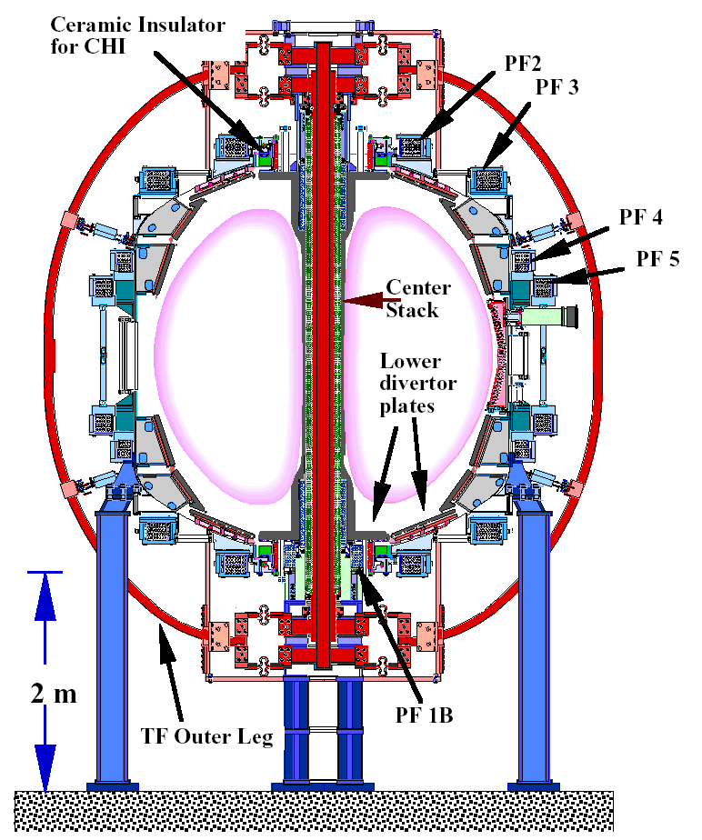

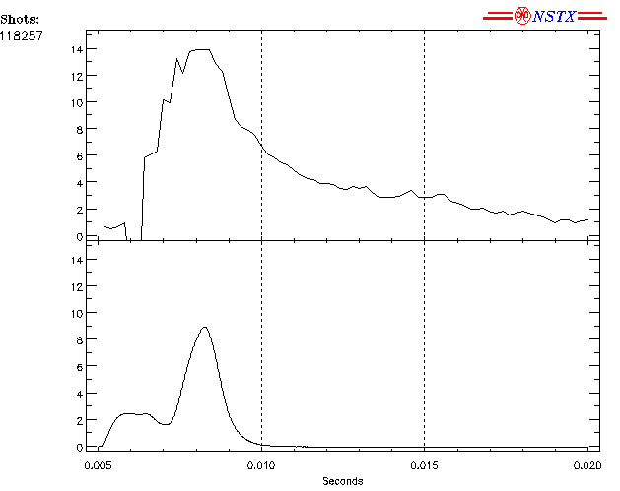
Fig. 1: The NSTX Machine layout showing the locations of the upper and lower insulator rings which allow the inner divertor plates and center stack to be biased with respect to the outer components to produce CHI. The PF1B and the lower PF2 coil are used to produce the CHI injector flux.

Figure 2: Shown are the plasma current, the injector current and fish-eye view of fast camera images of the CHI discharge inside the NSTX vessel. The bright region in the lower part of the image corresponding to 6ms, is the injector. Note that at 12 ms and beyond, the plasma discharge is disconnected from the injector region.

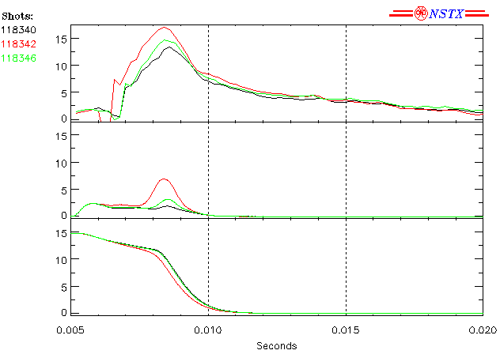

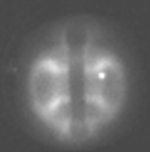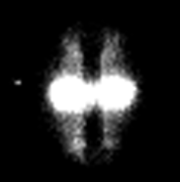
13ms
17ms

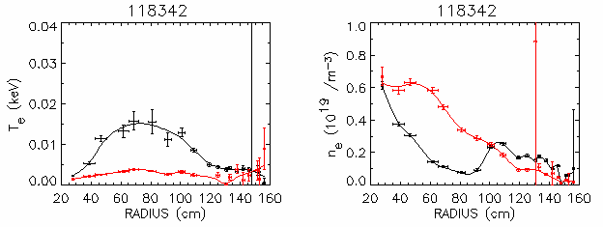

Figure 3: Shown are the plasma current, the injector current and the capacitor bank voltage. Thomson scattering electron temperature and density are shown at times corresponding to the fish eye camera images at 13 and 17ms. The red trace corresponds to 17ms, and the black trace to 13ms.
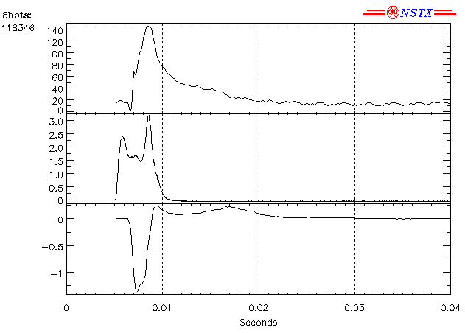
Plasma current (kA)
Injector current (kA)
Induced loop voltage (V)
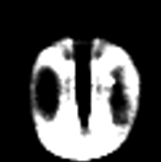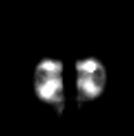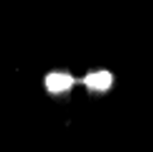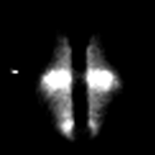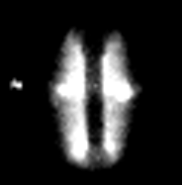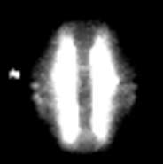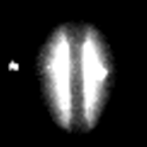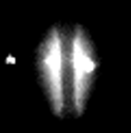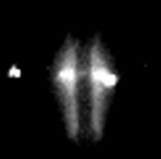
10ms
14ms
16ms
17ms
19ms
20ms
22ms
32ms
35ms
40ms

Figure 4: Plasma current, injector current and fast camera images for a discharge that persists for nearly 400ms.

