___________________________________________________________________________________________________________________________
Paper

Solenoid-free Plasma Startup in NSTX using Transient CHI

R. Raman¹, M.G. Bell², T.R. Jarboe¹, B.A. Nelson¹, D.Mueller², R. Maqueda³, R. Kaita², B. LeBlanc², J. Menard², T. Bigelow⁴, D. Gates², R. Maingi⁴, M. Nagata⁵, M. Ono², M. Peng⁴, S. Sabbagh⁶, M.J. Schaffer⁷, V. Soukhanowskii⁸, R. Wilson² and the NSTX Research Team

¹ University of Washington, Seattle, WA, USA
² Princeton Plasma Physics Lab., Princeton, NJ,USA
³ Nova Photonics, USA
⁴ Oak Ridge National Laboratory, Oak Ridge, TN, USA
⁵ University of Hyogo, Japan
⁶ Columbia University, New York, NY, USA
⁷ General Atomics, San Diego, CA, USA
⁸ Lawrence Livermore National Laboratory, Livermore, CA, USA

The favorable properties of the Spherical Torus (ST) arise from its very small aspect ratio. However, small aspect ratio devices have very restricted space for a substantial central solenoid. Thus methods for initiating the plasma current without relying on induction from a central solenoid are essential for the viability of the ST concept. Coaxial Helicity Injection (CHI) is a promising candidate for solenoid-free plasma startup in a ST. Previous experiments on the HIT-II ST at the University of Washington, have demonstrated the capability of a new method, referred to as transient CHI, to produce a high quality, closed-flux equilibrium that has then been coupled to induction, with a reduced requirement for transformer flux. This method has now been successfully used in the much larger NSTX device for an unambiguous demonstration of solenoid-free closed flux current generation. 60 kA of closed flux current has been generated using a few kA of injected current provided by a 15mF capacitor bank.

Key words: solenoid-free, CHI, ST, NSTX, plasma startup, spherical torus, coaxial helicity injection [ e-mail: raman@aa.washington.edu]

I. Introduction
The Spherical Torus is a magnetic confinement concept that has the advantages of high beta and a projected high fraction of bootstrap current drive. The favorable properties of the ST arise from its very small aspect ratio. However, such devices have very restricted space for a central solenoid, which restricts the inductive pulse duration, making sustained non-inductive operation necessary. Elimination of the central solenoid is essential for the viability of the ST concept and considered very important for the next generation of ST experiments. Thus, the development of methods to initiate and sustain a ST discharge without reliance on the central solenoid is a major element of the NSTX program plan⁽ ⁾.

Coaxial Helicity Injection (CHI) is a promising candidate both for plasma startup and for edge current drive during the sustained phase. The possibility of using CHI in a ST was first proposed in the late 1980's⁽⁾. The first experiments on helicity injection current drive in a ST were conducted on the Current Drive Experiment-Upgrade (CDX-U) at the Princeton Plasma Physics Laboratory (PPPL)⁽⁾. The concept gained support as a result of experiments conducted on the Proto-Helicity Injected Torus, and the Helicity Injected Torus - I (HIT-I) at the University of Washington⁽⁾. These experiments used a thick conducting copper wall for equilibrium control of the CHI produced plasma configuration. These were followed by two other experiments, the Helicity Injected Spherical Torus (HIST) in Japan and the SPHEX device in the UK⁽ ⁾. These devices also employed passive wall stabilization for equilibrium control and confirmed that CHI could be used in the presence of an external toroidal field for the generation of a plasma configuration. Later HIT was rebuilt as the HIT-II experiment, which extended CHI to a true ST device by employing poloidal field coils for equilibrium control.
* University of Washington, Seattle, WA, USA
** Princeton Plasma Physics Laboratory, Princeton, NJ, USA
*** Oak Ridge National Laboratory, Oak Ridge, TN, USA
**** University of Hyogo, Hyogo, Japan

The CHI method drives current initially on open field lines creating a current density profile in the poloidal (R-Z) plane that is hollow. Taylor relaxation⁽⁾ predicts a flattening of this current profile through a process of magnetic reconnection leading to current being driven throughout the volume, including closed field lines. Current penetration to the interior is needed for usefully coupling CHI to other current drive methods and to provide CHI produced sustainment current during an extended non-inductive phase.

In CHI discharges, there exists a minimum voltage between the injection electrodes that can produce sufficient injector current to allow the injector flux to expand into the main vessel. This is generally refereed to as the “bubble-burst” current. Below this bubble-burst current, the field lines do not move and the injector is effectively a short circuit. Once the bubble-burst current is exceeded then the injector acts approximately as a current regulator and the plasma flows away from the injector at the E/B speed with the back e.m.f. of this motion equal to the applied voltage.
__________________________________________________________________________________________________________________________
Solenoid-free plasma startup in NSTX using coaxial helicity injection
Fig. 1: The NSTX Machine layout showing the locations of the upper and lower insulator rings which allow the inner divertor plates and center stack to be biased with respect to the outer components to produce CHI. The PF1B and the lower PF2 coil are used to produce the CHI injector flux.

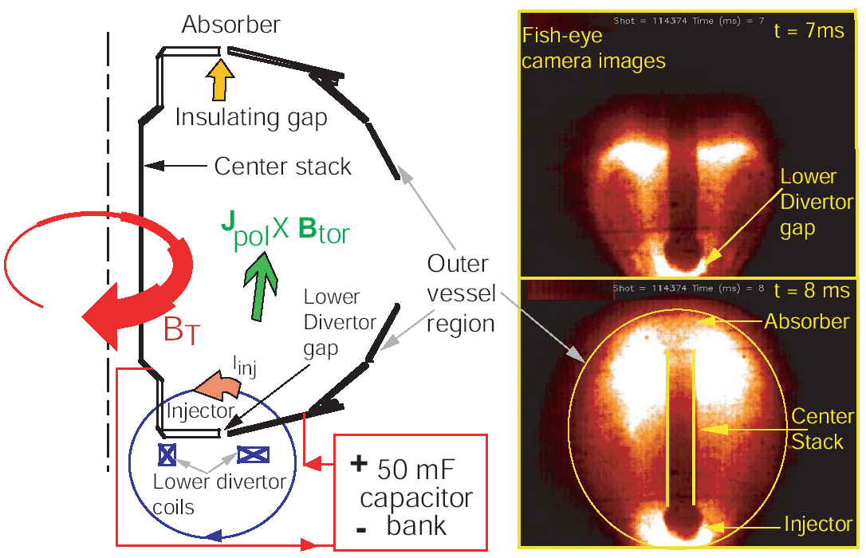

A requirement for successful CHI current drive is that the energy per unit helicity of the injected helicity must be higher than that dissipated by the equilibrium (λ_{inj}>λ_{tokamak}, where λ_{inj} = μ_{o}I_{inj}/ψ_{inj} and λ_{tokamak} = μ_{o}I_{p}/φ_{wall}); and the injected linked flux must flow into the equilibrium volume.
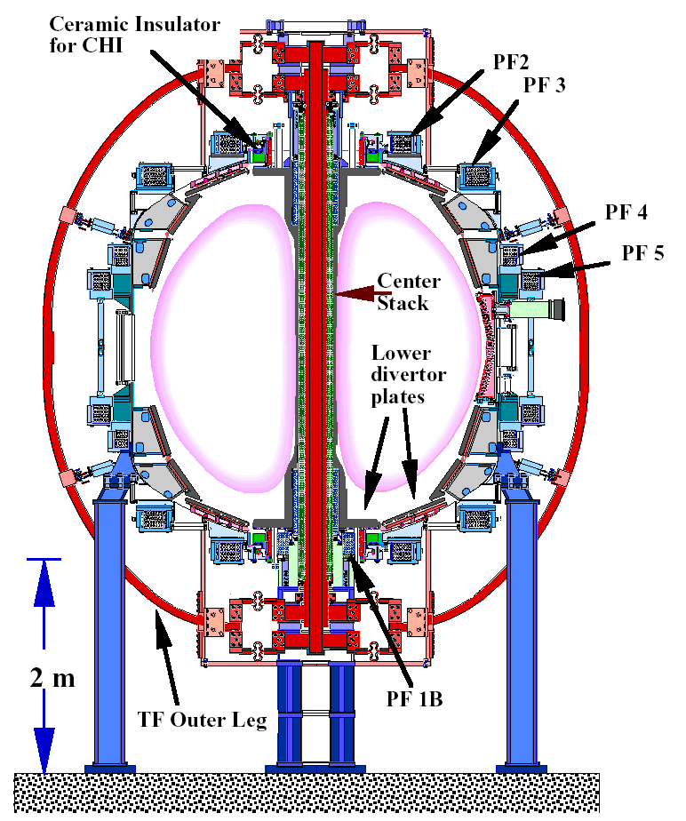
It was generally believed that the development of non-axisymmetric plasma perturbations is needed for plasma startup using CHI. This mode of CHI operation can be referred to as steady state CHI, during which the CHI injector circuit is continuously driven for some time (t_{pulse} > t_{L/R}). A significant development during the past three years has been the demonstration of a new mode of CHI operation, referred to as transient CHI⁽⁾. This mode involves an axisymmetric reconnection and has been highly successful on the HIT-II experiment. While the steady state approach is still needed for sustained edge current drive, transient CHI has been extremely successful on HIT-II. This method has now been successfully applied to the NSTX device to produce 60kA of closed flux current. The subsequent sections describe results from transient CHI experiments in NSTX.

Fig. 2: Implementation of CHI on NSTX. The fish eye camera images show the growth of a transient CHI discharge in the NSTX vessel. The lower divertor coils used to produce the CHI injector poloidal flux are below the lower divertor plates as shown in the line drawing in the left, and in Figure 1 The center stack, which is part of the inner vessel region, and the outer vessel region are electrically insulated from each other by toroidal ceramic insulators at the top and the bottom of the machine. The top region, above the upper divertor plates is referred to as the absorber region. The bottom region around the lower divertor plate region is referred to as the injector region, and the lower divertor plates act at the electrodes.

II. CHI Experimental Results

The nominal NSTX machine parameters are: major/minor radii of 0.85/0.65 m, elongation ≤ 2.5, plasma volume 12.5 m³ (Error: Reference source not found). The stainless steel vacuum vessel of NSTX (volume 30 m³) is fitted with toroidal ceramic breaks at the top and bottom so that the central column and the inner divertor plates (the inner vessel components) are insulated from the outer wall and the outer divertor plates as shown in Figure 1. These toroidal ceramic insulators also act as vacuum seals. Because of this, the inner divertor plate, which is part of the center stack assembly, is electrically separated from the outer divertor plates, which are part of the outer vessel assembly. poloidal field coils located beneath the lower divertor plates are used to produce poloidal flux, which is referred to as the injector flux. The flux pattern from these coils is such that it connects the lower inner and outer divertor plates, which are also the electrodes. Thus, in the presence of a plasma, currents can flow along these field lines from the lower outer divertor plate to the lower inner divertor plate2.
___________________________________________________________________________________________________________________________

__________________________________________________________________________________________________________________________
We refer to the lower gap connected by the poloidal field as the injector and the complementary upper gap as the absorber because when voltage is applied toroidal flux flows out of the injector and into the absorber.

CHI is implemented on NSTX by driving current along field lines that connect the inner and outer lower divertor plates. For transient CHI, a 15 or 20 mF capacitor bank was used at up to 1.5 kV to provide the injector current. The standard operating condition for CHI in NSTX uses the inner vessel and inner divertor plates as the cathode while the outer divertor plates and vessel are the anode.

The operational sequence for CHI involves first energizing the toroidal field coils and the CHI injector coils to produce the desired flux conditions in the injector region. The CHI voltage is then applied to the inner and outer divertor plates and a pre-programmed amount of gas is injected in a cavity below the lower divertor plates. These conditions cause the gas in the lower divertor region to ionize and result in current flowing along helical magnetic field lines connecting the lower divertor plates. The ratio of the applied toroidal field to the poloidal field causes the current in the plasma to develop a strong toroidal component, the beginning of the desired toroidal plasma current. If the injector current exceeds a threshold value, the resulting ∆B_{tor}², (J_{pol} × B_{tor}), stress across the current layer exceeds the field-line tension of the injector flux causing the helicity and plasma in the lower divertor region to move into the main torus chamber. Once extended into the vessel, currents need to be driven in the poloidal field coils for equilibrium position control.

II.I Transient CHI

A feature of CHI plasma generation using this method is that unambiguous flux closure can be demonstrated by the persistence of plasma current after the injector current has been reduced to zero. Closed flux is achieved by appropriate programming of the injector current, which can be easily achieved using a small capacitor based power system. The capacitor bank is sized so that the energy in the capacitor bank mostly drains by the time the CHI produced plasma has fully elongated. This causes the expanding plasma column to detach from the injector region, through a process of 2D axi-symmetric reconnection and produce closed flux, analogous to the detachment of a solar flare on the surface of the sun. Most of the divertor flux then reconnects the divertor electrodes again, the short way around; some of the remaining capacitor energy is dissipated along these field lines, in the private flux region. The method is simple and highly reproducible and works very well on HIT-II. It has allowed HIT-II consistently to produce higher current discharges than was possible by induction alone. Compared to inductive only operation, it is relatively insensitive to field errors and changing wall conditions(Error: Reference source not found).

The first attempts to apply transient CHI in NSTX used a brief voltage pulse using the programmable rectifier power supply, while simultaneously ramping down the PF1b and PF2L coil currents. Two issues were quickly apparent. These were (a) a significant variability in the discharge initiation time and (b) the inability to reduce the injector current quickly once the discharge formed. The power supplies used for CHI are well suited for the long pulse steady-state discharges. However for transient CHI, the timing of the voltage pulse needs to be synchronized with the gas injection, so that the least amount of gas could be used for initiating the discharge. When the injected gas pressure was reduced, the thyristor switches used in the rectifier power supplies did not maintain a voltage across the load.
This led to the design and construction of a capacitor based power system for transient CHI experiments in NSTX.

In Figure 2, we show traces for the plasma current, the injector current and fast camera images at different times during the discharge. The CHI cap bank discharge is initiated at 5ms. The images show a rapid growth of the discharge that fills the vessel within about 2ms. Then starting at about 10ms, the discharge begins to disconnect from the injector electrodes. At 10ms, the injector current is essentially zero and about 60kA of plasma current is present. As time progresses, the large bore plasma that fills the vessel shrinks in size and after about t=13 or 14ms, ends up as a small diameter ring that decays during the subsequent 5ms. The formation of closed flux regions is clearly seen in the camera frames corresponding to 12ms and beyond. Since there is no injector current during this period, the left over plasma current must be from a decaying closed flux configuration.

In Figure 3, we show similar traces for a discharge for which Thomson scattering electron temperature measurements were made. In general, Thomson profiles at later times are less hollow than at earlier times. This is consistent with the CHI startup method, since initially CHI drives current at the edge. After reconnection in the injector region, one expects the current profile to flatten out, which should result in the profiles becoming less hollow. The measured electron temperatures of about 15 to 20ev, combined with a plasma inductance of about 0.5 to 1 micro-Henry, should result in an e-folding current decay time on the order of about 5ms, which is consistent with the observation that the current persists for about 10ms after the injector current has been reduced to zero.

In other discharges, shown in Figure 4, the plasma current shrinks in size as described above, then at about 19ms, it becomes diffuse and spreads up along the center stack. This generally happens when the plasma current is about 10 to 20kA. Because the small bore plasma discharge now expands to fill a much larger area along the center stack, the light emission decreases and continues to remain faint for the subsequent 15ms (until about t=35ms). Then, the discharge begins to reduce in elongation and past 35ms, it once again becomes a faint small bore plasma that appears to persist for as long as the equilibrium coil currents are not reduced to zero. In the longest duration discharge, a 15 to 20kA plasma discharge remained for nearly 400ms. Since in an ST, the toroidal field near the center stack is very large, it is not know at this time if this discharge contains a thermal population of electrons, or if it is dominated by energetic electrons, although the current persistence for such long periods may suggest the possibility of fast electron discharge channel.

_______________________________________________________________________________
___________________________________________________________________________________________________________________________
Solenoid-free plasma startup in NSTX using coaxial helicity injection

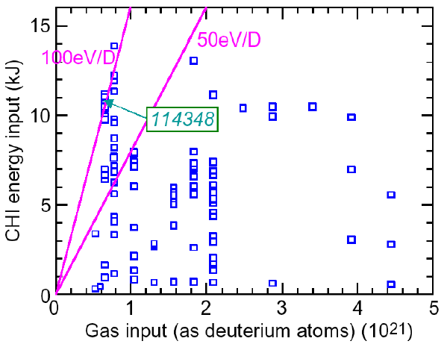
Fig. 3: Total amount of injected gas versus energy input per particle. Only for the lowest total gas injection cases, there is sufficient energy in the capacitor bank to ionize fully and heat the injected particles. Reducing the amount of injected gas with improved pre-ionization and increasing the bank voltage closer to the full 2kV limit will increase the available energy by a factor of four and provide more energy per particle.

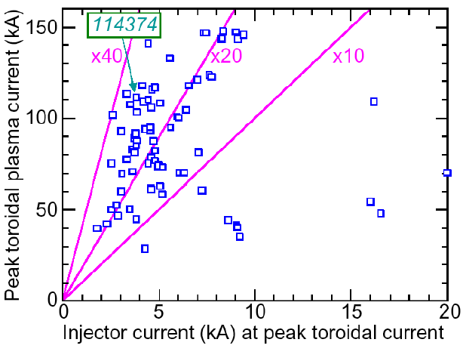
Fig. 4: Plot of the obtained toroidal current to injector current. Discharges with the lowest injector current have the highest current multiplication. Discharges with the lower injector current also have the lower injector flux and the lower values for the total gas injection.

___________________________________________________________________________________________________________________________
__________________________________________________________________________________________________________________________

___________________________________________________________________________________________________________________________
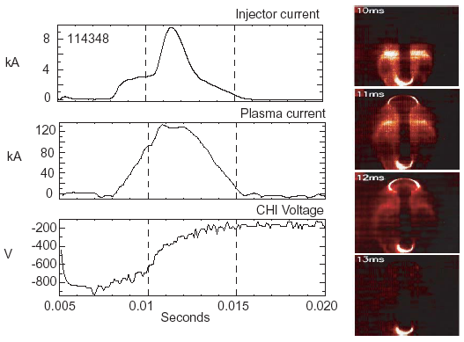
Fig. 5: A transient CHI discharge using the capacitor bank. The images on the right are fish-eye visible images from a fast camera.

________________________________________________________________________________

Solenoid-free plasma startup in NSTX using coaxial helicity injection

___________________________________________________________________________________________________________________________
___________________________________________________________________________________________________________________________

Fig. 6: The present NSTX CHI absorber insulator and surrounding structure.

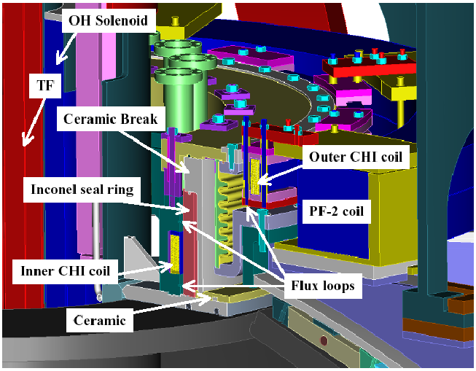
Solenoid-free plasma startup in NSTX using coaxial helicity injection

III Conclusions

Transient CHI experiments on NSTX thus far have succeeded in producing about 60 kA of closed flux toroidal current using less than 4 kA of injector current. Measured electron temperatures are similar to those seen on the HIT-II experiment. As time progresses, the measured profiles become less hollow, consistent with the expectations of CHI startup. Some discharges persist for very long durations, and seem to limited only by the lack of the presence of a vertical field.

Acknowledgements

We also acknowledge the NSTX team for support with machine operation and diagnostics. This work is supported by DOE contract numbers: FG03-96ER5436, DE-FG03-99ER54519 and DE-AC02-76CH03073.

________________________________________

References
_________________________________________________________________________________

________________________________________________________________________________

(?) M. Ono et al., “Exploration of spherical torus physics in the NSTX device,” Nucl. Fusion 40, 3Y 557 (2000).
(?) S.M. Kaye et al., “Physics design of the National Spherical Torus experiment,” Fusion Technol. 36, 16 (1999).
(?) T.R. Jarboe, “Formation and steady-state sustainment of a tokamak by coaxial helicity injection,” Fusion Tech. 15, 7 (1989).
(?) M. Ono, et al., “Steady-state tokamak discharge via dc helicity injection,” Phys. Rev. Lett. 44, 393 (1980).
(?) B.A. Nelson, et.al., “Formation and sustainment of a low-aspect ratio tokamak by CHI,” Phys. Plasmas 2, 2337 (1995).
(?) M. Nagata et al., “The internal magnetic field structures and current density profiles in the Helicity Injected Spherical Torus (HIST) plasma driven by coaxial helicity injection,” Phys. Plasmas 10, 2932 (2003).
(?) P.K. Browning et al., “Injection and sustainment of plasma in a preexisting toroidal field using a coaxial helicity source,” Phys. Rev. Lett. 68, 1722 (1992).
(?) J.B. Taylor, “Relaxation and magnetic reconnection in plasmas,” Reviews of Modern Physics 58, 741 (1986).
(?) A. Sykes, “The spherical tokamak program at Culham,” Nucl. Fusion 39, 1277 (1999).
(?) T.R. Jarboe, “Review of spheromak research,” Plasma Phys. Control. Fusion 36, 945 (1994).
(?) R. Raman, et al., “Demonstration of plasma startup by coaxial helicity injection,” Phys. Rev. Lett., 075005-1 (2003).
(?) R. Raman, et al., “Experimental demonstration of plasma startup by coaxial helicity injection,” Phys Plasmas 11, 2565 (2004).
(?) S.P Hirshman and G.H. Neilson, “External inductance of an axisymmetric plasma,” Physics Fluids 29, 790 (1986).
(?) D. Mueller, et al., “Design and installation of new insulator for NSTX CHI experiments,” 44th APS-DPP meeting, Orlando, Florida, Nov 11-15 (2002).
(?) D.J. Den Hartog, et al., “Impurities, temperature and density in a miniature electrostatic plasma and current source,” Plasma Sources Sci. Technol. 6, 492 (1997).

