Princeton Plasma Physics Laboratory
NSTX-U Experimental Proposal
Title: Make contact with NSTX for n=1 tearing stability
OP-XP-1544 | Revision: 1 | Effective Date:  (Approval date unless otherwise stipulated)  Expiration Date:  (2 yrs. unless otherwise stipulated)
PROPOSAL APPROVALS
Responsible Author: Robert J. La Haye |  |  | Date  March 27, 2016
SG, TSG or TF Leader (assigned by RC): J.W. Berkery |  |  | Date
Run Coordinator (RC): J.E. Menard |  |  | Date
Responsible Division: Experimental Research Operations
RESTRICTIONS or MINOR MODIFICATIONS
(Approved by Experimental Research Operations)

NSTX-U EXPERIMENTAL PROPOSAL
TITLE: Make contact with NSTX for n=1 tearing stability | No. OP-XP-1544
AUTHORS: La Haye, Paz-Soldan, Gerhardt, Myers | DATE: 03/27/16

1. Overview of planned experiment
This XP seeks to contrast the stability and physics of tearing modes in NSTX-U with that previously studied in the somewhat lower aspect ratio NSTX. This XP will be conducted using high beta H-mode plasmas with on-axis beams only.
The runtime allocation for this XP is 0.5 days in MS TG.
Summary outline:
1. Establish the conditions for the onset and growth to large amplitude without locking of an n=1 (m=2) tearing mode with pre-programmed step downs in beam power timed to be near the maximum amplitude such that beta goes low enough for self-stabilization (the marginal point) staying in H-mode without locking. Decision point (based on experience with NSTX-U plasmas through April 1, 2016): select an option from below…
A. At same Ip and TF coil current as studied on NSTX for same 0.9 MA and now lower 0.42T at new larger R0 (6 shots)
B. With same Ip, 0.9 MA, but 31% higher TF current for 0.55 T to match q95 as studied on NSTX (6 shots)
C. With same field, 0.44 T at new larger R0, as A but with Ip 31% lower at 0.7 MA to match q95 as on NSTX (6 shots)
2. New and not done on NSTX would be to get scaling with equilibrium magnetic field. A factor of 1.5 from 1A, for example, would be Ip=1.35 MA and BT=0.63T at new larger R0 which are within NSTX-U limits for mid-2016, i.e. 1.4 MA and 0.65 T per C. Meyers and D. Boyer. (6 shots)

2. Theoretical/ empirical justification
In NSTX at 0.9MA and 0.44T at old smaller R0, a prescription was found for reproducible onset of m/n=2/1 tearing modes with self-stabilization at the "marginal" condition on NBI step-down. Stability was interpreted as close to marginal classical tearing with balance thus between stabilizing curvature DR term and neoclassical bootstrap destabilization term Dnc; the stabilizing curvature effect is weak at large aspect ratio as in DIII-D (R/a=2.7) for the ratio scales as DR/Dnc ~-1.2*(a/R)**2 all else equal [1]. NSTX-U has somewhat larger aspect ratio than NSTX (R/a up from 1.4 to 1.7) so that the relative stabilizing effect of curvature should be decreased by a third, opening up the difference between onset beta and marginal beta. This XP will investigate this and make NSTX-U n=1 tearing onset beta contact with NSTX at similar parameters.

[1] R.J. La Haye, R.J. Buttery, S.P. Gerhardt, S.A. Sabbagh, and D.P. Brennan, “Aspect ratio effects on neoclassical tearing modes from comparison between DIII-D and National Spherical Torus Experiment”, PHYSICS OF PLASMAS 19, 062506 (2012).

3. Experimental run plan
1. Establish the onset, growth and marginality without locking of an n=1 (m=2) tearing mode (6 shots)

Experiment would be carried out as for NSTX #134020 with reproducible n=1 tearing onset using modest Li evaporation, IP=0.9 MA and TF-coil current same as before for BT=-0.42 T at now larger R0 as close to NSTX parameters. Of choices 1ABC, choice 1A allows easiest scaling to higher field subject to 2016 constraints although q95 somewhat lower. On-axis NBI only for H-mode and a preprogramed step-down of NBI power aiming to lower beta after tearing onset, stay in ELMing H-mode, keep n=1 tearing mode rotating (no locking to the wall) and self-stabilization at the "marginal" condition.
Shape and cross-section as in 134020 but the minor radius a is smaller (x0.92?), the major radius R0 is larger (X1.05?) and thus R/a is larger; so q95 is smaller (X0.77?).
Unless an active “dud” on n=1 Mirnov is available preprogrammed, and several half-beam steps [as in NSTX Ref 1 preprogrammed keeping beam 1A (for MSE) on as long as possible] from where n=1 Mirnov amplitude is expected to peak.
Needs best EFC to avoid n=1 wall locking before self-stabilization occurs and before H to L back transition occurs. Was density a trick to use on 134020? Recent Li evaporation helped.

2. Repeat 1 with 1.5 times Ip and BT as in 1 (6 shots)

Will 3 co-beams be enough to raise beta high enough to destabilize n=1 (m=2) mode at square of B 2.25X larger? Beta on 134020 was high enough at constant 3 MW NBI to excite mode. Equivalent would be 6.75 MW so marginal?

4. Required machine, NBI, RF, CHI and diagnostic capabilities

Machine:

All n=0 systems required for H-mode operation.
RWM coils and SPA power supplies for best EFC.
Require three on-axis NB1 sources. Desire 1A at 90 kV for diagnostic reasons.

Diagnostics:

Require all magnetic diagnostics, including RWM/EF sensors.
Require toroidal CHERS.
Desire all available rotation diagnostics: CHERS, rtCHERS, ERD, etc.
Require EFIT.
Require Thomson scattering.
Require MSE.

Prerequisite XMPs:

XP-1506: Low-β, low-density locked mode studies

5. Planned analysis
Primary analysis will be based on the mhd_odd_n_lowf sensor data etc including q-profile reconstructions
from MSE EFITs, as well as rotation and Ti data from CHERS and Thomson for kinetic EFITs.

DCON and PEST3 analysis will also be performed on kinetic EFITs to estimate the DR and Dnc terms
for comparison to that done for NSTX.

6. Planned publication of results
A follow up paper to that of Ref [1] could be warranted documenting any changes in tearing stability between NSTX and NSTX-U or lack thereof.

7. Estimated Neutron Production
Based on the number of shots, plasma current levels, and expected durations, estimate the maximum neutron production of this experiment. See calculator in Appendix #2 for this calculation.
# of Shots used in Estimate:__12______ Estimated Total Neutron Production:___3.0e+15_
PHYSICS OPERATIONS REQUEST
TITLE: Make contact with NSTX for n=1 tearing stability | No. OP-XP-1544
AUTHORS: La Haye, Paz-Soldan, Gerhardt, Myers | DATE: 2/10/2016

Brief description of the most important operational plasma conditions required and any special hardware requirement:
H-mode discharges with high kappa
Best EFC needed to avoid locking with mode as torque reduced
After Li evaporation made routine in order to achieve reproducibility?? Or not standard??
Previous shot(s) which can be repeated: TBD
Previous shot(s) which can be modified: 134020 on NSTX
Machine conditions (specify ranges as appropriate, strike out inapplicable cases)
B_{T} Range (T): 0.42 – 0.63 Flattop Duration (s): 1
I_{P} Range (MA): 0.9 – 1.35 Flattop Duration (s): 1
Configuration: DN
Equilibrium Control: Outer gap / Isoflux (rtEFIT) / Strike-point control (rtEFIT)
Outer gap (m): 0.105 Inner gap (m): 0.072 Z position (m): Centered
Elongation: 2.245 Triangularity (U/L): 0.412/0.744 OSP radius (m): ~0.36
Gas Species: D2 Injector(s): As appropriate
NBI Species: D2 Heating Duration (s): 1
Voltage (kV) 50 cm (1C): 90 60 cm (1B): 90 70 cm (1A): 90
Voltage (kV) 110 cm (2C): 120 cm (2B): 130 cm (2A):
ICRF Power (MW): Off Phase between straps (°): Duration (s):
CHI: Off Bank capacitance (mF):
LITERs: Off ?? Total deposition rate (mg/min) or dose per discharge (mg): ??
EFC coils: On
THIS PAGE IS BLANK
DIAGNOSTIC CHECKLIST [1]
TITLE: Make contact with NSTX for n=1 tearing stability | No. OP-XP-1544
AUTHORS: La Haye, Paz-Soldan, Gerhardt, Myers | DATE: 02/11/2016

Note special diagnostic requirements in Sec. 4
Diagnostic | Need | Want
Beam Emission Spectroscopy
Bolometer – midplane array |  | X
CHERS – poloidal |  | X
CHERS – toroidal | X
Divertor Bolometer (LADA)
Divertor visible cameras
Dust detector
Edge deposition monitors [2]
Edge neutral density diag.
Edge MIGs [2]
Penning Gauges [2]
Edge rotation diagnostic |  | X
Fast cameras – divertor [2]
Fast ion D_alpha - poloidal
Fast ion D_alpha - toroidal
Fast lost ion probes - IFLIP
Fast lost ion probes - SFLIP
Filterscopes [2] | X
FIReTIP
Gas puff imaging – divertor
Gas puff imaging – midplane
Hα cameras - 1D [2]
Infrared cameras [2]
Langmuir probes – divertor
Langmuir probes – RF
Langmuir probes – RF ant.
Magnetics – Diamagnetism | X
Magnetics – Halo currents
Magnetics – RWM sensors | X

Note special diagnostic requirements in Sec. 4
Diagnostic | Need | Want
MAPP
Mirnov coils – high f. |  | X
Mirnov coils – toroidal array | X
MSE-CIF | X
MSE-LIF | X
Neutron detectors [2] | X
Plasma TV
Reflectometer – 65GHz
Reflectometer – correlation
Reflectometer – FM/CW
Reflectometer – fixed f
Reflectometer – SOL
SSNPA [2]
RF edge probes
Spectrometer – divertor
Spectrometer – MonaLisa
Spectrometer – VIPS
Spectrometer – LOWEUS
Spectrometer – XEUS
TAE Antenna
Thomson scattering | X
USXR – pol. Arrays
USXR – multi-energy
USXR – TG spectr.
Visible Brems. det. [2]

Notes:

[1] Check marks in this table do not guarantee diagnostic availability. Check with diagnostic physicists or research operations management to ensure diagnostic coverage.

[2] In some cases, a given line represents multiple diagnostics. For instance, there are multiple SSNPAs, multiple IR cameras, multiple neutron detectors, and multiple Langmuir probe arrays.

Appendix #1: Allowed Neutral Beam Power vs. Pulse Duration

Heating of the primary energy ion dump limits the beam duration to that given in the following table:
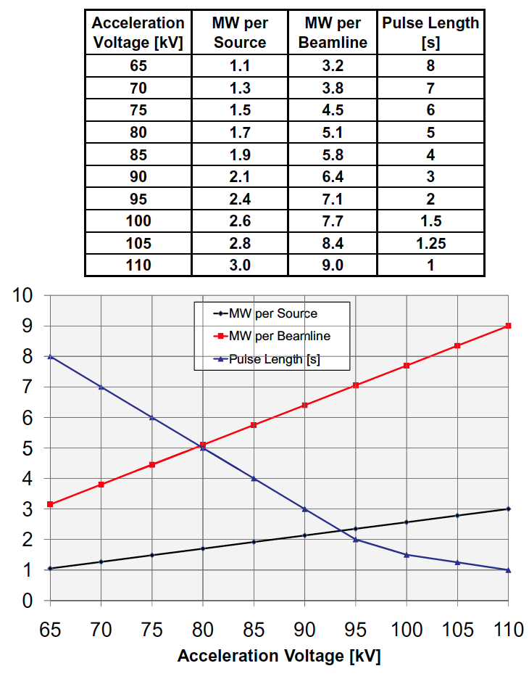
Table A1: Beam power and pulse length as a function of acceleration voltage

Appendix #2: Table for neutron rate estimations:

Table A2: Neutron Emission Rate Calculator. Double click to open in excel for automatic calculation. Change only the blue cells.

J.E. Menard, et al., Nuclear Fusion 52, 2012 (83015)

