Investigation of MHD Phenomena in NSTX using a Fast Soft X-ray Imaging Camera

C.E. Bush¹, B.C. Stratton², J. Robinson², L.E. Zakharov², E. Fredrickson², D. Stutman³, K. Tritz³

¹Oak Ridge National Laboratory, Oak Ridge, TN bushce@ornl.gov
²Princeton Plasma Physics Laboratory, Princeton, NJ bstratton@pppl.gov
³Johns Hopkins University, Baltimore, Md dstutman@pppl.gov

Theory and experiments indicate that MHD phenomena can cause significant fast particle losses which in turn lead to heating power loss and elevated wall power loading in present experiments and possibly future burning plasma devices. It is important for STs, ITER, and ITPA database scaling to understand the dominant MHD modes and their effects on fast particles. We have studied the spatial structure and time behavior of the MHD in NSTX using a unique fast soft x-ray imaging camera with a wide-angle (pinhole) tangential view of nearly the entire plasma minor cross section. The camera provides a 64x64 pixel image, on a CCD chip, of light resulting from conversion of soft x-rays incident on a phosphor to the visible. Frame rates up to 500 kHz (300 frames/shot) are available.

I. Introduction

The Fast Soft X-ray imaging camera is now established as a major diagnostic for study of magnetohydrodynamic (MHD) instabilities in high temperature magnetically confined plasmas. It has now been used for MHD studies on several toroidal fusion research devices. These include the Tokamak Experiment for Technology Oriented Research (TEXTOR), the Large Helical Device (LHD), and the National Spherical Torus Experiment (NSTX) at the Princeton Plasma Physics Laboratory. Theory indicates that the alpha heating power in sawtoothing ITER discharges could be reduced compared to non-sawtoothing plasmas. Effects on alphas have been observed experimentally during sawtoothing DT discharges on TFTR and JET. Theory and experiment also indicate that sawteeth cause redistribution of fast particles resulting from NBI. It is important for STs, ITER, and ITPA database aspect ratio scaling to understand the spatial structure of the associated modes in order to understand how they interact with the fast particles. We have studied the spatial structure and time behavior of the MHD in NSTX using Fast X-ray Camera Imaging. This includes use of a range of Be foil thicknesses to investigate different parts of the soft X-ray spectra associated with different modes. Highly reproducible and strongly sawtoothing target plasmas are also used. One example was a 1 second duration discharge, which showed EPMs early in the shot and later, sawteeth when the q was reduced. In addition it is possible the sawteeth could trigger NTMs. The target discharges include L-mode, H-mode, and He plasmas.

The goal is to study the physics of the interaction of the MHD with the plasma on NSTX using fast soft x-ray camera imaging. We have acquired plasma images at frame rates of 1-500 kHz, and have observed a variety of MHD phenomena: internal reconnection events, disruptions, sawteeth, fishbones, tearing modes, and ELMs. This is important to ITER due to fast particle (α’s,etc.) losses.

II. Experimental Setup

The pinhole camera with a wide-angle tangential view of the plasma [1-4] is based on the Princeton Scientific Instruments PSI-5 CCD camera. It has a 64 X 64 pixel image, and frame rates up to 500 kHz for 300 frames. The soft x-rays (~1-5 keV) converted to visible light by fast P47 phosphor deposited on fiber-optic faceplate, and the electrostatic image intensifier and lenses demagnify the image by 6:1 and couple light to the CCD. The remotely selectable pinholes (1-5 mm diameter) allow tradeoff of spatial resolution and signal level, and the remotely selectable beryllium foils allow low-energy cutoff to be varied.

The horizontal field-of-view of the fast soft x-ray imaging camera (FSXIC) is shown in Figure 1. The view includes nearly the full minor cross-section of the NSTX chamber.

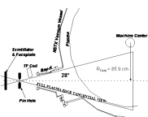

Fig. 1. Tangential view of the Fast Soft X-ray Imaging Camera on NSTX. The pinhole size is remotely changeable from 1 to 5 mm.

In NSTX, β_{t} is normally relatively high such that the hot core is Shaframov shifted toward the low B_{t} field side of the cross section that is always fully viewed by the FSXIC. Also shown is the location of the pinhole, which is remotely selectable from 1 to 5mm. Behind the pinhole is a filter array, which includes a remotely selectable variety of thicknesses and material (Be, T_{i}). Usually Be filters are used. The variety of filters and apertures allow viewing of a wide spectrum of plasma temperatures and MHD behavior. Figure 2 is a photograph of the FSXIC as it is installed on its viewing port on the machine. Also, there is an image intensifier installed between the pinholes and foils and the CCD camera. All components of the complete FSXIC system are indicated in the photograph.

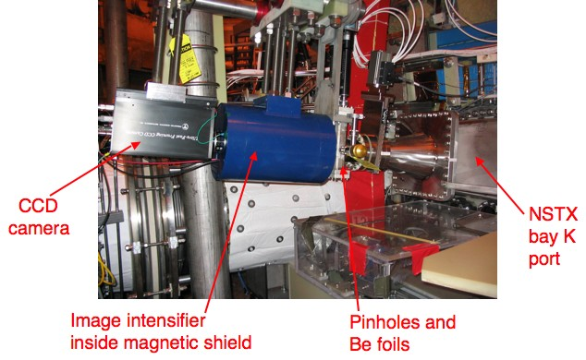

Fig. 2. Photograph of the Fast Soft X-ray Imaging Camera (FSXIC) system as installed on NSTX

III. RESULTS AND DISCUSSIONS

A good case illustrating the effectiveness of images (or snapshots) of MHD activity is that of discharge (shot) 113778). A grayscale image at t = 0.176 s of the recorded 300 frames (images) taken is shown in Figure 3. In this case the dynamics of the images correlated very well with data from core chordal data of an array of soft X-ray (SXR) diodes.

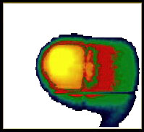

Fig. 3. FSXIC image for one frame of the 300 recorded for shot 113778.

The train of 64x64 pixel images/snapshots shows the time evolution of the Mode structure. Figure 4 shows time traces for a centrally viewing and an off axis viewing SXR diode. The SXR diodes show the mode to turn on at t = 0.175 s, and oscillate at 2.5 kHz through the time of Fig. 4. The camera was run at 100 kHz for 3 ms.

Most of the data to date has been obtained using the thinner B_{e} foils, mainly a 7.6 mm Be foil thus limiting observation to lower temperature (often ohmic) plasmas. In many cases coherent modes and their spatial extent are clearly discernable in the images before additional processing.

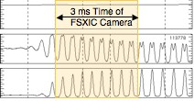

Fig. 4. Ip, and two SXR diode time traces for shot 113778. The first is for a centrally viewing diode and the second is for a diode viewing above the midplane.

A m/n=1/1 tearing mode was observed which showed structure with coherent oscillations. This was in agreement with the (central) chords of an array of soft x-ray detectors. The signal is plotted in Fig.4. The plasma current was I_{p} = _500 kA. The effects of the mode were seen in the stored energy, which decreased rapidly at the onset of the mode at t = 0.174 s. The camera was run at 100 kHz for 3 ms beginning at t = 0.175 s. A Singular value decomposition (SVD) analysis was done of the full train of images [5], 300 frames, from t = 175 s to t = 0.178 s.
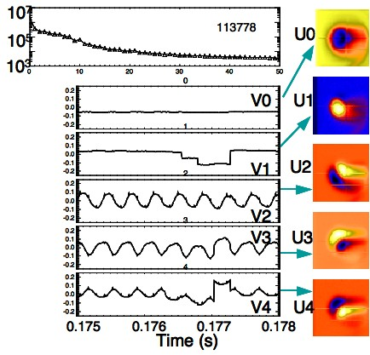
SVD was used in order to extract separate coherent fluctuations in space and time from background noise. SVD identifies major components of the dynamics recorded in the images. The camera images yield a matrix A(MxN) of N time series of M frames, where M = 300 frames per shot. The matrix A is decomposed into 3 matrices such that
d
Figure 5 Results of SVD for shot 113778
a
b
c
e
f
A(MxN) = UWV^{T}.
Where:
U(MxN) - columns are spatial vectors (topos)
V(NxN) - columns are temporal vectors (chronos) W(NxN)- a diagonal matrix (of weights)
g
h
i
j
k
Figure 5 summarizes results of the SVD, Figure 5a and b-f and g-k, where b-f are the time (chronos, V0 – V4) behaviors of the first five dominant modes and g-k are the respective spatial structures (topos, U0 – U4) for each of the chronos.

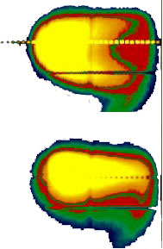

Fig. 6. Two consecutive frames in time for shot 113355

Figure 6 shows two frames of a second plasma that were taken 2 ms apart. A centrally viewing (perpendicular) SXR diode trace for the plasma is shown in Figure 7. The MHD mode is triggered at t = 0.226 s, beginning at a modest oscillation frequency and slows to a lower frequency toward the end of the burst. In this case the FSXIC was operated at 10 kHz, so that the 300 frames covered 30 ms, or nearly the full duration of the MHD burst. Again a SVD analysis of the images was done and the results are shown in Figure 8 (shot 113355). The chronos extracted by the SVD clearly match the SXR diode time trace of Fig. 7. Some of the major topos are slightly more complex in this case than those for the case of Fig, 5.

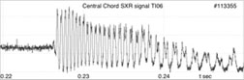Fig. 7. SXR diode trace for shot 113355.

A new code (Cbbst) [6] was written to simulate the line integral of the camera data and to invert it assuming a simple spatial dependence of ε= ε(a+ξ), where a is a flux surface label corresponding to the square root of the toroidal magnetic flux and ξ(a,θ,ϕ) is a perturbation that may include both ideal and tearing types of perturbations.
Step-like m/n=1/1 perturbations were considered.

The 21 radial values of the ε(a_{i}) function and the amplitude and phase of the ξ_{1/1} perturbation are reconstructed from the 64 X 64 data array S_{ij} using singular value decomposition and an iterative technique for solving the integral equation, which becomes non-linear in the presence of perturbations.

The plasma equilibrium was generated by the Equilibrium and Stability Code [4] using a plasma boundary reconstructed by the EFIT code and TRANSP code simulations of plasma pressure and q profiles.

II. CONCLUSIONS

A variety of MHD cases have been investigated on NSTX. A few cases were presented and discussed in this report. Simple m/n=1/1 modes are clear in the camera images and in results of SVD analysis. More complicated MHD cases and for higher temperatures will be studied in future experiments.

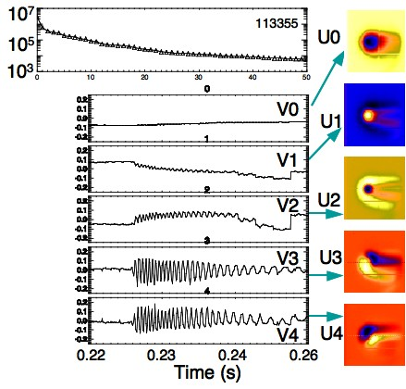

Fig. 8. SVD for shot 113355. The chronos match the time behavior of the SXR diode of Fig. 7.

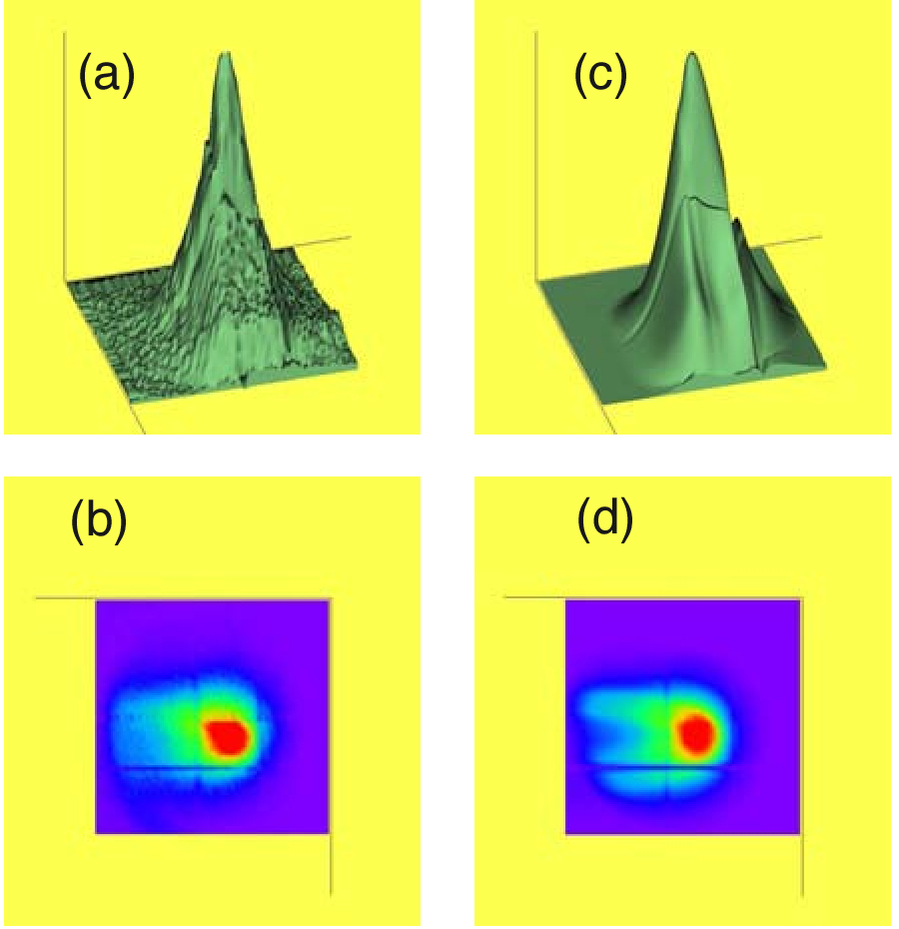

Fig. 9. (a) Surface and (b) contour plots of actual plasma emissivity (from FSXIC images) for shot 113355. The reconstructions are shown in (c) and (d) respectively.

ACKNOWLEDGMENTS

*This work was supported by US DOE contract DE-AC05-00OR22725.

REFERENCES

1. S. von Goeler, et al., Rev. Sci Instrum. 70 (1999) 599.
2. B. C. Stratton, et al., Rev. Sci Instrum. 75 (2004) 3959.
3. B.C. Stratton, S. von Goeler, D. Stutman, K. Tritz, and L.E. Zakharov, “Be Foil Filter Knee Imaging NSTX Plasma with Fast Soft X-Ray
Camera”, 32nd EPS Conference on Plasma Phys. Tarragona, 27 June - 1 July 2005 ECA Vol.29C, P-1.060 (2005)
4. B.C. Stratton, S. von Goeler, D. Stutman, K. Tritz, and L.E. Zakharov, “Be Foil Filter Knee Imaging NSTX Plasma with Fast Soft X-Ray
Camera”, PPPL Report PPPL-4093, August 2005
5. S. Ohdachi et al. Rev. Sci. Instrum., 74 (2003) 2136.
6. L. E. Zakharov and A. Pletzer, Phys. Plasmas 6 (1999) 4693

