Progress towards high performance, steady-state Spherical Torus *
M. Ono, M.G. Bell, R.E. Bell, T. Bigelow¹, M. Bitter, W. Blanchard, J. Boedo², C. Bourdelle³, C. Bush¹, W. Choe⁴, J. Chrzanowski, D.S. Darrow, S.J. Diem⁵, P.C. Efthimion, J.R. Ferron⁶, R.J. Fonck⁵, E.D. Fredrickson, G.D. Garstka⁵, D.A. Gates, L.R. Grisham, W. Heidbrink⁷, K.W. Hill, J.C. Hosea, T.R. Jarboe⁸, D.W. Johnson, R. Kaita, S.M. Kaye, C. Kessel, J.H. Kim⁴, M.W. Kissick⁵, S. Kubota⁹, H.W. Kugel, B.P. LeBlanc, K. Lee¹⁰, S.G. Lee¹¹, B.T. Lewicki⁵, R. Maingi¹, R. Majeski, J. Manickam, R. Maqueda¹², T.K. Mau², E. Mazzucato, S.S. Medley, J. Menard, D. Mueller, B.A. Nelson⁸, C. Neumeyer, N. Nishino¹³, C.N. Ostrander⁵, D. Pacella¹⁴, F. Paoletti¹⁵, H.K. Park, W. Park, S.F. Paul, Y.-K. M. Peng¹, C.K. Phillips, R. Pinsker⁶, P.H. Probert⁵, S. Ramakrishnan, R. Raman⁶, M. Redi, A.L. Roquemore, A. Rosenberg, P.M. Ryan¹, S.A. Sabbagh¹⁵, M. Schaffer⁶, R.J. Schooff⁵, C.H. Skinner, A.C. Sontag⁵, V. Soukhanovskii, T. Stevenson, D. Stutman¹⁶, D.W. Swain¹, E. Synakowski, Y. Takase¹⁷, X. Tang¹², G. Taylor, K.L. Tritz⁵, E.A. Unterberg⁵, A. Von Halle, J. Wilgen¹, M. Williams, J.R. Wilson, X. Xu¹⁸, S.J. Zweben, R. Akers¹⁹, R.E. Barry¹, P. Beiersdorfer¹⁸, J.M. Bialek¹⁵, B. Blagojevic¹⁶, P.T. Bonoli²⁰, M.D. Carter¹, W. Davis, B. Deng¹⁰, L. Dudek, J. Egedal, R. Ellis, M. Finkenthal¹⁶, J. Foley, E. Fredd, A. Glasser¹², T. Gibney, M. Gilmore²¹, R.J. Goldston, R.E. Hatcher, R.J. Hawryluk, W. Houlberg¹, R. Harvey²², S.C. Jardin, H. Ji, M. Kalish, J. Lawrance²³, L.L. Lao⁶, F.M. Levinton²⁴, N.C. Luhmann¹⁰, R. Marsala, D. Mastravito, M.M. Menon¹, O. Mitarai²⁵, M. Nagata²⁶, M. Okabayashi, G. Oliaro, R. Parsells, T. Peebles⁹, B. Peneflor, D. Piglowski, G.D. Porter¹⁸, A.K. Ram, M. Rensink, G. Rewoldt, P. Roney, K. Shaing, S. Shiraiwa¹⁶, P. Sichta, D. Stotler, B.C. Stratton, R. Vero¹⁶, W.R. Wampler²⁷, G.A. Wurden¹², X.Q. Xu¹⁸, L. Zeng⁹, W. Zhu⁹
Princeton Plasma Physics Laboratory, Princeton University, New Jersey, USA
¹ Oak Ridge National Laboratory, Oak Ridge, Tennessee, USA
²University of California, San Diego, California, USA
³CEA Cadarache, France
⁴Korea Basic Science Institute, Taejon, Republic of Korea
⁵University of Wisconsin, Wisconsin, USA
⁶General Atomics, San Diego, California, USA
⁷University of California, Irvine, California, USA
⁸University of Washington, Seattle, Washington, USA
⁹ University of California, Los Angeles, California, USA
¹⁰ University of California, Davis, California, USA
¹¹ Korea Basic Science Institute, Taejon, Republic of Korea
¹² Los Alamos National Laboratory, Los Alamos, New Mexico, USA
¹³ Hiroshima University, Hiroshima, Japan
¹⁴ENEA, Frascati, Italy
¹⁵Columbia University, New York, N.Y., USA
¹⁶Johns Hopkins University, Baltimore, Maryland, USA
¹⁷Tokyo University, Tokyo, Japan
¹⁸Lawrence Livermore National Laboratory, Livermore, California, USA
¹⁹Euratom-UKAEA Fusion Association, Abingdon, Oxfordshire, United Kingdom
²⁰Massachusetts Institute of Technology, Cambridge, Massachusetts, USA
²¹ University of New Mexico at Albuquerque, New Mexico, USA
²²Compx, Del Mar, California, USA
²³Princeton Scientific Instruments, Princeton, New Jersey, USA
²⁴Nova Photonics, Princeton, New Jersey, USA
²⁵Kyushu Tokai University, Kumamoto, Japan
²⁶Himeji Institute of Technology, Okayama, Japan
²⁷Sandia National Laboratories, Albuquerque, New Mexico, USA

Introduction – The spherical torus [1] (ST) research conducted worldwide has made a remarkable progress in recent years. In the US, the ST experimental research is carried out in the experimental facilities including National Spherical Torus Experiment (NSTX) [2] and CDX-U [3] at Princeton Plasma Physics Laboratory, PEGASUS [4] at University of Wisconsin, and HIT-II [5] at University of Washington. The Innovative Confinement Concept (ICC) program, the Innovative Diagnostic Development program, the US theory program and the Virtual Laboratory for Technology program are four crucial elements of the US ST research effort. The ST program is presently focusing on two broad goals. The first goal is to assess the attractiveness of the ST as a fusion energy concept such as the ST-based CTF (Component Test Facility) and Demo. The US ST program is indeed well aligned with the recently developed FESAC fusion energy development path plan [6]. The second goal is to use ST plasma characteristics to foster a deeper understanding of critical toroidal physics issues.
Scientifically important ST physics issues – The ST configuration offers the following scientifically important physics conditions to develop a deeper understanding of high temperature toroidal plasmas as well as astrophysics plasmas:
• High <β_{T}>(~ 40%) & central β₀ (~100%). Because of the favorable MHD stability at low aspect ratio A=R/a < 2 [1], the ST plasmas have already accessed high average toroidal beta of ≤ 35-40% and central beta of order unity. This property permits sufficient fusion power production at relative low confining toroidal field and, thus, reduces the power plant cost and recirculating power. It should be noted that the unity beta condition is also relevant for the physics of space plasmas.
• Strong plasma shaping & self fields (A ≥1.27, δ  ≤ 0.8, κ ≤ 2.5, B_{p}/B_{t} ~1). Because of the strong toroidicity and shaping produced in ST plasmas, the investigation in these extreme conditions could lead to improved and deeper understanding of the toroidal plasmas.
• Large plasma flow (V_{rotation}/V_{A} ~0.3). Since at unity beta, the Alfvén velocity V_{A} approaches the ion thermal velocity, it is relatively easy to access high Alfvén Mach number plasmas in NSTX. This property could relax the condition for the wall stabilization by the plasma rotation for ST reactor.
• Large flow shearing rate (γ_{ExB} ≤ 10⁶/s). With strong plasma rotation and toroidicity, ST plasmas could generate significant sheared flows, which could suppress the long wave length turbulence to improve confinement.
• Supra-Alfvénic fast ions (V_{fast}/V_{A} ~4–5). Again, this condition can be readily created because of the low Alfvén velocity of ST. The wav-particle interaction in this regime could be of relevance to the alpha particle physics in burning plasmas such as ITER.
• High dielectric constant (ε ~ 50). The high plasma dielectric property drastically modify the wave propagation characteristics of some of the plasma waves. While this property exclude utilization of certain types of plasma waves such as ECH and lower hybrid waves, it gives rise to new opportunities for waves such as high harmonic fast waves (HHFW) and electron Bernstein waves (EBW).
• Large mirror ratios in edge B field. Near the plasma boundary, the toroidal field could vary as much as a factor of 5, producing a large mirror ratio. This property could lead to edge power flow modification.
Physics requirements for the steady-state high-performance plasmas – It is important to note that these unique physics properties of ST described above could also help ST achieve its long range goal of steady-state operations at high performance needed for ST-based reactors. The physics requirements for ST fusion systems can be summarized as follows:
• MHD stability at high β and β: To produce required fusion power at low toroidal field, high β is needed. Since self-driven current fraction is proportional to ε β_{P} ≡ ε 2₀⟨p⟩ / B_{P}² and β_{T} ∝ β_{N}² / β_{P}, very high value of β_{N} is needed for high bootstrap current fraction. Typically, β ~ 20%, β ~ 6 is needed for CTF and much more challenging β ≥ 40%, β ~ 8 is needed for Power Plants (e.g., ARIES-ST). This power plant regime will require advanced ST operations with plasma beta near the ideal stability limits and therefore will likely to require some kind of active feed back stabilization of MHD modes.
• Transport and Confinement: Since the fusion power production is very strong funtion of the plasma confinement (P_{fusion} is proportional to the H-factor to as much as 7th power), it is important to understand the confinement trends and improve the predictive capability of confinement. The systems code studies of ST-based CTF and Power Plant design suggest that the required global confinement should be in the range of H_{98pby,2} ~ 1.4 - 1.7.
• Power and Particle Handling: Because of the small major radius of ST reactors, the expected P/R is much larger than that of conventional fusion reactors by a factor of ~ 2 to 3. While, this is a stringent requirement, the unique ST geometry may provide a solution to this problem such as large flux expansion together with innovative plasma facing component solution such as liquid lithium.
• Solenoid-Free Start-Up: An elimination of in-board ohmic heating solenoid is required for the ST to function as an attractive fusion power plant. An in-board ohmic solenoid, along with the shielding needed for its insulation, increases the size and, hence, the cost of the plant. Thus ST-based fusion systems including the CTF and power plant designs assume complete elimination of the ohmic solenoid.
• Integrating Scenarios: While it is often logical to explore each physics topic independently to facility understanding, it is necessary to demonstrate all the essential aspects of the physics requirements simultaneously in an integrated manner to be credible as a fusion system.

US ST Facilities – There are four US ST facilities: The National Spherical Torus Experiment (NSTX) at the Princeton Plasma Physics Laboratory (PPPL) is a 1 MA class facility designed to evaluate the physics principles of the ST, which is characterized by strong magnetic field curvature and high β_{T}, the ratio of the plasma pressure to the applied toroidal magnetic field pressure. The NSTX facility efficiently utilized the TFTR site credit to optimize the facility capability in terms of power supplies and auxiliary heating systems. There are three smaller facilities dedicated to study targeted innovative ST research areas. The PEGASUS facility at University of Wisconsin is a few 100 kA class facility aiming to investigate very low aspect ratio region aiming to bridge the physics gap between spheromaks and STs. The HIT-II facility is also a few 100 kA class facility dedicated to develop an innovative non-inductive plasma start-up concept using coaxial helicity injection (CHI). The CDX-U facility at PPPL is now focusing its effort to test concepts utilizing lithium coating and liquid lithium plasma facing components to develop an attractive power and particle handling methods for STs. The following Table I shows the parameters of the four facilities:
Devices | NSTX | PEGASUS | HIT-II | CDX-U
Ip (MA) | ≤1.5 | ≤ 0.3 | ≤0.26 | ≤ 0.1
R (M) | 0.86 | 0.25- 0.45 | 0.3 | 0.33
A(R/a) | ≥1.26 | 1.1 – 1.4 | 1.5 | 1.5
B_{T} R (kG-m) | 5 | 0.3 | 0.8 | 0.7
τ−pulse (sec) | ≤ 1.1 | ≤ 0.1 | ≤ 0.1 | ≤ 0.025
Elongation | ≤ 2.2 | 1 – 3.5 | 1.5 | 1.55
OH flux (V-S) | 0.7 | 0.1 | 0.1 | 0.1
NBI (MW) | 7 | NA | NA | NA
HHFW (MW) | 6 | ≤ 1 | NA | 0.1
CHI (MA) | 0.4 | NA | 0.2 | NA
Table 1

Progress on MHD stability at high β and β in NSTX - The beta limit investigations were conducted mainly in NSTX due to its strong auxiliary heating capability [7]. The PEGASUS device also investigated the plasma beta with ohmic heating taking advantage of the low-aspect ratio geometry as descrived below. In Fig. 1, the achieved normalized β_{T} vs normalized β_{pol} data points are shown. In 2001, a rapid progress was made to reach β_{T} ~ 25% which is near the so-called no-wall beta limits. In 2002, by realigning outer poloidal field coils, the n=1 error field component was reduced by a factor of 10. This error field reduction improved the plasma beta values dramatically as shown in the figure. The β_{T} value increased to 35% and the β_{pol} value doubled from 0.6 to 1.4. The beta improvement was also aided by the ready access to the H-mode which broadened the pressure profiles as broader pressure profiles improve MHD stability [8]. Analysis of many plasmas with high β_{N} indicates that the no-wall stability limit has been indeed exceeded, and that wall stabilization is likely a critical player in achieving these high beta state [9]. In Fig. 2, the 1.2 MA discharge evolution of the β_{T} ~ 35% shot is shown. As can be seen from the figure, the discharge reached 35% β_{T} shortly after entering H-mode. The presence of n=1 /m=1 mode seems to regulate the beta value and keeping the high beta maintained for a period of over energy confinement time until the end of current flattop. In Fig. 3, we show the high beta poloidal shot at 800 kA. As can be seen, the loop voltage drops from 2 V to about 0.1V around 0.3 sec coincident with the rise of β_{p}. We estimate that the non-inductive current drive fraction is about 60% due to the bootstrap currents and NBI current drive in this phase. The plasma internal inductance l_{i} stays nearly constant for about 400 msec much longer than the plasma current skin time. The H-mode access which kept the pressure profile broad and the EFIT calculated q-minimum staying around 2 contributed to the MHD stability. The rapid plasma rotation is likely helping the stability further with the wall stabilization effect allowing the plasma to stay above the no-wall stability limit for many tens of wall resistive time. The achieved parameters β_{N} H89P ~ 15 with β_{T} ~ 15% of the high poloidal discharges is already comparable to that is required for CTF. The plasma density however rises continuously leading to an MHD event which indicates that the particle control is an issue which must be addressed in order to realize truly steady state regime [10].

PEGASUS High Beta Experiment - High toroidal beta plasmas are obtained by operation at very low toroidal field, and cover a regime of β_{T} vs I_{N} space similar to neutral-beam heated high-β_{T} plasmas in START and other ST experiments (Fig. 5)[4]. As indicated, β_{T} values up to 25% and β_{N} ~ 5 have been obtained with no evidence of a beta limit to date. Densities range up to the Greenwald limit (~I_{p}/πa²). Stored energies are consistent with values expected from the ITER98pby1 confinement scaling. Plasma startup is characterized by high current ramp rates (15-45 MA/s), low internal inductance (l_{i} ~ 0.3), and high elongation. Two-dimensional images of X-ray emission from Pegasus plasmas have enabled, for the first time, non-perturbative measurement of the plasma current profile in a spherical torus [4]. This measurement is accomplished by determining intensity contours from the image and using the contours as inputs in the solution of the MHD equilibrium state. The shape of the contours is a strong constraint on the current profile in the equilibrium reconstruction. The safety factor profile is also well-constrained by this technique. A measured q-profile, showing near-zero central shear. Plasmas with β_{T} ~ 1 as A approaches unity in the tokamak-spheromak overlap region appear accessible with the addition of planned new capabilities which are aimed at lowering the plasma resistivity and manipulating the evolution of the q-profile to suppress limiting MHD activity. These include high-power RF heating, a transient increase in the toroidal field for a stabilized formation stage, loop voltage control and significantly increased ohmic volt-seconds, an upgraded equilibrium field system for shape and position control, and separatrix operation. Operation with a two-strap high-power Higher Harmonic Fast Wave heating system has begun. Initial loading tests show an impedance of 1 ohm, and up to 200 KW has been injected to date. TSC modeling of fast TF rampdown scenarios indicate accessible paths to regimes of higher current and increased stored energy.
Supra-Alfvénic fast ion induced high Frequency MHDs – The ST high beta regimes owing to high beta provide a good test bed to investigate the wave particle interactions for the Supra-Alfvénic fast ions (V_{NBI} /V_{A} ~4–5). This type of regime is similar to those encountered for alpha-heated discharges such as ITER. In NSTX NBI heated discharges, a wide variety of such instabilities has been seen in NSTX at frequencies ranging from a few kHz to many Mhz [11-13]. In the frequency range below about 200 kHz, a form of the fishbone or energetic particle mode has been seen, as well as modes that appear to be similar to the TAE modes of conventional tokamaks. Unlike in conventional tokamaks, the frequency ranges of these two classes of instabilities have substantial overlap, complicating the experimental identification and theoretical analysis. Significant fast ion losses have been correlated, under some conditions, with the appearance of both of these types of modes.
Progress on Transport and Confinement - The global confinement times in neutral beam heated NSTX plasmas compare favorably to the ITER-89P empirical scaling expression as well as the ITER-98(pby,2) scaling rule [14, 15]. In recent years, H mode operations have become routine on NSTX, aided by improved wall conditioning and reduced error fields. Access to the H mode is easiest in the lower single null configuration, but H modes have been obtained in double null as well. The power threshold of several hundred kW in some cases and is exhibiting a secular fall as wall conditions improve. The in-board gas injection shows favorable H-mode access compared to the outboard gas injection in the recent experiments [8]. In Fig. 5. NSTX H-mode experimental confinement data points obtained in quasi-steady conditions are shown compared to the ITER 98py2 H-mode scaling. The soild circles are the global confinement time and the rhombus points are the confinement with energetic component and NBI lost components removed. The H-mode data shows up to 50 % global confinement improvement compared to the H-mode scaling. The level of confinement enhancement is comparable to that is needed for the future ST devices. The global confinement scaling study has begun on NSTX. Accurate determination of R/a dependence is an active ITPA research topic. The L-mode data shows a similar scaling as found in the conventional aspect ratio tokamaks τ_{E}^{NSTX-L} ~ I_{p}^{0.76} B_{T}^{0.27} P_{L}^{-0.76}. The H-mode data on the other hand shows much less power degradation P^{-0.5} which is encouraging. But it should be also noted that the H-mode parameteric dependencies are turning out to be more complex and non-linear, showing the needs for further refinement for this low-aspect-ratio high beta ST regimes.
Transport diffusivities - The power balance analysis of the NSTX NBI heated discharges is shown in Fig. 6 with ordering of χ_{φ} < χ_{i} ≤ χ_{neo} < χ_{e}. The ion thermal conductivity χ_{i} appears to track the predictions from neoclassical theory quite well, and electron thermal conductivity χ_{e} that is significantly larger than χ_{i}. The momentum diffusivity χ_{φ} is much smaller than χ_{i} in this analysis, qualitatively consistent with expectations from neoclassical theory. In general, the observed diffusivity profiles are unusual in that the thermal diffusivities are falling with minor radius. This type of diffusivity profiles tends to give broader pressure profiles which is favorable for plasma high beta stability. Owing to the small χ_{φ}, the NSTX plasma rotates relatively rapidly at 200 – 300 km/sec reaching rather high Mach number of V_{rotation}/V_{A} ~0.3. The improved ion confinement appears to be indeed correlated with the plasma rotation. The plasma rotation could also provide stabilizing influence on the MHD modes as discussed earlier. The observed χ_{i} ~ χ_{neo} and χ_{φ} < χ_{i} suggest long wavelength turbulence may be suppressed. In order to develop fundamental understanding of the plasma transport, a variety of theoretical tools are utilized on the problem. The growth rates computed by GS2 indeed show that the ExB sharing rate is sufficiently greater than the predicted growth rates of ITG range turbulence as shown in Fig. 7, consistent with the low ion thermal diffusivity [16, 17]. In the ETG range of short wavelength modes, the linear instability growth-rate is significantly larger than the shearing rate, consistent with relatively large observed χ_{e}. This neo-classical ion transport regime can provide a unique test bed to investigate the electron transport physics in NSTX.
Progress on Power and Particle Handling – The NSTX boundary physics research thus far focused on power and particle balance [10]. High heat flux on the target plate has been measured in lower-single null (LSN) divertor plasmas. The peak heat flux in a lower single null ELM-free H-mode plasmas with 4.5 MW of heating power has reached 10 MWm⁻², with a full-width half-max of 2 cm at the outer target plate approaching the spatial resolution of the IR camera used to make the measurement. Peak heat flux in H-mode plasmas increases with NBI heating power. The peak heat flux at the inboard target is typically 0.5 – 1.5 MW/m², with a profile full-width half max. of ~ 10 cm. The power flowing to the inboard side is typically 0.2 – 0.33 of the outboard power. Similar in-out asymmetry ratios have been observed in the MAST devices. Double-null high triangularity discharges appear to have much lower peak heat flux than lower-single null. A preliminary measurement is shown in Fig. 8 which shows much larger degrees of heat dispersion, ~ 3 MW/m², consistent with the flux expansion expectation for the high triangularity discharges as shown in Fig. 8. This is a promising result to minimize the peak heat load on the divertor plates. It should be noted that the ARIES-ST configuration also assumes similar high triangularity configuration to reduce the divertor peak heat load to an acceptable level.
Liquid lithium limiter experiment on CDX-U - The primary research topic under investigation on CDX-U is the use of liquid metals, and in particular liquid lithium, as plasma facing components (PFCs) for the ST and tokamak [18]. The primary motivation for these experiments is a test of liquid metal PFCs as a potential engineering solution to the problems of high heat flux and erosion of the first wall, which is expected in a reactor. However, liquid lithium PFCs have attractive physics advantages as well. A shallow toroidal tray, which encircles the center stack and forms the lower limiting surface for the plasma, has been installed in the vessel. The tray has a major radius of 34 cm, is 10 cm wide and 0.5 cm deep, and is fitted with heaters to allow operation at temperatures up to 500C; the typical temperature during tokamak operations is 300C. The tray has been filled with approximately 1 liter of liquid lithium; a photograph of part of the tray, installed in CDX-U and filled with (highly reflective) liquid lithium is shown in Figure 9. Plasma operations with a bare stainless steel tray and with a liquid lithium-filled tray have been compared. The use of liquid lithium as a limiter material results in a significant reduction in the oxygen impurity in the discharge. Recycling is reduced during lithium operation, resulting in a requirement for an eightfold increase in the gas puffing rate in order to maintain a plasma density comparable to discharges with the bare, fully recycling, stainless steel tray. The plasma loop voltage during lithium operation is reduced from 2V to 0.5V at comparable plasma current. The lithium remains quiescent and is confined to the tray during plasma operations. The performance enhancement produced by the use of lithium as a PFC is far more evident than improvements produced by titanium gettering or boronization in CDX-U. Because of the encouraging results from CDX-U, NSTX will be testing the lithium techniques to solve the heat and particle issues.
Progress on Solenoid-Free Start-Up - The elimination of in-board ohmic heating solenoid is required for the ST to function as an attractive fusion power plant. An in-board ohmic solenoid, along with the shielding needed for its insulation, increases the size and, hence, the cost of the plant. Thus ST-based fusion systems including the CTF and power plant designs assume complete elimination of the ohmic solenoid. Indeed designs for advanced tokamak reactors such as the ARIES series of devices also eliminate the central solenoid. NSTX is investigating two alternative approached for the central solenoid-free start-up. The first one is the coaxial helicity injection developed by the HIT-II group at University of Washington [5]. The other is the outer PF coil start-up concept.
Coaxial Helicity Injection - This CHI concept is an outgrowth of the spheromak research. A number of smaller helicity injection experiments were performed with some success prior to introducing it on NSTX. On NSTX, CHI has already produced about 400 kA of toroidal current with a record current amplification of 14 accompanied by distinct n=1 relaxation activities [19]. The CHI near term research goal is to establish an understanding of the current penetration process and to confirm the existence of closed flux surfaces and to demonstrate coupling of the CHI produced current to other non inductive current drive methods. Theoretical modeling of CHI have been pursued with 3-D MHD codes such as CHIP to understand the reconnection processes during CHI. [20]
Transient Coaxial Helicity Injection in HIT-II – To complement the so-called slow CHI start-up research, an innovative transient CHI start-up method has been developed recently on HIT-II device [5]. By applying a short pulse CHI bias voltage, one can create a high quality (low impurity) CHI discharge which can detach from the electrode and form a closed flux surface discharge. This well formed clean CHI discharge provides an ideal target for OH induction. As shown in Fig. 10, this method indeed saves OH volt-second and produce much higher current than the OH only case. Using this method, the HIT-II produced record plasma current of 265 kA. This method will be tested on NSTX. If it works well, one can apply RF heating and current drive instead of OH to make the plasma start-up and ramp-up completely non-inductive.
Outer-Poloidal-Field-Coil Start-up - Because of the criticality of OH-solenoid-free start-up issue for ST research, the NSTX is pursuing alternate methods of OH-solenoid-free start-up. While it is very difficult to build an central OH solenoid for ST due to the space limitation, the ST geometry offers an interesting possibility to utilize outer PF coils for solenoid-free start-up [21]. By appropriately controlling the outer PF coil currents, one can create a high quality field null as shown in Fig. 11. Using a maximum coil current of 20 kA, this method can generate up to 10 V of loop voltage while retaining a good quality field null for the required duration of 3 msec. The Lloyd condition with strong preionization (E_{T}B_{T}/B_{p} > 0.12 kV/m) can be satisfied for a large plasma volume. The available flux for this case is about 120 mV-S, which may be sufficient for generating about 300 kA of plasma current in NSTX. If the Lloyd condition can be relaxed further using strong heating and current drive as observed on JT-60U [22], the V-S availability can be further increased for this method. This poloidal field coil start-up will be tested on NSTX since, if proven , it can be readily applied toward future devices.
Progress on Integrating Scenarios - While it is often logical to explore each physics topic independently to facility understanding, it is necessary to demonstrate all the essential aspects of the physics requirements simultaneously in an integrated manner to be credible as a fusion system. Integrated High Performance Scenarios. In order to achieve the ST reactor relevant physics goals of 40% β_{T} , I_{NI} = 100%, τ_{pulse} >> τ_{skin}, the following additional tools are planned on NSTX.
• Enhanced shaping improves MHD stability. As shown in Fig. 12, the achieved beta values trend favorably toward higher triangularity and high elongation regimes. A planned modification of inner PF coils in NSTX will permit the investigation of the κ =2.4 and δ = 0.8 regime. This favorable trend is consistent with the MHD stability calculations predicting stable 40% β_{T} , I_{NI} = 100% for the κ =2.4 and δ = 0.8 regime.
• Since 40% β_{T} , I_{NI} = 100% regime requires wall stabilization, we will install active feed back coils. NSTX will explore the regime approaching the ideal wall limit using the active coil system together with the plasma rotation.
• In order to achieve τ_{pulse} >> τ_{skin} in the advanced regime, it is important to control heat and particles. Maintenance of moderate n_{e} is important for efficient current drive. NSTX plans to install divertor lithium wall coating and cryo-pump system to control the particle exhausts. Improved fueling using supersonic gas injector and advance fueling techniques are also planned.
• The existing 6 MW of HHFW heating [23] will contributes to bootstrap current by raising T_{e}. and direct current drive. The electron heating by HHFW has been demonstrated as shown in Fig. 13 (a) where an electron ITB was formed and resulted in high Te regime. In Fig. 13 (b), the current drive was demonstrated by confirming differences in V_{loop} with co and counter-directed waves maintained for over the skin-time [24]. The observed V_{loop} differences can be attributable to ~ 100 kA of driven current which is consistent with a theoretical estimate. However, a theoretical modeling calculation indicates that HHFW off-axis CD efficiency may be reduced in the high thermal ion beta regimes due to the energetic and bulk ion absorption and trapping effects. The energetic ion interaction with HHFW has been observed on NSTX [25].
• The advanced regime also require off-axis current drive of ~ 100 kA to maintain the central q ~ 2. A 4 MW 15 Ghz EBW system is planned to provide needed off-axis CD as well as localized CD to stabilize NTMs as needed. EBW appear to not suffer from parasitic ion absorptions as in the case of HHFW. It should be also noted that the recent calculations indicate that the so-called Ohkawa current (which is induced by trapping the barely passing particles through heating) can greatly enhance the EBW driven current efficiency in the off-axis regions due to the large trapped particle populations in the ST plasmas. The calculated efficiency ζ_{ec} = 0,4 at large r/a >0.5 compares favorably to ECCD and HHFWCD. The EBW lunching efficiency can be optimized using the EBW emission measurements since the process is reversible. As shown in Fig. 14, the EBW emission measurements in NSTX agrees well with the theoretical calculations [26]. It is believed that by controlling the edge density gradient, the coupling efficiency can be raised toward 100% as demonstrated in CDX-U [3].

Conclusions and Discussions – The ST research is making rapid progress. In the MHD area, NSTX achieved 35% β_{T} with NBI heating and PEGASUS reached 25 % β_{T} with just ohmic heating. NSTX also reached high β_{p} regime (I_{NI} fraction ~ 60%) with β_{N} H_{89p} = 15 at β = 15% sustained over τ_{skin}. The β and confinement parameters reached are comparable to that is needed for CTF. Neo-classical-like ion confinement was observed in NBI heated discharges with H_{98pby,2} ~ 1.4. Very low χ_{φ} led to a rapid plasma rotation with V_{rotation} ~ 0.3 V_{A}. The sheared flow stabilization of long wavelength ITG modes is consistent with the observation. High triangularity double null configuration shows a large reduction in peak heat flux. The CDX-U liquid lithium limiter experiment yielded encouraging results. Two innovative plasma start-up concepts using CHI method developed by HIT-II and outer poloidal field coils are presented. A number of new tools are planned to access the ST power plant relevant advanced regimes of 40% β_{T} and 100% J_{NI} through strong plasma shaping (δ ~0.8, κ ~ 2.4) and profile control.

This research was supported by DoE contract DE-AC02-76CH03073Work and DoE Grant DE-FG02-96ER54375.

References:

[1] Y-K M. Peng, and D. J. Strickler, Nuclear Fusion 26 (1986) 576.
[2] E.J. Synakowski et al., Proceedings of the 19th IAEA meeting, Lyon, France 2002, to be published in Nuclear Fusion.
[3] B. Jones, et al., Phys. Rev. Lett. 90, 165001(2003)
[4] G.D. Garstka, et al., Phys. Plasmas 10, 1705 (2003).
[5] R. Raman, et al., Phys Rev. Lett. 90, 075005-1 (2003).
[6] FESAC Panel of Development Path. A Plan for the Development of Fusion Energy, Preliminary Report to FESAC,” issued March 2003.
[7] J. Menard et al., at this conference.
[8] R. Maingi et al., at this conference.
[9] S. Sabbagh et al., Proceedings of the 19th IAEA meeting, Lyon, France 2002, to be published in Nuclear Fusion.
[10] V.A. Soukhanovskii, et al., at this conference.
[11] E. Fredrickson, et al., at this conference.
[12] N. Gorelenkov et al., at this conference.
[13] E. Belova et al., at this conference.
[14] B. LeBlanc et al., at this conference.
[15] D. Stutman et al., at this conference.
[16] C. Bourdelle et al., accepted for publication in Phys. Plasmas (2003).
[17] M. Redi et al., at this conference.
[18] D. Majeski, R. Kaita, et al., Private Communication.
[19] Jarboe, T.R., Raman, R, Nelson, B.A., et al., “Progress with helicity injection current drive,” 19th IAEA Fusion Energy Conference, Lyon, IAEA-IC/P 10 (2002).
[20] Tang, X., 8th International ST Workshop, Nov. 18 – 21, Princeton Plasma Physics Laboratory, Princeton, NJ (2002).
[21] M. Ono and W. Choe, “Out-Board “Ohmic Induction” Coil for Low-Aspect-Ratio Toroidal Plasma Start-up”, Princeton University Patent Disclosure 03-2003-1.
[22] Takase, Y. et al., the Journal of Plasma and Fusion Research, 78, 719-721 (2002).
[23] M. Ono, Physics of Plasmas 2, 4075(1995).
[24] P.M. Ryan et al., IAEA-CN-94/EX/P2-13, Lyon, France (2002)
[25] S. Medley et al., at this conference.
[26] G. Taylor, et al., Phys. Plasmas 10, 1395 (2003)

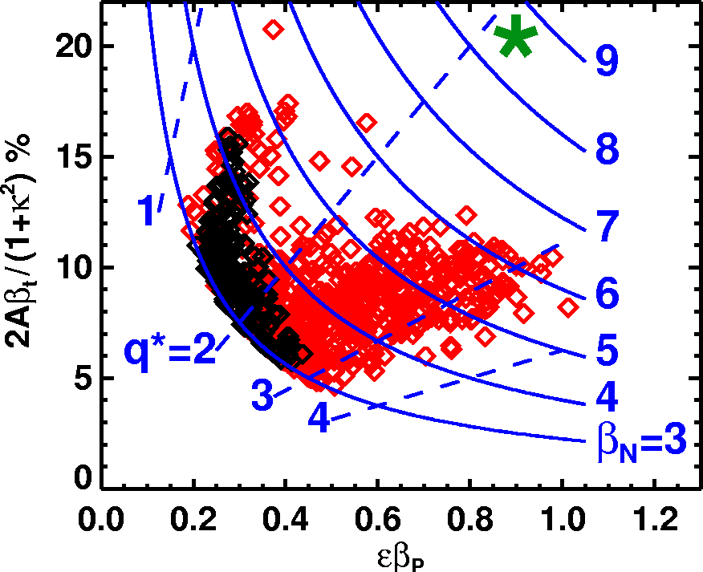

Fig. 1. Nomalized plasma toroidal beta vs. normalized plasma polodial beta. The normalized beta countours are as labeled. The taget beta regime is shown as a large circle.

H-mode

τ_{E}

Fig. 2. The discharge evolution of the β_{T} = 35 % discharge is shown.

τ_{skin}

Fig. 3. The discharge evolution of high β_{p} shot.

Fig. 4. Toroidal beta vs normalized current for ohmically heated PEGASUS discharges.

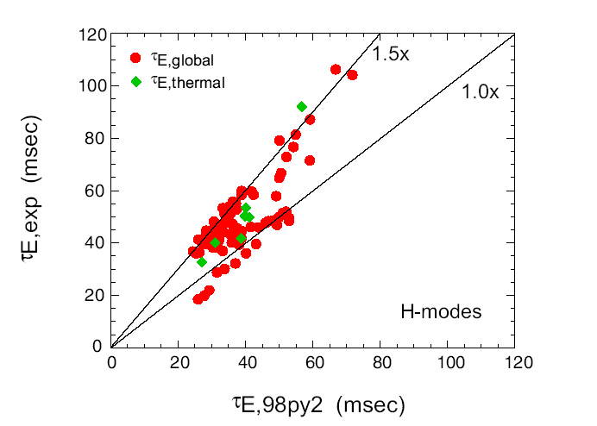
(a)
(b)

Fig. 5. NSTX H-mode experimental confinement data points are shown compared to the ITER 98py2 H-mode scaling. The circlar points are the global confinement time and the rhombus points are the confinement with energetic component and NBI lost components removed.

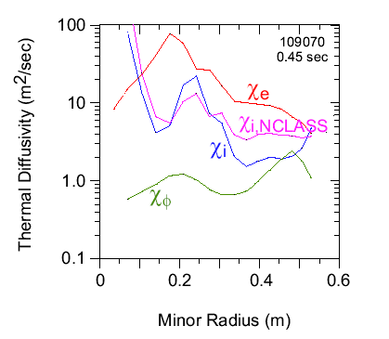
TRANSP

Fig. 6. Thermal and momentum diffusivities calculated from TRANSP power balance calculations. Shown for comparison is the calculated neoclassical thermal diffusivity from the NCLASS neoclassical model. The plasma radius is about 65 cm.

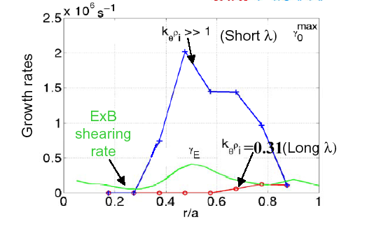

Fig. 7. Growth rates computed by GS2 show that the EXB sharing rate exceeds long wavelength modes thereby stabilizing them. The short wavelength modes on the other hand may dominate (electron) transport.

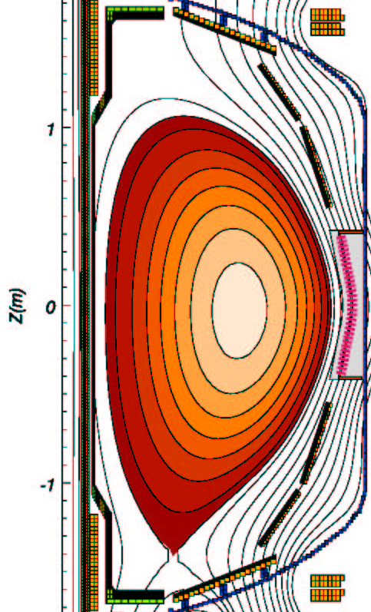

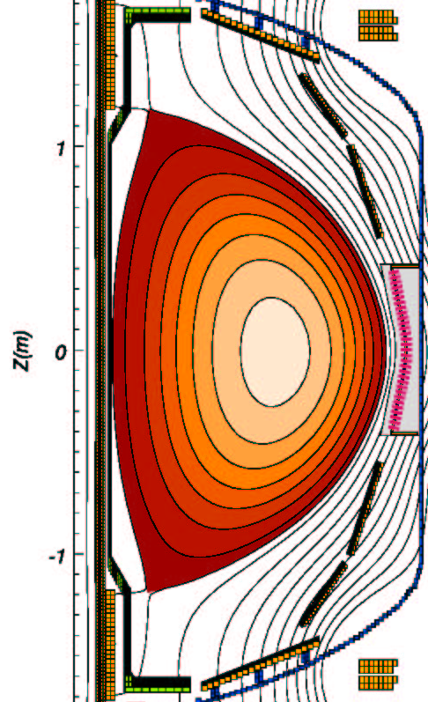

Fig. 8. Divertor heat load flux comparison for the single null and the high triangularity double null discharges.

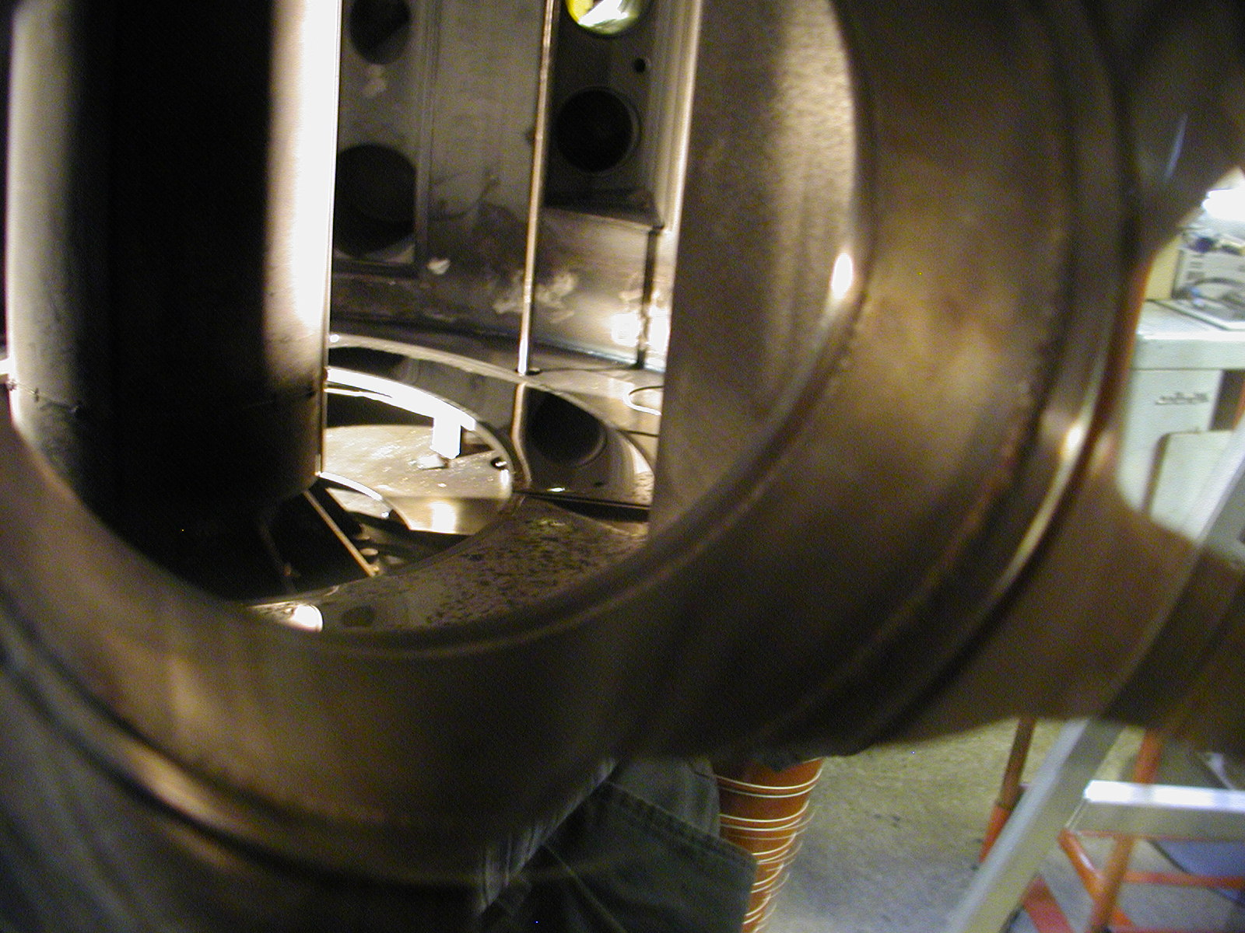

Figure 9. View of the lithium-filled toroidal tray in CDX-U through a port. The centerstack is the vertical column in the left side of the field of view. The tray is indicated by the arrow. Note the highly reflective surface, indicative of the liquid lithium in the tray.

CHI + OH
OH only

Fig. 10. Comparison of CHI + OH and OH only discharges as labeled. For all discharges a constant inductive voltage of 4 V is applied for 2 ms, followed by 3.2 V for the next 6.8 msec.

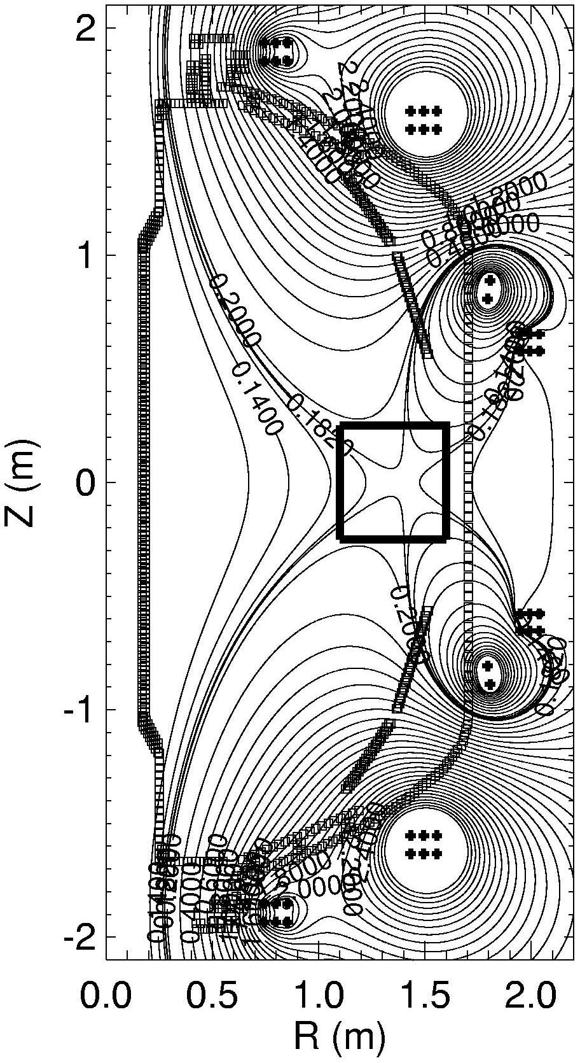

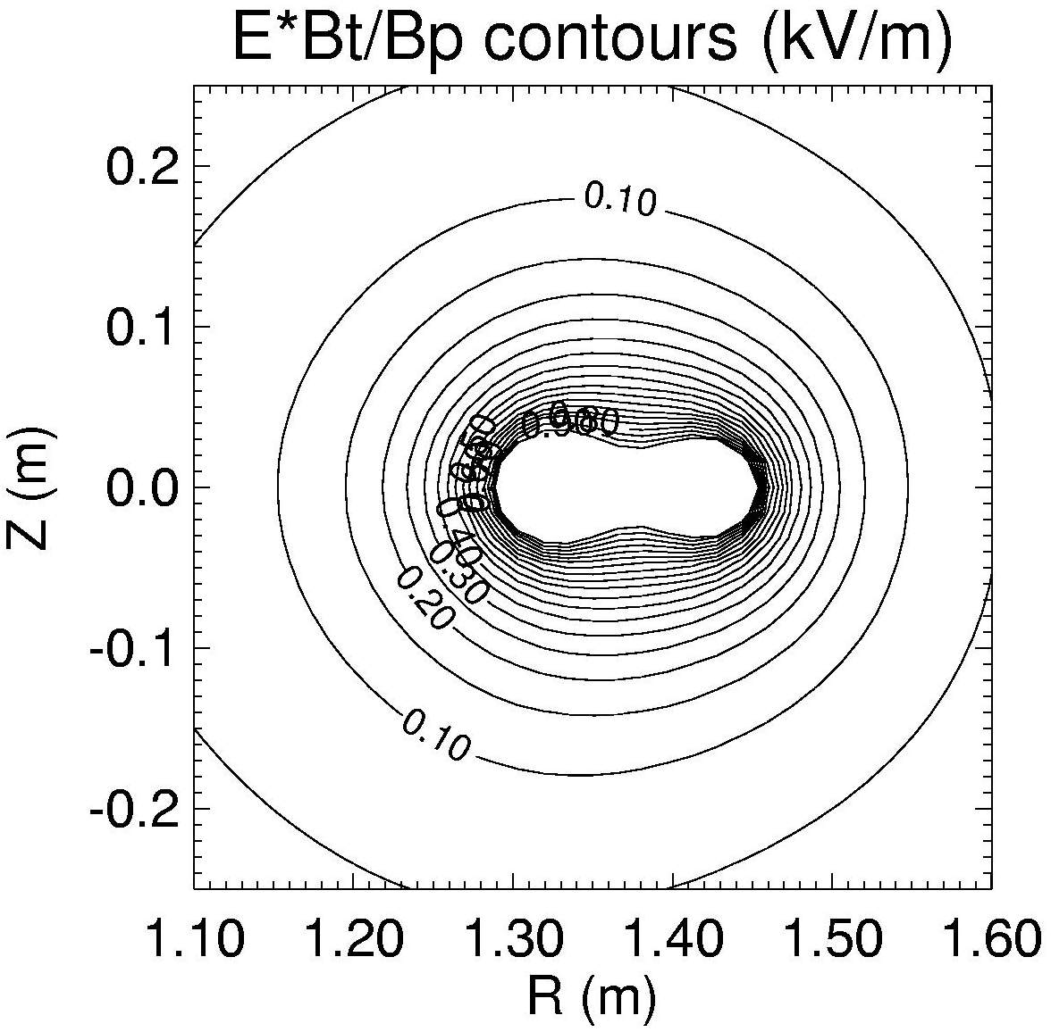

~ 35 cm

Fig. 11.The NSTX outer PF-only high quality null formation. (a) Flux contours. (b) E_{T} B_{T} / B_{p} contours in kV/m at the time of initiation.

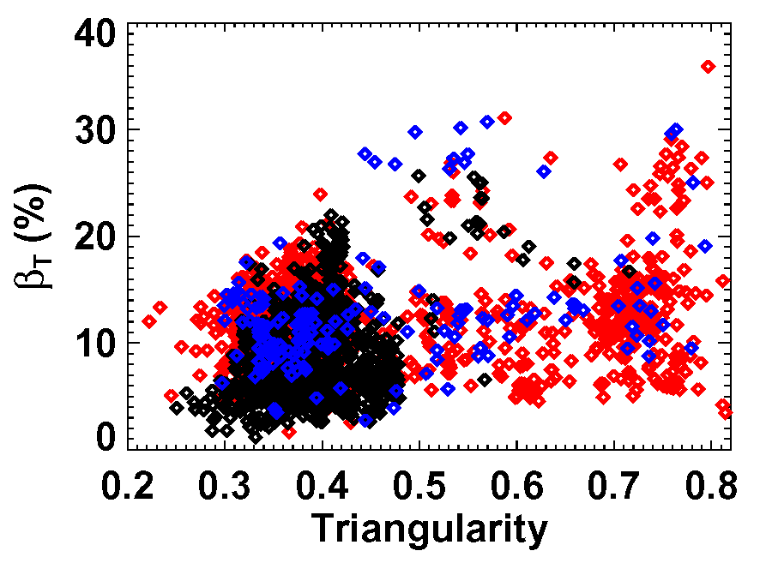
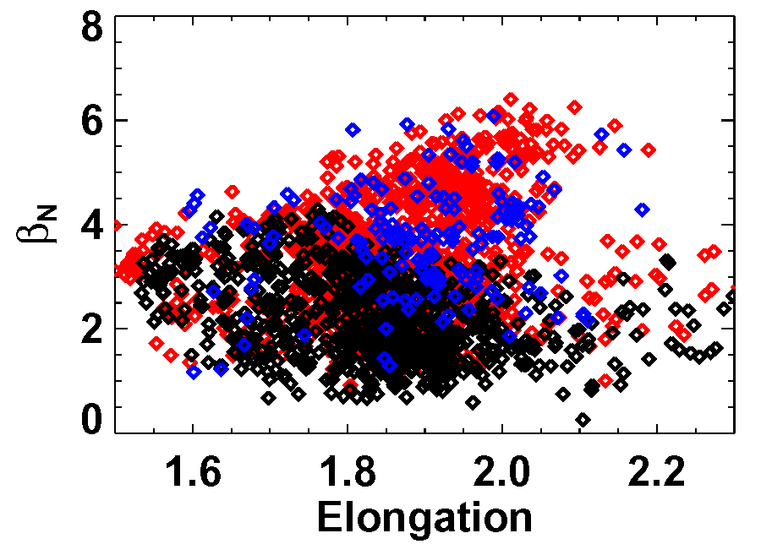
2003 data
2002 data
2001 data
?
(a)

(b)

Fig. 12. Achieved plasma beta values vs plasma shaping parameters. (a) β_{N} vs plasma elongation. (b) β_{T} vs plasma triangularity.

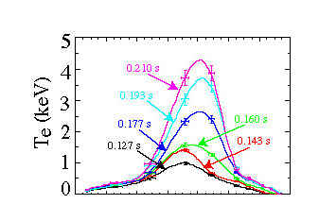
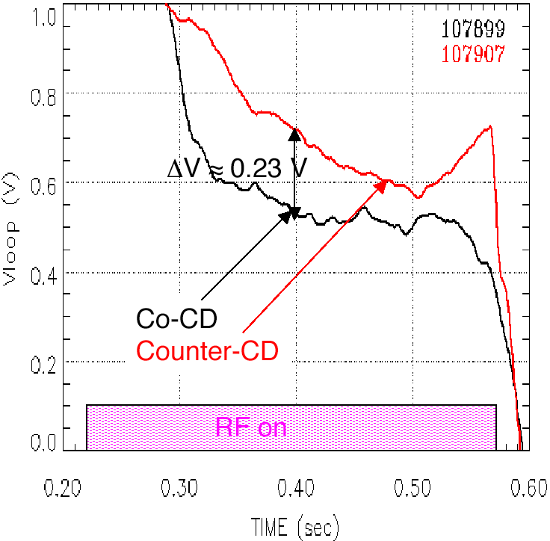

Fig. 13. High Harmonic Fast Wave Heating and Current Drive in NSTX. (a) Strong central heating by HHFW with creation of electron transport barrier. (b) Differences in V_{loop} with co and counter-directed waves indicate ~ 100 kA of current drive consistent with theoretical modeling estimate.

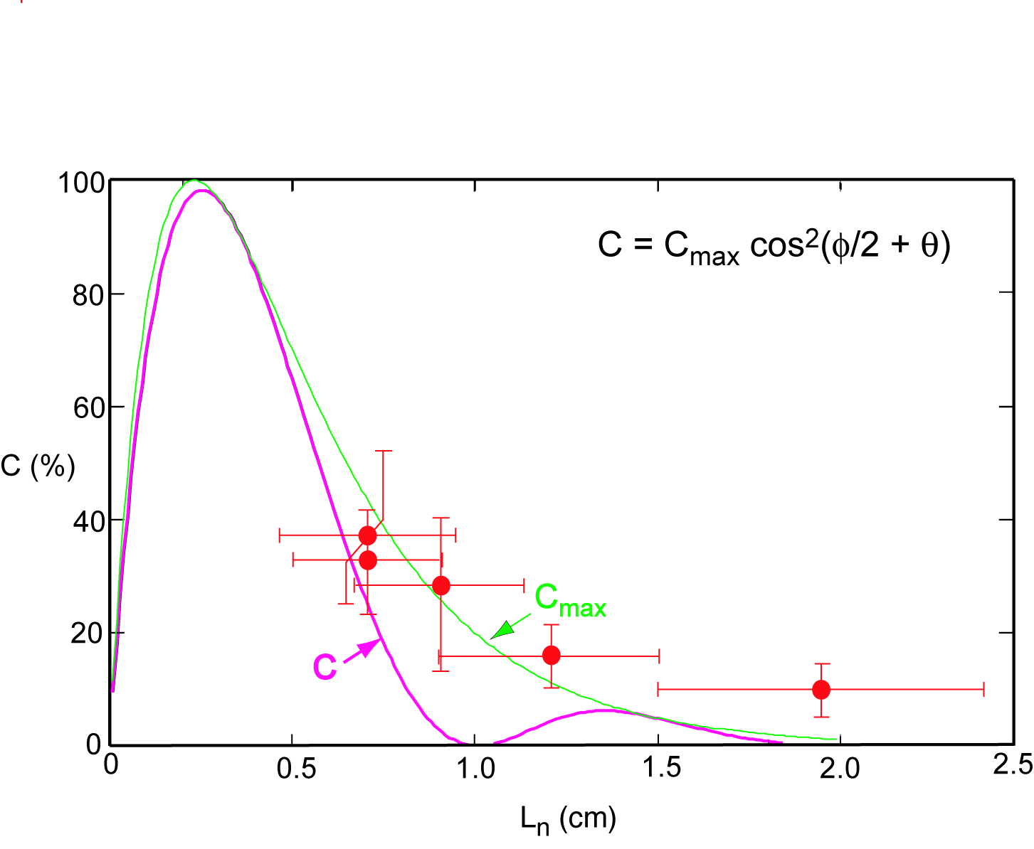
EBW Emission efficiency in NSTX

Fig. 14. Observed electron Bernstein wave emission coefficient in NSTX. The curves are theoretical values.

