Vertical Stability of NSTX and NSTX-U

E. Kolemen¹, D. A. Gates¹, S. Gerhardt¹, D. Humphreys², J. Menard¹, D. Mueller¹, A. Walender², M. Walker²,
¹ Princeton Plasma Physics Laboratory, Princeton, NJ 08543, email: ekolemen@pppl.gov
² General Atomics, CA 92186

Currently NSTX is being upgraded with a bigger center stack and an additional neutral beam, which will allow a higher toroidal field and plasma current and a pulse length [1]. This paper studies the vertical stability of NSTX and NSTX-U, and explains some of the upgrades to the control capabilities that have been implemented and under investigation for NSTX-U that can stabilize Vertical Displacement Events (VDEs).
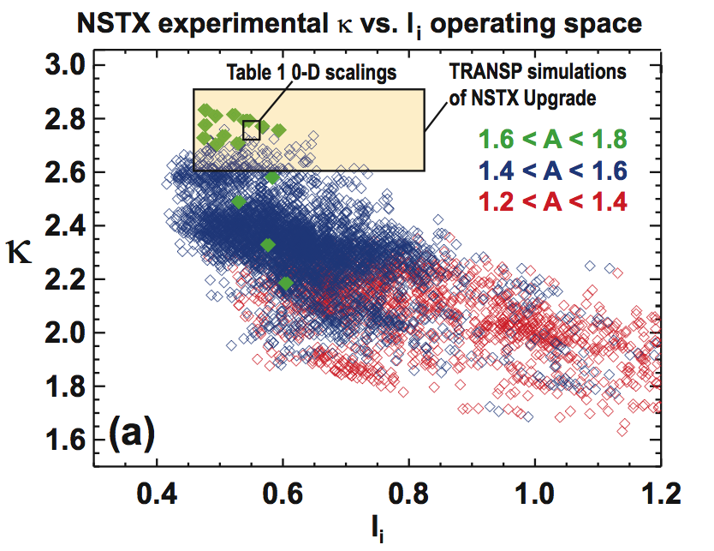
The vertical stability and controllability of the tokamak plasma is a function of the internal inductance, plasma pressure, distance between the plasma and the conducting wall, the location and type of sensors used for measuring vertical position, and the plasma aspect ratio and boundary shape. With an unfinished machine we don’t have access to any of these data experimentally. One way of assessing the stability for NSTX-U is to look at parametric scaling from NSTX database. Figure 1 shows the NSTX experimental κ versus l_{i} operating space sorted by aspect ratio with the lowest A = 1.2 −1.4 in red, typical NSTX A = 1.4 −1.6 in blue, and the highest A = 1.6 − 1.8 in green from the experiments dedicated to producing NSTX Upgrade-like shapes. In NSTX, κ ≈ 2.7 − 2.8 has been sustained for l_{i} < 0.65 for a range of aspect ratios A = 1.4 − 1.8 which includes aspect ratios A = 1.6 − 1.8 anticipated for NSTX Upgrade. However, for the cases with A = 1.6 − 1.8, loss of vertical control occurred for l_{i} ≥ 0.65 indicating that control of higher κ and/or high κ at higher l_{i} may require vertical control improvements [2]. These parametric scalings motivate further study of the vertical stability and control for NSTX-U.
Fig. 1. NSTX experimental κ vs l_{i} operating space sorted by A.

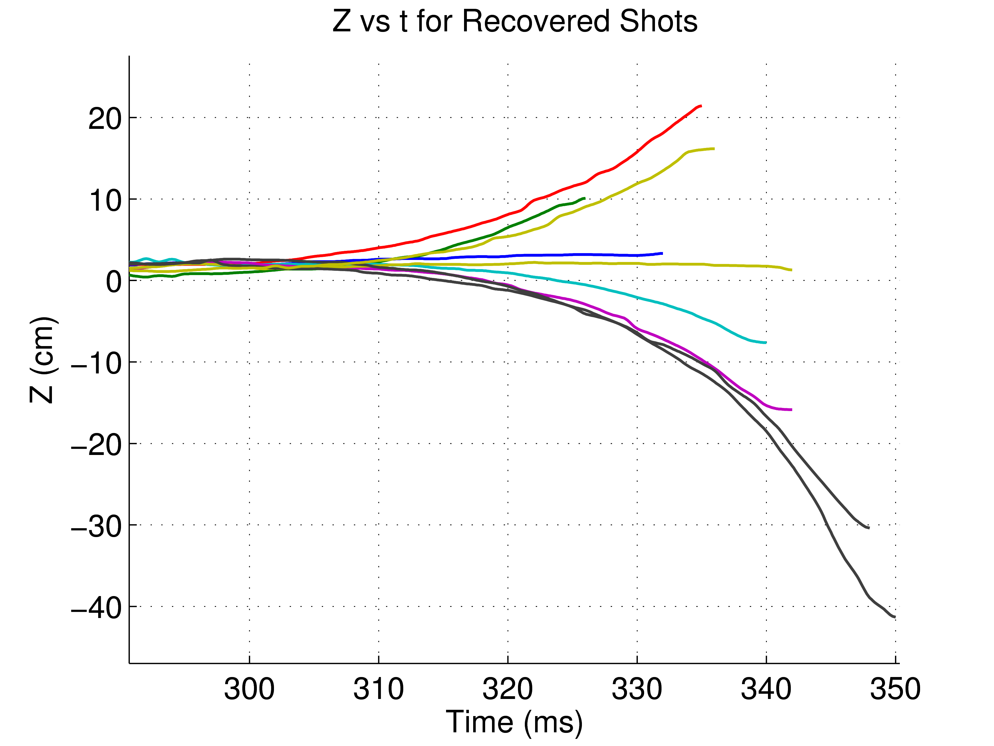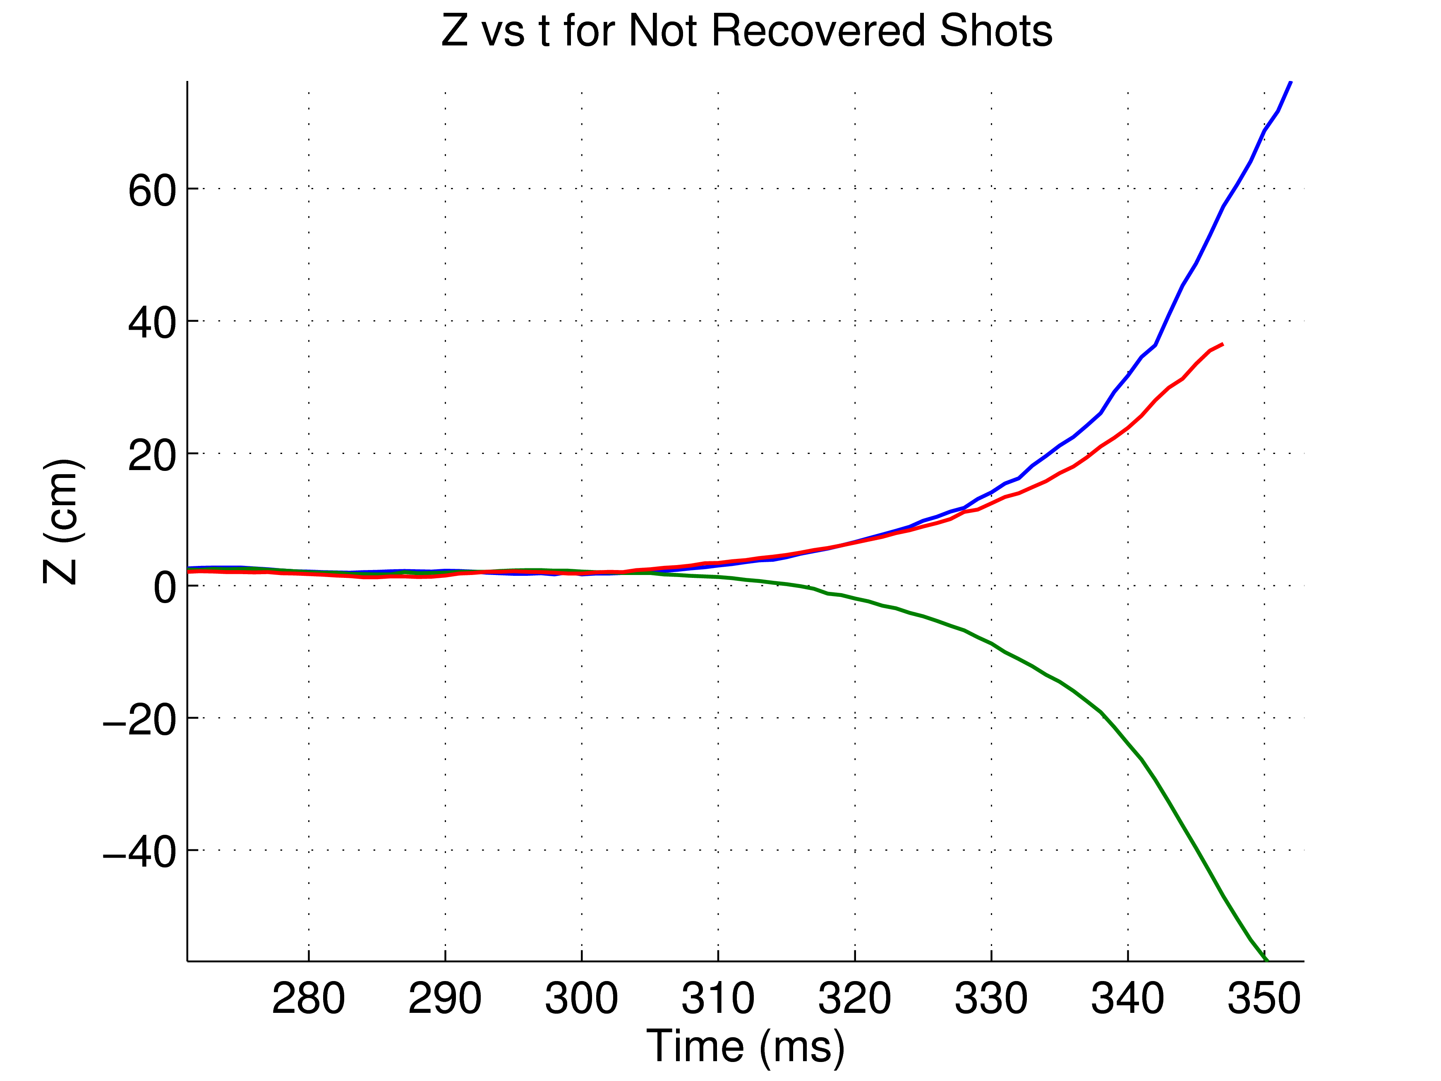
Fig. 2. NSTX vertical motion experimental data where the control is turned off for a certain time and turned on again. Recovered and the unrecoverable shots are shown on the left and right, respectively.

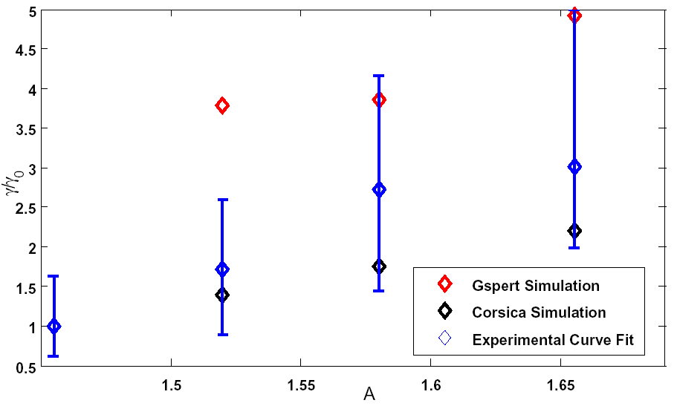
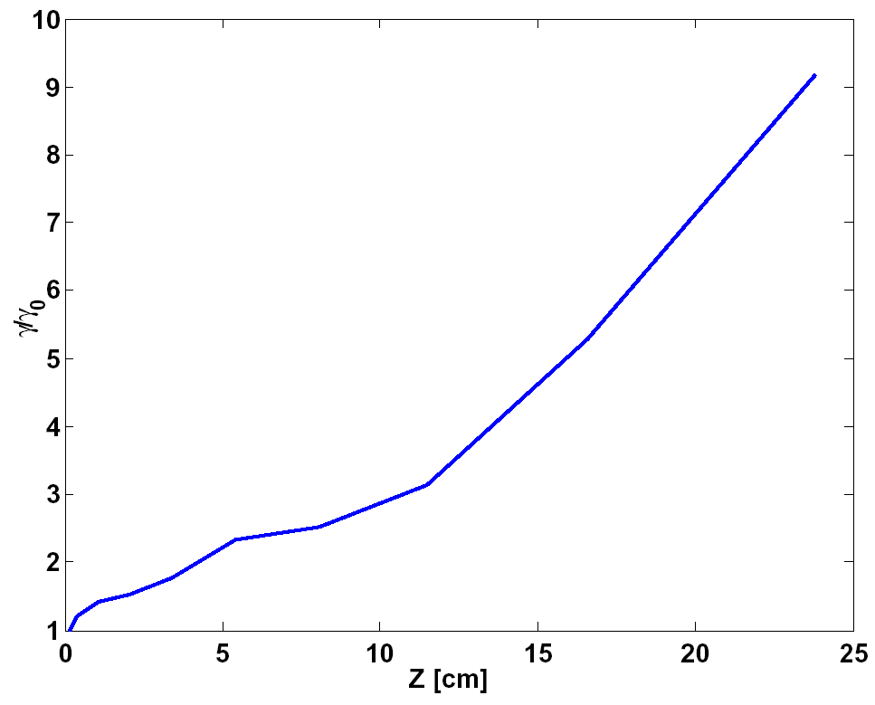
The approach in this paper is to first study VDE experiments for NSTX, which is the closest machine to NSTX-U. We have extensively studied vertical motion in NSTX as shown in Figure 2. In these studies it was observed that the growth rate, γ, increased as the plasma moved away from the center as shown in Figure 3. Thus, the NSTX vertical plasma motion shows non-linear characteristics in agreement with previous spherical tokamak data from MAST [4]. Secondly, we compare numerical simulations to these experimental data. In order to study the n=0 stability of the system, we use Gspert [3], a nonrigid plasma response model based on the linearized Grad-Shafranov equation, and Corsica [4], a free-boundary equilibrium and transport code. Thirdly, the simulation and the experimental results for NSTX are compared to obtain the accuracy and the statistics of the predictions. Figure 4 shows the result of comparison between the simulations and the experimental data. There is a large error bar in the γ calculations due to the uncertainty that results from fitting an exponential curve to the experimental data. While the error bars are large, both the experimental data and the simulations show a clear trend in the increase in the γ as an increase in A. Fourthly, the statistical analysis of the NSTX-U vertical motion via Gspert and Corsica simulations is obtained based on the results from the NSTX data. Fifthly, the controllability of the VDEs for a variety of parameters is assessed for NSTX-U under the current control algorithm. Results of these studies show that since NSTX-U will be operating at higher A, the vertical γ will be higher, which in turn will make control more difficult. Also, acceleration in the γ as the plasma drifts leads to the prioritization of early detection and faster control over more control power. With these considerations in mind, there are currently three improvements for the NSTX-U. First, a new, more sophisticated vertical position estimator will enable early and more accurate detection. Second, RWM coils, which are much faster than the poloidal field coils, were put in the vertical control loop, which will reduce control action delay against VDEs. Improvements to the control algorithm are also under development.
Fig. 3. Change in γ versus the displacement in the plasma vertical location (#127077)

Fig. 4. Change in γ versus A for Corsica and Gspert simulations, and experimental data (#141639-141642)

*This work was supported by U.S. DOE Contract DE-AC02-09CH11466.

References:
[1] Menard et al., EPS Conf. on Plas. Physics, Dublin, Ireland, 21–25 June 2010, P2.106
[2] Menard et al., SOFE, Chicago, IL, 26-30 June 2011
[3] Welander et al., 52nd APS/DPP Meeting, Chicago, Illinois, 8-12 Nov., 2010
[4] Lodestro and Pearlstein, Phys. Plasmas 1 (1994) 90
[5] Windridge et al., Plasma Phys. Control. Fusion 53 (2011) 035018

