a lithium evaporator design for extended operation of brief periods

Presented By John Timberlake for:

D. Mansfield, R. Kaita, H. Kugel, R. Majeski, L. Roquemore,
T. Bennett, L. Guttadora, and S. Jurczynski

CONSIDERATIONS FOR A LITHIUM EVAPORATOR
Vapor Pressure
of Lithium

Vapor Pressure
vs
Temperature for
Molten Lithium

400 600
Temperature of Lithium (°C )

- Evaporation at ~600° C has been estimated for lithium deposition rates of 1000 Å per 3 minutes centrally from a COS²Θ distribution. Temperature is the parameter that can be tweaked for rate control. Masking will be necessary for shaping the form from a COS²Θ distribution.

- With time constraints, as between discharges, reaching evaporation temperature quickly can be boosted with auxiliary heaters.

- Rapid cooling is also needed. A 3 to 10 minute cool down time can be aided with a jacket fitted for gas cooling. An “idling” or “coasting” temperature somewhere below the knee of the lithium vaporization (400° C) is a plausible scenario for achieving the heating cycling. The cooling rate is an integral part of the testing regime.

- A practical size for construction must also be considered. An aperture of 7/8 inch with a containment limit of ~30 grams of lithium has been designed. Loading under Argon is planned after vacuum conditioning.

- Construction details have taken into consideration experience gained with molten lithium on CDX-U.

EXPERIENCES WITH MOLTEN LITHIUM FROM CDX-U

- From our cdx-u experiences, we have learned (we think) some of the things that will help tame molten lithium.

- Molten Lithium has a tendency to do what it wants to do which may or may not be what you want it to do.

- Generally, molten lithium (up to ~ 300° C) does not flow with adherence to 304 stainless steel (except with glow discharge). However, adherence to stainless steel is observed when it is at or above the melting point of lithium (180.5° C) and immersed into molten lithium.

- 304 stainless steel is a poor thermal conductor. To restrict movement of molten lithium, an unheated portion of a stainless steel surface provides a dam. A cool spot on the evaporator is subject to condensation with clogging and a reduction in output area. Heating of the entire evaporator will likely be necessary.

- For molten lithium ≥ 500° C on 304 stainless steel, gravity is irrelevant. Molten lithium hydroxide (m.p. 471° C) will flux the surface in all directions and the molten lithium will follow. This creep is a serious problem as lithium hydroxide will inevitably be formed and operation of the evaporator is expected to be ~600° C or possibly higher.

- While other materials of construction (e. g. molybdenum, tungsten, and tantalum) may seem to be a better choice, they pose other more difficult problems than 304 stainless steel. Commercial evaporators are made from the refractory metals and would not serve us well as lithium evaporators.

pictorial diagram of lithium evaporator
(not to scale)

- Evaporator has three chambers. The end chamber is filled with lithium ( ).

- Creep is controlled by completely welded baffles. Baffle cutouts allow passage of lithium vapor ( ).

- The lithium is filled through a “removable” plug ( ). y2o3 is a candidate material to stop lithium welding of the plug.

heat ( ) is applied to the entire evaporator to prevent condensation and plugging. Auxiliary heat ( ) from cartridge heaters is available for rapid heating of the lithium.

a thermocouple well ( ) is available for monitoring the lithium temperature.

the evaporator

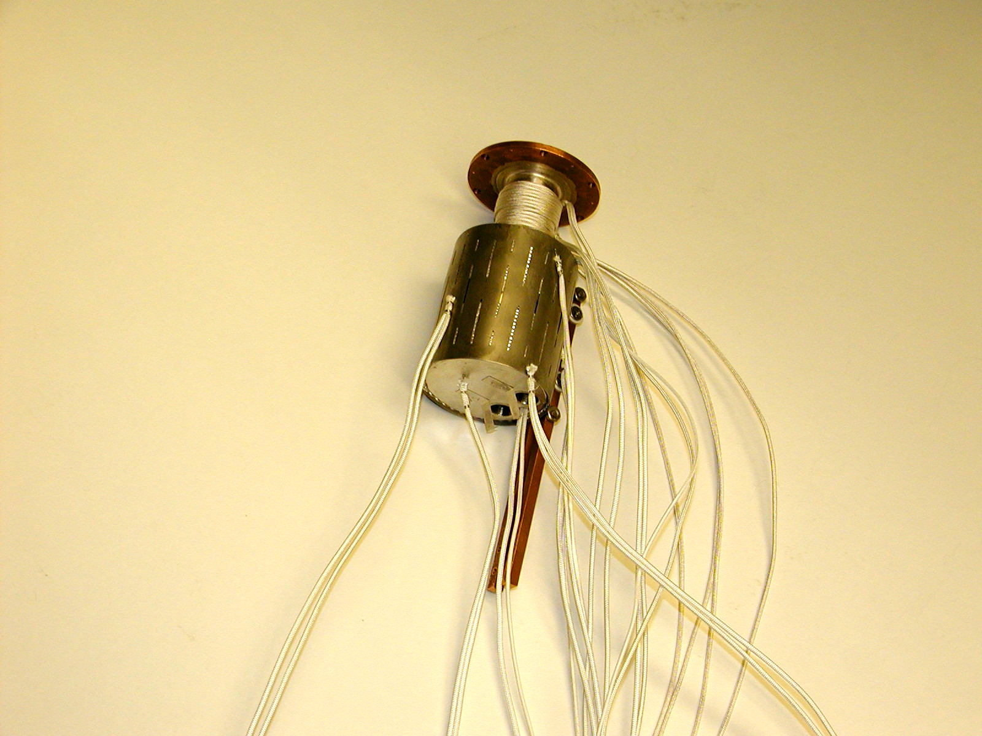
- Main heater with copper connections and two nichrome wire heaters can be seen. Holes for cartridge heaters can be seen.

- Copper disk on front of evaporator is for cooling and creep control around the outside of the evaporator. There is also a transition band of stainless steel between the evaporator and the copper disk.

- Thermocouples are for adjusting and monitoring heating parameters during testing. The necessity for multiple monitoring during operation is as yet undetermined.

HEAT SHIELD AROUND EVAPORATOR

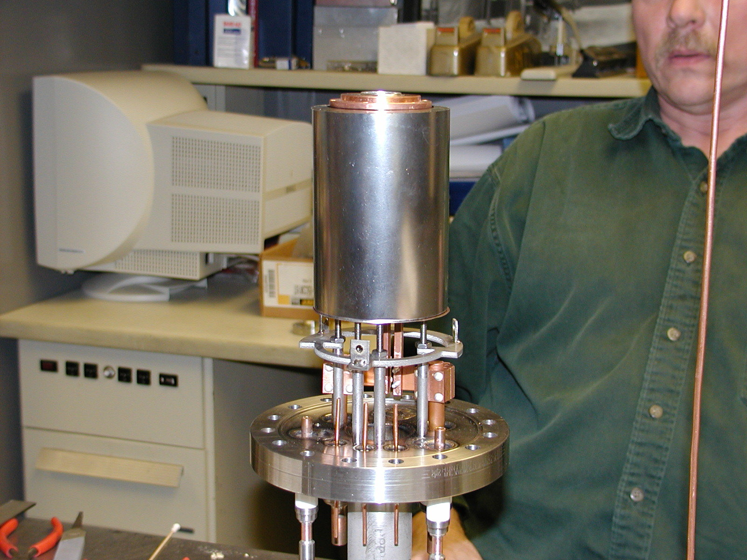

COOLING JACKET OVER HEAT SHIELD

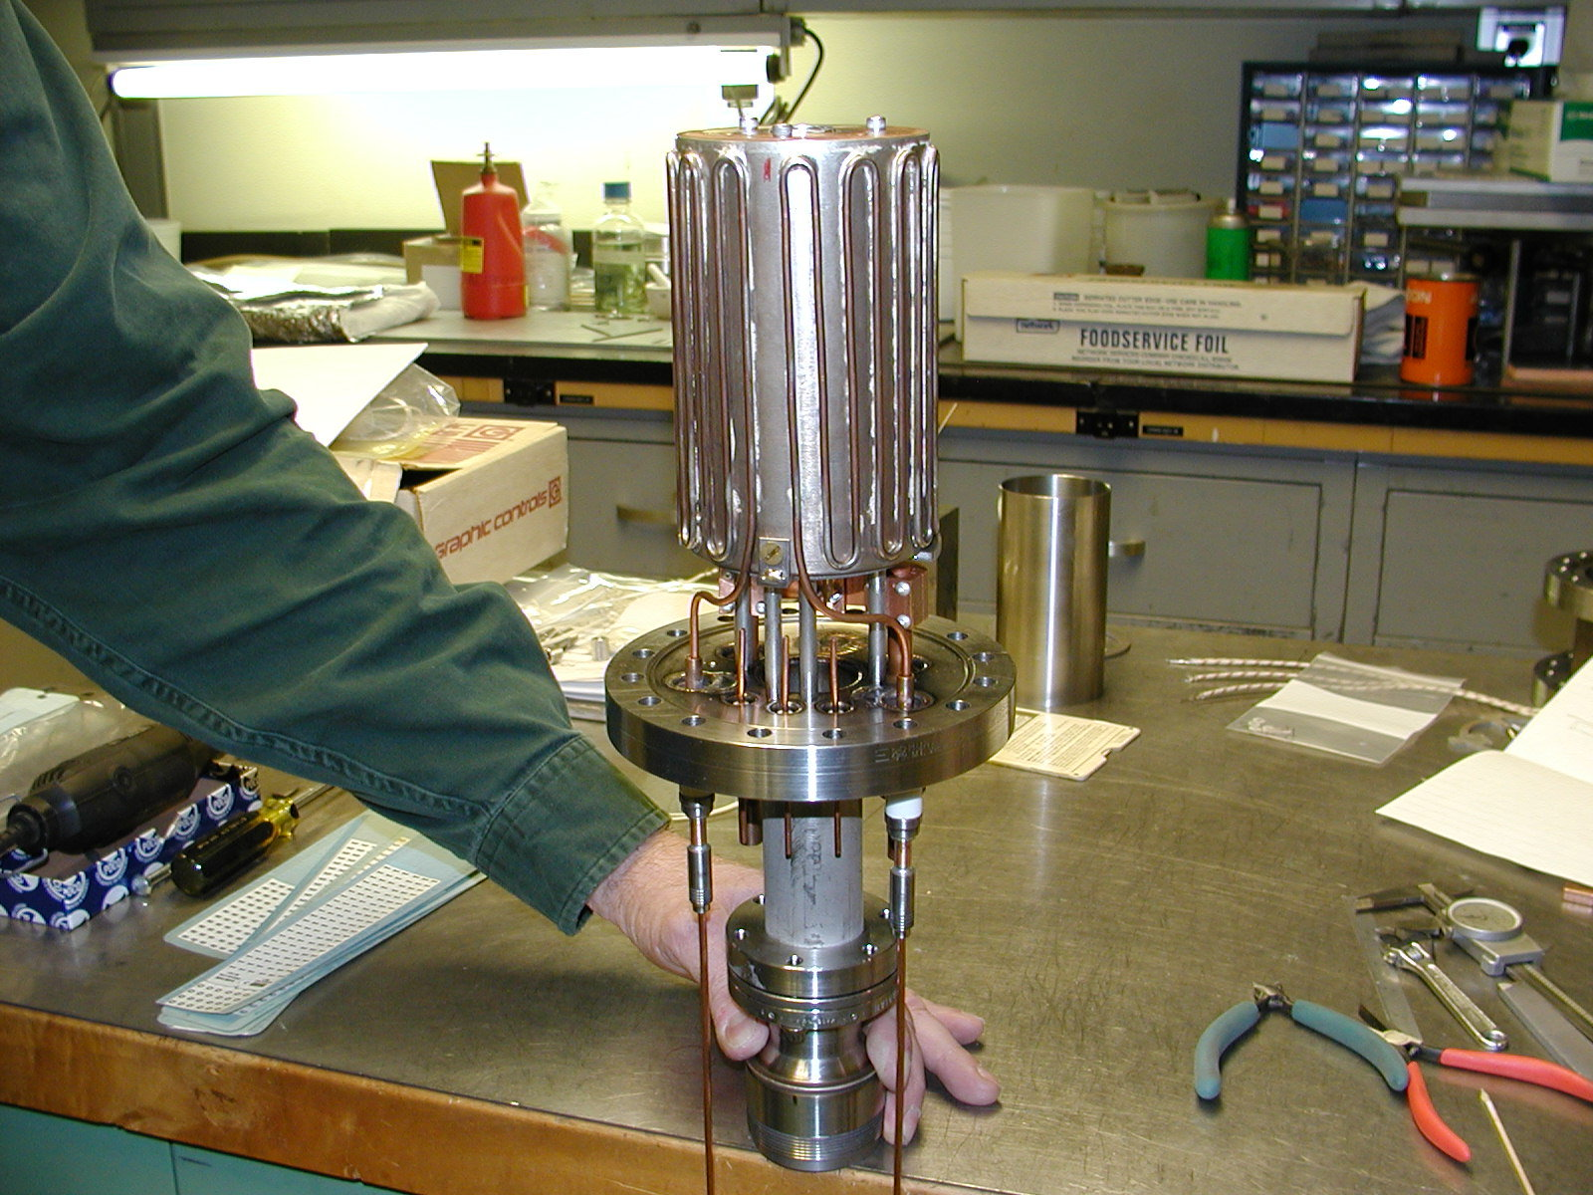

TEST CHAMBER MOUNTING LOCATION

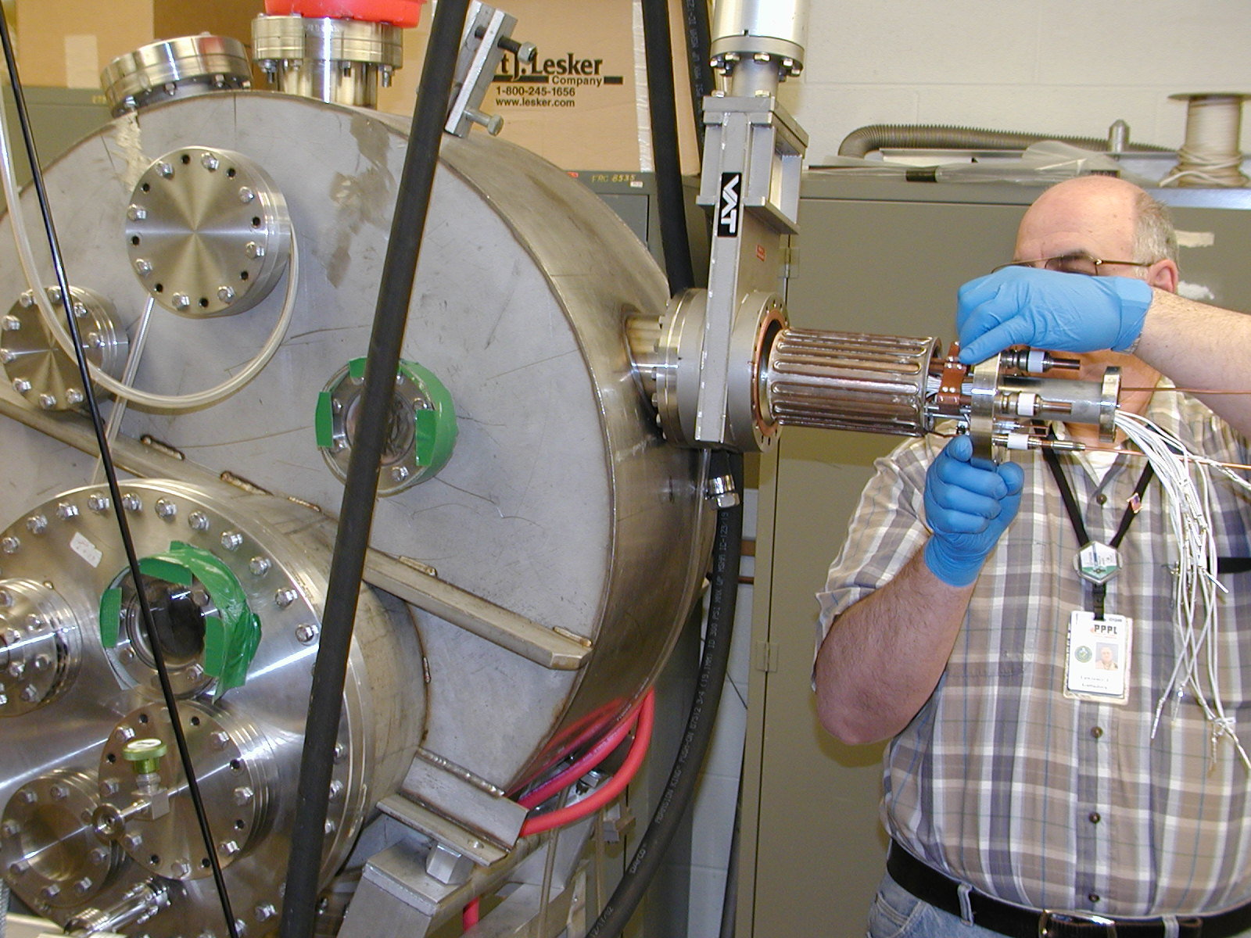

WHERE WE ARE

- construction of the evaporator, the heat shielding, the cooling mantle, the mounting flange, and the electrical and thermocouple connections are completed. The unit is ready for mounting on the test stand for pre-bake out (minus the heat shields).

- the test chamber is being readied for high vacuum operation (not needed for bake out).

- Monitoring includes real time display of the voltage, current, resistance and power to each of the four heaters, the temperature for eleven thermocouples as well as the chamber pressure. A Residual Gas Analyzer is also on the test chamber.

- A mask has been cut to catch and condense peripheral lithium vapor.

- A thickness monitor will be used to measure the central lithium deposition.

- Procedures are in place and high purity lithium is available for loading the evaporator.

